1. Makoto
1.1. eldlich
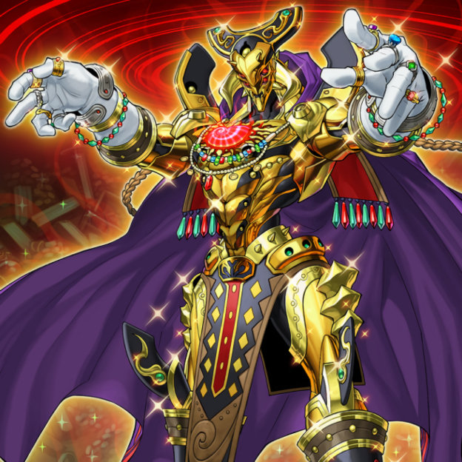

- conquistador:
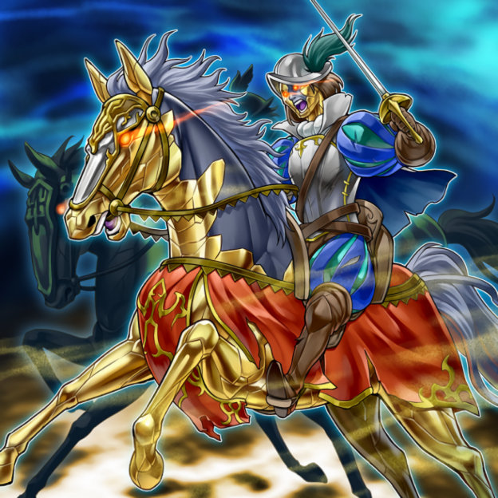

- huaquero:
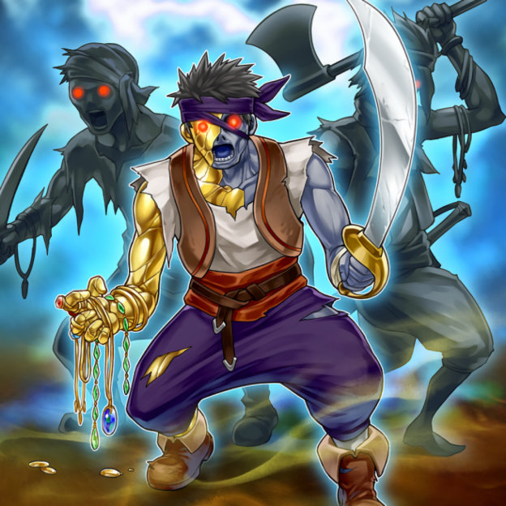

- guardian:

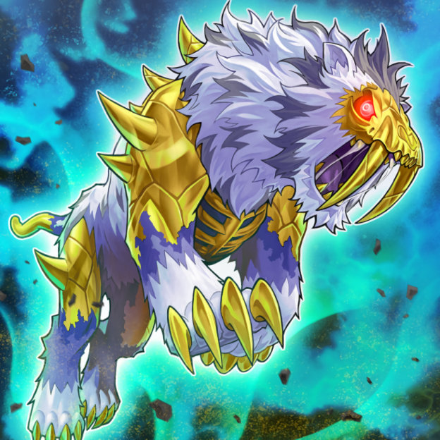

- el_dorado_adelantado:

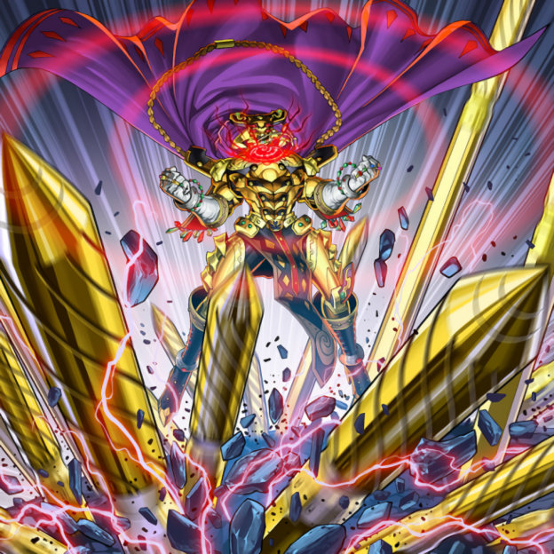

- cursed_eldland:
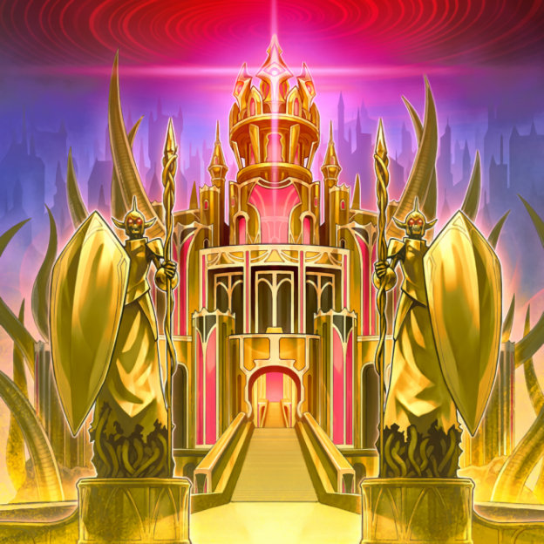

1.2. regenesis_warrior
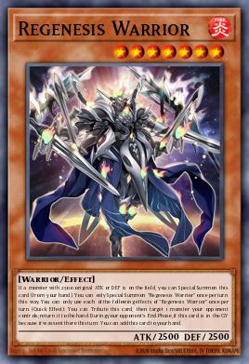

1.3. chaos_angel
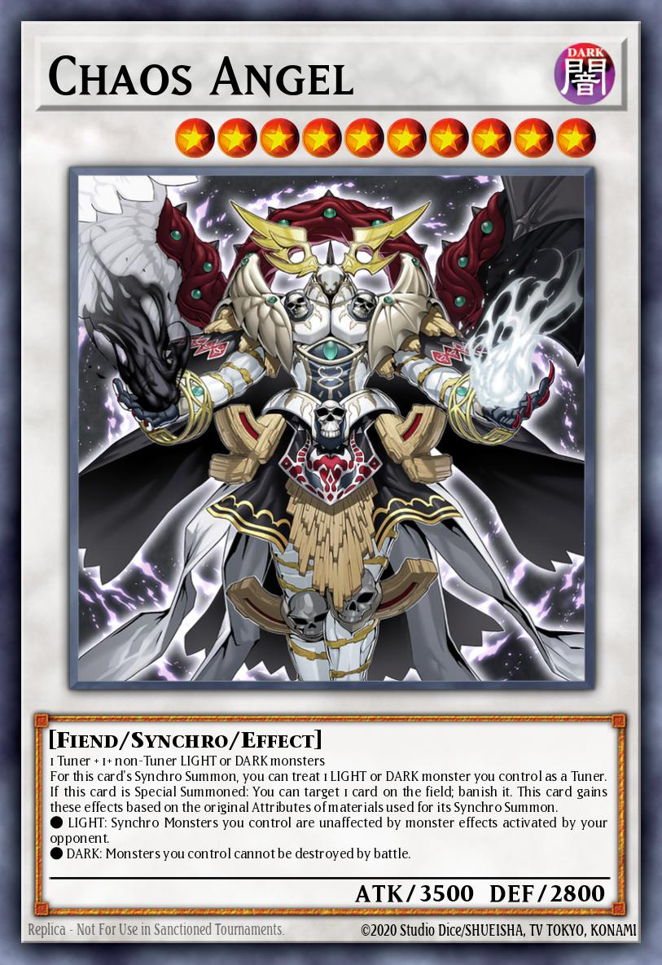

2. Eris
2.1. labrynth
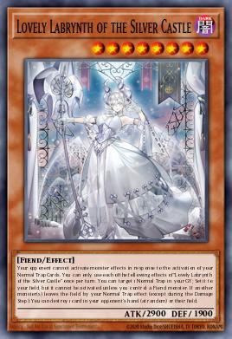

2.2. blazing_cartesia
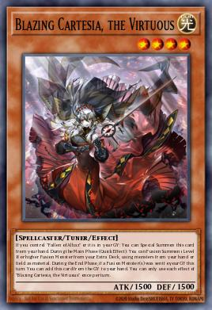

2.3. icejade_gymir_aegirince
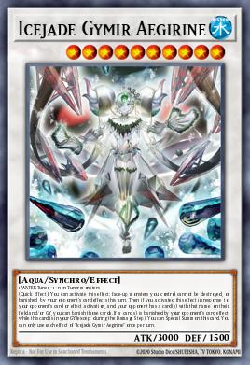

3. Others
3.1. flower_cardian_lightflare
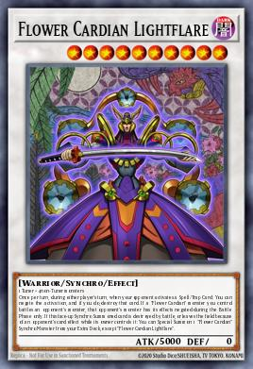

3.2. libromancer_fireburst
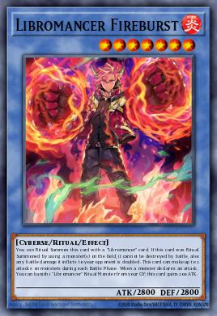

3.3. angelechy_shatranga
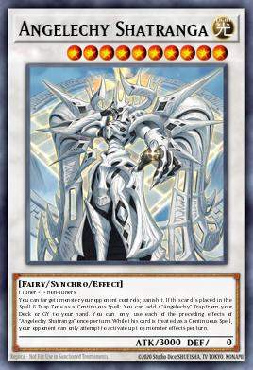

4. Defaults
4.1. knight
4.2. warrior
4.3. barbarian
4.4. defender

4.5. archer
4.6. strider

4.7. rogue
4.8. duelist

4.9. magician
4.10. battlemage
4.11. arcanist
4.12. summoner

4.12. inquisitor
4.13. priest
4.14. guardian
4.15. acolyte

