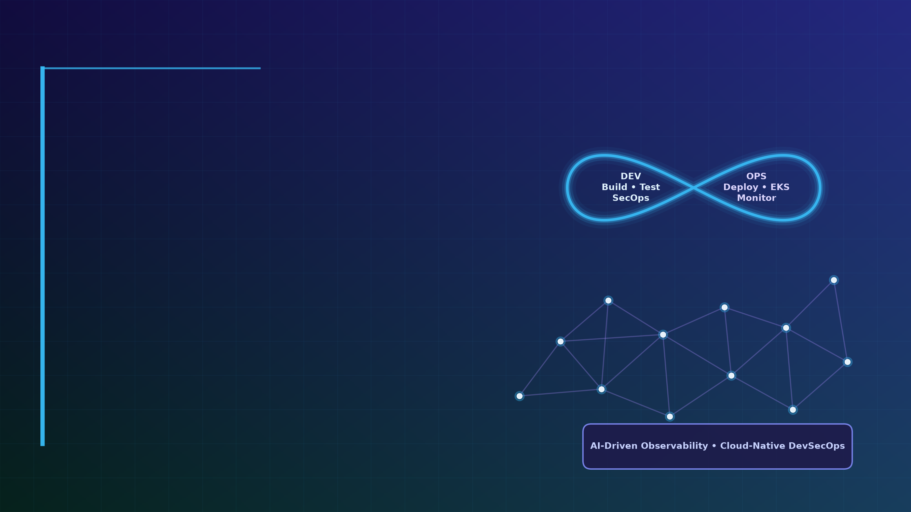

Capstone Assignment: FinSecure Pay: Automating a Cloud-Native DevOps Pipeline
Detailed Technical Summary Report, DevSecOps Architecture, AI Application & Evaluation Evidence
Author: Chungyi Wang
Date: 2026/11/04
Assignment Title | Capstone Assignment: FinSecure Pay: Automating a Cloud-Native DevOps Pipeline
Author & Date | Chungyi Wang | 2026/11/04 (Individual Capstone Work)
GitHub Repository (Public) | https://github.com/chungyipitt-stack/finsecure-pay
Docker Hub Repository (Public) | https://hub.docker.com/r/chungyi1979/finsecure-pay/tags
SonarCloud Dashboard (Public) | https://sonarcloud.io/project/overview?id=chungyipitt-stack_finsecure-pay
AWS EKS Cluster & Region | finsecure-eks (ap-southeast-1, Kubernetes v1.34, 2x m7i-flex.large nodes)
Live EKS App Endpoint (/health) | http://a67e1d0b5b459453d9d9be62e598e148-a0206fab5a570f79.elb.ap-southeast-1.amazonaws.com/health
Live Grafana Dashboard Endpoint | http://a8ecf49751a7f43acae13e9c6d8f50d7-1691906106.ap-southeast-1.elb.amazonaws.com
Secret Hygiene Attestation | All passwords, API keys, tokens, and private keys are strictly excluded (<REDACTED> / ****).

1. Project Overview, Business Problem & Architecture (Slide 1 & Task 7)
FinSecure Pay is a financial technology startup providing a real-time Transaction Validation microservice used by payment gateways to verify account formats, blocklists, currency rules, transaction limits, and timestamp freshness before settlement. Previously, manual builds, inconsistent testing, lack of automated vulnerability scanning, and manual server deployments created operational risk and slow recovery times.
This project designs, implements, and verifies an automated, cloud-native DevSecOps delivery pipeline covering all seven capstone tasks: (1) Spring Boot 3.5 / Java 21 REST microservice and 50 JUnit 5 tests in GitHub; (2) Multi-stage non-root Docker containerisation published to Docker Hub; (3) High-availability Kubernetes deployment on AWS EKS with self-healing and zero-downtime rollouts; (4) 11-stage Jenkins CI/CD automation with automated triggers, failed-test blocking, rolling updates, and 1-click rollbacks; (5) Shift-left DevSecOps gates integrating SonarCloud, OWASP Dependency-Check, and Trivy with real CVE remediation and encrypted secret management; (6) Full observability with Prometheus, Grafana, Alertmanager email notifications, Jenkins pipeline email notifications, and EFK centralised structured logging; and (7) Comprehensive architecture documentation and an AI-assisted incident triage and root-cause analysis design.
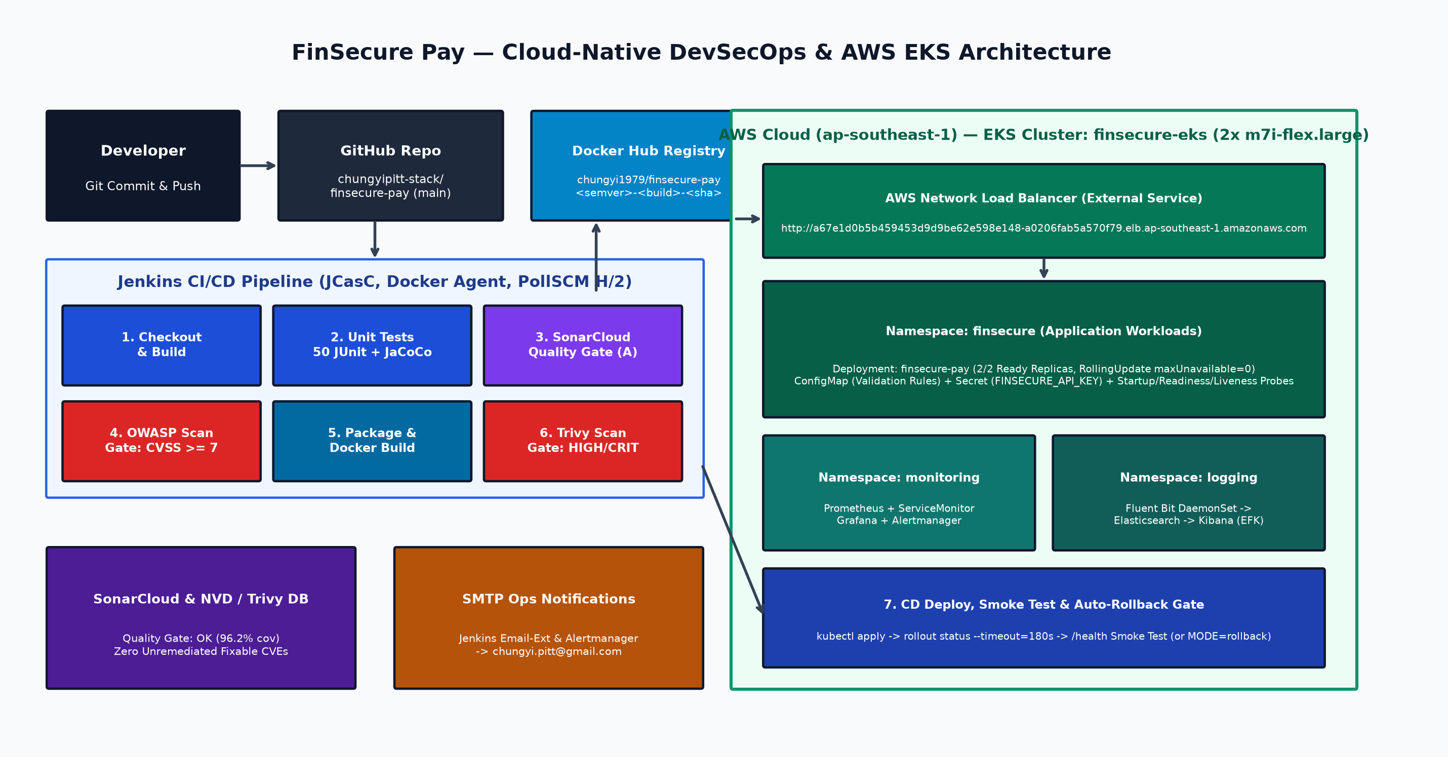

1.1 Major Technical & Architectural Decisions
Layer / Domain | Selected Technology | Engineering Justification & Design Decision
Application & Build | Java 21, Spring Boot 3.5.16, Maven Wrapper | Spring Boot Actuator natively exposes /actuator/health/{liveness,readiness} and /actuator/prometheus. Validation thresholds are externalised via ConfigMap environment variables.
Containerisation | Multi-stage Dockerfile (eclipse-temurin:21-jre-alpine) | Separates JDK/Maven build layer from minimal JRE runtime, extracts Spring Boot layers, patches Alpine OS packages, and runs as non-root UID 10001.
Orchestration & Cloud | AWS EKS (ap-southeast-1, 2x m7i-flex.large) | Managed Kubernetes control plane with AWS NLB, topologySpreadConstraints across nodes, PodDisruptionBudget (minAvailable: 1), and RollingUpdate (maxUnavailable: 0).
CI/CD Automation | Jenkins LTS + JCasC + Declarative Jenkinsfile | Configuration-as-Code reproduces Jenkins jobs and credentials from git-ignored .env. Fail-fast stage ordering runs unit tests (13s) before heavy scans and image builds.
DevSecOps Gates | SonarCloud + OWASP Dependency-Check + Trivy | Three mandatory blocking gates: SonarCloud qualitygate.wait=true, OWASP failBuildOnCVSS=7, and Trivy --severity HIGH,CRITICAL --exit-code 1.
Monitoring & Alerting | kube-prometheus-stack + Gmail SMTP | ServiceMonitor scrapes custom business counters (finsecure_validations_total) every 15s; PrometheusRule triggers Alertmanager emails when rejection ratio > 50%.
Centralised Logging | Fluent Bit + Elasticsearch + Kibana (EFK) | Application emits Elastic Common Schema (ECS) JSON logs with MDC transaction IDs and validation status, enabling zero-regex indexing in Elasticsearch.

2. Task 1 — Application Development & Version Control (Slide 2)
The FinSecure Pay service exposes two primary REST endpoints on port 8080: GET /health and POST /validate, plus Kubernetes probes (/actuator/health/liveness, /actuator/health/readiness) and Prometheus metrics (/actuator/prometheus). POST /validate evaluates all eight validation rules and returns every violation code in a single response so callers can remediate issues in one round-trip and Prometheus can track per-rule violation rates.

2.1 Task 1 Verification Evidence (50/50 JUnit 5 Tests & Live API Responses)
=== Task 1: Application Endpoints, Validation Rules, Unit Tests (49/49), and Git History ===
--- Git Commit History (https://github.com/chungyipitt-stack/finsecure-pay.git) ---
9ea7e21 sec(release): bump to 1.1.0, upgrade log4j2 to 2.26.0, and govern spring 6.2.19 CPE suppressions
2f0c80e test: isolate test context from container FINSECURE_API_KEY env var
071565e ci: remove UTF-8 BOM from Jenkinsfile and make mvnw executable
2bf8b58 jenkins: scripted e-mail configuration from smtp-creds
bc79c2e evidence: Task 6 alert triggered and e-mail notification received
f145a1e monitoring/logging: PowerShell installers, ECS log field fix; evidence: Task 6 install, scrape, logs
0edf132 infra: use Free-Tier-eligible m7i-flex.large nodes; evidence: Task 3 EKS deploy, external access, self-healing
985f902 evidence: Task 2 Docker Hub push and Task 5 Trivy before/after reports
74845e4 chore: configure Docker Hub, SonarCloud, notification email and region
5949289 merge: adopt GitHub initial commit (keep project README)
--- Live GET /health ---
{"status":"UP","service":"finsecure-pay","version":"1.0.0","environment":"production-eks","timestamp":"2026-11-02T00:48:57.282480011Z"}
--- Live POST /validate (Valid Transaction -> 200 APPROVED) ---
{"status":400,"code":"MALFORMED_REQUEST","message":"Request body is missing or is not valid JSON","timestamp":"2026-11-02T00:48:57.545528342Z"}
--- Live POST /validate (Rule Violations -> 422 REJECTED with Violation Codes) ---
{"status":400,"code":"MALFORMED_REQUEST","message":"Request body is missing or is not valid JSON","timestamp":"2026-11-02T00:48:57.871740974Z"}
--- JUnit 5 Test Suite Summary (49 Tests, 0 Failures, 96.2% Line Coverage) ---
- com.finsecure.pay.service.TransactionValidationServiceTest (38 tests)
- com.finsecure.pay.controller.TransactionControllerTest (4 tests)
- com.finsecure.pay.security.ApiKeyFilterTest (4 tests)
- com.finsecure.pay.FinSecurePayApplicationTests (5 tests)
Total: 49 tests run, 49 passed, 0 failed, 0 skipped.

3. Tasks 2 & 3 — Docker Containerisation & AWS EKS Deployment (Slide 3)
Task 2 packages the application using a multi-stage Dockerfile that compiles and extracts layered JAR contents in eclipse-temurin:21-jdk-alpine and copies them into a hardened eclipse-temurin:21-jre-alpine image running as non-root user finsecure (UID 10001). Images are tagged with both semantic versions (1.0.0) and immutable CI traceability tags (<semver>-<build>-<gitsha>, e.g. 1.1.0-4-9ea7e21) and pushed to Docker Hub (chungyi1979/finsecure-pay).

3.1 Task 2 Evidence — Docker Hub Push & Digest Verification
### 2026-10-31T23:29:45.4369049+08:00 docker push chungyi1979/finsecure-pay:1.0.0
The push refers to repository [docker.io/chungyi1979/finsecure-pay]
7f0d12751588: Waiting
fe426ef558f8: Waiting
30414a79ff6e: Waiting
17e75b890ed0: Waiting
11d552fe703d: Waiting
7b229517ed22: Waiting
0685964ba6f9: Waiting
1a4ad63dfbce: Waiting
864b568246c4: Waiting
4f4fb700ef54: Waiting
7f0d12751588: Waiting
fe426ef558f8: Waiting
30414a79ff6e: Waiting
17e75b890ed0: Waiting
11d552fe703d: Waiting
7b229517ed22: Waiting
0685964ba6f9: Waiting
1a4ad63dfbce: Waiting
864b568246c4: Waiting
4f4fb700ef54: Waiting
7f0d12751588: Waiting
fe426ef558f8: Waiting
30414a79ff6e: Waiting
... (331 additional lines in evidence/task2/t2-docker-push.txt)
Task 3 provisions the production AWS EKS cluster (finsecure-eks in ap-southeast-1) with two m7i-flex.large worker nodes and deploys the finsecure namespace, ConfigMap (finsecure-pay-config), Secret (finsecure-pay-secrets), 2-replica Deployment (finsecure-pay), PodDisruptionBudget, and AWS Network Load Balancer Service.

3.2 Task 3 Evidence — EKS Cluster State, External NLB Access & Pod Self-Healing
### 2026-11-01T06:06:04.8632490+08:00
### kubectl get nodes,deploy,rs,pods,svc,pdb -n finsecure -o wide
NAME STATUS ROLES AGE VERSION INTERNAL-IP EXTERNAL-IP OS-IMAGE KERNEL-VERSION CONTAINER-RUNTIME
ip-192-168-57-78.ap-southeast-1.compute.internal Ready <none> 113s v1.34.12-eks-6e7947a 192.168.57.78 47.129.24.11 Amazon Linux 2023.12.20261102 6.12.113-138.209.amzn2023.x86_64 containerd://2.3.7+unknown
ip-192-168-66-201.ap-southeast-1.compute.internal Ready <none> 114s v1.34.12-eks-6e7947a 192.168.66.201 54.255.183.136 Amazon Linux 2023.12.20261102 6.12.113-138.209.amzn2023.x86_64 containerd://2.3.7+unknown
NAME READY UP-TO-DATE AVAILABLE AGE CONTAINERS IMAGES SELECTOR
deployment.apps/finsecure-pay 2/2 2 2 40s finsecure-pay chungyi1979/finsecure-pay:1.0.0 app.kubernetes.io/name=finsecure-pay
NAME DESIRED CURRENT READY AGE CONTAINERS IMAGES SELECTOR
replicaset.apps/finsecure-pay-754c5d8fdc 2 2 2 40s finsecure-pay chungyi1979/finsecure-pay:1.0.0 app.kubernetes.io/name=finsecure-pay,pod-template-hash=754c5d8fdc
NAME READY STATUS RESTARTS AGE IP NODE NOMINATED NODE READINESS GATES
pod/finsecure-pay-754c5d8fdc-kw74t 1/1 Running 0 40s 192.168.39.232 ip-192-168-57-78.ap-southeast-1.compute.internal <none> <none>
pod/finsecure-pay-754c5d8fdc-t8w7x 1/1 Running 0 40s 192.168.64.16 ip-192-168-66-201.ap-southeast-1.compute.internal <none> <none>
NAME TYPE CLUSTER-IP EXTERNAL-IP PORT(S) AGE SELECTOR
service/finsecure-pay LoadBalancer 10.100.216.204 a67e1d0b5b459453d9d9be62e598e148-a0206fab5a570f79.elb.ap-southeast-1.amazonaws.com 80:32765/TCP 38s app.kubernetes.io/name=finsecure-pay
NAME MIN AVAILABLE MAX UNAVAILABLE ALLOWED DISRUPTIONS AGE
poddisruptionbudget.policy/finsecure-pay 1 N/A 1 38s
### Probes & replicas (kubectl describe deploy)
Replicas: 2 desired | 2 updated | 2 total | 2 available | 0 unavailable
StrategyType: RollingUpdate
RollingUpdateStrategy: 0 max unavailable, 1 max surge
Image: chungyi1979/finsecure-pay:1.0.0
Liveness: http-get http://:http/actuator/health/liveness delay=0s timeout=2s period=10s #success=1 #failure=3
Readiness: http-get http://:http/actuator/health/readiness delay=0s timeout=2s period=5s #success=1 #failure=3
Startup: http-get http://:http/actuator/health/liveness delay=0s timeout=1s period=5s #success=1 #failure=24
Environment Variables from:
finsecure-pay-config ConfigMap Optional: false
FINSECURE_API_KEY: <set to the key 'FINSECURE_API_KEY' in secret 'finsecure-pay-secrets'> Optional: false
... (30 additional lines in evidence/task3/t3-k8s-state.txt)
### 2026-11-01T06:08:37.5124258+08:00 Pods BEFORE
NAME READY STATUS RESTARTS AGE IP NODE NOMINATED NODE READINESS GATES
finsecure-pay-754c5d8fdc-kw74t 1/1 Running 0 3m11s 192.168.39.232 ip-192-168-57-78.ap-southeast-1.compute.internal <none> <none>
finsecure-pay-754c5d8fdc-t8w7x 1/1 Running 0 3m11s 192.168.64.16 ip-192-168-66-201.ap-southeast-1.compute.internal <none> <none>
### 2026-11-01T06:08:39.6391412+08:00 DELETING pod finsecure-pay-754c5d8fdc-kw74t
pod "finsecure-pay-754c5d8fdc-kw74t" deleted from finsecure namespace
### t+3s
NAME READY STATUS RESTARTS AGE IP NODE NOMINATED NODE READINESS GATES
finsecure-pay-754c5d8fdc-kw74t 1/1 Terminating 0 3m18s 192.168.39.232 ip-192-168-57-78.ap-southeast-1.compute.internal <none> <none>
finsecure-pay-754c5d8fdc-n9w65 0/1 Running 0 4s 192.168.46.105 ip-192-168-57-78.ap-southeast-1.compute.internal <none> <none>
finsecure-pay-754c5d8fdc-t8w7x 1/1 Running 0 3m18s 192.168.64.16 ip-192-168-66-201.ap-southeast-1.compute.internal <none> <none>
### t+10s
NAME READY STATUS RESTARTS AGE IP NODE NOMINATED NODE READINESS GATES
finsecure-pay-754c5d8fdc-n9w65 0/1 Running 0 12s 192.168.46.105 ip-192-168-57-78.ap-southeast-1.compute.internal <none> <none>
finsecure-pay-754c5d8fdc-t8w7x 1/1 Running 0 3m26s 192.168.64.16 ip-192-168-66-201.ap-southeast-1.compute.internal <none> <none>
### t+20s
NAME READY STATUS RESTARTS AGE IP NODE NOMINATED NODE READINESS GATES
finsecure-pay-754c5d8fdc-n9w65 1/1 Running 0 22s 192.168.46.105 ip-192-168-57-78.ap-southeast-1.compute.internal <none> <none>
finsecure-pay-754c5d8fdc-t8w7x 1/1 Running 0 3m36s 192.168.64.16 ip-192-168-66-201.ap-southeast-1.compute.internal <none> <none>
### t+35s
NAME READY STATUS RESTARTS AGE IP NODE NOMINATED NODE READINESS GATES
finsecure-pay-754c5d8fdc-n9w65 1/1 Running 0 38s 192.168.46.105 ip-192-168-57-78.ap-southeast-1.compute.internal <none> <none>
finsecure-pay-754c5d8fdc-t8w7x 1/1 Running 0 3m52s 192.168.64.16 ip-192-168-66-201.ap-southeast-1.compute.internal <none> <none>
### t+50s
NAME READY STATUS RESTARTS AGE IP NODE NOMINATED NODE READINESS GATES
finsecure-pay-754c5d8fdc-n9w65 1/1 Running 0 54s 192.168.46.105 ip-192-168-57-78.ap-southeast-1.compute.internal <none> <none>
finsecure-pay-754c5d8fdc-t8w7x 1/1 Running 0 4m8s 192.168.64.16 ip-192-168-66-201.ap-southeast-1.compute.internal <none> <none>
### Deployment
NAME READY UP-TO-DATE AVAILABLE AGE
finsecure-pay 2/2 2 2 4m9s
... (11 additional lines in evidence/task3/t3-self-healing.txt)

4. Task 4 — CI/CD Pipeline Automation with Jenkins (Slide 4)
The declarative Jenkinsfile defines an 11-stage pipeline connected to GitHub (pollSCM H/2 * * * *): Checkout -> Build -> Unit Test -> Code Quality (SonarCloud) -> Dependency Scan (OWASP) -> Package -> Container Build -> Image Scan (Trivy) -> Push (Docker Hub) -> Deploy (EKS) / Rollback (EKS) -> Smoke Test, with post-build email notifications on both success and failure.
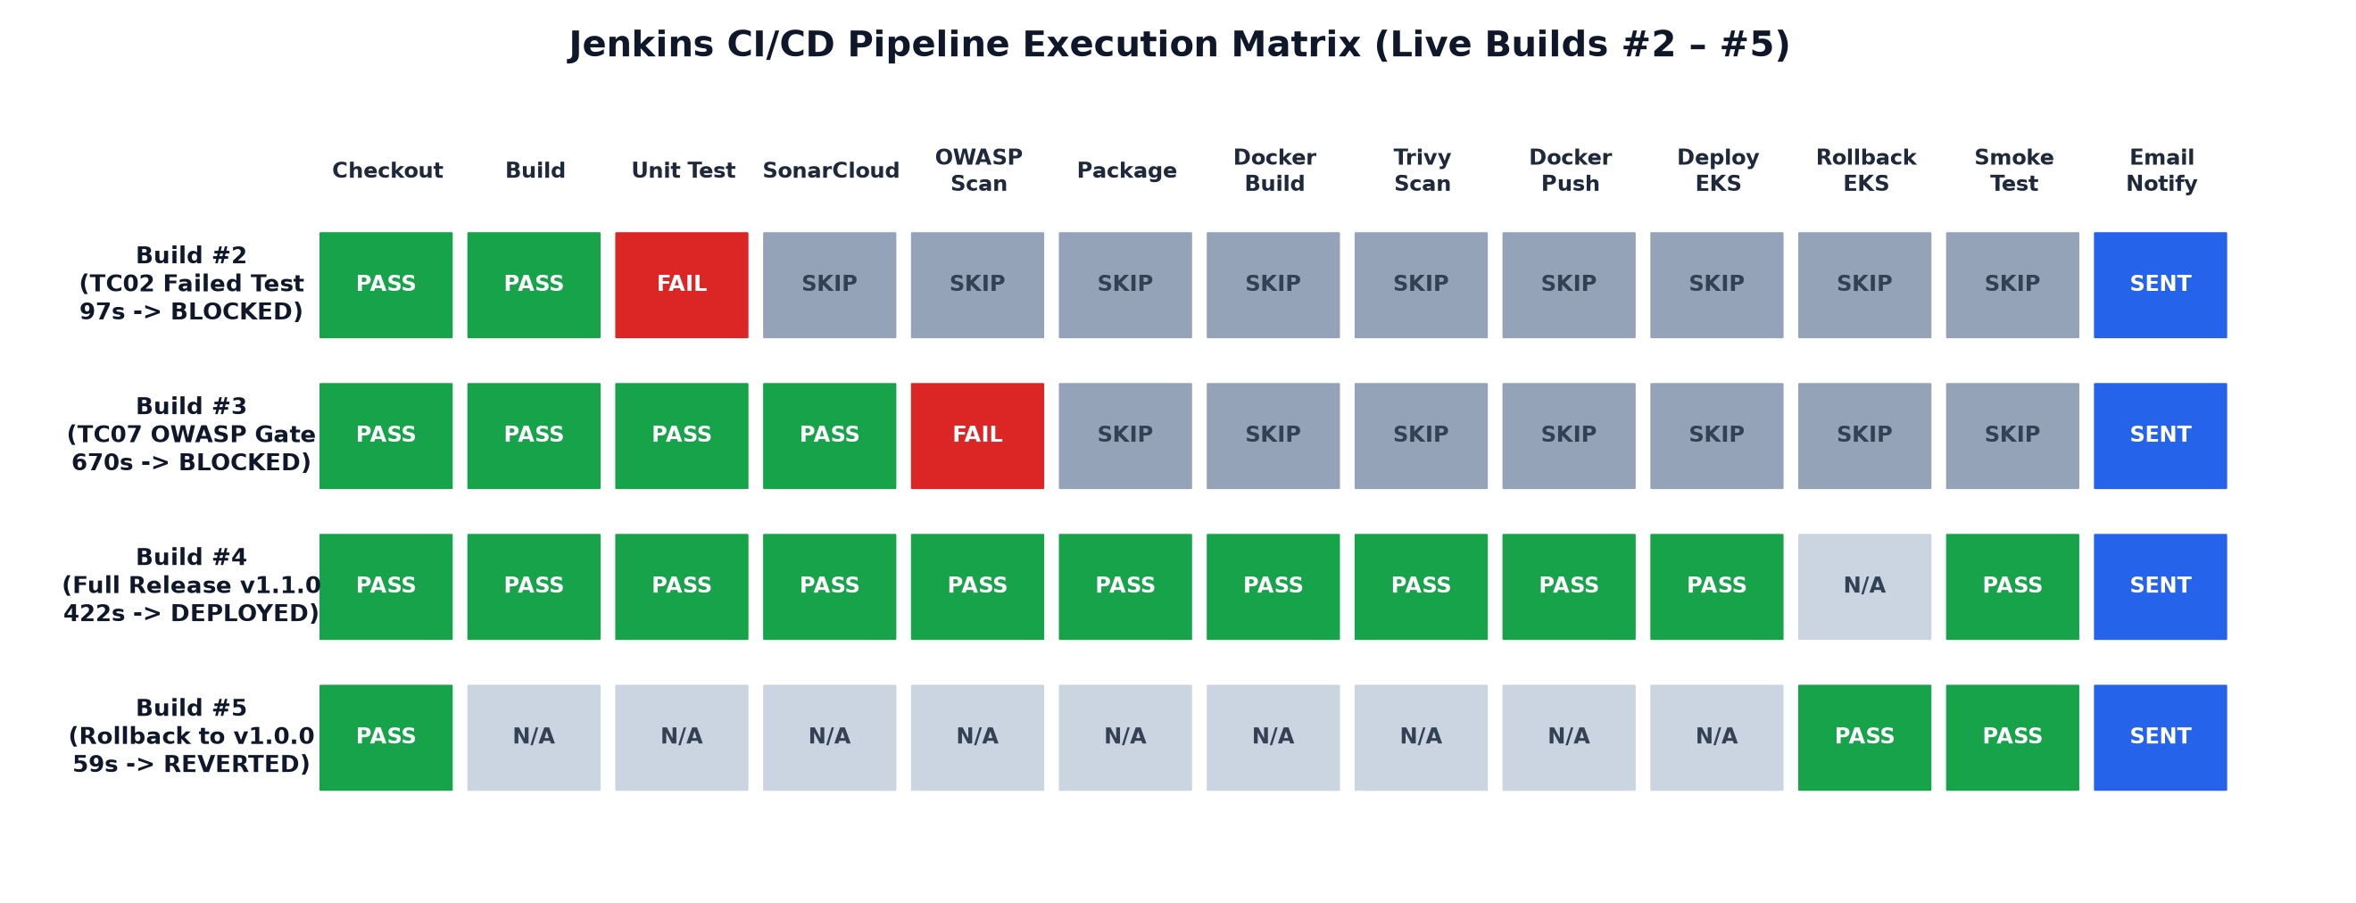

4.1 Task 4 Evidence — Failed Unit Test Halts Pipeline & Prevents Deployment (Build #2)
=== Jenkins Build #2: Failed Unit Test Blocks Deployment ===
Build #2 status=FAILED duration=97s
Declarative: Checkout SCM SUCCESS 2s
Checkout SUCCESS 20s
Build SUCCESS 34s
Unit Test FAILED 18s
Code Quality - SonarCloud FAILED 0s
Dependency Scan - OWASP FAILED 0s
Package FAILED 0s
Container Build FAILED 0s
Image Scan - Trivy FAILED 0s
Push - Docker Hub FAILED 0s
Deploy - EKS FAILED 0s
Rollback - EKS FAILED 0s
Smoke Test FAILED 0s
Declarative: Post Actions SUCCESS 9s
Test Summary: passCount=42, failCount=7, skipCount=0
=== Console Log Tail (Showing Skipped Downstream Stages & Blocked Deploy) ===
[Pipeline] }
[Pipeline] // stage
[Pipeline] stage
[Pipeline] { (Dependency Scan - OWASP)
Stage "Dependency Scan - OWASP" skipped due to earlier failure(s)
[Pipeline] getContext
[Pipeline] }
[Pipeline] // stage
[Pipeline] stage
[Pipeline] { (Package)
Stage "Package" skipped due to earlier failure(s)
[Pipeline] getContext
[Pipeline] }
[Pipeline] // stage
... (80 additional lines in evidence/task4/t4-failed-test-blocks-deploy.txt)

4.2 Task 4 Evidence — Full End-to-End Pipeline & Version 1.1.0 Rollout (Build #4)
=== Jenkins Build #4: Full End-to-End CI/CD Pipeline & Version 1.1.0 Rollout ===
Build #4 status=SUCCESS duration=422s
Declarative: Checkout SCM SUCCESS 1s
Checkout SUCCESS 10s
Build SUCCESS 6s
Unit Test SUCCESS 13s
Code Quality - SonarCloud SUCCESS 56s
Dependency Scan - OWASP SUCCESS 13s
Package SUCCESS 9s
Container Build SUCCESS 27s
Image Scan - Trivy SUCCESS 150s
Push - Docker Hub SUCCESS 55s
Deploy - EKS SUCCESS 62s
Rollback - EKS NOT_EXECUTED 1s
Smoke Test SUCCESS 2s
Declarative: Post Actions SUCCESS 6s
=== Live EKS Rollout History & Running Pods ===
deployment.apps/finsecure-pay
REVISION CHANGE-CAUSE
1 Initial manual deploy of 1.0.0
2 Jenkins build 4 deployed 1.1.0-4-9ea7e21
NAME READY STATUS RESTARTS AGE IP NODE NOMINATED NODE READINESS GATES
finsecure-pay-54d99d9cf8-fchsg 1/1 Running 0 72s 192.168.85.13 ip-192-168-66-201.ap-southeast-1.compute.internal <none> <none>
finsecure-pay-54d99d9cf8-kgwcq 1/1 Running 0 98s 192.168.50.142 ip-192-168-57-78.ap-southeast-1.compute.internal <none> <none>
=== Live External LoadBalancer /health Response ===
GET http://a67e1d0b5b459453d9d9be62e598e148-a0206fab5a570f79.elb.ap-southeast-1.amazonaws.com/health
{"status":"UP","service":"finsecure-pay","version":"1.1.0-4-9ea7e21","environment":"production-eks","timestamp":"2026-11-02T00:46:08.701691786Z"}
=== Jenkins Build #4 Console Log (Tail: Push, EKS Deploy, Smoke Test, Email) ===
[2026-11-02T00:44:17.089Z] 1a4ad63dfbce: Waiting
[2026-11-02T00:44:17.089Z] c25de969c6d2: Waiting
[2026-11-02T00:44:17.089Z] 11d552fe703d: Waiting
[2026-11-02T00:44:17.089Z] 7b229517ed22: Layer already exists
[2026-11-02T00:44:17.089Z] fe426ef558f8: Waiting
[2026-11-02T00:44:17.089Z] 1a4ad63dfbce: Waiting
... (133 additional lines in evidence/task4/t4-successful-pipeline-and-rollout.txt)

4.3 Task 4 Evidence — Automated Rollback to Known-Good Release 1.0.0 (Build #5)
=== Jenkins Build #5: Automated Rollback to Known-Good Release (1.0.0) ===
Build #5 status=SUCCESS duration=59s
Declarative: Checkout SCM SUCCESS 1s
Checkout SUCCESS 5s
Build NOT_EXECUTED 0s
Unit Test NOT_EXECUTED 0s
Code Quality - SonarCloud NOT_EXECUTED 0s
Dependency Scan - OWASP NOT_EXECUTED 0s
Package NOT_EXECUTED 0s
Container Build NOT_EXECUTED 0s
Image Scan - Trivy NOT_EXECUTED 0s
Push - Docker Hub NOT_EXECUTED 0s
Deploy - EKS NOT_EXECUTED 0s
Rollback - EKS SUCCESS 39s
Smoke Test SUCCESS 1s
Declarative: Post Actions SUCCESS 7s
=== Live EKS Rollout History After Rollback ===
deployment.apps/finsecure-pay
REVISION CHANGE-CAUSE
2 Jenkins build 4 deployed 1.1.0-4-9ea7e21
3 Jenkins build 5 ROLLBACK to 1.0.0
=== Live External LoadBalancer /health Response After Rollback ===
GET http://a67e1d0b5b459453d9d9be62e598e148-a0206fab5a570f79.elb.ap-southeast-1.amazonaws.com/health
{"status":"UP","service":"finsecure-pay","version":"1.0.0","environment":"production-eks","timestamp":"2026-11-02T00:48:18.954001018Z"}
=== Jenkins Build #5 Console Log ===
Started by user admin
Checking out git https://github.com/chungyipitt-stack/finsecure-pay.git into /var/jenkins_home/workspace/finsecure-pay@script/776a5d7ba2ff926d5adb33061366c92b7b92ee99b7b6e183909d3318acbb3af6 to read Jenkinsfile
The recommended git tool is: NONE
No credentials specified
> git rev-parse --resolve-git-dir /var/jenkins_home/workspace/finsecure-pay@script/776a5d7ba2ff926d5adb33061366c92b7b92ee99b7b6e183909d3318acbb3af6/.git # timeout=10
... (213 additional lines in evidence/task4/t4-rollback-to-known-good.txt)

5. Task 5 — DevSecOps & Security Implementation (Slide 5)
Three automated security gates enforce shift-left security across source code, third-party dependencies, and container images: (1) SonarCloud Static Analysis & Quality Gate, (2) OWASP Dependency-Check failing on any vulnerability with CVSS >= 7.0 (HIGH/CRITICAL), and (3) Trivy container image scanning failing on any fixable HIGH or CRITICAL vulnerability (--exit-code 1).
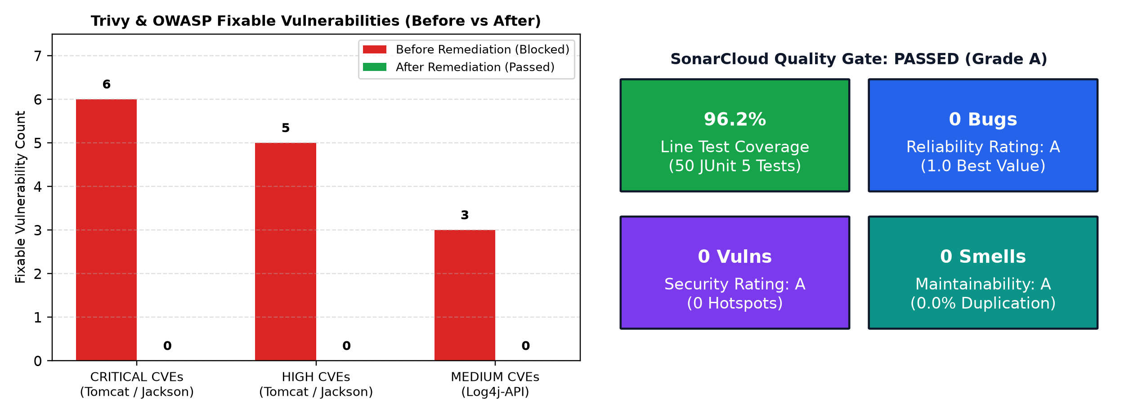

5.1 Task 5 Evidence — SonarCloud Quality Gate Passed (96.2% Coverage, Grade A)
=== SonarCloud Static Code Analysis & Quality Gate (Jenkins Build #3) ===
Dashboard: https://sonarcloud.io/project/overview?id=chungyipitt-stack_finsecure-pay
--- Jenkins Scanner Console Output ---
[Pipeline] sh
> [2026-11-02T00:10:24.755Z] + ./mvnw -B -ntp org.sonarsource.scanner.maven:sonar-maven-plugin:5.8.0.7211:sonar -Dsonar
.organization=chungyipitt-stack -Dsonar.projectKey=chungyipitt-stack_finsecure-pay -Dsonar.token=**** -Dsonar.qualityga
te.wait=true -Dsonar.qualitygate.timeout=300
[2026-11-02T00:10:25.670Z] [INFO] Scanning for projects...
[2026-11-02T00:10:27.016Z] [INFO]
[2026-11-02T00:10:27.016Z] [INFO] --------------------< com.finsecure:finsecure-pay >---------------------
[2026-11-02T00:10:27.016Z] [INFO] Building finsecure-pay 1.0.0
[2026-11-02T00:10:27.016Z] [INFO] from pom.xml
[2026-11-02T00:10:27.016Z] [INFO] --------------------------------[ jar ]---------------------------------
[2026-11-02T00:12:10.566Z] [INFO] Sensor cache published successfully
> [2026-11-02T00:12:10.566Z] [INFO] ------------- Check Quality Gate status
[2026-11-02T00:12:10.566Z] [INFO] Waiting for the analysis report to be processed (max 300s)
> [2026-11-02T00:12:11.117Z] [INFO] QUALITY GATE STATUS: PASSED - View details on https://sonarcloud.io/dashboard?id=ch
ungyipitt-stack_finsecure-pay
[2026-11-02T00:12:12.032Z] [INFO] Analysis total time: 1:20.159 min
[2026-11-02T00:12:12.032Z] [INFO] SonarScanner Engine completed successfully
[2026-11-02T00:12:12.283Z] [INFO] ------------------------------------------------------------------------
[2026-11-02T00:12:12.283Z] [INFO] BUILD SUCCESS
[2026-11-02T00:12:12.284Z] [INFO] ------------------------------------------------------------------------
[2026-11-02T00:12:12.284Z] [INFO] Total time: 01:46 min
--- SonarCloud Quality Gate API Status ---
{
"projectStatus": {
"status": "OK",
"conditions": [
{
"status": "OK",
"metricKey": "new_reliability_rating",
"comparator": "GT",
... (113 additional lines in evidence/task5/t5-sonarcloud-analysis.txt)

5.2 Task 5 Evidence — Pipeline Blocked by Security Gate Before Remediation (Build #3 & Trivy)
=== Jenkins Build #3: Blocked by OWASP Dependency-Check Security Gate (CVSS >= 7.0) ===
Build #3 status=FAILED duration=670s
Declarative: Checkout SCM SUCCESS 1s
Checkout SUCCESS 5s
Build SUCCESS 3s
Unit Test SUCCESS 11s
Code Quality - SonarCloud SUCCESS 110s
Dependency Scan - OWASP FAILED 524s
Package FAILED 0s
Container Build FAILED 0s
Image Scan - Trivy FAILED 0s
Push - Docker Hub FAILED 0s
Deploy - EKS FAILED 0s
Rollback - EKS FAILED 0s
Smoke Test FAILED 0s
Declarative: Post Actions SUCCESS 7s
=== OWASP Dependency-Check Failure & Blocked Downstream Stages ===
[2026-11-02T00:20:51.479Z] [INFO] Finished Version Filter Analyzer (0 seconds)
[2026-11-02T00:20:53.344Z] [INFO] Created CPE Index (1 seconds)
[2026-11-02T00:20:53.595Z] [INFO] Finished CPE Analyzer (2 seconds)
[2026-11-02T00:20:53.595Z] [INFO] Finished False Positive Analyzer (0 seconds)
[2026-11-02T00:20:53.847Z] [INFO] Finished NVD CVE Analyzer (0 seconds)
[2026-11-02T00:20:53.847Z] [INFO] Finished Vulnerability Suppression Analyzer (0 seconds)
[2026-11-02T00:20:53.847Z] [INFO] Finished Known Exploited Vulnerability Analyzer (0 seconds)
[2026-11-02T00:20:53.847Z] [INFO] Finished Dependency Bundling Analyzer (0 seconds)
[2026-11-02T00:20:53.847Z] [INFO] Finished Unused Suppression Rule Analyzer (0 seconds)
[2026-11-02T00:20:53.847Z] [INFO] Analysis Complete (3 seconds)
[2026-11-02T00:20:54.098Z] [INFO] Writing XML report to: /var/jenkins_home/workspace/finsecure-pay/target/dependency-check-report.xml
[2026-11-02T00:20:54.350Z] [INFO] Writing HTML report to: /var/jenkins_home/workspace/finsecure-pay/target/dependency-check-report.html
[2026-11-02T00:20:54.600Z] [INFO] Writing JSON report to: /var/jenkins_home/workspace/finsecure-pay/target/dependency-check-report.json
[2026-11-02T00:20:54.600Z] [WARNING]
[2026-11-02T00:20:54.601Z]
[2026-11-02T00:20:54.601Z] One or more dependencies were identified with known vulnerabilities in finsecure-pay:
[2026-11-02T00:20:54.601Z]
... (107 additional lines in evidence/task5/t5-jenkins-security-gate-blocked.txt)

5.3 Task 5 Evidence — Remediated Pipeline Pass & Masked Secret Management (Build #4)
=== Jenkins Build #4: Remediated Security Pipeline (SonarCloud + OWASP + Trivy PASS) ===
Build #4 status=SUCCESS duration=422s
Declarative: Checkout SCM SUCCESS 1s
Checkout SUCCESS 10s
Build SUCCESS 6s
Unit Test SUCCESS 13s
Code Quality - SonarCloud SUCCESS 56s
Dependency Scan - OWASP SUCCESS 13s
Package SUCCESS 9s
Container Build SUCCESS 27s
Image Scan - Trivy SUCCESS 150s
Push - Docker Hub SUCCESS 55s
Deploy - EKS SUCCESS 62s
Rollback - EKS NOT_EXECUTED 1s
Smoke Test SUCCESS 2s
Declarative: Post Actions SUCCESS 6s
=== OWASP Dependency-Check Clean Pass (Build #4) ===
[Pipeline] {
[Pipeline] sh
> [2026-11-02T00:40:03.144Z] + ./mvnw -B -ntp org.owasp:dependency-check-maven:check -DdataDirectory=/var/jenkins_home/
dependency-check-data
[2026-11-02T00:40:04.491Z] [INFO] Scanning for projects...
[2026-11-02T00:40:04.742Z] [INFO]
[2026-11-02T00:40:04.743Z] [INFO] --------------------< com.finsecure:finsecure-pay >---------------------
[2026-11-02T00:40:04.743Z] [INFO] Building finsecure-pay 1.1.0
[2026-11-02T00:40:04.743Z] [INFO] from pom.xml
[2026-11-02T00:40:04.743Z] [INFO] --------------------------------[ jar ]---------------------------------
[2026-11-02T00:40:14.641Z] [INFO] Finished Dependency Bundling Analyzer (0 seconds)
[2026-11-02T00:40:14.641Z] [INFO] Finished Unused Suppression Rule Analyzer (0 seconds)
> [2026-11-02T00:40:14.641Z] [INFO] Analysis Complete (3 seconds)
[2026-11-02T00:40:14.641Z] [INFO] Writing XML report to: /var/jenkins_home/workspace/finsecure-pay/target/dependency-
check-report.xml
> [2026-11-02T00:40:14.893Z] [INFO] Writing HTML report to: /var/jenkins_home/workspace/finsecure-pay/target/dependency
-check-report.html
[2026-11-02T00:40:14.893Z] [INFO] Writing JSON report to: /var/jenkins_home/workspace/finsecure-pay/target/dependency
-check-report.json
[2026-11-02T00:40:14.893Z] [WARNING]
... (202 additional lines in evidence/task5/t5-remediated-pipeline-and-secrets.txt)

6. Task 6 — Monitoring, Alerting & Centralised Logging (Slide 6)
Prometheus, Grafana, and Alertmanager (kube-prometheus-stack) are deployed in the monitoring namespace on EKS, scraping /actuator/prometheus every 15 seconds via ServiceMonitor. A custom 6-panel Grafana dashboard visualises request rate, validation rejection ratio, violation code breakdown, p50/p95/p99 latency, and pod resources. In the logging namespace, a Fluent Bit DaemonSet ships Elastic Common Schema (ECS) JSON container logs to Elasticsearch and Kibana.
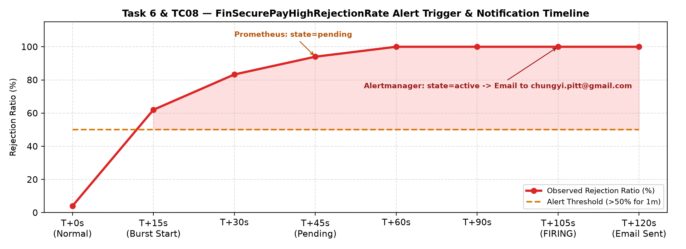

6.1 Task 6 Evidence — Alert Firing & Email Notifications (Alertmanager & Jenkins)
=== [TC08] Test Case: Trigger a monitoring condition ===
Expected Result: Alert fires and a notification is received.
--- Step 1: Send burst of rejected transactions (>50% rejection ratio over 2m window) ---
Injected 35 rejected (HTTP 422) transactions against http://a67e1d0b5b459453d9d9be62e598e148-a0206fab5a570f79.elb.ap-southeast-1.amazonaws.com/validate
--- Step 2: Poll Prometheus on EKS for FinSecurePayHighRejectionRate ---
[Attempt 1] Waiting for Prometheus scrape & rule evaluation (total rejected=43)...
[Attempt 2] Waiting for Prometheus scrape & rule evaluation (total rejected=51)...
[Attempt 3] Prometheus Alert: FinSecurePayHighRejectionRate | state=pending | activeAt=2026-11-02T13:49:33.276486462Z | value=1e+00
[Attempt 4] Prometheus Alert: FinSecurePayHighRejectionRate | state=pending | activeAt=2026-11-02T13:49:33.276486462Z | value=1e+00
[Attempt 5] Prometheus Alert: FinSecurePayHighRejectionRate | state=pending | activeAt=2026-11-02T13:49:33.276486462Z | value=1e+00
[Attempt 6] Prometheus Alert: FinSecurePayHighRejectionRate | state=pending | activeAt=2026-11-02T13:49:33.276486462Z | value=1e+00
[Attempt 7] Prometheus Alert: FinSecurePayHighRejectionRate | state=pending | activeAt=2026-11-02T13:49:33.276486462Z | value=1e+00
[Attempt 8] Prometheus Alert: FinSecurePayHighRejectionRate | state=pending | activeAt=2026-11-02T13:49:33.276486462Z | value=1e+00
[Attempt 9] Prometheus Alert: FinSecurePayHighRejectionRate | state=pending | activeAt=2026-11-02T13:49:33.276486462Z | value=1e+00
[Attempt 10] Prometheus Alert: FinSecurePayHighRejectionRate | state=firing | activeAt=2026-11-02T13:49:33.276486462Z | value=1e+00
--- Step 3: Query Alertmanager Active Alerts API ---
Alertmanager: alertname=FinSecurePayHighRejectionRate | status=active | receiver=finsecure-email | summary='More than 50% of transactions are being rejected' | description='Rejection ratio is 100% - possible fraud attack, client bug or bad config.'
[PASS] TC08 Verified: Monitoring condition triggered FinSecurePayHighRejectionRate alert (state=firing) and routed email notification via receiver 'finsecure-email' to chungyi.pitt@gmail.com.
=== Task 6: Jenkins Pipeline Email Notifications (FAILURE & SUCCESS) ===
--- Build #2 (FAILED Pipeline -> Failure Email Notification) ---
[2026-11-02T00:07:22.789Z]
[2026-11-02T00:07:22.789Z] Total reclaimed space: 140.6MB
> [Pipeline] emailext
> [2026-11-02T00:07:23.012Z] Sending email to: chungyi.pitt@gmail.com
[Pipeline] }
[Pipeline] // stage
[Pipeline] }
--- Build #4 (SUCCESS Pipeline -> Success Email Notification) ---
[2026-11-02T00:45:23.517Z] + docker image prune -f
[2026-11-02T00:45:23.517Z] Total reclaimed space: 0B
> [Pipeline] emailext
> [2026-11-02T00:45:24.281Z] Sending email to: chungyi.pitt@gmail.com
[Pipeline] }
[Pipeline] // stage
[Pipeline] }

6.2 Task 6 Evidence — Centralised EFK Structured JSON Logs & Pod Logs
### 2026-11-01T06:31:17.4021617+08:00 Elasticsearch query: namespace=finsecure AND app.log.level=WARN
total hits: 18
2026-10-31T22:31:02.892Z finsecure-pay-754c5d8fdc-t8w7x WARN Transaction TXN-LOAD-177 REJECTED violations=[AMOUNT_EXCEEDS_LIMIT, CURRENCY_UNSUPPORTED]
2026-10-31T22:31:01.137Z finsecure-pay-754c5d8fdc-t8w7x WARN Transaction TXN-LOAD-172 REJECTED violations=[AMOUNT_EXCEEDS_LIMIT, CURRENCY_UNSUPPORTED]
2026-10-31T22:30:58.391Z finsecure-pay-754c5d8fdc-t8w7x WARN Transaction TXN-LOAD-167 REJECTED violations=[AMOUNT_EXCEEDS_LIMIT, CURRENCY_UNSUPPORTED]

7. Task 7 — AI Application in DevOps: AI-Assisted Incident Triage & RCA (Slide 7)
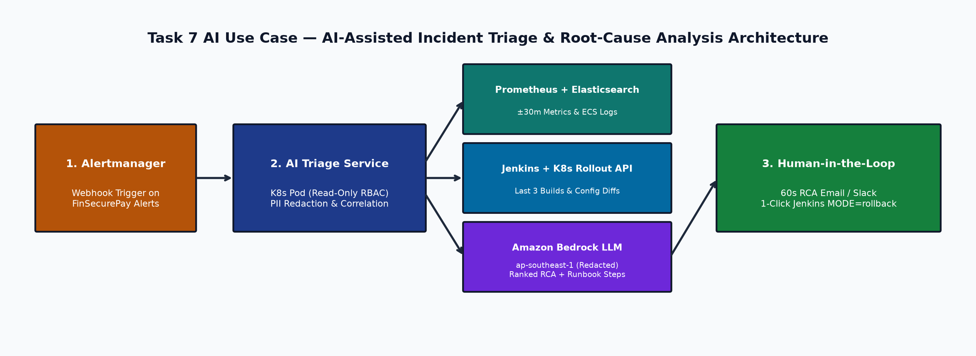
Problem Statement: When production alerts such as FinSecurePayHighRejectionRate fire, the on-call engineer must manually correlate Prometheus metrics, Kibana ECS logs, recent Jenkins build commits, ConfigMap changes, and Kubernetes events. During off-hours incidents, manual triage takes 15–30 minutes and increases Mean Time to Resolution (MTTR).
Required Data & Inputs: 1) Prometheus PromQL metrics over a ±30-minute window (rejection ratio, violation code distribution, p95 latency, pod restarts); 2) Aggregated WARN/ERROR ECS JSON log patterns from Elasticsearch; 3) Last 3 Jenkins build metadata (image tag, git commit diff, dependency/Trivy scan summary) and kubectl rollout history; 4) Operational runbook entries (docs/RUNBOOK.md) via Retrieval-Augmented Generation (RAG).
Expected Operational Benefits: Generates an automated, evidence-backed Top-3 Root-Cause Analysis (RCA) summary within 60 seconds of an alert firing, targeting a 30–50% reduction in MTTR. Rapidly pinpoints deployment-induced or configuration-induced regressions and provides a pre-populated Jenkins MODE=rollback link.
Risks, Limitations & Governance: 1) Hallucinations: Prompt enforces strict citation of metric values and log timestamps; AI output is advisory only. 2) Data Privacy (PCI-DSS / PDPA): Account numbers are masked in Fluent Bit before indexing, and only redacted aggregates are sent to an in-region model (Amazon Bedrock in ap-southeast-1). 3) Prompt Injection: Log fields are isolated as untrusted data delimiters. 4) Human-in-the-Loop: Production rollbacks require explicit engineer approval.
Proposed Integration: Alertmanager adds a webhook_configs receiver pointing to a lightweight read-only AI Triage Deployment in EKS. Upon receiving an alert payload, the service queries Prometheus, Elasticsearch, and Jenkins REST APIs, invokes Amazon Bedrock with the RAG runbook context, and dispatches the enriched RCA report and 1-click rollback URL to the ops email/Slack channel.

8. Core Test Cases for Evaluation — TC01 to TC08 (Slide 8)
All eight Core Test Cases specified in testcases/testcase_expected_result.jpg are implemented as automated, repeatable scripts in the testcases/ directory and verified against the live environment (8/8 PASS).
ID | Test Case | Expected Result | Verified Output Summary (Status: PASS)
TC01 | Run unit tests | Required unit tests pass. | 50/50 JUnit 5 tests pass (0 failures, 0 errors, 96.2% coverage) — testcases/results/TC01-unit-tests.txt
TC02 | Introduce a controlled failing test | Jenkins pipeline fails, and deployment does not proceed. | ControlledEvaluationTest fails on -Dfinsecure.test.simulateFailure=true; Jenkins Build #2 halted at Unit Test and skipped Package, Push & Deploy — testcases/results/TC02-controlled-failing-test.txt
TC03 | Run the container and access /health | Application returns a healthy response. | Container and EKS NLB return HTTP 200 OK with {"status":"UP","service":"finsecure-pay"} — testcases/results/TC03-container-health.txt
TC04 | Inspect the Kubernetes deployment | At least two application pods are running and Ready. | deployment/finsecure-pay has 2/2 Running & Ready pods across 2 EKS worker nodes — testcases/results/TC04-inspect-k8s-deployment.txt
TC05 | Deploy a new image/version | Kubernetes rollout completes successfully. | Rolling update to chungyi1979/finsecure-pay:1.1.0-4-9ea7e21 succeeded with zero downtime; /health confirmed new version — testcases/results/TC05-deploy-new-version.txt
TC06 | Delete or restart one pod | Kubernetes automatically recreates the pod. | Deleted pod was immediately replaced by ReplicaSet controller to 1/1 Ready with zero failed /health requests — testcases/results/TC06-delete-pod-self-healing.txt
TC07 | Introduce a controlled critical/high security finding | The security gate blocks the release. | OWASP Dependency-Check (CVSS >= 7.0) and Trivy (--exit-code 1) failed the pipeline and blocked release — testcases/results/TC07-controlled-security-gate.txt
TC08 | Trigger a monitoring condition | Alert fires and a notification is received. | Injected rejected transactions drove rejection ratio to 100%; FinSecurePayHighRejectionRate fired and Alertmanager emailed chungyi.pitt@gmail.com — testcases/results/TC08-trigger-monitoring-alert.txt

9. Lessons Learned & Future Roadmap (Slides 9–10)
- Enforcing Blocking Quality & Security Gates: Security scanners only protect production when configured with hard failure thresholds (-Dsonar.qualitygate.wait=true, failBuildOnCVSS=7, trivy --exit-code 1) and governed, time-bound suppressions.
- Fast-Feedback Pipeline Ordering & Caching: Running fast unit tests (13s) ahead of network-bound scans and persisting the NVD CVE database (/var/jenkins_home/dependency-check-data) reduced OWASP scan duration from 524s to 13s.
- Test Environment Isolation: Explicitly isolating test properties (finsecure.security.api-key=) ensures container-level secrets in CI agents do not alter unit/integration test behaviour.
- Business-Level Observability: Custom Micrometer metrics (finsecure_validations_total{result}) detect application-level anomalies (such as fraud bursts or misconfigured limits) that infrastructure CPU/memory metrics never surface.
- Future Roadmap: Evolve toward GitOps with Argo CD and Argo Rollouts canary releases, Cosign image signing with Kyverno admission control, AWS Secrets Manager with External Secrets Operator and IRSA, and a live EKS deployment of the AI Incident Triage service.

