Chapter 3: Methodology

3.1 Introduction
Chapter 2 reviewed the existing research and concluded with three research gaps. The first is the legal system gap, where most studies were conducted on United States case law and little research has applied retrieval-augmented generation to Malaysian statutory law. The second is the retrieval method gap, where almost all analysis of Southeast Asian statutory law was performed using a single retrieval method. The third is the verification gap, where only limited studies have validated the faithfulness of generated answers, which may be fluent but not faithful. The literature also identified the strategies used in this project: a hybrid retrieval method that merges the retrieved sections using Reciprocal Rank Fusion (RRF) followed by a cross-encoder reranker, and a citation verification layer that confirms every generated statement can be traced back to the retrieved sources. This chapter converts these design choices into a methodology.
The purpose of this chapter is to describe the design, implementation and evaluation of the proposed system so that the second, third and fourth objectives can be met. Objective O2 is addressed in Section 3.4, which explains the retrieval pipeline that obtains the relevant sections of Malaysian legislation for a question. Objective O3 is achieved in Section 3.5 through constrained answer generation and in Section 3.6 through the citation verification mechanism. Lastly, objective O4 is addressed in Section 3.7, which describes the evaluation that compares the full proposed pipeline against simpler retrieval methods using a self-built test set of Malaysian statutory questions.
The chapter is organised as follows. Section 3.2 introduces the overall architecture of the system. Section 3.3 explains the dataset preparation, including the selection of the Acts, the section-level chunking strategy and the extraction of cross-references. Section 3.4 describes the retrieval pipeline, including the expansion of retrieved sections with the sections they refer to, and Section 3.5 explains how answers are generated. Section 3.6 presents the citation verification mechanism and its failure handling, followed by Section 3.7 on the evaluation design, which covers the test set and the metrics for the retrieval, generation and verification components. Section 3.8 lists the tools used throughout the project and Section 3.9 discusses the ethical and practical considerations.

3.2 Overall System Architecture
This project uses the Design Science Research (DSR) approach, where an artefact is constructed to solve a specific problem and evaluated through measurable metrics to show that it actually solves the problem rather than simply claiming that it is useful. During evaluation, only the retrieval method is changed, while all other components, including cross-reference expansion, answer generation, citation verification and the evaluation dataset, stay the same. This decision answers research question RQ4, which asks whether the proposed retrieval and verification system produces more reliable output than a simpler RAG pipeline. It ensures that system performance is compared in a controlled environment, so that any difference can be attributed to the retrieval method. The pipeline developed and evaluated in this project is named LexRAG-MY: “Lex” means “law” in Latin and “MY” is the abbreviation for Malaysia, together representing RAG in the Malaysian legal domain.
The pipeline is divided into two stages. The offline stage (Stage 0) only needs to run once. Three Malaysian statutes, the Employment Act 1955, the Consumer Protection Act 1999 and the Personal Data Protection Act 2010, are downloaded from the Attorney General’s Chambers of Malaysia as PDF files and converted into clean text. The text is split so that each chunk holds one complete section, and each chunk is enriched with metadata, including the list of other sections it refers to. The chunks are then indexed twice, once for keyword retrieval and once for dense semantic retrieval.
The online stage is triggered each time a user asks a question. The plain English question passes through hybrid retrieval, where RRF fuses the keyword and semantic results and a reranker refines them, and the top-k most relevant sections are selected. These sections are then expanded with the sections they refer to, so that a provision that depends on another section is never explained without it. The LLM generates an answer strictly based on this context, written as a list of single-fact sentences, each citing one section and quoting the words that support it. Every sentence is verified through three checks before the answer is shown: a provenance check, a quote match check and a support check. If any sentence fails, the system regenerates the answer once with a stricter prompt and refuses to answer if it fails again, rather than presenting an unsupported answer. The full architecture is illustrated in Figure 3.1.
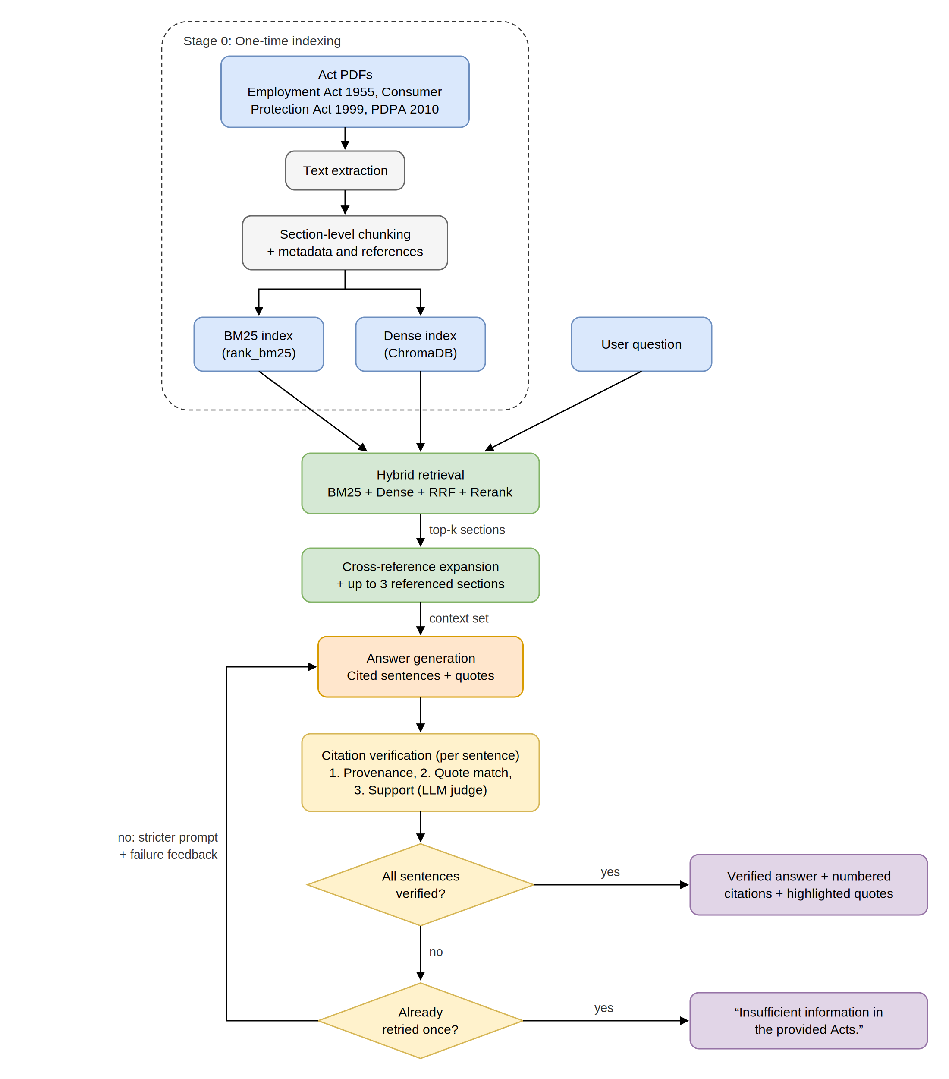
Figure 3.1 Full Architecture of LexRAG-MY
The architecture is modular: every component can be replaced or removed without rewriting the entire application, which aligns with the Modular RAG paradigm discussed in Section 2.3. Each component has its own input and output, so it can be replaced without affecting the flow of the pipeline. Although modularity generally allows a component to change without affecting the whole system, its main purpose in this project is to answer RQ4: the retrieval method must be swappable while all other components remain identical, so that the evaluation in Section 3.7 can be carried out under controlled conditions.
Several computing factors influenced the architecture design. In terms of performance, both retrieval indexes are built once and reused, as shown in Stage 0 of Figure 3.1, so the system searches existing indexes instead of reprocessing the documents each time a user asks a question. This gives faster responses and lower computational effort per question. From the usability perspective, LexRAG-MY is designed for Malaysian laypeople, allowing users to ask questions in natural English without understanding complex legal terminology, which addresses one of the problems in Section 1.2. For example, a user can simply ask “Can I get any refund for receiving a defective item?” rather than asking in legal language such as “What constitutes a false or misleading representation under the Consumer Protection Act 1999?” or “Please explain Section 32 of the Consumer Protection Act 1999”. For reliability and safety, every sentence shown to the user can be traced back to a section of the Acts and to a quoted passage within it, and no answer is produced when the system cannot find the evidence in the Acts. Regarding reproducibility, the exact version of each Act and the configuration of the system will be documented so that future researchers can rebuild the same system as a baseline for Malaysian statutory legal RAG.
LexRAG-MY operates in two modes that share the same pipeline. User mode is intended for end users, who ask a question and receive a natural language response in real time. Batch mode passes the full test set through the pipeline for evaluation and records metrics such as precision, recall and verification outcomes. The two operating modes are compared in Figure 3.2.
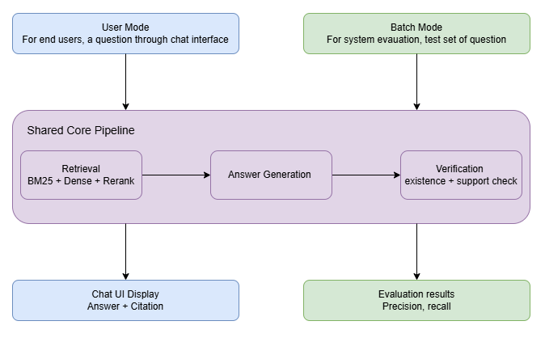
Figure 3.2 User Mode and Batch Mode with a Shared Core Pipeline

3.3 Dataset Preparation
As discussed in Section 2.3, the effectiveness of a RAG system depends heavily on retrieval quality, so dataset preparation is treated as a critical step rather than basic preprocessing. This section describes the three Malaysian Acts, the extraction process, the section-level chunking strategy and the extraction of cross-references between sections.

3.3.1 Source and Selection of Acts
The dataset consists of three Malaysian statutes enacted by the Malaysian Parliament: the Employment Act 1955 (Act 265), the Consumer Protection Act 1999 (Act 599) and the Personal Data Protection Act 2010 (Act 709). All three documents are publicly accessible and can be viewed and downloaded from the Attorney General’s Chambers of Malaysia at https://www.agc.gov.my/. Using the official source rather than third-party platforms ensures that the statutory documents are original, accurate and up to date, which serves the main purpose of the system: providing users with reliable answers.
Only three Acts are selected instead of the whole corpus of Malaysian legislation. This allows the cleaning process and the construction of the test set, which both require substantial manual effort, to be completed within the proposed timeline. The three Acts were chosen because they govern matters that ordinary Malaysians face in daily life: their rights as employees, their rights as consumers, and how organisations may collect and use their personal data. Covering three different areas of law allows the system to answer a wide range of questions without requiring a large number of documents. The Personal Data Protection Act 2010 also contains many provisions that refer to other sections of the same Act, which makes it a suitable test of the cross-reference expansion described in Section 3.4.5. All three documents are statutory law rather than case law, and their structure of parts and sections suits section-based retrieval. The version of each Act and its download date will be documented, because the Acts may be amended and differ between versions. This ensures reproducibility, keeping the test set consistent with the exact version of the indexed text.

3.3.2 PDF Parsing and Chunking
The three documents are published as PDF files, so their text must be extracted before it can be split into sections. Text extraction is performed using PyMuPDF, a Python library that reads documents page by page for extracting and manipulating PDF content. Since some extracted output is not part of the legal content, such as headers and page numbers, a further cleaning step keeps only the actual content of the Acts. Cleaning is based on the consistent layout of the documents and will be checked manually for accuracy.
While text extraction is necessary, the decision on how to split the cleaned text into chunks is the most important decision in this stage, because the chunks are the context for the retrieval, generation and verification stages. Instead of splitting text into fixed-size chunks as a general-purpose RAG system would, the text is split according to the structure of the Acts: each chunk holds one complete section, including all of its subsections and paragraphs, and is identified by its section number. Section-level chunking is adopted because each section of a Malaysian statute is a complete unit of legal information. Its subsections often depend on each other, for example when one subsection states an entitlement and a later subsection states its exceptions, so splitting a section would risk retrieving a rule without its conditions. Fixed-length window chunking has the same weakness and would also produce chunks that do not match any citable unit of the Act, leading to poor citation quality. Figure 3.3 illustrates how a section becomes a chunk.
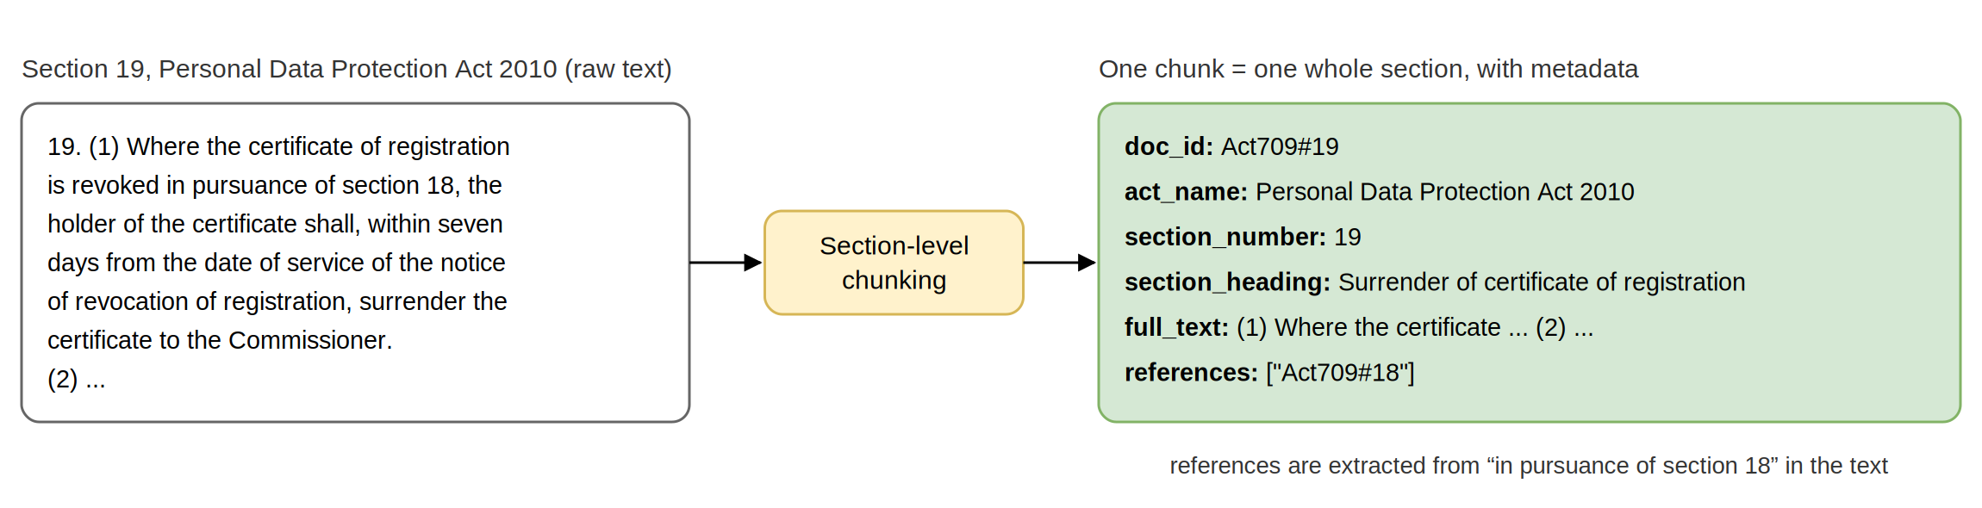
Figure 3.3 Example of Section-Level Chunking using the Personal Data Protection Act 2010
Statutory sections frequently depend on other sections. For example, section 19(1) of the Personal Data Protection Act 2010 requires the holder of a certificate of registration that is revoked “in pursuance of section 18” to surrender it within seven days, while the conditions for revocation are stated in section 18 itself. To capture these dependencies, the references in each section are extracted during Stage 0 using pattern matching on phrases such as “section 18” or “sections 12 and 13”. Each reference is resolved to the identifier of the referenced section in the same Act and stored with the chunk. References to other Acts, such as “section 5 of the Industrial Relations Act 1967”, are ignored, because those sections are not part of the corpus.
Each chunk is stored with the metadata summarised in Table 3.1. The doc_id combines the Act number and the section number into a unique identifier that the generator uses for citation. The metadata ensures that each generated sentence can be traced back to its source, allows the verification stage to confirm that a cited section was among the sections given to the generator, and allows the retrieval stage to add the sections that a retrieved section refers to. In addition, the list of all section identifiers in the three Acts is kept, so that the verification stage can tell whether an incorrect citation refers to a real section or to one that does not exist (Section 3.6).
Field | Description | Example
doc_id | Unique identifier combining the Act number and section number, used for citation | Act709#19
act_name | The name of the Act | Personal Data Protection Act 2010
section_number | The section number within the Act | 19
section_heading | The heading of the section | Surrender of certificate of registration
full_text | Full text of the section, including all subsections | (1) Where the certificate of registration is revoked in pursuance of section 18, …
references | Sections of the same Act that this section refers to | [“Act709#18”]
Table 3.1 Metadata for Statutory Chunks

3.4 Retrieval Pipeline
The retrieval pipeline addresses objective O2: designing a retrieval approach that accurately retrieves the relevant sections for questions phrased in non-technical English. As discussed in Section 2.5, the two retrieval methods are complementary rather than direct substitutes. Sparse retrieval captures exact legal terms and identifiers but fails to match questions asked in plain language. Dense semantic retrieval solves this by capturing the meaning of a sentence but may overlook technical terms or unique phrases. LexRAG-MY combines both methods using RRF, refines the result with a reranker, and finally expands the selected sections with the sections they refer to. The full pipeline, together with the three other retrieval configurations used to answer RQ4, is shown in Figure 3.4.
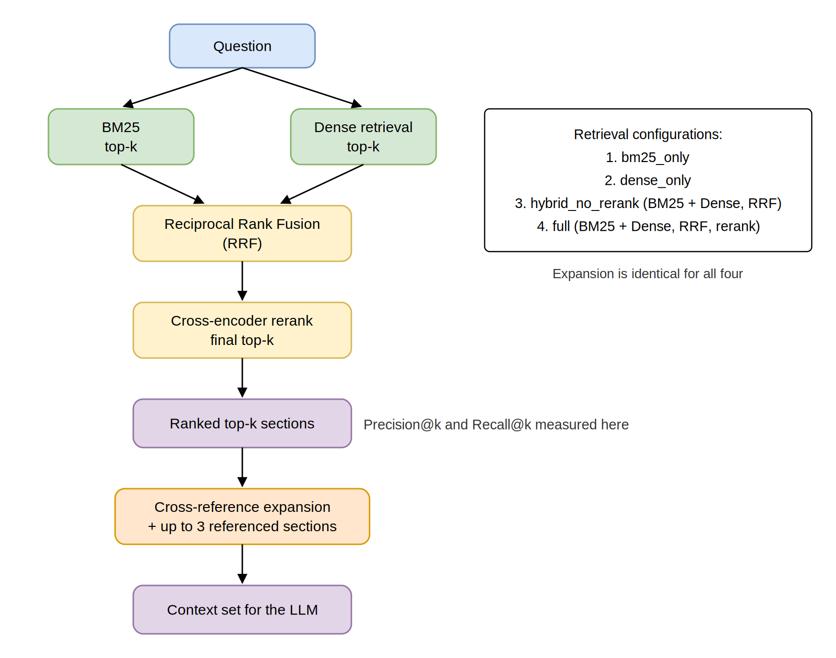
Figure 3.4 Hybrid Retrieval Pipeline with Cross-Reference Expansion
The pipeline supports four retrieval configurations so that each stage can be evaluated and measured. The bm25_only configuration uses only sparse keyword search, while dense_only uses only semantic search. The hybrid_no_rerank configuration combines both methods and merges their results into a single ranked list through Reciprocal Rank Fusion. The full configuration, the proposed system, extends hybrid_no_rerank by adding a reranker before the final top-k sections are selected. Each configuration returns a list of top-k sections, which is then passed through the same cross-reference expansion step before being given to the LLM as context.

3.4.1 Sparse Retrieval
Sparse retrieval is implemented with the rank_bm25 Python library. The relevance score is based on three factors. Term Frequency (TF) counts how often a query term appears in a chunk, Inverse Document Frequency (IDF) gives uncommon terms higher weight to reduce the influence of common terms, and length normalisation ensures that longer chunks do not gain an advantage simply because they contain more words. These characteristics make sparse retrieval effective at capturing sections that rely on exact wording such as “Section 32(1)”, which semantic retrieval might treat as a number with embedded meaning or confuse with similar-looking numbers. The full text of each chunk is tokenised once and added to the BM25 index during Stage 0 (Figure 3.1), whereas the question is tokenised during the online stage, scored against all chunks, and the most relevant chunks are returned. Despite its weakness in semantic matching, BM25 provides exactly the complementary strength discussed in Section 2.5, where dense retrieval may miss technical legal terms or rare phrases.

3.4.2 Dense Retrieval
Dense retrieval is used to capture the meaning of a question even when it shares no exact wording with the statutory text. Each chunk is converted into a numerical vector through an embedding model, so chunks with similar meanings lie close to each other even when no words match. The embeddings are computed once during the offline stage and stored in ChromaDB, an open-source vector database. When a user asks a question, the question is converted into an embedding with the same model, and the top-k chunks whose vectors are closest to it by cosine similarity are returned. This allows the system to retrieve the correct section even when the user’s wording differs from the legal text. Because external embedding APIs charge per chunk and add network latency to every indexing run, the embeddings are generated with a local model and stored locally in ChromaDB.

3.4.3 Hybrid Fusion (Reciprocal Rank Fusion)
Once sparse and dense retrieval each produce a top-k ranked list, the lists are merged into a single ranking using Reciprocal Rank Fusion (RRF), introduced in Section 2.5. For each chunk, RRF calculates a combined score with the formula below, so chunks that consistently rank highly in both lists receive a higher score.
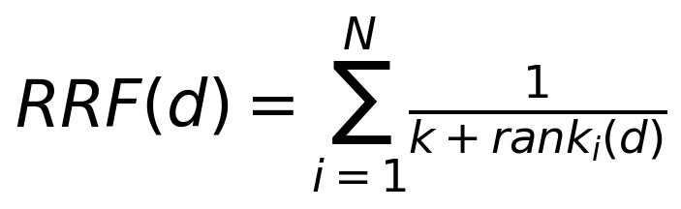
Where N is the number of retrieval systems, rank_i(d) is the rank of chunk d in list i, and k is a constant (commonly 60).
RRF is chosen over other fusion techniques because it works well with very different types of retrievers. BM25 and dense retrieval produce relevance scores on different scales that cannot simply be added. RRF ignores the scores and only considers ranking positions, avoiding the need to calibrate scores onto a common scale. It is also a fixed mathematical rule that requires no training data, which suits this project given the lack of labelled question datasets for Malaysian statutory law.

3.4.4 Reranking (Cross-Encoder)
While fusion combines the retrieval methods into a single ranked list using a mathematical rule, the ordering can be further sharpened in a reranking stage. The top candidates from fusion are passed to a cross-encoder reranker, which reads the question and each chunk as a pair and produces a relevance score for each pair. Because the reranker compares each chunk directly with the question, it can produce a more accurate ranking than RRF. However, it increases computational cost, since every question and chunk pair must be scored. The “retrieve then rerank” approach discussed in Section 2.5 is therefore adopted: only a small set of candidates passes through reranking rather than all chunks, which is why the reranker is placed after hybrid retrieval rather than used as the primary retriever.
Section 2.5 also questioned the accuracy of rerankers trained on open-domain data, whose effectiveness does not automatically transfer to the Malaysian legal context. This project therefore does not assume that a reranker improves a Malaysian statutory RAG system. Instead, it treats the reranker as one candidate architecture to be compared against the other retrieval configurations, addressing objective O4.

3.4.5 Cross-Reference Expansion
Statutory provisions are often incomplete on their own. A section that refers to another section, such as section 19 of the Personal Data Protection Act 2010 referring to section 18, can only be explained correctly if the referenced section is also available. Retrieval does not guarantee this, because the referenced section may use different wording from the question and therefore rank low. Without it, the generator would either explain only half of the rule or fill the gap from its training knowledge, which is exactly the behaviour this project aims to prevent.
Cross-reference expansion closes this gap. After the top-k sections have been selected, the system reads the references field of each selected section (Section 3.3.2) and adds the referenced sections to the context. Three rules keep the expansion controlled. First, references are followed one level deep only: the sections referred to by a top-k section are added, but the sections they in turn refer to are not, because following references further would quickly add large parts of the Act and dilute the context. Second, at most three sections are added per question, which limits the additional prompt length and cost. Third, a section already present in the top-k is not added again. The result is the context set, which consists of the top-k sections plus the expanded sections, and each expanded section is labelled in the prompt with the section that referred to it.
The expansion step is identical for all four retrieval configurations, so it does not change the independent variable of the evaluation. Retrieval metrics are calculated on the top-k sections before expansion (Section 3.7.2), so they measure the retrieval methods alone. The share of cited sections that came from expansion is reported separately, showing how often answers depend on a cross-referenced section (Section 3.7.4).

3.5 Answer Generation
After the context set has been assembled, it is passed to a large language model (LLM) that explains the sections in plain, non-technical language. The answer must allow the user to check every statement against the statutory text, which addresses objective O3 by preventing hallucinated answers. The generator is Claude, accessed through the Anthropic API, with the temperature set to 0 so that repeated runs during evaluation produce outputs that are as consistent as possible. The model’s output is constrained so that it only explains what the provided sections state, rather than adding assumptions from its training knowledge.

3.5.1 Prompt Design and Context Constraint
The context set is assembled into a single prompt under a set of instructions that keep the answer grounded in the context. The prompt follows the RACE prompting framework, which consists of Role, Action, Context and Expectation. Role specifies that the model acts as a legal information assistant for Malaysian statutes. Action states exactly what the model must do and sets its scope and constraints: explain the provided sections in plain English, use no outside knowledge, and give no advice about the user’s personal situation. Context supplies the sections, each labelled with its doc_id, Act name, section number and heading, and with the section that referred to it if it was added by cross-reference expansion. This shifts the question from “what is the AI expected to do” to “what material is the AI given”. Expectation defines the exact shape of the output, described in Section 3.5.2.
The Expectation component sets four rules. First, the answer is written as a list of sentences, each stating a single fact. Second, each sentence cites exactly one section by its doc_id. An answer may draw on as many sections as the question needs, but a fact that depends on two sections is written as two sentences. Third, each sentence carries a verbatim quote copied from the cited section that supports it. Fourth, any part of the question that the sections do not cover is listed separately as a short topic phrase, without stating any facts about it. If none of the question is covered, the sentence list is left empty. Section numbers are not written inside the sentence text, because the system attaches the citations itself when the answer is displayed (Section 3.5.2).
These rules narrow the model’s task to three things: understanding the user’s question, translating the relevant legal text into plain language, and pointing to the exact words that justify each translated sentence. The model does not reason about the user’s personal scenario; it only explains what the relevant sections state, keeping the system within a safe boundary. Two versions of the prompt are prepared: an initial prompt for the first attempt and a stricter prompt used only when verification fails (Table 3.3, Section 3.6).

3.5.2 Structured Output and Citation Generation
The model returns its answer in a structured form rather than free text. The output is requested through a forced tool call: the API request defines a single tool, record_answer, with a strict input schema, and requires the model to call that tool instead of replying in free text. The schema has two fields. sentences is a list in which each item holds text (one plain-language sentence), cited_doc_id (the identifier of the one section it relies on) and quote (the verbatim supporting passage from that section). not_covered is a list of short topic phrases from the question that the provided sections do not address. An illustrative output for the question “I have worked at my company for three years. How much annual leave and sick leave do I get?” is shown below. The answer draws on two sections, each sentence citing the one it relies on (quotes shortened).
{
"sentences": [
{
"text": "An employee with two years or more, but less than five years, of service with the same employer is entitled to 12 days of paid annual leave for every 12 months of continuous service.",
"cited_doc_id": "Act265#60E",
"quote": "twelve days for every twelve months of continuous service ... two years or more but less than five years"
},
{
"text": "An employee with two years or more, but less than five years, of service is entitled to 18 days of paid sick leave in each calendar year when no hospitalisation is needed.",
"cited_doc_id": "Act265#60F",
"quote": "eighteen days in the aggregate in each calendar year if the employee has been employed for two years or more but less than five years"
}
],
"not_covered": []
}
Making the sentences themselves the unit of verification means that the text the user reads is exactly the text that is verified, word for word. A design that returns a free-text answer together with a separate list of claims would verify only the claims while the user reads the paragraph, so a sentence in the paragraph could drift from the verified claim it refers to. Because each sentence is already linked to one section and one quote, the verifier can check it directly, without first splitting free text into claims and searching for their sources.
The structured output is checked by a rule-based schema checker before verification. The checker confirms that the response was not cut off by the output token limit, that a record_answer call exists, that every field has the correct type, that each sentence has non-empty text, a cited_doc_id and a quote of at least five words, and that the output is not empty overall (it contains at least one sentence or at least one uncovered topic). If the check fails, the request is sent once more with an added reminder to follow the schema. If it fails again, the system displays “Unable to generate a verified response.” with the status generation_error. If the output is valid but contains no sentences and only uncovered topics, the system displays “Insufficient information in the provided Acts.” with the status insufficient_info, and verification is skipped. Otherwise, the sentences proceed to the citation verification mechanism in Section 3.6.
When an answer passes verification, the system assembles the displayed answer itself rather than showing a paragraph written by the model. The verified sentences are joined in order and the system adds a numbered marker, such as [1] or [2], after each sentence. Below the answer, an expandable source panel lists each cited section with its quoted passage highlighted, so the user can confirm every sentence against the Act without reading the whole document. If the output also lists uncovered topics, the system adds a fixed line after the answer: “The provided Acts do not cover:” followed by the topic phrases. The only text on screen that is not verified is therefore a list of topic names in a fixed template, with no legal statements in it.

3.6 Citation Verification Mechanism
The citation verification mechanism achieves objective O3 and is what moves LexRAG-MY from a Naive RAG design to a Modular RAG pipeline. Its role is to ensure that every sentence shown to the user can be genuinely traced back to a section of the Acts, so that users receive answers they can check against the source rather than believing them because they sound authoritative. Section 2.6 explained why this is necessary: a citation may look relevant to a generated statement while the statement is not actually derived from it. Section 2.6 also showed that techniques requiring access to a model’s internals, such as MIRAGE, are not suitable here, because LexRAG-MY uses a closed-source model through an external API. The verifier therefore compares each generated sentence with the statutory text directly.
The mechanism checks every sentence in three steps, ordered from the most objective to the one that needs judgement. The first two checks are rule-based and the third uses an LLM as a judge. This order is deliberate. Because the retrieval method is the only independent variable in the evaluation (Section 3.7.6), the verifier must behave identically across all four retrieval configurations. Rule-based checks give the same result for the same input every time, so the less the mechanism depends on model judgement, the more confidently any difference in verification outcomes can be attributed to retrieval rather than to the verifier. The full mechanism and its failure handling are shown in Figure 3.5.
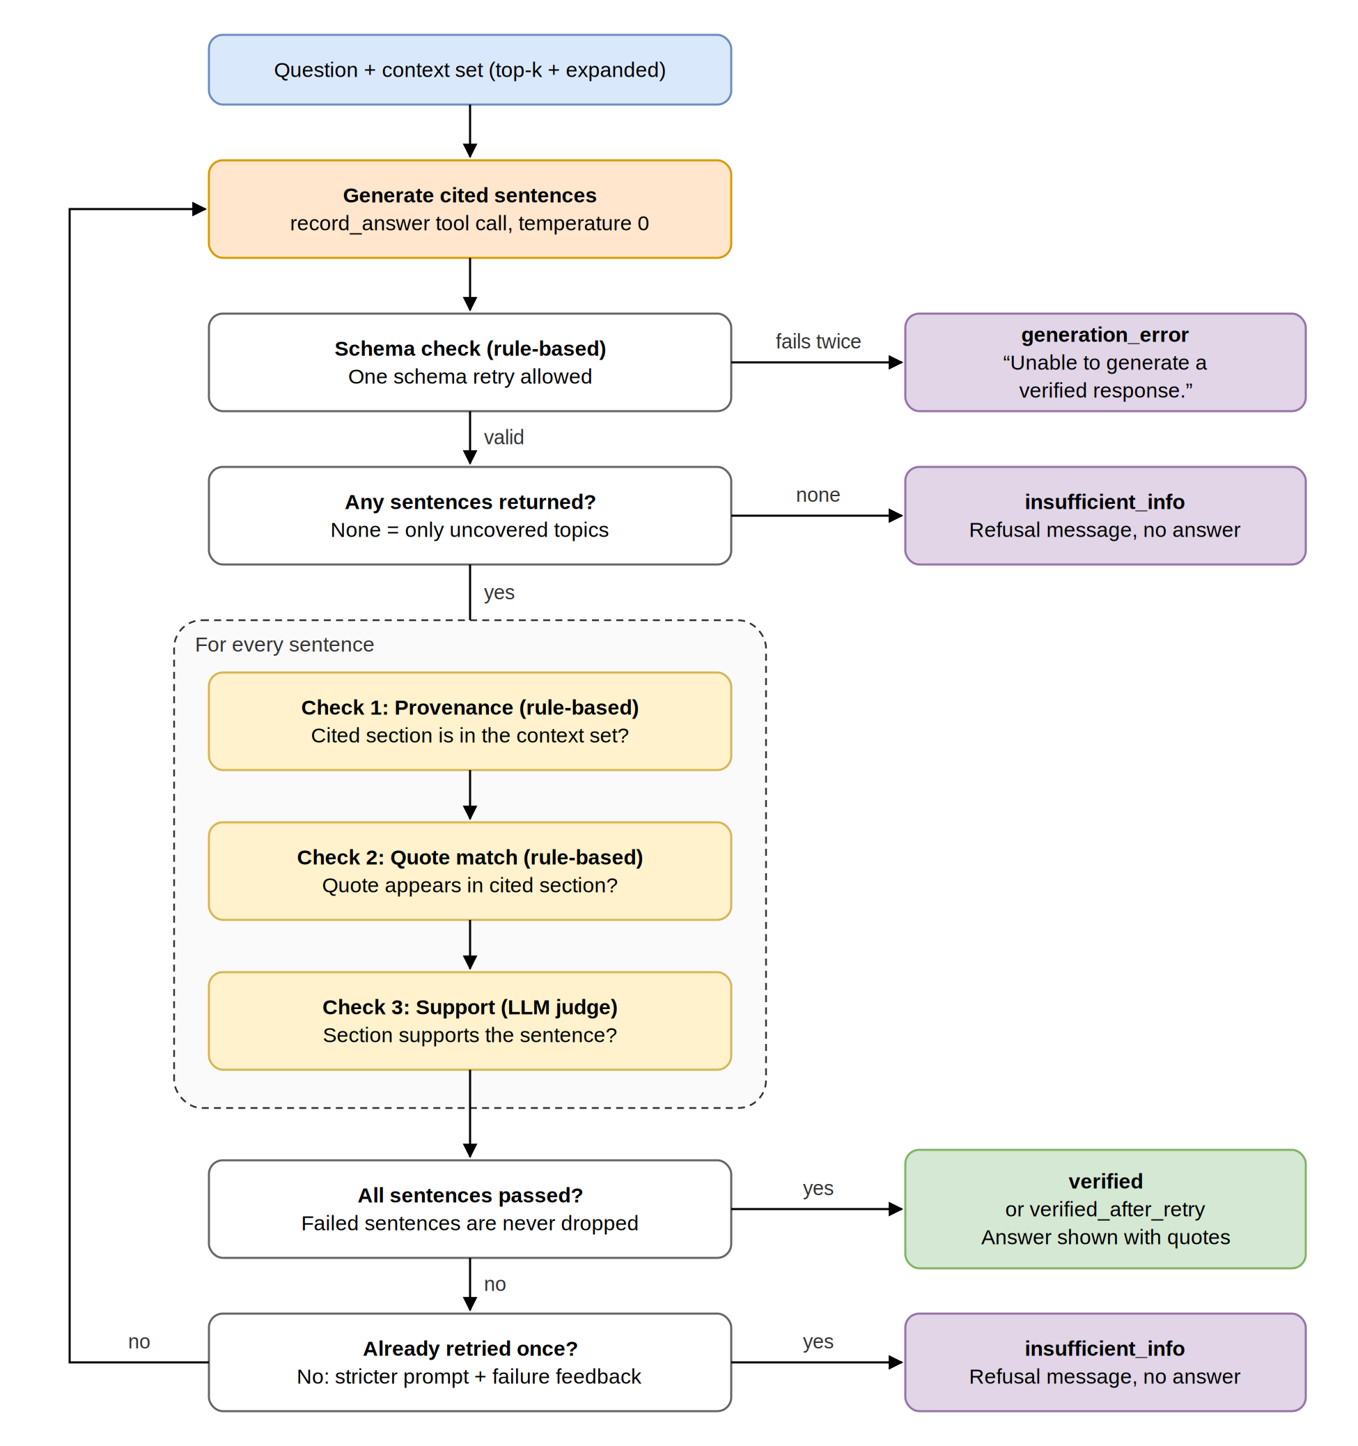
Figure 3.5 Citation Verification and Retry Flow
Check 1: Provenance check (rule-based). This check confirms that the section a sentence cites was actually part of the context set given to the generator, that is, either one of the top-k retrieved sections or one of the sections added by cross-reference expansion. For a sentence that passes, the check records whether the cited section came from retrieval or from expansion. If the cited section is not in the context set, the sentence fails, because the model has either invented the identifier or relied on a section it was never shown. The failure reason is recorded using the list of all section identifiers kept in Stage 0: not_retrieved when the section exists in the Acts but was not in the context set, meaning the model drew on its training memory, and nonexistent when no such section exists, meaning the citation was invented. Recording the two reasons separately allows the evaluation to report which kind of citation error occurs.
Check 2: Quote match check (rule-based). This check confirms that the quoted evidence really appears in the cited section. Both the quote and the section text are normalised (lowercased, whitespace collapsed, and quotation marks and dashes unified), after which the quote must appear in the section as an exact substring. To tolerate small differences introduced by PDF extraction, such as broken lines or hyphenation, a quote that is not an exact match is accepted if its fuzzy partial-match similarity, computed with the RapidFuzz library, is at least 90 out of 100. Quotes shorter than five words are rejected, so that a trivial phrase cannot pass as evidence. A sentence whose quote fails this check is treated as resting on fabricated or altered evidence.
Check 3: Support check (LLM as judge). This check asks whether the cited section actually supports the plain-language sentence. The judge receives only the sentence and the full text of the cited section with the quoted passage marked inside it. It does not receive the user’s question or the other sentences, so that it cannot be influenced by what the answer is trying to achieve and can only compare one sentence with one source. The judge is asked whether the section, including any conditions or exceptions it states, fully supports the sentence, and returns a structured verdict of supported or not_supported with a one-line reason. It runs at temperature 0 and uses the same forced tool call approach as the generator, so its output can always be parsed. Showing the whole section rather than the quote alone matters because a quote can be accurate yet incomplete. For example, a sentence stating that employees are entitled to 16 days of annual leave may quote those words correctly while omitting the condition that this only applies after five years of service. Because the judge compares one sentence with one section and a marked passage, its task is narrow and consistent. Its accuracy is validated separately against human labels (Section 3.7.5). Table 3.2 compares the three checks.
Aspect | Provenance check | Quote match check | Support check
Question answered | Was the cited section given to the model? | Do the quoted words appear in that section? | Does the section support what the sentence says?
Type of check | Rule-based | Rule-based (with fuzzy tolerance) | LLM as judge
Input | cited_doc_id, identifiers in the context set | Quote, cited section text | Sentence, cited section with quote marked
Risk addressed | Citation hallucination | Fabricated or altered evidence | Unfaithful paraphrase, missing conditions
Outcome recorded | Pass (retrieved or expanded), not_retrieved, nonexistent | Pass, fail | supported, not_supported with reason
Table 3.2 Comparison of the Three Verification Checks
Failure handling is designed so that an unverified answer is never displayed. An answer passes only if every one of its sentences passes all three checks. Failed sentences are not silently removed, because the remaining sentences could then read as a complete answer when an important part is missing. If any sentence fails, the system regenerates the answer once using the stricter prompt. The stricter prompt includes feedback naming each failed sentence and the reason it failed (for example, “Sentence 2 was not supported by Act265#60E”) and instructs the model to move content it cannot support into the uncovered topics list rather than rephrasing it. This gives the model an honest alternative to guessing: on retry it can return a correct partial answer that openly names what the Acts do not cover. The regenerated output passes through the schema check and all three verification checks again. Table 3.3 compares the initial and stricter prompts.
Aspect | Initial prompt | Stricter prompt (regeneration)
Main instruction | Explain the provided sections in plain English, one fact per sentence, with one citation and one supporting quote each | Explain only information explicitly stated in the sections; every sentence must be directly supported by its quote
Feedback included | None | Each failed sentence, its cited section and the check it failed
Unsupported content | List topics the sections do not cover | Move any content that failed verification into the uncovered topics list instead of rephrasing it
Goal | A helpful, natural answer fully grounded in the sections | An answer, possibly partial, in which every sentence is verifiable
When used | First generation | Only if any sentence of the first generation fails a check
Table 3.3 Comparison of Initial and Stricter Generation Prompts
Every question ends with exactly one of four statuses:
- verified: all sentences passed all three checks on the first attempt; the answer is shown with its citations.
- verified_after_retry: the first attempt failed, and all sentences of the regenerated answer passed; the answer is shown with its citations.
- insufficient_info: the model reported that the sections do not cover the question, or the regenerated answer still failed verification; the system displays “Insufficient information in the provided Acts.” and no answer.
- generation_error: the output failed the schema check twice; the system displays “Unable to generate a verified response.” and no answer.
Separating generation_error from insufficient_info ensures that a technical failure is never counted as a correct refusal during evaluation. LexRAG-MY allows only a single regeneration, which balances answer coverage against safety: the model receives one further opportunity to produce a faithful answer, but the system cannot keep retrying until an unsupported answer happens to pass.

3.7 Evaluation Design
The evaluation addresses objective O4 by measuring how well the system retrieves the correct sections and produces faithful, verifiable answers, rather than assuming that a RAG system reduces hallucination. It compares the full proposed pipeline with simpler baselines using a self-built Malaysian statutory test set across the four retrieval configurations defined in Section 3.4. Three groups of metrics are collected for each configuration: retrieval metrics, generation metrics and citation verification metrics. The verifier itself is also validated against human labels, because its decisions determine which answers reach the user. The full evaluation flow is illustrated in Figure 3.6.
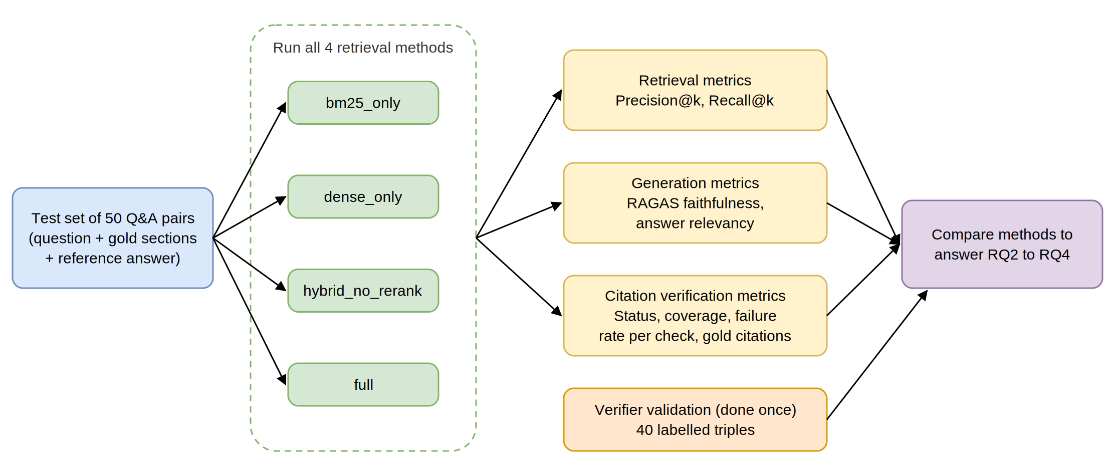
Figure 3.6 Evaluation Design

3.7.1 Test Set Construction
Since no benchmark exists for Malaysian statutory question answering, a test set is created specifically for this project. It consists of 50 question and answer pairs drawn from the Employment Act 1955, the Consumer Protection Act 1999 and the Personal Data Protection Act 2010. Each pair includes a question, the section or sections that answer it (the gold sections), and a reference answer written from those sections. Four types of questions test the system’s ability to handle different information needs. Exact term questions use legal wording or section numbers, which sparse retrieval is expected to handle well. Paraphrased questions use everyday language and are expected to suit semantic retrieval. Distractor questions contain keywords that also appear in incorrect sections, testing the precision of the reranking stage. Out-of-scope questions check that LexRAG-MY refuses to answer rather than producing a hallucinated answer when no relevant section exists.
The 42 in-scope questions are spread evenly across the three Acts, about 14 per Act, and across different parts of each Act to avoid concentrating on a single topic. Some questions require a single section while others require more than one, so that the metrics reflect a range of difficulty. At least six of the twelve multiple-section questions are answerable only with a section that is reached through a cross-reference, so that the contribution of cross-reference expansion can be observed. The distribution of questions is shown in Table 3.4. As stated in Section 1.5, the test set only includes questions with a single objectively correct answer, to keep answers consistent and avoid legal bias. Each pair is checked against the actual text of the Act to confirm that the gold sections genuinely answer the question before it is included.
Type | Single section | Multiple sections | Total
Exact term | 9 | 3 | 12
Paraphrase | 12 | 6 | 18
Distractor | 9 | 3 | 12
Out of scope | 8 (no section) | - | 8
Total | 38 | 12 | 50
Table 3.4 Distribution of Question Type and Section Count

3.7.2 Retrieval Metrics (Precision@k and Recall@k)
Retrieval quality is measured with Precision@k and Recall@k, which compare the retrieved sections with the gold sections of the test set. Both metrics are calculated on the top-k sections returned by the retrieval configuration, before cross-reference expansion, so that they measure the retrieval methods alone. Precision@k is the number of gold sections in the top-k results divided by k, capturing how many irrelevant sections are passed to the LLM. Recall@k is the number of gold sections in the top-k results divided by the total number of gold sections, capturing whether the retrieval strategy surfaces the sections the answer depends on. High recall is especially important for this system, because the generated answer can only be built from the sections in the context. Both metrics are computed for k = 1, 3, 5 and 10 on the 42 in-scope questions to examine the balance between retrieving too little information and passing unnecessary context. These metrics answer research question RQ2 by identifying which retrieval pipeline most accurately locates statutory sections for plain-language questions.

3.7.3 Generation Metrics (RAGAS)
Retrieval metrics alone do not show whether the generated answer is faithful to the context. Generation quality is therefore measured with the RAGAS framework introduced in Section 2.6. RAGAS faithfulness decomposes an answer into individual claims and checks each against the context, producing a score from 0 to 1 without requiring reference answers. It is computed on the final displayed answer of every in-scope question that ends as verified or verified_after_retry. Because RAGAS uses its own claim decomposition and its own judging prompts, it acts as an independent check on the answers that the verifier of LexRAG-MY has already accepted. RAGAS answer relevancy is also recorded for the same answers. The support check confirms that each sentence is true to its source, but not that the answer actually responds to the question, so answer relevancy covers this remaining gap. Together, these scores address research question RQ3.

3.7.4 Citation Verification Metrics
The outcomes of the verification mechanism are recorded for every question in every retrieval configuration, because the quality of retrieval directly affects how often answers can be verified. Weaker retrieval is expected to produce more uncovered topics, more failed checks and more regenerations. The following metrics are collected.
- Status distribution: the share of the 42 in-scope questions ending in each of the four statuses (Section 3.6), and the share of the 8 out-of-scope questions correctly refused with insufficient_info.
- Answer coverage: the share of in-scope questions that end with a displayed answer (verified or verified_after_retry).
- Failure rate per check: across all sentences of first-attempt answers, the share failing the provenance check (split into not_retrieved and nonexistent), the quote match check and the support check.
- Gold citation rate: the share of cited sections in displayed answers that are among the gold sections of the question, showing whether the system cites the sections a human expert would cite.
- Expansion share: the share of cited sections in displayed answers that entered the context through cross-reference expansion, showing how often answers depend on a referenced section.
These metrics also connect to the citation recall and precision discussed in Section 2.6.1. By design, every displayed sentence carries a citation, so the citation recall of displayed answers is complete. Citation precision corresponds to the share of first-attempt sentences that pass the support check, which is reported as part of the failure rate per check.

3.7.5 Verifier Validation
The verifier acts as the final gate that decides which answers reach the user, so its own accuracy must be established; an unreliable verifier would undermine the purpose of building a reliable RAG system. The two rule-based checks are deterministic and are validated with unit tests on constructed cases, such as a citation to a section outside the context set, a quote with altered wording, and a quote differing only by a line break. The support check is validated against human labels using a set of 40 triples, each consisting of a sentence, its cited section and its quote, whose quotes pass the quote match check. Twenty triples are sampled from first-attempt outputs of the batch run across the four configurations. The other twenty are deliberately altered copies of correct sentences, in which a number, a condition, a party or a negation is changed while the quote stays the same, ensuring that the set contains enough unsupported cases. The author labels every triple as supported or not supported by reading the cited section of the Act. Where possible, a second labeller independently labels 15 of the triples, and the agreement between the two labellers is reported.
The judge’s verdicts are compared with the human labels in a confusion matrix. Because the purpose of the support check is to catch unsupported sentences, “not supported” is treated as the positive class. True Positives (TP) are unsupported sentences the judge rejects, True Negatives (TN) are supported sentences it accepts, False Positives (FP) are supported sentences it wrongly rejects, and False Negatives (FN) are unsupported sentences it wrongly accepts. The agreement rate, precision and recall are calculated as follows.
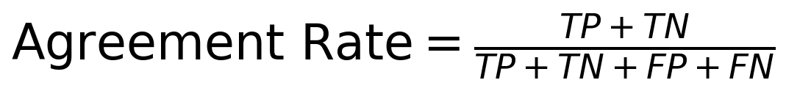
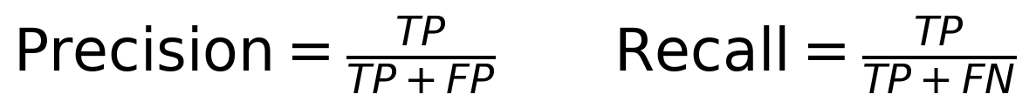
Recall is the most important of the three for this system: a false negative is an unsupported sentence that would be shown to the user, while a false positive only causes an unnecessary regeneration or refusal. To check consistency, the judge is also run three times on the same 40 triples, and the share of triples receiving the same verdict in all three runs is reported. This validation is carried out once rather than per retrieval configuration, so it does not interfere with the main comparison. The detailed evaluation templates are shown in Appendix 1.

3.7.6 Baseline Comparison
The main part of the evaluation compares the four retrieval strategies to answer research question RQ4, using the same test set, the same cross-reference expansion, the same generation stage and the same verification mechanism. Only the retrieval strategy is treated as the independent variable, so the contribution of each retriever can be evaluated fairly. Comparing bm25_only and dense_only against hybrid_no_rerank shows whether Naive RAG can match Advanced RAG in the Malaysian statutory setting. Comparing hybrid_no_rerank with the full configuration shows whether the reranker adds value in retrieving accurate sections. Although a reranker can reorder sections to improve retrieval quality, this benefit should not be assumed to transfer to the legal setting, as highlighted in Section 2.5. Because the verifier is held constant and its rule-based checks behave identically across runs, differences in the verification metrics can also be attributed to the retrieval strategy. Table 3.5 summarises the metrics collected for each retrieval strategy.
Retrieval method | Retrieval stages used | Retrieval metrics | Generation metrics | Verification metrics
bm25_only | BM25 only | Precision@k, Recall@k | RAGAS faithfulness, answer relevancy | Status distribution, answer coverage, failure rate per check, gold citation rate, expansion share
dense_only | Dense only | Precision@k, Recall@k | RAGAS faithfulness, answer relevancy | Status distribution, answer coverage, failure rate per check, gold citation rate, expansion share
hybrid_no_rerank | BM25 + Dense + RRF | Precision@k, Recall@k | RAGAS faithfulness, answer relevancy | Status distribution, answer coverage, failure rate per check, gold citation rate, expansion share
full (proposed) | BM25 + Dense + RRF + rerank | Precision@k, Recall@k | RAGAS faithfulness, answer relevancy | Status distribution, answer coverage, failure rate per check, gold citation rate, expansion share
Table 3.5 Summary of the Four Retrieval Approaches and the Evaluation Metrics

3.8 Tools and Technologies
The system is implemented in Python because of its wide range of libraries for retrieval and evaluation, which reduces the need to code from scratch, and its support for integrating external LLM APIs. Tools that run locally and free of charge are prioritised where possible, given the cost constraints of a student project. However, some costs, such as the Claude API used for generation and the support check, are unavoidable. Each component, the technology used and the reason for its selection are summarised in Table 3.6.
Component | Technology used | Reason for selection
Programming language | Python | Large choice of libraries and support for integrating external LLMs
PDF extraction | PyMuPDF | Extracts text from the three Acts locally and allows unwanted content to be removed
Sparse retrieval | rank_bm25 | Lightweight Python library that performs sparse retrieval without external APIs
Embeddings | Sentence-Transformers | Python library that converts text into numerical vectors for semantic search, run locally
Vector database | ChromaDB | Stores and retrieves embeddings locally without relying on external services
Reranking | BGE cross-encoder reranker | Produces a more accurate ranking by scoring each question and section pair together
Answer generation and support check | Claude API | Pay-as-you-go pricing; forced tool calls with a strict schema give reliably structured output for both the generator and the judge
Quote matching | RapidFuzz | Fast local fuzzy string matching for the quote match check, tolerating small PDF extraction differences
Evaluation | RAGAS | Provides faithfulness and answer relevancy scores without reference answers
User interface | Streamlit | Open-source Python framework for building a simple chat interface with an expandable source panel
Version control | GitHub | Keeps the code under version control so previous versions can be restored
Table 3.6 Summary of Technology Stack

3.9 Ethical and Practical Considerations
Since the system provides legal information to Malaysian citizens, ethical and practical considerations are addressed during the methodology phase rather than after development. LexRAG-MY is not designed to replace professional legal advice, but to help Malaysians obtain legal information independently and to understand official statutory documents written in complex legal terminology. A clear disclaimer to this effect is included in this report and will be displayed in the system’s interface. Furthermore, the design described in Section 3.5 ensures that the generated answer does not reason about the user’s personal scenario, keeping the system within the safe boundary of explaining what the statutes state rather than giving legal advice.
In terms of data collection, all three Acts are publicly available and were obtained from the Attorney General’s Chambers portal, the official Malaysian government website that publishes official copies of Malaysian legislation. LexRAG-MY does not collect sensitive user information: it is a one-directional question answering system and no conversation history is stored, as noted in the limitations in Section 1.5. This design also ensures that questions are not accumulated, which reduces the chance of the LLM making assumptions carried over from earlier context. Because one of the indexed Acts is the Personal Data Protection Act 2010, it is also fitting that the system itself avoids storing personal data.
Regarding the responsible use of AI, the architecture ensures that the system only provides answers grounded in the statutory text. Every displayed sentence is shown with its source section and the quoted passage that supports it, so users can check the answer themselves rather than trusting the AI’s confidence. The failure handling in the verification layer ensures that users are never shown a confident but unfaithful answer, and that a technical failure is reported as such rather than disguised as a refusal. This is particularly important, as noted in Section 1.6.3, in sensitive domains such as law, medicine and engineering, where errors can have serious consequences. These considerations address the ethical, reliability and usability requirements of a legal domain RAG system.
This chapter has explained how LexRAG-MY will be designed and evaluated. Section 3.2 presented the Design Science Research approach and the overall architecture, divided into an offline stage (Stage 0), where the three Acts are indexed once, and an online stage, where each question passes through retrieval, cross-reference expansion, generation and verification. Section 3.3 explained how the Employment Act 1955, the Consumer Protection Act 1999 and the Personal Data Protection Act 2010 will be obtained, extracted and divided into section-level chunks, each with a unique identifier for citation and a list of the sections it refers to.
Section 3.4 fulfils objective O2 by combining sparse and dense retrieval through Reciprocal Rank Fusion, refining the top-k sections with a cross-encoder reranker and expanding them with the sections they refer to, alongside simpler retrieval configurations so that each can be measured. Sections 3.5 and 3.6 address objective O3. The generator produces an answer as a list of single-fact sentences, each citing one section and quoting the words that support it, through a forced tool call with a strict schema. Every sentence then passes a rule-based provenance check, a rule-based quote match check and an LLM support check, with a single regeneration using failure feedback and a refusal when verification fails again. Section 3.7 described the evaluation, including the 50-question test set, retrieval metrics (Precision@k and Recall@k), generation metrics (RAGAS faithfulness and answer relevancy), citation verification metrics, the validation of the support check against human labels, and the comparison of the full pipeline with simpler baselines that addresses objective O4. Section 3.8 listed the tools used to develop LexRAG-MY with the reasons for their selection, and Section 3.9 outlined the ethical and practical considerations, including the system boundary, data handling and the reliability of AI-generated answers. Together, these elements form the methodology that answers research questions RQ2 to RQ4. The work plan and timeline for implementing the system are explored in Chapter 4.

