INDEL Analysis

C.J. Liu

12/12/2016

Table of Contents

## Somatic Mutation Calling

1. Download 20 cases of BRCA WXS bam files from GDC-portal.
2. Download Regulatory Build annotation from Ensembl.
3. Call Regulatory element mutations by GATK (DP > 10, AD > 3 )
4. Exclude dbSNP, avsnp147 (ANNOVAR)
5. Find recurrent tumor and nomal respectively.
6. Somatic tumor.recurrent - normal.recurrent.

## Result

### Recurrent count and feature distribution

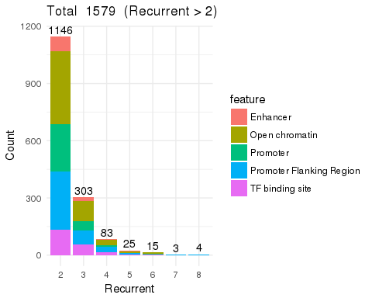

### Feature distribution on the chromosome

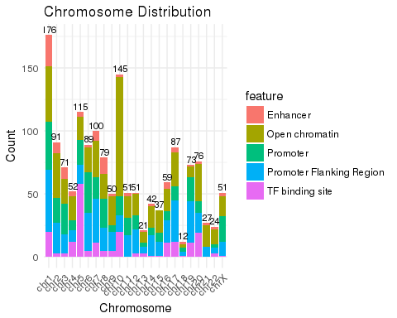

### Mutation type

### Filter recurrent larger than or equal to 5

