BRCA Somatic Recurrent in 20 Samples

C.J. Liu

11/18/2016

Table of Contents

## Samples

Normal Sample Information

|  |  |  |  |
| --- | --- | --- | --- |
| sample.type | file.name | file.id | submitter.id |
| Solid Tissue Normal | 01da42b4a27c13a339740f19dbbaaa35_gdc_realn.bam | e2d7a695-b0bf-4432-8f98-1843bb49efba | TCGA-E2-A1LB-11A-22D-A142-09 |
| Blood Derived Normal | 02e1e61e442e4704324345cb90bf566f_gdc_realn.bam | f81a32c0-960c-4ff7-a98a-6c8a7906a74d | TCGA-E9-A5UO-10A-01D-A28E-09 |
| Blood Derived Normal | 01218e1cd1b806450e6954adedb202b1_gdc_realn.bam | 498c2e11-687c-431f-805f-0acb439dd89b | TCGA-AR-A256-10A-01D-A167-09 |
| Blood Derived Normal | 020e7383d3e592386d6aea440a98aec5_gdc_realn.bam | 1b49dbc3-ced0-4b4c-91be-e0782040f7aa | TCGA-GM-A2DM-10C-01D-A17W-09 |
| Blood Derived Normal | 01ba6cd35f5da1da90e1c2d95eab0068_gdc_realn.bam | 1cec4a02-8b01-4786-a711-32d58c6a6110 | TCGA-AC-A5XS-10A-01D-A29N-09 |
| Solid Tissue Normal | 010e244507a1e9ad1e3e41b771305d52_gdc_realn.bam | 714e11fb-be71-4bbd-9327-457883a07ef0 | TCGA-AC-A2FF-11A-13D-A17D-09 |
| Blood Derived Normal | 0017ba4c33a07ba807b29140b0662cb1_gdc_realn.bam | d853e541-f16a-4345-9f00-88e03c2dc0bc | TCGA-AR-A2LL-10A-01D-A17W-09 |

Tumor Sample Information

|  |  |  |  |
| --- | --- | --- | --- |
| sample.type | file.name | file.id | submitter.id |
| Primary Tumor | 021812fd40481352dc8378963e6da3c6_gdc_realn.bam | 70522eb8-84b4-47c7-b014-cf477ebc8821 | TCGA-AC-A2B8-01A-11D-A17D-09 |
| Primary Tumor | 00a0b7fe73741312c23f4f63317cc972_gdc_realn.bam | f7ff88d6-e315-4c0c-89e9-b2407879cc0d | TCGA-GM-A2DO-01A-11D-A19Y-09 |
| Primary Tumor | 00925769611d88cb0379798246946580_gdc_realn.bam | 622b6de4-26f4-4bfc-9911-6bc38c48a7a5 | TCGA-B6-A409-01A-11D-A243-09 |
| Primary Tumor | 0047eb6e338c99ed7e7e399875b83181_gdc_realn.bam | c3d2d64d-ebbe-4a95-8434-8506a1d3ad10 | TCGA-LL-A73Z-01A-11D-A32I-09 |
| Primary Tumor | 015537fb5f5fb8cdbefb1556ec7568e5_gdc_realn.bam | 3ee66331-0c51-45a6-b238-fe1f88fb5629 | TCGA-AR-A24H-01A-11D-A167-09 |
| Primary Tumor | 01e5961cf18d86fb266ca104136b5361_gdc_realn.bam | 8232d88f-6eac-493b-bd79-6a1fb349feec | TCGA-AR-A5QN-01A-12D-A28B-09 |
| Metastatic | 00649547f0ace32d81d190498392263b_gdc_realn.bam | 55707e43-b7b0-42d3-bfa5-68a988873f1f | TCGA-AC-A6IX-06A-11D-A32I-09 |
| Primary Tumor | 003860a34c9b244a5d8435b220ca5673_gdc_realn.bam | 56fb8a1f-e897-4a45-a22d-ff86dced05f8 | TCGA-A2-A4S1-01A-21D-A25Q-09 |
| Primary Tumor | 025ddef03b5bd3acdde431df4c0d7e62_gdc_realn.bam | 70c1e811-e680-4389-86f6-6950ab1b0eb4 | TCGA-D8-A1XK-01A-21D-A14K-09 |
| Primary Tumor | 0205cabb2bae0812e6966871567cb1b0_gdc_realn.bam | c3e043c1-615e-4bff-a81a-2da2a10749a5 | TCGA-E2-A576-01A-11D-A31U-09 |
| Primary Tumor | 02a4ce4a222d05324858158e0aab7317_gdc_realn.bam | 3d3384e7-15b7-40e1-825d-0db288eda7e3 | TCGA-LL-A73Y-01A-11D-A33E-09 |
| Primary Tumor | 01c12736511241497f2e976c1764b1e4_gdc_realn.bam | c18178f9-9426-4684-b049-2ca8ee8f37c2 | TCGA-AC-A3TM-01A-11D-A228-09 |
| Primary Tumor | 011fbd7adeb9b3b263fda1d95f5aa06f_gdc_realn.bam | 2f2b0909-488b-4fa3-8251-2ef6e7d5869e | TCGA-GI-A2C9-01A-11D-A21Q-09 |

## Somatic Mutation Calling

1. Download 20 cases of BRCA WXS bam files from GDC-portal.
2. Download Regulatory Build annotation from Ensembl.
3. Call Regulatory element mutations by GATK (DP > 10, AD > 3 )
4. Exclude dbSNP, avsnp147 (ANNOVAR)
5. Find recurrent tumor and nomal respectively.
6. Somatic tumor.recurrent - normal.recurrent.

## Result

### Recurrent count and feature distribution

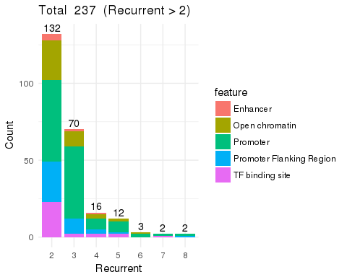

### Feature distribution on the chromosome

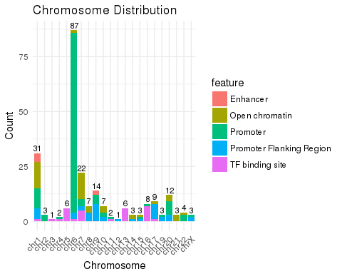

### Mutation type

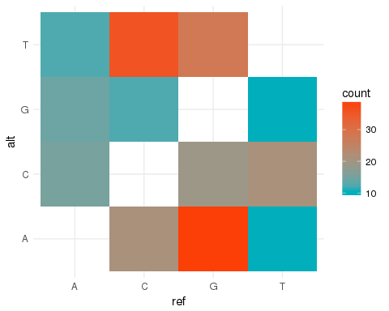

### Filter recurrent larger than or equal to 5

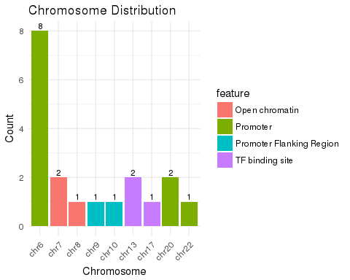

|  |  |
| --- | --- |
| ensid | count |
| ENSR00000195346 | 4 |
| ENSR00000195522 | 4 |
| ENSR00000059579 | 2 |
| ENSR00000219298 | 2 |
| ENSR00000025152 | 1 |
| ENSR00000089846 | 1 |
| ENSR00000135911 | 1 |
| ENSR00000135924 | 1 |
| ENSR00000143446 | 1 |
| ENSR00000232222 | 1 |
| ENSR00000235360 | 1 |

### Annotation from BioMart

## # A tibble: 5 × 3  
## dataset  
## <S3: AsIs>  
## 1 hsapiens_annotated_feature  
## 2 hsapiens_motif_feature  
## 3 hsapiens_regulatory_feature  
## 4 hsapiens_mirna_target_feature  
## 5 hsapiens_external_feature  
## # ... with 2 more variables: description <S3: AsIs>, version <S3: AsIs>

# Done, Find another 20 cases.