РУ “Ангел Кънчев” – Русе
Факултет: ЕЕА
Катедра: Комуникационна техника и технологии
Специалност: Компютърни системи и технологии

КУРСОВА РАБОТА

по “Микропроцесорна техника”

Студент:
Фак. №
Спец: КСТ
Група:

Ръководител:
/ доц. Л.Георгиева /
- Задание
?????????????????????????????????????????????????????????

- Блок схема

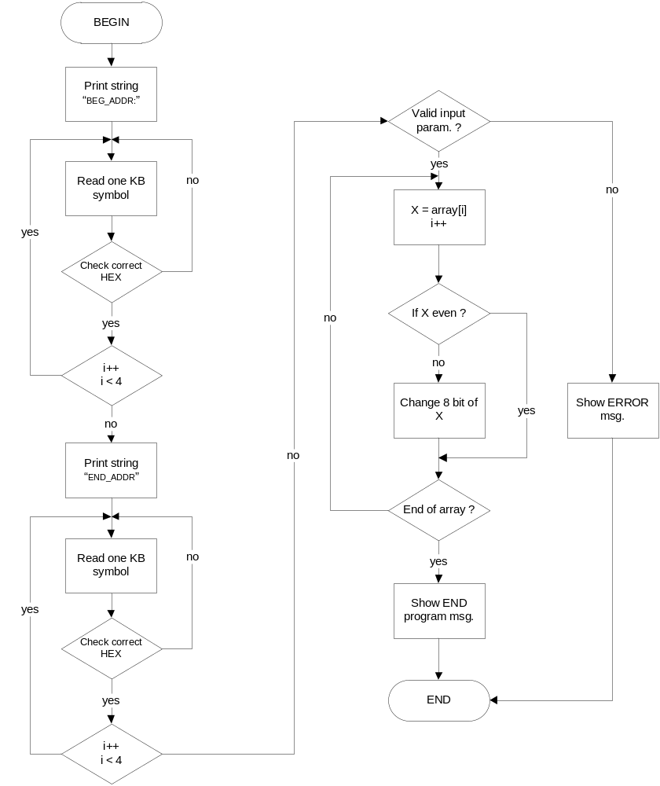

- Код на програмата

name "EVEN_ARR"
org 100h
jmp BEGIN
;-------------------------------------
; Define variable
;-------------------------------------
msgBegAddr DB "BEG_ADDR:" , 20h, 24h
msgEndAddr DB 09h, 09h, "END_ADDR:" , 20h, 24h
msgFinish DB 0dh, 0ah, "Program end." , 24h
msgError DB 0dh, 0ah, "ERROR - invalid address!" , 24h

;example array
array DB ',', ' ', 0ah, 'п', '5', 0ch, '7', 0eh, '9', 'a', 0dh, 'c', 'd', 0bh, 'f'

startAddr DW ?
endAddr DW ?

;-------------------------------------
;Main program code
;-------------------------------------
BEGIN:
;Init:

;Set video mode:
mov ax, 3 ; text mode 80x25, 16 colors, 8 pages (ah=0, al=3)
int 10h ; do it!

;Show first text line:
lea ax, msgBegAddr
call print
;Read array begin address:
mov cx, 4
call read
mov startAddr, bx

;Show next text line:
lea ax, msgEndAddr
call print
;Read array end address:
mov cx, 4
call read
mov endAddr, bx

;Call validate input param :
call valid

;Convert array elemenst to even:
call conv

;Show finish message:
lea ax, msgFinish
call print

;On end wait to press KEY
mov ah, 0
int 16h
int 20h
; ret

;-------------------------------------
;Program functions
;-------------------------------------
;Show text:
print: mov dx,ax
mov ah,09h
int 21h
ret

;Convert ASCII to HEX:
a2h: add al,40h
cbw
and ah,09h
add al,ah
and al,0fh
ret

;Check correct HEX symbol:
check: cmp al,30h;
jb n
cmp al,3ah
jb y
cmp al,41h
jb n
cmp al,47h
jb y
cmp al,61h;
jb n
cmp al,67h
jb y
n: jmp badHex
y: ret

;Read one kyeboard symbol:
badHex: pop bx
read: mov ah,0
int 16h
call check
push ax
mov ah,0eh
int 10h
loop read
;Packed four readed ASCCI numbers:
pop ax
call a2h
mov bl,al
pop ax
call a2h
mov cl,4
shl al,cl
or bl,al
pop ax
call a2h
mov bh,al
pop ax
call a2h
mov cl,4
shl al,cl
or bh,al
ret

;Validate input param. :
valid: mov ax, endAddr
cmp ax, startAddr
ja pass
;Show bad input param. :
lea ax, msgError
call print
mov ah, 0
int 16h
int 20h
pass: ret

;Convert array:
conv: mov cx, endAddr
sub cx, startAddr
inc cx
mov si, startAddr
and bx, 0
lp: lodsb
;Check for even number:
or al, 0
jpe even
test al, 10000000b
jz zf
and al, 01111111b
jmp store
zf: or al, 10000000b
store: mov [si]-1, al
even: loop lp
ret

- Разпечатка на LST файла

[ 1] : name "EVEN_ARR"
[ 2] : org 100h
[ 3] 0100: EB 55 jmp BEGIN
[ 4] : ;-------------------------------------
[ 5] : ; Define variable
[ 6] : ;-------------------------------------
[ 7] 0102: 42 45 47 5F 41 44 44 52 3A 20 24 msgBegAddr DB "BEG_ADDR:" , 20h, 24h
[ 8] 010D: 09 09 45 4E 44 5F 41 44 44 52 3A 20 msgEndAddr DB 09h, 09h, "END_ADDR:" , 20h, 24h
24
[ 9] 011A: 0D 0A 50 72 6F 67 72 61 6D 20 65 6E msgFinish DB 0dh, 0ah, "Program end." , 24h
64 2E 24
[ 10] 0129: 0D 0A 45 52 52 4F 52 20 2D 20 69 6E msgError DB 0dh, 0ah, "ERROR - invalid address!" , 24h
76 61 6C 69 64 20 61 64 64 72 65 73
73 21 24
[ 11] :
[ 12] : ;example array
[ 13] 0144: 2C 20 0A EF 35 0C 37 0E 39 61 0D 63 array DB ',', ' ', 0ah, 'п', '5', 0ch, '7', 0eh, '9', 'a', 0dh, 'c', 'd', 0bh, 'f'
64 0B 66
[ 14] :
[ 15] 0153: 00 00 startAddr DW ?
[ 16] 0155: 00 00 endAddr DW ?
[ 17] :
[ 18] : ;-------------------------------------
[ 19] : ;Main program code
[ 20] : ;-------------------------------------
[ 21] 0157: BEGIN:
[ 22] : ;Init:
[ 23] :
[ 24] : ;Set video mode:
[ 25] 0157: B8 03 00 mov ax, 3 ; text mode 80x25, 16 colors, 8 pages (ah=0, al=3)
[ 26] 015A: CD 10 int 10h ; do it!
[ 27] :
[ 28] : ;Show first text line:
[ 29] 015C: B8 02 01 lea ax, msgBegAddr
[ 30] 015F: E8 2C 00 call print
[ 31] : ;Read array begin address:
[ 32] 0162: B9 04 00 mov cx, 4
[ 33] 0165: E8 54 00 call read
[ 34] 0168: 89 1E 53 01 mov startAddr, bx
[ 35] :
[ 36] : ;Show next text line:
[ 37] 016C: B8 0D 01 lea ax, msgEndAddr
[ 38] 016F: E8 1C 00 call print
[ 39] : ;Read array end address:
[ 40] 0172: B9 04 00 mov cx, 4
[ 41] 0175: E8 44 00 call read
[ 42] 0178: 89 1E 55 01 mov endAddr, bx
[ 43] :
[ 44] : ;Call validate input param :
[ 45] 017C: E8 6C 00 call valid
[ 46] :
[ 47] : ;Convert array elemenst to even:
[ 48] 017F: E8 7F 00 call conv
[ 49] :
[ 50] : ;Show finish message:
[ 51] 0182: B8 1A 01 lea ax, msgFinish
[ 52] 0185: E8 06 00 call print
[ 53] :
[ 54] : ;On end wait to press KEY
[ 55] 0188: B4 00 mov ah, 0
[ 56] 018A: CD 16 int 16h
[ 57] 018C: CD 20 int 20h
[ 58] : ; ret
[ 59] :
[ 60] : ;-------------------------------------
[ 61] : ;Program functions
[ 62] : ;-------------------------------------
[ 63] : ;Show text:
[ 64] 018E: 8B D0 print: mov dx,ax
[ 65] 0190: B4 09 mov ah,09h
[ 66] 0192: CD 21 int 21h
[ 67] 0194: C3 ret
[ 68] :
[ 69] : ;Convert ASCII to HEX:
[ 70] 0195: 04 40 a2h: add al,40h
[ 71] 0197: 98 cbw
[ 72] 0198: 80 E4 09 and ah,09h
[ 73] 019B: 02 C4 add al,ah
[ 74] 019D: 24 0F and al,0fh
[ 75] 019F: C3 ret
[ 76] :
[ 77] : ;Check correct HEX symbol:
[ 78] 01A0: 3C 30 check: cmp al,30h;
[ 79] 01A2: 72 14 jb n
[ 80] 01A4: 3C 3A cmp al,3ah
[ 81] 01A6: 72 12 jb y
[ 82] 01A8: 3C 41 cmp al,41h
[ 83] 01AA: 72 0C jb n
[ 84] 01AC: 3C 47 cmp al,47h
[ 85] 01AE: 72 0A jb y
[ 86] 01B0: 3C 61 cmp al,61h;
[ 87] 01B2: 72 04 jb n
[ 88] 01B4: 3C 67 cmp al,67h
[ 89] 01B6: 72 02 jb y
[ 90] 01B8: EB 01 n: jmp badHex
[ 91] 01BA: C3 y: ret
[ 92] :
[ 93] : ;Read one kyeboard symbol:
[ 94] 01BB: 5B badHex: pop bx
[ 95] 01BC: B4 00 read: mov ah,0
[ 96] 01BE: CD 16 int 16h
[ 97] 01C0: E8 DD FF call check
[ 98] 01C3: 50 push ax
[ 99] 01C4: B4 0E mov ah,0eh
[ 100] 01C6: CD 10 int 10h
[ 101] 01C8: E2 F2 loop read
[ 102] : ;Packed four readed ASCCI numbers:
[ 103] 01CA: 58 pop ax
[ 104] 01CB: E8 C7 FF call a2h
[ 105] 01CE: 8A D8 mov bl,al
[ 106] 01D0: 58 pop ax
[ 107] 01D1: E8 C1 FF call a2h
[ 108] 01D4: B1 04 mov cl,4
[ 109] 01D6: D2 E0 shl al,cl
[ 110] 01D8: 0A D8 or bl,al
[ 111] 01DA: 58 pop ax
[ 112] 01DB: E8 B7 FF call a2h
[ 113] 01DE: 8A F8 mov bh,al
[ 114] 01E0: 58 pop ax
[ 115] 01E1: E8 B1 FF call a2h
[ 116] 01E4: B1 04 mov cl,4
[ 117] 01E6: D2 E0 shl al,cl
[ 118] 01E8: 0A F8 or bh,al
[ 119] 01EA: C3 ret
[ 120] :
[ 121] : ;Validate input param. :
[ 122] 01EB: A1 55 01 valid: mov ax, endAddr
[ 123] 01EE: 3B 06 53 01 cmp ax, startAddr
[ 124] 01F2: 77 0C ja pass
[ 125] : ;Show bad input param. :
[ 126] 01F4: B8 29 01 lea ax, msgError
[ 127] 01F7: E8 94 FF call print
[ 128] 01FA: B4 00 mov ah, 0
[ 129] 01FC: CD 16 int 16h
[ 130] 01FE: CD 20 int 20h
[ 131] 0200: C3 pass: ret
[ 132] :
[ 133] : ;Convert array:
[ 134] 0201: 8B 0E 55 01 conv: mov cx, endAddr
[ 135] 0205: 2B 0E 53 01 sub cx, startAddr
[ 136] 0209: 41 inc cx
[ 137] 020A: 8B 36 53 01 mov si, startAddr
[ 138] 020E: 83 E3 00 and bx, 0
[ 139] 0211: AC lp: lodsb
[ 140] : ;Check for even number:
[ 141] 0212: 0C 00 or al, 0
[ 142] 0214: 7A 0D jpe even
[ 143] 0216: A8 80 test al, 10000000b
[ 144] 0218: 74 04 jz zf
[ 145] 021A: 24 7F and al, 01111111b
[ 146] 021C: EB 02 jmp store
[ 147] 021E: 0C 80 zf: or al, 10000000b
[ 148] 0220: 88 44 FF store: mov [si]-1, al
[ 149] 0223: E2 EC even: loop lp
[ 150] 0225: C3 ret

