Abstract

[Draw your reader in with an engaging abstract. It is typically a short summary of the document.   
When you’re ready to add your content, just click here and start typing.]

ISCG 8038 Advanced Web Development

Assignment 1

[Email address]

# Architecture

## Information structure of the web-based system

Organization structure of the web-based system (like the pages in the website and what’s in it)

This is done by us by identifying the websites hierarchy

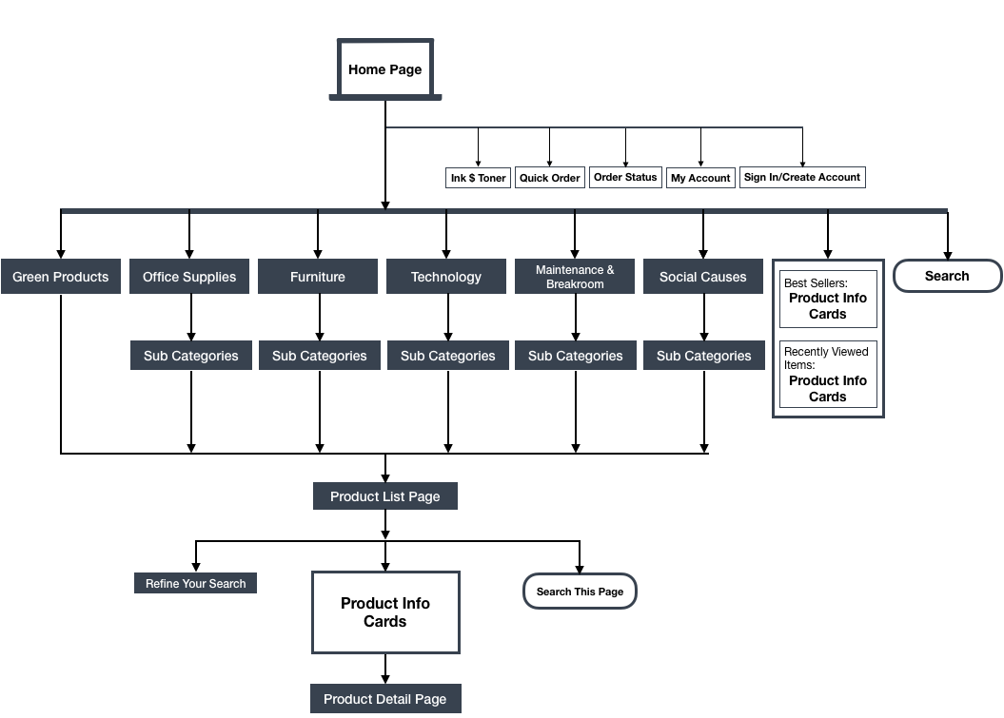

Figure : Home Page Architecture

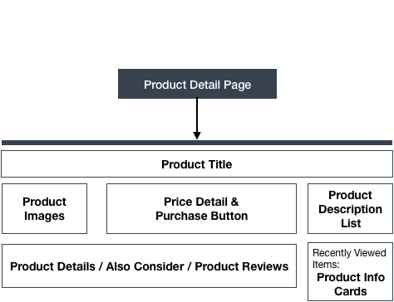

Figure : Product Detail Page Architecture