Predicting antimicrobial resistance of Streptococcus pneumoniae from genomic k-mers using machine learning: a lineage-aware evaluation
Chunjiang Zhaoª, Shuyi Wangª, Shuo Yangª, Feifei Zhangª and Hui Wang^{a*}

ª Department of Clinical Laboratory, Peking University People’s Hospital, Beijing, China, 100044

*Corresponding author
Hui Wang
Email: whuibj@163.com; wanghui@pkuph.edu.cn

Abstract
Background: Whole-genome sequencing (WGS) can be used to predict antimicrobial resistance, but the clonal population structure of Streptococcus pneumoniae may overestimate model performance when related isolates are present in both training and test sets. We evaluated genomic k-mer-based machine learning models for MIC prediction with consideration of genetic lineage.
Methods: The training dataset included 927 isolates, comprising 607 clinical isolates from China and 320 isolates from the Global Pneumococcal Sequencing project. Canonical 10-mer counts were extracted from genome assemblies, and XGBoost regression and classification models were developed for six antimicrobial agents. Performance was assessed by nested cross-validation using random and lineage-grouped splitting. Final models were validated in 48 clinical isolates collected in 2021, with Etest as the reference method.
Results: Lineage-grouped splitting reduced EA compared with random splitting for penicillin (87.7% vs 90.1%), erythromycin (82.3% vs 89.4%), clindamycin (80.9% vs 87.2%), and ceftriaxone (78.4% vs 88.9%). For trimethoprim-sulfamethoxazole, EA in domestic isolates decreased from 80.4% to 50.7%. Typing-only models showed poor performance after lineage separation, while adding serotype and sequence type to k-mer features provided little improvement. In the validation set, 47 of 48 isolates belonged to lineages represented in the training data. EA was 85.4% for penicillin, 83.3% for ceftriaxone, 81.2% for erythromycin, 68.8% for clindamycin, 100% for levofloxacin, and 72.9% for trimethoprim-sulfamethoxazole. No VME or ME occurred for penicillin, whereas two VMEs were observed for ceftriaxone.
Conclusions: K-mer-based models showed good performance for penicillin and macrolide resistance, particularly in lineages represented in the training data. Ceftriaxone and trimethoprim-sulfamethoxazole predictions were more affected by clonal background. Lineage-aware evaluation is important before clinical application. These models may complement phenotypic susceptibility testing in genomic surveillance and in isolates that are difficult to test conventionally.

Keywords: Streptococcus pneumoniae; antimicrobial resistance; machine learning; k-mer; whole-genome sequencing; population structure

1. Introduction
Streptococcus pneumoniae is an important cause of community-acquired pneumonia, bacteremia and meningitis, and antimicrobial resistance of this pathogen remains a serious problem in China [1–3]. Antimicrobial susceptibility testing (AST) is the basis for the selection of antimicrobial agents. However, conventional culture-based AST usually requires 48–72 h to achieve final results [4, 5]. For S. pneumoniae, the commonly used automated systems, such as the VITEK 2 system, have limitations in AST, and many laboratories still rely on manual methods. In addition, AST cannot be performed when the isolate grows poorly or loses viability, which is not uncommon for this fastidious and autolytic organism. Therefore, alternative methods for predicting susceptibility are needed as a backup.
With the rapid development and decreasing cost of sequencing technology, whole-genome sequencing (WGS) has been widely used in pathogen identification, molecular epidemiology and resistance surveillance [6–8]. Resistance phenotypes can be predicted from genomic data by two main approaches. The first approach is based on known resistance genes and mutations [9, 10]. For S. pneumoniae, β-lactam MICs can be predicted from the types of penicillin-binding proteins (PBPs) [11]. This approach has good interpretability, but it depends on existing knowledge and databases. The second approach is machine learning, which learns the relationship between genome features and phenotypes directly from data [12]. k-mers, short DNA sequences of fixed length, can be extracted from any genome without prior knowledge of resistance mechanisms, and k-mer-based models have been used to predict the MICs of several bacterial species [13].
However, the evaluation of such models needs special attention. S. pneumoniae has an obvious clonal population structure, and resistance is often spread with successful clones, such as CC271 in China. If isolates are randomly divided into training and test sets, closely related isolates will appear in both sets. In this situation, the model may make correct predictions by recognizing the clone rather than the resistance determinants, and its performance for isolates of new lineages may be overestimated [14]. In addition, serotype and sequence type (ST) are closely related to clonal lineage, and their contribution to the prediction should be evaluated separately from that of genome sequence features.
In this study, we developed XGBoost models based on genomic 10-mers to predict the MICs and susceptibility categories of S. pneumoniae for six antimicrobial agents, using 927 isolates from China and the Global Pneumococcal Sequencing project. Model performance was evaluated by nested cross-validation with both random and lineage-grouped splitting, and the contributions of k-mer and typing features were compared. The final models were then validated in clinical isolates collected during 2021. The aim of this study was to determine for which antimicrobial agents and in which situations genome-based prediction can be used as a reliable supplement to conventional culture-based AST.

2. Materials and methods

2.1. Bacterial isolates
A total of 927 Streptococcus pneumoniae isolates with whole-genome sequencing data and reference minimum inhibitory concentrations (MICs) were included in the training set (Table 1). The workflow of this study is shown in Figure 1. Among them, 607 clinical isolates were collected from patients with bloodstream infection, pneumonia or central nervous system infection in different regions of China between 2010 and 2018 in our previous studies [1–3]. Since no penicillin-susceptible isolate was found among the domestic isolates, 320 isolates with different resistance phenotypes, including 273 penicillin-susceptible isolates, were selected from the Global Pneumococcal Sequencing (GPS) project [15] to increase the diversity of the training data. These GPS isolates were from the United Kingdom (n = 144), Norway (n = 121), South Africa (n = 38) and five other countries (n = 17).
In addition, 50 non-duplicate clinical isolates collected at Peking University People’s Hospital in 2021 were used as the validation set. The specimens included sputum, blood, cerebrospinal fluid, pleural fluid and bronchoalveolar lavage fluid. None of these isolates was used in model training. Two isolates (V-36 and V-48) were excluded because the quality control of genome assembly suggested mixed culture (abnormal genome size and GC content). Finally, 48 isolates were included in the validation analysis.

2.2. Antimicrobial susceptibility testing
For the domestic isolates, MICs of penicillin, amoxicillin-clavulanate, ceftriaxone, erythromycin, clindamycin, levofloxacin, moxifloxacin, and trimethoprim-sulfamethoxazole were determined by broth microdilution or agar dilution according to CLSI guidelines [16]. Antimicrobial reference powders were obtained from the National Institutes for Food and Drug Control, China, and the tested concentration ranges covered the CLSI breakpoints. The lowest penicillin concentration tested was 0.016 mg/L. S. pneumoniae ATCC 49619 and Staphylococcus aureus ATCC 29213 were used for quality control.
For GPS isolates, MICs were obtained from the GPS metadata. MICs of amoxicillin-clavulanate, moxifloxacin, and trimethoprim-sulfamethoxazole were genotype-predicted rather than phenotypically measured. Therefore, amoxicillin-clavulanate and moxifloxacin were reported only in the Supplementary Material (Table S7), and trimethoprim-sulfamethoxazole was additionally analyzed in the domestic isolates with measured MICs.
For the validation isolates, MICs were determined by Etest (bioMérieux, Marcy-l’Étoile, France) on Mueller-Hinton agar supplemented with 5% sheep blood after incubation at 35 °C in 5% CO₂ for 20–24 h. S. pneumoniae ATCC 49619 was used for quality control. Etest values not falling on the standard doubling dilution series were converted to the nearest doubling dilution.
MICs were interpreted according to CLSI M100, 32nd edition [16]. Oral penicillin breakpoints and non-meningitis ceftriaxone breakpoints were used. Isolates were classified as susceptible (S), intermediate (I), or resistant (R), with I and R grouped as non-susceptible (NS).

2.3. Serotyping and multilocus sequence typing
The serotypes of the domestic isolates were determined by the Quellung reaction with the Pneumotest-Latex kit and type-specific antisera (Statens Serum Institut, Copenhagen, Denmark) as described previously [3, 17]. Serotypes were also predicted from sequencing reads by SeroBA [18] for comparison. The Quellung results were used in all analyses, and the comparison of the two methods is shown in Table S8. Thirty-three isolates were reported as possible mixed samples by SeroBA. These isolates were retained because their assemblies met the quality criteria described below and their serotypes had been determined by the Quellung reaction. Sequence types (STs) were determined from the assembled genomes by MLST 2.0 [19]. For the GPS isolates, serotypes and STs were obtained from the GPS metadata. For the validation isolates, serotypes were predicted by SeroBA and STs were determined by mlst (PubMLST S. pneumoniae scheme).

2.4. Whole-genome sequencing and assembly
The domestic isolates were sequenced in previous studies on Illumina NextSeq 500, NovaSeq, HiSeq X Ten and HiSeq platforms with paired-end reads. The validation isolates were sequenced on the same Illumina platform as the domestic isolates. Raw reads were trimmed by fastp [20] and assembled by SPAdes v3.13.0 with the --careful option. The validation isolates were assembled with the same software version and parameters. For the GPS isolates, the published assemblies were used.
To remove possible contaminating sequences, the same filtering rule was applied to all isolates. Contigs shorter than 500 bp were removed, and contigs with coverage lower than 0.3 times the main coverage peak of each isolate (the length-weighted median coverage of contigs ≥500 bp) were also removed. The published GPS assemblies only contained contigs ≥500 bp. An assembly was accepted when the filtered genome length was 1.9–2.3 Mb and the GC content was 39%–40%. All 927 training isolates met these criteria, and the median genome length of the domestic isolates was 2.07 Mb (range, 1.97–2.27 Mb). The validation assemblies were processed in the same way.

2.5. k-mer features
Canonical 10-mers were counted from each assembly by KMC 3 [21] (v3.2.4; parameters -k10 -fm -ci1 -cs65535, to avoid truncation of counts), and the count of each 10-mer was used as the feature value. A 10-mer not detected in an isolate was given a value of zero. In total, 503,875 distinct canonical 10-mers were detected in the 927 training isolates. We chose k = 10 for the following reasons. The total number of canonical 10-mers is about 5.2 × 10⁵, which is almost saturated in a pneumococcal genome of 2.1 Mb. Therefore, all isolates, including new isolates, can be described in the same fixed feature space. In addition, the counts can reflect copy number variation (such as rRNA operons and insertion sequences), and the computational cost is acceptable. To evaluate whether longer k-mers could better capture the mosaic penicillin-binding protein genes, canonical 21-mers (presence or absence) were also tested. A total of 10,225,337 distinct 21-mers were detected, of which 4,352,999 were present in 10 to 917 isolates. After merging 21-mers with identical presence patterns, 344,159 features were obtained (Table S4). Extreme k-mer counts were checked against the original data and retained.

2.6. Definition of genetic lineages
Antimicrobial resistance of S. pneumoniae is closely related to clonal lineages. Therefore, the isolates were grouped into lineages based on the k-mer data. The pairwise Jaccard distance between isolates was calculated according to the presence or absence of variable 10-mers, and hierarchical clustering was performed with the average linkage method (UPGMA). The clustering tree was cut at a distance of 0.2363, which was the smallest threshold at which ST271, ST320, ST236 and ST1464, the main STs of clonal complex 271 (CC271) in this collection, were grouped into one cluster. As a result, 123 lineage clusters were obtained. The largest cluster contained 233 isolates, including the CC271 isolates.

2.7. Model development and cross-validation
For each antimicrobial agent, XGBoost (v3.2.0) models were developed using the scikit-learn interface (v1.8.0), including a regression model for log₂ MIC and, when at least 10 non-susceptible (NS) isolates were available, a binary classification model for S versus NS. No classification model was therefore built for levofloxacin or moxifloxacin. Class imbalance was handled using scale_pos_weight. Three feature sets were evaluated: k-mers alone, serotype and sequence type (ST) alone, and their combination.
Model performance was evaluated using nested cross-validation with 5 outer folds and 3 inner folds. Within each outer training fold, constant k-mers were removed and the 20,000 k-mers with the highest variance were retained without reference to phenotype. Hyperparameters were optimized by randomized search in the inner folds for each antimicrobial agent and model type (Table S5). For classification models, the decision threshold was selected by maximizing the Youden index based on inner-fold out-of-fold probabilities. The resulting model was then applied to the corresponding outer test fold. Thus, each isolate was predicted once by a model that had not been trained on it, and all outer-fold predictions were pooled for performance evaluation.
Two splitting strategies were used. Random splitting was stratified by phenotype and allowed related isolates to occur in both training and test folds, reflecting performance for lineages represented in the training data. In lineage-grouped splitting, isolates from the same lineage cluster were assigned to the same fold, with no lineage shared between training and test folds (Table S6), reflecting performance for unseen lineages. The same grouping strategy was applied in the inner folds.
The predicted log₂ MIC was rounded to the nearest doubling dilution, instead of rounding up as in the original version, and was limited to the MIC range of the training data. The predicted MICs were then interpreted according to the breakpoints described above. All analyses were performed in Python 3.11.14 on a MacBook Pro (Apple M3, 36 GB RAM). The source code is available at https://github.com/chunkiang/spn_prediction.

2.8. Final model and clinical validation
For clinical application, a final model was trained for each antimicrobial agent using all 927 training isolates and k-mer features alone. After the same feature-filtering procedure, hyperparameters were selected by 5-fold lineage-grouped cross-validation, and classification thresholds were determined by maximizing the Youden index based on out-of-fold probabilities. The resulting models were applied unchanged to the independent validation set. Validation 10-mers were generated using the same KMC parameters and aligned to the feature index derived from the training set.
To evaluate the uncertainty of prediction, 20 additional models were trained for each antimicrobial agent by bootstrap resampling of the training lineage clusters. The 2.5th and 97.5th percentiles of the predictions were used as the 95% interval of the predicted log₂ MIC. Clonal overlap between the validation and training sets was assessed using Jaccard distances based on variable training-set 10-mers. For each validation isolate, the nearest training isolate and the number of training isolates within the predefined lineage threshold (0.2363) were recorded. Isolates with no training isolate within this threshold were classified as belonging to lineages not represented in the training set.

2.9. Performance evaluation and statistical analysis
Agreement between predicted and reference MICs was evaluated according to CLSI M52 and ISO 20776-2 [24]. Essential agreement (EA) was defined as a predicted MIC within ±1 doubling dilution of the reference MIC, and categorical agreement (CA) as agreement in the S/I/R category. Very major error (VME), major error (ME), and minor error (mE) were defined as resistant predicted as susceptible, susceptible predicted as resistant, and any disagreement involving the intermediate category, respectively, with resistant, susceptible, and all isolates as the corresponding denominators. EA, CA, and error rates were calculated for the regression models. Bland–Altman analysis was used to assess bias between predicted and reference log₂ MICs.
For classification models, sensitivity for non-susceptible isolates, specificity, positive and negative predictive values, F1 score, AUROC, and AUPRC were calculated. In cross-validation, 95% confidence intervals (CIs) were obtained from 1,000 bootstrap resamples of the pooled out-of-fold predictions. For the validation set, Wilson 95% CIs were used for proportions and 2,000 bootstrap resamples for AUROC. Because resistance distributions differed between domestic and GPS isolates, results were also reported separately for the two groups. Metrics were not calculated when the denominator was zero or only one class was present. All analyses were descriptive, and no hypothesis testing was performed.

2.10. Ethics statement
This study was approved by the Ethics Committee of Peking University People’s Hospital (approval Nos. 2010PHB065, 2013PHB188, 2014PHB104, 2016PHB135, and 2018PHB129). Validation isolates were obtained from routine clinical cultures, and only bacterial isolates and de-identified clinical data were used. The requirement for informed consent was therefore waived. The study was conducted in accordance with the Declaration of Helsinki.

2.11. Data availability
The source code, trained models (XGBoost JSON files), list of selected k-mers and model information are available at https://github.com/chunkiang/spn_prediction. The genome assemblies and metadata of the GPS isolates are publicly available on the GPS project website (https://www.pneumogen.net/gps/). The k-mer data and the sequencing data of the domestic and validation isolates are stored on the bioinformatics server of our laboratory and are available from the corresponding author upon reasonable request.

3. Results

3.1. Characteristics of the isolates
Among the 607 domestic isolates, 54 serotypes and 124 sequence types (STs) were identified. The predominant serotypes were 19F (n=192), 19A (n=83), 23F (n=54), and 14 (n=45), while ST271 (n=139) and ST320 (n=61) were the most common STs (Table 1). The 320 GPS isolates comprised 40 serotypes and 121 STs. Hierarchical clustering of all 927 training genomes identified 123 lineage clusters. The largest cluster contained 233 isolates, including all 218 CC271 isolates, which were exclusively from the domestic dataset.
Resistance profiles differed markedly between the two data sources (Table 1). Among domestic isolates, no penicillin-susceptible isolate was identified using the oral breakpoint, and 61.1% were penicillin resistant. Non-susceptibility rates were 29.5% for ceftriaxone and 76.6% for trimethoprim-sulfamethoxazole, while resistance rates were 97.5% for erythromycin and 92.8% for clindamycin. Only one isolate was resistant to levofloxacin. In contrast, 85.3% of GPS isolates were susceptible to penicillin and only two were non-susceptible to ceftriaxone. Resistance distributions were therefore strongly related to isolate source and were considered in subsequent analyses.
Serotypes determined by the Quellung reaction and SeroBA agreed in 571 of 607 domestic isolates (94.1%) (Table S8). All 32 discordant results were within the same serogroup, mainly involving serogroups 6, 9, 15, and 23. Four Quellung-non-typeable isolates were identified as 19F or 19A by SeroBA, all belonging to CC271. No discordance across serogroups was observed.

3.2. Performance of cross-validation with random and lineage-grouped splitting
The performance of the k-mer models for the six main antimicrobial agents is summarized in Table 2 and Figure 2, with results for domestic and GPS isolates shown separately in Table S2. With random splitting, EA ranged from 85.1% for trimethoprim-sulfamethoxazole to 99.4% for levofloxacin, and CA ranged from 83.9% to 99.4%. With lineage-grouped splitting, EA decreased for all agents except levofloxacin, with reductions of 2.4 percentage points for penicillin, 7.1 for erythromycin, 6.3 for clindamycin, 10.5 for ceftriaxone, and 20.9 for trimethoprim-sulfamethoxazole.
Penicillin. EA was 90.1% with random splitting and 87.7% with lineage-grouped splitting. Only one VME (1/379) and no ME were observed with either method. Most categorical errors were mEs near the 1–2 mg/L breakpoint. The overall AUROC exceeded 99%, while in GPS isolates it was 97.1% and 94.4% with random and lineage-grouped splitting, respectively.
Ceftriaxone. EA decreased from 88.9% with random splitting to 78.4% with lineage-grouped splitting. Under lineage-grouped splitting, the regression model underestimated MICs (mean bias, −0.36 log₂ dilution), and all 128 resistant isolates were misclassified as non-resistant by MIC prediction. In contrast, the classification model showed a sensitivity of 81.2% for NS isolates and a specificity of 76.8%, with an AUROC of 86.9% versus 90.5% with random splitting.
Erythromycin and clindamycin. CA remained high for erythromycin (97.2% and 94.4%) and clindamycin (95.6% and 92.8%) with random and lineage-grouped splitting, respectively. However, among GPS isolates, lineage-grouped splitting reduced the sensitivity for erythromycin-NS isolates from 81.1% to 43.2% and increased the VME rate from 8.1% to 40.5%. For clindamycin, most errors occurred among the 39 susceptible domestic isolates, 29 of which were erythromycin resistant. The ME rate in domestic isolates was 71.8% with random splitting and 87.2% with lineage-grouped splitting.
Levofloxacin. EA and CA were both above 99% with either splitting method. However, only two resistant isolates were present, and neither was correctly predicted; therefore, resistance detection could not be reliably assessed.
Trimethoprim-sulfamethoxazole. This agent showed the largest effect of lineage separation. Among domestic isolates with measured MICs, EA decreased from 80.4% with random splitting to 50.7% with lineage-grouped splitting, while mE increased from 15.5% to 24.1%. Results for GPS isolates were based on in silico MICs and should be interpreted cautiously.
Results for amoxicillin-clavulanate and moxifloxacin are provided in Table S7.

3.3. Contribution of k-mer and typing features
With lineage-grouped splitting, the models based only on serotype and ST showed much lower performance than the k-mer models (Table 3). The EA was 28.8% vs. 87.7% for penicillin, 46.4% vs. 82.3% for erythromycin, 26.9% vs. 80.9% for clindamycin and 28.2% vs. 64.2% for trimethoprim-sulfamethoxazole, and the AUROC of penicillin in the GPS isolates decreased from 94.4% to 62.3%. With random splitting, the typing-only models performed much better (for example, the EA of penicillin was 73.7%; Table S3). These results suggested that serotype and ST mainly helped the model to recognize lineages already included in the training data. When serotype and ST were added to the k-mer features, the EA of β-lactams, macrolides and lincosamides changed by only 0.3 to 2.9 percentage points, and the AUROC was not consistently improved. The largest improvement was observed for trimethoprim-sulfamethoxazole (EA, from 64.2% to 73.4%). Therefore, only k-mer features were used in the final model, so that a new isolate can be analyzed with its genome assembly without additional typing.

3.4. Selection of k value and hyperparameters
With lineage-grouped splitting, the 21-mer presence/absence features did not improve the prediction of MICs compared with the 10-mer count features (Table S4). The EA was similar for penicillin (78.3% vs. 76.3%), ceftriaxone (78.9% vs. 78.7%), levofloxacin and trimethoprim-sulfamethoxazole, but was obviously lower for erythromycin (81.6% vs. 60.1%) and clindamycin (82.0% vs. 63.3%). This suggested that the copy number information provided by the 10-mer counts was useful for these two agents. The selected hyperparameters were different among antimicrobial agents and folds (Table S5). For example, deeper trees (max_depth up to 6) and more estimators (up to 400) were selected for the regression models of erythromycin and clindamycin, whereas shallow trees (max_depth = 2) were always selected for the regression models of penicillin and trimethoprim-sulfamethoxazole. These results supported separate hyperparameter optimization for each antimicrobial agent.

3.5. Clinical validation
The 48 validation isolates included 11 serotypes and 24 STs, with serotype 19F (n=20) and ST271 (n=16) being the most common (Table 1 and Table S1). Most isolates were obtained from sputum (n=34) or blood (n=9). Forty-seven isolates belonged to lineages represented in the training set, including 21 in the CC271 cluster. The median Jaccard distance to the nearest training isolate was 0.088 (IQR, 0.055–0.111). Only one isolate (V-50, ST8227, serotype 19F) belonged to a lineage not represented in the training data. Thus, the validation set mainly represented a later sample from the same population.
Clinical validation results are shown in Table 4 and Figure 3. Levofloxacin showed 100% EA and CA. For erythromycin, CA was 97.9% and EA was 81.2%; isolates with MICs of 32–128 mg/L were generally predicted at 8–16 mg/L, without affecting categorical interpretation. For penicillin, EA and CA were 85.4% and 81.2%, respectively, with no VME or ME; all nine categorical errors were mEs around the intermediate/resistant breakpoint. For clindamycin, EA was 68.8% and CA was 93.8%. Both susceptible isolates were erythromycin resistant and were incorrectly predicted as clindamycin resistant (ME, 2/2).
For ceftriaxone, EA and CA were 83.3% and 79.2%, respectively. Two of 14 resistant isolates were predicted as susceptible (VME, 14.3%); both belonged to lineages poorly represented in the training set. Two susceptible CC271 isolates were predicted as resistant (ME, 6.5%). The ceftriaxone classification model identified 15 of 17 NS isolates, with a sensitivity of 88.2% and specificity of 80.6%. For trimethoprim-sulfamethoxazole, both EA and CA were 72.9%, with 13 mEs and no VME or ME. Across all agents, mean bias between predicted and reference log₂ MICs ranged from −0.36 to +0.13 dilution, and lineage-bootstrap 95% prediction intervals covered the Etest MICs in 85.4%–100% of isolates.

3.6. k-mers associated with resistance
The most important k-mers in the regression models were different among antimicrobial agents, but some of them were shared by agents of the same class (Figure 4). Among the 50 most important k-mers of penicillin, 23 were also among the top 50 k-mers of amoxicillin-clavulanate and 11 were among those of ceftriaxone. Thirteen of the top 50 k-mers were shared by erythromycin and clindamycin, whereas only six were shared by penicillin and erythromycin. These results suggested that agents of the same class may share common resistance determinants. However, these k-mers were not mapped to specific genes in this study.

4. Discussion
In this study, we re-analyzed the prediction of antimicrobial resistance of S. pneumoniae from genome k-mers by using nested cross-validation with both random and lineage-grouped splitting, and evaluated the final model in 48 clinical isolates. The main findings were as follows. First, the performance of the model was obviously different among antimicrobial agents. The prediction of penicillin was the most stable, while the predictions of ceftriaxone and trimethoprim-sulfamethoxazole were highly dependent on whether related isolates were included in the training data. Second, the k-mer features provided information beyond serotype and ST, and adding typing data to the k-mer features brought little improvement. Third, most validation isolates belonged to lineages already included in the training set, and the validation results were close to those of random splitting.

4.1. Influence of population structure on model evaluation
S. pneumoniae has a strong clonal population structure, and antimicrobial resistance is often associated with successful clones. In China, CC271, mainly ST271/ST320 and serotypes 19F/19A, is a major multidrug-resistant lineage [1–3]. In our dataset, all 218 CC271 isolates were from the domestic collection and formed a single lineage cluster. With random splitting, closely related isolates may therefore occur in both training and test sets, allowing the model to partly recognize clonal background rather than resistance-associated features. This may lead to overestimation of performance for genetically distinct isolates, as reported in other bacterial machine-learning studies [14].
We therefore compared random and lineage-grouped splitting. Random splitting reflects performance when related lineages are represented in the training set, whereas lineage-grouped splitting provides a stricter evaluation for unseen lineages. The marked performance loss of typing-only models after lineage separation supports the influence of clonal background. In contrast, k-mer models retained relatively good performance for penicillin, erythromycin, and clindamycin, suggesting that their predictions were not based solely on lineage information.

4.2. Differences in predictive performance among antimicrobial agents
Penicillin resistance in S. pneumoniae is mainly associated with mosaic alleles of PBP1a, PBP2b, and PBP2x generated by recombination with related streptococci [25]. Because these alleles occur across different lineages and contain multiple sequence changes, they can be captured by k-mer features. This may explain why penicillin prediction was least affected by lineage separation. Most errors were minor errors around the 1–2 mg/L breakpoint, where a one-dilution difference can change the categorical interpretation.
Ceftriaxone resistance also involves PBP2x and PBP1a, but resistant isolates in our training set were concentrated in a few domestic lineages, particularly CC271. After lineage separation, the regression model underestimated MICs of resistant isolates, whereas the classification model performed better. The two ceftriaxone VMEs in the validation set also occurred in poorly represented lineages. These findings suggest that ceftriaxone prediction was more dependent on lineage representation, and categorical prediction may be more reliable than the estimated MIC.
Macrolide resistance is mainly mediated by erm(B) and mef(A/E) [26]. Because erm(B)-associated resistance predominates in China, the model mainly learned the common pattern of combined erythromycin and clindamycin resistance. As a result, M-phenotype isolates, which are erythromycin resistant but clindamycin susceptible, were frequently misclassified as clindamycin resistant. This explains the high clindamycin ME rate in both cross-validation and clinical validation. Greater representation of M-phenotype isolates may improve clindamycin prediction.
Only two isolates were resistant to levofloxacin; therefore, the high EA and CA mainly reflected accurate prediction of susceptible isolates and did not demonstrate reliable detection of fluoroquinolone resistance. Trimethoprim-sulfamethoxazole showed the poorest performance. Its resistance involves changes in folA and folP, and MIC testing may also be affected by trailing growth and endpoint variability. These factors may have increased label noise. In addition, GPS MICs for this agent were genotype-predicted, making the results from domestic isolates with measured MICs more informative.
The choice of k-mer length also affected performance. Using 21-mers did not improve prediction and reduced performance for erythromycin and clindamycin. This may be related to the use of presence/absence encoding and the much larger feature space. With fewer than 1,000 training isolates, 10-mer counts appeared more suitable for the present dataset.

4.3. Interpretation of the clinical validation
In clinical validation, performance for penicillin, erythromycin, and levofloxacin was similar to that observed with random cross-validation, with no VMEs. However, 47 of 48 validation isolates belonged to lineages represented in the training set, so these results mainly reflect prediction within previously represented clonal backgrounds. Generalization to populations with different lineage compositions remains uncertain and may be better reflected by the lineage-grouped results.
The reference MICs of the validation isolates were determined by Etest, whereas dilution methods were used for the training isolates. Differences between these methods may have affected EA, although the mean bias for all agents remained within ±0.4 dilution, suggesting no marked systematic shift.

4.4. Clinical application and barriers
The model is not intended to replace phenotypic antimicrobial susceptibility testing, which remains faster, cheaper, and more reliable for most culturable isolates. Its potential use is mainly in isolates that cannot be tested conventionally, in surveillance programs where whole-genome sequencing is already performed, and in retrospective studies of genomes without phenotypic data.
For isolates from lineages represented in the training set, predictions for penicillin and erythromycin may provide useful reference information, while ceftriaxone should be interpreted primarily from the classification model and clindamycin results should be used cautiously when the M phenotype is suspected. Trimethoprim-sulfamethoxazole prediction is not recommended based on the present performance. Predictions for isolates from unseen lineages should be considered less reliable and confirmed by phenotypic testing.
Several barriers remain before routine clinical use. Whole-genome sequencing is still more costly and time-consuming than conventional susceptibility testing and requires standardized sequencing and bioinformatics procedures. The present model was developed using assemblies from pure isolates and has not been evaluated for metagenomic or long-read data. Local validation and prospective evaluation will therefore be required before clinical implementation. The trained models and source code have been made publicly available.

4.5. Generalizability to new resistance mechanisms and new antimicrobial agents
The model is limited by the genomic and phenotypic diversity represented in the training data and may not reliably predict resistance caused by novel mechanisms or antimicrobial agents not included during training. Its performance may be improved by periodic updating with newly collected isolates, particularly those with new phenotypes or from poorly represented lineages. Distance to the nearest training isolate may also help identify predictions made outside the represented genomic space. For new antimicrobial agents, model development should be based on sufficient phenotypic data. Combining k-mer models with knowledge-based approaches, including PBP type-based β-lactam prediction and detection of known resistance genes or mutations, may further improve interpretability and robustness across lineages [11].

4.6. Limitations
This study has several limitations. The validation set was small, derived from a single center, and consisted mainly of lineages already represented in the training data; therefore, independent validation in other regions is still needed. In addition, all domestic isolates were penicillin non-susceptible, and resistance phenotypes for several agents were associated with isolate origin, which could not be fully addressed by stratified analysis. Some GPS MICs were genotype-predicted rather than phenotypically measured, and fluoroquinolone-resistant isolates were rare. The training and validation sets also used different reference MIC methods. Finally, important k-mers were not mapped to specific resistance genes or loci, and their biological significance remains to be clarified.

5. Conclusions
K-mer-based machine learning models showed good performance for predicting resistance in S. pneumoniae, particularly for penicillin and erythromycin. However, performance varied across antimicrobial agents and was influenced by clonal population structure. Lineage-aware evaluation is therefore important when assessing genome-based resistance prediction models. These models cannot replace phenotypic AST at present but may provide useful support for genomic surveillance and isolates that are difficult to test conventionally. Broader and more diverse training data will be needed to improve their generalizability.

Author contributions
HW initiated the study. CZ, SW and HW designed the study. CZ and SW completed the code programming part of this study. CZ and SY completed the Quellung serotyping of S. pneumoniae in this study. CZ and FZ completed the drug sensitivity experiments of this study. CZ and HW drafted the first version of the manuscript.

Conflicts of Interest
The authors declare that they have no conflicts of interest.

Funding
This work was supported by the National Natural Science Foundation of China (No. 81991533 and No. 81401695).

Reference
1. Zhao C, Yang S, Zhang F, Wang Z, Zhang Y, Wang X, et al. Antimicrobial Resistance Trends of the Most Common Causative Pathogens Associated with Community-acquired Respiratory Infections in China: 2009–2018. Infect Drug Resist. 2022;15: 5069–5083. doi:10.2147/IDR.S374805
2. Zhao C, Wang X, Zhang Y, Wang R, Wang Q, Li H, et al. In vitro activities of Eravacycline against 336 isolates collected from 2012 to 2016 from 11 teaching hospitals in China. BMC Infect Dis. 2019;19: 508. doi:10.1186/s12879-019-4093-1
3. Zhao C, Li Z, Zhang F, Zhang X, Ji P, Zeng J, et al. Serotype distribution and antibiotic resistance of Streptococcus pneumoniae isolates from 17 Chinese cities from 2011 to 2016. BMC Infect Dis. 2017;17: 804. doi:10.1186/s12879-017-2880-0
4. Bourbeau PP, Ledeboer NA. Automation in clinical microbiology. J Clin Microbiol. 2013;51: 1658–1665. doi:10.1128/JCM.00301-13
5. Mauri C, Consonni A, Briozzo E, Giubbi C, Meroni E, Tonolo S, et al. Microbiological Assessment of the FilmArray Blood Culture Identification 2 Panel: Potential Impact in Critically Ill Patients. Antibiot (Basel, Switzerland). 2023;12. doi:10.3390/antibiotics12081247
6. Zhang L, Chen F, Zeng Z, Xu M, Sun F, Yang L, et al. Advances in Metagenomics and Its Application in Environmental Microorganisms. Front Microbiol. 2021;12. Available: https://www.frontiersin.org/journals/microbiology/articles/10.3389/fmicb.2021.766364
7. Batool M, Galloway-Peña J. Clinical metagenomics—challenges and future prospects. Front Microbiol. 2023;14. Available: https://www.frontiersin.org/journals/microbiology/articles/10.3389/fmicb.2023.1186424
8. Xie F, Duan Z, Zeng W, Xie S, Xie M, Fu H, et al. Clinical metagenomics assessments improve diagnosis and outcomes in community-acquired pneumonia. BMC Infect Dis. 2021;21: 352. doi:10.1186/s12879-021-06039-1
9. Van Camp P-J, Haslam DB, Porollo A. Prediction of Antimicrobial Resistance in Gram-Negative Bacteria From Whole-Genome Sequencing Data. Front Microbiol. 2020;11. Available: https://www.frontiersin.org/journals/microbiology/articles/10.3389/fmicb.2020.01013
10. Nguyen M, Olson R, Shukla M, VanOeffelen M, Davis JJ. Predicting antimicrobial resistance using conserved genes. PLOS Comput Biol. 2020;16: e1008319. doi:10.1371/journal.pcbi.1008319
11. Li Y, Metcalf BJ, Chochua S, Li Z, Gertz RE, Walker H, et al. Penicillin-binding protein transpeptidase signatures for tracking and predicting β-lactam resistance levels in Streptococcus pneumoniae. mBio. 2016;7: e00756-16. doi:10.1128/mBio.00756-16
12. Alpaydin E. Introduction to machine learning. MIT press; 2020.
13. Nguyen M, Brettin T, Long SW, Musser JM, Olsen RJ, Olson R, et al. Developing an in silico minimum inhibitory concentration panel test for Klebsiella pneumoniae. Sci Rep. 2018;8: 421. doi:10.1038/s41598-017-18972-w
14. Hicks AL, Wheeler N, Sánchez-Busó L, Rakeman JL, Harris SR, Grad YH. Evaluation of parameters affecting performance and reliability of machine learning-based antibiotic susceptibility testing from whole genome sequencing data. PLoS Comput Biol. 2019;15: e1007349. doi:10.1371/journal.pcbi.1007349
15. Gladstone RA, Lo SW, Lees JA, Croucher NJ, Van Tonder AJ, Corander J, et al. International genomic definition of pneumococcal lineages, to contextualise disease, antibiotic resistance and vaccine impact. EBioMedicine. 2019;43: 338–346. doi:10.1016/j.ebiom.2019.04.021
16. CLSI. Performance Standards for Antimicrobial Susceptibility Testing. 32nd ed. CLSI supplement M100. Wayne, PA: Clinical and Laboratory Standards Institute; 2022.
17. Zhao C, Xie Y, Zhang F, Wang Z, Yang S, Wang Q, et al. Investigation of Antibiotic Resistance, Serotype Distribution, and Genetic Characteristics of 164 Invasive Streptococcus pneumoniae from North China Between April 2016 and October 2017. Infect Drug Resist. 2020;13: 2117–2128. doi:10.2147/IDR.S256663
18. Epping L, van Tonder AJ, Gladstone RA, Bentley SD, Page AJ, Keane JA, et al. SeroBA: rapid high-throughput serotyping of Streptococcus pneumoniae from whole genome sequence data. Microb Genomics. 2018;4: e000186. doi:10.1099/mgen.0.000186
19. Larsen M V., Cosentino S, Rasmussen S, Friis C, Hasman H, Marvig RL, et al. Multilocus sequence typing of total-genome-sequenced bacteria. J Clin Microbiol. 2012;50: 1355–1361. doi:10.1128/JCM.06094-11
20. Chen S, Zhou Y, Chen Y, Gu J. fastp: an ultra-fast all-in-one FASTQ preprocessor. Bioinformatics. 2018;34: i884–i890. doi:10.1093/BIOINFORMATICS/BTY560
21. Kokot M, Dlugosz M, Deorowicz S. KMC 3: counting and manipulating k-mer statistics. Bioinformatics. 2017;33: 2759–2761. doi:10.1093/BIOINFORMATICS/BTX304
22. Chen T, Guestrin C. XGBoost: a scalable tree boosting system. In: Proceedings of the 22nd ACM SIGKDD International Conference on Knowledge Discovery and Data Mining. New York: ACM; 2016. pp. 785–794. doi:10.1145/2939672.2939785
23. Pedregosa F, Varoquaux G, Gramfort A, Michel V, Thirion B, Grisel O, et al. Scikit-learn: Machine learning in Python. J Mach Learn Res. 2011;12: 2825–2830.
24. Humphries RM, Ambler J, Mitchell SL, Castanheira M, Dingle T, Hindler JA, et al. CLSI Methods Development and Standardization Working Group best practices for evaluation of antimicrobial susceptibility tests. J Clin Microbiol. 2018;56: e01934-17. doi:10.1128/JCM.01934-17
25. Chewapreecha C, Marttinen P, Croucher NJ, Salter SJ, Harris SR, Mather AE, et al. Comprehensive identification of single nucleotide polymorphisms associated with beta-lactam resistance within pneumococcal mosaic genes. PLoS Genet. 2014;10: e1004547. doi:10.1371/journal.pgen.1004547
26. Schroeder MR, Stephens DS. Macrolide resistance in Streptococcus pneumoniae. Front Cell Infect Microbiol. 2016;6: 98. doi:10.3389/fcimb.2016.00098

Figure legend
Figure 1. Workflow of the study. Genomes of 607 domestic and 320 GPS isolates were assembled, filtered and converted into canonical 10-mer counts. Lineage clusters were defined from the Jaccard distance of variable 10-mers. XGBoost regression and classification models were evaluated by nested cross-validation with random splitting (upper bound) and lineage-grouped splitting (lower bound). The final k-mer model trained on all 927 isolates was applied to 48 clinical validation isolates. GPS, Global Pneumococcal Sequencing project; ST, sequence type; NS, non-susceptible; AMC, amoxicillin-clavulanate; MFX, moxifloxacin; SXT, trimethoprim-sulfamethoxazole; PKUPH, Peking University People’s Hospital.
Figure 2. Cross-validated performance of the k-mer models under random and lineage-grouped splitting (n = 927). (A) Essential agreement (predicted MIC within ±1 doubling dilution). (B) Categorical agreement (S/I/R). (C) Sensitivity of the S/NS classifier for non-susceptible isolates. Points show pooled out-of-fold estimates and horizontal lines show bootstrap 95% confidence intervals. For trimethoprim-sulfamethoxazole, only domestic isolates with measured MICs are shown. Because all domestic isolates were penicillin-NS and most were erythromycin- and clindamycin-resistant, the pooled sensitivity in (C) is partly influenced by isolate origin; results stratified by origin are given in Table S2. The levofloxacin classifier was not fitted because fewer than 10 isolates were NS.
Figure 3. Comparison of predicted MICs and Etest MICs in 48 clinical validation isolates. (A) Penicillin, (B) ceftriaxone, (C) erythromycin, (D) clindamycin, (E) levofloxacin and (F) trimethoprim-sulfamethoxazole. Numbers in the cells indicate the number of isolates. Gray cells indicate agreement within ±1 doubling dilution (essential agreement). Dashed and solid lines indicate the CLSI susceptible and resistant breakpoints, respectively (penicillin, oral; ceftriaxone, non-meningitis). EA, essential agreement; CA, categorical agreement; VME, very major error; ME, major error.
Figure 4. Important k-mers in the regression models (lineage-grouped cross-validation, k-mer features). (A) The six k-mers with the highest gain for each antimicrobial agent; color indicates the share of total gain of each k-mer within each agent. (B) Number of k-mers shared among the 50 most important k-mers of each pair of agents. The k-mers were not mapped to specific genes. PEN, penicillin; AMC, amoxicillin-clavulanate; CRO, ceftriaxone; ERY, erythromycin; CLI, clindamycin; SXT, trimethoprim-sulfamethoxazole.

Figures
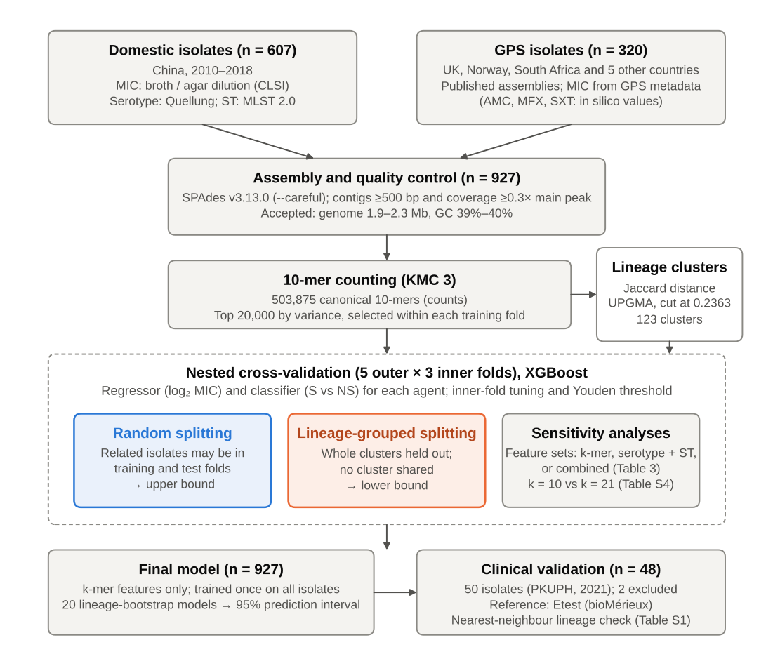

Figure 1. Workflow of the study.
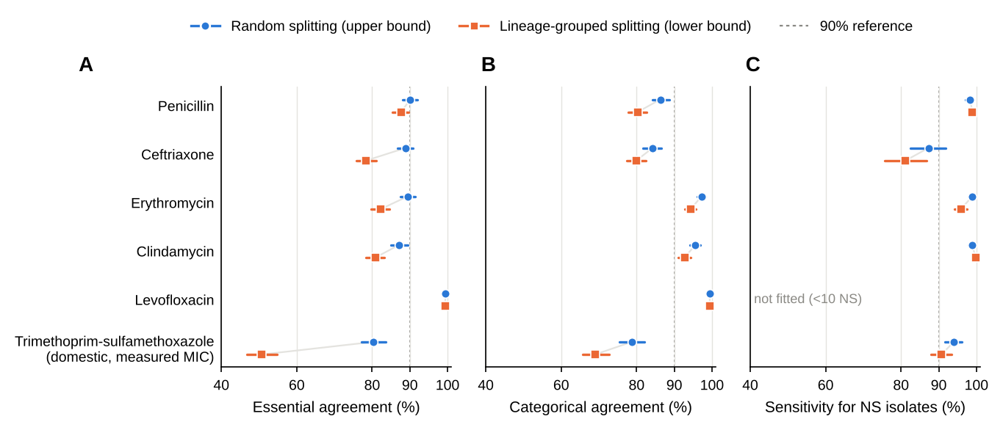

Figure 2. Cross-validated performance of the k-mer models under random and lineage-grouped splitting (n = 927).
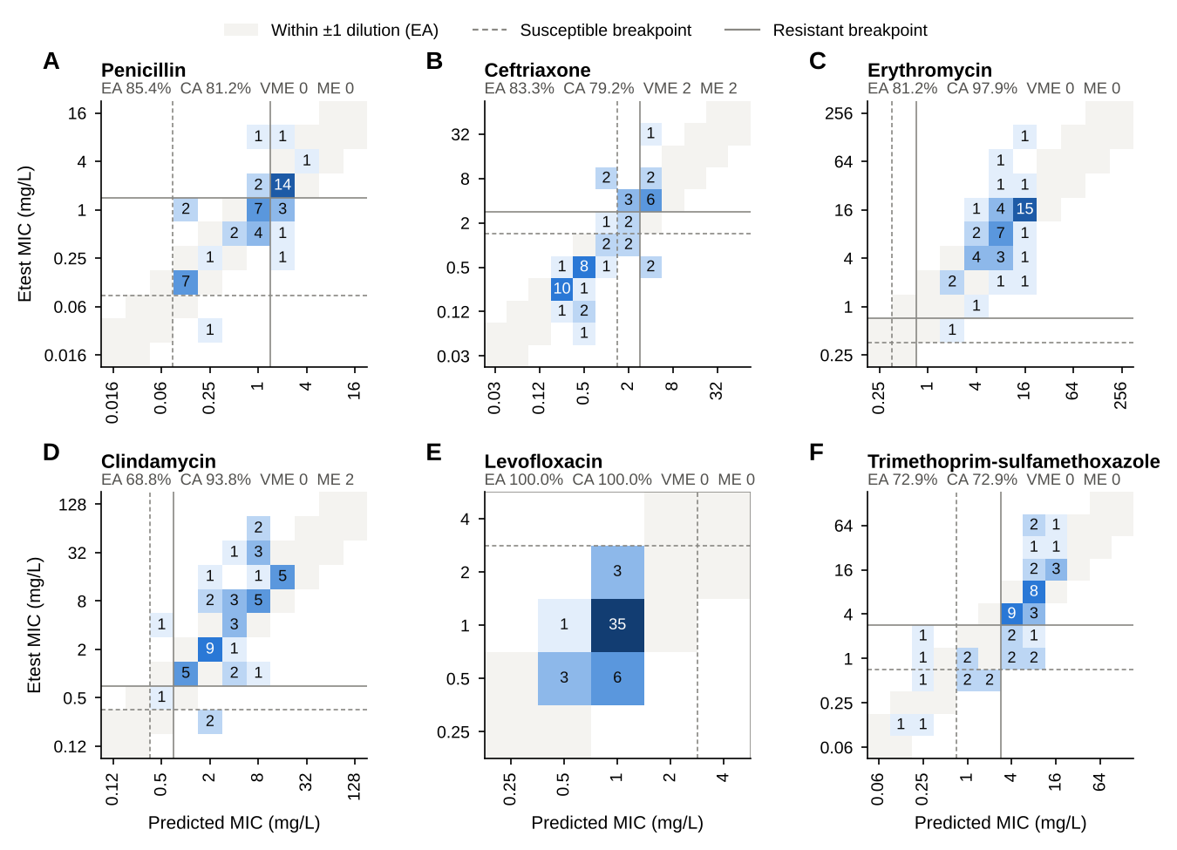

Figure 3. Comparison of predicted MICs and Etest MICs in 48 clinical validation isolates.
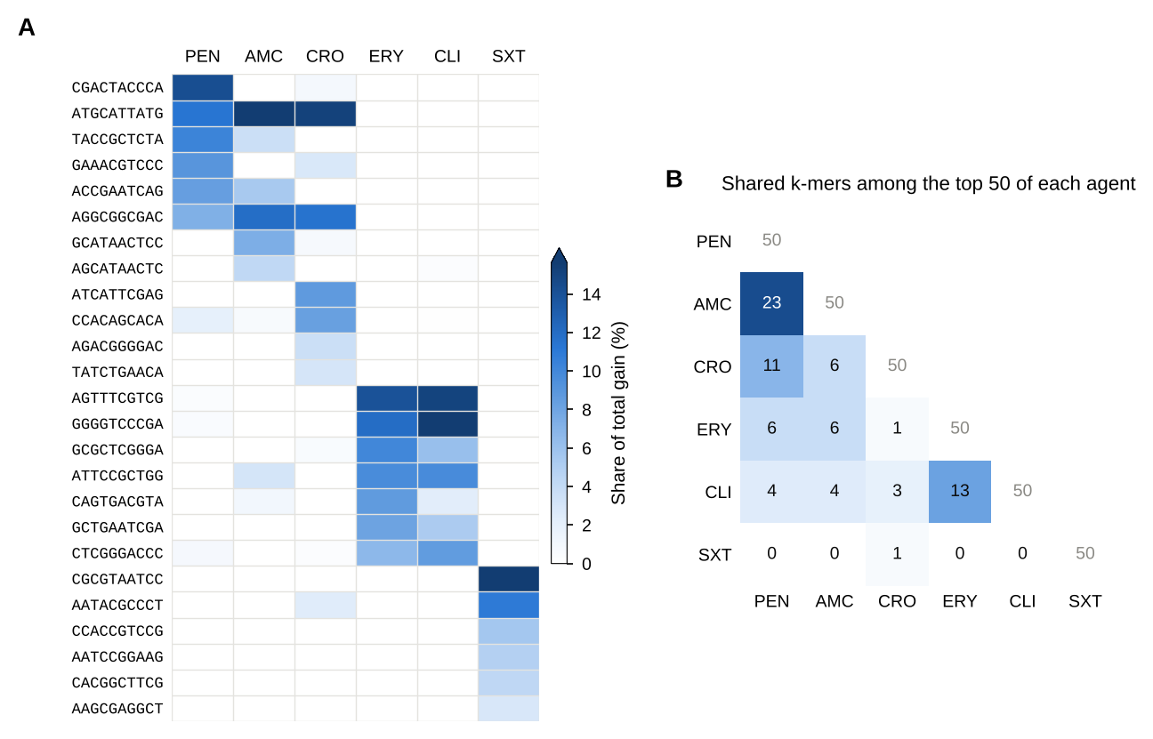

Figure 4. Important k-mers in the regression models (lineage-grouped cross-validation, k-mer features).

Tables
Table 1. Characteristics and antimicrobial susceptibility of the training (n = 927) and clinical validation (n = 48) S. pneumoniae isolates
Characteristic | Domestic training (n = 607) | GPS training (n = 320) | Clinical validation (n = 48)
Isolates, n | 607 | 320 | 48
Country of origin; collection period | China; 2010–2018 ᵇ | UK 144, Norway 121, South Africa 38, other 17 | China; 2021
Patient age, median (IQR), y | – | – | 38.0 (3.0–63.0)
Age group, n | – | – | <5 y 16, 5–17 y 4, 18–64 y 16, ≥65 y 11; missing 1
Specimen, n | – | – | Sputum 34, Blood 9, CSF 3, Pleural fluid 1, BALF 1
Serotypes, n | 54 | 40 | 11
Sequence types, n | 124 | 121 | 24
Most common serotypes, n | 19F (192), 19A (83), 23F (54), 14 (45), 6A (29) | 8 (66), 3 (36), 22F (21), 9N (20), 23B (16) | 19F (20), 23F (9), 6B (4), 19A (4), 6A (3)
Most common STs, n | ST271 (139), ST320 (61), ST876 (41), ST81 (22), ST505 (17) | ST53 (59), ST180 (27), ST433 (20), ST66 (12), ST62 (9) | ST271 (16), ST13646 (5), ST230 (3), ST9114 (2), ST8589 (2)
MIC method | Agar/broth dilution (CLSI) | Reported in GPS metadata ᵃ | Etest
Serotyping / MLST | Quellung / MLST 2.0 | GPS metadata | SeroBA / mlst (PubMLST)
In a training lineage cluster, n | – | – | 47/48 (CC271 cluster 21/48)
Jaccard distance to nearest training isolate, median (IQR) | – | – | 0.088 (0.055–0.111)

Antimicrobial agent | Domestic: S / I / R, n (%) | GPS: S / I / R, n (%) | Validation: S / I / R, n (%)
PEN – Penicillin | 0 (0.0) / 236 (38.9) / 371 (61.1) | 273 (85.3) / 39 (12.2) / 8 (2.5) | 1 (2.1) / 28 (58.3) / 19 (39.6)
CRO – Ceftriaxone | 428 (70.5) / 51 (8.4) / 128 (21.1) | 318 (99.4) / 2 (0.6) / 0 (0.0) | 31 (64.6) / 3 (6.2) / 14 (29.2)
ERY – Erythromycin | 10 (1.6) / 5 (0.8) / 592 (97.5) | 283 (88.4) / 0 (0.0) / 37 (11.6) | 0 (0.0) / 1 (2.1) / 47 (97.9)
CLI – Clindamycin | 39 (6.4) / 5 (0.8) / 563 (92.8) | 304 (95.0) / 0 (0.0) / 16 (5.0) | 2 (4.2) / 1 (2.1) / 45 (93.8)
LVX – Levofloxacin | 606 (99.8) / 0 (0.0) / 1 (0.2) | 316 (98.8) / 3 (0.9) / 1 (0.3) | 48 (100.0) / 0 (0.0) / 0 (0.0)
SXT – Trimethoprim-sulfamethoxazole | 142 (23.4) / 47 (7.7) / 418 (68.9) | 268 (83.8) / 5 (1.6) / 47 (14.7) | 7 (14.6) / 11 (22.9) / 30 (62.5)
AMC – Amoxicillin-clavulanate | 395 (65.1) / 60 (9.9) / 152 (25.0) | 317 (99.1) / 2 (0.6) / 1 (0.3) | Not tested
MFX – Moxifloxacin | 606 (99.8) / 1 (0.2) / 0 (0.0) | 319 (99.7) / 1 (0.3) / 0 (0.0) | Not tested
S, susceptible; I, intermediate; R, resistant; ST, sequence type; GPS, Global Pneumococcal Sequencing project. Categories were assigned with CLSI M100 breakpoints (mg/L, S / I / R): penicillin ≤0.06 / 0.12–1 / ≥2 (oral); ceftriaxone ≤1 / 2 / ≥4 (non-meningitis); erythromycin and clindamycin ≤0.25 / 0.5 / ≥1; levofloxacin ≤2 / 4 / ≥8; trimethoprim-sulfamethoxazole ≤0.5 / 1–2 / ≥4; amoxicillin-clavulanate ≤2 / 4 / ≥8; moxifloxacin ≤1 / 2 / ≥4.
ᵃ MICs as recorded in the GPS metadata. For trimethoprim-sulfamethoxazole, amoxicillin-clavulanate and moxifloxacin, GPS values are genotype-derived (in silico) predictions rather than phenotypic measurements; amoxicillin-clavulanate and moxifloxacin are therefore reported only in the Supplementary Material, and trimethoprim-sulfamethoxazole results are additionally reported for domestic isolates alone.
The 48 validation isolates were collected at Peking University People's Hospital in 2021 and were not part of the training set; two of 50 sequenced isolates (V-36, V-48) were excluded because of suspected mixed culture (abnormal genome size and GC content). Validation serotypes were determined in silico with SeroBA and STs with mlst (PubMLST scheme); per-isolate data are given in Table S1. Lineage cluster membership and nearest-neighbour distances were computed on the training-set variable 10-mers (Jaccard distance; cluster threshold 0.2363).
ᵇ Collected in previous studies [1–3].

Table 2. Cross-validated performance of the k-mer XGBoost models under random and lineage-grouped splitting (n = 927)
Agent | Split | EA, % (95% CI) | CA, % (95% CI) | VME, n/N (%) | ME, n/N (%) | mE, % | AUROC, % (95% CI) | NS sensitivity, % (95% CI) | Specificity, % (95% CI) | AUROC within GPS, % (95% CI)
PEN | Random | 90.1 (88.0–92.0) | 86.3 (84.2–88.7) | 1/379 (0.3) | 0/273 (0.0) | 13.6 | 99.8 (99.5–99.9) | 98.3 (97.1–99.2) | 98.5 (96.8–99.7) | 97.1 (94.0–99.4)
 | Lineage | 87.7 (85.4–89.8) | 80.3 (77.8–82.7) | 1/379 (0.3) | 0/273 (0.0) | 19.6 | 99.5 (99.0–99.8) | 98.9 (98.1–99.7) | 96.0 (93.6–98.1) | 94.4 (88.4–98.3)
CRO | Random | 88.9 (86.7–90.8) | 84.3 (81.8–86.5) | 26/128 (20.3) | 14/746 (1.9) | 11.4 | 90.5 (87.8–93.1) | 87.3 (82.5–91.9) | 83.8 (81.1–86.5) | – ᶜ
 | Lineage | 78.4 (75.8–81.0) | 79.9 (77.3–82.5) | 128/128 (100.0) | 0/746 (0.0) | 6.3 | 86.9 (84.0–89.6) | 81.2 (75.6–86.7) | 76.8 (73.9–79.7) | – ᶜ
ERY | Random | 89.4 (87.5–91.5) | 97.2 (96.1–98.3) | 3/629 (0.5) | 9/293 (3.1) | 1.5 | 98.4 (97.1–99.4) | 98.9 (98.0–99.5) | 96.9 (95.0–98.7) | 94.3 (86.4–99.6)
 | Lineage | 82.3 (79.7–84.7) | 94.4 (92.8–95.8) | 15/629 (2.4) | 23/293 (7.8) | 1.5 | 98.3 (97.1–99.2) | 95.9 (94.2–97.4) | 97.3 (95.4–99.0) | 89.9 (84.3–94.6)
CLI | Random | 87.2 (85.0–89.5) | 95.6 (94.2–96.9) | 1/579 (0.2) | 31/343 (9.0) | 1.0 | 96.4 (94.9–97.7) | 98.8 (97.8–99.6) | 89.8 (86.4–92.8) | 94.1 (80.6–100.0)
 | Lineage | 80.9 (78.4–83.3) | 92.8 (91.0–94.4) | 1/579 (0.2) | 47/343 (13.7) | 2.0 | 96.0 (94.5–97.5) | 99.8 (99.5–100.0) | 89.2 (85.8–92.4) | 95.2 (84.8–99.9)
LVX | Random | 99.4 (98.8–99.8) | 99.4 (98.8–99.8) | 2/2 (100.0) | 0/922 (0.0) | 0.4 | NF | NF | NF | NF
 | Lineage | 99.4 (98.8–99.8) | 99.5 (98.9–99.9) | 2/2 (100.0) | 0/922 (0.0) | 0.3 | NF | NF | NF | NF
SXT | Random | 85.1 (82.7–87.4) | 83.9 (81.4–86.1) | 19/465 (4.1) | 18/410 (4.4) | 12.1 | 95.4 (93.9–96.7) | 93.6 (91.5–95.7) | 89.5 (86.6–92.4) | 97.2 (92.9–99.7)
 | Lineage | 64.2 (60.9–67.3) | 75.7 (72.9–78.4) | 29/465 (6.2) | 15/410 (3.7) | 19.5 | 93.7 (91.8–95.2) | 87.2 (84.3–90.1) | 89.0 (85.9–91.8) | 97.0 (92.5–99.5)
SXT, domestic ᵇ | Random | 80.4 (77.3–83.5) | 78.7 (75.5–82.0) | 18/418 (4.3) | 17/142 (12.0) | 15.5 | 89.3 (86.0–92.3) | 94.0 (91.6–96.1) | 73.9 (66.7–81.5) | –
 | Lineage | 50.7 (46.8–54.9) | 69.0 (65.7–72.7) | 28/418 (6.7) | 14/142 (9.9) | 24.1 | 85.4 (81.6–88.9) | 90.8 (87.9–93.4) | 70.4 (62.8–77.7) | –
Results are pooled out-of-fold predictions from 5-fold outer × 3-fold inner nested cross-validation; hyperparameters were tuned independently for each agent, and the classification threshold was selected within the training folds (Youden index). Random, isolates assigned to folds at random (no lineage separation; upper bound); Lineage, folds formed from 123 k-mer lineage clusters (Jaccard distance threshold 0.2363) so that no cluster appears in both training and test sets (lower bound). 95% CIs were obtained by bootstrap (1,000 resamples).
EA, essential agreement (predicted MIC within ±1 doubling dilution); CA, categorical agreement (S/I/R); VME, very major error (reference R, predicted S; denominator, reference-resistant isolates); ME, major error (reference S, predicted R; denominator, reference-susceptible isolates); mE, minor error (denominator, all isolates); NS, non-susceptible (I + R); NF, classifier not fitted (<10 NS isolates). EA, CA and error rates derive from the MIC regression model; AUROC, sensitivity and specificity from the S/NS classifier.
All domestic isolates were penicillin-NS and 97.5% erythromycin-R, so pooled AUROC partly reflects isolate origin; AUROC within the GPS subset, which contains both classes, is shown as a less confounded estimate.
ᵇ Domestic isolates only (n = 607; phenotypically measured MICs). GPS trimethoprim-sulfamethoxazole MICs are in silico values.
ᶜ Not informative: only 2 GPS isolates were ceftriaxone-NS.

Table 3. Contribution of k-mer and typing features under lineage-grouped cross-validation (n = 927)
Agent | Feature set | EA, % (95% CI) | CA, % (95% CI) | VME, n/N (%) | AUROC, % (95% CI) | AUROC within GPS, % (95% CI)
PEN | k-mer only | 87.7 (85.4–89.8) | 80.3 (77.8–82.7) | 1/379 (0.3) | 99.5 (99.0–99.8) | 94.4 (88.4–98.3)
 | Serotype + ST | 28.8 (25.9–31.5) | 29.6 (26.6–32.5) | 2/379 (0.5) | 80.2 (77.1–83.2) | 62.3 (52.8–71.5)
 | Combined | 88.0 (85.9–90.2) | 81.7 (79.2–84.1) | 1/379 (0.3) | 99.4 (99.0–99.8) | 94.7 (89.4–99.0)
CRO | k-mer only | 78.4 (75.8–81.0) | 79.9 (77.3–82.5) | 128/128 (100.0) | 86.9 (84.0–89.6) | – ᶜ
 | Serotype + ST | 67.3 (64.2–70.3) | 80.5 (78.0–83.0) | 128/128 (100.0) | 78.1 (74.0–82.1) | – ᶜ
 | Combined | 79.6 (76.7–82.0) | 78.6 (76.1–81.1) | 108/128 (84.4) | 80.9 (77.8–83.8) | – ᶜ
ERY | k-mer only | 82.3 (79.7–84.7) | 94.4 (92.8–95.8) | 15/629 (2.4) | 98.3 (97.1–99.2) | 89.9 (84.3–94.6)
 | Serotype + ST | 46.4 (43.3–49.8) | 68.7 (65.7–71.5) | 26/629 (4.1) | 78.3 (75.0–81.6) | 58.8 (49.8–67.6)
 | Combined | 83.3 (80.8–85.5) | 94.0 (92.3–95.5) | 13/629 (2.1) | 97.8 (96.4–98.9) | 87.0 (80.7–92.4)
CLI | k-mer only | 80.9 (78.4–83.3) | 92.8 (91.0–94.4) | 1/579 (0.2) | 96.0 (94.5–97.5) | 95.2 (84.8–99.9)
 | Serotype + ST | 26.9 (23.9–29.8) | 62.6 (59.3–65.7) | 24/579 (4.1) | 78.5 (75.4–81.5) | 70.3 (57.9–81.5)
 | Combined | 83.8 (81.4–86.1) | 94.1 (92.7–95.5) | 1/579 (0.2) | 96.4 (95.0–97.7) | 96.2 (88.1–99.9)
SXT | k-mer only | 64.2 (60.9–67.3) | 75.7 (72.9–78.4) | 29/465 (6.2) | 93.7 (91.8–95.2) | 97.0 (92.5–99.5)
 | Serotype + ST | 28.2 (25.3–31.0) | 25.1 (22.3–27.8) | 47/465 (10.1) | 66.7 (62.7–70.2) | 41.4 (33.0–50.1)
 | Combined | 73.4 (70.7–76.1) | 75.7 (72.8–78.4) | 33/465 (7.1) | 94.0 (92.3–95.3) | 97.2 (93.6–99.5)
Serotype + ST, one-hot encoded serotype and sequence type only; Combined, k-mer features plus serotype and ST. Levofloxacin is omitted because ≤5 isolates were NS. Results under random splitting are given in Table S3. ᶜ Not informative (2 ceftriaxone-NS GPS isolates). Abbreviations as in Table 2.

Table 4. Performance of the final k-mer model in 48 clinical validation isolates compared with Etest
Agent | Reference S/I/R | EA, n/N (%; 95% CI) | CA, n/N (%; 95% CI) | VME, n/N (%; 95% CI) | ME, n/N (%; 95% CI) | mE, n/N (%; 95% CI) | Bias, log₂ (95% LoA) | AUROC, % (95% CI) | NS sensitivity, n/N (%; 95% CI) | Specificity, n/N (%; 95% CI)
PEN | 1/28/19 | 41/48 (85.4; 72.8–92.8) | 39/48 (81.2; 68.1–89.8) | 0/19 (0.0; 0.0–16.8) | 0/1 (0.0; 0.0–79.3) | 9/48 (18.8; 10.2–31.9) | +0.09 (-2.07, 2.24) | 79.8 (67.0–90.4) | 47/47 (100.0; 92.4–100.0) | 0/1 (0.0; 0.0–79.3)
CRO | 31/3/14 | 40/48 (83.3; 70.4–91.3) | 38/48 (79.2; 65.7–88.3) | 2/14 (14.3; 4.0–39.9) | 2/31 (6.5; 1.8–20.7) | 6/48 (12.5; 5.9–24.7) | +0.05 (-2.37, 2.48) | 86.7 (76.0–96.1) | 15/17 (88.2; 65.7–96.7) | 25/31 (80.6; 63.7–90.8)
ERY | 0/1/47 | 39/48 (81.2; 68.1–89.8) | 47/48 (97.9; 89.1–99.6) | 0/47 (0.0; 0.0–7.6) | NE | 1/48 (2.1; 0.4–10.9) | -0.07 (-2.41, 2.27) | NE | 48/48 (100.0; 92.6–100.0) | NE
CLI | 2/1/45 | 33/48 (68.8; 54.7–80.1) | 45/48 (93.8; 83.2–97.9) | 0/45 (0.0; 0.0–7.9) | 2/2 (100.0; 34.2–100.0) | 1/48 (2.1; 0.4–10.9) | -0.36 (-3.35, 2.63) | 62.0 (40.0–80.9) | 45/46 (97.8; 88.7–99.6) | 0/2 (0.0; 0.0–65.8)
LVX | 48/0/0 | 48/48 (100.0; 92.6–100.0) | 48/48 (100.0; 92.6–100.0) | NE | 0/48 (0.0; 0.0–7.4) | 0/48 (0.0; 0.0–7.4) | -0.03 (-0.92, 0.86) | NF | NF | NF
SXT | 7/11/30 | 35/48 (72.9; 59.0–83.4) | 35/48 (72.9; 59.0–83.4) | 0/30 (0.0; 0.0–11.4) | 0/7 (0.0; 0.0–35.4) | 13/48 (27.1; 16.6–41.0) | +0.13 (-2.75, 3.01) | 78.6 (50.7–97.4) | 37/41 (90.2; 77.5–96.1) | 4/7 (57.1; 25.0–84.2)
The final model was trained once on all 927 training isolates (k-mer features only) and applied without modification to the validation isolates. Reference MICs were determined by Etest; training MICs by agar or broth dilution. Proportions are shown with Wilson 95% CIs; AUROC with bootstrap 95% CIs (2,000 resamples). Bias is the mean difference between continuous predicted and reference log₂ MIC, with 95% limits of agreement (LoA).
NE, not estimable (no isolates in the denominator, or only one class present); NF, classifier not fitted. Other abbreviations as in Table 2. Penicillin and ceftriaxone categories use oral and non-meningitis breakpoints, respectively.

