DATE | SOURCE | IMAGE | REASON
23/3/26 | https://openverse.org/ | 
23/3/26 | https://openverse.org/ | 
23/3/26 | https://openverse.org/ | 
23/3/26 | https://openverse.org/ | 
23/3/26 | https://openverse.org/ | 
23/3/26 | https://openverse.org/ | 
23/3/26 | https://openverse.org/ | 
23/3/26 | https://openverse.org/ | 
23/3/26 | https://openverse.org/ | 
23/3/26 | https://openverse.org/ | 
23/3/26 | https://openverse.org/ | 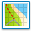
23/3/26 | https://openverse.org/ | 
23/3/26 | https://openverse.org/ | 
23/3/26 | https://openverse.org/ | 
24/3/26 | https://stock.adobe.com/search?k=meat+banner | 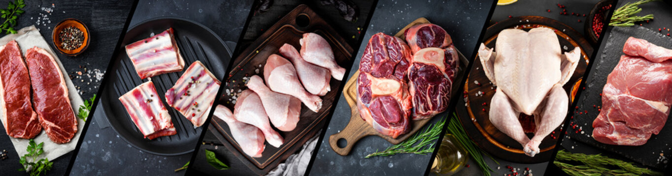
24/3/26 | https://openverse.org/image/a34b048e-bb53-4dff-af37-6d8d313cb6c3?q=farm+shop&p=11 | 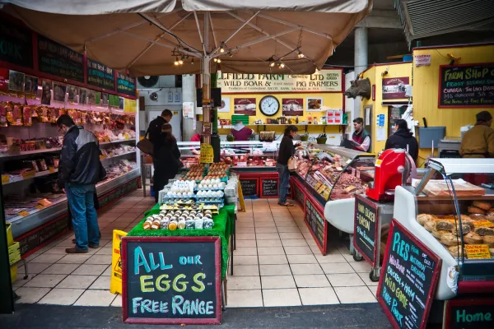
24/3/26 | https://openverse.org/image/551e2fa4-945c-483b-a91d-a04083aeea62?q=farmer&p=51 | 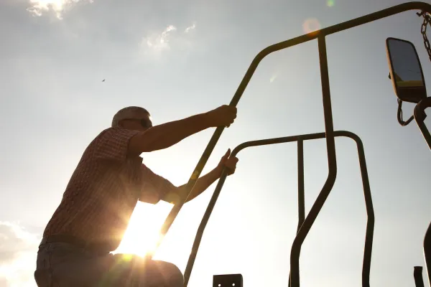
24/3/26 | https://openverse.org/image/3b5ce4c2-b330-46b3-ad33-45ce8f378675?q=farmer&p=52 | 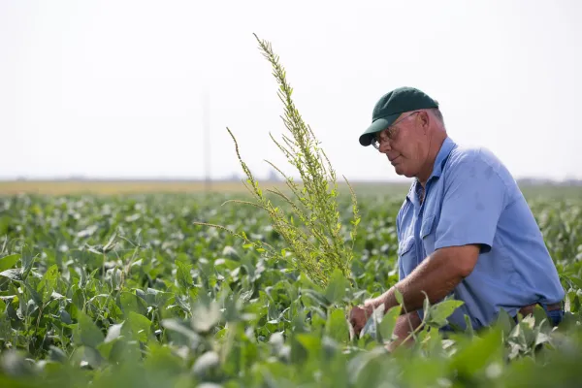
25/3/26 | https://stock.adobe.com/uk/search?k=banner+vegetable | 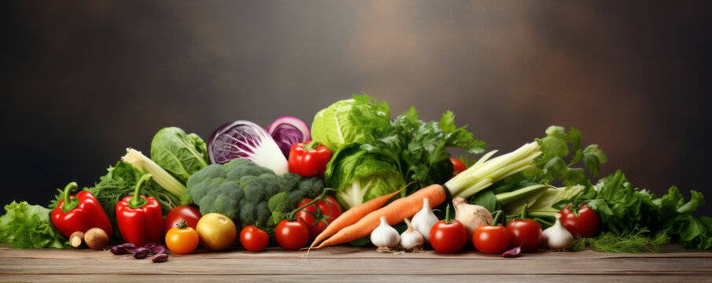
25/3/26 | https://stock.adobe.com/uk/search?k=eggs&asset_id=105081326 | 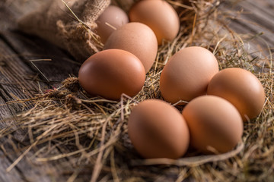
25/3/26 | https://stock.adobe.com/uk/search?k=fresh%2Bmeat&asset_id=243132640 | 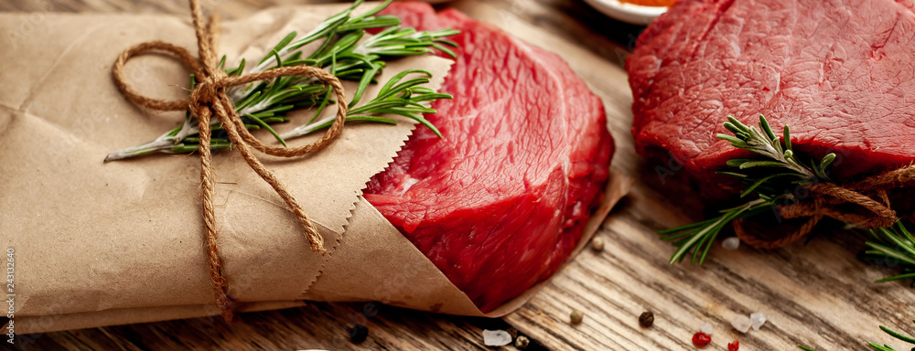
25/3/26 | https://stock.adobe.com/uk/search?k=carrots&asset_id=95449632 | 