1. STUDENT NAME 2. URL to STUDENT WEB SITE 3. user_role TABLE DESIGN 4. web_user TABLE DESIGN and FOREIGN KEY 5. “OTHER” TABLE DESIGN and FOREIGN KEY 6. DATA ENTRY ERRORS a) Error: Duplicate user_role PK b) Error: Invalid user_role FK in web_user record c) Error: Cannot delete a user_role record that’s referenced by a web _user record d) Invalid web_user FK in “other” record e) Error trying to delete a web_user record that’s referenced by an “other” record 7. SELECT STATEMENTS a) USER_ROLE: all rows, all columns, sorted by user_role_id. b) WEB_USER: all rows, all columns, sorted by web_user_id. c) WEB_USER JOINED WITH USER_ROLE: all rows, certain columns, sorted. f) “OTHER”: all rows, all columns, sorted by the id of your “other” table. g) “OTHER” JOINED WITH WEB_USER all rows, certain columns, sorted. h) “OTHER” JOINED WITH WEB_USER some rows, certain columns, sorted.

**Product Table**

-product_id int(11) (PRIMARY KEY)

-product_name varchar(45)

-img varchar(300)

-price decimal(8,2)

-stock int (11)

-web_user_id (11) (FOREIGN KEY)

a) add foreign key from ‘product’ table to web_user

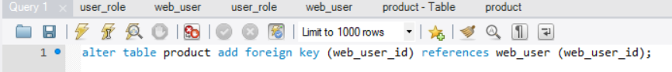

b) add data into ‘product’ table

**>> try to add ‘product’ with an invalid web_user_id 8 , then FK violation error**



**>> try to delete referenced web_user record, then error**



**c) Run SQL select statement**

1) select * from product (sort by product_id)



2) select product_name, price, user_email from product, web_user order by product_name, price;



3) select product_name, price, user_email from product,web_user where product.web_user_id=1;

