ED 200 – Teaching as a Professional NAME: _______________________

**CONSTRUCTIVISM vs BEHAVIORISM (Learning Theory)**

**PART I.** Provide a detailed description of each philosophy that answers the following questions:

Describe **CONSTRUCTIVSM** (3-5 sentences):

______________________________________________________________________________

______________________________________________________________________________

______________________________________________________________________________

______________________________________________________________________________

______________________________________________________________________________

What would be most important to a teacher who is an ‘**Constructivist**’?

______________________________________________________________________________

______________________________________________________________________________

______________________________________________________________________________

______________________________________________________________________________

What types of instructional strategies might be used by the teacher who is an ‘**Constructivist**’?

______________________________________________________________________________

______________________________________________________________________________

______________________________________________________________________________

______________________________________________________________________________

Citations: ______________________________________ ___________________________________________

______________________________________ ___________________________________________

Describe **BEHAVIORISM** (3-5 sentences):

______________________________________________________________________________

______________________________________________________________________________

______________________________________________________________________________

______________________________________________________________________________

______________________________________________________________________________

What would be most important to a teacher who is an ‘**Behaviorist**’?

______________________________________________________________________________

______________________________________________________________________________

______________________________________________________________________________

______________________________________________________________________________

What types of instructional strategies might be used by the teacher who is an ‘**Behaviorist**’?

______________________________________________________________________________

______________________________________________________________________________

______________________________________________________________________________

______________________________________________________________________________

Citations: ______________________________________ ___________________________________________

______________________________________ ___________________________________________

**PART II.** Analyze these two philosophies. Use a Venn Diagram to annotate the common aspects (if any) shared by each, while contrasting their distinct differences.

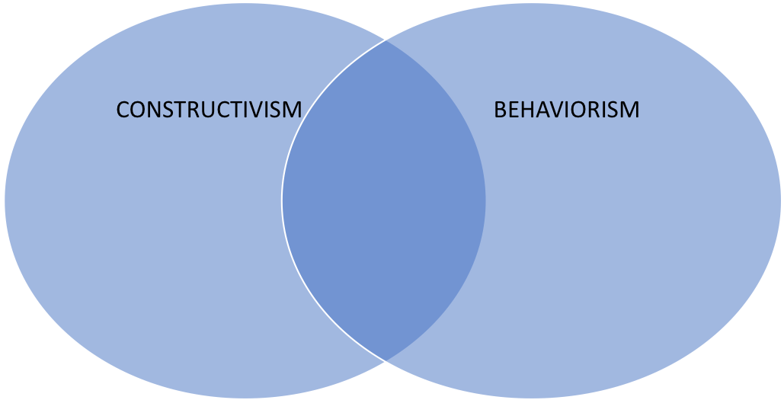

**PART III.** Identify 3 examples of ‘Constructivism’ and ‘Behavioralism’ observed in classes you have attended:

**CONSTRUCTIVISM**

1.

2.

3.

**BEHAVIORISM**

1.

2.

3.