**Homework #1**

1. **Write a program to generate following images**

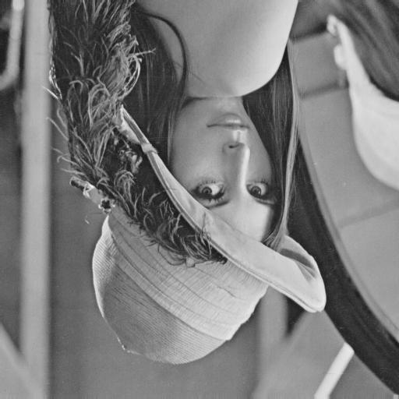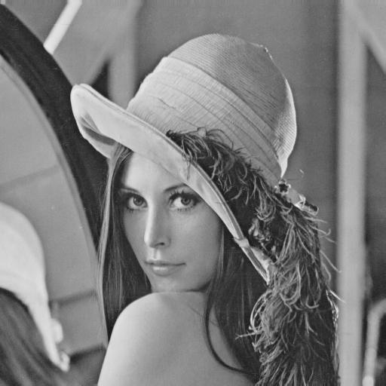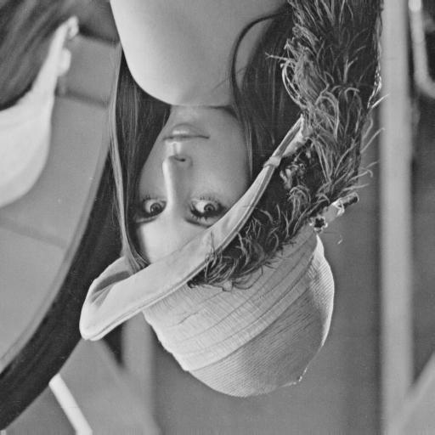

Figure 1: The result of upside down, right-side left and diagonally mirrored.

The program is written by Matlab, and it has only input of one channel bmp image. The algorithm is clarified as follow:

* 1. Upside down: Reshuffle row pixels from top to down once.
  2. Right-side Left: Reshuffle column pixels from left to right once.
  3. Diagonally mirrored: Reshuffle each pixels from top left to down right.

1. **Use Photoshop to generate following images**

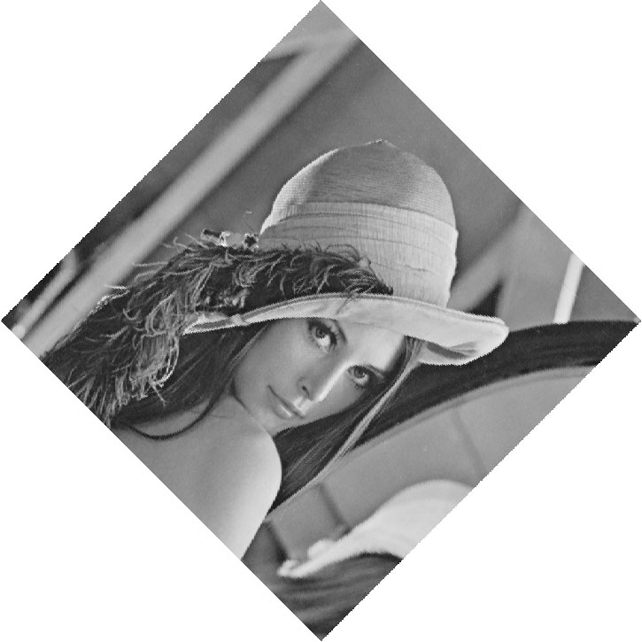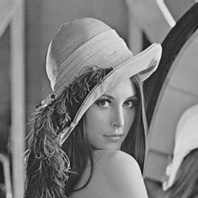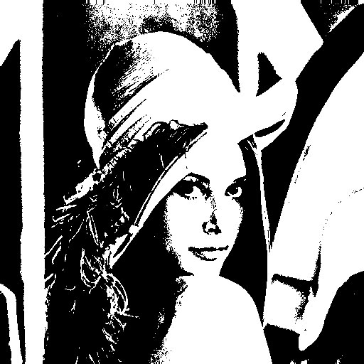

Figure 2: The result of rotating 45 degrees clockwise, shrinking, and binarizing at 128.

* 1. All results in 1.2 done by Adobe Photoshop CS3.