**Homework #10**

1. **Second order edge detection**

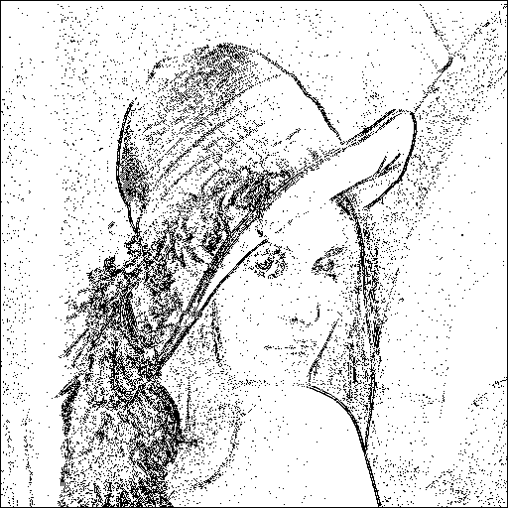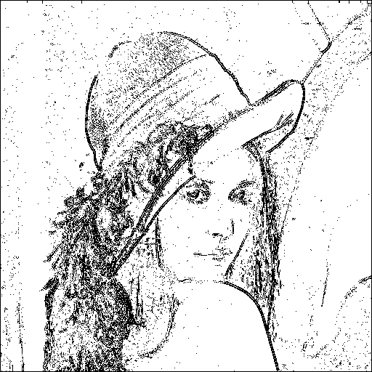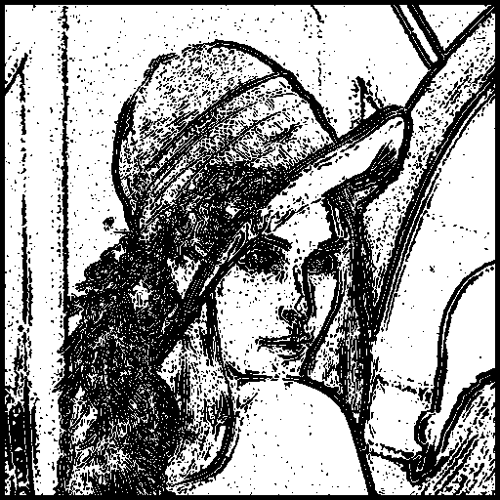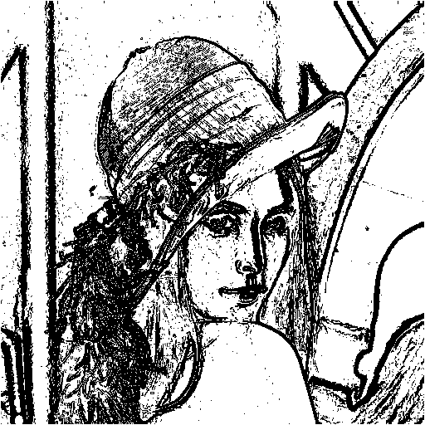

|  |  |  |  |
| --- | --- | --- | --- |
| 25 | 15 | 2400 | 0 |

Figure 1 and Table 1: the Lena edge wall and the threshold of each method.

We implement several edge detector set the threshold as Table 1 to get the result as Figure 1. The hardness of edge detector is deciding the zero crossing threshold value. Through the process we understand how the problem is difficult so no a non-heuristic is addressed at that time.

**Appendix**

The program is written by MATLAB. To run the program, copy the input data to the folder “dat/”, and run “src/hw10.m” to get the edge wall output.