**Homework #2**

1. **Write a program to generate following images**

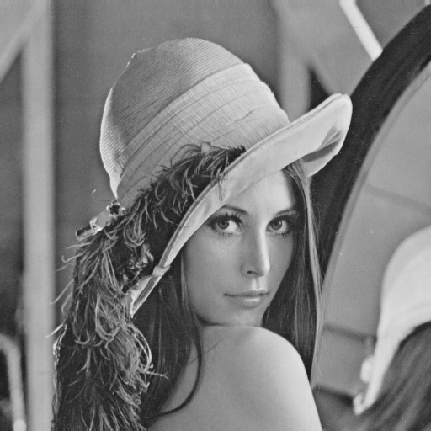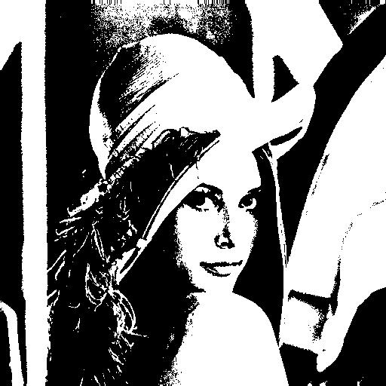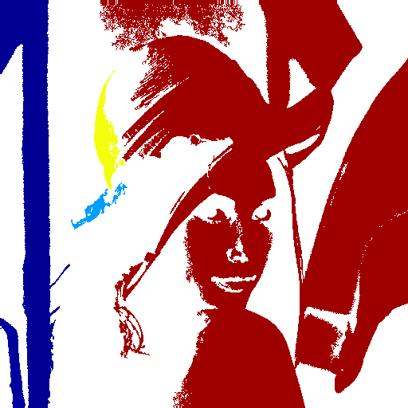

Figure 1: The result of binaried Lena, and connected component Lena.

The program is written by Matlab, and it has only input of one channel bmp image. The algorithm is clarified as follow:

* 1. Binarization: for all pixels in the image, take 128 as the threshold to reassign pixel value which lass than threshold to 0, otherwise to 1.
  2. Connected-component: after binarized input image, we assign pixel value from 1 to N and run top-down approach once and bottom-up approach to assign the label, then using Matlab function to transform the label to RGB color image for visualization.

1. **The histogram of Lena**

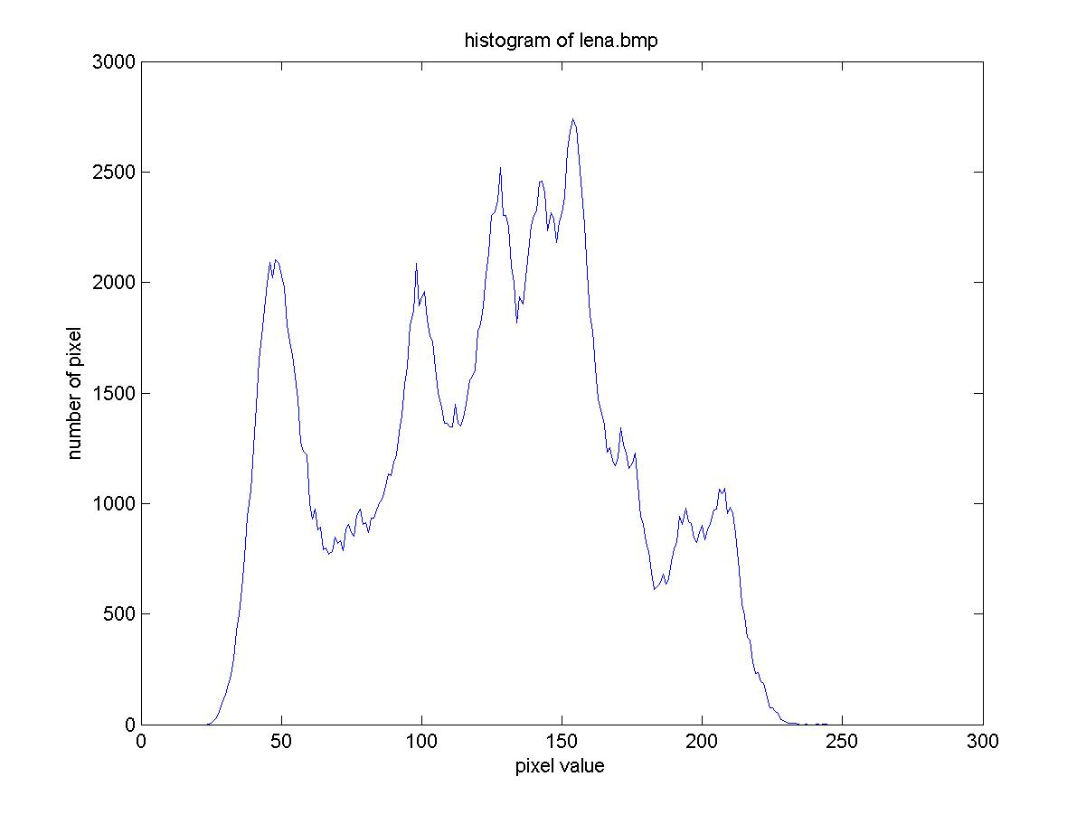

Figure 2: The histogram of image intensity of the Lena.

The program is written in Matlab, and the input is also a gray level intensity image lena.bmp. Algorithm is described as follow:

* 1. Create a vector with 256 bins.
  2. For any pixel in image, taking the intensity as index and add a unit at the bin witch indexing by that color.