**Homework #3**

1. **Write a program to generate following images**

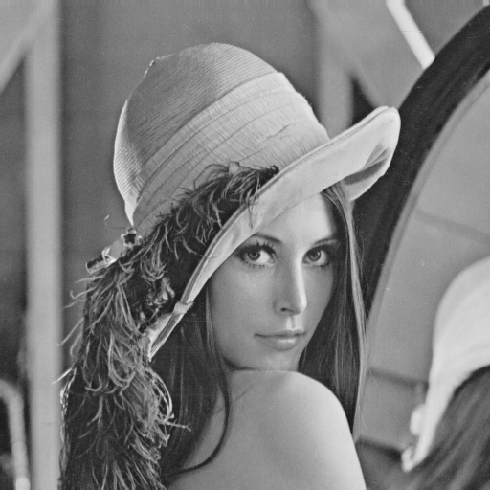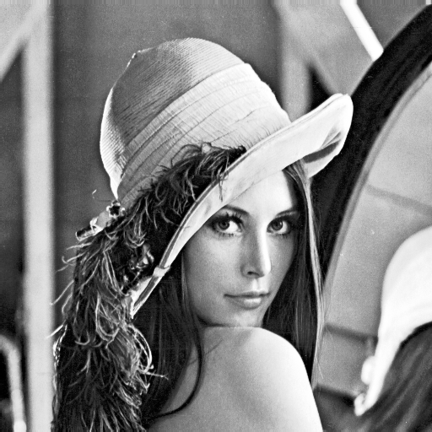

Figure 1: The comparison of Lena and equalized Lena.

We implement a histogram equalization method, which base on look up table method, to enhance the contrast of original image. As we can see in Figure 1, after equalized, Lena has darker hair and eyes.  
  
The statistic result in Figure 2 shows us the difference between two images. One is more dense and concentrated, and the other one is more sparse and scattered.

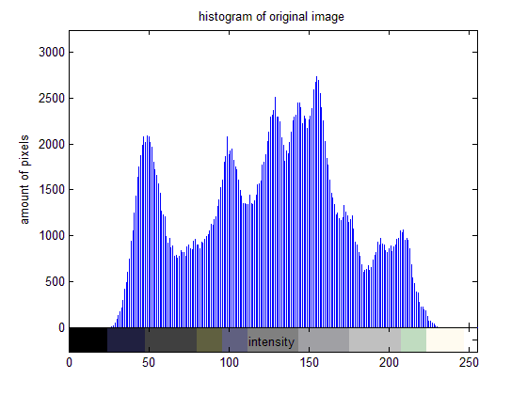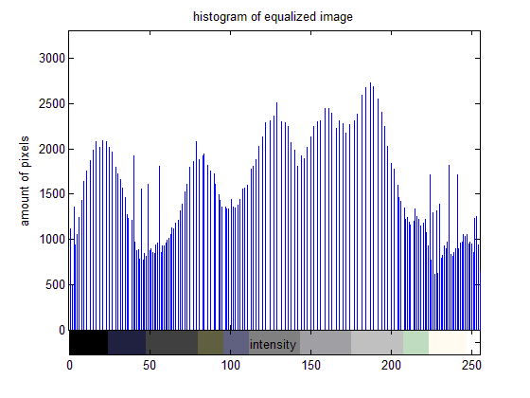

Figure 2: The histogram comparison of Lena and equalized Lena.

**Appendix**

The program is written by MATLAB. To run the program, copy the input data to the folder “dat/”, and run “src/enhance_stream.m” without any argument to get the output in “out/”.