**Homework #5**

1. **Image dilation and erosion**

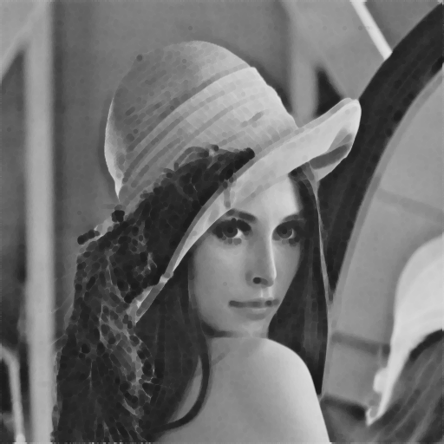

Figure 1: The comparison of dilation (left) and erosion (right) Lena.

We implement the binary dilation and erosion algorithm in a simple way. Define the dilation operator $Q=P⊕K$ as follow, taking dilation as finding the local maximum value through a given 3-5-5-5-3 kernel:

$$\left[\begin{matrix}0 & 1 & 1 & 1 & 0 \\ 1 & 1 & 1 & 1 & 1 \\ 1 & 1 & 1 & 1 & 1 \\ 1 & 1 & 1 & 1 & 1 \\ 0 & 1 & 1 & 1 & 0\end{matrix}\right]$$

In the other hand, $P=Q⊖K$ is defined as finding the local minimum in that given region.

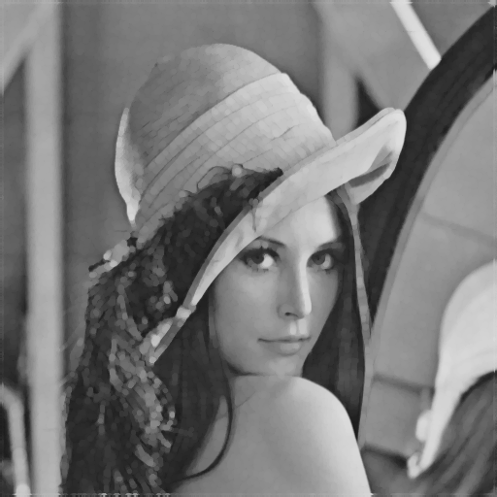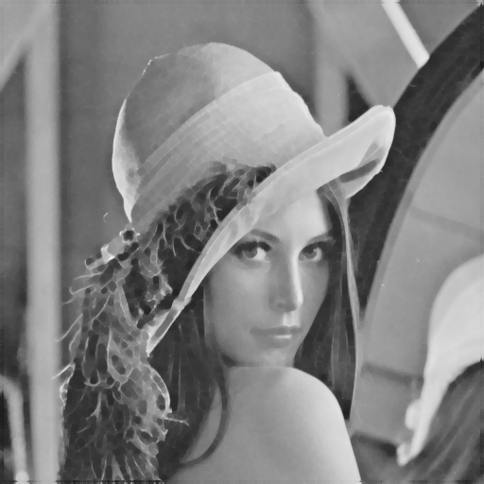

Figure 2: The comparison of opening (left) and closing (right) Lena.

1. **Cascading dilation and erosion**

We try to cascade two operations to form the new image with different effect. For image opening: we cascade erosion and dilation; for image closing we cascade dilation and erosion. The result shows in Figure 2.

**Appendix**

The program is written by MATLAB. To run the program, copy the input data to the folder “dat/”, and run “src/hw5_sh.m” without any argument to get the output in “out/”.