**Homework #7**

1. **Yokoi thinning operation**



Figure 1: The input image Lena.

We implement the thinning operation by iterative doing following sub operator:

Do

1. Yokoi number operator.
2. Pair relationship operator.
3. Connect shrink operator.

Until the picture didn’t upgrade anymore, we stop the iteration.

The program down-sample the input to 64 x 64, and the thinning history shows as follow. Because the picture is small, it only takes us 6 operations to thin the image:

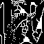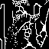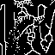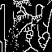

Figure 2: The history of thinning Lena.

**Appendix**

The program is written by MATLAB. To run the program, copy the input data to the folder “dat/”, and run “src/yokoiThinning.m” without any argument to get the output in “out/”.