**Homework #8**

1. **Image noising and de-noising processing**

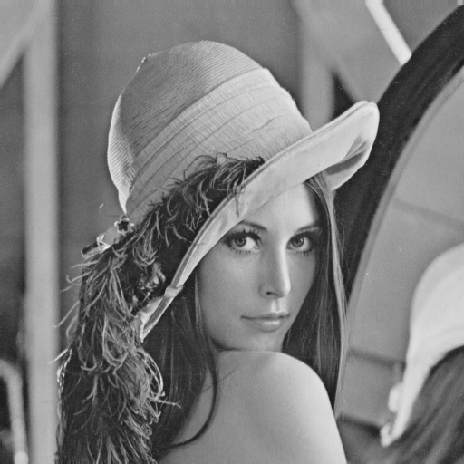

Figure 1: the original input image Lena.bmp

We implement a white noise generator and apply it to the input image Lena to get the 4 noised images as Figure 2’s first row shows. After that, we try a Gaussian low-pass filter and medium filter to see if they have capability to de-noise the images shows in Figure 2 second row to the last row show the result. The SNR value is shows in Table 1.

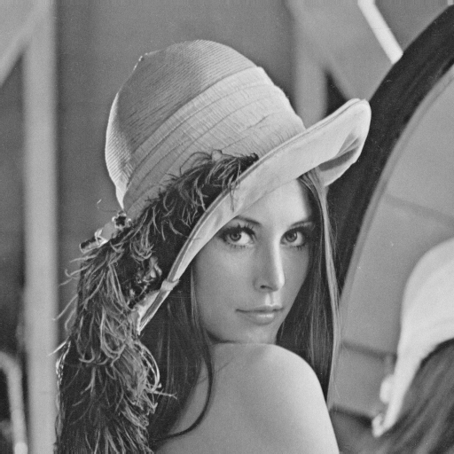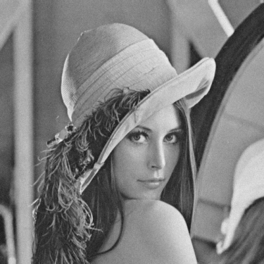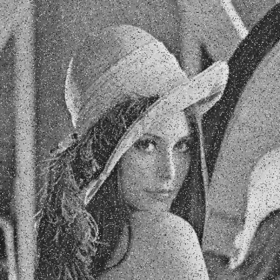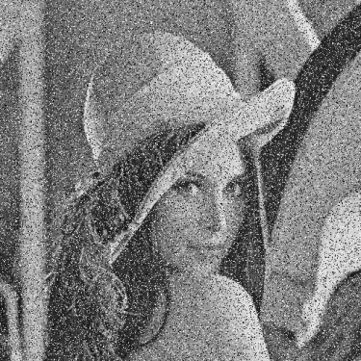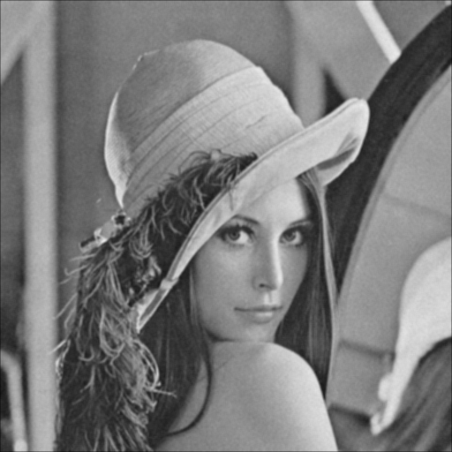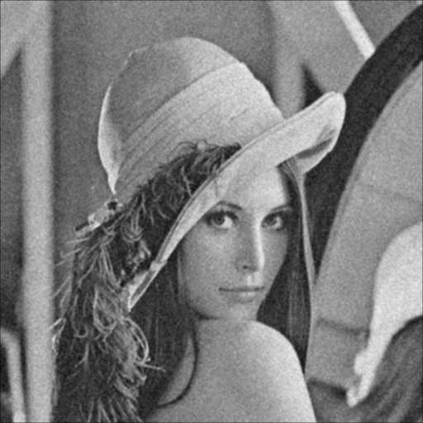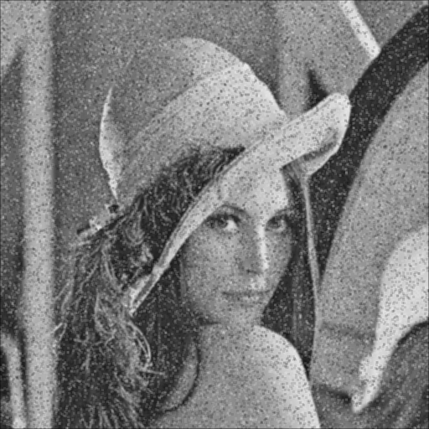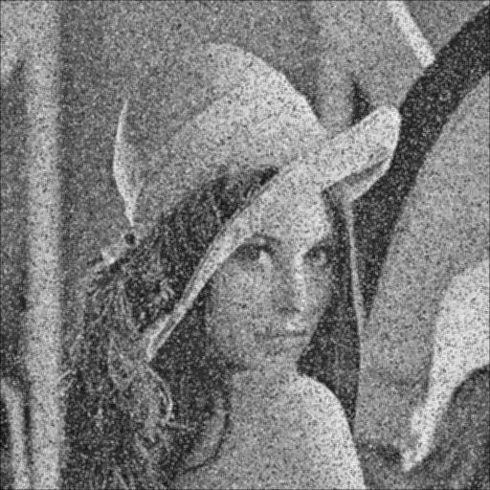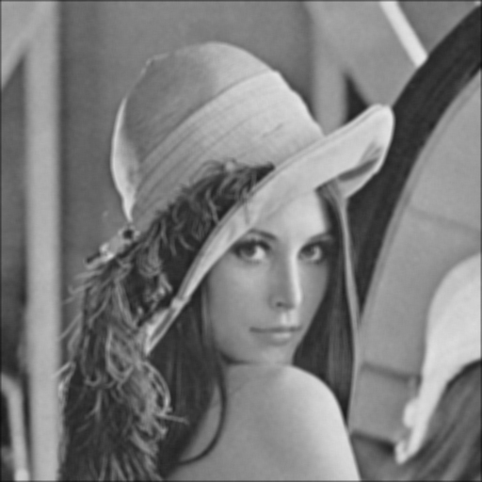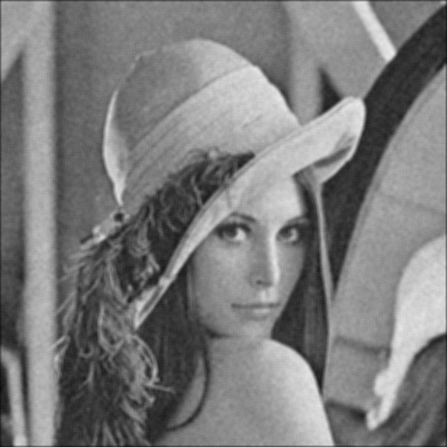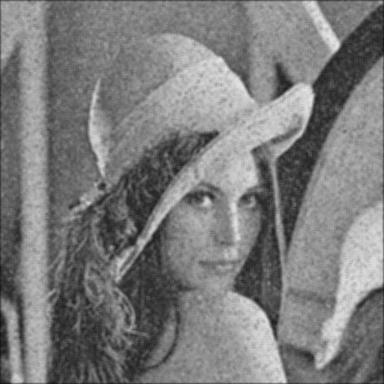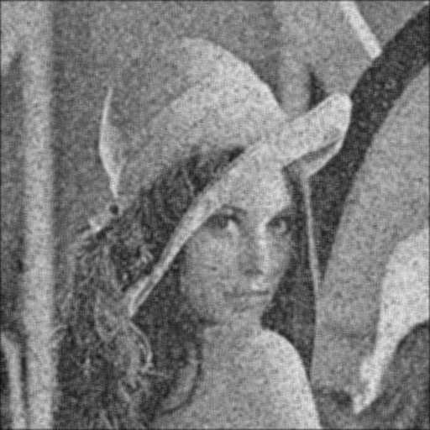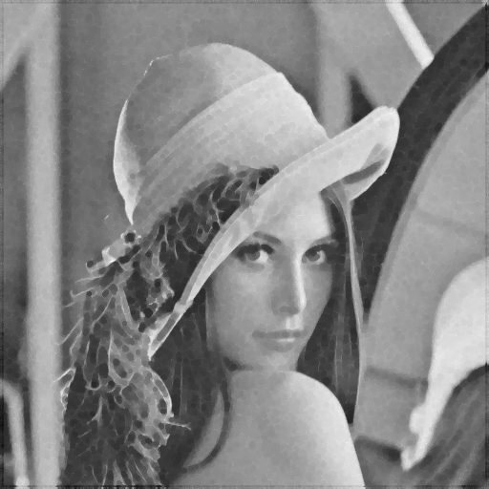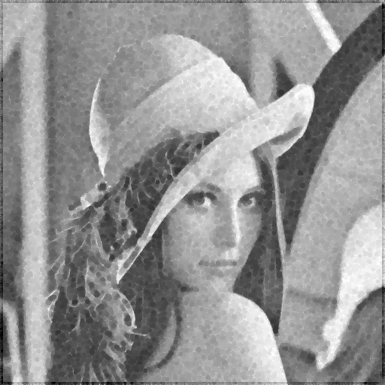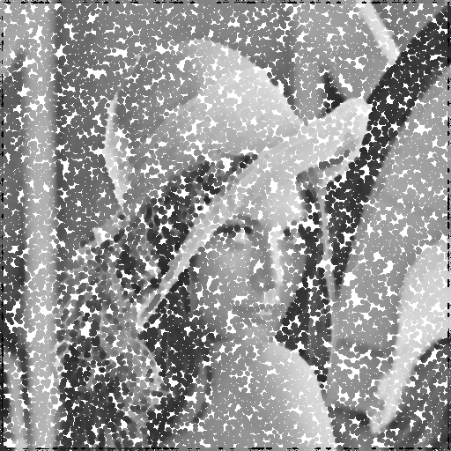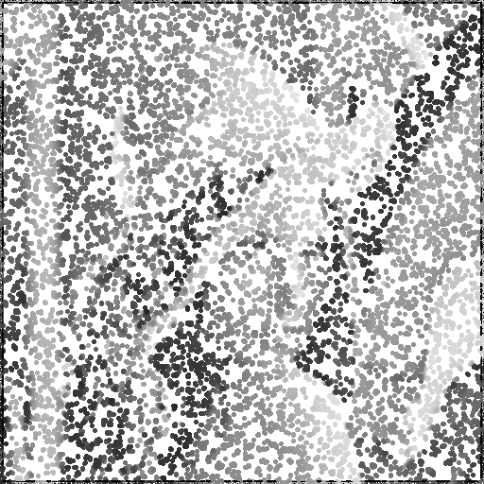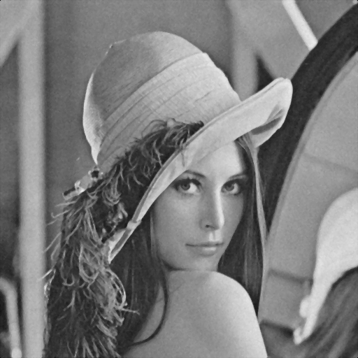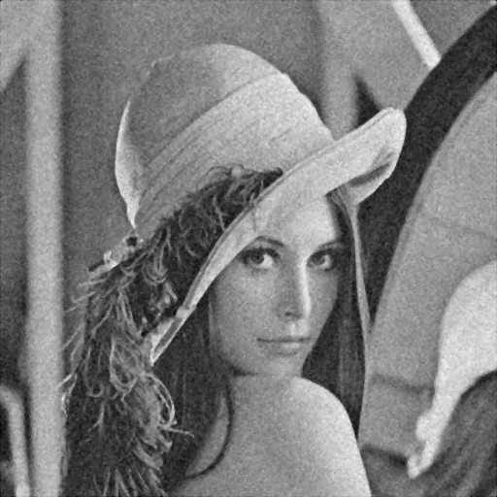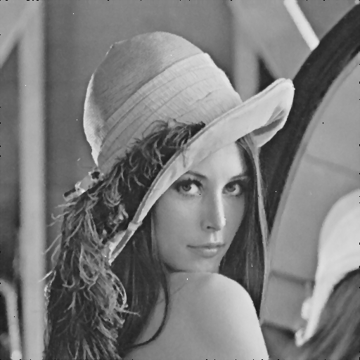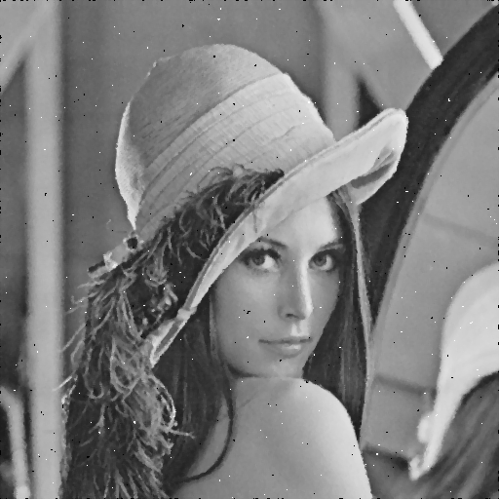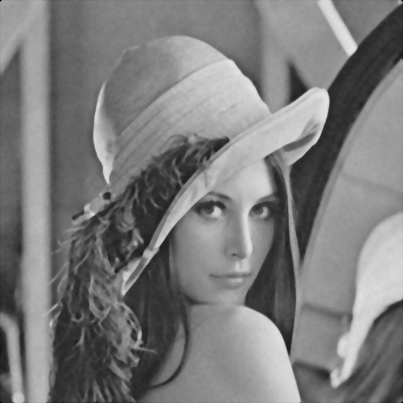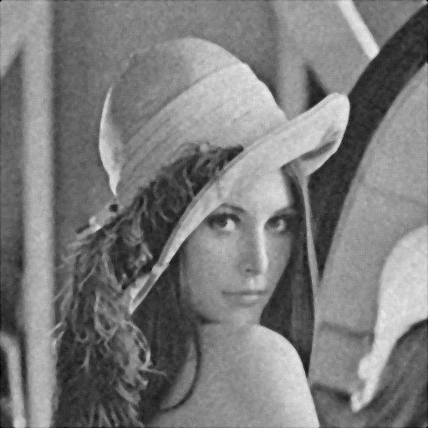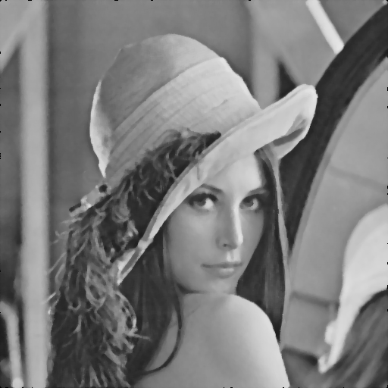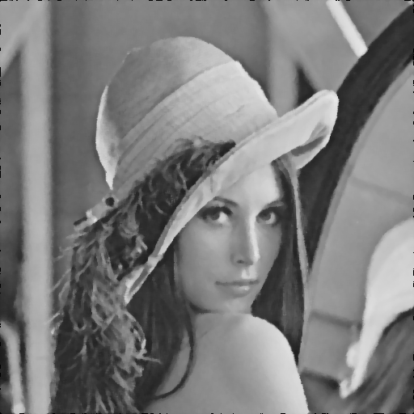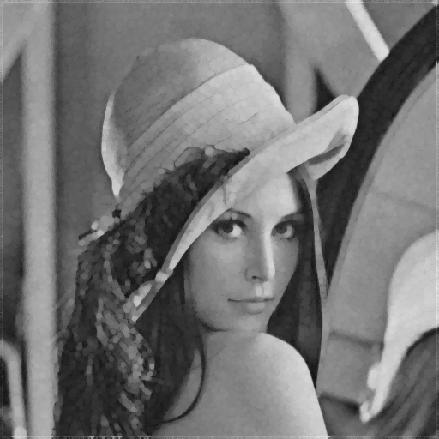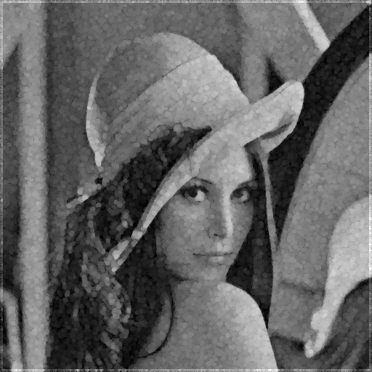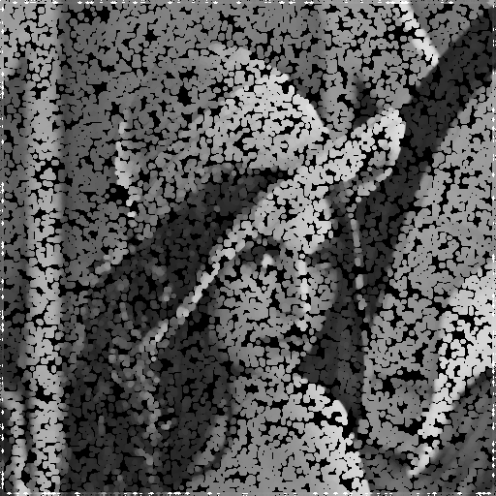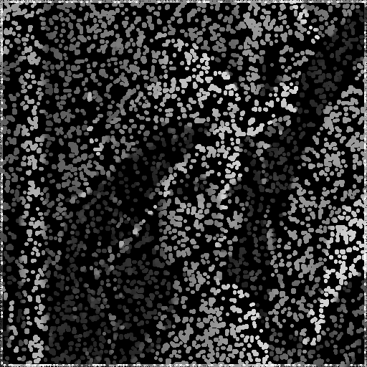

Figure 2: the Lena wall.

|  |  |  |  |  |
| --- | --- | --- | --- | --- |
| Image  filter | Gaussian noise amplitude = 10 | Gaussian noise amplitude = 30 | Salt-and-pepper threshold = 0.05 | Salt-and-pepper threshold = 0.1 |
| 3x3 box | 14.7787 | 8.6315 | 3.4290 | 1.9846 |
| 5x5 box | 12.3691 | 7.7585 | 3.0014 | 1.6033 |
| 3x3 median | 16.1422 | 8.6336 | 2.9978 | 1.4736 |
| 5x5 median | 14.1525 | 8.0742 | 2.8901 | 1.3857 |
| opening | 13.9743 | 8.1023 | 1.4184 | -0.9080 |
| closing | 12.8143 | 7.8423 | 0.2077 | -1.1348 |

Table 1: the SNR (signal noise ratio) rates of corresponding image

**Appendix**

The program is written by MATLAB. To run the program, copy the input data to the folder “dat/”, and run “src/hw8_noise_sh.m” to get the noise image, and use “src/hw8_denoise_sh.m” without any argument to get the output in “out/”.