我要看一下康妥的定义方式，怎样规避没有阿基米德定理的问题。

这个有待进一步的商榷说，考虑考虑是否要加：用尺规作图图示画加法的定义那里要做一个进一步的说明，就是词规作图的过程中两个线段相加，他们是有共同的交点的，但是在实际上两条线段相加，也就是把这两条线段截起来，他们是不应该有共同的焦点，应该是相接，接起来的定义。【】（我用图示的方法展示两个线段的加法，实际上是想让两条线段接起来，把两条线段接起来，但实际上那两条线段有共同的焦点，但实际上但实际上把两条线段接起来，就是让这两个线段连续在一起，而上述展示过程中那两条线段有共同的焦点，而两条线段把它接起来变得联系起来，他们是没有公共的交点的，其所表现出来的性质如上面一开始提到的二条性质所描述的那样子，所以这里我们应该限定我们用的线段是不包含右端点的。

有时候是什么不重要的，重要的是通过关系来界定它的存在。
仅仅只是知道它是什么东西，比如说知道它是不能表示为p/q的数，没有多少用处，没有多少价值，更重要的是要知道它的运算法则，是否是能够像有理数那样满足他们的应算法，则如交换率结合率之类的。

要结合书中那里关于阿基米德定理的说法，看一下阿基米德定理是否可以不通过切界原理推出最初的话要先从自然数的阿基米德性质是怎样证明的来思考作为切入点。（后面还是不打算从这个方向入手，因为连续体是最根本的需要，而从这个方向入手的话感觉比较费精神，抓住连续体是最根本的需要这一点着手我觉得才是关键）

什么是数学：
While the Greeks chose the geometrical con-
concepts of point and line as the basis of their mathematics, it has
become the modern guiding principle that all mathematical statements
should be reducible ultimately to statements about the natural numbers,
1, 2, 3, • • • . "God created the natural numbers; everything else is
man's handiwork." In these words Leopold Kronecker A823-1891)
pointed out the safe ground on which the structure of mathematics can
be built.

before Weierstrass, the introduction of irrational "number" was, explicitly or implicitly, geometrical. The view that number has a geometrical basis was taken by Newton and most of his successors.

The problem was to interpret the geornetric property of the line: ‘a continuum of points' to be phrased in terms of arithrnetic rules.

The more precise statement is that the Greeks possessed no method for
producing or defining, arithmetically, the general irrational number in terms of rational numbers. This is a result of modern development and will soon engage our attention（虽然说从数的扩充来看是这种路子好像也是趋势所在，我的没有这么做）
我选择line的基本操作作为实数的基础，并且无理数最初就是来源于几何（Klein的书上也讲了）

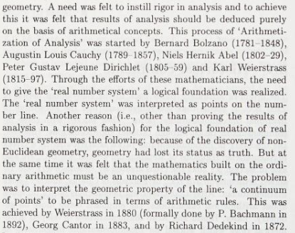
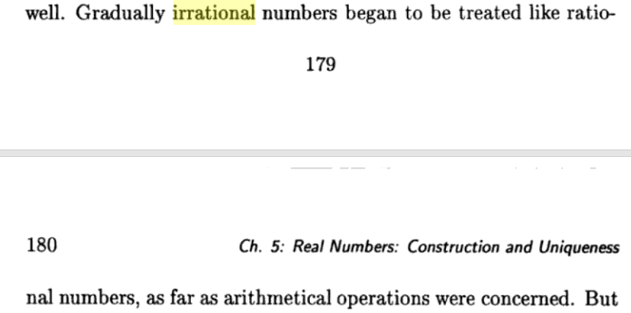 From Numbers to Analysis
作者：Inder K. Rana
这一小段序言也不错：
https://books.google.com.hk/books?id=CIsOVPm6zE8C&pg=PA180&lpg=PA180&dq=Otto+Stolz+irrational+decimal&source=bl&ots=Il6uZ3Yxe7&sig=ACfU3U2pUp-MeQJsN6Mba-kgnSgl9KsIuQ&hl=zh-CN&sa=X&ved=2ahUKEwim2Y2w1anvAhWGMd4KHTo2BOEQ6AEwAnoECAQQAw#v=onepage&q=Otto%20Stolz%20irrational%20decimal&f=false

当问及无理数是什么，我们可能会收到两种回答：（1）不能写作$\frac{p}{q}$的数；（2）无限不循环小数。当再继续问无理数为什么也满足有理数的算术法则和不等关系（如乘法结合律、分配律等），大多数人可能就不知道怎么回答了，实际上这个问题的答案与无理数的定义是息息相关的，如果我们连无理数是什么都不知道就研究与之相关的性质，这不就是瞎折腾吗？
This is all very well and good, but it does seem somewhat alien to one’s prior experience with these numbers

正如Dedekind基于最简单的几何公理，我也基于最简单的几何事实来构造。不过多依赖于几何现象，为了避免产生错误结论

为什么要简单化，因为=========要阐述本文的意义，重大作用
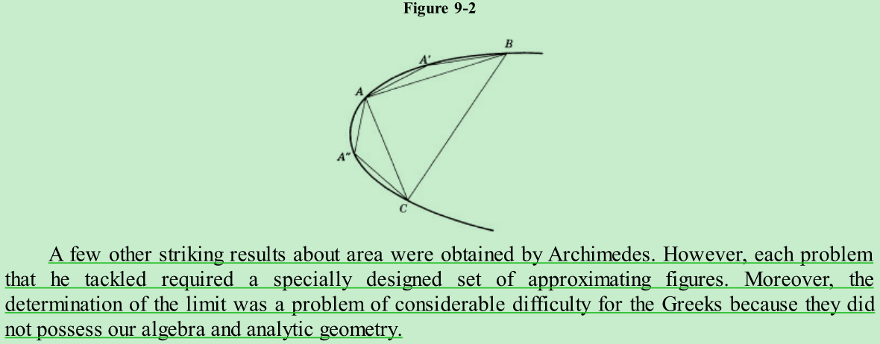
A few other striking results about area were obtained by Archimedes. However, each problem that he tackled required a specially designed set of approximating figures. Moreover, the determination of the limit was a problem of considerable difficulty for the Greeks because they did not possess our algebra and analytic geometry. From Greek times until the seventeenth century very little progress was made in finding areas and volumes bounded in whole or in part by curved figures. However, in that Century some mathematicians—Pascal, Fermat, and notably Leibniz—introduced a general method of approximating curvilinear areas by rectilinear figures and of coming closer and closer to the desired area by improving the rectilinear approximation. When we understand what these men did we shall be able to outdo Archimedes, who was one of the greatest mathematicians of all times.

17世纪的数学家们一度相信把数学分析建立在几何上是可以做到的，可是随着数学分析在18世纪发展得越来越复杂，这一想法便很难行得通了，相反代数（基于算术）方法却彰显了几何难以企及的威力；

另外，这两种实数定义是数学家在对实数有了基本的直观的认识之后为实数建立严谨逻辑基础而得出的产物，这些定义为的是严谨，至于是否让初学者觉得简单易学可能并不是这些定义主要关心的问题。（关于数学知识的严谨性与可理解性、可学性的探讨读者可以看看Morris Kline的 Calculus: An Intuitive and Physical Approach, Second Edition的preface to the first edition部分，作者对微积分的教学和它的严谨性间的关系有着非常有见地的认识！）

irrational Numbers in English Language Textbooks, 1890-I 915: Constructions and Postulates for the Completeness of the Real Numbers里面包含Russell罗素读Dedekind和Cantor的批评（搜索就能看到：not obvious that Russell’s is a valid criticism, but (unknown to Russell) Dedekind ）
https://core.ac.uk/download/pdf/81114496.pdf
——似乎用处不大

所以本文构建起来的实数系Definition of the numbers are based on the geometry of a straight line，那要建立起来之后，在本人的观点一下，实数集就是 A set of notations which follow the rules of arithmetic

Arithmetic and the inequalities

加个后记，有些人说这个没有意义，但至少有教学意义
代数方法用在微积分上彰显了为能力强大的力量，而不是像阿基米德那样绞尽脑汁构造出意想不到的构造方法，正好人都可以打败阿基米德
做这个事情的意义在于，就像阿基米德用天才的构造方法计算面积或体积养而用微积分的方法能够让普通人也可以很容易的计算出来另外一个例子就是说比如说罗马数字大数的运算就只有少数人能够做到而，阿拉伯数字的话上一般人也可以做到，这就是变容易的好处，make it accessible to everyone

如果这种联系割舍不断，那么为什么不从一开始就用二者的联系来定义彼此呢？

从和点一一对应的角度来看，有的是与p/q形式的有理数对应的点，和非有理点；如果从是否循环小数的角度来看的话，对于根号2是否是循环小数的判别乍看之下似乎没有简单的方法。

The origin and need for Arithmetization of analysis

The real numbers: Stevin to Hilbert https://almerja.com/reading.php?idm=20468

实数是符号的历史出现
https://books.google.com.hk/books?id=CVRZEXFVsZkC&lpg=PA301&ots=ifxybzxvYe&dq=The%20formal%20conception%20of%20numbers%20requires%20of%20itself%20more%20mod-est%20limitations%20than%20does%20the%20logical%20conception.%20It%20does%20not%20ask%2C%20what%20are%20and%20what%20shall%20the%20numbers%20be%2C%20but%20it%20asks%2C%20what%20does%20one%20require%20of%20numbers%20in%20arithmetic.&hl=zh-CN&pg=PA301#v=onepage&q=The%20formal%20conception%20of%20numbers%20requires%20of%20itself%20more%20mod-est%20limitations%20than%20does%20the%20logical%20conception.%20It%20does%20not%20ask,%20what%20are%20and%20what%20shall%20the%20numbers%20be,%20but%20it%20asks,%20what%20does%20one%20require%20of%20numbers%20in%20arithmetic.&f=false

Mathematical Thought from Ancient to Modern Times, Vol. 3, 1990 edition, Morris Kline, p948
D.C. Goldrei， Classic Set Theory: For Guided Independent Study，P8

