the number axis - a straight line L,
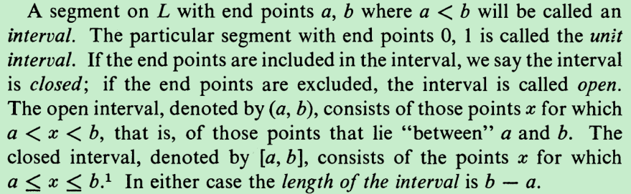
So an interval is a continuous domain.
The points corresponding to the integers 0, ± 1, ± 2, ... subdivide the number axis into intervals of unit length. From elementary geometry we recall that with ruler and compass it is possible to construct a subdivision of the unit length into any number of equal parts [1]. To represent fractions with the denominator n, we divide each of the segments of unit length into n equal parts, the points of subdivision then represent the fractions with denominator n. If we do this for every integer n, then all the rational numbers will be represented by points of the number axis. It follows that any rational length can be constructed and hence that the point representing a rational number x can be found by purely geometrical methods. We shall call such points rational points, and we shall use the terms "rational number" and "rational point" interchangeably.
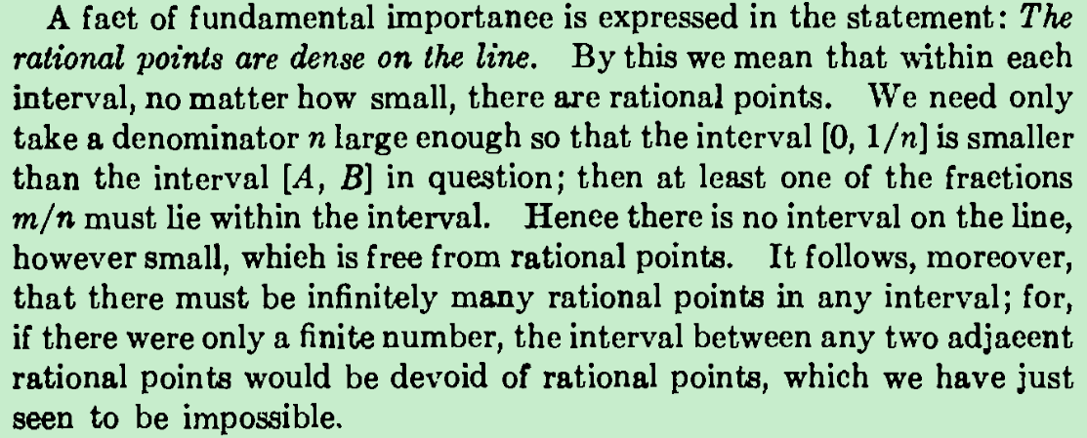
In a word, density of rational numbers implies there are infinitely many rational numbers in any nonzero-length interval, so the sole kinds of intervals which may be devoid of rational points should be zero-length intervals, obviously , a zero-length interval could hold at most one point , so are there other non-rational points on the number axis?
It is easy to show the existence of such points. The diagonal of a square with the sides of unit length, if marked off from the point 0 on the number axis by means of a compass, the end-points of such segments cannot coincide with any of the rational points.
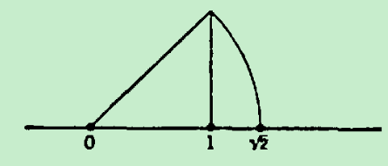
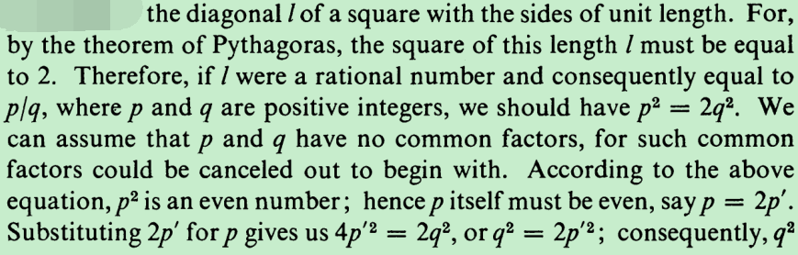
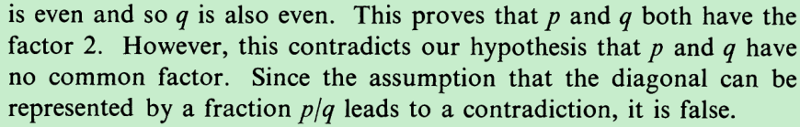
This reasoning, a characteristic example of indirect proof, shows that there is a point that cannot correspond to any rational points on the number axis. In fact, it is easy to construct as many such non-rational points as we want.

The system of rational numbers, although it is everywhere dense, does not cover the entire number axis, there are an infinite number of “gaps” or “holes” between the rational numbers, although this denseness property does ensure that these holes are in the form of zero-length closed intervals, each of these holes contains only one non-rational point. These non-empty holes

so they do not suffice as a theoretical basis of measurement by numbers. For example, the length of the diagonal of a square with the sides of unit length cannot be measured by rational numbers, so it is necessary to introduce new numbers for measurement.

if we demand that there should be a mutual correspondence between numbers on the one hand and points of a straight line on the other, it is necessary to give the following definition:
For every non-rational point on the number axis, we say it defines an irrational number corresponding with itself, the number is greater than every rational number to the left of itself and less than the right.
The gaps between the rationals is filled by the introduction of irrational numbers resulting in the number continuum.

The profound need for expressing measures of quantities in terms of what we would like to call numbers forces us to extend the number concept so that we may describe a continuous gradation of measures. This extension is called the number continuum or the system of "real numbers" (a nondescriptive but generally accepted name).
The basic notions of Calculus are derivative and integral: the derivative is a measure for the rate of change, the integral a measure for the total effect of a process of continuous change. A precise understanding of these concepts and their overwhelming fruitfulness rests upon the concepts of limit and of function which in turn depend upon an understanding of the continuum of numbers.

Why introduce the new concept - the number continuum?

the set of rational numbers is riddled
with “holes” where there ought to be numbers. Here we will try to make this
statement more precise and then indicate how these holes can be “filled” result-
ing in the number continuum.

give an example of a point which doesn’t coincide with any of the of the rational points on the number axis.

A simple geometrical construction could be carried to show there are points which doesn’t coincide with any of the of the rational points on the number axis.

, are called irrational points
For the time being, all quantities occurring are assumed to be rational numbers.
Dedekind remark

