《数据库理论与技术》期终考试复习题
- 填空题：
- 数据仓库是面向(主题的)、(集成的) 、(时变的)、(非易失)的数据集合.
- 多维数据模型由(维表)和(事实表)定义，其常见的形式有(星型)、(雪花型) 及(事实星座型)；在多维立方体的某一维上选定一个维成员值的操作称为（切片）。
- 在ORDB中，从已知的属性值找未知的属性值时沿途经过的属性名构成的式子称为(路径表达式)；将一个嵌套关系转换为1NF的过程称为(解除嵌套)；在ODMG对象模型中，由类中所有持久对象构成的集合称为(类外延)；
- 描述时间数据的最小时间单位称为(时间粒度)；而(系统时间量子)是计算机系统所支持的最小的、不可分割的时间间隔。时态数据模型中的三种时间分别是（用户自定义时间）、（有效时间）、（事务时间）。
- 分布式数据库的六级模式结构分别是（全局外模式）、（全局概念模式）、（分片模式）、（分配模式）、（局部概念模式）、（局部内模式）；分布式数据库系统中，查询代价主要由（CPU代价）、（I/O代价）、（通信代价）三部分构成。
- 两关系间的连接运算可通过（嵌套循环）、（块嵌套循环）、(索引嵌套循环)及（归并联接）、（散列联接）等不同方法实现，当采用块嵌套循环方法时，通常将较大的关系作为嵌套循环计算过程中的(内)关系。
- 线性散列是为了解决可扩展散列面临的桶的（数目过快增长）及（利用率不足）问题而引入的。
- 乐观的并发控制协议中，事务的执行可划分为（读与执行）、（有效性检查）、（写）等三个阶段。
- 影响并行数据库系统性能的3个因素分别是（启动代价）、（干扰）和（偏斜）。
- 在并行数据库中，将互相独立的多个操作或者一个操作内互相独立的多个子操作分配给不同的处理机并行执行称为（独立并行），将存在流水线方式依赖关系的多个操作分配给不同处理机并行执行称为（流水线并行）。
- CAP定理中的C、A、P分别是指（Consistency（一致性））、（Availability（可用性））、（Partition tolerance（分区容忍性））。
- 区块链是一个（去中心化）、（去信任化）的公开透明分布式账本。
- 按照开放程度，区块链可分为（公有链）、（联盟链）和（私有链）等三种类型；区块链的基础架构模型包括（数据层）、（网络层）、（共识层）、（激励层）、（合约层）、（应用层）等六层。
- 选择题:
- The separation of the data definition from the program is known as: _____b______
a) Data dictionary
b) Data independence
c) Data integrity
d) Referential integrity
- In order to reduce the overhead in retrieving the records from the storage space we use: _____b______
a) Logs
b) DB buffer
c) Medieval space
d) Lower records
- The main reason why data is retrieved in "blocks" is to: a
a) minimize the number of actual disk accesses
b) save space
c) make programming easier
d) increase the lifetime of hardware
- The order of log records in the stable storage _____a______ as the order in which they were written to the log buffer.
a) Must be exactly the same b) Can be different c) Is opposite
d) Can be partially same
- The difference between files storing spanned(跨块的)versus unspanned (非跨块的)records is that：_______a_______（个人觉得是D）
- a file with spanned records will use less disk space for storing records than with unspanned records, if an integral number of records do not fit in a block.
- a file with spanned records can have records that are stored on more than one disk block.
- a file with spanned records must be used when the size of a record is larger than the block size.
- all of the above. e) NOA.
- An index is used in relational database systems to：_____b________
- improve the efficiency of normalizing relations.
- improve the efficiency of retrieving records from a relation.
- improve the efficiency of the Create Table statement.
- b and c only. e) NOA.
- Which of the following would not be considered a benefit of indexing? _______b_______
- To improve performance during data sorting.
- To insure uniqueness of key values.
- To improve performance during large sequential table scans.
- To avoid reading the records when processing queries that retrieve only indexed columns.
- To help query optimizer in cost estimation.
- The difference between a dense(稠密) index and a sparse(稀疏) index is that: ______都不是__c ?__
- a dense index contains keys and pointers for a subset of the records whereas a sparse index contains keys and pointers for every record.
- a dense index can only be a primary index whereas a sparse index can only be a secondary index.
c) a dense index contains keys and pointers for each record whereas a sparse index contains keys and pointers for a subset of the records.
d) the size of dense index is always smaller than the size of sparse index.
- In ordered indices the file containing the records is sequentially ordered, a ___a____ is an index whose search key also defines the sequential order of the file.
a) Clustered index b) Structured index c) Unstructured index d) Nonclustered index
- Indices whose search key specifies an order different from the sequential order of the file are called _____c______ indices.
a) Nonclustered b) Secondary c) All of the mentioned d) None of the mentioned
- Consider the table: Rented(cust_no, vid_no, start_date, return_date).Suppose you have created an index with the command:
create index indx1 on rented (start_date, returned_date)；
start_date is the main ordering criterion for the index entries; returned_date becomes only important if two entries have the same start_date. Which of the following conditions can be evaluated using the index? (Circle ALL that apply) a+c
a) start_date between '15-10-99' and '20-10-99' b) returned_date >= '20-10-99'
c) start_date='15-10-99' and returned_date>'16-10-99'
d) start_date='15-10-99' or returned_date>'16-10-99'
- When searching a B+-tree for a range of key values: _______d_______
a) the search always starts at the root node. b) the search always ends at a leaf node.
c) multiple leaf nodes may be accessed. d) all of the above.
e) a and b only.
- The insertion of a record in a B+-tree will always cause the height of the tree to increase by one when: ______c________
a) the tree consists of only a root node. b)the record is to be inserted into a full leaf node.
c) all the nodes in the path from the root to the desired leaf node are full before insertion.
d) all the nodes in the B+-tree are half full. e) NOA.
- In a B+-tree index ___a___ for each value, we would normally maintain a list of all records with that value for the indexed attribute.
a) Leaf b) Node c) Root d) Link
- Bitmap indices are a specialized type of index designed for easy querying on： ____c____
a) Bit values b) Binary digits c) Multiple keys d) Single keys
- SELECT *
FROM r
WHERE gender = ’f’ AND income level = ’L2’;
In this selection, we fetch the bitmaps for gender value f and the bitmap for income level value L2, and perform an _______d_______of the two bitmaps.
a) Union b) Addition c) Combination d) Intersection
- To identify the deleted records we use the _____a____
a) Existence bitmap b) Current bitmap c) Final bitmap d) Deleted bitmap
- Bitmaps can be used as a compressed storage mechanism at the leaf nodes of ____b____ for those values that occur very frequently.
a) B-trees b) B+-trees c) Bit trees d) Both B-trees and B+-trees
- A(n) ____a_____ can be used to preserve the integrity of a document or a message.
a) Message digest b) Message summary c) Encrypted message
d) None of the mentioned
- In the client / server model, the database: _____d____
a) Is downloaded to the client upon request b) Is shared by both the client and server
c) Resides on the client side d) Resides on the server side
- Before a block of data in main memory can be output to the database, all log records pertaining to data in that block must have been output to stable storage. This is: ____c_____
a) Read-write logging b) Read-ahead logging
c) Write-ahead logging d) None of the mentioned
- Writing the buffered log to ____d______ is sometimes referred to as a log force.
a) Memory b) Backup c) Redo memory d) Disk
- The ____b_______ policy, allows a transaction to commit even if it has modified some blocks that have not yet been written back to disk.
a) Force b) No-force c) Steal d) No-steal
- The _____b_____ policy allows multiple updates to accumulate on a block before it is output to stable storage, which can reduce the number of output operations greatly for frequently updated blocks.
a) Force b) No-force c) Steal d) No-steal
- The _____c______ policy, allows the system to write modified blocks to disk even if the transactions that made those modifications have not all committed.
a) Force b) No-force c) Steal d) No-steal
- The operating system reserves space on disk for storing virtual-memory pages that are not currently in main memory; this space is called b)
a) Latches b) Swap Space c) Dirty Block d) None of the mentioned
- Locks on buffer blocks are unrelated to locks used for concurrency-control of transactions, and releasing them in a non-two-phase manner does not have any implications on transaction serializability. This is: a)
a) Latches b) Swap Space c) Dirty Block d) None of the mentioned
- ARIES uses a ___b)______ to identify log records, and stores it in database pages.
a) Log sequence number b) Log number c) Lock number d) Sequence number
- ARIES supports ____a)______ operations, which are physical in that the affected page is physically identified, but can be logical within the page.
a) Physiological redo b) Physiological undo c) Logical redo d) Logical undo
- The ______a)________ is used to minimize unnecessary redos during recovery.
a) Dirty page table b) Page table c) Dirty redo d) All of the mentioned
- If a piece of data is stored in two places in the database, then _____d)_____
a) Storage space is wasted
b) Changing the data in one spot will cause data inconsistency
c) It can be more easily accessed
d) Storage space is wasted & Changing the data in one spot will cause data inconsistency
- When a database is implemented on a single server regardless of the number of physical locations that may require access to it is known as: a)
a) centralization b) horizontal distribution c) vertical distribution
d) replication e) none of these
- When a table or entire rows in a table are assigned to different database servers and locations, it is known as: b)
a) centralization b) horizontal distribution c) vertical distribution
d) replication e) none of these
- By sending messages through Paxos, processes can ensure that concurrent messages become: b)
a) Global time ordered multicasts. b) Totally ordered multicasts.
c) Causally ordered multicasts. d) Unordered multicasts.
- Based on their vector timestamps, which event causally precedes (4, 2, 8, 5)? c)
a) (3, 1, 7, 7) b) (5, 1, 6, 2) c) (4, 2, 8, 4) d) (4, 3, 8, 5)
- With Paxos, message sequence numbers are assigned by the: d)
a) Acceptor b) Client c) Learner d) Proposer
- Paxos reaches agreement when: d)
  - All proposers agree on a value to send to the acceptors.
  - All acceptors agree to a proposed value.
  - The majority proposers agree on a value to send to the acceptors.
  - The majority of acceptors agree to a proposed value.
- A write-ahead log does NOT enable a process to: d)
a) Undo changes in case of an abort. b) Record that a transaction has committed.
c) Record the response that was sent to a vote in a commit protocol.
d) Achieve higher performance by prefetching data.
- To abort a distributed transaction: a)
  - At least one participant must vote to abort.
  - The majority of participants must vote to abort.
  - All of the participants must vote to abort.
  - All live participants must vote to abort.
- The motivation for an eventual consistency model was: a)
  - It is impossible to have highly available replicated data that is fully consistent in a system that can survive network partitioning.
  - Data inconsistencies are highly undesirable, so the primary focus should be on ensuring that all replicas are consistent.
  - Distributed commit protocols can never work reliably, so data is bound to become inconsistent on some participants.
  - Data might be in an inconsistent state during the execution of transactions but will be made consistent when they commit.
- Which of these operations is most efficiently implemented on a large-scale GFS (Google File System) system? b)
a) Read one 1 TB file. b) Read 1 million 1 MB files.
c) Write one 1 TB file. d) Write 1 million 1 MB files.
- The partitioning function in MapReduce is a)
a) Determines which shard will be assigned to a specific map worker.
b) Filters out unnecessary input data prior to being processed by the map worker.
c) Determines the division of available servers into map workers and reduce workers.
d) Determines which reduce worker will process data associated with a particular key.
- Which of the following is NOT a responsibility of a map worker in the MapReduce framework: d)
a) Generate (key, value) pairs.
b) Target (key, value) data for one of Rreduce workers.
c) Partition original data into shards. d) Discard data of no interest.
- A key design principle of the Google cluster architecture is d)
a) Merging is fast; break up databases into lots of pieces and use lots of processes, each working on a piece of the data.
b) Minimize the number of phases in a task; create many replicas of a database and allow each system full access to it without the need for sharing or locking.
c) Minimize context switch overhead; machines are cheap and it's more efficient to devote a node to one task exclusively.
d) Machines and software fail; run the same task redundantly in parallel to ensure successful execution.
三、简答题:
- [Buffer Management]Suppose you have a Buffer Pool that can hold 3 pages. There are 26 blocks on your disk; for simplicity we will refer to each block with a letter of the English alphabet between A and Z. An “access pattern” is a string of letters that log the requests to the Buffer Pool for pages. For each access pattern below, write down next to it the number of I/Os that would occur starting with an empty buffer pool each time, for both the LRU and MRU replacement policies. (Spaces in the access patterns are there just for legibility.)
Access pattern | LRU  (清除最近最少使用) | MRU（清除最近最常使用）
ZYXW ZYXW  ABCD DCBA ABCD  ACEG BDFH ACEG BDFH | FIFO=8 8  FIFO=8 6  16 | 5  6  13
计算方法：从左到右书写，超过3个时，LRU从最左边删，MRU从最右边删
- [Disk Manager.]Consider a disk with a sector size of 512 bytes, 2000 tracks per surface, 50 sectors per track, five double-sided platters, and average seek time of 10 msec. Suppose a block size of 1024 bytes is chosen. A file containing 100k records of 100 bytes each is to be stored on such a disk and that no record is allowed to span two blocks.
- If the disk platters rotate 5400 rpm, what is the maximum rotational delay?
如果盘片以5400rpm转速旋转，则一次旋转所需的时间(即最大旋转延迟)为1/5400×60 = 0.011s.平均旋转延迟是旋转时间的一半，0.006秒
- If one track of data can be transferred per revolution, what is the transfer rate?
每个磁道50个扇区,每个扇区512字节，则一个磁道25kb，每转一圈传输一条数据，则数据传输速率为：25kb/(60/5400)s=2250kb/s
- What is the time required to read the file sequentially? What if the disk were capable of reading/writing from all heads in parallel?
文件包含100k条记录(100b)，每个磁道25kb，则需要400个磁道或者40个柱面 ；一条数据传输时间为0.011秒,则传输400次需要轨400×0.011=4.4秒；需要寻道40次，查找时间为40×0.01s=0.4秒。因此，总的访问时间是4.4+0.4=4.8秒。
如果磁盘能够并行地读写所有磁头，那么磁盘一次可以读10个磁道。传输时间少了10倍，也就是0.44秒。因此，总的访问时间是0.44+0.4=0.84秒
- What is the time required to read each block in the file in a random order? (assuming that each block request incurs the average seek time and rotational delay)==每块1024字节=1kb
对于任何数据块，平均访问时间=寻道时间+旋转延迟+传输时间
寻道时间=10ms，旋转延迟=6ms，传输时间=1k/(2250k/s)= 0.44ms
即数据块的平均访问时间为16.44ms，那么对于包含100字节的100k记录的文件，总访问时间为164.4秒。
- [B+ Trees.]Consider a B+ tree containing the elements 2,4,8,9,11,12,13,14,16,17,18,20. The tree has order d = 2. This means that internal nodes have at least 2 keys and 3 pointers, and at most 4 keys and 5 pointers; leaf nodes have at least 2 data entries and at most 4 data entries.
  - In the picture below, draw what the tree looks like if the leaves are as densely packed as possible. Draw directly on the picture.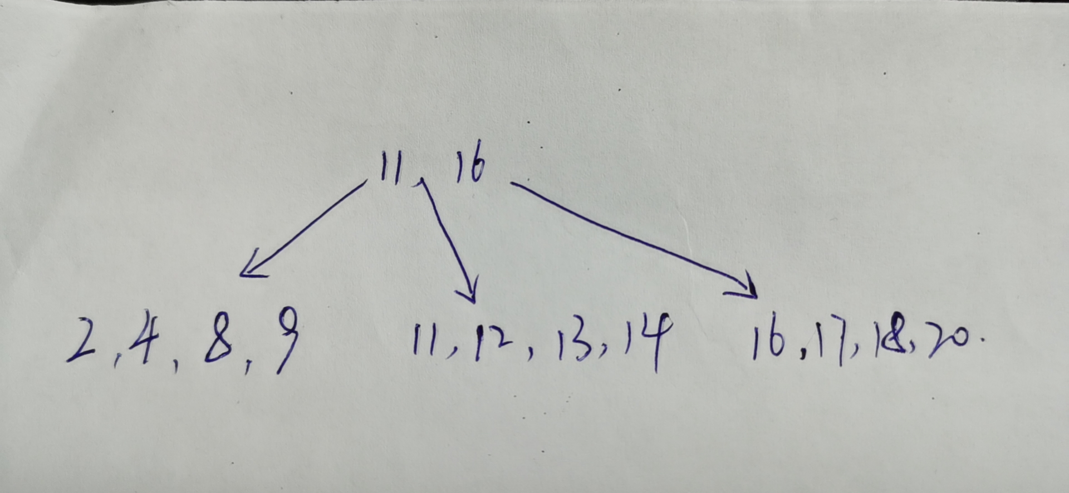
  - Based on your original tree from 1, what is the minimum number of inserts that could cause a root split? 最少插入3个数，3,15,21
分裂节点:将n 个键值对对半划分,将前 ⎡ n/2 ⎤ 个放在原节点中, 其余放在一个新节点中。设新节点为p, 并令k 是p 中最小的键值,将(k,p) 插入到分裂节点的父节点中,若父节点满, 则继续分裂。向上进行节点分裂直至找到不满的节点。最坏情况下导致根节点的分裂, 树的高度加 1
  - Draw the tree just after the root has split with a minimum of insertions as you described in 2. Use any value you like that would cause the split. We have started you off by drawing the root and internal nodes; you need to fill them in and draw the leaves.
root:14 ,index:[8,11],[16,20],leaf:[234][89][11,12,13][14,15][16,17,18][20,21]
  - Given the B+ tree shown in Figure 1, draw the tree after deleting keys 19, 20, 24 in the given order.
2333333
5
7
8
14 16
24
19 20 22
27 29
33 34 38 39
19
5
14
24 33
Root[5,14,27,33],L1[2,3,5],L2[5,7,8],L3[14,16,22],L4[27,29],L5[33,34,38,39]
删除时，叶节点不满则和兄弟节点合并，若导致父节点不满，父节点同样合并， 直至根节点
- 下图为插入关键字0000、0101、1111、1010后的线性散列索引结果，其中：i-当前使用的散列函数的位数，n-当前的桶，r-当前散列表中的记录总数，要求 r<=1.7n。
试分别给出插入以下关键字后的线性散列索引结果。
- 0001 b) 0111 c) 1011
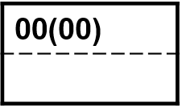
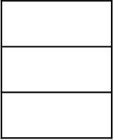
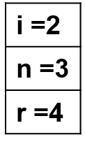
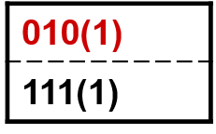
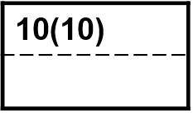
00
01
10
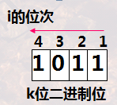

- r>1.7n需要分裂。10桶要由00桶分裂而来(低位相同而最高位不同的那一个桶)
- 存储块并不总是可以分裂，所以允许有溢出块，尽管每个桶的平均溢出块数远小于1。
- 桶序号的二进制位数是⎡log₂n⎤，其中n是当前的桶数。这些位总是从散列函数得到的位序列的右端(即低位)开始取。
- 0001
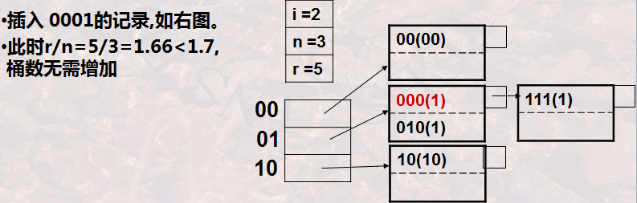
- 0111
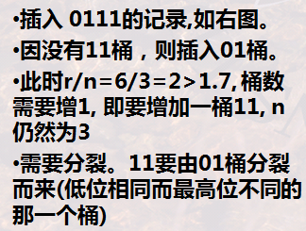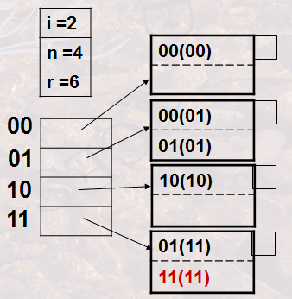
- 1011
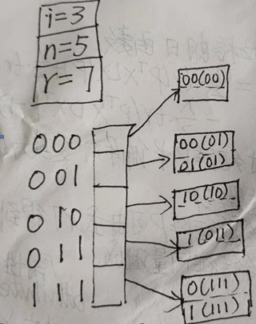
- Consider the following log where the DPT represents the Dirty Page Table and TT represents the Active Transaction Table
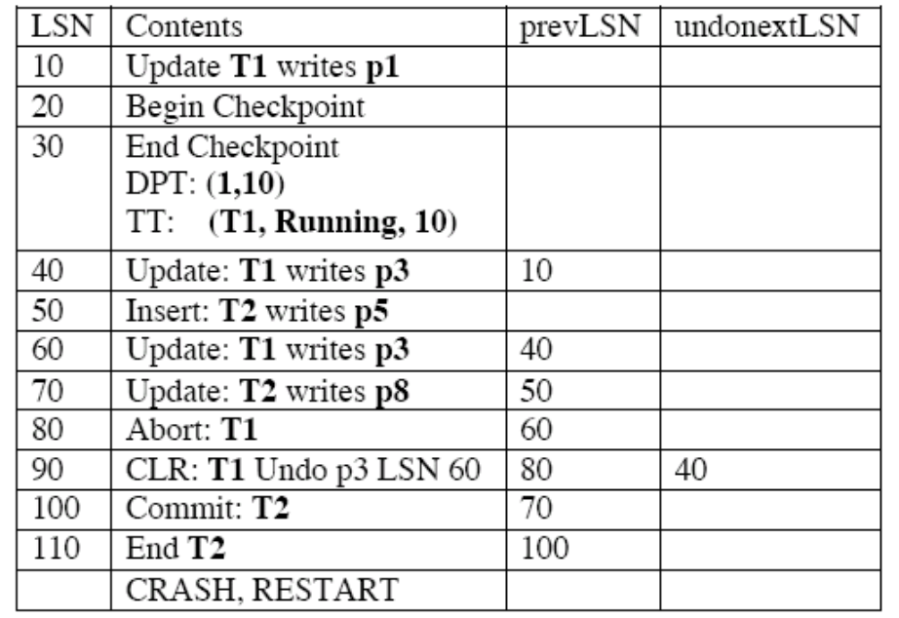
Answer the following questions (using the ARIES-like algorithm we studied in class):
- What is the smallest LSN accessed during the Analysis phase？
- Fill in the contents of the Dirty Page Table and the Transaction Table at the end of the Analysis phase. (you may not need all the space we give you)
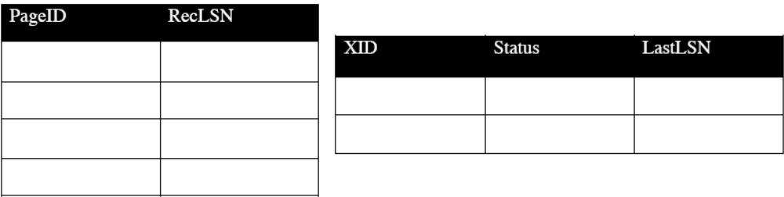
- At which LSN does the Redo phase begin?
- What entries (specify only LSNs) do get undone as part of the Undo phase?
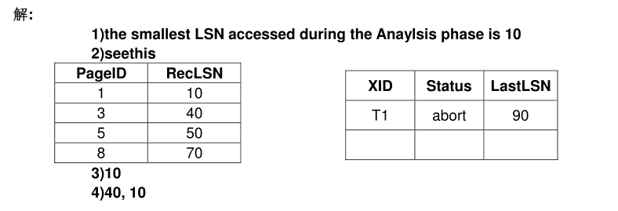
- 假设一个事务应用是用SQL嵌入到C中编写的，其中80%的时间花费在运行SQL语句上，其余20%的时间花费在运行C代码上，如果只对SQL进行了并行化，那么可以期望得到多大的加速比? 为什么?加速比（speedup），是同一个任务在单处理器系统和并行处理器系统中运行消耗的时间的比率，用来衡量并行系统或程序并行化的性能和效果。
答：由于不能被并行话的部分占总运行时间的20%，所以可获得的加速比最多不会超过5.
- 利用频率分布直方图建立负载均衡的范围划分向量:
- 假设有一个取值范围为1~100的直方图,划分为以下10个范围: 1~10,11~20,…,91~100。其出现频率分别为: 15,5,20,10,10,5,5,20,5,5。请给出一个负载均衡的范围划分向量,将这些值划分为5个部分
在每个分区中给出5个分区、20个元组的分区向量为[21.31,51.76]。
得到的5个分区是1-20、21-30、31-50、51-75和76-100。
得出这个分割向量的假设是，在一个直方图范围内，每个值都是等可能的。
- 对于给定的包括n个范围的频率分布直方图，请说明应如何计算出划分为p(p<n)个分区的负载均衡划分向量。
设直方图的范围为h1,h2…hh，分区为P1，P2……Pp.令直方图范围的频率为n1,n2…nh
每个分区应该包含N/p元组，其中为了构造负载均衡的分区向量，我们需要确定元组的值，元组的值等等，其中k1 = N/p,k2 = 2N/p，以此类推，直到k p-1。那么分割向量就是[k1,k2,…,kp-1]。元组的值确定如下：
首先确定它所在的直方图范围h1。假设一个范围内的所有值都是等可能的，那么值就是
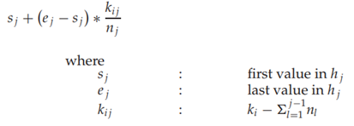

- The key-value store uses quorums for consistency. The total number of replicas, N, for a key, is fixed – however, N may be different for different keys. Each read has to access at least r replicas (and returns if all of them agree), while each write has to write to at least w replicas.For each of the following design choices, say whether it (by itself) does or does not guarantee strong consistency, i.e., one copy serializability?是否保证了强一致性，即，一份拷贝的可串行性?
a. w=3, r=1
No:节点可以是数百个。写只应用于3个节点。不可交叉的写操作可能会破坏一个副本的可串行性
b. w = 2N/3
No:由于读操作只在一个副本上执行，所以我们可以对一个陈旧副本执行读操作，而这个副本不是为写操作选择的2N/3节点的一部分
c. r+w = N
No:写可以等于1在这里(即r = N1)。因此。可以有不交叉写，这违反了一个副本的串行性
d. w = N
是的，因为所有节点都应用了写操作，所以任何读操作都会得到最新的数据。
e. r + w > N/2
No。与C类似，设置w=1结果将导致非交叉写，会破坏一个副本的串行性。
f. r + w > 3N/2
是的。这里w > N/2，否则r > N没有意义，所以读和写将相交，写和写也相交
g. r + w > 3N/2, w > 2N/3
是的，在这种情况下写不会相交，因为r+w> 3N/2。读写一定会相交。所以，我们保证得到最新的数据
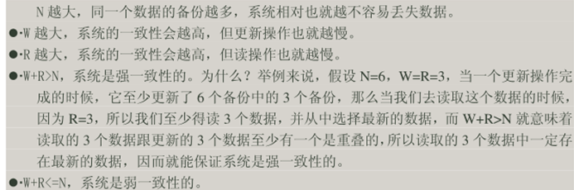
- The following scenario is a distributed file system which spans multiple datacenters. There are several choices for how to handle network partitions that occur in between datacenters (given below). For each of these choices, tell me: if it violates consistency？它是否违反一致性?
- Allow all partitions to process both reads and writes.
网络分区期间,它提供了可用性，但牺牲了一致性
- Allow all partitions to process reads, but only one special partition (prechosen)to process writes.
它提供了读的可用性，但是牺牲了写的一致性和可用性(除非写客户机连接到特殊的写分区)。
- Allow only the partition which has at least a quorum number of servers (measured across all datacenters) to execute writes.( 只允许具有至少一个仲裁服务器数量(跨所有数据中心测量)的分区执行写操作)
它提供了读的可用性，但牺牲了写的一致性和可用性(除非有一个具有quorum服务器的分区，并且写客户机正在与这个分区通信)
- Until partitions are repaired, allow only reads but no writes.
它为读提供了一致性和可用性，但牺牲了写的可用性。
- Allow only partitions with a quorum of servers (measured across all data centers) to execute writes and reads.
它提供了一致性，但是牺牲了可用性(除非有一个使用quorum服务器的分区，并且客户机正在与该分区进行通信)
- Lamport’s Logical Clocks, among other things, help make inferences about consistency of replicated data items operated upon concurrently. The following figure shows the time-line diagrams of three processes P, Q and R.
- Fill in the logical times for each event (a)–(o) in the three processes using the rules of local ordering(本地排序), send/receive ordering(发送接收排序) and transitive closure（闭包规则）.
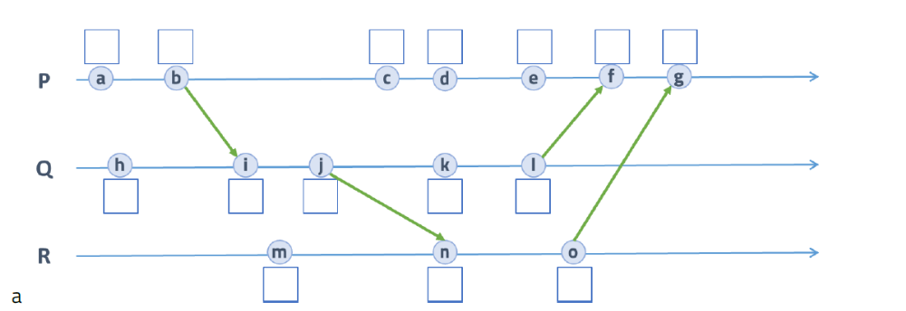
P: 1,2,3,4,5,7,8 Q:1,3,4,5,6 R:1,5,6
- Assuming you are given only the logical times for each event in a process, answer the following True, False or Unknown questions
    - Event b happened before event a. False
    - Events a, h and m happened concurrently. True
    - Event n happened before event c. Unknown
    - Events d, k and n occur at the same time instant. False
    - Event g did not happen before event l. True
    - Event o happened after event l. Unknown
- 设某WEB内容缓存系统采用一致性哈希算法进行内容分发管理。其环形哈希表地址空间大小N=4096，存储节点A, B, C, D的哈希值分别为: 13，1025，2047，3011；给定数据对象obj1~obj14，其ID值分别为：56，256，643，654，726，1365，1276，652，1887，1535，827，2323，892, 1337。哈希值计算方式为： h(id) = 3*(id↑2) mod 4096
- 对给定数据对象obj1~obj14进行哈希计算，按顺时针方向将其映射到离其最近的存储节点上；套用哈希函数计算即可
- 在a)的结果基础上新增存储节点E和F(哈希值分别为1657，3987)，并对数据对象重新进行映射；
此哈希值顺时针的相邻物理节点中的obj可能会被rehash，不考虑逆时针情况
- 在b)的结果上插入数据对象obj15,obj16,obj17，其ID值分别如下：835，1765，2325
套用哈希函数计算即可
- 在c)的结果基础上删除存储节点D, 并对数据对象重新进行映射；
删除节点迁移时，数据obj直接迁移到顺时针相邻的节点
注：以下为开放型题目
- The hash join algorithm described in the textbook computes the natural join of two relations. Write pseudocode for an iterator that implements a hash based algorithm for computing an “anti-join” operation:R anti-join S contains all tuples in R that have no matching tuples in S.Although anti-join is not an operation that can be specified directly in SQL, it is implemented in the query processor to support some types of queries. Your pseudocode must define the standard iterator functions open(),next(),and close(), and must fetch the input tuples using iterator calls (in other words, R and S may not be base relations, but may be outputs of other operators). Show what state information the iterator must maintain between calls. For simplicity, you can assume that S is small and easily fits in memory. Here are more details on anti-join: http://en.wikipedia.org/wiki/Relational_algebra#Antijoin
教科书中描述的散列连接算法计算两个关系的自然连接。为迭代器编写伪代码，该迭代器实现了一个基于哈希的算法来计算“反连接”操作:R反连接S包含R中所有没有匹配元组的元组。虽然反连接不是可以在SQL中直接指定的操作，但它是在查询处理器中实现的，以支持某些类型的查询。您的伪代码必须定义标准的迭代器函数open()、next()和close()，并且必须使用迭代器调用获取输入元组(换句话说，R和S可能不是基本关系，但可能是其他操作符的输出)。显示迭代器在调用之间必须维护的状态信息。为了简单起见，可以假设S很小，并且很容易装入内存。反连接的正式定义:
R ▷ S = { t : t ∈ R ∧ ¬∃s ∈ S(Fun (t ∪ s)) } R ▷ S = { t : t ∈ R, S中没有满足 Fun (t ∪ s)的元组 }，也可以定义为半连接的补码：
- Consider a secondary B⁺-tree index. Each internal node contains m child pointers, and each leaf node contains m pointers to records. There are a total of N records indexed by the B+-tree. We wish to choose the value of m that will minimize search times on a particular disk drive, given the following information:
- For the disk holding the index, the time to read a given block into memory is given by (30 + 0.01m) milliseconds. The 30 milliseconds represent the seek time and the rotational delay of the read; the 0.01m milliseconds is the transfer time.

- Once the block is in memory, a binary search is used to find the right pointer. The time to process a block in main memory is (a + b log₂ m) milliseconds, for some constants a and b.

- The main memory time constant a is negligible compared to the disk seek time and rotational delay of 30 milliseconds.

- You can assume that the index is completely full and perfectly balanced, and that N is conveniently a power of m.
Questions:
a) What value of m minimizes the time to search for a given record? An approximate answer is okay.
b) What happens as the disk latency (30 milliseconds) decreases? For instance, if this constant is cut in half, how does the optimal m value change?
考虑二级B+-树索引。每个内部节点包含m个子指针，每个叶节点包含m个指向记录的指针。B+-树总共索引了N条记录。我们希望选择的值m将最小化搜索时间对特定的磁盘驱动器，给出以下信息:
1)对于保存索引的磁盘，将给定块读入内存的时间是(30 + 0.01m)毫秒。其中30毫秒为寻道时间和读的旋转延迟;0.01m毫秒是传输时间
2）一旦块在内存中，使用二分查找查找正确的指针。对于一些常量a和b，在主存中处理一个块的时间是(a + b log2 m)毫秒。
3)主存时间常数a与磁盘寻道时间和30毫秒的旋转延迟相比可以忽略不计。
4)你可以假设指数完全是满的，并且完全平衡，N是m的幂。
问题:
a)什么值使搜索给定记录的时间最小化?近似的答案是可以的。
b)当磁盘延迟(30毫秒)减少时会发生什么?例如，如果将这个常数减半，最优m值如何变化?

