**Chronicles of Scara asset tutorial**

1. Scripts description

1.1 Scene controllers.

Each scene has an object with same name as a script (*Controller). This script controls behavior of a scene.

1.1.1 MainMenuController

Controls the MainMenuScene which is called at the start of an application. It creates background image, buttons to change languages and the start button, that goes to the next scene (1.1.2).

1.1.2 SelectLocationController

User selects which location will be played (each location has 24 levels and one by one unlock-order). Calls 1.1.3 scene

1.1.3 SelectLevelController

User selects a level in a location from the 1.1.2 scene. After confirming a choice loads 1.1.4 scene.

1.1.4 GameController

In this scene is the main part of a game - exactly the game process. The level settings are loaded from 1.3.2 script. Interface resources are loaded from Interface, $English or $Russian resources folders.

1.1.5 FrescoContoller

This scene is called after user gets 3 stars on a level. It has 48 pieces on each fresco - one part will be shown for each 3-stars-levels.

1.2 Classes

1.2.1 GUIObject

Abstract class to create a GUIImage, GUIButton and Div that represents an image on the screen (which can be attached to the screen size or be constant) and can\can't be clicked by user.

1.2.2 GUIImage : GUIObject

Creates an image on the screen. Constructor without parameters is used usually to create static image on the scene. Then you have to set texture (Texture type), sizeInMeters (Vector2, (-1, -1)) - the size will be set to analog of the pixel size of the texture, positionInMeters (Vector2), layer (float, more value - more top image will be, usually is <=0)

1.2.3 GUIButton : GUIImage

Creates an image and sets callbacks to click actions. Creation is the same to the GUIImage.

1.2.4 Div

This class is like a GUIButton but was created only for GameController. It is coords are linked to the left-top corner and constructor gets a ref Dictionary <GameObject,Div> to add it to the list of divs of a level. Used to create hidden objects.

1.3 Other Controllers

1.3.1 Pull scripts

Classes to optimize Create-Destroy process of an objects. Instantiate is a heavy process to the Unity, so when destroys objects of type A, it won't be destroyed - it will be removed from all lists and it's position will be set to deadPosition. After that when some script creates now objects of type A, it won't be instantiated - Pull scripts would return that old object.

1.3.1.1 PullController

Class that contains methods to "destroy" and "create" objects and stores link for them.

1.3.1.2 GamePullController  
Class that changes to different projects and contains methods to create\destroy objects of different logical types.

1.3.2 LevelsHolder

Contains definitions for each level. This definitions are saved in files in folders too, but on some devices there is a bug that gets reading from file wrong, so this script were created. It has commented function to load levels from files and create a C# code to this script.

1.3.3 Settings

Contains static and dynamic settings of the game.

1.3.4 SlideController

Script to control touches on mobile devices.

1.3.5 ScenePassageController

Script to create animations between the scenes.

1.3.6 GUIController

Controls clicks on GUIButtons and uses to create some interface elements (as settings button).

1.3.7 CameraController

Script to move and resize camera as you need.

1.3.8 AudioController

Script to control audio.

1.3.9 AnimationController

Script to control animation. Animations can be used on buttons effects or other. To create an animation use 1.3.10.

1.3. 10 ObjectAnimation

Script to create slide animations.

1.3.11 AnimationBox

Script to load and store animations.

2. Class diagram

You can find it in Help folder.

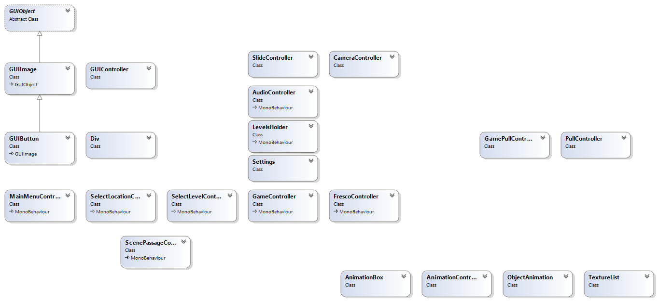

3. Asset limits

This asset has only two levels of each language with different mechanics.

4. Game description

In this game you need to find 8 of 15 items on the background (what can be hard). Items you need to find are described in left side of a screen by their names or shadows (2 types of levels). When you find some items on 1-2-3 seconds timeframe you will get more points (combo). The target is 3 stars to unlock fresco.

5. Before start

You need to set Input->Perspective positive and negative buttons (set it to q and e to increase\decrease camera size in editor).

6. Screen resolutions

For some "square" resolutions like iPad Mini and other, you should add to backgrounds "white" lines from top and bottom, so background will be not 720x1280, it will be like 1280x1280 and when player has 720x1280 screen he will see only minimum of background, but when he has 1000x1280 he will see those 280 pixels of additional background.

7. Unity Ads

You can use unity ads by calling AdsController. ShowRewardedAd.

8. Google Play Services

You can implement achievements using GooglePlayServicesController (uncomment all lines).

9. AdsController

You can add AdMob and use AdsController (uncomment all lines) to implement it. Also you can delete it if you don't want to add Ads.

10.Contacts

E-mail: goldeneternitystudio@gmail.com