**Toy Box Blast (Unity5.3.2 or higher)**

**Platform:** Android & IOS only

**Platform Setting:** File > Build Setting > (in platform panle, select your platform to android or IOS and click on) Switch Platform.

**For re-skin**

* **Go to Asset > Sprites**

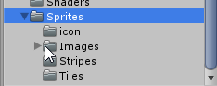

* **Go to Resources > Images**

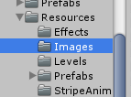

**Replace all Texture files in these folders.  
  
Features include:**

* Chartboost Unity Plugin 4.6.1 (Follow these steps)

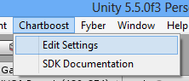

* Add your chartboost app ids for android and IOS

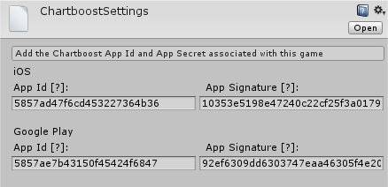

* **Admob**  **Setting**

Replace with your admob INTERSTITIAL, BANNER AND REWARDED VIDEO ID.

* 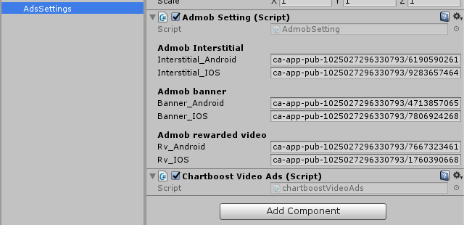
* **Inapps**

Open the INAPP.cs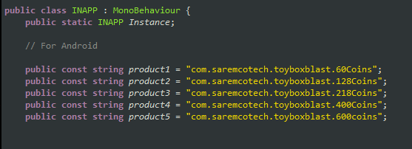 script in the script folder and change the inapp ids.

Please read documentation before contact us.