Setup admob:

Fill app id as image: 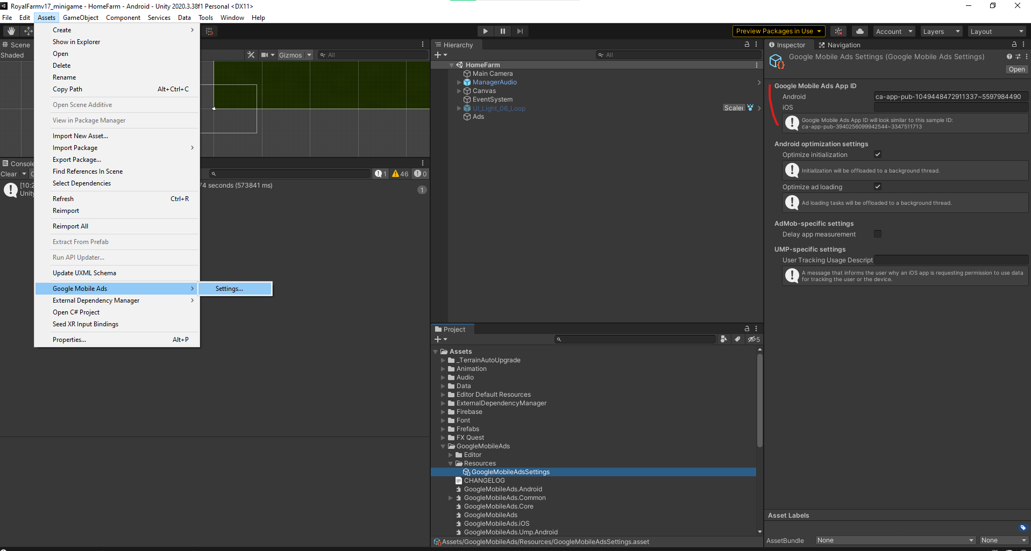

Fill id app open in class AdsAppOpen

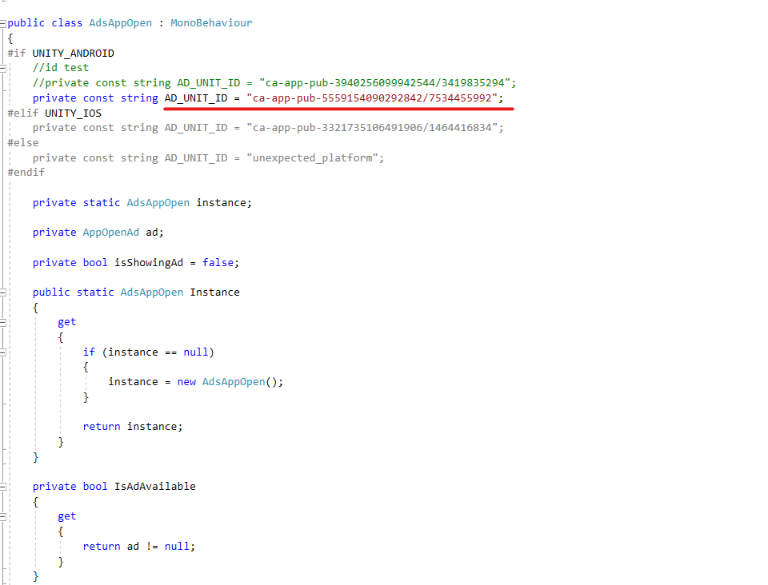

Fill id app inter in class MobileFullVideo:

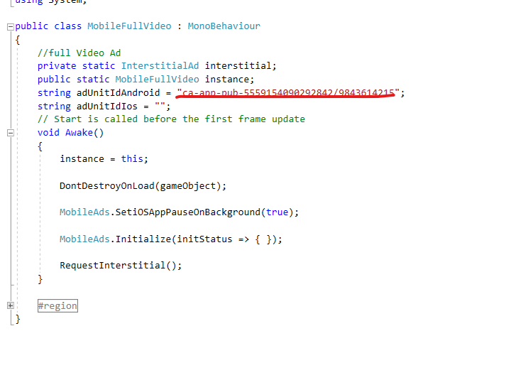

Fill id app reward in class MobileRewardVideoAd

