Move the block out manual
How to install 2
How to play 2
Reskin 3
Change you own unity id. 4
Setup your own bundle ID 5
Other game information 5
Advanced Scripts 5
Important API and functions 7
Scores 8
Switch game Mode 9
In app purchase 10
Use as in-game puzzle 12
Level Editor (new!) 12
Localization 13
Ready your localization file 13
Add new language to system 13
Use localization in game 14
Problem you may face 15
I got ton of error after import 15
Why I get errors during a import? 16
Basic knowleage must know 17
build and submit a game on app store with unity. 17
build and apk on android platform 17
create iap on goolgeplay 17
create iap on apple console(please ignore code part) 17
How to get support 18

How to install
Make sure the inspector panel include tags and layers which default project not have. Which means you have set up the project properly.
To test the game, search startscene by project panel of unity editor to found the scene file named startscene.
You can also found the scene files under
Assets/blockout/gamelevel
Double click on it to active the scene. Then you can run the game correctly. Other scene files can running independently but you may not get correct level data for test without a correct initialization sequence.

Following this if when you finish the import. Install in app purchasing to your game with package manager.

How to play
The name also names “block out”,” Klotski”,”unblock” or ”rush hour”.
This was a classic game which you may already played in many places. The game rule were very clear even without a tutorial.
Just touch and hold each block to drag and move them.
Blocks can only move along its longer side.
Try to drag the red block into the exit place.

Reskin
The only thing you need to know about reskin is the unity sprite or the unity ui image. Find the referring picture sources by just click on the image/sprite component on each gameobject from editor window.
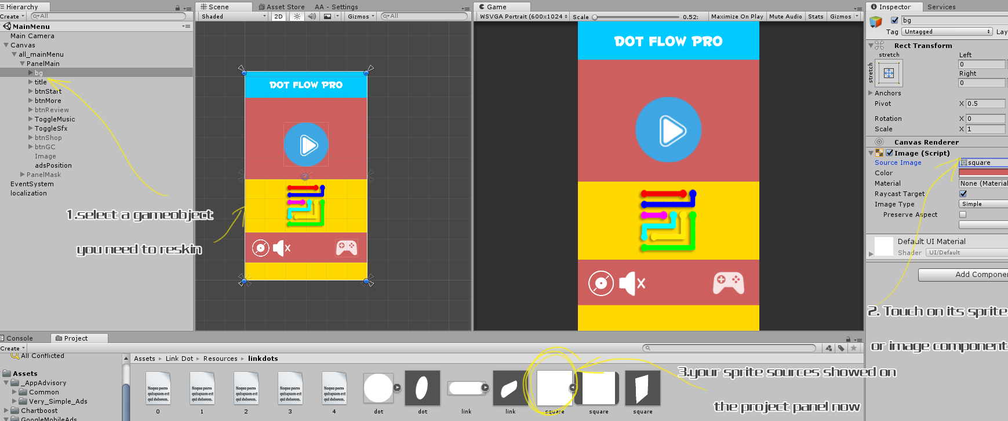
(zoom the picture by holding ctrl+mouse wheel)
All other resources were under
Assets/blockout/Resources

Change you own unity id.
You should open your unity developer website console to add id and placement first.
An Id refers to each game and the placement refers to what ads you use.

Your Developer Site

See detail in unity tutorial. Or navigate from service tab -> ads -> click learn more.

After you finish create your ads ID
Open Gamemanager.cs

const string gameId = "1238100";
const string interestitialPlacement = "Interestitial";
const string rewardPlacement = "rewardedVideo";

change all id with you created.

Finally,you should set
public bool test = true;
to
public bool test = false;
after you have finished testing the game.

If you want to add more ads. I’d like suggest you use ads Plugin from the store like Gley
Currently the game shows an interstitial every 2 levels(on even level) and get 2 rewards for each free ads.
Search and find where my game call showInterestitial or ShowRewardedAd to make sure where is the best place you put your game ads.
Basic Game Settings

Setup your own bundle ID
Each game must have a different Bundle id. So you must made the id to fit the id you request from apple or gp.
File->build setting, open the build setting panel. Find and click player setting button.
On right inspector panel, touch other settings panels. Change buddle id in bundle identifier section.

Other game information
Type const.cs to search on project panel.
Pay attention for LEADER_BOARD_ID,appid.
These 2 relative your gamecenter id and your game app id.

Search and found
Application.OpenURL ("http://itunes.apple.com/WebObjects/MZSearch.woa/wa/search?submit=seeAllLockups&media=software&entity=software&term=
Change the url you need to be a more games link.

Advanced Scripts
Under Assets->blockout->scripts folder. There are all scripts of the game. The major files’ detail were listed as below.
Const.cs: some parameters not for game but for your publish services like user id etc.
GameData.cs: Store the temporary variables of the game like score, level, time cost, etc. Can be called by Game.getInstance().xxx in any place of the game.
GameManager.cs: The most important file for initialize and process game controller service like music, advertisement, iap etc. Can be called by GameManager.getInstance().xxx in any place of the game.
LevelMenu: The level menu UI file. Attached on the UI root element of the levelmenu scene.
MainScript.cs: the game logical class. Attached on the gameobject of the game level scene. Process the game start ,retry,or the win or fail.
PanelMain.cs: Attached on the UI element of MainMenu (game title) Scene. Just deal with the things for game start, rate etc.
StartSplash.cs：File attached on the gameObject of startScene ,The start scene of the game. It initialize some forever exist object.
TipPanel.cs: process the UI events of the tip panel.Not used for this game yet.
Winpanel.cs:process the UI events of the game win panel.

Important API and functions
Now all the functions and variables were commented in the script files and you can open each script to see. There is not much to say as most of them only describes the UI which all can be understand easily for a glance.

To play a music: Use GameManager.getInstance().playMusic(xxx);
To play a sound effect: Use
GameManager.getInstance().playSfx(xxx)
Remember to put your music and sound effect file into assets/blockout/Resources/sound source folder. And for a background music you must start its name with text bg ,Like bg1,bg2,bgmusic.

Scores
The game count the totalscore at starts.
Refresh scores when finish each level. Temporary, each level you finishes ,you will get 1 score.
Score is not used for this game yet, to get the score information, call the API at any places you want.
GameData.instance.bestScore

Switch game Mode
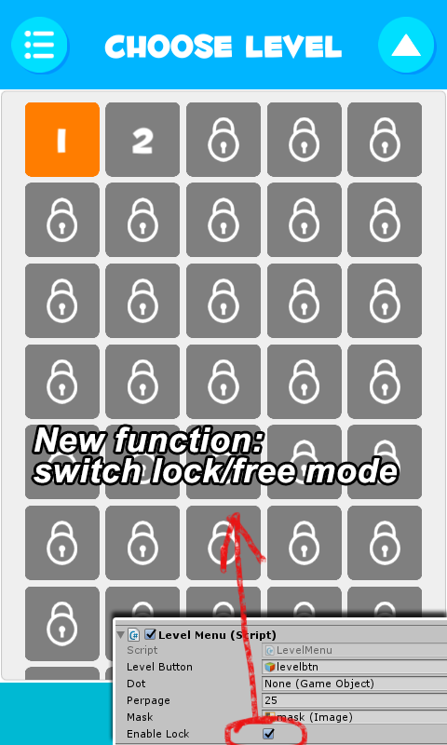
Active LevelMenu scene file. Select Canvas gameobject, on its inspector, the levelmenu script component, there is an enable lock checkbox. You can switch game mode by check on/off it for whether you want player to unlock the level one by one.

In app purchase
First make sure the service were updated to the lastest and being turned on. The services were all unity native function so they maybe update some files for different version. Just let unity do the job automatically and no worry about it.
Make sure the following services were on
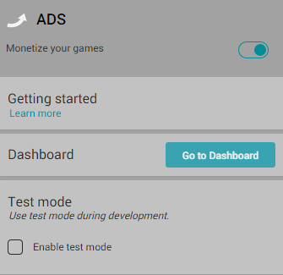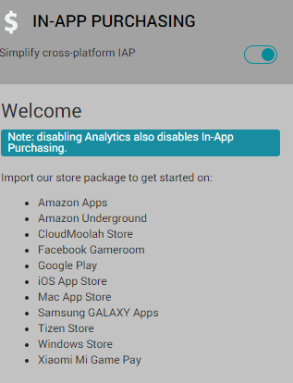

The in-app purchasing sometimes require a reimport, if the import button on service tab not works, find unitychannel and unitypurchasing these 2 package files under asset/plugin folder and double click them to import the packages manually.
Find Gamemanager.cs
Find
public const string CONSUMABLE0 = "20Coin";
public const string CONSUMABLE1 = "50Coins";
public const string CONSUMABLE2 = "100Coins";
Set these 3 id to your own product id, If you don’t know what is product id, please read apple or google development guide for in app purchase section.
I would not talk detail about this because this is not unity or game template issues.
The iap setting can be very very difficulty so make sure you are very familiar the process and have done all the job correctly yourself.
Here are 2 quick recommended tutorial

Learn basic about iap setting for IOS development
Learn basic about iap setting for googleplay

Remember, sometimes the iap service not work on test device before them active online because some development console requires test id or sandbox environment. You can not run the game just with normal users account.
By default, the game always returns true for any buy action. You must turn off this before you publish to a real store.
In Gamemanager.cs find
public bool test = true;//set it to false when you publish to test for real.
Set it to false.

Iap attached on a gameobject on music.cs
This music only start from startscene. So there maybe error if you start on other scene with test mode shut down.

Use as in-game puzzle
Find the level file named 3dTest
The game prefab used for the minigame is under
Assets/blockout/src/prefab
When use the game as a prefab widget, just drag and drop the blockoutC prefab into your scene.
The camera uses the depth mode so make sure you 3d scene camera was also a depth camera. Do not put objects within more than camera area unless you use layer mask for each camera.
The example scripts for control is TestGame.cs
Open the script for detail with comment.
To detect a game win,In BlockOnMouseDrag.cs, locate:
GameObject testCube = GameObject.Find("testCube");
Here the script would call the TestGame.cs which attached on the cube to do some win perform.
You can change these code anyway you want to deal with the win situation yourself.
To change the 3d view of the game section, find “camera” under blockoutC gameobject. Rotate or move this would work. Do not try other cameras.

Level Editor (new!)
Open Scene File build-in level editor to active the level editor.
This editor works in game run mode. So make sure you are running the game while editing it.
After you finish making a level, use ctrl-c to copy the json text which generated below.
Then find a level file under resources/blockout
Paste the copied line into any file (0-4).txt file.(0-4 refers to easy – hard 5 degree of difficulties)
The line position refers to the level number.

Watch this video for detail of how to use it.
https://www.youtube.com/watch?v=NP2ccaPI49Q
Localization

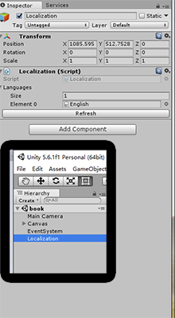
Ready your localization file
Find src/localization folder. Duplicate English.txt and rename it a new name like French.
Open the file, see like
btnBack = back
This means the btnBack key refers to the value of translation “back”
After your localization file were all ready, set the size of localization attribution to 2 or more and assign your language files.(see right picture)

Add new language to system
In GameData.cs,we see the function GetSystemLanguage().
This function get system language by switch branches.
You should add the language cases only when your localization file(txt) is ready. Otherwise if the system can not find the right translation file or the file does not include current translation phases, it would throw errors and break the game.

For default testing ,it is
public int GetSystemLaguage(){
int returnValue = 0;
switch (Application.systemLanguage) {
case SystemLanguage.Chinese:
returnValue = 1;
break;
case SystemLanguage.ChineseSimplified:
returnValue = 1;
break;
case SystemLanguage.ChineseTraditional:
returnValue = 1;
break;
default:
returnValue = 0;
break;
}
returnValue = 0;//test
return returnValue;
}
see returnValue = 0;//test
This line is uncommented. The language will always be English .If you may not have time to deal with your own native translation or you did not want a localization function for your game, just leave it uncommented. Otherwise, you should comment this line and make the system to decide which localization to choose.
The returnValue must be refer to the element order of localization Gameobject as I said upon.

Use localization in game
Just call like:
xxx.text = Localization.Instance.GetString("phasename");

Problem you may face

I got ton of error after import
If you got import problem like this which refers to iap issues not found.

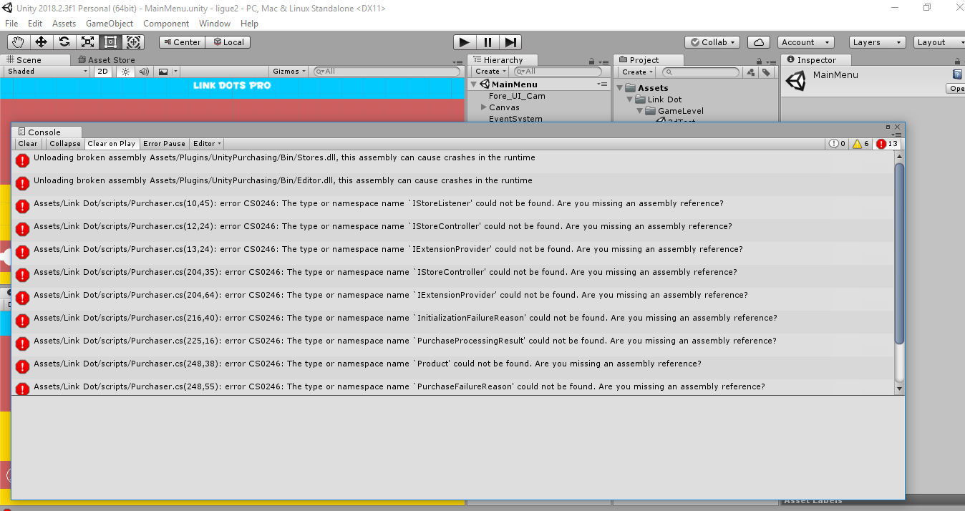
If you got errors like occurred on in-app purchasing
Goto window->package manage
Select unity registry
search like "in app" to find in app purchasing
install a valid version of it.
If still there are errors, find unitychannel and unitypurchasing these 2 package files under asset/plugin folder and double click them to import the packages manually.
You could delete plugin folder to retry again.
If you deleted this folder but used unity ads in this project,you should reinstall unity ads.
Just search advertisement in package manage like upon to install the unity ads.
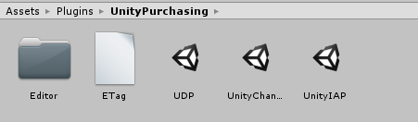

Why I get errors during a import?
As unity start to use package manager, sometimes,especially when you update the unity. It may got import error like below:
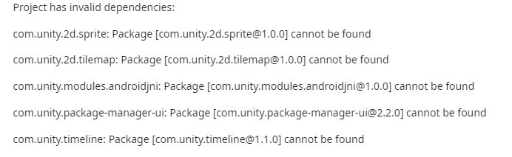
If you face such problems, do not be afraid. Just see there are some keywords in these errors.
Here above, there are many things in the branch before a version.
Like[com.unity.timeline@1.0.0] so this will be a native plugin in unity.
And this plugin is now not be imported correctly.
To fix this just
Goto window->package manage
Select unity registry like below
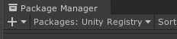
Then search timeline on the right.
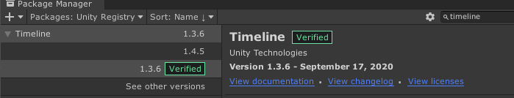
Here you can choose to reinstall a valid version or remove the package.
Most probably your error would be fixed.

Basic knowleage must know

build and submit a game on app store with unity.
https://www.youtube.com/watch?v=C3izqF6h_aY

build and apk on android platform
https://www.youtube.com/watch?v=0eK3vPbYNqk

create iap on goolgeplay
https://www.youtube.com/watch?v=KBcOjMI6WVo

create iap on apple console(please ignore code part)
https://www.youtube.com/watch?v=YHGIij_stpk

How to get support
Contact to us E-mail
Remember attach your invoice otherwise there would not be my reply.
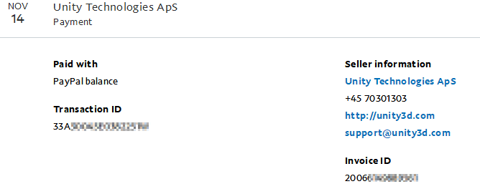
The invoice you can get from your paypal account records.
If you do not have a invoice. Grab some screenshot to confirm your buy successful flow is also ok.

If you want support our work or feel interested in other assets, take a look at More Games

