1. Start Revit 2013
2. Before coding, make sure all processes are detached.

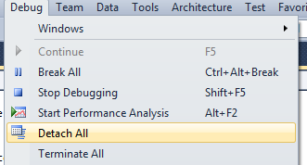

1. After coding, build solution and attach to Revit process.

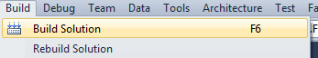

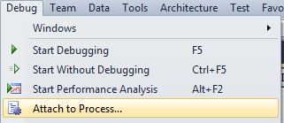

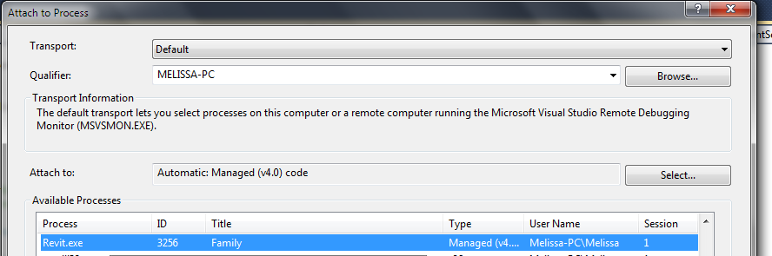

1. In Revit, go to the Add-Ins tab > Add-In Manager > (re)load desired dll.

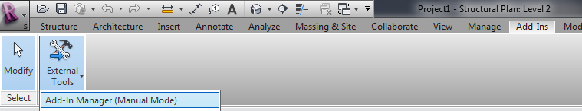

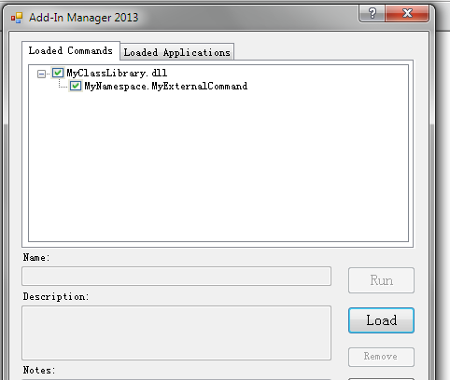

1. Run desired external command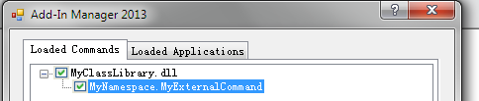
2. Repeat steps 2 to 5.