DBT-Oracle Installation Guide

- Windows Software checklist before install DBT :
- Microsoft Visual C++ : https://visualstudio.microsoft.com/visual-cpp-build-tools/​
Download buildtool -> Run file -> Chose Desktop development with C++​
​
- VSCode : Visual Studio Code - Code Editing. Redefined​
Make sure VSCode have dbt and Cmake extension​
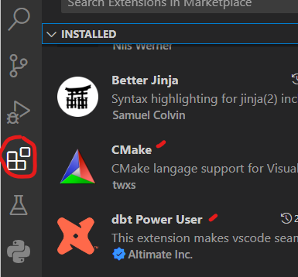
​

- Git : Git - Downloads (git-scm.com)​
​
- Python : Download Python | Python.org​
​
- Update Pip : python.exe -m pip install --upgrade pip​
​
- Install Python Virtual Env​ :
  - python -m venv .dbtenv​
  - Vir_Env sẽ tự động được active mỗi lần truy cập vào

- Prepare requirement file
Edit dbt-oracle-requirement.txt | dbt-core  dbt-oracle  oracledb

- Install dbt-core and dbt-oracle
(.dbtenv) C:\Users\chuong.nguyenh2\Documents\dbt_oracle_d5>pip install --force-reinstall -r dbt-oracle-requirement.txt
- Install dbt Package / Library
Edit packages.yml
- package: calogica/dbt_expectations
version: [">0.8.0"]
- git: "https://github.com/dbt-labs/dbt-utils.git"
revision: 0.9.2
- package: calogica/dbt_date
version: 0.8.0 # version 0.9.1 not yet compatible
Install dbt library : dbt deps
- Clone remote Repository for Dbt Directory Structure
https://github.com/chuongnh1709/dbt_oracle_d5.git
- Set biến môi trường cho dbt : -- Có thể sử dụng cmd hoặc PowerShell
Cmd | Edit : activate.bat
C:\Users\chuong.nguyenh2\Documents\dbt_oracle_d5\.dbtenv\Scripts\activate.bat
# My ENV Variables
set ORA_PYTHON_DRIVER_TYPE=thin
set DBT_PROFILES_DIR=C:\Users\chuong.nguyenh2\Documents\dbt_oracle_d5\profiles_oracle.yml
-- Check : echo %ORA_PYTHON_DRIVER_TYPE%

PowerShell | Edit : Activate.ps1
C:\Users\chuong.nguyenh2\Documents\dbt_oracle_d5\.dbtenv\Scripts\Activate.ps1
# My ENV Variables
$Env:ORA_PYTHON_DRIVER_TYPE = "thin"
$Env:DBT_PROFILES_DIR = 'C:\Users\chuong.nguyenh2\Documents\dbt_oracle_d5\profiles_oracle.yml'
-- Note : biến được add vào phải nằm trước phần signature block
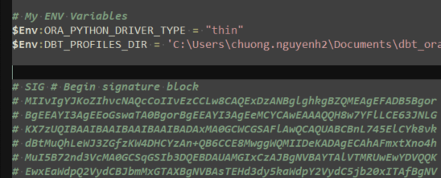

-- Check : $env:ORA_PYTHON_DRIVER_TYPE

- Add .gitignore (để ngăn sync thông tin connection lên Repo) – đã add sẵn trong repo
# DBT
target/
dbt_packages/
logs/
.user.yml
profiles.yml

# Config files
conf/.*
!conf/.gitkeep
!conf/*.bk

# Python venv
.dbtenv/

- Configure Connection to Oracle
Edit profiles_oracle.yml
dbt_oracle_d5:
outputs:
dev:
host: DBVN00D5HD.CZ.INFRA
password: VN00D5HD
port: 1521
protocol: tcps
schema: LDM_FIN_ETL
service: VN00D5HD.CZ.INFRA
threads: 1
type: oracle
user: appdeploy
target: dev

- Modified dbt_project.yml
- Test Connection to Oracle
- Add Dbt Directory into Git Repo
- cấu trúc thư mục đã được chuẩn bị sẵn

