siri churakanti

HOSPITAL PATIENT INFORMATION AND APPOINTMENT SCHEDULING

Lawrence Technological University

Name : Siri Sri Churakanti

Masters Of Computer Science

Department Of Mathematics and Computer Science

Professor: Oriehi Anyaiwe

Date: 12/08/2023



**Abstract:**

In the rapidly advancing landscape of healthcare services, the efficient management of patient information and appointment scheduling has become paramount for enhancing overall healthcare delivery. This paper proposes a comprehensive Hospital Patient Information and Appointment Scheduling System (HPIASS) designed to streamline and optimize the administrative processes within healthcare institutions.

The HPIASS integrates advanced information technology to create a centralized database for patient records, ensuring secure and accessible storage of crucial medical information. The system employs robust security measures to safeguard sensitive patient data, adhering to established privacy regulations and standards. Through this centralized repository, healthcare providers can easily access patient histories, diagnoses, and treatment plans, facilitating informed decision-making and personalized care.

Moreover, the HPIASS incorporates an intelligent appointment scheduling module that automates the booking process, reducing administrative burden and minimizing scheduling conflicts. Patients can conveniently schedule appointments online, view available time slots, and receive automated reminders, enhancing overall patient experience and engagement.

The system also features real-time updates, enabling healthcare professionals to collaborate seamlessly across departments and ensuring continuity of care. Additionally, analytics tools are integrated to provide insights into patient demographics, resource utilization, and appointment trends, allowing hospitals to optimize their operations and resource allocation.

The HPIASS represents a significant advancement in healthcare administration, promoting efficiency, accuracy, and patient-centric care. By leveraging cutting-edge technology, this system contributes to the evolution of healthcare services towards a more interconnected and data-driven future.

|  |  |
| --- | --- |
| S.NO | TOPICS |
| 1 | INTRODUCTION |
| 2. | DELIVERABLES:   * Architectural Levels: * Schemas: * Data Mapping: * Data Independence: * Properties of Relations: * Relational Algebra: * Data Manipulations * Critiques of Database System Development Lifecycle: * Modeling of Entity Relationships: * Normalization: * Database Web Server: * Security Measures * Transactions with the Database |
| 3 | REFERENCE |

**Introduction:**

In the dynamic landscape of healthcare, the effective utilization of technology is essential to meet the evolving demands of patient care and administrative efficiency. This paper introduces the Hospital Patient Information and Appointment Scheduling System (HPIASS), a groundbreaking solution designed to revolutionize the traditional approaches to managing patient data and scheduling appointments within hospitals. As the volume of patient information continues to grow, there is an increasing need for systems that can securely store, retrieve, and disseminate this data in real-time. The HPIASS addresses this challenge by offering a centralized digital repository, enhancing accessibility and accuracy in patient information management.

One of the critical aspects of healthcare administration is appointment scheduling, an area often plagued by manual errors and inefficiencies. The HPIASS integrates an intelligent appointment scheduling module, automating the booking process and providing patients with the convenience of online appointment scheduling. This not only streamlines administrative workflows but also minimizes scheduling conflicts, ensuring a smoother experience for both healthcare providers and patients. Furthermore, the system's real-time communication infrastructure facilitates seamless collaboration among healthcare professionals, promoting enhanced continuity of care and informed decision-making.

As healthcare systems strive to embrace digital transformation, the HPIASS emerges as a pivotal tool in optimizing operational processes, improving patient care, and laying the groundwork for a more interconnected and efficient future in healthcare administration. This paper delves into the core features and benefits of the HPIASS, shedding light on its potential to reshape the healthcare landscape by harnessing the power of technology for streamlined patient information management and appointment scheduling.

**Architecture Level:**

The external architecture focuses on the user interaction and interfaces with the system. In the context of a Hospital Patient Information and Appointment Scheduling System, external architecture involves the design of user interfaces, both web and mobile applications, which allow patients to interact with the system. The conceptual architecture defines the abstract representation of the system's structure and behavior. It focuses on the high-level design and logical organization of data.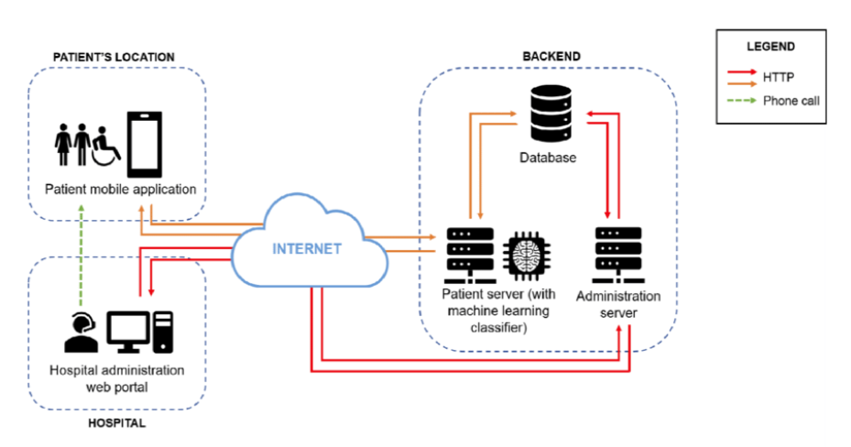

The conceptual architecture defines the abstract representation of the system's structure and behavior. It focuses on the high-level design and logical organization of data.

This breakdown provides a comprehensive view of the architecture at different levels, considering both the user-facing aspects and the underlying database and infrastructure components. It's essential to balance usability, functionality, and security to create an effective Hospital Patient Information and Appointment Scheduling System

**SCHEMA:**

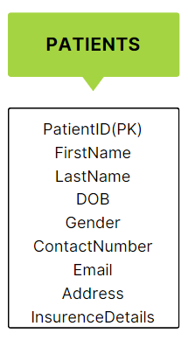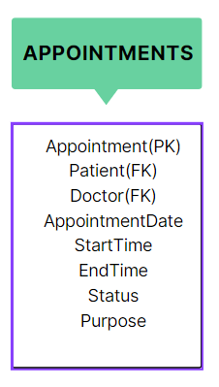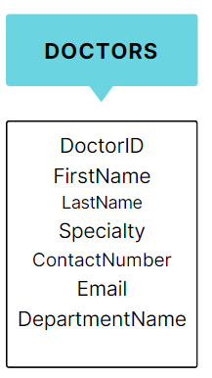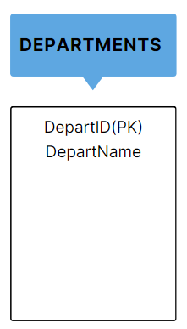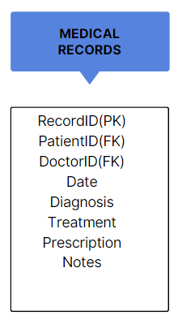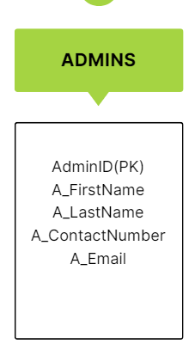

A hospital's patient information and admissions system is a comprehensive database architecture with well-structured schema documentation. The system includes tables with specific patient information and appointment scheduling, with limits defined for data integrity. Primary keys and reference keys create relationships between linked tables, while constraints like date and time increase system reliability. Schematic documentation serves as a guide for developers and a transparent reference for stakeholders, promoting a common understanding of the system's complexity. Overall, chart documentation is crucial for maintaining system-to-system unity, integrity, and efficiency in managing hospital patient records and admission plans.

**Data Mapping:**

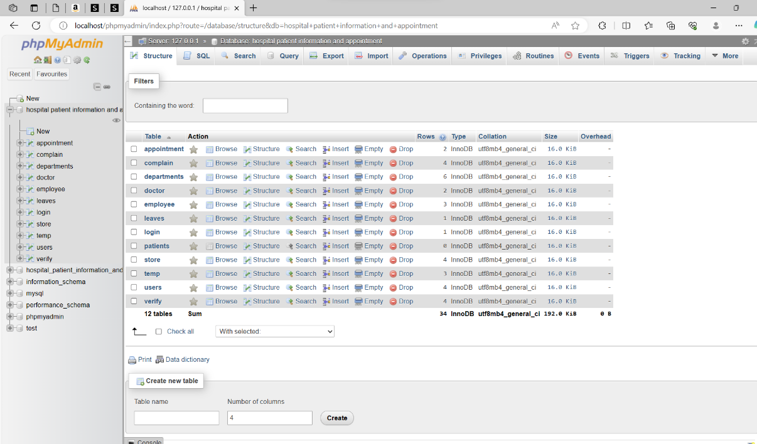

**Signup Page:**

User-Friendly Registration Process: Design the signup page to be user-friendly, with clear and concise form fields. Collect essential information such as name, contact details, and a secure password. Include validation checks to ensure accurate data entry, and provide informative feedback for any errors. Additionally, consider incorporating multi-step forms to simplify the registration process and make it more manageable for users.

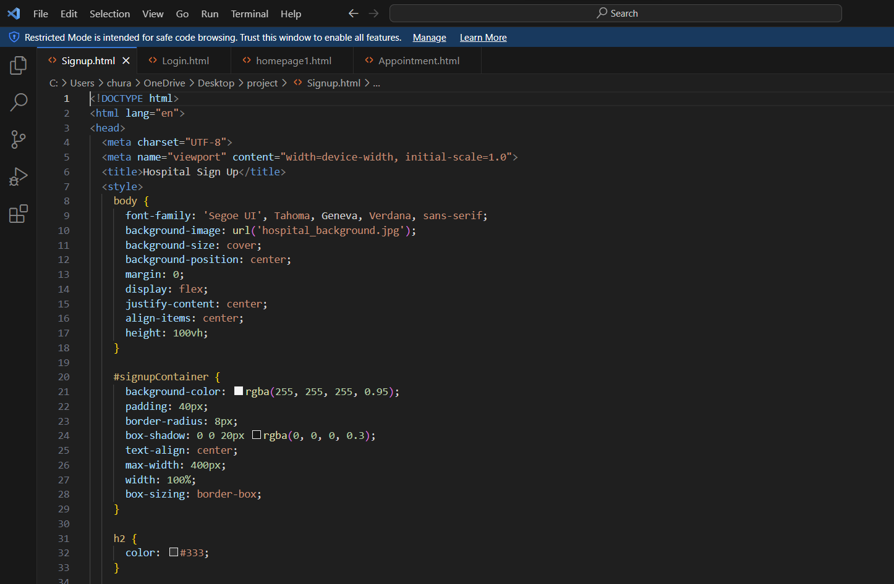

**Login Page:**

Secure Authentication Mechanism: Implement a robust authentication mechanism on the login page to ensure the security of patient and staff accounts. Utilize strong encryption for password storage, and consider incorporating additional layers of security such as two-factor authentication (2FA) to enhance user account protection. Display clear error messages to guide users in case of login failures and encourage the use of strong, unique passwords.

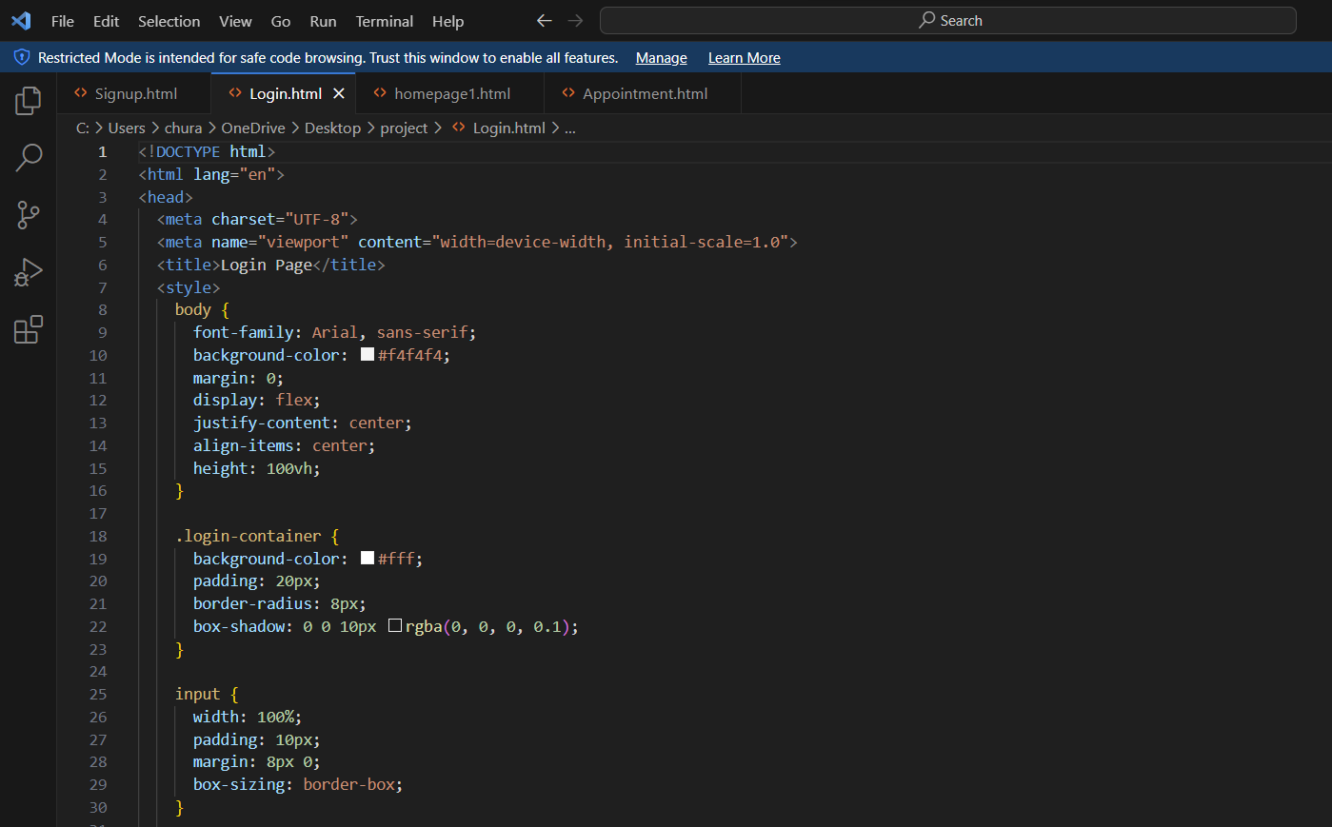

**Homepage:**

Customized Dashboard for Users: Design a dynamic homepage/dashboard that provides a personalized experience for each user. For patients, display upcoming appointments, medication reminders, and access to their medical records. For doctors and administrators, include quick access to appointment schedules, patient information, and relevant administrative tools. Ensure the homepage is intuitive and efficiently directs users to the most frequently used features of the system.

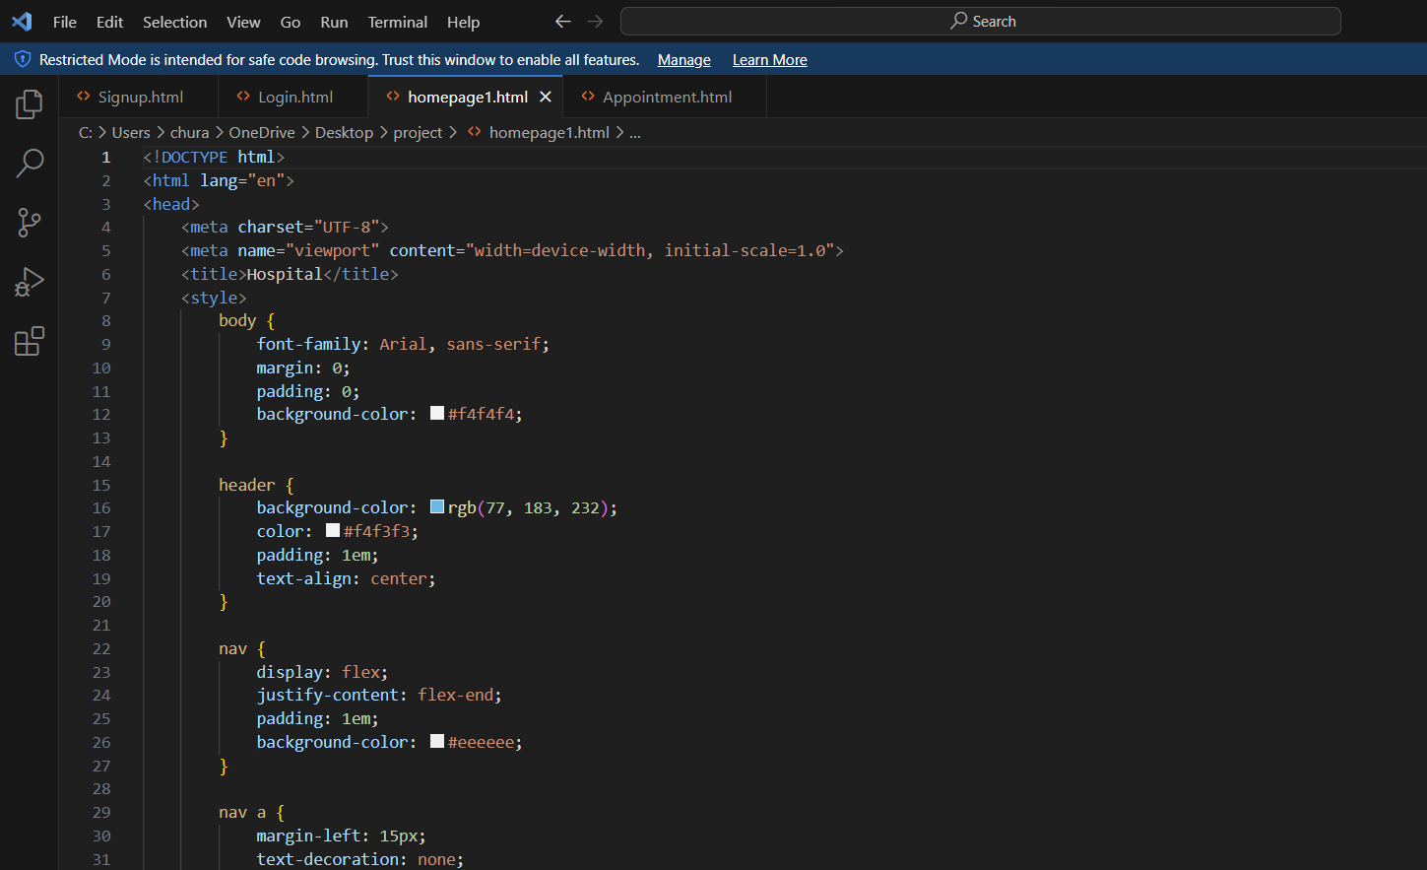

**Appointment Page:**

Intuitive Appointment Scheduling: Create a user-friendly appointment scheduling interface that allows patients to easily select preferred dates and times. Implement features like real-time availability updates, appointment confirmation notifications, and the ability to reschedule or cancel appointments. Ensure the system considers the availability of doctors and resources, and provide a clear overview of scheduled appointments to both patients and medical staff. 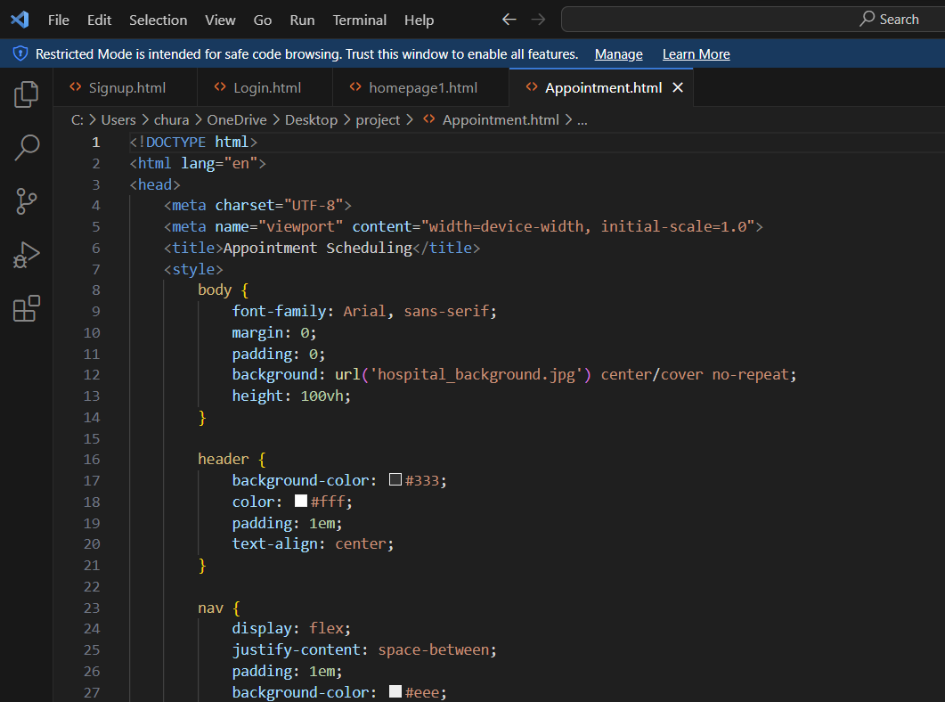

**Data Independence:**

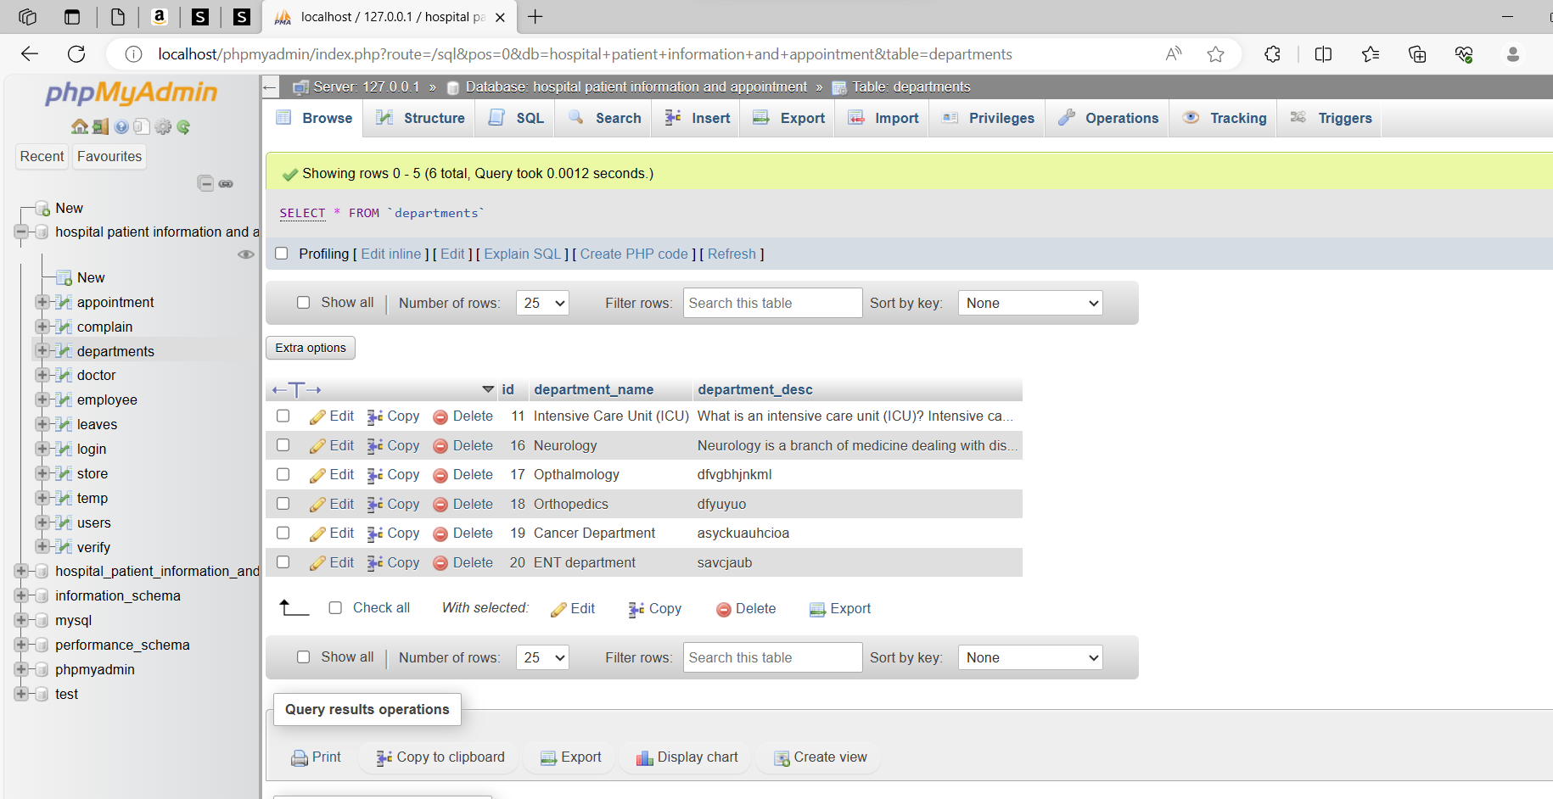

**Logical Data Independence:**

Explanation: Logical data independence assures that changes to the database's logical structure (such as adding or updating tables, attributes, or relationships) have no effect on the application programs. Application programs interact with data via a conceptual schema, and changes to this schema should not require rewriting of the application code.

Implementation: Views, stored procedures, and well-defined data abstraction layers were used to do this. Views are logical representations of data that protect applications from underlying changes. Database activities are encapsulated in stored procedures, reducing the impact of structural changes.

**Physical data Independence:**

Explanation: Physical data independence protects applications against changes in data storage and retrieval processes. It enables changes to how data is stored, indexed, or retrieved without impacting the logical structure or application programs. This guarantees that performance enhancements or changes in storage technology may be deployed smoothly.

Implementation: A database management system (DBMS) is used to isolate the physical storage details from the conceptual structure. The database management system (DBMS) manages data storage, indexing, and retrieval techniques, enabling the logical structure to stay intact. This is frequently performed by utilizing a data dictionary and metadata, which hold information about the physical structure and organization of data.

Additionally, establishing well-defined data abstraction layers within the application architecture acts as a buffer, insulating application programs from changes in the database structure. Versioning and migration tools play a crucial role, ensuring seamless transitions during updates to the database schema while maintaining data consistency. These strategies collectively enable both logical and physical data independence, allowing the system to adapt to evolving requirements without disrupting the functionality of existing applications.

**Properties of Relations:**

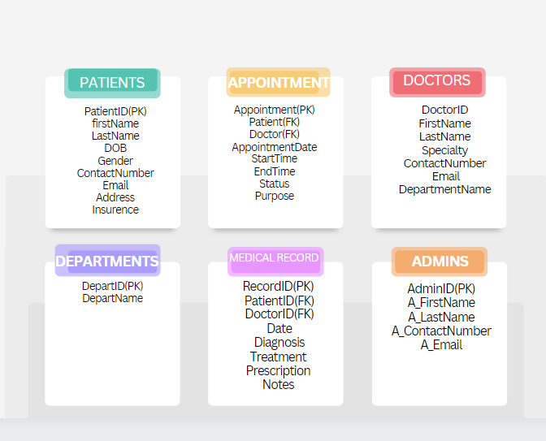

**Patients table relation**

|  |  |  |  |  |  |  |  |  |
| --- | --- | --- | --- | --- | --- | --- | --- | --- |
| PatientID | FirstName | LastName | DOB | Gender | ContactNumber | Email | Address | Insurence |
| 111 | John | Doe | 05/13/23 | male | 1234567890 | john@email.com | 123 main st,MI | ISO |
| 121 | Jane | Smith | 08/22/22 | female | 1234545455 | Jane@email.com | 456 Oak st,MI | ISO |
| 131 | Bob | William | 04/03/22 | male | 1234647568 | bob@email.com | 789 pine St,MI | ISO |

**Appointment table:**

|  |  |  |  |  |  |  |
| --- | --- | --- | --- | --- | --- | --- |
| DoctorID | Appointment  Date | Start  Time | End  Time | Status | Purpose | PatientID |
| 101 | 2023/01/15 | 10:00:00 | 11:00:00 | Scheduled | General checkup | 111 |
| 102 | 2023/01/20 | 14:30:00 | 15:30:00 | Cancelled | Annual Physical | 121 |
| 102 | 2023/02/25 | 16:00:00 | 17:00:00 | Completed | Dental checkup | 131 |

**Doctors Table:**

|  |  |  |  |  |  |  |
| --- | --- | --- | --- | --- | --- | --- |
| DoctorID | FirstName | LastName | Specialty | ContactNumber | Email | DepartmentName |
| 101 | Dr. Michael | Johnson | Cardiologist | 5551234567 | michael@email.com | Cardiology |
| 102 | Dr. Sarah | Smith | pediatrician | 3331234567 | sarah@email.com | pediatrics |
| 103 | Dr. Robert | Williams | Orthopedic surgeon | 4541234567 | robert@email.com | orthopedics |

**Departments Table:**

|  |  |
| --- | --- |
| DepartID | DepartName |
| 1 | Cardiology |
| 2 | pediatrics |
| 3 | orthopedics |
| 4 | Dermatology |
| 5 | Neurology |

**Medical Record:**

|  |  |  |  |  |  |  |
| --- | --- | --- | --- | --- | --- | --- |
| RecordID | PatientID | DoctorID | date | Diagnosis | Treatment | Prescription Notes |
| 1 | 111 | 101 | 2023/01/15 | Common cold | Rest and over-the-counter medication recommended | Stay hydrated and get plenty of rest |
| 2 | 121 | 102 | 2023/01/20 | Sprained Ankle | Applied a brace and recommended physical therapy | Avoid putting excessive weight on the ankle. Attend physical therapy sessions |
| 3 | 131 | 103 | 2023/02/25 | Dental Checkup | Routine dental examination and cleaning | Schedule the next dental checkup in six months |

**Relation Algebra:**

relational algebra is a theoretical framework that underlies the SQL language and provides a set of operations for manipulating relational database. There are four fundamental relational algebra operations:

* Selection



* Projection



* Join

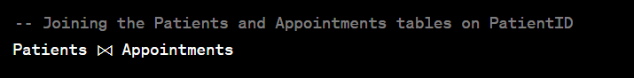

* Set Difference

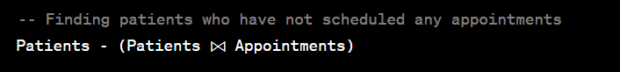

**Optimization Strategies:**

Indexing: Ensure that relevant columns are indexed to speed up data retrieval, especially in tables like Patients, Doctors, and MedicalRecords.

Query Optimization: Utilize database management system tools to analyze and optimize the execution plans of queries. This may involve proper indexing, caching, and query rewriting.

Normalization: Design the database using normalization techniques to reduce redundancy and improve query performance.

Materialized Views: Create materialized views for complex queries that are frequently executed, to precompute and store the results, improving overall query efficiency.

By applying these relational algebra operations and optimizing queries using the mentioned strategies, you can enhance the data retrieval and manipulation efficiency of the Hospital Patient Information and Appointment Scheduling System.

**Data Manipulation Operations:**

Data manipulation operations are essential for managing patient records, appointments, and other related information. Here's an overview of how these operations can be implemented, along with considerations for data security and concurrency control**:**

1. INSERT:

Purpose: To add new data into the database, such as adding new patient records or scheduling appointments.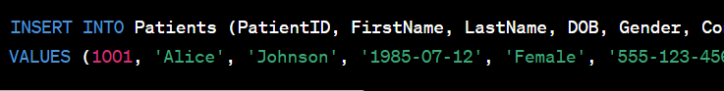

2. UPDATE:

Purpose: To modify existing data in the database, like updating patient information or changing appointment details

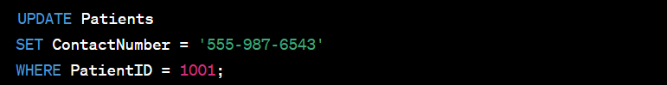

3. DELETE:

Purpose: To remove data from the database, such as deleting patient records or canceling appointments.



4. SELECT:

Purpose: To retrieve data from the database, allowing for queries to retrieve patient information, appointment details, etc.



**Data Security Measures:**

Access Control:

Implement role-based access control (RBAC) to restrict access to sensitive data.

Grant specific privileges to users based on their roles (e.g., doctors, nurses, administrators).

Encryption:

Use encryption for sensitive data, both in transit and at rest, to protect patient information.

Audit Trails:

Implement audit trails to track who accessed the data and when.

**Concurrency Control Mechanisms:**

Transaction Isolation:

Use appropriate transaction isolation levels (e.g., READ COMMITTED, SERIALIZABLE) to control concurrent access and ensure data consistency.

Locking:

Employ locking mechanisms to prevent conflicts when multiple users attempt to access or modify the same data simultaneously.

Deadlock Prevention:

Implement deadlock prevention techniques to avoid situations where transactions are mutually blocking each other.

Versioning:

Consider using versioning mechanisms to keep track of changes, allowing for concurrent access without conflicts.

**Critiques of Database System Development Lifecycle:**

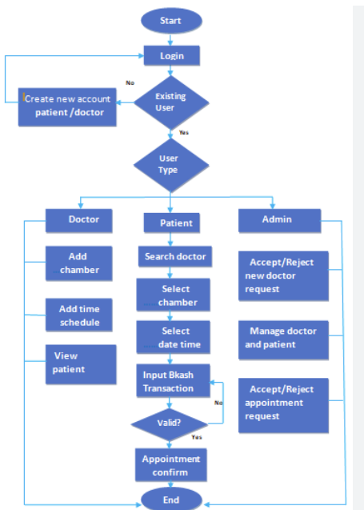

**Critique: Lack of Flexibility in Requirements**

One common critique is the inflexibility of requirements during the database system development lifecycle, leading to difficulties in accommodating changes.

**Mitigation: Agile Development Methodology**

To address this, adopting an agile development methodology allows for iterative and flexible adjustments to requirements throughout the project, enhancing adaptability.

**Critique: Inadequate Stakeholder Involvement**

Another critique involves insufficient stakeholder involvement, which may result in misalignment between system functionalities and user needs.

**Mitigation: Regular Stakeholder Engagement**

Implementing regular and effective communication channels ensures ongoing stakeholder engagement, promoting a better understanding of user requirements and expectations.

**Critique: Poor Data Quality and Integration**

Poor data quality and integration issues may arise, impacting the accuracy and consistency of information across the database system.

**Mitigation: Robust Data Validation and Integration Processes**

Implementing robust data validation mechanisms and integration processes helps ensure data accuracy, reliability, and consistency within the database system.

**Critique: Overemphasis on Technology Rather Than User Needs**

A common critique is an overemphasis on technology choices without sufficient focus on meeting the specific needs and usability requirements of end-users.

**Mitigation: User-Centric Design Principles**

Prioritizing user-centric design principles ensures that technological choices align with the practical needs and preferences of end-users, enhancing overall system usability.

**Critique: Insufficient Security Measures**

Insufficient security measures pose a significant critique, as inadequate protection of patient information can lead to privacy breaches and data compromises.

**Mitigation: Robust Security Protocols and Regular Audits**

Implementing robust security protocols, encryption, and conducting regular security audits help safeguard patient information and maintain compliance with data protection regulations**.**

**Modeling of Entity Relationships:**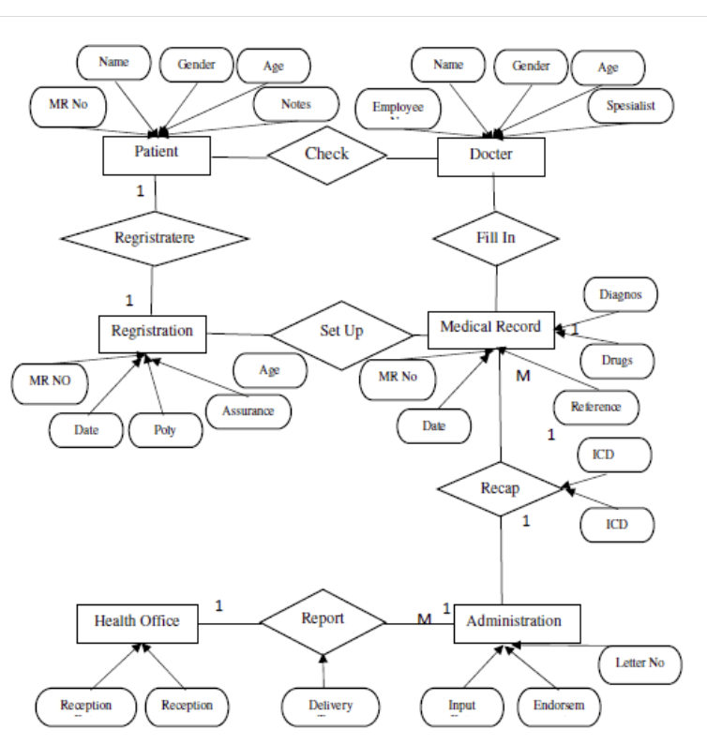

**Normalization:**

Normalization is a crucial aspect of designing a Hospital Patient Information and Appointment Scheduling System database. It involves the application of systematic techniques to organize and structure data, aiming to eliminate redundancy and enhance data integrity. The primary goal is to reduce data anomalies, such as insertion, update, and deletion errors, by breaking down tables into smaller, interrelated entities

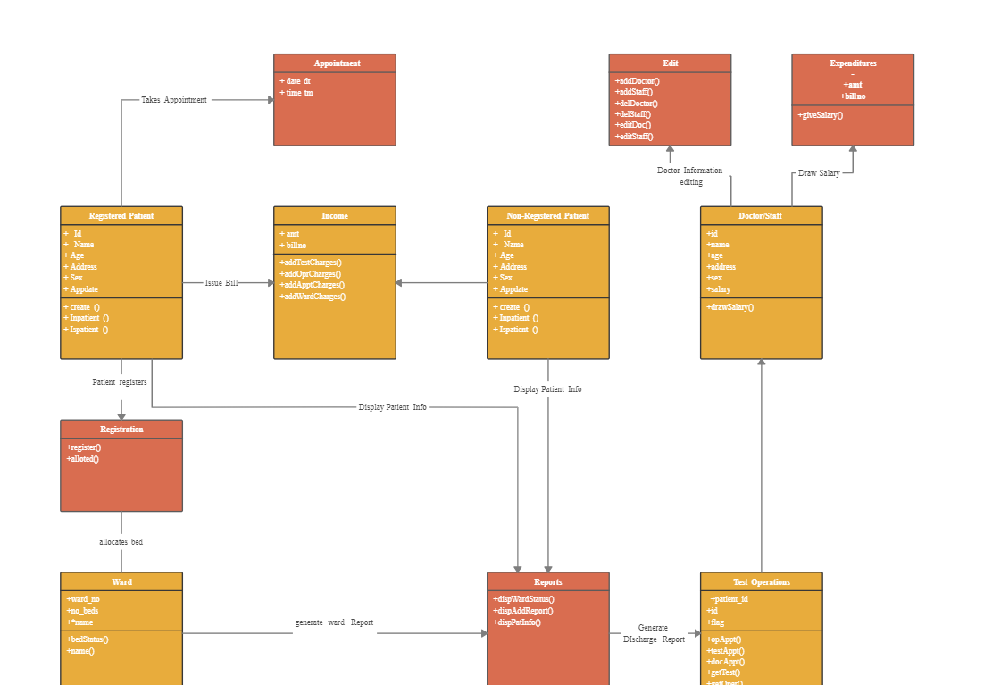

In a well-normalized database schema for the hospital system, each table represents a single logical entity, and relationships between tables are clearly defined. Common normalization forms, such as First Normal Form (1NF), Second Normal Form (2NF), and Third Normal Form (3NF), are applied to ensure data is organized efficiently, avoiding unnecessary duplication.

Normalization not only reduces the storage space required but also facilitates easier maintenance and modification of data. Clear documentation of the normalization process is essential for understanding the rationale behind the database structure, making it easier for developers, administrators, and stakeholders to comprehend and maintain the system over time. This documentation includes the identification of primary keys, establishment of relationships, and the reasoning behind decomposing tables to adhere to normalization principles. Overall, normalization plays a vital role in creating a robust and efficient database structure for a Hospital Patient Information and Appointment Scheduling System

**Database Web Server:**

The integration involves connecting the hospital's database to a web server, creating a dynamic environment where users can interact with patient information and appointment scheduling through web applications.

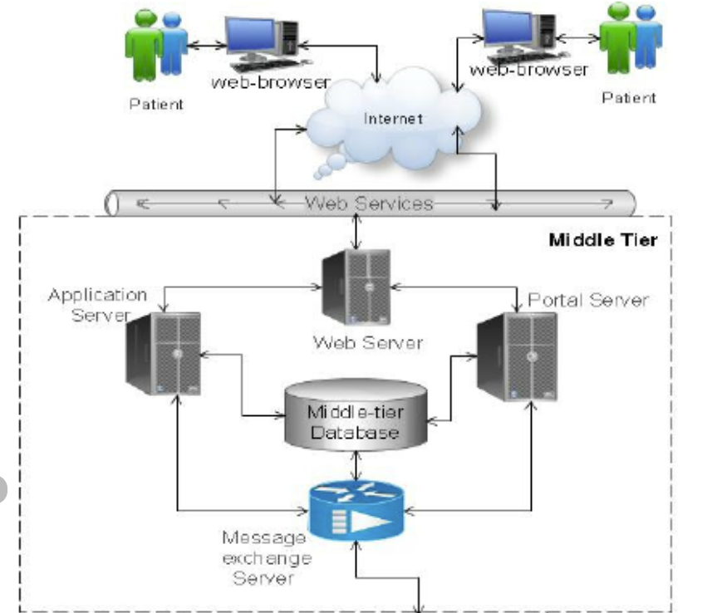

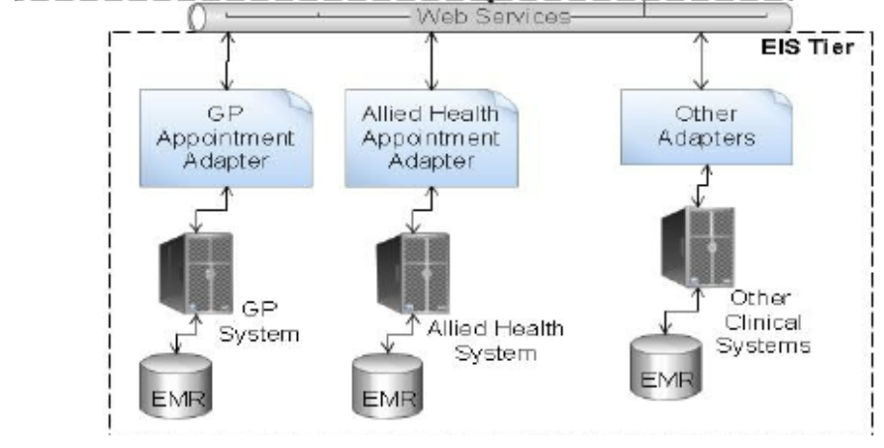

Web Server Documentation:

Comprehensive documentation is essential for the functional web server, detailing API endpoints, routes, and interactions with the database. This documentation serves as a guide for developers and users, outlining how to utilize the web server's capabilities.

API Endpoints:

The documentation includes a list of API endpoints that define specific functionalities, such as retrieving patient details, scheduling appointments, or updating medical records. Each endpoint is associated with a particular task within the system.

Routes:

Routes define the paths or URLs through which users can access different functionalities of the web server. For instance, "/patients" might be a route to access patient information, while "/appointments" could lead to appointment-related functionalities.

Interactions with the Database:

The documentation elucidates how the web server interacts with the underlying database. This includes details on database queries, updates, and any specific protocols for ensuring data consistency and security.

**Security Measures:**

Access Control, Authentication, and Authorization:

The system incorporates access controls to manage user permissions, ensuring that only authorized individuals can access specific functionalities. Authentication mechanisms, such as username/password or multi-factor authentication, validate the identity of users before granting access. Authorization mechanisms determine the level of access granted to authenticated users based on their roles and responsibilities.

Encryption and Secure Coding Practices:

To fortify data protection, the implementation includes encryption techniques, ensuring that data is transmitted and stored in an encrypted format. Secure coding practices are employed during application development to mitigate vulnerabilities and reduce the risk of unauthorized access or manipulation of sensitive information.

Protection Against Security Threats:

The system is designed to defend against common security threats, including SQL injection, cross-site scripting (XSS), and cross-site request forgery (CSRF). This involves input validation, parameterized queries, and other preventive measures to thwart potential malicious activities.

Regular Security Audits and Monitoring:

Continuous monitoring of the system's security is ensured through regular security audits. These audits identify vulnerabilities, assess compliance with security policies, and help in promptly addressing any emerging security concerns. Monitoring tools are in place to detect and respond to suspicious activities in real-time.

Compliance with Data Protection Regulations:

The security measures align with relevant data protection regulations, ensuring compliance with laws such as HIPAA (Health Insurance Portability and Accountability Act) or GDPR (General Data Protection Regulation). This includes safeguarding patient privacy, providing transparency about data practices, and obtaining necessary consents.

**Transactions with the Database:**

Support for Transactions and Transaction Management:

The database system supports transactions, which are sequences of one or more operations treated as a single, indivisible unit of work. Transaction management ensures that a series of database operations are executed successfully as a whole or rolled back entirely in case of failure.

Initiation and Commitment Documentation:

Comprehensive documentation outlines how transactions are initiated and committed within the system. This includes details on the specific database operations encompassed by a transaction, how the system ensures the atomicity, consistency, isolation, and durability (ACID properties) of transactions, and any error-handling mechanisms in place.

Ensuring Data Integrity:

The system employs transaction mechanisms to safeguard data integrity, preventing scenarios where only part of a set of related operations is executed. Transactions are structured to either complete successfully, leaving the database in a consistent state, or to be fully rolled back, maintaining the system's overall data integrity.

Concurrency Control:

Transaction management incorporates concurrency control mechanisms to handle multiple transactions occurring simultaneously. This ensures that the system can handle concurrent requests from various users without compromising the correctness of the database.

Error Handling and Rollback Procedures:

The documentation includes explicit details on error handling procedures within transactions. In the event of an error, the system is designed to roll back the transaction to its previous state, preventing incomplete or incorrect changes from being persisted to the database.

**References:**www.pearsonglobaleditions.com

© Pearson Education Limited 2015

The rights of Thomas Connolly and Carolyn Begg to be identified as the authors of this work have been asserted by

them in accordance with the Copyright, Designs and Patents Act 1988.

Authorized adaptation from the United States edition, entitled Database Systems: A Practical Approach to Design, Implementation, and

Management, 6th edition, ISBN 978-0-13-294326-0, by Thomas Connolly and Carolyn Begg, published by Pearson Education © 2015.

1. *HTML and CSS:*

- MDN Web Docs: HTML (https://developer.mozilla.org/en-US/docs/Web/HTML)

- MDN Web Docs: CSS (https://developer.mozilla.org/en-US/docs/Web/CSS)

- W3Schools HTML Tutorial (https://www.w3schools.com/html/)

- W3Schools CSS Tutorial (https://www.w3schools.com/css/)

2. *PHP:*

- PHP Manual (https://www.php.net/manual/en/)

- W3Schools PHP Tutorial (https://www.w3schools.com/php/)

3. *JavaScript:*

- MDN Web Docs: JavaScript (https://developer.mozilla.org/en-US/docs/Web/JavaScript)

- W3Schools JavaScript Tutorial (https://www.w3schools.com/js/)