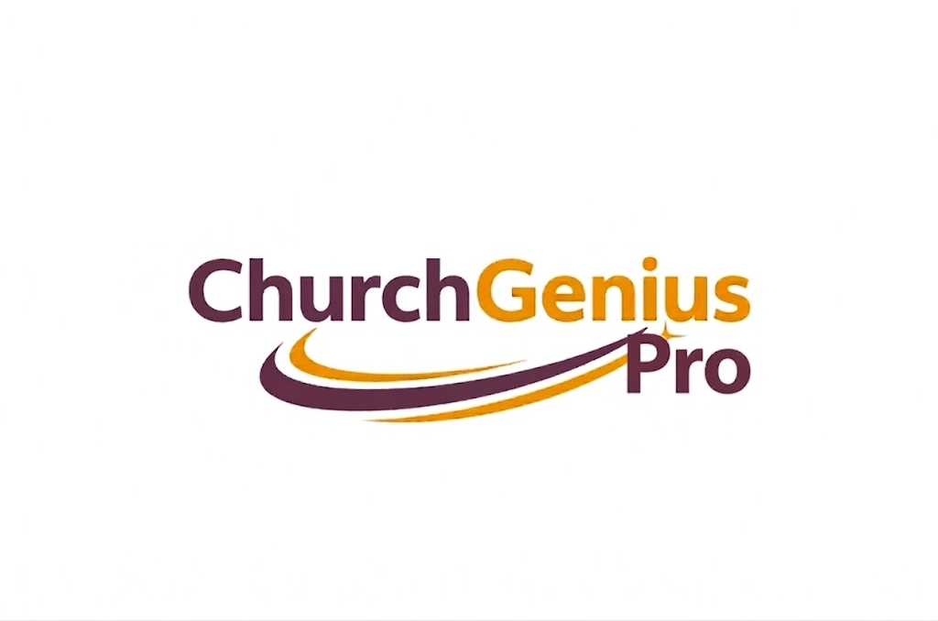
The All-in-One Platform for Modern Churches
Run your church effortlessly — so you can spend less time on admin and more time with people.
User Guide & Feature Overview
Everything Church Genius Pro can do — explained in plain language.

At a Glance: One Platform for Everything
Church Genius Pro replaces a dozen disconnected tools with one connected system. Here is the full picture on a single page — every chapter that follows explains each feature in plain language.
1 · Know & Care for Your People  ▸ Member & family management  ▸ Searchable member directory  ▸ Auto-fill from membership forms  ▸ Groups + group email & SMS  ▸ Follow-up management | 2 · Giving & Generosity  ▸ Online & text-to-give donations  ▸ Real-time donation tracking  ▸ Giving management  ▸ Pledge & campaign tracking
3 · Accounting & Finance  ▸ Accounting + financial reports  ▸ Automatic tax/giving statements  ▸ Recurring income & expenses  ▸ Payroll & employee records | 4 · Your Built-In AI Assistant  ▸ AI text search & commands  ▸ Voice & conversational AI  ▸ Snap a check/document to auto-fill  ▸ Bank-statement photo → transactions  ▸ Hands-free accounting entry  ▸ One-word meeting creation
5 · Communication & Engagement  ▸ Email & SMS messaging  ▸ Reminders: events, birthdays, holidays  ▸ Daily Bible verses & notifications  ▸ Certificate generation | 6 · Events, Worship & Scheduling  ▸ Events & shared calendar  ▸ Worship planning & service order  ▸ Attendance tracking  ▸ Volunteer assignment by availability
7 · Ministries on Autopilot  ▸ Sunday School + auto exams & grading  ▸ Kids check-in (code & barcode)  ▸ Auto classroom by age + medical info  ▸ Prayer ministry & assignments | 8 · Access, Mobile & Security  ▸ Staff, Member & Child portals  ▸ Linked accounts + role switching  ▸ Mobile app & favorites  ▸ Barcode / NTAG quick login  ▸ Wi-Fi-only private pages  ▸ Public display screens
9 · Help Whenever You Need It  ▸ Step-by-step Help Center  ▸ Built-in tutorials & guidance | ✦ And it all works together  ▸ One login, one connected system  ▸ No re-typing between tools  ▸ Built for non-experts  ▸ Secure, role-based access

Welcome to Church Genius Pro
Running a church means juggling a hundred things at once — members and families, giving and budgets, volunteers, events, classrooms full of children, and a steady stream of follow-ups that can never be allowed to slip. Most churches do this with a patchwork of spreadsheets, paper forms, and half a dozen disconnected apps.
Church Genius Pro replaces all of it with one friendly, connected platform. Your people, your money, your ministries, and your communication all live in one place — and much of the busywork is handled for you by built-in AI that lets you simply talk, snap a photo, or type a single word instead of filling out long forms.
You do not need any technical background or church-software experience to use it. This guide walks through everything Church Genius Pro can do, what each feature means for you, and how you would actually use it day to day.

Why churches love it
- One system instead of many — no more copying the same information between tools.
- AI that does the typing — speak, scan, or use one-word commands to get things done in seconds.
- Built for non-experts — clear screens, helpful prompts, and a step-by-step Help Center.
- Works anywhere — on your computer, on the mobile app, and on screens around your campus.
- Safe and private — role-based access, private pages, and secure check-in for children.

How to use this guide
Features are grouped into easy-to-browse chapters. Each feature includes a short description of what it does for your church and a “How you’ll use it” note describing it in everyday terms. Jump to any chapter from the Table of Contents on the next page.

Contents

1. Know and Care for Your People
Everything in your church starts with people. Church Genius Pro keeps every member, family, and visitor organized in one living directory — and helps you make sure no one is forgotten.

People & Member Management
A complete, always-up-to-date record of everyone in your church family — individuals and whole households together. Track contact details, family relationships, roles, milestones, and history without ever digging through spreadsheets again.
How you’ll use it: Add a new family or member in a couple of clicks, then find anyone instantly with a quick search. Each profile becomes the single source of truth that the rest of the system — giving, attendance, events — connects to automatically.

Member Directory
A searchable, shareable directory that helps your congregation stay connected with one another, with privacy controls so people only see what they are meant to.
How you’ll use it: Members look up a name and reach out directly. You decide which details are visible and which stay private.

Auto-Fill Input Fields from Membership Forms
Hand someone a paper or digital membership form, then let the system do the data entry. Church Genius Pro reads the completed form and fills in the member’s details for you — no retyping, no mistakes.
How you’ll use it: Snap a photo or upload a filled-in membership form. The information is pulled in automatically, you glance over it, and you save. What used to take ten minutes of typing now takes seconds.

Group Management, Group Emails & SMS
Organize people into the groups that matter — small groups, ministries, teams, age groups — and reach any of them with a single message.
How you’ll use it: Build a group once, then send the whole group an email or text in moments. Perfect for reminders, encouragement, and last-minute updates.

Follow-Up Management
Make sure first-time visitors, prayer requests, and pastoral needs never fall through the cracks. Assign follow-ups, track their progress, and see what is still outstanding at a glance.
How you’ll use it: When someone needs a call or a visit, create a follow-up and assign it to the right person. Everyone can see what’s done and what still needs attention — so care actually happens.

2. Giving & Generosity, Made Effortless
Generous giving fuels your mission. Church Genius Pro makes giving simple for your congregation and painless for you to manage — with a clear view of every gift and pledge.

Online Giving, Text Donations & Giving Management
Let people give the way they already live — online in a few taps or by sending a quick text. Every gift flows straight into your records, and donors get the experience they expect from a modern organization.
How you’ll use it: Share your giving link or a text-to-give number. Donations arrive instantly and are matched to the right donor and fund, so there is nothing to reconcile by hand later.

Donation Tracking
See exactly who gave, when, how, and to which fund — all updated in real time. No more guesswork at year-end and no more lost envelopes.
How you’ll use it: Open a donor’s record to view their complete giving history, or pull a fund summary to see how a campaign is doing. Everything is ready for receipts and reporting whenever you need it.

Pledge Management
Run building funds and giving campaigns with confidence. Record pledges, track progress against them, and gently keep commitments on course.
How you’ll use it: Set up a pledge campaign, log each commitment, and watch fulfillment update automatically as gifts come in — so you always know where the campaign stands.

3. Accounting & Finances Without the Headache
You don’t need an accounting degree to keep clean books. Church Genius Pro gives you proper financial tools — supercharged with AI that can read your documents and take dictation — so bookkeeping takes minutes, not evenings.

Accounting System & Financial Reporting
A full church accounting system that tracks income and expenses by fund and category, and turns it all into clear, board-ready reports.
How you’ll use it: Record income and expenses as they happen, then generate a financial report any time — for a leadership meeting, an audit, or your own peace of mind.

Tax Statement Generation
Produce accurate giving statements for your donors automatically, so tax season is a non-event instead of a scramble.
How you’ll use it: At year-end (or any time), generate contribution statements for every donor in a few clicks — ready to email or print.

Recurring Income & Expense Entries
Set up the payments and income that repeat — rent, salaries, subscriptions, regular gifts — once, and let the system enter them on schedule for you.
How you’ll use it: Create a recurring entry, choose how often it repeats, and Church Genius Pro keeps your books current automatically. No more forgetting the monthly bills.

AI Auto-Fill from Check Photos & Scanned Documents
Stop typing in numbers from checks and receipts. Take a photo and the AI reads the amount, date, payer, and other details — then fills in the entry for you.
How you’ll use it: Snap a picture of a check or a scanned document. The fields populate themselves; you simply review and save. Accuracy goes up and effort goes down.

Add Many Transactions from Bank Statement Photos
Behind on data entry? Photograph a bank statement or transaction document and the AI pulls out every line, ready to import as income and expenses in one batch.
How you’ll use it: Upload a photo of your statement, review the transactions it found, adjust anything if needed, and save them all at once — turning hours of entry into a few minutes.

Hands-Free Voice Commands for Accounting Data Entry
Record income and expenses just by talking. Say what you received or spent, and the AI captures it into the right fields — hands free.
How you’ll use it: Tap the microphone and speak naturally: the assistant fills in amounts, dates, and categories as you go, so you can log transactions while your hands are busy.

Employee Records & Payroll Generation
Keep staff records in order and run payroll right inside Church Genius Pro — no separate payroll service required.
How you’ll use it: Maintain each employee’s details and pay information, then generate payroll and pay statements when it’s time. Everything stays connected to your accounting.

4. Your Built-In AI Assistant
This is what makes Church Genius Pro feel like it has a staff member living inside it. Instead of hunting through menus and filling out forms, you can search in plain English, give one-word commands, or simply talk — and the assistant does the work.

AI Text Search & AI Text Commands
Find anything and do almost anything by typing the way you think. Ask a question in plain language, or type a short command, and the AI takes you straight there or carries out the action.
How you’ll use it: Type “show last month’s giving” or “add a new family” and the assistant responds instantly — no need to learn where every menu lives.

Voice Commands
Prefer to talk? Speak your request and Church Genius Pro listens and acts. Ideal when you’re on the move or your hands are full.
How you’ll use it: Tap the mic and say what you need — navigate, search, or start a task — entirely hands-free.

Conversational AI
Have an actual back-and-forth with your church software. The assistant asks the right questions, confirms details, and completes multi-step tasks with you, like a helpful colleague.
How you’ll use it: Start a conversation to record a gift, create a meeting, or enter a transaction. The assistant guides you step by step, confirming as it goes so nothing is entered wrong.

Hands-Free Voice & One-Word Commands for Creating Meetings
Scheduling a meeting shouldn’t take longer than the meeting. Speak the details — or even use a single word — and the AI sets it up for you.
How you’ll use it: Say or type a quick command and the meeting is created with the right people, time, and place. Add the details by voice and you’re done.
Note: the AI also powers hands-free accounting entry, check and bank-statement scanning, and membership-form auto-fill — covered in their own chapters.

5. Communication & Engagement
Staying in touch is the heartbeat of community. Church Genius Pro keeps your congregation informed, encouraged, and remembered — automatically.

Email & SMS Communications
Reach the right people with the right message through email and text, individually or in groups, all from inside the platform.
How you’ll use it: Compose a message, choose who receives it, and send. Because it’s tied to your member data, your lists are always current.

Custom Reminders for Meetings, Events, Birthdays, Anniversaries, Holidays & More
Never miss a moment that matters. Set up automatic reminders for the events and milestones in your church’s life, worded the way you want them.
How you’ll use it: Choose what to be reminded about and who should be notified. Birthdays, anniversaries, holidays, and meetings all trigger friendly messages on their own.

Custom Event & Meeting Reminders & Notifications
Make sure people actually show up. Send tailored reminders and notifications ahead of events and meetings so attendance and engagement stay high.
How you’ll use it: Set when and how reminders go out for each event or meeting, and let the system handle the nudges automatically.

Daily Bible Verses & Reminder Notifications
Put a verse of encouragement in front of your congregation every day, alongside the reminders that keep church life running.
How you’ll use it: Daily Bible verses and notifications are delivered automatically — a simple, consistent touchpoint that keeps people connected and encouraged.

Certificate Generation
Create polished certificates — for baptisms, dedications, course completions, volunteer service, and more — without wrestling with a design tool.
How you’ll use it: Pick a certificate, fill in the name and details, and generate a print-ready document in moments.

6. Events, Worship & Scheduling
From a single calendar to a fully planned worship service, Church Genius Pro keeps your church’s schedule and its teams perfectly in sync.

Event Management & Calendar System
Plan, publish, and manage every event on one shared calendar your whole church can see, with registrations and check-in handled in the same place.
How you’ll use it: Create an event, open registration, and track who’s coming — then check people in on the day. Your calendar keeps everyone on the same page.

Worship Planning, Scheduling & Service Order Management
Plan services from start to finish — the order of worship, the songs, and the people serving — and keep the whole team aligned.
How you’ll use it: Build your service order, schedule worship team members, and share the plan so everyone knows their part before Sunday arrives.

Attendance Tracking
Understand your church’s rhythms with accurate attendance records for services, classes, groups, and events.
How you’ll use it: Record attendance quickly, then review trends over time to see who’s engaged and where to focus your care and outreach.

Volunteer Assignment Based on Availability & Areas of Interest
Match the right volunteers to the right roles, taking into account when they’re free and what they love to do — so serving feels like a fit, not a chore.
How you’ll use it: The system suggests and assigns volunteers based on their stated availability and interests, making it easy to fill every role with the right person.

7. Ministries That Practically Run Themselves
Your most people-intensive ministries — children, education, and prayer — get purpose-built tools that save your volunteers time and keep families safe and cared for.

Sunday School: Management, Auto Exam Generation, Auto-Grading & Progress Tracking
Run your education ministry with far less manual work. Church Genius Pro can generate exams automatically, grade them for you, and track each student’s progress over time.
How you’ll use it: Manage classes and students, let the system create and auto-grade exams, and follow each learner’s growth with clear progress tracking — freeing teachers to teach.

Kids Ministry Management
Keep children safe and check-in stress-free with a complete kids ministry toolkit built for busy Sunday mornings.
- Child check-in with a secure code and barcode for fast, safe drop-off and pick-up.
- Automatic classroom assignment based on each child’s age.
- Auto-fill of child information directly from registration forms — no manual typing.
- Medical information tracking, so allergies and needs are always on hand.
- Mobile check-in for quick, contactless arrivals.
How you’ll use it: Parents check children in with a code or barcode; kids are automatically placed in the right classroom for their age; and volunteers can see medical notes instantly — all from a phone or a check-in station.

Prayer Ministry Management & Volunteer Assignments
Honor every prayer request by making sure it reaches someone who will pray. Organize requests and assign them to your prayer team with care.
How you’ll use it: Collect prayer requests, assign them to prayer volunteers, and keep track of how each one is being lifted up — so no request goes unanswered.

8. Access, Portals, Mobile & Security
Everyone gets exactly the access they need — staff, members, and children — across the web, the mobile app, and screens around your building, with smart security that keeps sensitive pages protected.

Staff Portal, Member Portal & Child Portal
Three tailored experiences in one platform. Staff get the tools to run the church, members get a friendly self-service space, and children get a safe, age-appropriate view.
How you’ll use it: Each person signs in and sees what’s relevant to them — nothing more, nothing less — keeping the experience simple and appropriate for everyone.

Linked Accounts with Role-Based Access & Easy Account Switching
One person can wear many hats — a parent who is also a volunteer and a staff member. Link related accounts and switch between them in a tap, with each role seeing only what it should.
How you’ll use it: Connect a family’s or individual’s accounts, then switch roles without logging out and back in. Role-based access keeps every view secure.

Mobile Application
Church Genius Pro travels with you. The mobile app puts giving, check-in, communication, and your everyday tools right in your pocket.
How you’ll use it: Download the app and your team and members can do what they need from anywhere — in the lobby, at home, or on the go.

Favorites & Quick Access Links
Pin the pages and tools you use most for one-tap access, so your daily routine is always a click away.
How you’ll use it: Star any page to add it to your Favorites, then jump straight to it from your quick-access links.

Temporary Login Using Barcode & NTAG
Give volunteers and guests quick, secure, time-limited access without creating full accounts — using a simple barcode or an NTAG tap.
How you’ll use it: A volunteer scans a barcode or taps an NTAG tag to log in for their shift, then access ends automatically — convenient for them, secure for you.

Page Access through NTAG
Turn a physical NTAG tap into an instant doorway to the right page — perfect for kiosks, check-in stations, and on-site tools.
How you’ll use it: Place an NTAG tag where it’s needed; a quick tap opens exactly the page that station is meant for, with no typing or searching.

Make Pages Private — Accessible Only on the Same Wi-Fi
Lock sensitive pages so they can only be opened on your church’s own network. If someone isn’t connected to the approved Wi-Fi, the page simply won’t open.
How you’ll use it: Switch on private access and choose your approved networks. Pages like check-in or temporary login then work on-site only — an easy, powerful layer of protection.

Public Screen Generation & Display Management
Power the screens around your campus — welcome displays, announcements, event info — straight from Church Genius Pro.
How you’ll use it: Create a public screen and display it on any monitor or TV in your building, updating what it shows from the same system you already use.

9. Help Whenever You Need It
You’re never on your own. Church Genius Pro is built to be learned as you go, with guidance built right into the platform.

Advanced Help Center with Step-by-Step Instructions & Tutorials
Clear, friendly help for every feature — step-by-step instructions and tutorials that turn first-time users into confident pros.
How you’ll use it: Open the Help Center any time to follow a guided walkthrough for the task in front of you. No experience required — just follow along.

One Platform. Every Part of Church Life.
Church Genius Pro brings your people, your giving, your finances, your ministries, your events, and your communication together — and wraps it all in AI that does the heavy lifting for you. The result is less time at a keyboard and more time doing what you were called to do: caring for people.
Whether you’re a one-person office or a large multi-ministry church, Church Genius Pro grows with you, keeps your information safe, and stays simple enough for anyone on your team to use.

Ready to make church management effortless?
Explore Church Genius Pro today — and let your software do the busywork.

