The History of the Pipe Organ
St. Martin’s Episcopal Church.

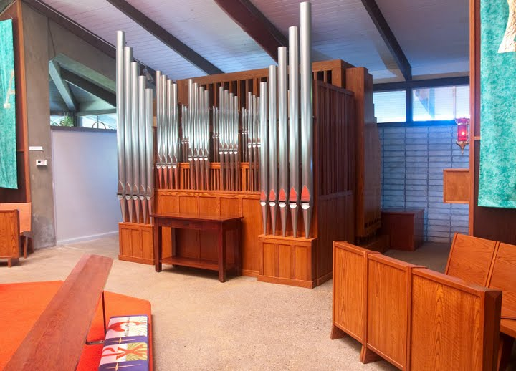
Bond Pipe Organ, Opus 35, built 2009

In The Beginning…
When the church sanctuary for St. Martin’s Episcopal Church was built in 1965 it had no pipe organ. For 18 years, organist and choir director Dona Lee Brandon played an electronic substitute until suitable funds could be collected for a real pipe organ.

(Interesting note. In the year the contract for the organ was signed, the congregation had another outstanding project waiting to be done, but they could only afford one large project. Their choices: Replace the church seating (which were metal folding chairs), or buy a pipe organ. The pipe organ came first and it took another eleven years before the congregation replaced the metal folding chairs with solid oak pews. From a musician’s point of view, St. Martin’s congregation had its priorities in sensible order.)

The organ committee was formed in the fall of 1977 by the Vestry and included Jim Cheney, Marti Parks, Dick Walters, and Margaret Hill (chair), with the Rector and organist as ex officio members.

The Blackmore Memorial Organ, Schlicker Organs, 1982

In 1982 the Schlicker Organ Company of Buffalo, New York installed a nine rank, thirty three stop unit organ. It was placed behind the main altar in the front of the church sanctuary. The organ pipes were enclosed in a swell box with the exception of 23 exposed pipes: the 12 lowest 16’ Bourdon pipes (side placement) and the 11 lowest 8’ Principal pipes which made up the façade. Voicing was done by Schlicker Head Voicer, Louis Rothenbueger and assisted by John DeCamp. It played for the first time on Easter Day, 1982.

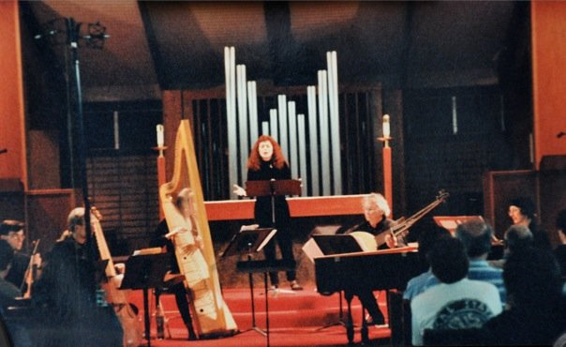
Schlicker organ façade. Concert of University of California at Davis’ Early Music Ensemble. Photo David Nutter

The organ contained 33 stops and 9 ranks which were controlled by a 2 manual and pedal console that included 7 general pistons and Crescendo Pedal. The console, of solid oak, included a locking roll top – a rarity for the Schlicker Company. There was also a mechanism to lock the swell shades closed when the organ was not in use to prevent curious hands from damaging the pipes.

Specification for Schlicker Organ, 1982
Manual 1 | Manual 2 | Pedal
16’ Bourdon  8’ Principal  8’ Rohrfloete  8’ Gemshorn  4’ Octave  4’ Bourdon  2 2/3 Nasat  2’ Octave  2’ Rohrfloete  II-III Mixture  8’ Dulzian  4’ Dulzian | 8’ Bourdon  8’ Gemshorn  4’ Principal  4’ Rohrfloete  4’ Gemshorn  2’ Octave  2’ Gemshorn  1 1/3 Klein Nasat  8’ Dulzian  Tremluant | 16’ Bourdon  8’ Principal  8’ Bourdon  8’ Gemshorn  4’ Octave  4’ Gemshorn  4’ Rohrfloete  2’ Rohrfloete  III Rauschpfeife  16’ Dulzian  8’ Dulzian  4’ Dulzian

The Schlicker organ was voiced in the style of its time, Neo-Baroque, and made a good accounting of itself. The church’s acoustics, while not overly reverberant, were live and a musical line carried well in the soaring, glass-topped ceiling. The enclosed pipework gave the organ more expressive flexibility. The flutes and principals were large scale and voiced to speak with a broad, clear tone. Open-toe voicing, low cut-ups and low wind pressure assured a clean sound with excellent articulation. The tremulant was adjustable.

The dedicatory recital was given by Dona Lee Brandon, organist of the church:
Prelude and Fugue in F# minor, Dietrich Buxtehude
From Organ Concerto 1 Adagio-Andante, George F. Handel
Chorale in A Minor, Cesar Franck
Pastorale (from 24 Pieces in Free Style), Louis Vierne
Hymne d’ Actions de Graces: Te Deum, Jean Langlais
Seven Settings of Bryn Calfaria, George Brandon
Trumpet Rondo (no. 9 from Eleven Short Pieces, George Brandon
Gaudeamus (from Four Improvisations on Gregorian Themes, Everett Titcomb
Concerto 1: Moderato-Grave-Presto, Johann S. Bach
From Trio Sonata III: Adagio e dolce, Johann S. Bach
Fantasie and Fugue in G minor, Johann S. Bach

With only 9 ranks, there were limits to the tonal palette. There was no1-3/5’ Tierce. (Correspondence between the church and builder show this was a disappointment to the Schlicker tonal designers.) The quarter-length resonators of the Dulzian reed rank caused a lack of tuning stability, making the stop unusable for most of the year.

The Bond Pipe Organ Opus 35, 2009

After 30 years of use, the parish that loved all types of music longed for an instrument that could, “Handle more than Handel.” They especially wanted an organ that could keep up with enthusiastic hymn singing. Also, the excellent choirs at St. Martin’s enjoyed singing English-cathedral style anthems. An organ voiced in the German Baroques style was just not up to the task. So a more flexible tonal pallet was required.

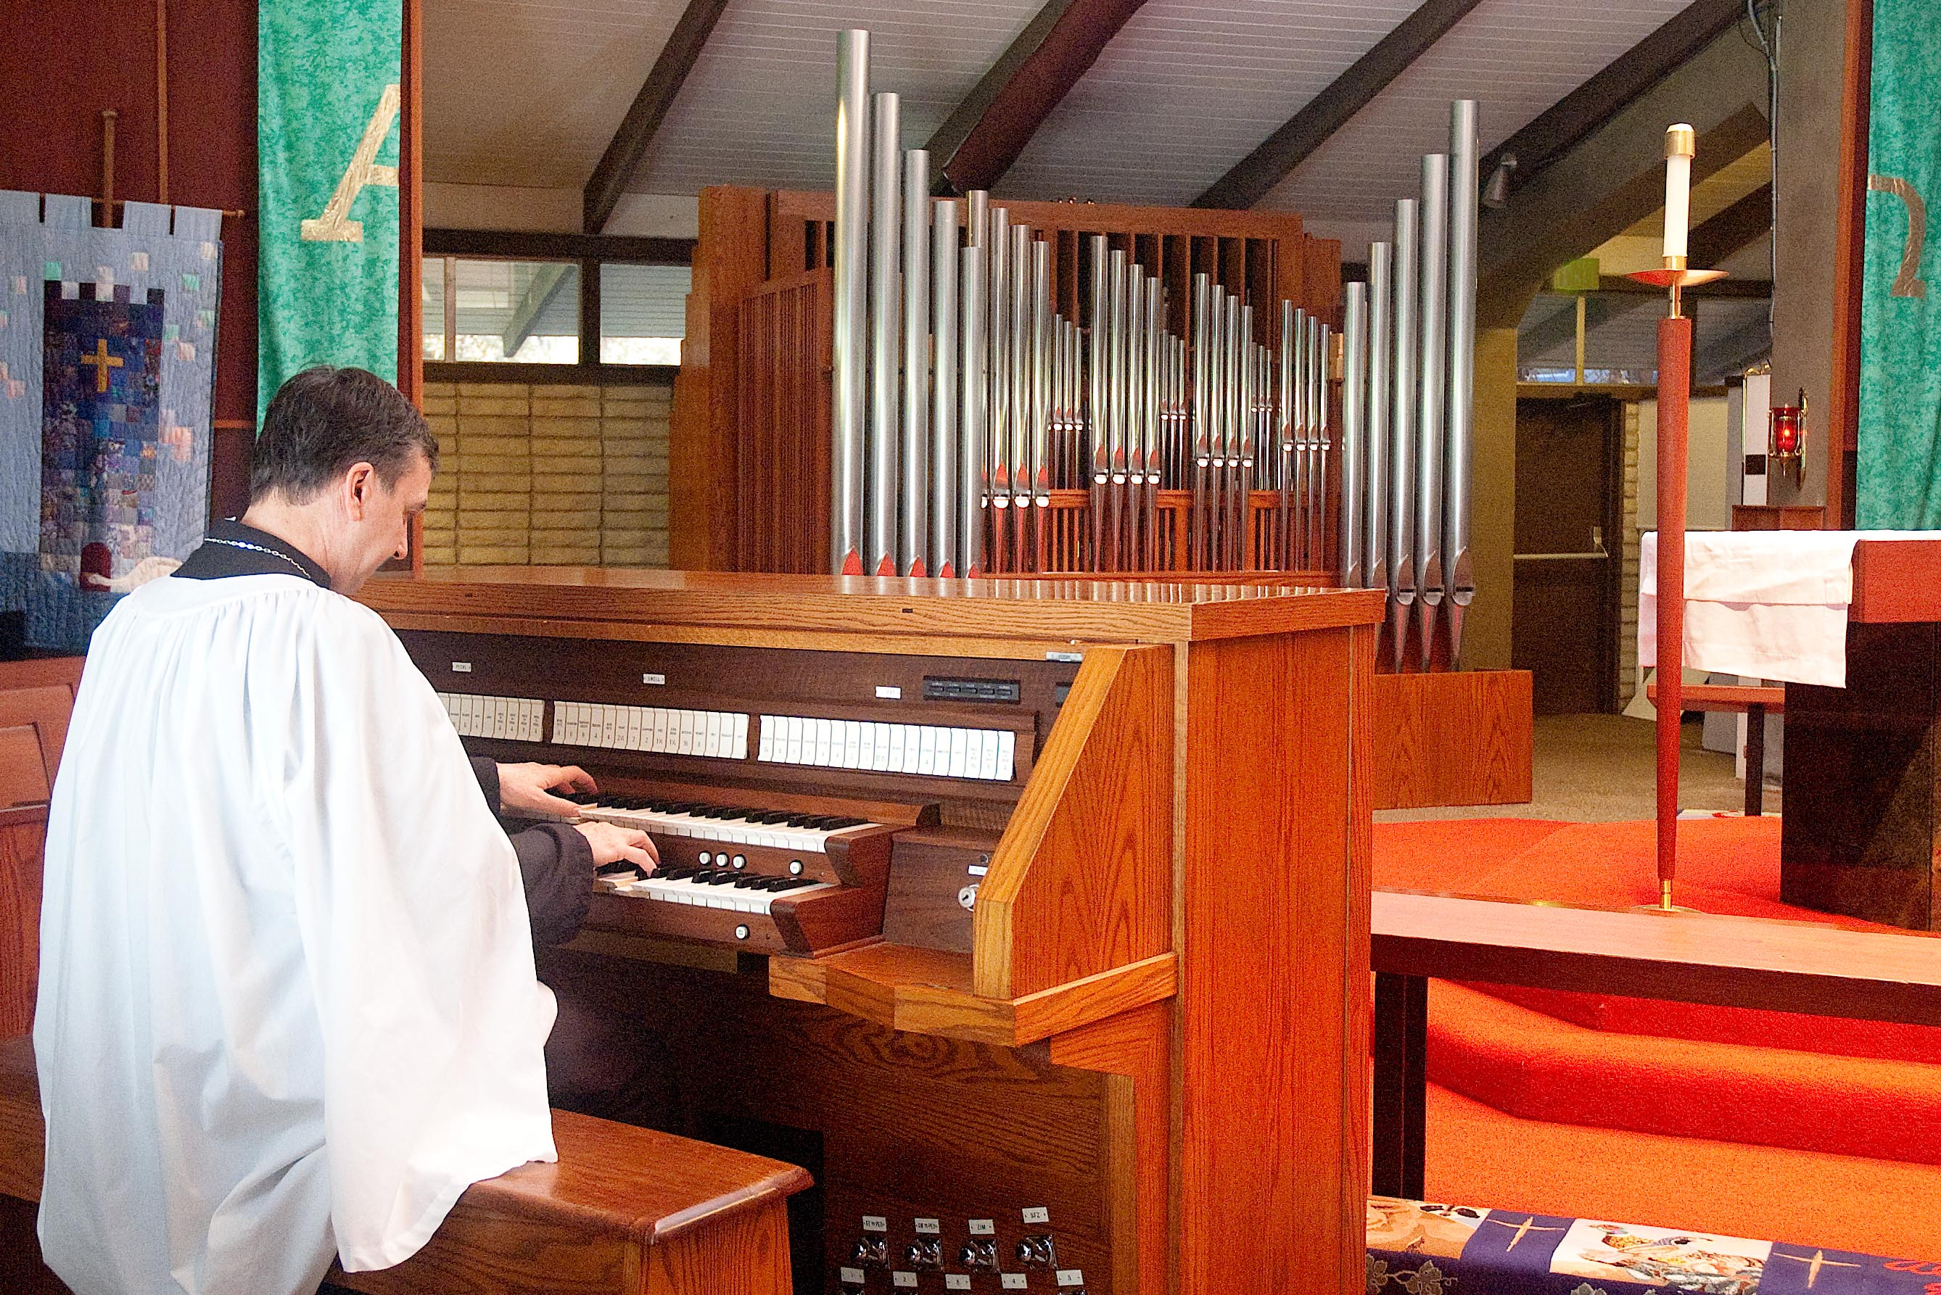
Gerard Montana, Music Director and Organist at newly rebuilt and expanded organ.

In 2007, an anonymous donor gave a large gift for renovation and rebuilding of the pipe organ. An informal process was begun to search for organ builders who could expand the instrument. In 2008, Gerard Montana, was hired as Music Director and Organist.

With the enthusiastic assistance of The Rev. Mark Allen, Rector, and The Rev. Ernest Lewis, Deacon, an active campaign was begun to raise more money for the organ. Gerard reminded the parish that an organ project is a long term investment, “We might as well do as much as we can now. We won’t tackle this again for 40 or 50 years.”

Gerard embarked on an education program to teach the congregation about pipe organs, how they were built, and why they were the solution to provide a high-caliber music program for the church. There were classes and videos and demonstrations.

By the end of 2008 donations doubled the initial gift. A contract was signed with Bond Organ Builders, Inc. of Portland OR.

Our instructions to Bond were to retain the best of the Schlicker and add more solo reeds and a new principal chorus. The organ would finally get the Tierce stop as well as a Trumpet; an Oboe; a Bassoon; a full Principal Chorus at 8’, 4’, 2’, and a revoiced and expanded Mixture stop; and a set of undulating String ranks. The original oak console would be completely rebuilt with state-of-the-art technology and 100 levels of memory for the combination action. The Dulzian rank was to be removed.

We asked that the sound of the new instrument be both noble and exciting. Bond Organs presented a final design that almost doubled the number of pipes from 540 to 980 pipes.

Bond’s Opus 35 was completed (on time!) in September 2009. It was played for the first time, at all services, on Sunday September 27, 2009 - one week after the church’s 56th anniversary.

The end result surpassed our expectations. Richard Bond’s exacting attention to tonal finishing assured a beautiful end result. The organ has distinctive solo stops, a warm and cohesive ensemble, and is at its most exciting when the full organ is engaged.

The new organ is 35 stops and 16 ranks, it was designed and tonally finished by Richard Bond. The façade of quarter-sawn oak and elegantly designed pipes (70% polished tin) was designed by Roberta Bond. It is fully MIDI compatible.

Specification for Bond Organ, Opus 35, 2009
Great (unenclosed) | Swell (enclosed) | Pedal | Accessories
16′ Bourdon  8′ Principal*  8′ Bourdon  8′ Gemshorn  4′ Octave*  4′ Bourdon  2′ Superoctave*  2′ Rohrflute  III-IV Mixture*  8′ Trumpet*  8′ Oboe*  4′ Clarion*  Zimbelstern 8 bells*  MIDI*  Swell to Great 16*  Swell to Great 8*  Swell to Great 4* | 8′ Rohrflute  8′ Gemshorn  8′ Gemshorn Celeste*  4′ Principal  4′ Rohrflute  2-2/3′ Nasat  2′ Octave  2′ Gemshorn  1-3/5’ Tierce*  1-1/3’ Klein Nasat  16′ Bassoon*  8′ Trumpet*  8′ Oboe*  MIDI*  Tremulant | 16′ Bourdon  8′ Principal  8′ Bourdon  8′ Gemshorn  4′ Octave  4′ Rohrflute  III Mixture  16′ Bassoon*  8′ Trumpet*  4′ Oboe*  MIDI*  Great to Pedal 8*  Great to Pedal 4*  Swell to Pedal 8*  Swell to Pedal 4* | 8 General pistons  8 General toe studs  5 Pedal pistons  5 Pedal toe studs  5 Great pistons  5 Swell pistons  Gt to Ped Reversible  Sw to Ped Reversible  Tutti piston  Tutti toe stud  General Cancel  Set piston  Zimbelstern toe stud  Crescendo Pedal  100 levels of memory  Peterson ICS4000
*Denotes new

On November 1, 2009, Sunday the Feast of All Saints. The organ was blessed by Bishop Barry Beisner, Bishop of Northern California.

The organ’s dedication concert: February 21, 2010 at 7pm played by (then) twenty-one year old concert organist, Nathan Laube to an almost full church. See program below.
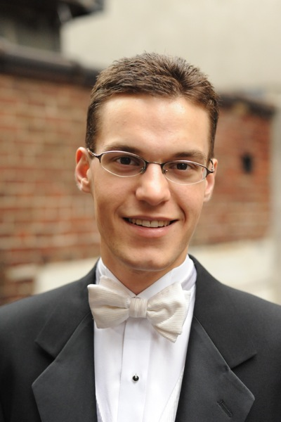

Nathan Laube Program:
Dedication Concert February 21, 2010

Sinfonia from Cantata 29 Johann Sebastian Bach
Wir daken, dir Gott

Passacaglia, BWV 582 Johann Sebastian Bach

Andante and Allegro for Mechanical Organ K. 594 Wolfgang Amadeus Mozart

Overture to Die Feldermaus Johann Strauss Jr.
Transcription: Nathan Laube

Sonata in A, Op. 65, No. 3 Felix Mendelssohn
Con moto Maestoso

Chorale No. 1 in E major César Franck

Overture to William Tell G. Rossini
Transcription: Nathan Laube

