**Welcome/About us: Staff and Vestry**

**Staff**

[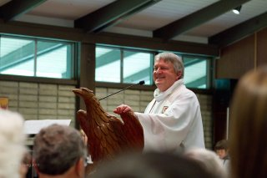](http://churchofstmartin.org/wp-content/gallery/staff_new/mark.jpg)

**The Rev. Mark F. Allen, Rector**

e-mail: [mark@churchofstmartin.org](mailto:mark@churchofstmartin.org)

Mark+ has been Rector of St. Martin’s since 2004. He and his wife Nancy are the parents of five adult children and grandparent of one beautiful granddaughter. They share their home with Penny, a goldendoodle, and Toby, a ragdoll cat, as well as their children who come to visit often — but not enough. Mark loves movies, sports, music and good stories. He is passionate about preaching, teaching, and leading others on a deeper spiritual journey. His life motto is, “Take your faith seriously, but don’t take yourself seriously.”

[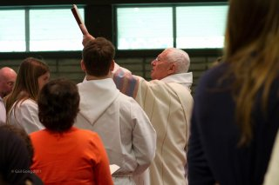](http://churchofstmartin.org/wp-content/gallery/staff_new/ernie.jpg)  
  
**The Rev. Ernie L. Lewis, Associate Priest**

e-mail: [ernie@churchofstmartin.org](mailto:ernie@churchofstmartin.org)

The Rev. Ernest L Lewis, M.D., (Ernie) is a native of Fresno and a graduate of California State University, Fresno. He received his medical degree from Washington University in Saint Louis. He is Professor Emeritus of Clinical Urology and Associate Dean Emeritus of Medical Education at the University of California, Davis School of Medicine.

Ernie was ordained as an Episcopal Priest on October 1, 2011. Previously, he attended the Episcopal School for Deacons in Berkeley and returned to St. Martin’s after ordination in 2002. From 2006-2011 he has served as Archdeacon for Deacons for the Diocese of Northern California and is active on the Commission on Ministry and the Total Ministry Planning Group of the diocese. He has been married to Mary Ann since 1964. Their family includes four grown children and nine grandchildren. Ernie considers himself primarily a teacher. His hobbies include gardening, photography, cooking, grandchildren, and books, books, books!

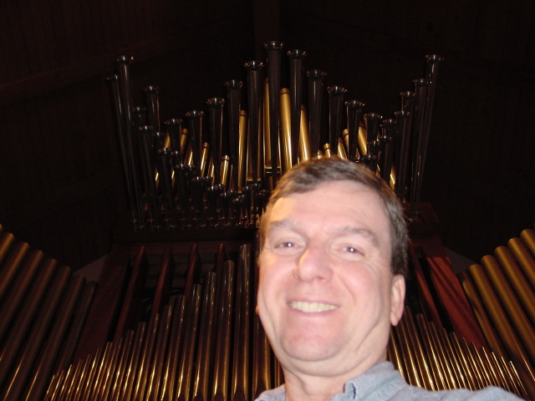

**Gerard Montana, Music Director and Organist**

e-mail: [gerard@churchofstmartin.org](mailto:gerard@churchofstmartin.org)

Gerard is our music director, choral conductor, organist and keyboard accompanist for the music at all our services. Gerard has a Masters Degree in Choral Conducting from DePaul University, Chicago. Gerard is former Assistant Organist at St. James Episcopal Cathedral, Chicago; Trinity Episcopal Church, Chicago and St. Simon’s Episcopal Church, Arlington Heights. Before coming to St. Martin’s, Gerard was interim organist and choir master at Christ Church, Alameda. “I believe music in the church should be both beautiful and singable,” says Gerard. “I invite you to join one of our many singing groups.”

**Janie Howard Knudsen, Children’s Choir Director**

e-mail: [janie@churchofstmartin.org](mailto:janie@churchofstmartin.org)

Janie Howard Knudsen

M.M. WTA&MU, Boston Conservatory

Ms Knudsen has been in music ministry for 27 years, 19 as the Director of Music Ministries.

Ms Knudsen began The Interfaith Children's Musical, now in it's 11th year and is beginning her third year with The Church of St Martin as the Children's Choir Director.

Ms. Knudsen and her spouse of 18 years, Julie, have 11 year old triplets-2 girls and a boy!

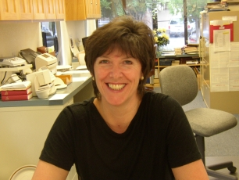

**Jan Sanders, Parish Administrator**

e-mail: [jan@churchofstmartin.org](mailto:jan@churchofstmartin.org)

Jan Sanders, a native of Liverpool, England, provides a welcoming presence in the office of St. Martin’s. In addition to her administrative gifts and calm demeanor, Jan makes a mean batch of scones with clotted cream.

Vestry

|  |  |
| --- | --- |
| **2012 Vestry** | **Officer/Committee Liaison** |
| Pierre Neu | Senior Warden |
| Janet Lane | Junior Warden; Buildings and Grounds Liaison |
| Robert Lynch | Worship Liaison |
| Charlotte Sobeck | Budget, Finance, and Stewardship Liaison |
| Jeanne George | Clerk; Caring Ministries Liaison |
| Corey Owens | Chair of Youth Ministry Architects Renovation Team (YMART) |
| Mike Hannon | Communications Commission Liaison |
| Jerry Hulbert | Outreach Liaison |
| Lisa Halko Leigh | Christian Formation Liaison |
| Neil Willits | Budget, Finance, and Stewardship Liaison |
| Gerry Braun | Hospitality and Evangelism Liaison |
|  |  |
| Stephen Lawrence | Treasurer (not on Vestry) |