**Welcome/About us: Ministries**

**Ministries and Groups**

(If you are interested in learning more about these groups please refer to the list of Ministries Leaders)

**Caring Ministries**

**Eucharistic Visitors:** St Martin’s is fortunate to have a small group of faithful people who are designated Eucharistic Visitors. These people are specially trained to take the communion elements (bread and wine) from the service of Holy Table to those who are unable to attend the regular services. They are charged and sent out at the end of the service to deliver the sacrament. This is an important caring ministry and provides a link between the congregation gathered for worship and those who cannot, for reasons of health, be present.

**Healing Ministry (“the laying on of hands”):** are trained St. Martin’s volunteers that gently place their hands on your head, their arms around your shoulders, and pray with you. They draw a cross with warm oil on your forehead and surround you with prayer. Their goal is spiritually to have you feel the warmth, love and comfort that Jesus promised. The healing prayer stations are available during the services in the back of the church for people that need healing or comfort for themselves or those they love.

**Quiet Days:** are actually ~six hours of a powerful connection to God enclosed in quiet, contemplation, prayer and resuscitation from a busy world. These are casual and held approximately twice a year in a parishioner’s home. There is usually a shared bag lunch that is social to bring you back to the world. 10 to 12 people are ideal. These are refreshing to the mind, body, heart and soul. Watch the Bulletin for announcements.

**Helping Hands:** are St. Martin’s extraordinary chefs. They bring dinners complete with a decadent dessert to your home, at your convenience in times of need, and when you’d like some good food to celebrate the best of times. There is a limit of 10 nights of dinners; however, this is negotiable. Dinner can also be arranged for every other night. If you’d like the chefs company at dinner too, please make that request. “Thinking of you” baskets of cookies are also available. All information related to this service is confidential.

**Intercessory Prayers:** Would you like us to pray for you? Or for someone you care and worry about? There are twenty of us and we pray daily for people who have requested prayers. Any information given us is kept absolutely confidential, and all we need is a name, although it is helpful to know the nature of the problem – whether it is an illness, work problems, family problems, safety during travel, or the like. We also enjoy giving praise and thanksgiving when they are due!

**Holy Rollers:** When you just can’t get to church, these volunteers are happy to give you a warm smile and a ride.



**Order of St. Luke:** The Order of St. Luke is an international Christian order premised on the understanding that “healing is an ongoing, lifelong process of growing into the wholeness that God wills for all of us.” (Sharing: A Journal of Christian Healing, October 2007, p. 13). At St. Martin’s, our OSL chapter meets 1-2 times a month to engage in a biblically-based healing ministry study series. Participation in these meetings is a wonderful way to help parishioners discern whether they feel a call to join OSL and/or a call to participate in the healing ministry at St. Martin’s. Participation in the healing ministry at St. Martin’s as a commissioned healing minister involves a separate process. The first step in this process is meeting with our rector and OSL Chaplain, Rev. Mark Allen.

  
**Stephen Ministry** is our congregation’s one-to-one caregiving ministry. God works through Stephen Ministers to plant a seed of hope and healing in a person whose life seems barren and forlorn because of some crisis or tragedy. Stephen Ministers listen, pray, explore feelings, share Christ’s love, maintain confidentiality, attend to the caregiving process, and leave the results to God. Stephen Ministers care for people who are grieving, in a crisis, in need of long-term care, dying, hospitalized, divorcing, experiencing losses as they age, going through a crisis of childbirth, or the family and friends of people in crisis.

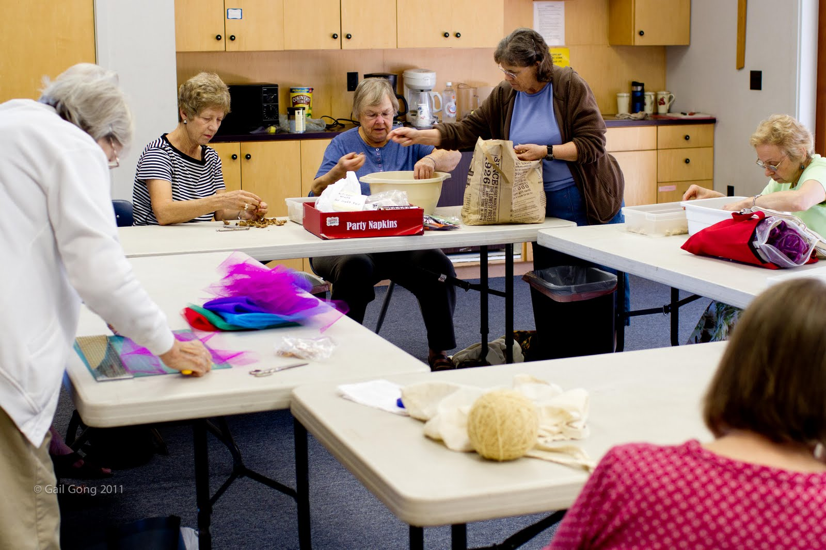

Making Prayer Shawls for the Sick and Blankets for the Homeless

**Committees and Groups**

**Acolytes**  
[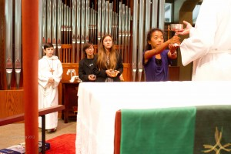](http://churchofstmartin.org/wp-content/uploads/2008/06/2011-10-23-stMartin-33496.jpg)

Everyone, ages 9 to 99 of St. Martin’s volunteer their time and talent to serve during church services. We process with the altar party at the beginning and end of services, carrying crosses, torches, banners, and streamers. Acolytes also take part in the Gospel Procession, help distribute the offering plates, and assist in setting the altar table for Eucharist.

Acolytes generally serve once per month during the school year and once or twice during the summer. Training for new and returning acolytes is offered semiannually, and mentorship continues throughout the year.

**Readers (for Sunday Services)**  
If you are interested in reading one of the lessons on Sundays please call the church office to get your name on the list of volunteers.

When your name is selected for a specific Sunday you will be given sufficient notice and you will be sent a copy of the reading(s). If you cannot do the readings that day you can ask the church administrator to reschedule you.

**Altar Guild**  
We are the women and men who take care of getting the altar ready for each service. For the 3 services on Sunday and the Tuesday service also we keep the silver and brass clean and bright. We also wash all the linens that are used for the service.

We also set up for funerals and weddings. We are always looking for new people to help set up and take down for all the services that are held at St. Martin.

**Ushers and Greeters**  
Ushers welcome all to church, encourage use of name tags, and assist worshipers by distributing the program for the service, finding seats when seating is limited, and guiding people to communion. Ushers also help by making name tags available before the service and putting them away at the end of the service, moving the welcome table to the entrance to the church, counting attendees, bringing the elements to the altar, passing offering plates, distributing bread to newcomers, collecting and recycling programs at the end of the service, and cleaning up pews after the service.

Greeters welcome all to the church, especially newcomers. They ensure that the welcome table is outside the entrance to the church, encourage newcomers to sign the guest book, help them obtain a name tag, provide information about the church, and visit and introduce them to others during the coffee hour after the service.

**Buildings & Grounds**  
There are many different people that belong to a church such as St Martin. We are those who are willing to work with their hands, legs and brains, etc. to keep St Martin’s physical plant in good shape.

[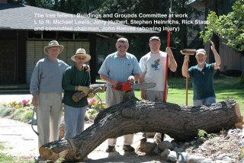](http://churchofstmartin.org/wp-content/gallery/people/lumberjacks.jpg)

St. Martin is fortunate in that we can afford a cleaning contractor and a lawn mowing contractor. But in addition to those major items, there is always something else to do to keep St Martin in good shape. B&G’s job includes looking for anything that needs to be done including plumbing, electrical, carpentry, painting, taking care of the grounds by, picking up trash, weeding, pruning, planting, taking care of buildings by washing windows, spot cleaning rugs, cleaning and maintaining closets and sheds, moving/cleaning tables and chairs as needed, etc.

In addition, we currently have a spring and a fall cleanup weekend, where we invite everyone to help. It is amazing, how much better you can feel about the Lord when you actually have to put your brain, hands, and back into doing something physical for him.

B&G meets the first Sunday of every month to discuss, plan, and advise the Vestry as to what should be done as to major renovations and repairs in order to keep the physical plant of St Martin in good shape. COME join us.

[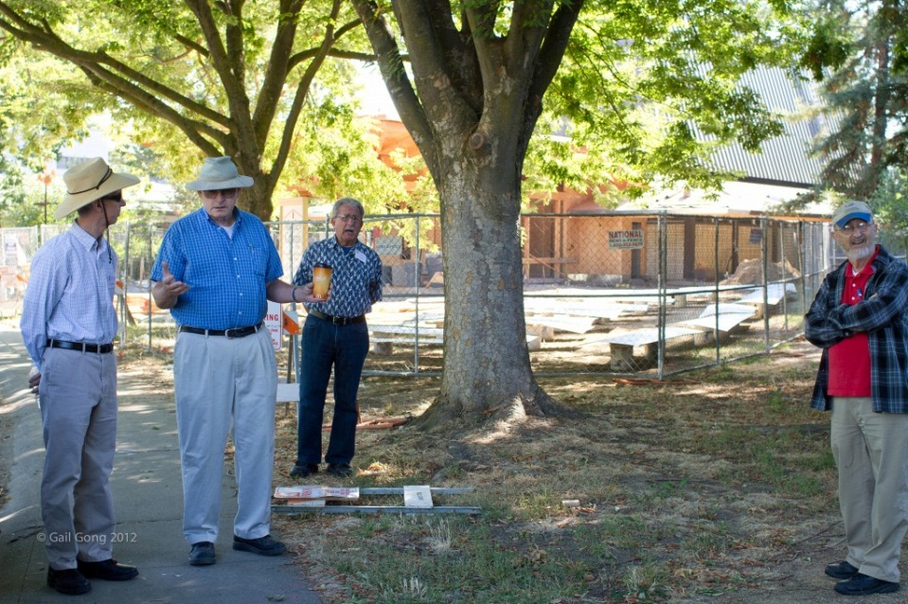](http://churchofstmartin.org/wp-content/uploads/2008/06/2011-08-07-stMartin-23646.jpg)

**Flower Guild**  
Members of the flower guild are responsible for obtaining and arranging flowers for the Sunday services. Generally we order flowers from one of the florists with whom the church has an account, but occasionally we bring flowers from our own gardens. The perk of the “job” is the hour spent arranging flowers in the splendid isolation of the church, sometimes along with some rather lovely organ music!

We would love to have you join us and will happily orient you!

**Holy Folders**  
[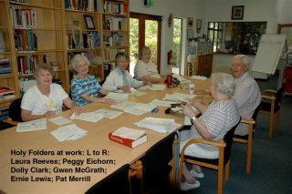](http://churchofstmartin.org/wp-content/gallery/people/folders.jpg)

The “Holy Folders” are a committed group of men and women who meet faithfully every Thursday morning to fold the service booklets for Sunday as well as the parish newsletter and other bulletins.

**Stewardship Committee**  
Stewardship at St Martin involves our time, talent and treasure. Time and talent offerings can be found in other parts of this website. As far as our treasure is concerned, the Stewardship Campaign conducts an annual pledge drive to facilitate parish giving and hosts a fall dinner for the parish, which is the largest social gathering of our whole parish. The Campaign collected generous pledges from 160 parish members and families. The Campaign operates through the combined efforts of more than 50 parishioners, who volunteer for everything from stuffing envelopes, to hosting tables at the Stewardship Dinner, to calling fellow parishioners for pledges in the final weeks of the campaign. More help is always needed.

**Education for Ministry (EFM)**

Every baptized person is called to ministry. The Education for Ministry (EFM) program provides people from all walks of life with the education “to be” Christians and to carry out their ministry. All Christians need a Christian education which supports their faith and which prepares them to express that faith in day-to-day events. EFM is a worldwide program developed by the School of Theology of the University of the South. It holds before us that the foundation for bringing Christ to the world lies in a church empowered by an active, theologically articulate laity. Thousands of persons have completed this four-year program. Students enroll one year at a time, and can transfer almost anywhere in the USA and in many foreign countries. The four years contain studies of the Old Testament, the New Testament, church history, and theological and moral choices, and are under girded by regular theological reflection and prayer and worship in a community of study.

**The Communications Committee**  
?????

**Choirs**

Our choirs and music program are described in the Worship section of this site. Music