Welcome: **Labyrinth and Columbarium**

**Labyrinth**

St. Martin’s labyrinth was built in November 2009 by a team of volunteers under the direction of labyrinth designer and artist Robert Ferré of Labyrinth Enterprises, Inc. With a diameter of 42 feet, 3 and 3/8 inches and 11 circuits, it is the same pattern and design as that of the ancient labyrinth in Chartres Cathedral in France. Made of concrete and granite resin, it is a permanent and magnificent structure on our church grounds.

People use labyrinths in many ways—for meditation, reflection, prayer, centering, healing, and simply enjoyment. St. Martin’s labyrinth is in a peaceful setting, surrounded by redwood and cypress trees, a winding decomposed granite path, and wooden benches.

Our labyrinth is open to the public from dawn to dusk. All are welcome, and we hope it will bring insight, peace, and renewal to all who walk its path.

“When asked ‘what is the right way to use a labyrinth?’ I respond with the phrase, ‘Go with the flow.’”

(The Rev. Jill Geoffrion, on labyrinth praying; <http://jillgeoffrion.com>)

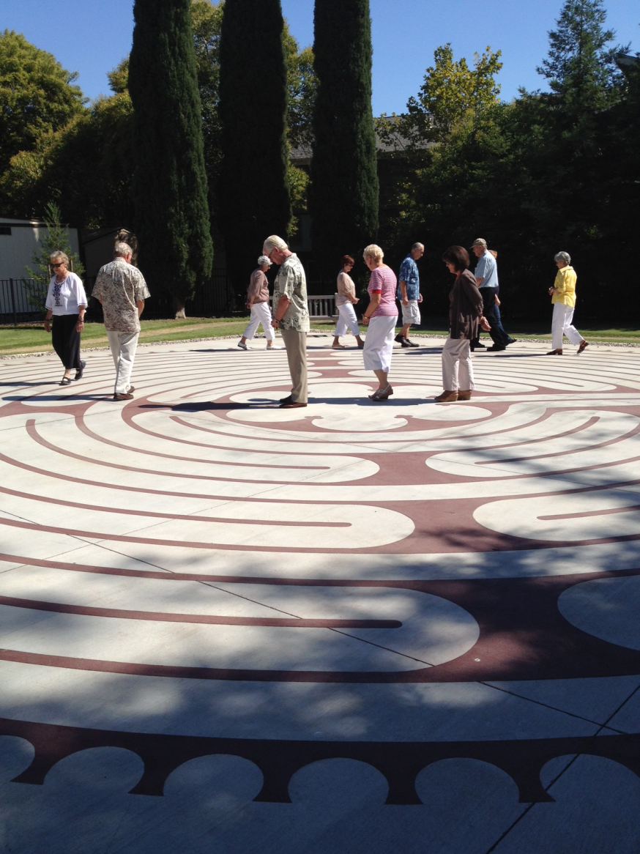

**Columbarium**

Adjacent to the labyrinth, but separated from it by a beautiful wrought iron gate, is St. Martin’s columbarium. Churches have traditionally laid the departed to rest on their grounds. In keeping with that tradition, St. Martin’s established a columbarium on its campus. The term columbarium is derived from the Latin “Columba,” meaning dove, an almost universal symbol of God’s love and peace.

Our Columbarium offers a peaceful and dignified space under magnificent redwood trees. The cremated remains of loved ones may be laid to rest and cared for in perpetuity in a space that is both beautiful and sacred.

Niche spaces are available.

For information please call 530-756-0444 or write [info@churchofstmartin.org](mailto:info@churchofstmartin.org)