# Music at St. Martin’s

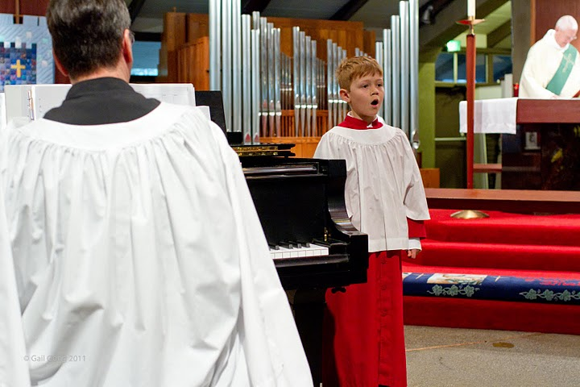

Gerard Montana is our music director and organist. Under his direction our parishioners and choirs experience the many different styles of liturgical music. The Contemporary Choir sings more upbeat and current contemporary sacred music. The Choir is robed in traditional cassock and cotta and sings Anglican-style anthems in a more formal setting with organ accompaniment

“My primary goal is to assure that music and the words to the music complement the liturgy. Music should be beautiful and sing-able,” says Gerard.  “Our rehearsal time is productive and fun.  We honor the great music of the Anglican Communion as a priceless treasure. We embrace new musical styles as well. We invite you to join our choirs for worship, music, and friendship.”

Gerard Montana M.M. is a member of the Association of Anglican Musicians and former dean of the Sacramento Chapter of the American Guild of Organists. i

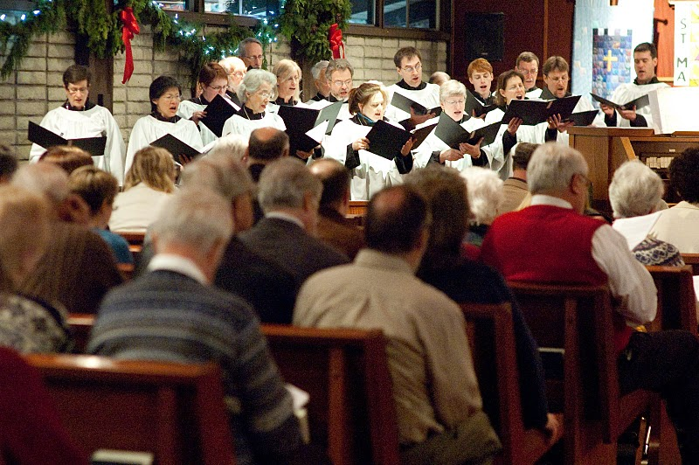  
**St. Martin Choir**

The Choir sings traditional, classical anthems in the great tradition of the Anglican Church with organ accompaniment.

We sing for the 11am Service on Sundays during the academic year (beginning September to mid June.)

Hymns are selected from The Episcopal Hymnal 1982.  This choir is robed in cassocks and cottas and processes with the clergy at the beginning and end of the service.  The Choir rehearses in the church on Thursday evenings starting at 7PM till 8:30PM.  If you wish to join us please inquire with the Music Director after a service or come early to a Thursday rehearsal for audition.

[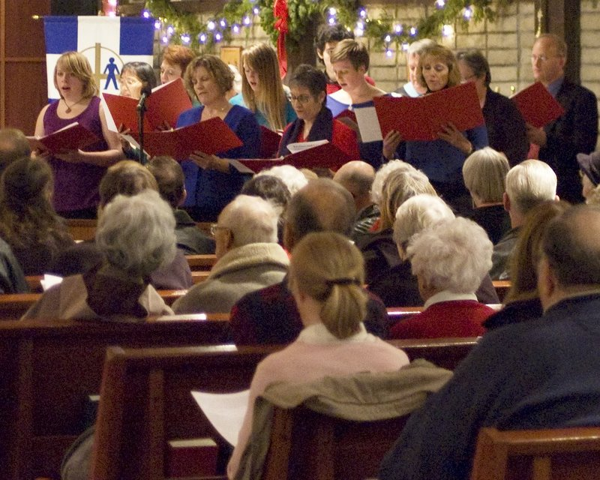](http://churchofstmartin.org/wp-content/uploads/2009/03/contemporary.jpg)**St. Martin Contemporary Choir**

The Contemporary Choir sings contemporary music with keyboard, guitar, and instrumental accompaniment. The music is a contemporary style and is generally up-tempo.

We sing for the 9am Service on Sundays during the academic year (beginning September to mid June.)

Rehearsals are held Tuesdays, from 7pm to 8pm. If you would like to join us please inquire with the Music Director or come a bit early to a rehearsal on Tuesdays. Rehearsals are held in the church sanctuary.

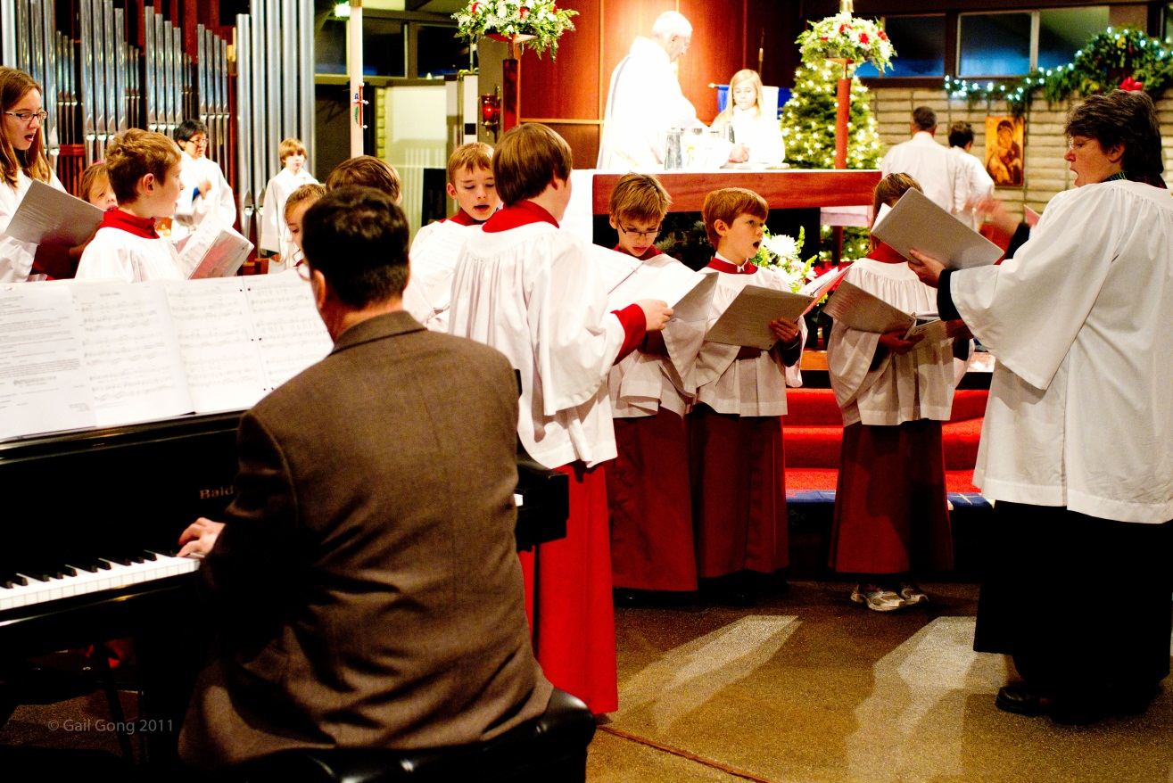

**St. Martin Children’s Choirs**

**Cherub Choir:**Meeting Wednesdays 4:00pm

The Cherub Choir is for children 3-5 years of age. With circle music and musical pattern games and using the teaching methods of Carl Orff and Zoltan Koday , we sing our faith stories while learning the basics of rhythm and pitch...It's also for kids who just love to sing! Please contact Janie Knudsen, Director of Children's Choir if would would like to join this happy bunch!  
  
**Beginning Choir:**Meeting Wednesdays at 4:30pm  
  
Beginning Choir continues where Cherub Choir leaves off - children who love to sing and are now ready to begin learning to read music. With the use of solfegio ( do, re, mi ) and colorfully tuned BoomWhackers, these choristers learn to sing their do re mi's as they singing the songs of the liturgical seasons. They even sing occasionally with the Youth choir! If you and your budding chorister are interested in singing with this energetic group please contact the Director of Children's Choir, Janie Knudsen.  
  
**Youth Choir:**Meeting Sundays 10:00-11:00a.m.  
for Children and youth ages 8-14  
  
St. Martin’s Church is affiliated with the **Royal School of Church Music**. Through this excellent program the choristers in the Children’s Choir, under the direction of Janie Knudsen, learn singing skills, music theory and deportment. The choristers attend weekly rehearsals on Sundays. The Youth Choir sings at services once a month and for principal feasts such as Christmas, Easter and Pentecost. If you would like your child to join our choir please talk with the Children’s Choir Director. There is a required parent orientation session to help you learn how the Youth Choir can enrich your child’s educational training, and to understand the necessary commitments involved. These choristers are also sorted into Houses (a la *Hogwarts*) and are given many opportunities to grow their leadership skills though choir service roles of Head Chorister and House Leader..plus, they have lots of fun!

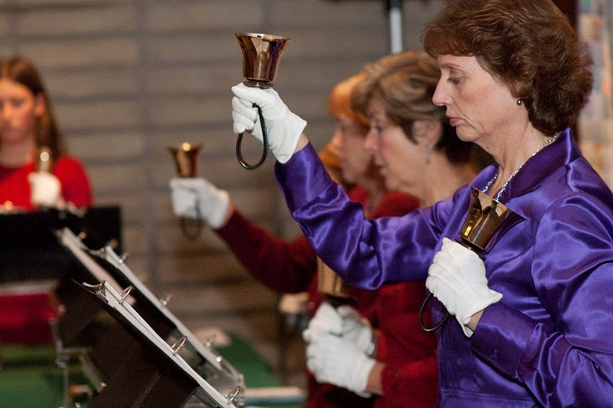  
**St. Martin Bell Choir**

St. Martin’s is blessed with a 3-1/2 octave set of Schulmerich Handbells.  The Bell Choir plays for special services and Principal Feasts such as Christmas and Easter.  Members of the Bell Choir can read music and provide a glorious sound to our services.  Rehearsals are Monday evenings at 7pm in the church during the academic year. Check with the Music Director for more information.

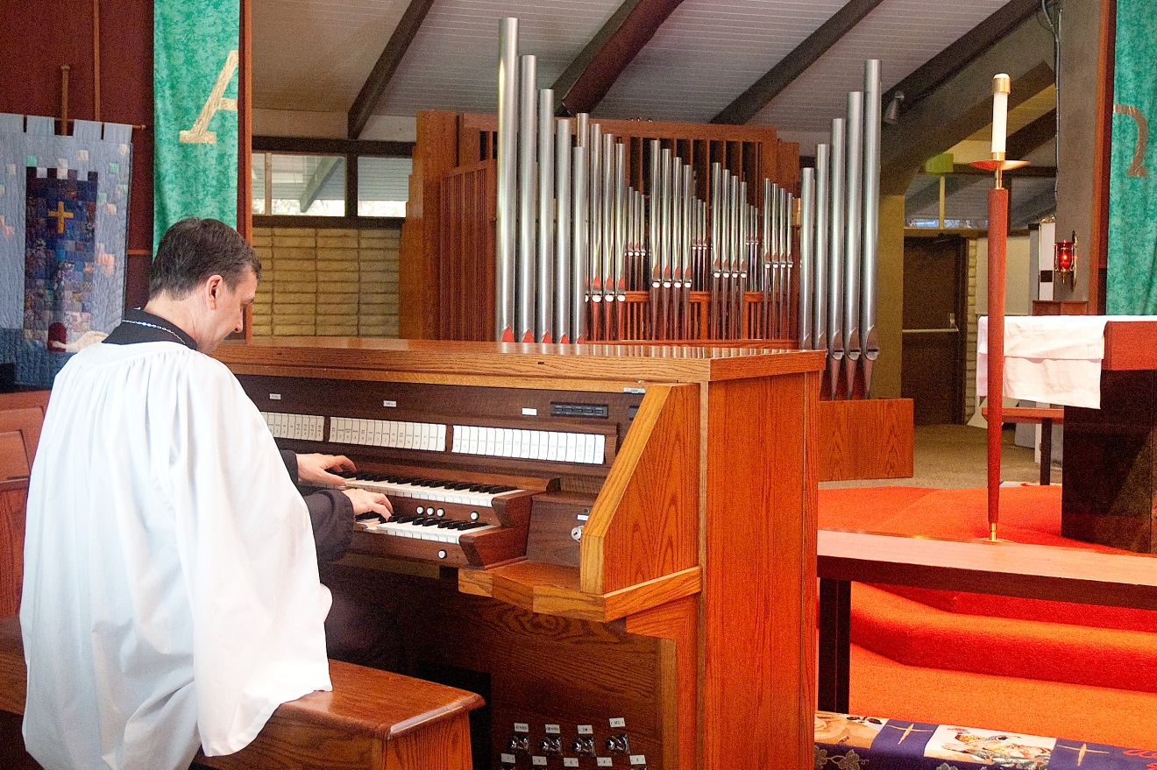

**Bond Pipe Organ, Opus 35**

**Bond Organ Builders of Portland Oregon completed work on a new pipe organ, Opus 35, in September, 2009. Controlled from 2 manual and pedal oak console, its 16 ranks, 33 stops, was designed and tonally finished by Richard Bond. The façade of 70% polished tin was designed by Roberta Bond. The organ contains almost 1,000 pipes.**

**The History of the Pipe Organs at St. Martin’s Episcopal Church**

**The Baldwin Grand Piano**  
The grand piano in the church sanctuary is a Baldwin SF10E – 7’ concert grand. It is entirely handcrafted in the USA, except for the Renner action which is made in Germany.  Considered one of the finest instruments available today, the piano offers a distinctive rich tone.

**The St. Martin Camerata**This is a select group of trained singers who sing a traditional Anglican-style Choral Evensong multiple times during the year and a beautiful Tenebrae on Wednesday of Holy Week before Easter. Singers must be able to sight-read music at an advanced level.

**The Elizabeth Rudisill Homann Fund**  
The Elizabeth R Homann endowment was given to St. Martin’s for the sole purpose of enhancing the music of our church services. The board of this fund is made up of selected parishioners, the Rector and the Music Director. Each year the board suggests the best use of the fund for liturgical music activities.