**Christian Formation: Children (PreK-6)**

St. Martin’s has a rich array of educational, fellowship, and service activities for children led by staff and adult volunteers.

[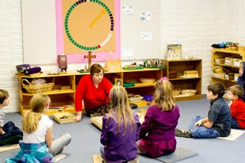](http://churchofstmartin.org/wp-content/gallery/mar2011/2011-02-20-stMartin-churchSchool-4089.jpg)

St. Martin’s offers Pre-K through 6th Grade Church School every Sunday in Classrooms 3 and 4 at **9am during our regular school year** (September – May). After Church School is over, children are escorted into the Sanctuary to join their parents for communion.

The **Godly Play** curriculum is offered during Church School to children in Pre-Kindergarten through to 6th grade during our regular school year (September through May/early June). We have accredited Godly Play leaders in all the classrooms who are passionate about this program, which encompasses:

Oral storytelling tradition  
Wondering about God  
Experience of God  
Sacred time  
Sacred space  
Liturgical tradition  
A personal creative response unique for each individual child.  
Sharing bread and thanksgivings together.

For more information about this curriculum visit [www.godlyplay.com](http://www.godlyplay.com)

[Church School Enrollment Form](http://churchofstmartin.org/wp-content/uploads/2008/09/churchschool.pdf)

[Photo Release Permission Form](http://churchofstmartin.org/wp-content/uploads/2009/09/Photo_Release_Permission.pdf)

St. Martin’s offers several **intergenerational festivals** throughout the year, including:

Picnics and games  
Advent wreath workshop  
Christmas pageant  
Easter egg dyeing  
Easter egg hunt  
Children’s Fellowship Activities: Martinmas Lantern Walk and Feast