**Christian Formation: University / Belfry**

**University Students at The Belfry**

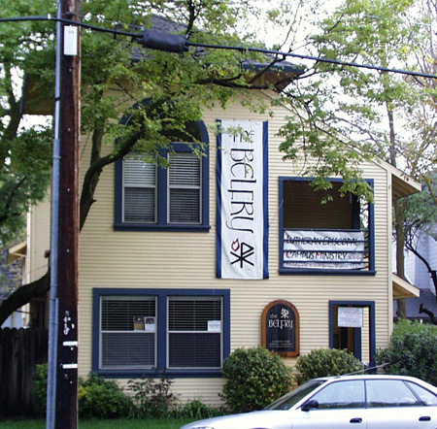

The Belfry building

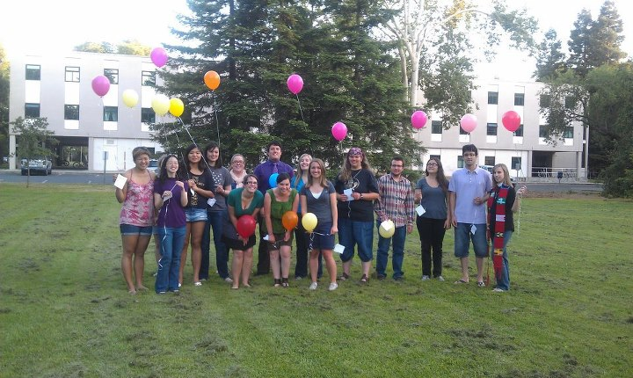

The Belfry is a community of UC Davis students who gather to…

* celebrate grace
* serve
* explore faith
* follow in a Lutheran-Episcopal tradition

You are welcome at The Belfry, whether you’re Lutheran or Episcopalian, or come from another faith tradition, or no tradition at all; whether you’re a person of deep faith or you’re searching for spirituality. Students live, work, worship, volunteer, eat and play here. Everyone has a place at The Belfry! Join us for worship, fellowship meals, conversation, service opportunities, a game of Xbox, or a round of air hockey.

We’re located at 216 A Street, across from Young Hall, between 2nd and 3rd Streets. You also can find us on facebook or at [www.thebelfry.org](http://www.thebelfry.org), and can reach us via e-mail — Pastor Jocelynn Hughes at [pastor@thebelfry.org](mailto:pastor@thebelfry.org), — or on our land line, 530-756-1550.