**Serving Others: What We Do**

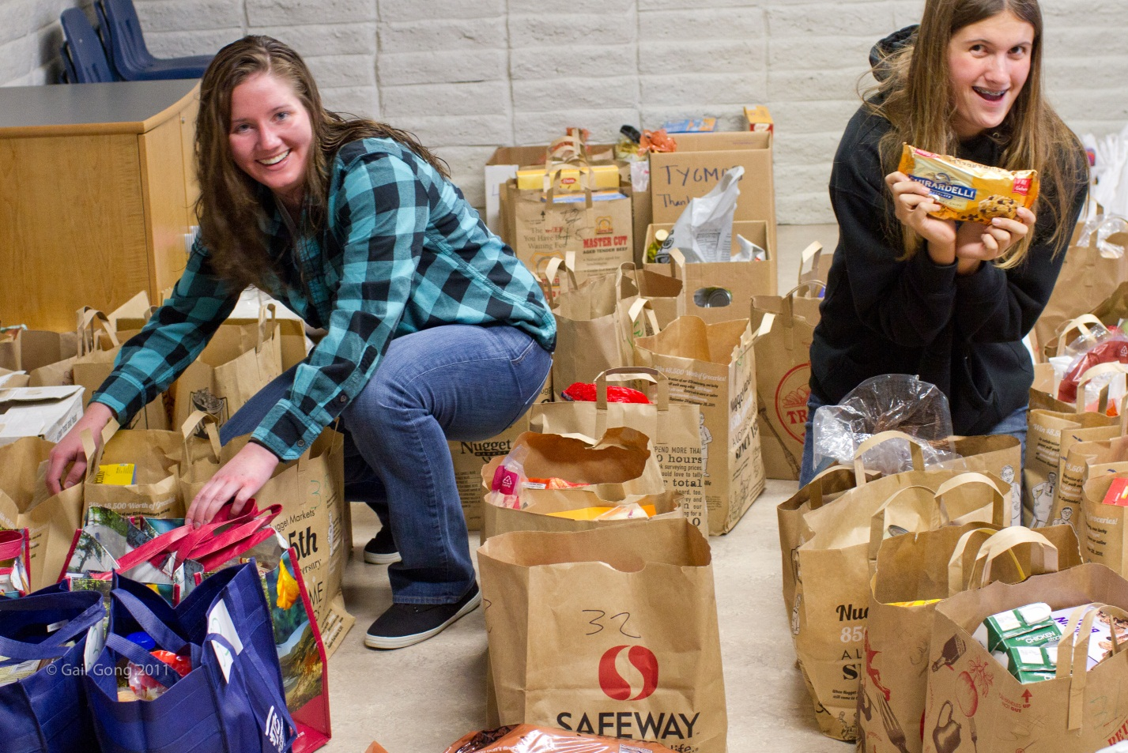

Preparing Thanksgiving Baskets for Local Families in Need

St. Martin’s Davis has a deeply embedded culture and long history of commitment to Outreach. We embrace Matthew 25:

*“For I was hungry and you gave me food, I was thirsty and you gave me something to drink, I was a stranger and you welcomed me, I was naked and you gave me clothing, I was sick and you took care of me, I was in prison and you visited me.”*

**See list of recent grant recipients: Grants Awarded**

**Some of Our Projects**

* Annual Thanksgiving Basket Project (named after parishioner Christine Blanchard; local families in need receive food for Thanksgiving)
* Weekly donations of food for STEAC and Dixon Family Services
* Coat, sock, and baby clothes collections for the homeless and low income
* Davis Community Meals (serving on the board, working at the meals, helping with DCM fundraisers)
* Yolo Interfaith Immigration Network (stuff backpacks for local migrant youth, work at the Davis and Madison migrant centers, visit undocumented youth at Yolo County Juvenile Hall)
* Sandwiches for the DCM Cold Weather Shelter or coffee funds the Interfaith Winter Rotating shelter
* Toiletry collections for St. Matthew’s Parish and other shelters
* Respite Care for Citizens Who Care Clients
* Advertise opportunities for service, such as Salvation Army Bell Ringing or Walk to Cure Cancer
* Collection of funds for United Thank Offering (UTO)
* Prayer shawls and blankets for the sick and the homeless
* The Belfry (UC Davis campus ministry). Prepare meals for weekly worship, support their fundraisers and Lutheran Episcopal Volunteer Network (LEVN) interns
* Piano concerts that support organizations that give to the community
* Participation in Celebration of Abraham (interfaith group working towards finding common ground on which to build a foundation of respect and tolerance)
* Participation in the national Episcopal Church campaign to rebuild the Cathedral in Port au Prince, Haiti
* Support for international service projects in Sudan, Honduras, and other countries
* Rebuilding Together Projects (renovating the homeless shelter and a local home)
* Sharing our facilities with community groups such as AA, the Boy Scouts, and Davis Community Meals, on a regular basis
* Support for Youth Group involvement in parish Outreach projects and support for youth service projects.

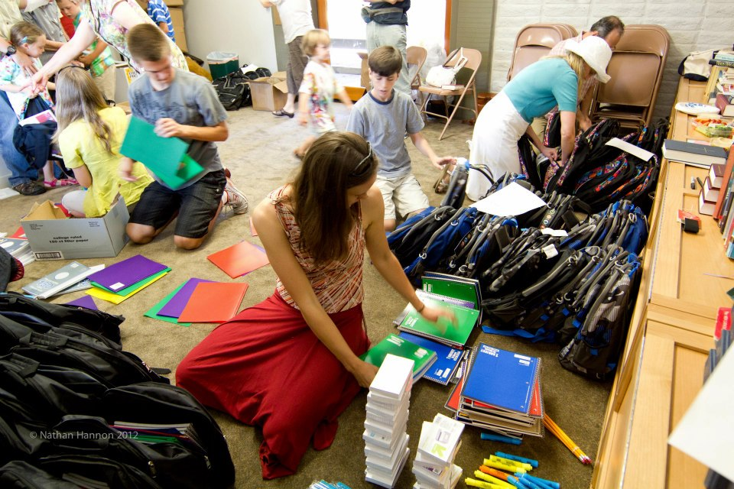

**Preparing Backpacks with School Supplies to Give to Local Migrant Children**

**Join Us at One of Our Meetings**

Are you interested in joining us? Do you want to help lead our parishioners into new areas of “hands on” outreach programs, service projects and “social action” discussions. Do you want to step up to help the poor, the downtrodden, the hungry and the sick?

The Outreach Commission meets the **first Sunday of each month after the 11:00 a.m. service** in the **Blanchard Library** (after the 10:00 a.m. service during the summer).

**How We Are Funded**

St. Martin’s strives to give 10% (tithe) of the income the church collects each year, including parishioner pledges and collections at services, to Outreach. Included in this tithe is the money set aside by Vestry as Matthew 25 funds as well as the special offerings given at Christmas, Easter and Good Friday.

In 2011, St. Martin’s gave $29,728.20 or 6.85 % of pledge and donation to Outreach. Added to this amount are generous financial gifts given by parishioners for outreach projects sponsored or co-sponsored by the church.

The designated Matthew 25 line item in our budget as well as the practice of “giving away” our Christmas and Easter offerings are representative of St. Martin’s institutional commitment to doing outreach in the community – local, national and international.

St. Martin’s is pleased to have earned the distinction of “Jubilee Parish”, that is, a congregation whose mission efforts affect the lives of those in need, addressing basic human needs and justice issues. We support the Millennium Development Goals (MDG’s) set forth by the United Nations, especially keeping these goals in mind when we make our annual Outreach grants.

In a very real way, Outreach giving is a tangible way of living out our faith. When there is a need or an opportunity to give, St. Martins responds . . . to be Christ in the world to the least among us.

**How Your Organization Can Be Considered for a Grant**

Contact the church office: [info@churchofstmartin.org](mailto:info@churchofstmartin.org); (530) 756-0444

**How to Donate to Our Efforts**

Contact the church office: [info@churchofstmartin.org](mailto:info@churchofstmartin.org); (530) 756-0444

Updated September 2012