**Serving Others: Davis Community Meals**

[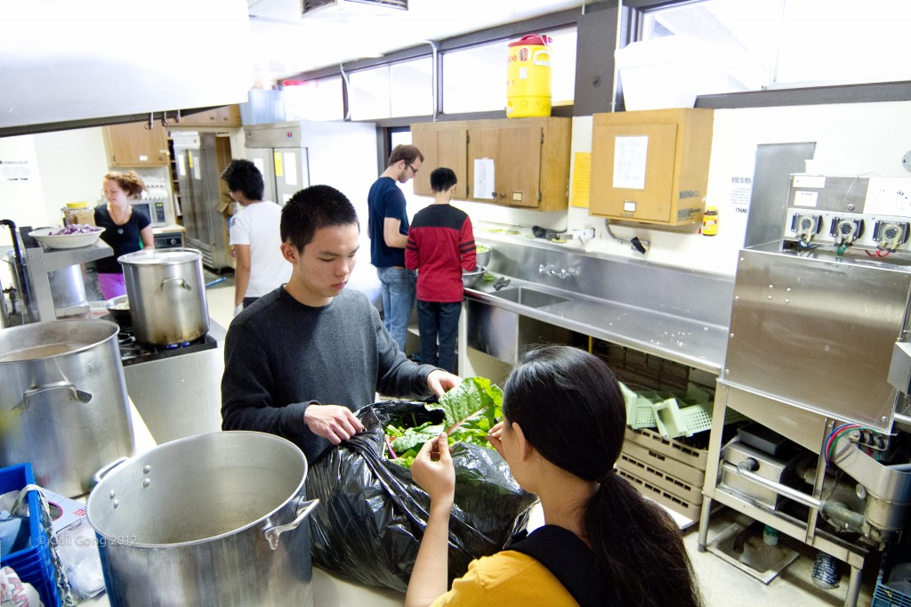](http://churchofstmartin.org/wp-content/uploads/2012/03/2011-05-21-meals-15181.jpg)

Volunteers prepare healthy meals for those in need three times a week.

Since February 1991, St. Martin’s has donated its kitchen and parish hall space to Davis Community Meals for its weekly meals program. Currently, three nutritious meals are served each week (total of 500 – 600 meals per month) on Tuesdays and Thursdays at 5:45 PM. and on Saturdays at 11:30 AM. On Thursdays, the meal is prepared and served primarily by the UC Davis student group H.E.L.P. (Health and Education Leading to Prevention) under DCM’s  
supervision.

St. Martin’s members join many other groups and individuals from the Davis community to serve as volunteers at the meals, assisting with tasks such as set- up, clean up, and serving. We also have a St. Martin’s host who attends each meal and serves as the welcoming face of St. Martin’s. A towel-washing brigade of St. Martin’s parishioners launders all the towels for the meals.

At least two St. Martin’s parishioners serve on the Davis Community Meals Board of Directors at all times and our rector is an ex-officio member. In the winter months, St. Martin’s also provides several weeks of sandwiches for the evening meal at DCM’s Cold Weather Shelter located in downtown Davis.