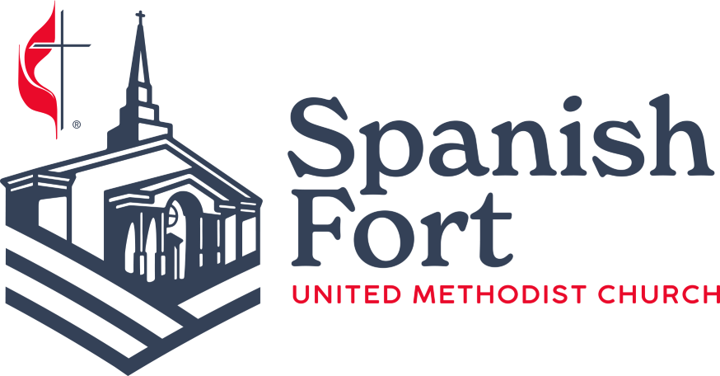

March 11, 2026
Greetings,
We are excited for our upcoming Easter Celebration, taking place on the afternoon of Palm Sunday, March 29th. We are adding a Silent Auction this year to raise funds for our Mission efforts.
During our Easter Celebration on March 29^{th,} we plan to offer a variety of items on display. While the children bunny hop, our adults can bid for their favorite local goods, baked items, and gift cards to restaurants in our Spring Silent Auction. All funds will be used to enhance a new Community Dinner initiative, relationships with our local service organizations, and future mission trips.
Please help Spanish Fort United Methodist Church support our Missions Committee with a donation to our Silent Auction. If you have an item to donate, a baked good to share, or a skill to teach, we welcome and thank you for your gift!
If you wish to donate, please bring items to the Church Office by Thursday, March 26th. Please complete the attached form so we know who to thank and acknowledge the donation. If you have any questions or would like to assist with the Silent Auction, please feel free to call us at 251-626-1334 or email margie@spanishfortumc.org.

Thank you for your support!

