A F R A M E W O R K F O R D I S C I P L E S H I P
The Christian Life: The Labyrinth
Framework by Rev. Michael Precht · Shared by Spanish Fort UMC
Before we were called "Christians," the people who dedicated their lives to Jesus were known as "Followers of the Way" (Acts 9:2). This framework, written by Rev. Michael Precht, begins there: faith is an ongoing act of trust and growth, and the ancient labyrinth is its map.
An ancient image of the Way
Christians have walked and traced labyrinths for most of the church’s history. The oldest known Christian labyrinth was built around 324 AD and is still visible in a church in Al-Asnam, Algeria; at eight feet wide, its paths are too small for walking, and early pilgrims likely followed it with their eyes or traced it with a finger. The most famous labyrinth was laid into the floor of Chartres Cathedral around 1200 AD. There are many guides and aids to prayer, but for centuries Christians have found the labyrinth helpful for keeping their focus on God.
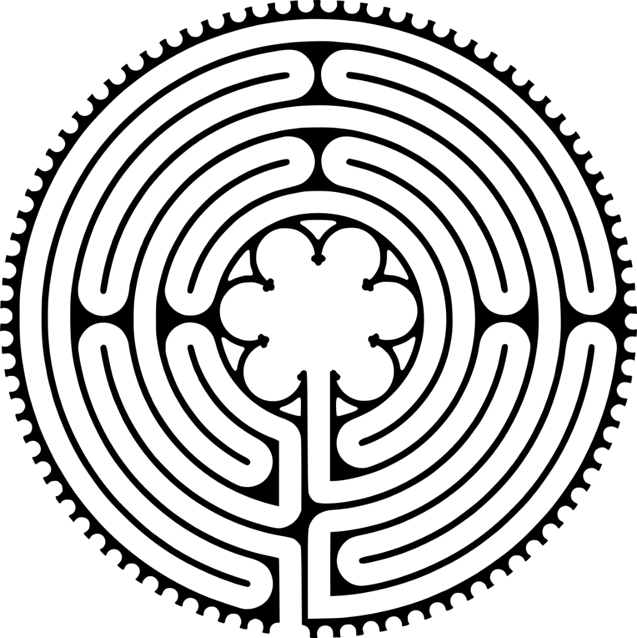
The labyrinth, reproduced from Rev. Michael Precht’s original framework document
Three characteristics
The labyrinth is open. It is not a maze. There are no dead ends, no tricks, no secret paths, and the only way to get lost is to look too far ahead. Precht points to Catherine of Siena’s saying that "all the way to heaven is heaven" and to 2 Corinthians 5:7, walking by faith and not by sight. Anyone can know Jesus by taking the next step and then the next one, trusting that simple faith draws us deeper into God’s love.
The labyrinth has thin places. As you walk or trace it, there are moments when you are so close to the center it feels like arrival, and stretches when the center seems far off even though the path is still carrying you forward. We may be drawing closer to God even when God feels distant, and God draws us near even when we still have a long road to travel.
Everyone is in it together. If the Way were a straight line, longtime disciples would be far removed from beginners. The twists and turns of the labyrinth bring all disciples alongside each other to encourage one another.
Walking it
The key is to move steadily and slowly. On the way in, pilgrims pray over whatever they need to surrender in order to live more fully open to God. The center represents the heart of God, where we rest in wonder, love, and praise as God’s will is done in us as it is in heaven. At the center, pilgrims wait until they receive a word, a remembered scripture, a mental image, or a feeling of consolation. Then they retrace their steps, praying as they return outward into ordinary life.
The five practices, mapped onto the labyrinth
Our lives are shaped by the five practices and promises of the membership vow: prayers, presence, gifts, service, and witness. Precht maps these five disciplines onto the labyrinth with witness at the heart of everything and Jesus at the center of it all. These disciplines are means of grace. In his words, "Instead of practicing these disciplines to prove how good we are, we believe these habits help us discover how good God is." Jesus has promised to meet us when we pray in hidden moments, when we gather in his name, when we share generously, when we serve others, and when we tell the story of how we have come to know him.
The vows on the Way
The first three membership vows have been used by Christians for two thousand years, and all three are about Who we follow: turning from sin and the paths that will not endure in the Kingdom, accepting God’s freedom and power to resist evil, injustice, and oppression wherever they appear, and confessing Jesus Christ as Savior and Lord. The fourth vow belongs to the local congregation, and it is about how we help one another along the way: faithful participation through prayers, presence, gifts, service, and witness. We want to be known by what we are for more than by what we are against.
How to use this
This framework works as the backbone of a new member or confirmation class, as a follow-up conversation with people joining the church, and as a teaching frame for preaching through the membership vows. A printed finger labyrinth alongside the document turns it into a prayer practice anyone can take home. Credit the framework to Rev. Michael Precht wherever it is used.
Framework written by Rev. Michael Precht and shared here with gratitude and full credit.
Spanish Fort UMC · Shared through the Church Resource Hub, churchresourcehub.github.io

