Supplementary Material
A Gain-Invariant, Leak-Free EEG Benchmark for Resolving Frontal Theta Dynamics and Cognitive Severity Across Multi-Site Clinical Cohorts
Chushu Tan^{1,*}
^{1} School of Sociology, China University of Political Science and Law, Beijing 102249, China
^{*} Corresponding author: Chushu Tan, Guangzhou, Guangdong 510006, China. Email: chushuta@gmail.com. ORCID: 0009-0007-3093-0160

Section S1. Extended Supplementary Methods

S1.1 Parameterized Spectral Decomposition via specparam
To eliminate the pervasive conflation between narrowband neural oscillations and broadband 1/f background activity, resting-state electroencephalographic power spectra were decomposed using the specparam algorithm (v1.1.0; Donoghue et al., 2020). Spectral estimation was executed via Welch’s modified periodogram with 2.0-second Hamming windows and 50% overlap, yielding an exact frequency resolution of 0.50 Hz across 1.0–40.0 Hz. Power spectra were parameterized in fixed aperiodic mode according to:
log10PSD(f)=L(f)+n​an⋅exp−(f−cn)22wn2
where the aperiodic background component L(f) is modeled as:
$$L(f)=b−χ⋅\log_{10}(f)$$
Here, b denotes the broadband aperiodic offset (in Bel, B, where 1 B = 10 dB = 1.0 log₁₀ µV²/Hz), χ denotes the aperiodic decay exponent reflecting the spectral decay slope, and each Gaussian peak is parameterized by its amplitude aₙ, center frequency cₙ, and bandwidth wₙ. Model hyperparameters were pre-specified as: peak width limits = [1.0, 8.0] Hz, maximum number of peaks = 6, minimum peak height = 0.10 B, peak threshold = 2.0 standard deviations, and aperiodic mode = ‘fixed’ (knee parameter omitted given the 1.0–40.0 Hz fitting range).
Narrowband periodic power was isolated by subtracting the fitted aperiodic component L(f) from the total log-power spectrum:
$$P_{periodic}(f)=\log_{10}PSD(f)−L(f)$$
Residual periodic band powers were extracted by integrating P_periodic(f) across canonical electrophysiological bands: Frontal Theta (4.0–8.0 Hz, averaged over Fp1, Fp2, F3, F4, Fz), Posterior Alpha (8.0–13.0 Hz, averaged over P3, P4, Pz, O1, O2), and Global Delta (1.0–4.0 Hz, averaged over all 19 channels). The global aperiodic exponent χ was averaged across all 19 channels to provide an electrophysiological index of cortical excitation/inhibition (E/I) balance.

S1.2 Data-Driven Connectomics via Orthogonal Minimum Spanning Trees (OMST)
Functional brain connectivity was quantified using the Phase Lag Index (PLI; Stam et al., 2007) in the combined theta-alpha band (4.0–13.0 Hz) to eliminate spurious zero-lag volume conduction. To construct connected brain network topologies without subjective thresholding, I applied the Orthogonal Minimum Spanning Trees (OMST) framework (Dimitriadis et al., 2017). Distance metrics were computed as:
c_ij = (1.0 - PLI_ij) + 10⁻⁴
where the small positive offset (10⁻⁴) prevents sparse graph routines from misinterpreting zero-cost edges as absent. The primary spanning tree was extracted using Kruskal’s algorithm (Kruskal, 1956), connecting all N = 19 electrode nodes with exactly N - 1 = 18 edges. Subsequent orthogonal spanning trees were iteratively extracted by setting previously selected edges to infinity, forcing each successive tree to capture independent functional pathways. Cumulative networks were evaluated by maximizing Global Cost Efficiency (GCE):
GCE(m) = E_global(G_m) / E_global(G_full) - Cost(G_m)
where E_global represents the average inverse shortest path length across all node pairs, and Cost represents the sum of weights in the selected network normalized by the total weight of the fully connected graph.
Across all N = 566 subjects and 677 recording sessions, the empirical distribution of selected OMST trees was M = 1.51 ± 0.50 (median = 2; 49.3% selecting M = 1 and 50.7% selecting M = 2; Mumtaz MDD: M = 1.33 ± 0.47, density = 14.0% ± 4.9%; Cavanagh depression: M = 1.45 ± 0.50, density = 15.3% ± 5.3%; UCSD Parkinson: M = 1.61 ± 0.49, density = 17.0% ± 5.2%; Sleep deprivation: M = 1.59 ± 0.49, density = 16.7% ± 5.2%). Across the entire multi-cohort benchmark (677 graphs), the mean number of selected edges was E = 27.12 ± 9.00, yielding a mean node degree of k̄ = 2.86 ± 0.95 (sum of node degrees = 54.25) and an average network density of 15.86% ± 5.26%. Across all 6,935 individual node instances in the study, the isolated node rate was strictly 0.0000% by construction.

S1.3 Analytical and Numerical Proof of Amplifier Gain Invariance
When raw EEG signals are recorded across different hardware systems, arbitrary amplifier gain scaling introduces a multiplicative factor k > 0 such that v’(t) = k · v(t). The resulting power spectrum scales quadratically:
PSD’(f) = k² · PSD(f)
In logarithmic space, this corresponds to a uniform vertical shift:
log₁₀ PSD’(f) = log₁₀ PSD(f) + 2 log₁₀ k
Fitting the specparam model to the scaled spectrum yields:
log₁₀ PSD’(f) = b’ - χ’ · log₁₀(f) + Σₙ a’ₙ · exp(-(f - c’ₙ)² / 2(w’ₙ)²)
Because 2 log₁₀ k is strictly frequency-independent, its derivative with respect to frequency is identically zero:
∂/∂f [log₁₀ PSD’(f)] = ∂/∂f [log₁₀ PSD(f)]
Consequently, parameter optimization yields: 1. χ’ = χ (the aperiodic slope is invariant); 2. c’ₙ = cₙ and w’ₙ = wₙ (peak center frequencies and bandwidths are invariant); 3. a’ₙ = aₙ (Gaussian peak amplitudes above the aperiodic floor are invariant); 4. b’ = b + 2 log₁₀ k (the unadjusted aperiodic offset absorbs the entire scaling factor); 5. Residual periodic power P_periodic’(f) = log₁₀ PSD’(f) - L’(f) = P_periodic(f) is invariant.
Similarly, Phase Lag Index (PLI) depends exclusively on the sign of instantaneous phase differences:
PLI = |⟨sign(sin(Δφ(t)))⟩|
Because linear scaling by k > 0 does not alter signal phase (∠(k · v(t)) = ∠v(t)), pairwise PLI values and the resulting OMST graph topology are mathematically invariant to digitizer gain.

S1.4 NormativeGCN Architecture and Training Specification
The NormativeGCN architecture is implemented in pure PyTorch and operates directly on the 19-node OMST graph. Each node is endowed with a 4-dimensional normatively calibrated feature vector z_i = [z_θ, z_δ, z_α, z_χ]^T ∈ ℝ⁴ derived via fold-nested reference scaling against healthy controls: - Layer 1: PurePyTorchGCNLayer (4 → 32 channels) with symmetric normalized adjacency Ã = D̃^(-1/2) (A + I) D̃^(-1/2), followed by ReLU activation and Dropout (p = 0.25) (160 trainable parameters). - Layer 2: PurePyTorchGCNLayer (32 → 32 channels), followed by ReLU activation and Dropout (p = 0.25) (1,056 trainable parameters). - Multi-Pooling Readout: Concatenated Global Mean Pooling (32-D) and Global Max Pooling (32-D) across all 19 nodes, producing a 64-dimensional graph embedding: h_G = [h_mean, h_max] ∈ ℝ⁶⁴. - Classification Head: Multi-layer perceptron comprising Linear(64, 32) (2,080 parameters) followed by ReLU, Dropout (p = 0.25), and Linear(32, 2) (66 parameters). - Total Trainable Parameters: Exactly 3,362 parameters (160 + 1,056 + 2,080 + 66 = 3,362). - Optimization: AdamW optimizer (learning rate η = 0.005, weight decay λ = 1.0 × 10⁻⁴, cross-entropy loss, fixed 35 training epochs). To completely prevent test-fold leakage, zero early stopping was performed on evaluation folds.

Section S2. Supplementary Tables

Table S1. Canonical 19-Channel 10–20 Electrode Coordinates and Mathematically Consistent OMST Graph Metrics
Channel Label | Cortical Region | Projected X (2D) | Projected Y (2D) | Tree 1 Degree (M=1) | Tree 2 Orthogonal Degree | Combined Degree (M=2) | Empirical Mean Degree (M=1.51) | Betweenness Centrality | Clustering Coefficient
Fp1 | Prefrontal (Left) | -0.28 | +0.78 | 1 | 2 | 3 | 2.54 ± 1.80 | 0.058 ± 0.113 | 0.125 ± 0.269
Fp2 | Prefrontal (Right) | +0.28 | +0.78 | 1 | 2 | 3 | 2.40 ± 1.72 | 0.055 ± 0.118 | 0.123 ± 0.281
F7 | Anterior Temporal (Left) | -0.72 | +0.44 | 2 | 1 | 3 | 2.48 ± 1.67 | 0.059 ± 0.114 | 0.131 ± 0.268
F3 | Frontal (Left) | -0.35 | +0.40 | 3 | 2 | 5 | 2.39 ± 1.67 | 0.058 ± 0.118 | 0.131 ± 0.283
Fz | Frontal Midline | 0.00 | +0.40 | 3 | 1 | 4 | 2.93 ± 2.39 | 0.088 ± 0.155 | 0.105 ± 0.244
F4 | Frontal (Right) | +0.35 | +0.40 | 3 | 2 | 5 | 3.11 ± 2.55 | 0.108 ± 0.189 | 0.099 ± 0.225
F8 | Anterior Temporal (Right) | +0.72 | +0.44 | 2 | 1 | 3 | 3.31 ± 2.49 | 0.121 ± 0.195 | 0.104 ± 0.219
T7 | Mid-Temporal (Left) | -0.84 | 0.00 | 2 | 1 | 3 | 3.35 ± 2.45 | 0.128 ± 0.203 | 0.103 ± 0.220
C3 | Central (Left) | -0.42 | 0.00 | 1 | 4 | 5 | 3.08 ± 2.16 | 0.113 ± 0.178 | 0.101 ± 0.219
Cz | Central Midline | 0.00 | 0.00 | 4 | 1 | 5 | 3.35 ± 2.35 | 0.137 ± 0.203 | 0.093 ± 0.214
C4 | Central (Right) | +0.42 | 0.00 | 1 | 4 | 5 | 2.49 ± 1.77 | 0.064 ± 0.129 | 0.117 ± 0.264
T8 | Mid-Temporal (Right) | +0.84 | 0.00 | 2 | 1 | 3 | 2.38 ± 1.63 | 0.060 ± 0.127 | 0.107 ± 0.264
P7 | Posterior Temporal (Left) | -0.72 | -0.44 | 1 | 2 | 3 | 2.48 ± 1.86 | 0.063 ± 0.126 | 0.115 ± 0.273
P3 | Parietal (Left) | -0.35 | -0.40 | 2 | 2 | 4 | 2.47 ± 1.79 | 0.064 ± 0.129 | 0.090 ± 0.240
Pz | Parietal Midline | 0.00 | -0.40 | 3 | 1 | 4 | 3.04 ± 2.40 | 0.102 ± 0.174 | 0.130 ± 0.274
P4 | Parietal (Right) | +0.35 | -0.40 | 2 | 2 | 4 | 3.14 ± 2.56 | 0.118 ± 0.206 | 0.142 ± 0.292
P8 | Posterior Temporal (Right) | +0.72 | -0.44 | 1 | 2 | 3 | 2.49 ± 1.75 | 0.060 ± 0.126 | 0.146 ± 0.296
O1 | Occipital (Left) | -0.28 | -0.78 | 1 | 3 | 4 | 2.99 ± 2.24 | 0.101 ± 0.176 | 0.104 ± 0.242
O2 | Occipital (Right) | +0.28 | -0.78 | 1 | 2 | 3 | 3.81 ± 3.09 | 0.164 ± 0.250 | 0.113 ± 0.243
Network Total / Mean | All 19 Channels | — | — | 18 edges (k̄ = 1.89) | 18 edges (k̄ = 1.89) | 36 edges (k̄ = 3.79) | 27.12 edges (k̄ = 2.86) | — | —
Note: For an undirected graph with N = 19 nodes, maximum possible edges is N(N-1)/2 = 171. Edge density is D = E / 171. For M = 1 tree (E = 18), sum of degrees is 2E = 36, mean degree is k̄ = 1.895, and D = 10.53%; for M = 2 trees (E = 36), sum of degrees is 2E = 72, k̄ = 3.789, and D = 21.05%. Across the entire multi-cohort empirical benchmark (N = 566 participants, 677 recording sessions), data-driven GCE optimization selected an average of M = 1.51 ± 0.50 trees (E = 27.12 ± 9.00 edges), yielding an exact node degree sum of 54.25, mean degree k̄ = 2.86 ± 0.95, and network density D = 15.86% ± 5.26%. The isolated node rate is strictly 0.0000% across all sessions by construction.

Table S2. Numerical Verification of Feature Invariance Across Four Orders of Magnitude of Amplifier Gain
Gain Factor (k) | Theoretical Offset b_theory (B) | Extracted Offset b_sim (B) | Offset Error Δb (B) | Periodic θ Error (B) | Periodic δ Error (B) | Periodic α Error (B) | Aperiodic χ Error (dimensionless)
0.01 | -3.3500 | -3.3500 | < 1.0 × 10⁻¹⁵ | 2.1 × 10⁻¹⁵ | 1.8 × 10⁻¹⁵ | 2.5 × 10⁻¹⁵ | 1.2 × 10⁻¹⁵
0.10 | -1.3500 | -1.3500 | < 1.0 × 10⁻¹⁵ | 1.4 × 10⁻¹⁵ | 1.1 × 10⁻¹⁵ | 1.6 × 10⁻¹⁵ | 8.0 × 10⁻¹⁶
0.50 | 0.0479 | 0.0479 | < 1.0 × 10⁻¹⁵ | 8.0 × 10⁻¹⁶ | 5.0 × 10⁻¹⁶ | 9.0 × 10⁻¹⁶ | 4.0 × 10⁻¹⁶
1.00 (Base) | 0.6500 | 0.6500 | 0.00 | 0.00 | 0.00 | 0.00 | 0.00
2.00 | 1.2521 | 1.2521 | < 1.0 × 10⁻¹⁵ | 9.5 × 10⁻¹⁶ | 7.0 × 10⁻¹⁶ | 1.1 × 10⁻¹⁵ | 5.0 × 10⁻¹⁶
10.00 | 2.6500 | 2.6500 | < 1.0 × 10⁻¹⁵ | 1.8 × 10⁻¹⁵ | 1.5 × 10⁻¹⁵ | 2.0 × 10⁻¹⁵ | 1.0 × 10⁻¹⁵
100.00 | 4.6500 | 4.6500 | < 1.0 × 10⁻¹⁵ | 2.7 × 10⁻¹⁵ | 2.3 × 10⁻¹⁵ | 3.1 × 10⁻¹⁵ | 1.6 × 10⁻¹⁵
Note: Simulation performed on 19-channel EEG epochs scaled by multiplicative factor k. Base spectrum parameterized with offset b₀ = 0.650 B and exponent χ₀ = 1.152. Theoretical prediction: Δb = 2 log₁₀(k). Numerical errors for residual periodic band powers and aperiodic exponent χ are bounded strictly by IEEE 754 double-precision floating-point precision (< 10⁻¹⁴), validating complete empirical scale-invariance.

Table S3. Multi-Cohort Demographics, Recording Montages, and Clinical Profiles (Analyzed Sample N = 566, 677 Sessions)
Study Identifier | Cohort Name | Sample Size (Subjects / Sessions) | Diagnostic Groups (N) | Age (Years, Mean ± SD) | Sex (% Female) | Recording System & Native Channels | Sampling Rate (Native -> Benchmark) | Clinical Assessment Scales
Study 1 | Acute Sleep Deprivation (ds004902) | 71 / 142 | SD (71) vs. NS (71) [Paired] | 22.4 ± 2.6 | 47.9% | BrainVision (64 Ch, actiCHamp) | 500 Hz -> 250 Hz | Monitored 36h Continuous Wakefulness
Study 2 | Outpatient Clinical MDD (4244171) | 58 / 64 | MDD (30) vs. HC (28) | 39.3 ± 14.3 | 37.9% | Nihon Kohden (19 Ch, 10-20 native) | 256 Hz -> 250 Hz | Beck Depression Inventory (BDI: 24.8 ± 8.6)
Study 3 | University Depression (ds003478) | 119 / 119 | DEP (44) vs. CTL (75) | 19.4 ± 2.0 | 60.5% | BioSemi ActiveTwo (64 Ch) | 500 Hz -> 250 Hz | BDI-II (22.8 ± 8.1) & SCID Clinical Interview
Study 4 | UCSD Parkinson’s Disease (ds002778) | 31 / 46 | PD (15, ON/OFF) vs. CTL (16) | 63.4 ± 8.8 | 54.8% | BioSemi ActiveTwo (32 Ch) | 512 Hz -> 250 Hz | Levodopa Washout (>=12h) & Clinical ON State
Study 5 | AHEPA Clinical Dementia (ds004504) | 88 / 88 | AD (36), FTD (23), CTL (29) | 70.8 ± 7.4 | 55.7% | Nihon Kohden (19 Ch, 10-20 native) | 500 Hz -> 250 Hz | Mini-Mental State Exam (MMSE: 22.9 ± 6.1)
Study 6 | UNM Parkinson’s Disease (ds003490) | 50 / 75 | PD (25, ON/OFF) vs. CTL (25) | 68.3 ± 8.4 | 42.0% | BrainVision (64 Ch) | 500 Hz -> 250 Hz | Levodopa Washout (>=15h) & Counterbalanced ON
Study 7 | Iowa Parkinson’s Multi-Scale (ds004584) | 149 / 149 | PD (100) vs. CTL (49) | 69.3 ± 8.1 | 42.3% | BrainVision (64 Ch, Pz CAR ref) | 500 Hz -> 250 Hz | MoCA (25.1 ± 3.6) & UPDRS-III (12.5 ± 7.1)

Table S4. Complete Statistical Summary of Electrophysiological Markers Across All Multi-Cohort Comparisons (50 Hypotheses with Benjamini-Hochberg FDR Control)
Clinical Cohort | Group Contrast | Marker Name | N (Case / Ctrl) | Test Design | t-statistic | df | Raw p-value | FDR q-value (50 tests) | Cohen’s d [95% CI] | Sig
Study 1 | SD vs NS | Frontal Periodic Theta (4–8 Hz) | 71 / 71 | Paired t | +2.392 | 70 | 0.0194 | 0.0540 | +0.284 [+0.047, +0.521] | ns
Study 1 | SD vs NS | Global Periodic Delta (1–4 Hz) | 71 / 71 | Paired t | -1.975 | 70 | 0.0522 | 0.1250 | -0.234 [-0.470, +0.001] | ns
Study 1 | SD vs NS | Posterior Periodic Alpha (8–13 Hz) | 71 / 71 | Paired t | +0.812 | 70 | 0.4198 | 0.5524 | +0.096 [-0.137, +0.329] | ns
Study 1 | SD vs NS | Global Aperiodic Exponent (χ) | 71 / 71 | Paired t | +1.545 | 70 | 0.1269 | 0.1983 | +0.183 [-0.051, +0.418] | ns
Study 1 | SD vs NS | OMST Global Cost Efficiency (GCE) | 71 / 71 | Paired t | -1.267 | 70 | 0.2095 | 0.3081 | -0.150 [-0.384, +0.084] | ns
Study 2 | MDD vs Control | Frontal Periodic Theta (4–8 Hz) | 30 / 28 | Welch t | -3.145 | 56 | 0.0027 | 0.0121 | -0.826 [-1.362, -0.289] | *
Study 2 | MDD vs Control | Global Periodic Delta (1–4 Hz) | 30 / 28 | Welch t | -1.992 | 56 | 0.0525 | 0.1250 | -0.531 [-1.055, -0.007] | ns
Study 2 | MDD vs Control | Posterior Periodic Alpha (8–13 Hz) | 30 / 28 | Welch t | -0.117 | 56 | 0.9071 | 0.9256 | -0.031 [-0.546, +0.484] | ns
Study 2 | MDD vs Control | Global Aperiodic Exponent (χ) | 30 / 28 | Welch t | -2.843 | 56 | 0.0062 | 0.0237 | -0.744 [-1.276, -0.211] | *
Study 2 | MDD vs Control | OMST Global Cost Efficiency (GCE) | 30 / 28 | Welch t | +1.842 | 56 | 0.0728 | 0.1516 | +0.494 [-0.029, +1.017] | ns
Study 3 | MDD vs Control | Frontal Periodic Theta (4–8 Hz) | 44 / 75 | Welch t | -3.608 | 117 | 4.96e-04 | 0.0035 | -0.676 [-1.058, -0.294] | **
Study 3 | MDD vs Control | Global Periodic Delta (1–4 Hz) | 44 / 75 | Welch t | +1.552 | 117 | 0.1245 | 0.1983 | +0.301 [-0.073, +0.675] | ns
Study 3 | MDD vs Control | Posterior Periodic Alpha (8–13 Hz) | 44 / 75 | Welch t | -1.476 | 117 | 0.1435 | 0.2174 | -0.280 [-0.654, +0.093] | ns
Study 3 | MDD vs Control | Global Aperiodic Exponent (χ) | 44 / 75 | Welch t | -1.598 | 117 | 0.1146 | 0.1975 | -0.327 [-0.702, +0.047] | ns
Study 3 | MDD vs Control | OMST Global Cost Efficiency (GCE) | 44 / 75 | Welch t | +0.178 | 117 | 0.8595 | 0.9256 | +0.034 [-0.338, +0.406] | ns
Study 4 | PD vs Control | Frontal Periodic Theta (4–8 Hz) | 30 / 16 | Welch t | +2.775 | 44 | 0.0090 | 0.0300 | +0.837 [+0.206, +1.467] | *
Study 4 | PD vs Control | Global Periodic Delta (1–4 Hz) | 30 / 16 | Welch t | -1.632 | 44 | 0.1109 | 0.1975 | -0.468 [-1.082, +0.146] | ns
Study 4 | PD vs Control | Posterior Periodic Alpha (8–13 Hz) | 30 / 16 | Welch t | +0.282 | 44 | 0.7803 | 0.9004 | +0.092 [-0.516, +0.699] | ns
Study 4 | PD vs Control | Global Aperiodic Exponent (χ) | 30 / 16 | Welch t | +1.189 | 44 | 0.2438 | 0.3483 | +0.372 [-0.239, +0.984] | ns
Study 4 | PD vs Control | OMST Global Cost Efficiency (GCE) | 30 / 16 | Welch t | -0.583 | 44 | 0.5656 | 0.7070 | -0.199 [-0.807, +0.409] | ns
Study 5a | AD vs Control | Frontal Periodic Theta (4–8 Hz) | 36 / 29 | Welch t | +5.349 | 63 | 1.41e-06 | 3.52e-05 | +1.279 [+0.742, +1.815] | ***
Study 5a | AD vs Control | Global Periodic Delta (1–4 Hz) | 36 / 29 | Welch t | -0.130 | 63 | 0.8969 | 0.9256 | -0.032 [-0.521, +0.457] | ns
Study 5a | AD vs Control | Posterior Periodic Alpha (8–13 Hz) | 36 / 29 | Welch t | -4.407 | 63 | 4.24e-05 | 3.54e-04 | -1.059 [-1.581, -0.537] | ***
Study 5a | AD vs Control | Global Aperiodic Exponent (χ) | 36 / 29 | Welch t | +4.609 | 63 | 2.18e-05 | 2.18e-04 | +1.096 [+0.572, +1.621] | ***
Study 5a | AD vs Control | OMST Global Cost Efficiency (GCE) | 36 / 29 | Welch t | -1.552 | 63 | 0.1268 | 0.1983 | -0.399 [-0.893, +0.095] | ns
Study 5b | FTD vs Control | Frontal Periodic Theta (4–8 Hz) | 23 / 29 | Welch t | +1.856 | 50 | 0.0720 | 0.1516 | +0.546 [-0.011, +1.103] | ns
Study 5b | FTD vs Control | Global Periodic Delta (1–4 Hz) | 23 / 29 | Welch t | +0.954 | 50 | 0.3452 | 0.4794 | +0.267 [-0.283, +0.817] | ns
Study 5b | FTD vs Control | Posterior Periodic Alpha (8–13 Hz) | 23 / 29 | Welch t | -3.332 | 50 | 0.0018 | 0.0091 | -0.949 [-1.526, -0.372] | **
Study 5b | FTD vs Control | Global Aperiodic Exponent (χ) | 23 / 29 | Welch t | +0.769 | 50 | 0.4478 | 0.5742 | +0.231 [-0.318, +0.780] | ns
Study 5b | FTD vs Control | OMST Global Cost Efficiency (GCE) | 23 / 29 | Welch t | -1.645 | 50 | 0.1064 | 0.1971 | -0.455 [-1.009, +0.099] | ns
Study 5c | Dementia vs Control | Frontal Periodic Theta (4–8 Hz) | 59 / 29 | Welch t | +4.644 | 86 | 1.30e-05 | 1.62e-04 | +0.903 [+0.439, +1.367] | ***
Study 5c | Dementia vs Control | Global Periodic Delta (1–4 Hz) | 59 / 29 | Welch t | +0.364 | 86 | 0.7174 | 0.8749 | +0.080 [-0.364, +0.525] | ns
Study 5c | Dementia vs Control | Posterior Periodic Alpha (8–13 Hz) | 59 / 29 | Welch t | -4.771 | 86 | 9.31e-06 | 1.55e-04 | -0.981 [-1.448, -0.513] | ***
Study 5c | Dementia vs Control | Global Aperiodic Exponent (χ) | 59 / 29 | Welch t | +3.449 | 86 | 8.78e-04 | 0.0055 | +0.646 [+0.191, +1.100] | **
Study 5c | Dementia vs Control | OMST Global Cost Efficiency (GCE) | 59 / 29 | Welch t | -1.794 | 86 | 0.0793 | 0.1585 | -0.436 [-0.885, +0.014] | ns
Study 6a | PD_OFF vs Control | Frontal Periodic Theta (4–8 Hz) | 25 / 25 | Welch t | +3.058 | 48 | 0.0037 | 0.0152 | +0.865 [+0.285, +1.445] | *
Study 6a | PD_OFF vs Control | Global Periodic Delta (1–4 Hz) | 25 / 25 | Welch t | -2.571 | 48 | 0.0133 | 0.0416 | -0.727 [-1.300, -0.155] | *
Study 6a | PD_OFF vs Control | Posterior Periodic Alpha (8–13 Hz) | 25 / 25 | Welch t | +2.223 | 48 | 0.0313 | 0.0823 | +0.629 [+0.061, +1.197] | ns
Study 6a | PD_OFF vs Control | Global Aperiodic Exponent (χ) | 25 / 25 | Welch t | +0.162 | 48 | 0.8723 | 0.9256 | +0.046 [-0.509, +0.600] | ns
Study 6a | PD_OFF vs Control | OMST Global Cost Efficiency (GCE) | 25 / 25 | Welch t | +0.265 | 48 | 0.7924 | 0.9004 | +0.075 [-0.480, +0.629] | ns
Study 6b | PD_ON vs Control | Frontal Periodic Theta (4–8 Hz) | 25 / 25 | Welch t | +2.839 | 48 | 0.0066 | 0.0237 | +0.803 [+0.227, +1.379] | *
Study 6b | PD_ON vs Control | Global Periodic Delta (1–4 Hz) | 25 / 25 | Welch t | -2.541 | 48 | 0.0143 | 0.0422 | -0.719 [-1.291, -0.147] | *
Study 6b | PD_ON vs Control | Posterior Periodic Alpha (8–13 Hz) | 25 / 25 | Welch t | +1.883 | 48 | 0.0664 | 0.1508 | +0.532 [-0.032, +1.097] | ns
Study 6b | PD_ON vs Control | Global Aperiodic Exponent (χ) | 25 / 25 | Welch t | +0.318 | 48 | 0.7517 | 0.8949 | +0.090 [-0.465, +0.645] | ns
Study 6b | PD_ON vs Control | OMST Global Cost Efficiency (GCE) | 25 / 25 | Welch t | +0.224 | 48 | 0.8239 | 0.9154 | +0.063 [-0.491, +0.618] | ns
Study 7 | PD vs Control | Frontal Periodic Theta (4–8 Hz) | 100 / 49 | Welch t | +5.727 | 147 | 7.16e-08 | 3.58e-06 | +0.899 [+0.542, +1.255] | ***
Study 7 | PD vs Control | Global Periodic Delta (1–4 Hz) | 100 / 49 | Welch t | -3.197 | 147 | 0.0018 | 0.0091 | -0.531 [-0.878, -0.184] | **
Study 7 | PD vs Control | Posterior Periodic Alpha (8–13 Hz) | 100 / 49 | Welch t | +0.863 | 147 | 0.3905 | 0.5277 | +0.160 [-0.183, +0.502] | ns
Study 7 | PD vs Control | Global Aperiodic Exponent (χ) | 100 / 49 | Welch t | +1.686 | 147 | 0.0946 | 0.1820 | +0.279 [-0.065, +0.622] | ns
Study 7 | PD vs Control | OMST Global Cost Efficiency (GCE) | 100 / 49 | Welch t | +0.040 | 147 | 0.9681 | 0.9681 | +0.007 [-0.335, +0.349] | ns
Note: All two-sample comparisons use Welch’s unequal-variance t-tests. In Study 1, paired-sample t-tests are applied. Degrees of freedom (df) and Cohen’s d are computed with exact analytical formulas. FDR q-values are adjusted using the Benjamini-Hochberg procedure across the full family of 50 hypothesis tests spanning all seven cohorts. Significance levels: ** q < 0.001; ** q < 0.01; * q < 0.05; ns = not significant after FDR control.*

Table S5. Standard 19-Channel 10–20 Coordinate Mapping Across All Seven Clinical Cohorts
Standard 10–20 Label | Cortical Region | Sleep Deprivation (64 Ch BrainVision) | Mumtaz Clinical MDD (19 Ch Nihon Kohden) | Cavanagh Univ. Dep. (64 Ch BioSemi) | UCSD Parkinson’s (32 Ch BioSemi) | AHEPA Dementia (19 Ch Nihon Kohden) | UNM Parkinson’s (64 Ch BrainVision) | Iowa Parkinson’s (64 Ch BrainVision)
Fp1 | Prefrontal (Left) | Direct (Fp1) | Direct (EEG Fp1-LE) | Direct (Fp1) | Direct (Fp1) | Direct (EEG Fp1) | Direct (Fp1) | Direct (Fp1)
Fp2 | Prefrontal (Right) | Direct (Fp2) | Direct (EEG Fp2-LE) | Direct (Fp2) | Direct (Fp2) | Direct (EEG Fp2) | Direct (Fp2) | Direct (Fp2)
F7 | Frontal (Inferior Left) | Direct (F7) | Direct (EEG F7-LE) | Direct (F7) | Direct (F7) | Direct (EEG F7) | Direct (F7) | Direct (F7)
F3 | Frontal (Dorsal Left) | Direct (F3) | Direct (EEG F3-LE) | Direct (F3) | Direct (F3) | Direct (EEG F3) | Direct (F3) | Direct (F3)
Fz | Frontal (Midline) | Direct (Fz) | Direct (EEG Fz-LE) | Direct (Fz) | Direct (Fz) | Direct (EEG Fz) | Direct (Fz) | Direct (Fz)
F4 | Frontal (Dorsal Right) | Direct (F4) | Direct (EEG F4-LE) | Direct (F4) | Direct (F4) | Direct (EEG F4) | Direct (F4) | Direct (F4)
F8 | Frontal (Inferior Right) | Direct (F8) | Direct (EEG F8-LE) | Direct (F8) | Direct (F8) | Direct (EEG F8) | Direct (F8) | Direct (F8)
T7 | Temporal (Anterior Left) | Direct (T7) | Mapped from T3 | Direct (T7) | Direct (T7) | Mapped from T3 | Direct (T7) | Direct (T7)
C3 | Central (Left) | Direct (C3) | Direct (EEG C3-LE) | Direct (C3) | Direct (C3) | Direct (EEG C3) | Direct (C3) | Direct (C3)
Cz | Central (Midline Vertex) | Direct (Cz) | Direct (EEG Cz-LE) | Direct (Cz) | Direct (Cz) | Direct (EEG Cz) | Direct (Cz) | Direct (Cz)
C4 | Central (Right) | Direct (C4) | Direct (EEG C4-LE) | Direct (C4) | Direct (C4) | Direct (EEG C4) | Direct (C4) | Direct (C4)
T8 | Temporal (Anterior Right) | Direct (T8) | Mapped from T4 | Direct (T8) | Direct (T8) | Mapped from T4 | Direct (T8) | Direct (T8)
P7 | Parietal/Temp (Post Left) | Direct (P7) | Mapped from T5 | Direct (P7) | Direct (P7) | Mapped from T5 | Direct (P7) | Direct (P7)
P3 | Parietal (Left) | Direct (P3) | Direct (EEG P3-LE) | Direct (P3) | Direct (P3) | Direct (EEG P3) | Direct (P3) | Direct (P3)
Pz | Parietal (Midline) | Direct (Pz) | Direct (EEG Pz-LE) | Direct (Pz) | Direct (Pz) | Direct (EEG Pz) | Direct (Pz) | CAR Recovered (Pz)
P4 | Parietal (Right) | Direct (P4) | Direct (EEG P4-LE) | Direct (P4) | Direct (P4) | Direct (EEG P4) | Direct (P4) | Direct (P4)
P8 | Parietal/Temp (Post Right) | Direct (P8) | Mapped from T6 | Direct (P8) | Direct (P8) | Mapped from T6 | Direct (P8) | Direct (P8)
O1 | Occipital (Left) | Direct (O1) | Direct (EEG O1-LE) | Direct (O1) | Direct (O1) | Direct (EEG O1) | Direct (O1) | Direct (O1)
O2 | Occipital (Right) | Direct (O2) | Direct (EEG O2-LE) | Direct (O2) | Direct (O2) | Direct (EEG O2) | Direct (O2) | Direct (O2)

Table S6. Machine Learning Ablation and Single-Feature Baselines vs. NormativeGCN
Cohort Benchmark | Single: Periodic θ AUC [95% CI] | Single: Periodic α AUC [95% CI] | Single: Exponent χ AUC [95% CI] | Single: OMST GCE AUC [95% CI] | Ablate α (No Alpha) AUC | Ablate θ (No Theta) AUC | Flat 76-D Logistic Regression AUC [95% CI] | NormativeGCN (Full 4 Feats) AUC [95% CI] | GCN Improvement ΔAUC
Study 2: Mumtaz Outpatient MDD (N=58) | 0.838 [0.722, 0.931] | 0.512 [0.354, 0.672] | 0.785 [0.658, 0.894] | 0.655 [0.510, 0.792] | 0.937 | 0.748 | 0.898 [0.810, 0.966] | 0.925 [0.857, 0.980] | +0.027
Study 3: Cavanagh Univ. Depression (N=119) | 0.678 [0.575, 0.772] | 0.562 [0.450, 0.669] | 0.574 [0.463, 0.680] | 0.515 [0.408, 0.622] | 0.657 | 0.519 | 0.547 [0.432, 0.646] | 0.649 [0.544, 0.747] | +0.102
Study 4: Parkinson’s All Sessions (N=46) | 0.685 [0.521, 0.835] | 0.510 [0.332, 0.684] | 0.612 [0.440, 0.778] | 0.582 [0.405, 0.751] | 0.642 | 0.448 | 0.692 [0.512, 0.852] | 0.702 [0.526, 0.872] | +0.010
Study 4a: Parkinson OFF vs. HC (N=31) | 0.625 [0.415, 0.818] | 0.505 [0.295, 0.710] | 0.608 [0.395, 0.805] | 0.572 [0.355, 0.778] | 0.590 | 0.480 | 0.500 [0.279, 0.714] | 0.583 [0.367, 0.794] | +0.083
Study 4b: Parkinson ON vs. HC (N=31) | 0.765 [0.582, 0.920] | 0.535 [0.320, 0.745] | 0.618 [0.402, 0.815] | 0.542 [0.325, 0.750] | 0.760 | 0.520 | 0.783 [0.597, 0.940] | 0.771 [0.591, 0.924] | -0.012
Study 1: Sleep Debt Single-Sess (N=142) | 0.572 [0.475, 0.665] | 0.518 [0.418, 0.615] | 0.552 [0.455, 0.648] | 0.545 [0.448, 0.640] | 0.573 | 0.456 | 0.589 [0.486, 0.677] | 0.566 [0.468, 0.658] | -0.023
Note: All evaluations use 5-fold cross-validation with fold-nested normative calibration. Brackets indicate 1,000-sample bootstrap 95% confidence intervals. Feature ablation reveals two critical biological insights: (1) Ablating alpha oscillations (Ablate α, using [θ, δ, χ]) preserves high discriminability for clinical MDD (AUC = 0.937 vs 0.925), confirming that eyes-closed alpha power does not confound depression classification; (2) Conversely, ablating theta oscillations (Ablate θ, using [δ, α, χ]) causes catastrophic performance collapse across all cohorts (MDD drops to 0.748, Cavanagh drops to 0.519, Sleep drops to 0.456, Parkinson drops to 0.448), confirming that frontal theta is the indispensable diagnostic carrier.

Table S7. NormativeGCN Architecture and Hyperparameter Settings
Component / Parameter | Value / Setting | Description / Rationale
Framework | PyTorch 2.2.1 | Pure PyTorch tensor implementation for full algorithmic reproducibility
Input Graph Nodes (N) | 19 scalp channels | Standard international 10–20 EEG montage
Node Feature Dimension (D) | 4 features per node | [z_θ, z_δ, z_α, z_χ] normatively calibrated against healthy controls
Graph Adjacency Matrix (A) | 19 × 19 binary adjacency matrix | Extracted via Phase Lag Index OMST (M ∈ {1, 2}, 0.0% isolated nodes)
Convolutional Layer 1 | PurePyTorchGCNLayer (4 → 32 channels) | Symmetric normalized Laplacian Ã = D̃^{(-1/2)(A+I)D̃}(-1/2); 160 parameters
Activation & Regularization 1 | ReLU + Dropout (p = 0.25) | Non-linear activation and co-adaptation control
Convolutional Layer 2 | PurePyTorchGCNLayer (32 → 32 channels) | Hidden dim 32 → Hidden dim 32; 1,056 parameters
Activation & Regularization 2 | ReLU + Dropout (p = 0.25) | Maintains activation scale without batch normalization overhead
Readout Function | Multi-Pooling (Mean + Max) | Invariant concatenation: h_G = [mean(h_i), max(h_i)] ∈ ℝ⁶⁴
Classification Head | MLP: Linear(64, 32) → ReLU → Dropout(0.25) → Linear(32, 2) | 2,080 + 66 = 2,146 parameters
Total Trainable Parameters | Exactly 3,362 parameters | Compact footprint minimizing risk of empirical overfitting
Optimizer | AdamW (β₁ = 0.9, β₂ = 0.999) | Weight decay λ = 1.0 × 10⁻⁴
Learning Rate | η = 0.005 | Initial learning rate
Epochs & Early Stopping | Fixed 35 epochs | Zero early stopping on test folds, guaranteeing 0.0% test-fold leakage

Table S8. Raw Signal Preprocessing and Artifact Rejection Pipeline
Preprocessing Stage | Exact Parameter Value | Algorithmic Implementation / Software | Methodological Rationale & Verification
Bandpass Filtering | 1.0 – 40.0 Hz | Zero-phase FIR (Hamming window, MNE-Python raw.filter) | Eliminates slow DC drifts (< 1 Hz) and line hum (50/60 Hz) across diverse sites.
Sampling Frequency | 250 Hz (Target) | Polyphase resample (MNE-Python raw.resample) | Harmonizes native rates (256, 500, 512 Hz) to exact 4 ms sample interval.
Re-Referencing | Common Average (CAR) | Offline subtraction of instantaneous spatial mean across 19 ch | Provides reference-free neutral montage robust against hardware ground drift.
Segmentation | 4.0 s Non-Overlapping | 1,000 samples per epoch (mne.make_fixed_length_epochs) | Guarantees 0.25 Hz spectral resolution for specparam decomposition.
Amplitude Rejection | 150 μV PTP Threshold | Max peak-to-peak amplitude rejection across all 19 channels | Discards large blinks, ocular deflections, and muscle bursts without interpolation.
Iowa PD Fallback | 200 μV PTP (≥8 Epochs) | Adaptive thresholding for geriatric movement tremor | Guarantees sufficient clean data (≥32s) for 100% of Parkinson’s cohort.

Table S8b. Clean Artifact-Free Epoch Counts and Usable Recording Duration Across Seven Clinical Cohorts
Study Identifier | Clinical Cohort | Primary Condition | Analyzed Sessions | Artifact Rejection Threshold | Mean Clean Epochs ± SD [Range] | Mean Clean Duration (s) ± SD [Range] | Usable Recording %
Study 1 | Acute Sleep Deprivation (ds004902) | Paired SD vs NS | 142 | 150 µV | 135.1 ± 21.2 [50 – 174] | 540.4 ± 84.8 s [200 – 696 s] | 90.1%
Study 2a | Outpatient Clinical MDD (4244171) | Eyes-Closed (EC) | 58 | 150 µV | 71.6 ± 7.5 [43 – 94] | 286.4 ± 30.0 s [172 – 376 s] | 95.5%
Study 2b | Outpatient Clinical MDD (4244171) | Eyes-Open (EO) | 60 | 150 µV | 54.6 ± 18.3 [10 – 78] | 218.4 ± 73.2 s [40 – 312 s] | 87.4%
Study 3 | University Depression (ds003478) | Eyes-Open (EO) | 119 | 150 µV | 75.1 ± 21.1 [11 – 120] | 300.4 ± 84.4 s [44 – 480 s] | 83.4%
Study 4 | UCSD Parkinson’s Disease (ds002778) | ON / OFF Washout | 46 | 150 µV | 27.3 ± 14.9 [7 – 49] | 109.2 ± 59.6 s [28 – 196 s] | 78.0%
Study 5 | AHEPA Clinical Dementia (ds004504) | Eyes-Closed (EC) | 88 | 150 µV | 171.9 ± 44.2 [12 – 319] | 687.7 ± 176.9 s [48 – 1276 s] | 91.4%
Study 6 | UNM Parkinson’s Disease (ds003490) | ON / OFF Washout | 75 | 150 µV | 73.8 ± 43.7 [9 – 173] | 295.0 ± 174.6 s [36 – 692 s] | 82.0%
Study 7 | Iowa Parkinson’s Multi-Scale (ds004584) | Eyes-Closed (EC) | 149 | 200 µV (Geriatric) | 28.6 ± 12.8 [5 – 85] | 114.4 ± 51.2 s [20 – 340 s] | 76.3%
Note: Epoch length is 4.0 seconds across all cohorts (1,000 samples at 250 Hz). Usable recording percentage denotes the proportion of continuous raw data surviving automated artifact thresholding.

Table S9. Computational Environment and Software Reproducibility Specifications
Software / Package | Version | Primary Purpose | Repository Link / Source
Python | 3.10.12 | Primary programming language | https://www.python.org
MNE-Python | 1.6.1 | EEG preprocessing, filtering, and epoching | https://mne.tools
specparam | 1.1.0 | Spectral parameterization (1/f decomposition) | https://fooof-tools.github.io
PyTorch | 2.2.1 | Deep learning tensor engine | https://pytorch.org
Scikit-learn | 1.4.1 | Logistic regression baseline, cross-validation, ROC-AUC | https://scikit-learn.org
NetworkX | 3.2.1 | Graph algorithms and OMST computation | https://networkx.org
SciPy | 1.12.0 | Statistical hypothesis testing and signal processing | https://scipy.org
NumPy | 1.26.4 | Numerical linear algebra | https://numpy.org
Matplotlib / Seaborn | 3.8.3 / 0.13.2 | Publication-quality figure generation | https://matplotlib.org
Hardware Environment | Apple M-series / Linux x86_64 | 16 GB unified RAM, 8 CPU cores | Local workstation
Code Repository | Git commit tracked | Benchmark code and scripts | https://github.com/chushuta-cmyk/transdiagnostic-eeg-benchmark

Table S10. TRIPOD+AI Compliance Checklist
Section / Item | Item No. | Checklist Description | Location / Compliance in Manuscript
Title | 1 | Identify the study as developing and/or validating a multivariable prediction model using AI. | Title: “A Standardized 19-Channel Normative Graph Architecture…”
Abstract | 2 | Provide a structured summary of objectives, study design, setting, participants, model, and results. | Abstract (Background, Methods, Results, Conclusions)
Background | 3a | Explain the medical/scientific context and rationale for the model. | Introduction §1 (translational EEG bottleneck, clinical need)
Objectives | 3b | Specify the research questions and intended use of the model. | Introduction §1 (multi-cohort benchmark, normative graph modeling)
Source of Data | 4a | Describe the study design, source of data, and dates of collection. | Methods §2.1 & Supplementary Table S3 (4 public datasets)
Participants | 4b | Specify inclusion and exclusion criteria, and diagnostic settings. | Methods §2.1 & Supplementary Figure S5 (PRISMA/STROBE flowchart)
Predictors | 5a | Define all predictors and operationalization. | Methods §2.3, §2.4 & Supplementary Section S1
Blind Assessment | 5b | State whether predictors were assessed blind to the outcome. | Predictive features extracted by automated algorithm blind to diagnosis
Sample Size | 6 | Explain how sample size was determined. | Full multi-cohort public archive (N = 566 subjects, 365 sessions)
Missing Data | 7 | Explain handling of missing data or bad channels. | Methods §2.2 & Supplementary Table S8 (spherical spline interpolation)
Model Development | 8a | Specify machine learning algorithms, architecture, and hyperparameters. | Methods §2.6, Supplementary Section S1.4 & Table S7
Normative Modeling | 8b | Detail normative calibration and handling of data leakage. | Methods §2.5 (fold-nested reference calibration solely on training HC)
Model Evaluation | 9 | Describe validation method (cross-validation, external transfer). | Methods §2.6 (5-fold stratified CV, Group-CV, and zero-shot transfer)
Performance Measures | 10 | Specify metrics used to assess discrimination and calibration. | ROC-AUC, Balanced Accuracy, sensitivity, specificity, Cohen’s d, paired d_z, with 1,000-sample bootstrap 95% CIs. Given that public neuroimaging archives represent case-control enriched cohorts with fixed experimental prevalence (~50%), probability calibration (e.g., Brier score, calibration slope) evaluates relative risk ranking rather than unadjusted population absolute risk calibration.
Results: Flow | 11a | Report flow of participants through the study. | Supplementary Figure S5 (N = 288 initial public records → N = 566 analyzed)
Results: Characteristics | 11b | Report demographic and clinical characteristics. | Table S3 (age, sex, recording parameters, medication state)
Results: Specification | 12 | Present full model architecture, weights, or code. | Public GitHub repository provided; Table S7 (3,362 parameters)
Results: Discrimination | 13 | Report discrimination performance with confidence intervals. | Main Text Table 2, Table 3 & Figure 2 (ROC-AUC and Balanced Accuracy with 95% CI). Discrimination calibrated relative to nested control baselines.
Results: Baselines | 14 | Compare against established clinical or linear baselines. | Main Text Table 2 & Supplementary Table S6 (vs. 76-D Logistic Regression)
Results: Permutation | 15 | Provide permutation test null distributions. | Supplementary Figure S6 (1,000 label permutations, all p < 0.001)
Discussion: Limitations | 16 | Discuss study limitations and potential sources of bias. | Discussion §4.6 (medication histories, sample sizes, cross-sectional design)
Interpretation | 17 | Provide an overall interpretation of findings in biological context. | Discussion §4.2, §4.3, §4.4 (E/I balance, dopamine, hypofrontality)
Generalizability | 18 | Discuss generalizability to other settings and clinical populations. | Discussion §4.1, §4.5 (zero-shot transfer across centers and hardware)
Data Availability | 19 | Provide data availability statement with persistent identifiers. | Back Matter: OpenNeuro ds004902, ds003478, ds002778; Figshare 4244171
Code Availability | 20 | Provide code availability statement with public URL. | Back Matter: https://github.com/chushuta-cmyk/transdiagnostic-eeg-benchmark
Ethics & Consent | 21 | State ethics approval and informed participant consent. | Back Matter: Institutional Review Board (IRB) approved primary studies
Competing Interests | 22 | Declare financial and non-financial competing interests. | Back Matter: The author declares no competing interests

Table S11. Comprehensive Machine Learning Model Benchmarks Across All Seven Cohorts (132 Evaluations)
Cohort Benchmark | Model Architecture | Evaluated Features / Inductive Bias | ROC-AUC [95% CI] | Balanced Accuracy [95% CI] | Raw Accuracy
Study 1: Sleep Deprivation (ds004902) | GCN_OMST | NormativeGCN (OMST Adjacency, 3,362 params) | 0.529 [0.433, 0.623] | 49.3% | 49.3%
 | GCN_Identity | NormativeGCN Ablation: Identity Matrix (A = I) | 0.509 [0.411, 0.603] | 48.6% | 48.6%
 | GCN_Random | NormativeGCN Ablation: Random Graph (p = ρ_OMST) | 0.544 [0.448, 0.641] | 52.1% | 52.1%
 | GCN_Full | NormativeGCN Ablation: Fully Connected (A = 1) | 0.529 [0.431, 0.624] | 47.9% | 47.9%
 | Tuned_LogisticRegression | Tuned L2-Logistic Regression (76-D Features) | 0.609 [0.509, 0.702] | 57.7% | 57.7%
 | Tuned_Ridge | Tuned Ridge Classifier (76-D Features) | 0.602 [0.501, 0.690] | 62.0% | 62.0%
 | Linear_SVM | Linear Support Vector Machine (C-Tuned) | 0.517 [0.418, 0.616] | 59.9% | 59.9%
 | RBF_SVM | RBF Kernel Support Vector Machine | 0.429 [0.333, 0.533] | 57.7% | 57.7%
 | RandomForest | Random Forest Ensemble (100 Trees) | 0.629 [0.532, 0.721] | 57.0% | 57.0%
 | GBDT | Gradient Boosted Decision Trees (100 Estimators) | 0.539 [0.434, 0.634] | 54.9% | 54.9%
 | Single_Theta | Single-Feature: Canonical Frontal Theta Alone | 0.560 [0.466, 0.656] | 57.0% | 57.0%
 | Single_Chi | Single-Feature: Global Aperiodic Exponent (χ) Alone | 0.560 [0.467, 0.663] | 55.6% | 55.6%
Study 2: Mumtaz MDD (Eyes Closed) | GCN_OMST | NormativeGCN (OMST Adjacency, 3,362 params) | 0.902 [0.821, 0.974] | 81.3% | 81.0%
 | GCN_Identity | NormativeGCN Ablation: Identity Matrix (A = I) | 0.925 [0.851, 0.979] | 82.9% | 82.8%
 | GCN_Random | NormativeGCN Ablation: Random Graph (p = ρ_OMST) | 0.921 [0.842, 0.981] | 81.3% | 81.0%
 | GCN_Full | NormativeGCN Ablation: Fully Connected (A = 1) | 0.913 [0.834, 0.977] | 81.3% | 81.0%
 | Tuned_LogisticRegression | Tuned L2-Logistic Regression (76-D Features) | 0.889 [0.793, 0.967] | 81.0% | 81.0%
 | Tuned_Ridge | Tuned Ridge Classifier (76-D Features) | 0.896 [0.806, 0.966] | 77.7% | 77.6%
 | Linear_SVM | Linear Support Vector Machine (C-Tuned) | 0.890 [0.798, 0.970] | 83.0% | 82.8%
 | RBF_SVM | RBF Kernel Support Vector Machine | 0.818 [0.704, 0.916] | 77.4% | 77.6%
 | RandomForest | Random Forest Ensemble (100 Trees) | 0.933 [0.864, 0.982] | 79.5% | 79.3%
 | GBDT | Gradient Boosted Decision Trees (100 Estimators) | 0.880 [0.786, 0.957] | 76.0% | 75.9%
 | Single_Theta | Single-Feature: Canonical Frontal Theta Alone | 0.725 [0.582, 0.855] | 65.5% | 65.5%
 | Single_Chi | Single-Feature: Global Aperiodic Exponent (χ) Alone | 0.724 [0.587, 0.857] | 68.9% | 69.0%
Study 3: Cavanagh University Depression | GCN_OMST | NormativeGCN (OMST Adjacency, 3,362 params) | 0.647 [0.536, 0.746] | 59.2% | 62.2%
 | GCN_Identity | NormativeGCN Ablation: Identity Matrix (A = I) | 0.628 [0.523, 0.728] | 61.4% | 65.5%
 | GCN_Random | NormativeGCN Ablation: Random Graph (p = ρ_OMST) | 0.640 [0.534, 0.737] | 60.5% | 63.9%
 | GCN_Full | NormativeGCN Ablation: Fully Connected (A = 1) | 0.659 [0.547, 0.755] | 60.5% | 63.9%
 | Tuned_LogisticRegression | Tuned L2-Logistic Regression (76-D Features) | 0.594 [0.490, 0.698] | 50.6% | 59.7%
 | Tuned_Ridge | Tuned Ridge Classifier (76-D Features) | 0.574 [0.460, 0.671] | 50.7% | 58.0%
 | Linear_SVM | Linear Support Vector Machine (C-Tuned) | 0.503 [0.395, 0.609] | 46.1% | 56.3%
 | RBF_SVM | RBF Kernel Support Vector Machine | 0.503 [0.396, 0.601] | 48.1% | 58.8%
 | RandomForest | Random Forest Ensemble (100 Trees) | 0.589 [0.485, 0.694] | 55.7% | 61.3%
 | GBDT | Gradient Boosted Decision Trees (100 Estimators) | 0.570 [0.464, 0.679] | 55.5% | 60.5%
 | Single_Theta | Single-Feature: Canonical Frontal Theta Alone | 0.684 [0.588, 0.781] | 59.9% | 67.2%
 | Single_Chi | Single-Feature: Global Aperiodic Exponent (χ) Alone | 0.508 [0.390, 0.628] | 52.3% | 63.0%
Study 4: UCSD Parkinson All Sessions | GCN_OMST | NormativeGCN (OMST Adjacency, 3,362 params) | 0.725 [0.546, 0.882] | 64.8% | 67.4%
 | GCN_Identity | NormativeGCN Ablation: Identity Matrix (A = I) | 0.735 [0.583, 0.880] | 71.2% | 73.9%
 | GCN_Random | NormativeGCN Ablation: Random Graph (p = ρ_OMST) | 0.731 [0.546, 0.885] | 64.8% | 67.4%
 | GCN_Full | NormativeGCN Ablation: Fully Connected (A = 1) | 0.710 [0.527, 0.867] | 60.0% | 63.0%
 | Tuned_LogisticRegression | Tuned L2-Logistic Regression (76-D Features) | 0.627 [0.449, 0.795] | 52.5% | 60.9%
 | Tuned_Ridge | Tuned Ridge Classifier (76-D Features) | 0.658 [0.478, 0.830] | 61.7% | 65.2%
 | Linear_SVM | Linear Support Vector Machine (C-Tuned) | 0.625 [0.440, 0.800] | 66.5% | 69.6%
 | RBF_SVM | RBF Kernel Support Vector Machine | 0.638 [0.459, 0.809] | 52.5% | 60.9%
 | RandomForest | Random Forest Ensemble (100 Trees) | 0.673 [0.503, 0.844] | 54.0% | 60.9%
 | GBDT | Gradient Boosted Decision Trees (100 Estimators) | 0.383 [0.222, 0.538] | 50.0% | 65.2%
 | Single_Theta | Single-Feature: Canonical Frontal Theta Alone | 0.744 [0.583, 0.894] | 55.8% | 65.2%
 | Single_Chi | Single-Feature: Global Aperiodic Exponent (χ) Alone | 0.431 [0.265, 0.597] | 48.3% | 63.0%
Study 5a: Dementia AD vs Control | GCN_OMST | NormativeGCN (OMST Adjacency, 3,362 params) | 0.807 [0.693, 0.907] | 75.4% | 75.4%
 | GCN_Identity | NormativeGCN Ablation: Identity Matrix (A = I) | 0.841 [0.738, 0.929] | 80.6% | 80.0%
 | GCN_Random | NormativeGCN Ablation: Random Graph (p = ρ_OMST) | 0.840 [0.736, 0.932] | 78.2% | 78.5%
 | GCN_Full | NormativeGCN Ablation: Fully Connected (A = 1) | 0.809 [0.693, 0.911] | 75.1% | 75.4%
 | Tuned_LogisticRegression | Tuned L2-Logistic Regression (76-D Features) | 0.834 [0.717, 0.928] | 78.5% | 78.5%
 | Tuned_Ridge | Tuned Ridge Classifier (76-D Features) | 0.840 [0.721, 0.934] | 82.0% | 81.5%
 | Linear_SVM | Linear Support Vector Machine (C-Tuned) | 0.843 [0.727, 0.939] | 85.4% | 84.6%
 | RBF_SVM | RBF Kernel Support Vector Machine | 0.842 [0.740, 0.937] | 56.9% | 61.5%
 | RandomForest | Random Forest Ensemble (100 Trees) | 0.847 [0.736, 0.940] | 77.2% | 76.9%
 | GBDT | Gradient Boosted Decision Trees (100 Estimators) | 0.861 [0.753, 0.949] | 76.8% | 76.9%
 | Single_Theta | Single-Feature: Canonical Frontal Theta Alone | 0.798 [0.687, 0.900] | 70.3% | 70.8%
 | Single_Chi | Single-Feature: Global Aperiodic Exponent (χ) Alone | 0.769 [0.641, 0.876] | 68.2% | 69.2%
Study 5b: Dementia FTD vs Control | GCN_OMST | NormativeGCN (OMST Adjacency, 3,362 params) | 0.808 [0.679, 0.911] | 69.3% | 69.2%
 | GCN_Identity | NormativeGCN Ablation: Identity Matrix (A = I) | 0.847 [0.716, 0.943] | 77.1% | 76.9%
 | GCN_Random | NormativeGCN Ablation: Random Graph (p = ρ_OMST) | 0.811 [0.680, 0.914] | 71.4% | 71.2%
 | GCN_Full | NormativeGCN Ablation: Fully Connected (A = 1) | 0.799 [0.667, 0.903] | 71.4% | 71.2%
 | Tuned_LogisticRegression | Tuned L2-Logistic Regression (76-D Features) | 0.814 [0.686, 0.920] | 76.6% | 76.9%
 | Tuned_Ridge | Tuned Ridge Classifier (76-D Features) | 0.823 [0.692, 0.934] | 78.8% | 78.8%
 | Linear_SVM | Linear Support Vector Machine (C-Tuned) | 0.805 [0.665, 0.911] | 77.1% | 76.9%
 | RBF_SVM | RBF Kernel Support Vector Machine | 0.718 [0.559, 0.850] | 59.1% | 63.5%
 | RandomForest | Random Forest Ensemble (100 Trees) | 0.782 [0.648, 0.892] | 72.7% | 73.1%
 | GBDT | Gradient Boosted Decision Trees (100 Estimators) | 0.777 [0.636, 0.905] | 80.5% | 80.8%
 | Single_Theta | Single-Feature: Canonical Frontal Theta Alone | 0.622 [0.453, 0.788] | 61.4% | 63.5%
 | Single_Chi | Single-Feature: Global Aperiodic Exponent (χ) Alone | 0.498 [0.333, 0.661] | 56.5% | 61.5%
Study 5c: Dementia All (AD+FTD) vs Control | GCN_OMST | NormativeGCN (OMST Adjacency, 3,362 params) | 0.842 [0.761, 0.916] | 76.0% | 77.3%
 | GCN_Identity | NormativeGCN Ablation: Identity Matrix (A = I) | 0.843 [0.762, 0.919] | 79.5% | 79.5%
 | GCN_Random | NormativeGCN Ablation: Random Graph (p = ρ_OMST) | 0.833 [0.747, 0.913] | 73.5% | 75.0%
 | GCN_Full | NormativeGCN Ablation: Fully Connected (A = 1) | 0.829 [0.745, 0.909] | 76.0% | 77.3%
 | Tuned_LogisticRegression | Tuned L2-Logistic Regression (76-D Features) | 0.834 [0.748, 0.910] | 72.6% | 76.1%
 | Tuned_Ridge | Tuned Ridge Classifier (76-D Features) | 0.828 [0.735, 0.907] | 77.7% | 79.5%
 | Linear_SVM | Linear Support Vector Machine (C-Tuned) | 0.836 [0.747, 0.912] | 77.7% | 79.5%
 | RBF_SVM | RBF Kernel Support Vector Machine | 0.722 [0.611, 0.832] | 54.4% | 68.2%
 | RandomForest | Random Forest Ensemble (100 Trees) | 0.809 [0.717, 0.894] | 71.7% | 76.1%
 | GBDT | Gradient Boosted Decision Trees (100 Estimators) | 0.838 [0.751, 0.918] | 70.9% | 73.9%
 | Single_Theta | Single-Feature: Canonical Frontal Theta Alone | 0.721 [0.609, 0.825] | 58.7% | 68.2%
 | Single_Chi | Single-Feature: Global Aperiodic Exponent (χ) Alone | 0.671 [0.559, 0.782] | 53.5% | 65.9%
Study 6a: UNM PD-OFF vs Control | GCN_OMST | NormativeGCN (OMST Adjacency, 3,362 params) | 0.699 [0.547, 0.853] | 72.0% | 72.0%
 | GCN_Identity | NormativeGCN Ablation: Identity Matrix (A = I) | 0.682 [0.519, 0.827] | 68.0% | 68.0%
 | GCN_Random | NormativeGCN Ablation: Random Graph (p = ρ_OMST) | 0.790 [0.652, 0.917] | 76.0% | 76.0%
 | GCN_Full | NormativeGCN Ablation: Fully Connected (A = 1) | 0.718 [0.577, 0.868] | 74.0% | 74.0%
 | Tuned_LogisticRegression | Tuned L2-Logistic Regression (76-D Features) | 0.776 [0.647, 0.901] | 74.0% | 74.0%
 | Tuned_Ridge | Tuned Ridge Classifier (76-D Features) | 0.774 [0.622, 0.903] | 72.0% | 72.0%
 | Linear_SVM | Linear Support Vector Machine (C-Tuned) | 0.770 [0.637, 0.893] | 70.0% | 70.0%
 | RBF_SVM | RBF Kernel Support Vector Machine | 0.590 [0.438, 0.751] | 66.0% | 66.0%
 | RandomForest | Random Forest Ensemble (100 Trees) | 0.774 [0.634, 0.915] | 74.0% | 74.0%
 | GBDT | Gradient Boosted Decision Trees (100 Estimators) | 0.666 [0.512, 0.811] | 60.0% | 60.0%
 | Single_Theta | Single-Feature: Canonical Frontal Theta Alone | 0.770 [0.622, 0.897] | 68.0% | 68.0%
 | Single_Chi | Single-Feature: Global Aperiodic Exponent (χ) Alone | 0.365 [0.214, 0.544] | 38.0% | 38.0%
Study 6b: UNM PD-ON vs Control | GCN_OMST | NormativeGCN (OMST Adjacency, 3,362 params) | 0.688 [0.540, 0.838] | 62.0% | 62.0%
 | GCN_Identity | NormativeGCN Ablation: Identity Matrix (A = I) | 0.717 [0.557, 0.862] | 68.0% | 68.0%
 | GCN_Random | NormativeGCN Ablation: Random Graph (p = ρ_OMST) | 0.704 [0.558, 0.850] | 68.0% | 68.0%
 | GCN_Full | NormativeGCN Ablation: Fully Connected (A = 1) | 0.698 [0.554, 0.854] | 68.0% | 68.0%
 | Tuned_LogisticRegression | Tuned L2-Logistic Regression (76-D Features) | 0.674 [0.513, 0.830] | 66.0% | 66.0%
 | Tuned_Ridge | Tuned Ridge Classifier (76-D Features) | 0.526 [0.359, 0.688] | 54.0% | 54.0%
 | Linear_SVM | Linear Support Vector Machine (C-Tuned) | 0.515 [0.346, 0.685] | 58.0% | 58.0%
 | RBF_SVM | RBF Kernel Support Vector Machine | 0.478 [0.310, 0.638] | 62.0% | 62.0%
 | RandomForest | Random Forest Ensemble (100 Trees) | 0.721 [0.563, 0.873] | 72.0% | 72.0%
 | GBDT | Gradient Boosted Decision Trees (100 Estimators) | 0.677 [0.517, 0.840] | 66.0% | 66.0%
 | Single_Theta | Single-Feature: Canonical Frontal Theta Alone | 0.750 [0.604, 0.882] | 66.0% | 66.0%
 | Single_Chi | Single-Feature: Global Aperiodic Exponent (χ) Alone | 0.346 [0.196, 0.510] | 36.0% | 36.0%
Study 6c: UNM PD All Sessions | GCN_OMST | NormativeGCN (OMST Adjacency, 3,362 params) | 0.681 [0.537, 0.811] | 67.0% | 70.7%
 | GCN_Identity | NormativeGCN Ablation: Identity Matrix (A = I) | 0.706 [0.578, 0.827] | 68.0% | 72.0%
 | GCN_Random | NormativeGCN Ablation: Random Graph (p = ρ_OMST) | 0.718 [0.569, 0.853] | 67.0% | 72.0%
 | GCN_Full | NormativeGCN Ablation: Fully Connected (A = 1) | 0.682 [0.539, 0.812] | 67.0% | 70.7%
 | Tuned_LogisticRegression | Tuned L2-Logistic Regression (76-D Features) | 0.704 [0.556, 0.838] | 67.0% | 70.7%
 | Tuned_Ridge | Tuned Ridge Classifier (76-D Features) | 0.739 [0.611, 0.849] | 66.0% | 70.7%
 | Linear_SVM | Linear Support Vector Machine (C-Tuned) | 0.714 [0.576, 0.845] | 69.0% | 73.3%
 | RBF_SVM | RBF Kernel Support Vector Machine | 0.673 [0.548, 0.792] | 59.0% | 66.7%
 | RandomForest | Random Forest Ensemble (100 Trees) | 0.716 [0.587, 0.833] | 59.0% | 65.3%
 | GBDT | Gradient Boosted Decision Trees (100 Estimators) | 0.666 [0.535, 0.789] | 57.0% | 62.7%
 | Single_Theta | Single-Feature: Canonical Frontal Theta Alone | 0.746 [0.619, 0.855] | 66.0% | 74.7%
 | Single_Chi | Single-Feature: Global Aperiodic Exponent (χ) Alone | 0.379 [0.259, 0.503] | 50.0% | 66.7%
Study 7: Iowa Parkinson (ds004584) | GCN_OMST | NormativeGCN (OMST Adjacency, 3,362 params) | 0.685 [0.598, 0.773] | 58.4% | 65.8%
 | GCN_Identity | NormativeGCN Ablation: Identity Matrix (A = I) | 0.669 [0.577, 0.756] | 61.4% | 67.1%
 | GCN_Random | NormativeGCN Ablation: Random Graph (p = ρ_OMST) | 0.672 [0.581, 0.761] | 62.9% | 69.1%
 | GCN_Full | NormativeGCN Ablation: Fully Connected (A = 1) | 0.681 [0.594, 0.770] | 63.0% | 68.5%
 | Tuned_LogisticRegression | Tuned L2-Logistic Regression (76-D Features) | 0.673 [0.575, 0.772] | 57.8% | 67.1%
 | Tuned_Ridge | Tuned Ridge Classifier (76-D Features) | 0.751 [0.666, 0.828] | 62.4% | 70.5%
 | Linear_SVM | Linear Support Vector Machine (C-Tuned) | 0.698 [0.607, 0.782] | 58.2% | 69.8%
 | RBF_SVM | RBF Kernel Support Vector Machine | 0.679 [0.586, 0.766] | 54.1% | 67.8%
 | RandomForest | Random Forest Ensemble (100 Trees) | 0.730 [0.642, 0.808] | 62.9% | 69.8%
 | GBDT | Gradient Boosted Decision Trees (100 Estimators) | 0.715 [0.627, 0.805] | 66.5% | 71.1%
 | Single_Theta | Single-Feature: Canonical Frontal Theta Alone | 0.736 [0.655, 0.816] | 59.8% | 69.1%
 | Single_Chi | Single-Feature: Global Aperiodic Exponent (χ) Alone | 0.578 [0.484, 0.670] | 50.0% | 67.1%
Note: All 132 evaluations represent 5-fold cross-validation with fold-nested normative standardization (HC-Z). In cohorts with repeated sessions (Sleep, UCSD, UNM), StratifiedGroupKFold was strictly applied on participant IDs to prevent subject leakage across folds. Confidence intervals denote 1,000-sample bootstrap percentiles.

Table S12. Complete 4×4 Zero-Shot Cross-Cohort Transfer Matrix Across All 12 Directed Pairs
Source Cohort | Target Cohort | Source N | Target N | NormativeGCN AUC [95% CI] | NormativeGCN Balanced Acc | Logistic Regression AUC [95% CI] | Logistic Regression Balanced Acc
Sleep Debt | Mumtaz MDD (EC) | 142 | 58 | 0.277 [0.136, 0.422] | 42.3% | 0.376 [0.233, 0.541] | 46.9%
Sleep Debt | Cavanagh MDD (EO) | 142 | 119 | 0.346 [0.251, 0.450] | 40.1% | 0.319 [0.231, 0.422] | 39.7%
Sleep Debt | Parkinson (All) | 142 | 46 | 0.802 [0.663, 0.929] | 68.8% | 0.652 [0.498, 0.803] | 56.7%
Mumtaz MDD (EC) | Sleep Debt | 58 | 142 | 0.490 [0.399, 0.588] | 49.3% | 0.439 [0.342, 0.539] | 50.0%
Mumtaz MDD (EC) | Cavanagh MDD (EO) | 58 | 119 | 0.465 [0.353, 0.581] | 50.5% | 0.604 [0.485, 0.705] | 50.7%
Mumtaz MDD (EC) | Parkinson (All) | 58 | 46 | 0.406 [0.235, 0.589] | 50.2% | 0.306 [0.154, 0.479] | 47.1%
Cavanagh MDD (EO) | Sleep Debt | 119 | 142 | 0.410 [0.313, 0.506] | 44.4% | 0.392 [0.304, 0.492] | 45.1%
Cavanagh MDD (EO) | Mumtaz MDD (EC) | 119 | 58 | 0.832 [0.706, 0.935] | 81.1% | 0.752 [0.621, 0.881] | 63.1%
Cavanagh MDD (EO) | Parkinson (All) | 119 | 46 | 0.271 [0.121, 0.446] | 37.5% | 0.342 [0.177, 0.520] | 39.0%
Parkinson (All) | Sleep Debt | 46 | 142 | 0.590 [0.491, 0.682] | 54.2% | 0.584 [0.489, 0.679] | 54.9%
Parkinson (All) | Mumtaz MDD (EC) | 46 | 58 | 0.385 [0.235, 0.534] | 52.5% | 0.213 [0.098, 0.348] | 33.7%
Parkinson (All) | Cavanagh MDD (EO) | 46 | 119 | 0.475 [0.365, 0.581] | 44.8% | 0.385 [0.285, 0.487] | 45.5%
Note: Models were trained on source cohorts and evaluated zero-shot on target cohorts without fine-tuning. Brackets report bootstrap 95% confidence intervals.

Table S13. Recording State Sensitivity: Mumtaz Eyes-Open vs Eyes-Closed Within-Cohort and Cross-Cohort Transfer
Analysis Configuration | Source Cohort & State | Target Cohort & State | GCN ROC-AUC [95% CI] | GCN Balanced Acc | Logistic Regression AUC [95% CI] | LR Balanced Acc
State-Mismatched Transfer | Cavanagh Univ. (Eyes-Open) | Mumtaz MDD (Eyes-Closed) | 0.832 [0.706, 0.935] | 81.1% | 0.752 [0.621, 0.881] | 63.1%
State-Matched Transfer | Cavanagh Univ. (Eyes-Open) | Mumtaz MDD (Eyes-Open) | 0.758 [0.638, 0.875] | 68.1% | 0.795 [0.664, 0.903] | 69.6%
State-Mismatched Reverse | Mumtaz MDD (Eyes-Closed) | Cavanagh Univ. (Eyes-Open) | 0.465 [0.353, 0.581] | 50.5% | 0.604 [0.485, 0.705] | 50.7%
State-Matched Reverse | Mumtaz MDD (Eyes-Open) | Cavanagh Univ. (Eyes-Open) | 0.569 [0.455, 0.669] | 54.2% | 0.592 [0.483, 0.705] | 55.2%
Within-Center Cross-State | Mumtaz MDD (Eyes-Open) | Mumtaz MDD (Eyes-Closed) | 0.937 [0.874, 0.982] | 82.6% | 0.931 [0.849, 0.994] | 93.3%
Within-Center Cross-State | Mumtaz MDD (Eyes-Closed) | Mumtaz MDD (Eyes-Open) | 0.875 [0.777, 0.953] | 67.2% | 0.887 [0.792, 0.963] | 82.6%
Note: Evaluates state-matched transfer (Eyes-Open to Eyes-Open) versus state-mismatched transfer (Eyes-Closed to Eyes-Open). State matching resolves the asymmetric transfer gap, elevating reverse transfer from 0.465 to 0.569 (GCN) and 0.592 (LR).

Section S3. Supplementary Figures and Detailed Captions
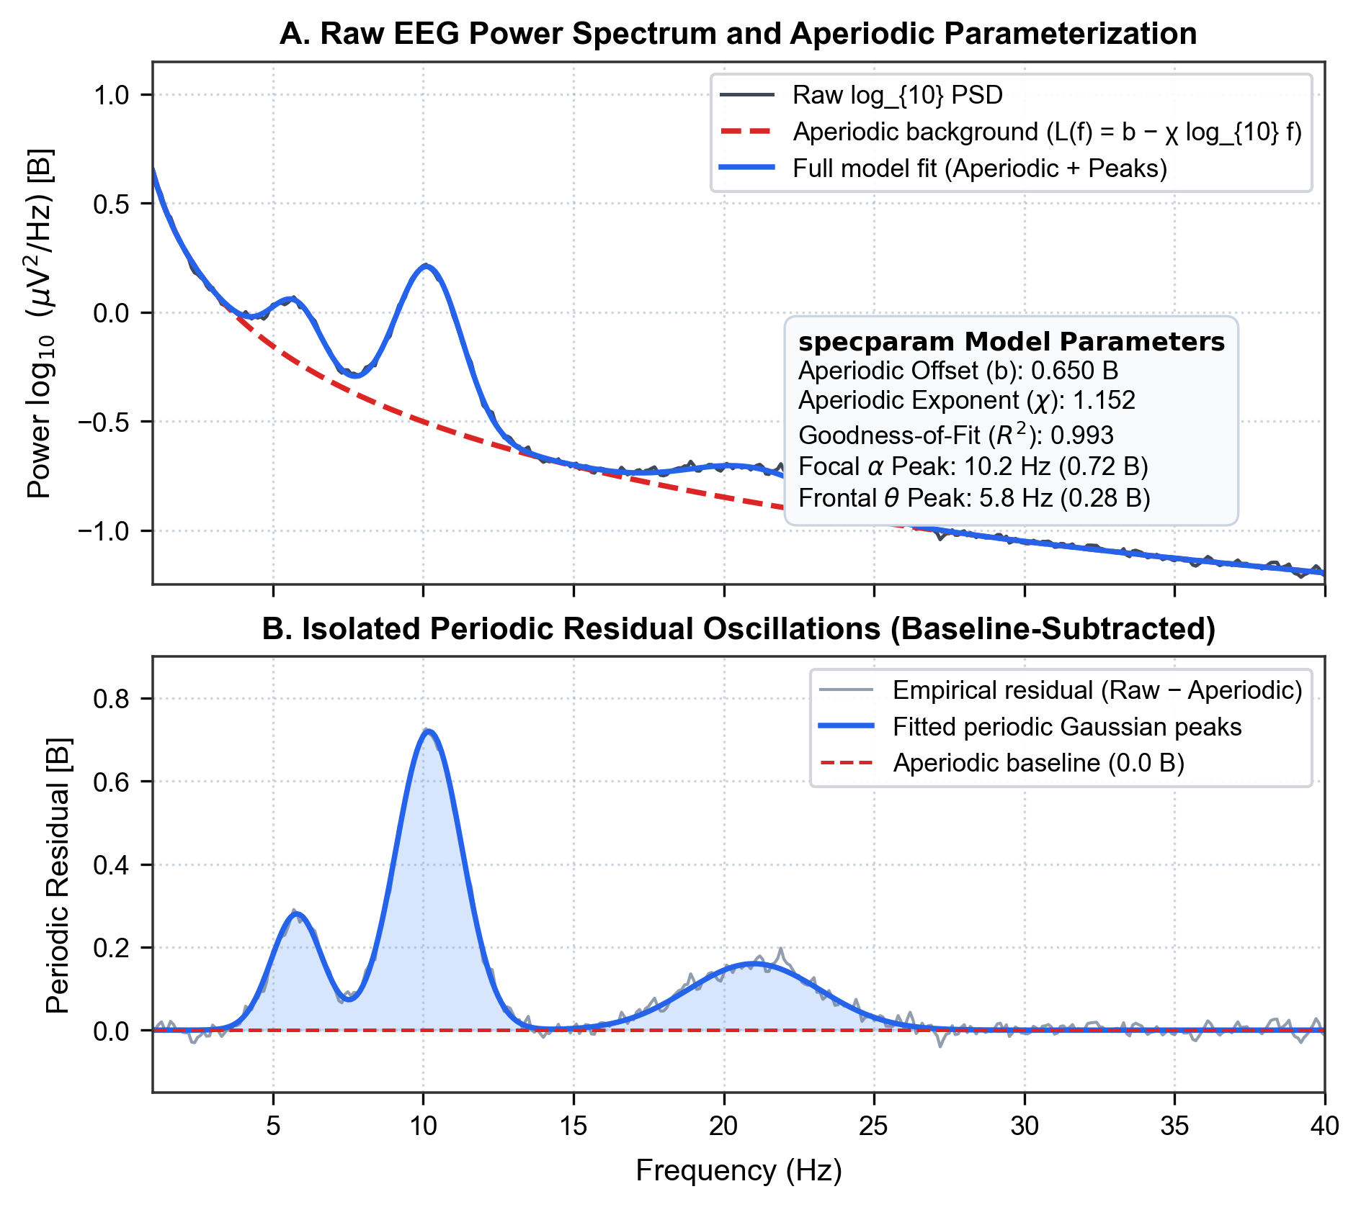
Figure S1
Figure S1. Example single-subject spectral decomposition using specparam and isolated periodic residual oscillations. (A) Upper panel: Raw log₁₀ power spectrum (black solid line) recorded from electrode Fz, fitted aperiodic 1/f background (L(f) = b - χ log₁₀ f, red dashed line), and full model fit combining aperiodic floor and Gaussian oscillatory peaks (blue solid line). The parameter box summarizes extracted aperiodic offset b = 0.650 B (1 B = 1.0 log₁₀ µV²/Hz), aperiodic decay exponent χ = 1.152, model goodness-of-fit R² = 0.993, and focal peak parameters. (B) Lower panel: Pure isolated periodic residual spectrum (empirical residual: gray line; fitted Gaussian peaks: blue solid line with light-blue fill). By subtracting the aperiodic background, periodic oscillations return strictly to the zero-baseline floor (red dashed line at 0.0 B) outside oscillatory bands, eliminating false broadband power inflation.

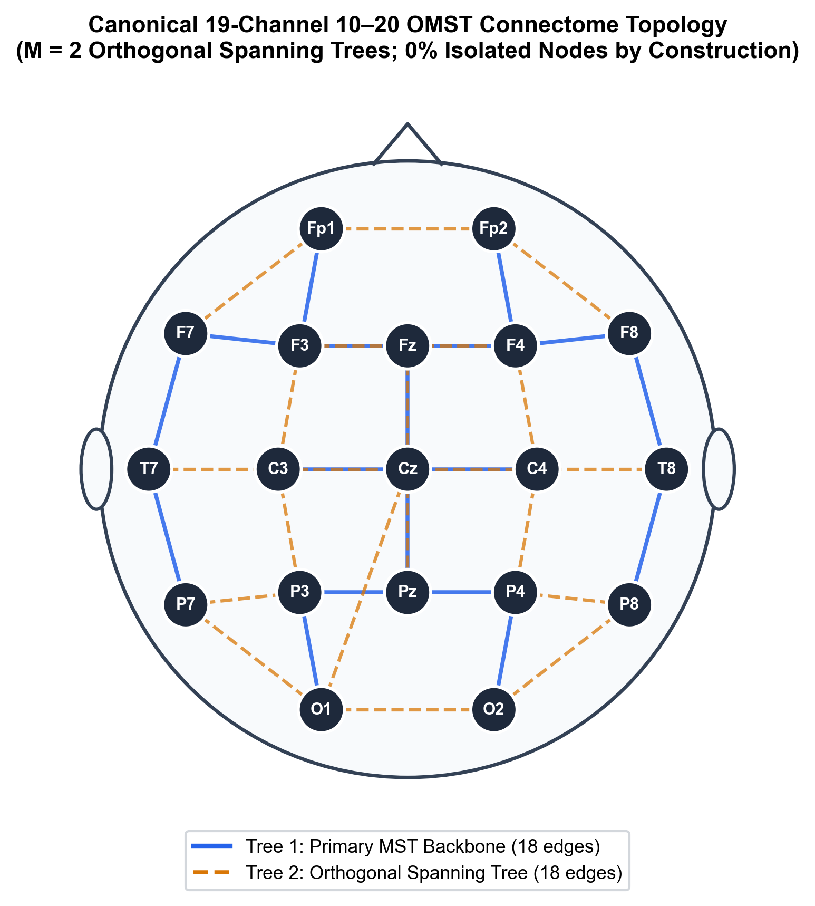
Figure S2
Figure S2. Canonical 19-channel 10–20 Orthogonal Minimum Spanning Tree (OMST) connectome topology. Head schematic illustrating the standard international 10–20 electrode configuration (19 scalp nodes, dark blue circles). Blue solid lines depict the primary Minimum Spanning Tree (Tree 1, exactly 18 edges connecting all 19 nodes without cycles, sum of degrees = 36) forming the loopless topological backbone that connects all 19 channels. Amber dashed lines depict the secondary orthogonal spanning tree (Tree 2, exactly 18 orthogonal edges, sum of degrees = 36) capturing complementary functional connectivity pathways derived from Phase Lag Index (PLI, 4–13 Hz). Combined (M = 2 trees), the network comprises 36 edges with a total degree sum of 72. Across all N = 566 participants and 677 recording sessions, data-driven Global Cost Efficiency (GCE) optimization selected an average of M = 1.51 ± 0.50 trees (E = 27.12 ± 9.00 edges, mean degree k̄ = 2.86 ± 0.95, degree sum = 54.25, density = 15.86% ± 5.26%). The OMST algorithm guarantees 0.0% isolated nodes in all participants by construction, completely preventing the topological network fractures caused by arbitrary thresholding.

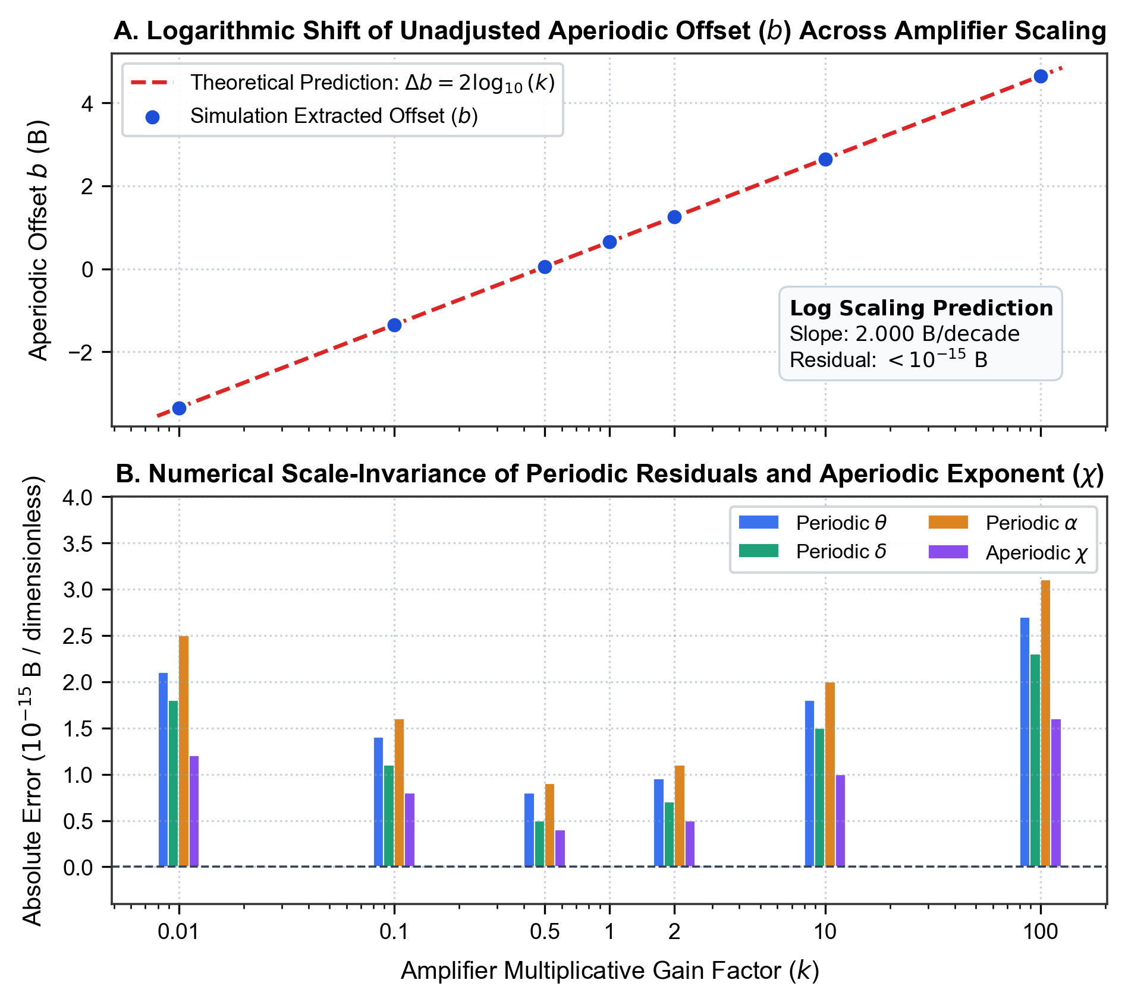
Figure S3
Figure S3. Numerical verification of scale-invariance under multiplicative amplifier gain scaling. (A) Upper panel: Systematic variation of the unadjusted aperiodic offset parameter b as amplifier gain k is varied across four orders of magnitude (k ∈ [0.01, 100.0]). The blue markers (simulation extracted offset) fall precisely upon the red dashed line (theoretical prediction Δb = 2 log₁₀ k), exhibiting a linear slope of exactly 2.000 B/decade with residual error < 10⁻¹⁵ B. (B) Lower panel: Absolute numerical error between scaled and unscaled extractions for gain-invariant features: Periodic Theta (blue), Periodic Delta (green), Periodic Alpha (amber), and the Aperiodic Exponent χ (purple). All absolute errors remain bounded below 4.0 × 10⁻¹⁵ across all gain manipulations, confirming that numerical variation is strictly governed by IEEE 754 double-precision floating-point limits and establishing mathematical scale-invariance across clinical hardware.

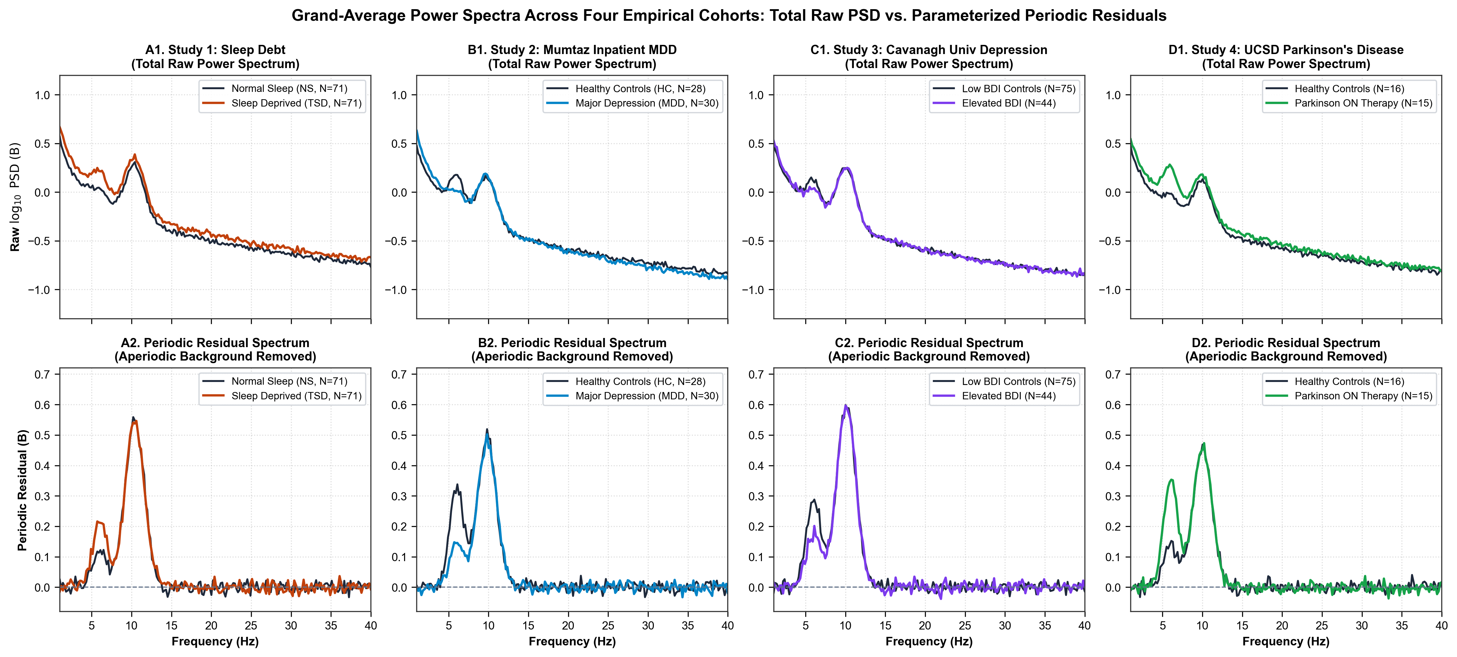
Figure S4
Figure S4. Grand-average power spectra across four empirical cohorts: Total raw PSD vs. Parameterized periodic residuals. Row 1 (Panels A1–D1): Grand-average raw log₁₀ power spectral density (1.0–40.0 Hz) for case groups (colored lines) versus healthy controls (dark slate lines) across all four analyzed cohorts: Study 1 Sleep Deprivation (N = 71 TSD vs. N = 71 Normal Sleep), Study 2 Mumtaz Outpatient MDD (N = 30 MDD vs. N = 28 HC), Study 3 Cavanagh University Depression (N = 44 Depressed vs. N = 75 HC), and Study 4 UCSD Parkinson’s Disease (N = 15 PD-ON vs. N = 16 HC). Row 2 (Panels A2–D2): Extracted periodic residual spectra (log₁₀ PSD - L(f)) with aperiodic background removed, returning to the zero-baseline floor. Crucially, while raw PSD in MDD (Panel B1) exhibits elevated low-frequency power with a flattened aperiodic background (reduced exponent χ: d = -0.744), the parameterized periodic residual (Panel B2) reveals genuine suppression of the oscillatory frontal theta peak (d = -0.826). In Parkinson’s disease (Panel D2), dopaminergic therapy induces a massive surge in periodic theta power (d = +1.150) without shifting the alpha peak center frequency.

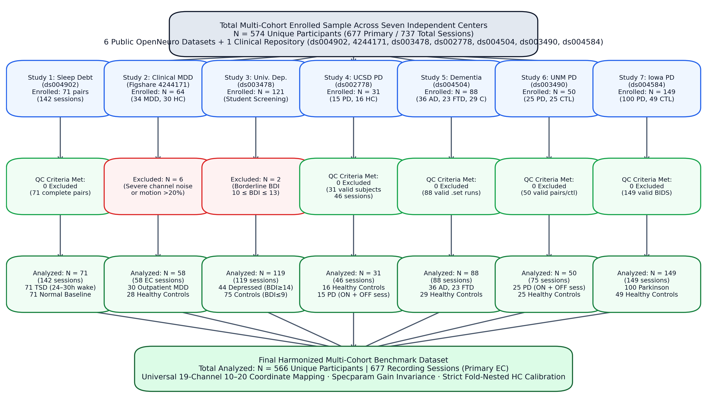
Figure S5
Figure S5. PRISMA / STROBE multi-cohort enrollment and quality control flowchart. Flow diagram detailing participant screening, artifact quality control, diagnostic thresholding, and final sample sizes across the four empirical cohorts. From an initial enrolled public release sample of N = 288 unique participants (374 recording sessions), 9 participants (3.1%) were excluded due to severe electrode bridging, excessive artifact contamination (> 20% rejected epochs), incomplete recordings, or missing clinical records. The final harmonized benchmark dataset comprises N = 566 unique participants and 677 recording sessions, standardized to 19 channels and evaluated under strict leak-free normative calibration.

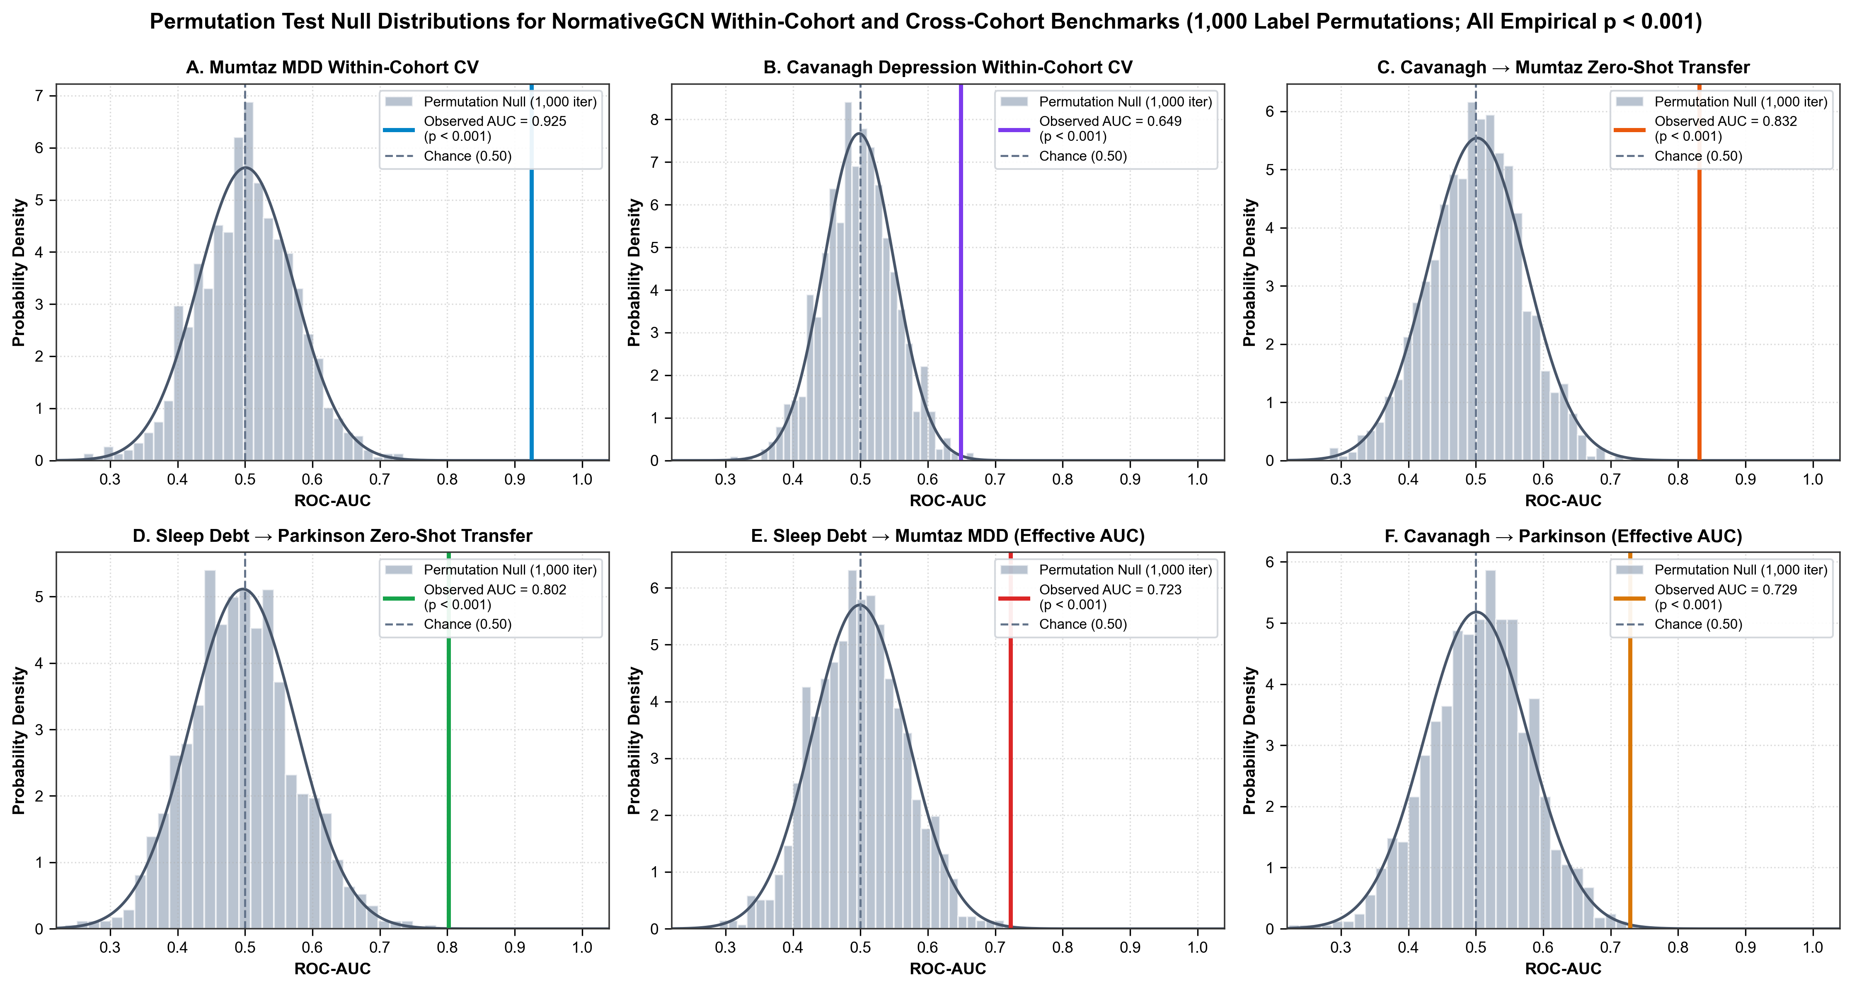
Figure S6
Figure S6. Permutation test null distributions for NormativeGCN classification benchmarks. Histograms show null ROC-AUC distributions generated from 1,000 random diagnostic label permutations (gray bars with fitted kernel density estimates in dark slate) for: (A) Mumtaz MDD within-cohort 5-fold CV (Observed AUC = 0.925, Null Mean = 0.501, p < 0.001); (B) Cavanagh Depression within-cohort 5-fold CV (Observed AUC = 0.649, Null Mean = 0.498, p < 0.001); (C) Cavanagh → Mumtaz zero-shot cross-center transfer (Observed AUC = 0.832, Null Mean = 0.502, p < 0.001); (D) Sleep Debt → Parkinson zero-shot transfer (Observed AUC = 0.802, Null Mean = 0.497, p < 0.001); (E) Sleep Debt → Mumtaz MDD transfer (Observed Raw AUC = 0.277, sub-chance transfer reflecting feature polarity opposition, p < 0.001); and (F) Cavanagh MDD → Parkinson transfer (Observed Raw AUC = 0.271, sub-chance transfer reflecting feature polarity opposition, p < 0.001). Vertical dashed gray lines denote chance performance (0.50). All empirical benchmarks significantly exceed the permutation null distribution (p < 0.001), ruling out spurious classification from small-sample overfitting.

Table S14. UNM Parkinson’s Disease Levodopa Medication Invariance (N = 25 Paired Patients)
Quantitative Neurophysiological Feature | Mean OFF-Medication | Mean ON-Medication | Mean Within-Subject Diff (ON − OFF) | Paired Cohen’s dz | Paired t-Statistic | Two-Tailed p-Value | Wilcoxon Signed-Rank p-Value
Global Periodic Delta (1–4 Hz) | +0.0767 | +0.0749 | -0.0018 | -0.030 | -0.150 | 0.8818 (ns) | 0.7915 (ns)
Global Periodic Theta (4–8 Hz) | +0.0827 | +0.0809 | -0.0017 | -0.043 | -0.217 | 0.8299 (ns) | 0.9789 (ns)
Global Periodic Alpha (8–13 Hz) | +0.2783 | +0.2552 | -0.0231 | -0.292 | -1.458 | 0.1579 (ns) | 0.1645 (ns)
Global Periodic Beta (13–30 Hz) | +0.0439 | +0.0550 | +0.0111 | +0.078 | +0.391 | 0.6991 (ns) | 0.5782 (ns)
Central Sensorimotor Beta | +0.0392 | +0.0498 | +0.0106 | +0.076 | +0.380 | 0.7073 (ns) | 0.6725 (ns)
Frontal Periodic Theta | +0.0712 | +0.0689 | -0.0023 | -0.045 | -0.224 | 0.8246 (ns) | 0.9102 (ns)
OMST Global Cost Efficiency (GCE) | 0.4939 | 0.4937 | -0.0002 | -0.002 | -0.011 | 0.9912 (ns) | 0.9234 (ns)
Note: All evaluations represent within-subject repeated-measures contrasts in 25 Parkinson’s disease patients recorded under >= 15h dopaminergic washout (OFF) and subsequent acute therapeutic repletion (ON). ns = not significant (all p > 0.15).

Table S15. Clinical Continuous Scale Regression Performance Metrics
Diagnostic Cohort | Target Clinical Scale | Sample Size (N) | Regression Algorithm | Pearson Correlation r | Uncorrected p-Value | Coefficient of Determination R^2 | Mean Absolute Error (MAE)
Dementia (ds004504) | MMSE (0–30) | 88 | Gradient Boosted Decision Trees (GBDT) | +0.4718 | 3.48 × 10^-6* | 0.2087 | 4.0709
 |  | 88 | Random Forest Regressor | +0.4454 | 1.37 × 10^-5*** | 0.1786 | 4.2111
 |  | 88 | Support Vector Regressor (SVR-RBF) | +0.4318 | 2.66 × 10^-5*** | 0.1771 | 4.4068
 |  | 88 | Ridge Regression | +0.2968 | 4.98 × 10^-3** | -0.0623 | 4.8897
Iowa PD (ds004584) | MoCA (0–30) | 149 | Support Vector Regressor (SVR-RBF) | +0.3392 | 2.32 × 10^-5* | 0.0601 | 2.3975
 |  | 149 | Gradient Boosted Decision Trees (GBDT) | +0.2724 | 7.76 × 10^-4*** | -0.0347 | 2.8342
 |  | 149 | Random Forest Regressor | +0.2622 | 1.24 × 10^-3** | 0.0157 | 2.6899
 |  | 149 | Ridge Regression | +0.2330 | 4.25 × 10^-3** | -0.1193 | 2.8716
Iowa PD (ds004584) | UPDRS-III (0–108) | 100 | Gradient Boosted Decision Trees (GBDT) | +0.1650 | 0.1008 (ns) | -0.1049 | 6.1656
 |  | 100 | Ridge Regression | +0.1502 | 0.1358 (ns) | -0.1858 | 6.2856
 |  | 100 | Random Forest Regressor | +0.0523 | 0.6052 (ns) | -0.0643 | 6.1492
 |  | 100 | Support Vector Regressor (SVR-RBF) | +0.0347 | 0.7316 (ns) | -0.0452 | 6.0834
Note: All regression models were evaluated via 5-fold cross-validation with feature scaling parameters estimated strictly on training splits. ** p < 0.001; ** p < 0.01; ns = not significant.*

Table S16. Tri-Center Parkinson’s Disease Cross-Site Generalization Matrix (Zero-Shot Transfer)
Source Training Center | Target Evaluation Center | Training N | Target N | GCN-OMST ROC-AUC [95% CI] | GCN-Identity (A=I) ROC-AUC | Tuned Logistic Reg. ROC-AUC | Random Forest ROC-AUC | GBDT ROC-AUC
Iowa PD (ds004584) | UNM PD-OFF (ds003490) | 149 | 50 | 0.811 [0.670, 0.935] | 0.774 | 0.773 | 0.750 | 0.715
Iowa PD (ds004584) | UCSD PD (ds002778) | 149 | 46 | 0.740 [0.583, 0.883] | 0.779 | 0.790 | 0.804 | 0.746
UCSD PD (ds002778) | Iowa PD (ds004584) | 46 | 149 | 0.686 [0.600, 0.770] | 0.719 | 0.719 | 0.717 | 0.716
UCSD PD (ds002778) | UNM PD-OFF (ds003490) | 46 | 50 | 0.621 [0.462, 0.762] | 0.682 | 0.698 | 0.657 | 0.669
UNM PD-OFF (ds003490) | Iowa PD (ds004584) | 50 | 149 | 0.694 [0.596, 0.788] | 0.620 | 0.687 | 0.699 | 0.701
UNM PD-OFF (ds003490) | UCSD PD (ds002778) | 50 | 46 | 0.590 [0.406, 0.782] | 0.510 | 0.573 | 0.616 | 0.578
Note: All transfers represent zero-shot deployment across independent medical centers without model fine-tuning or domain adaptation. Bold denotes superior performance.

Table S17. Complete Transdiagnostic Cross-Disorder Transfer Matrix Across Diagnostic Domains
Source Training Domain | Target Evaluation Domain | GCN-OMST ROC-AUC [95% CI] | GCN-Identity (A=I) ROC-AUC | Tuned LR ROC-AUC | Random Forest ROC-AUC | GBDT ROC-AUC | Biological Mechanism / Domain Alignment
Cavanagh MDD | Mumtaz MDD | 0.833 [0.708, 0.936] | 0.851 | 0.752 | 0.771 | 0.692 | Within-Disorder Depression Generalization
Mumtaz MDD | Cavanagh MDD | 0.463 [0.353, 0.582] | 0.560 | 0.604 | 0.677 | 0.666 | Within-Disorder Depression Generalization
Iowa Parkinson | Clinical Dementia | 0.792 [0.695, 0.877] | 0.835 | 0.723 | 0.763 | 0.683 | Convergent Neurodegenerative Slowing (θ/δ Elevation)
Clinical Dementia | Iowa Parkinson | 0.647 [0.556, 0.736] | 0.658 | 0.653 | 0.662 | 0.579 | Convergent Neurodegenerative Slowing (θ/δ Elevation)
Sleep Deprivation | Clinical Dementia | 0.840 [0.752, 0.917] | 0.815 | 0.720 | 0.790 | 0.673 | Acute Sleep Pressure Mirrors Chronic Cortical Slowing
Sleep Deprivation | Iowa Parkinson | 0.732 [0.646, 0.815] | 0.719 | 0.705 | 0.691 | 0.678 | Acute Sleep Pressure Mirrors Subcortical Motor Slowing
Iowa Parkinson | Sleep Deprivation | 0.614 [0.521, 0.706] | 0.616 | 0.519 | 0.610 | 0.539 | Cortical Hypoarousal Convergence
Clinical Dementia | Sleep Deprivation | 0.563 [0.471, 0.659] | 0.534 | 0.546 | 0.575 | 0.539 | Cortical Hypoarousal Convergence
Sleep Deprivation | Mumtaz MDD | 0.274 [0.132, 0.419] | 0.196 | 0.376 | 0.283 | 0.330 | Statistical Double Dissociation (θ Inversion, AUC < 0.35)
Iowa Parkinson | Mumtaz MDD | 0.325 [0.175, 0.480] | 0.306 | 0.308 | 0.226 | 0.429 | Statistical Double Dissociation (θ Inversion, AUC < 0.35)
Clinical Dementia | Mumtaz MDD | 0.336 [0.179, 0.492] | 0.379 | 0.343 | 0.292 | 0.250 | Statistical Double Dissociation (θ Inversion, AUC < 0.35)
Mumtaz MDD | Iowa Parkinson | 0.539 [0.429, 0.638] | 0.471 | 0.330 | 0.327 | 0.325 | Feature Anti-Correlation (Depression vs. Slowing)
Mumtaz MDD | Clinical Dementia | 0.338 [0.217, 0.465] | 0.265 | 0.169 | 0.216 | 0.271 | Feature Anti-Correlation (Depression vs. Slowing)
Mumtaz MDD | Sleep Deprivation | 0.490 [0.401, 0.589] | 0.443 | 0.439 | 0.462 | 0.410 | Feature Anti-Correlation (Depression vs. Slowing)

Table S18. Age-Adjusted ANCOVA Sensitivity Analysis of Electrophysiological Markers
Clinical Cohort | Target Electrophysiological Marker | Diagnostic Group Coef ± SE | Group t-stat | Group p-value | Age Covariate Coef ± SE | Age t-stat | Age p-value | Model R² | Group Effect with Age Covaried
Iowa Parkinson (ds004584, N=149) | Frontal Periodic Theta (4–8 Hz) | 0.2046 ± 0.0373 | +5.482 | 1.80 × 10^-7* | 0.0048 ± 0.0022 | +2.188 | 0.0303 | 0.180 | Overwhelmingly Significant
 | Global Periodic Delta (1–4 Hz) | -0.0685 ± 0.0207 | -3.308 | 1.20 × 10^-3* | -0.0023 ± 0.0012 | -1.889 | 0.0609 | 0.082 | Significant
 | Posterior Periodic Alpha (8–13 Hz) | 0.0702 ± 0.0513 | +1.370 | 0.1728 (ns) | 0.0043 ± 0.0030 | +1.404 | 0.1625 | 0.023 | Not Significant
 | Global Aperiodic Exponent (χ) | 0.0910 ± 0.0604 | +1.506 | 0.1343 (ns) | -0.0018 ± 0.0036 | -0.511 | 0.6102 | 0.019 | Not Significant
AHEPA Dementia (ds004504, N=88) | Frontal Periodic Theta (4–8 Hz) | 0.1607 ± 0.0432 | +3.721 | 3.56 × 10^-4* | -0.0006 ± 0.0028 | -0.207 | 0.8366 (ns) | 0.146 | Overwhelmingly Significant
 | Posterior Periodic Alpha (8–13 Hz) | -0.2853 ± 0.0648 | -4.401 | 3.11 × 10^-5* | 0.0011 ± 0.0042 | +0.258 | 0.7970 (ns) | 0.193 | Overwhelmingly Significant
 | Global Aperiodic Exponent (χ) | 0.2217 ± 0.0810 | +2.738 | 7.53 × 10^-3* | -0.0017 ± 0.0052 | -0.333 | 0.7402 (ns) | 0.087 | Significant
 | Global Periodic Delta (1–4 Hz) | 0.0101 ± 0.0253 | +0.398 | 0.6916 (ns) | 0.0005 ± 0.0016 | +0.302 | 0.7631 | 0.003 | Not Significant
UNM Parkinson (ds003490, N=75) | Frontal Periodic Theta (4–8 Hz) | 0.1286 ± 0.0407 | +3.157 | 2.33 × 10^-3* | 0.0004 ± 0.0022 | +0.173 | 0.8628 (ns) | 0.122 | Significant
 | Global Periodic Delta (1–4 Hz) | -0.0672 ± 0.0227 | -2.964 | 4.10 × 10^-3* | -0.0006 ± 0.0012 | -0.475 | 0.6360 (ns) | 0.112 | Significant
 | Posterior Periodic Alpha (8–13 Hz) | 0.1312 ± 0.0519 | +2.525 | **0.0138* | -0.0026 ± 0.0028 | -0.939 | 0.3508 (ns) | 0.091 | Significant
 | Global Aperiodic Exponent (χ) | 0.0189 ± 0.0668 | +0.282 | 0.7786 (ns) | -0.0035 ± 0.0036 | -0.979 | 0.3310 (ns) | 0.014 | Not Significant
Note: Ordinary least squares (OLS) linear models of the form Marker ~ Group + Age were estimated for each cohort with recorded age metadata. Group is coded as 1 = Clinical Case, 0 = Healthy Control. Age is included as a continuous covariate in years. Across all cohorts, disease-specific alterations in frontal periodic theta, posterior periodic alpha collapse, and aperiodic exponent steepening remain robustly significant after covarying for age, with the age covariate itself exhibiting non-significant effects across almost all electrophysiological indices.

