**C**ompany **A**sset **M**anagement **S**ystem

Release Notes

Version 1.0.0

© Copyright 2013 ccplusplus or its subsidiaries. All rights reserved. All information contained in this document is confidential and proprietary to Symphony Services, Corporation and may not be disclosed, reproduced, used, modified, made available, used to create derivative works, or transmitted in any form or by any means, electronic, mechanical, photocopying, recording, scanning, or otherwise, by or to any person or entity without the express written authorization of Symphony Services, Corporation. In consideration for receipt of this document, the recipient agrees to treat this document and its contents as confidential and agrees to fully comply with this notice.

This document refers to numerous products by their trade names. In most, if not all, cases their respective companies claim these designations as Trademarks or Registered Trademarks.

This document and the related software described herein are supplied under license agreement or nondisclosure agreement and may be used or copied only in accordance with the terms of such agreement. The information in this document is subject to change without notice and does not represent a commitment on the part of Symphony Services, Corporation. Contact ccplusplus, Customer Support to verify the date of the latest version of this document.

The names of companies and individuals used in the sample database and in examples in the manuals are fictitious and are intended to illustrate the use of the software. Any resemblance to actual companies or individuals, whether past or present, is purely coincidental. ccplusplus, reserves all copyrights, trademarks, patent rights, trade secrets and all other intellectual property rights in this document, its contents and the software described herein.

This edition applies to version 1.0.0 of the licensed program.

# Contacting ccplusplus Customer Support

You can obtain technical support through the ccplusplus Customer Support website or by contacting Customer Support by telephone or e-mail. To service your request better, please read the “Before contacting ccplusplus Support” section in this guide.

Support Website information

Support Website address **:** <http://www.ccplusplus.com/p/about-me.html>

Main product Website address **:** <http://www.ccplusplus.com/>

Support by e-mail

Please send an e-mail to **:** [support@ccplusplus.com](mailto:support@ccplusplus.com?subject=CAMS%201.0.0%20:%20)

Support by phone

## Before Contacting ccplusplus Support

Please gather the following information and have it ready before contacting ccplusplus. This will help us service your request immediately.

- Product information

* Product name
* Product version (Release Number)
* License Number and Password (Trial or Permanent)

- Operating system and environment information

* Machine type
* Operating system type, version, and service pack or other maintenance level such as PUT or PTF
* System hardware configuration
* Serial numbers
* Related software (database, application, and communication) including type, version, and service pack or maintenance level

- Sequence of events leading to the issue

- Commands and options that you used

- Messages received along with the time and date that you received them

* Product error messages
* Messages from the operating system, such as file system full
* Messages from related software

# About the CAMS Release Notes

This release notes provides information about the enhancements, changes made, problems resolved and all the known issues in the ccplusplus Company Asset Management System (CAMS) 1.0.0 release. The information in this document supplements and supersedes information in the product guides.

This section contains the following information:

* *Purpose/Audience* as given on page ii.
* *Common Conventions used* as given on page ii.
* *Organization of this guide* as given on page ii.

## Purpose / Audience

This release notes is intended to help personnel responsible for installing, configuring, administering, and using the CAMS product by providing all the changes, enhancements, and issues addressed in this release.

## Common Conventions Used

This guide uses the following conventions:

|  |  |
| --- | --- |
| Convention Used | Description |
| Words in bold. | Represents words that appear on the product user interface or filenames |
| Words in bold and separated by an angle bracket. E.g. Click **Start** > **All Programs** > **ADAM** | For the sake of brevity, an abbreviated style for menu commands has been used. Click **Start** and then from the submenu that appears, select **All Programs** and then **ADAM**. |
| Italicized words in blue. E.g. *Installing WAM* as given on page 7. | Represent cross references within this guide. Click the cross reference to access the referenced topic |
| Italicized words in black. For more information refer to the Eg. *Symphony Web Access Manager Installation Guide*. | Represent references to other guides in the documentation set provided with this product. |
| Screen shots with curved edges. | Indicate that only a part of the UI is displayed. |

## Organization of this guide

This release notes is organized in a way that will help you easily identify the changes made to the product, and all the current issues with this release.

This release notes is organized into the following sections:

* *Introduction* on page 1. This section provides basic information about CAMS, platforms on which CAMS is supported, and the documentation set provided with CAMS.
* *Release Highlights* on page 5. This section highlights the major changes that are addressed by this release and gives you an overview of how these changes will affect your enterprise.
* *Enhancements / Changes* on page 7. This section provides information about all the enhancements and changes made to CAMS.
* *Defects Fixed* on page 10. This section provides information about all the defects that have been fixed in this release of CAMS.
* *Known Issues, on page 12*. This section provides information about all the known issues with this release of CAMS.

# Introduction

This introductory chapter provides an overview of the Symphony Web Enforcement Agent (WEA), along with the hardware, software required for using it and the platforms on which it is supported.

This section contains the following information:

* *About CAMS* as given on page 2.
* *CAMS Supported Platforms* as given on page 2.
* *CAMS Documentation Set* as given on page 4.

## About CAMS

CAMS is a general purpose Asset tracking product suite that is designed to use at each of the business and personal end. CAMS is a fully functional multi database supported product working on various platform considering the requirement and easiness at each end whether it is business and personal need. CAMS can be used at various level of requirements. At business level it can track all the assets that are being used in your organization which can start from a small pencil to big end hardware and software’s used and running. At the personal and end users level CAMS can be used to manage all the general purpose assets used in house for an example keeping the track of your purchase on the food items. CAMS will intelligently tell you how much your monthly use on a particular item is.

## CAMS Supported Platform

CAMS is supported on mostly all kind of the platform that a business user can use or a personal user will use. CAMS can be easily installed and configured on any personal computer and a server. Below are the supported product where CAMS can be used.

|  |  |  |  |  |  |  |  |  |
| --- | --- | --- | --- | --- | --- | --- | --- | --- |
| **CAMS Version** | **Windows 2003**  **(32 / 64 bit)** | **Windows 2008**  **(32/64 bit)** | **Windows XP  (32/64 bit)** | **Windows 7**  **(32/64 bit)** | **Windows 8**  **(32/64 bit)** | **Red Hat Enterprise Linux Server** | **Ubuntu** | **Solaris** |
| 1.0.0 | √ | √ | √ | √ |  | √ | √ | √ |
|  |  |  |  |  |  |  |  |  |
|  |  |  |  |  |  |  |  |  |
|  |  |  |  |  |  |  |  |  |

Note:

Before opting for a particular platform verify the supported database and requirement. Version specific details can found in the coming sections.

## CAMS Documentation Set

|  |  |
| --- | --- |
| **Document** | **Description** |
| ccplusplus Company Asset management System Release Notes  (CAMS – 1.0.0 Release Notes.pdf) | Provides information about the enhancements, changes made, problems resolved and all the known issues in this release of the CAMS. |
| ccplusplus Company Asset management System Installation Guide  (CAMS – 1.0.0 Installation Guide.pdf) | Provides information about all the requirements to be satisfied before installing the WEA, instructions to install the WEA and all configurations that must be done after installing the CAMS. |
| ccplusplus Company Asset management System User Configuration Wizard  (CAMS – 1.0.0 Configuration Wizard User Guide.pdf) | Provides information about configuring the CAMS, using the ccplusplus Configuration Wizard. |
| ccplusplus Company Asset management System Administrator  (CAMS – 1.0.0 Administrator Guide.pdf) | Provides information on how to use the CAMS features and the methods used to manage the asset items. |

# Analysis of the current system

If we look today at any level of the information flow we will see that computers have made a significantly large progress in performing a task from simplest to complex level. At each level we are related to many other existing systems and objects around us. Now it depends upon the complexity and the need of the objects at a particular level the system may require a different level of object management and its maintenance. With a object and system we mean actually is a group of related or unrelated items that are in use with a particular working entity called as a system. A system may be any of the hardware, software or any other know item that we are using or in the effect of that. For an example a printer may be considered as a system where as a paper sheet can be consider as an object. It depends and differs from person to person that object and system may be a very simple and complex.

Having now the knowledge of system and object me can now see how we are managing the our objects and systems,

1. **Dedicated software system:**

This is a most advance and common way of managing the objects in a system. It comes with a bundle of software that needs to be installed in a computer. They are especially dedicated to manage a group of objects based for a particular system. Using this method it is very easy and fast to manage the items that we want to. Usually to run this kind of software we need to have to install and configure the software. Usually this is complex job and required and administrative job. Once configured they can be made to run for a long time.

1. **Manual working system:**

This method of management is old traditional way of working.

# Advantages / Disadvantages of the current system

# Coming Over to the current system

# Introducing - Company Asset Management System (CAMS)

The aim to design CAMS is to overcome with the existing asset management systems. CAMS aim to provide a simple & cleaner solution. CAMS aim to provide below silent features,

* Simple in design.
* Easy to use.
* Generic Asset Management.
* Platform independent.
* Manageable by each End users / Business users.
* Easily affordable by most of business / personal need.

Let us start and see each of the features of the CAMS that we have seen in short.

Simple in Design:

CAMS is very simple and stable in its design. It is designed to make it as simple as much as possible. The design is aimed to handle it by each of the users who may a regular user for managing any particular system or an administrator level person managing a group of complex system. CAMS has a simple user interface and a simple database for storing all the local objects and system details under observation. The Graphics User Interface (GUI) designed can be used by any user who is very less friendly very using a graphics system and for a business user who is much expert in using such GUI. CAMS also provide a Command Line (CLI) Option for users who are not much interested in using Graphics System. Basically this is designed for the users who are much habitual with using Linux based system. This is very fast and time effective based.

CAMS also provide choice among the database that we can use to store for our management items. For a simplest case it can use a simple file for example an XML file to store and maintain its operation. This is the case that is used when requirement is very simple and less complex. This is ideally can be used for home purpose and usage.

CAMS also support popular databases like MySQL and Microsoft SQL Server. Coming version will be supporting more databases too.

Coming sections will show a clear steps and visualization in using CAMS.

Easy to Use:

CAMS has a very less configuration as mandatory to work on. A few of the minor configuration that can easily be done if required for a customization. By default CAMS is designed to work intelligently without requiring much attention. Within few minutes of triggering the CAMS instance it makes it-self ready according to the environment and starts working easily. It is designed to run until it is been shutdown manually. Most of the user component can be easily understood by seeing the GUI and its text. Beside that a complete user admin guide is available that can be referred for any difficulty.

CAMS has been intelligently written to retrieve the most required parameters from the system itself. Only a few parameters need to be added.

Generic Asset management:

In comparison to the other Asset management Products, CAMS is designed to handle most of the general objects and system. Since it is working based on the Unique Identification System (UIS) it needs a general entry when adding any system and its object. Actually CAMS has a both option available. It has a predefined most popular assets based on the personal and business needs. Before we start CAMS it can be configured in the configuration files. CAMS can also be fully customized for a particular asset item for a business need.

Manageable by each End users / Business users:

From the simplicity and the easy design CAMS can be used by any of the user who has a basic understanding of using a Computer System. CAMS has two edition

* Enterprise User Level.
* Personal user Level.

For each of the category CAMS has unique features. For example an Enterprise user has a separate system called as Hardware and Software has been added under which various objects like computer parts, stationary items has been added. If we take Personal user generic asset management functionality has been given. A user can add the as many system as possible for his management.

Easily affordable by most of business / personal need:

The best feature of the CAMS is that it is very cheap and affordable. CAMS uses module and component based on the editions. At personal level it very cheap and can be easily opted. The basic version of both the edition is ready to use with a minimal fixed price. There are numerous features designed that can be added as required by the users. They additionally cost very less.

Brief pricing details can be found separately with our sales team. Please see the “Contacting ccplusplus Customer Support”.

# Getting Inside CAMS

This section covers detailed information about the CAMS and is feature. A brief discussion over the technical feature in design will also be discussed. Later on we will see the features of both the version of the CAMS i.e. Enterprise and Personal Edition. Below are the headed items that we will discuss,

* **Design Overview**.
* **CAMS Personal Edition**.
* **CAMS Enterprise Edition**.

Let us start and get inside the CAMS in details as below.

## Design Overview

Having all the details we will explore CAMS in this section. Before we go in details first look at the high level architecture of the CAMS we can look on figure 1.0 below. This architecture explains the both the enterprise and personal edition of the CAMS.

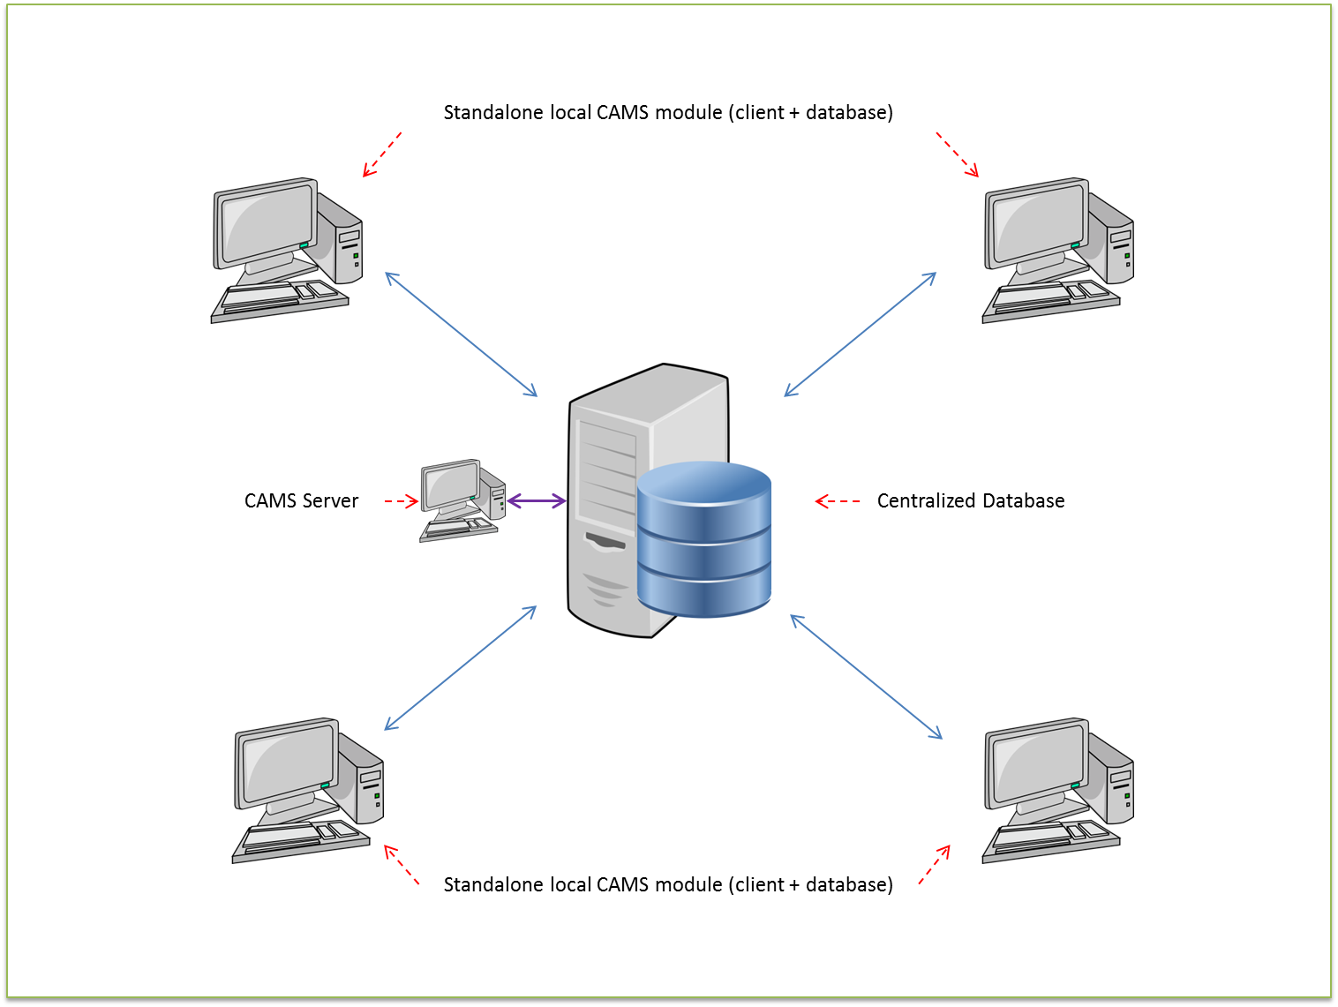

**Figure 1.0**

This is a standard design diagram with the core functionality. We haven’t shown any of the features like Graphical User Interface, CAMS code engine etc. We will see them in the technical design document in details.

If we look the above figure, as a standard we have two separate working entities,

* **CAMS Server Module.**
* **CAMS Client Module.**

Server Module is a centralized server that aims to provide a global consistency and data storage system. This server contains a user selected database and server application running. CAMS is designed to run 24*7 without any interruption as a always online system. It always receives and stores data from all the working client entities. Another feature of this server is that it can also be used as a standalone application to monitor and manage the assets in a system. A few of the server module feature are as below,

* Centralized database application.
* Does an online monitoring of all the clients attached.
* Works as a dedicated and standalone module.
* Runs the GUI application.
* Secure connection from client to server CLI/Terminal.

Another module is CAMS client application. This is also a standalone application that manages a separate level of system management and stores information locally or can store on the server also. In ideal condition we prefer to store on server as it causes a consistent and unique report for all the clients running. This client application is ideally best suited for Personal Level of asset management. A few of the client features are,

* Standalone application for a sub level.
* Secure connection on using Linux Terminal and Windows CLI prompt.
* Standalone database / Centralized databases.
* Sleep / hibernate / Shut down mode.
* Graphical User Interface option available.

We have seen the individual features of the Server and Client module. They are not just the limited of them but are the feature that make the CAMS a very unique and durable in terms of security and failure. We will discuss all of them in details soon in the technical document. If we combine and add it to the features of the CAMS we will get a summary as below,

1. Dedicated Server application that can work on Intranet/Internet gateway.
2. Secure data transfer between server and client in a secure tunnel gateway.
3. 24*7 standalone server/client application combination.
4. Works on both the Windows and Linux platform e.g. Red Hat Linux, Ubuntu, Windows Server etc.
5. Graphics User interface for all kind of supported operation.
6. Command Line Interface (CLI) support for all kind of supported operation.
7. Intermediate security layer option available in between the database and the GUI application.

Above are a few of features that are unique and very important in both the Enterprise and Personal level of management. CAMS use 128 bit secure encryption to transfer the data between the server and client. It uses OpenSSL application programming interface (api) to secure the data communication. A detailed picture of the secure communication between a client and server using OpenSSL library is shown below in figure 1.1,

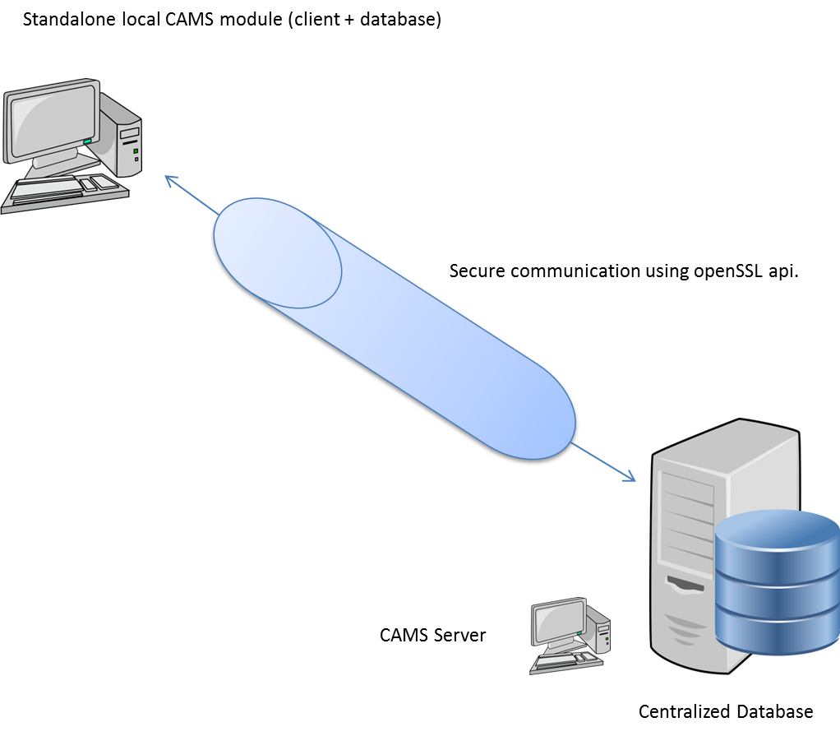

**Figure 1.1**

For a CAMS Personal Edition this feature is not required as we are only concerned about security when it comes to data transfer over a network and this is the case with Enterprise edition.

## CAMS Personal Edition

This edition has especially been designed by scoping below users,