|  |
| --- |
| METU INFORMATICS INSTITUTE |
| OLEMS: OnLine Exam Management System |
| Software Project Management Plan |
| **v.2.0**  **(SPMP_IS502_200802_G4_V_2_00)**  by |
| **Group 4** |
| **15/4/2009** |

|  |
| --- |
|  |

IS 502 INFORMATION SYSTEMS PROJECT

Spring 2009

# ****Signatures****

|  |  |  |
| --- | --- | --- |
| **Name/Role** | **Date** | **Signature** |
| **Assoc. Prof. Dr. Onur Demirörs** |  |  |
| **Acquirer** |
| **Banu Aysolmaz Bozlu** |  |  |
| **Acquirer Asst.** |
| **Betül Aygün** |  |  |
| **Review Team Member** |
| **Duygu Fındık** |  |  |
| **Review Team Member** |
| **Emre Sezgin** |  |  |
| **Review Team Member** |
| **Muammer Özge Kaya** |  |  |
| **Review Team Member** |

# ****Change History****

|  |  |  |
| --- | --- | --- |
| Project Name | : | OLEMS |
| Version Number | : | 2.0 |
| Document Reference | : | SPMP_IS502_200802_G4_V_2_00 |
| Date of Release | : | 15/4/2009 |

## ****Document Change Record****

|  |  |  |
| --- | --- | --- |
| **Page** | **Section** | **Reason for change** |
| various | various | Review report (see Review Report dated 10/4/2009) |

## Document Version History

|  |  |  |
| --- | --- | --- |
| **Version** | **Date of Release** | **Reason for change** |
| 0 | 28/3/2009 | Milestone start |
| 1.0 | 8/4/2009 | v.1.0 Release |
| 2.0 | 15/4/2009 | v.2.0 Release |

# Preface

A software project management plan is a document which describes the summary and the organization of the project; as well as the different plans for the project. This document describes the managerial process plans; the technical process plans and the supporting process plans for project OLEMS. This document is based on the IEEE Std 1058-1998, IEEE Standard for Software Project Management Plans.

# Table of Contents

Signatures ii

Change History iii

Document Change Record iii

Document Version History iii

Preface iv

Table of Contents v

List of Figures viii

List of Tables ix

1 Overview 1

1.1 Project summary 1

1.1.1 Purpose, scope, and objectives 1

1.1.2 Assumptions and constraints 1

1.1.3 Project deliverables 2

1.1.4 Schedule and budget summary 2

1.2 Evolution of the SPMP 3

2 References 4

3 Definitions 5

4 Project organization 7

4.1 External interfaces 7

4.1.1 Acquirer 7

4.1.2 Quality assurance group 7

4.1.3 End users 7

4.2 Internal structure 8

4.3 Roles and responsibilities 8

5 Managerial process plans 11

5.1 Project start-up plan 11

5.1.1 Estimation plan 11

5.1.2 Staffing plan 15

5.1.3 Resource acquisition plan 16

5.1.4 Project staff training plan 16

5.2 Work plan 16

5.2.1 Work activities 16

5.2.2 Schedule allocation 25

5.2.3 Resource allocation 25

5.2.4 Budget allocation 26

5.3 Control plan 27

5.3.1 Requirements control plan 27

5.3.2 Schedule control plan 28

5.3.3 Budget control plan 29

5.3.4 Quality control plan 30

5.3.5 Reporting plan 30

5.3.6 Metrics collection plan 33

5.4 Risk management plan 35

5.4.1 RISK-1 35

5.4.2 RISK-2 35

5.4.3 RISK-3 35

5.4.4 RISK-4 35

5.4.5 RISK-5 36

5.5 Project closeout plan 36

5.5.1 Turnover Project Deliverables 36

5.5.2 Redistributing Resources 36

5.5.3 Closing out financial accounts 36

5.5.4 Completing, collecting, and archiving project records 36

5.5.5 Documenting the successes of the project 37

5.5.6 Documenting lessons learned 37

5.5.7 Writing Project Closeout Report 38

6 Technical process plans 39

6.1 Process model 39

6.2 Methods, tools, and techniques 40

6.3 Infrastructure plan 40

6.3.1 Development Environment Planning 40

6.3.2 Policies Planning 40

6.3.3 Standards Planning 41

6.4 Product acceptance plan 41

7 Supporting process plans 43

7.1 Configuration management plan 43

7.1.1 Internal Change Requests 43

7.1.2 External Change Requests 43

7.1.3 Common Features of Internal and External Change Requests 43

7.1.4 Life Cycle of a Change Request 44

7.2 Verification and validation plan 45

7.3 Documentation plan 45

7.4 Quality assurance plan 45

7.5 Reviews and audits plan 45

7.6 Problem resolution plan 46

7.7 Subcontractor management plans 46

7.8 Process improvement plan 46

8 Additional plans 47

Annexes 48

Annex A. Project Summary 49

Annex B. Legend for Schedule 50

Annex C. Schedule Summary 51

Annex D. Change Report 55

Annex E. Weekly Project Time Billing 57

Annex F. WBS Dictionary 58

Annex G. Project Schedule 90

Annex H. Weekly Resource Usage 99

Annex I. Resource Allocation by Task 106

Annex J. Budget Report (by Cost) 115

Annex K. Budget Report (by Task) 123

Annex L. Budget Report (by Cost, excluding Summary Tasks) 131

Annex M. Budget Report (by Task, excluding Summary Tasks) 138

Annex N. Completed Tasks Report 145

Annex O. MKII Function Point Calculation 148

Index 158

# List of Figures

Figure 4‑1 OLEMS Project Environment 7

Figure 4‑2 Internal organization of OLEMS 8

Figure 6‑1 Waterfall model (Royce 1970) 39

Figure 7‑1 Life cycle of a change request 44

# List of Tables

Table 1‑1 Project Deliverables 2

Table 4‑1 Roles and related Responsibilities in OLEMS 10

Table 4‑2 Roles and Responsible for OLEMS 10

Table 5‑1 Degree of Influence scales 12

Table 5‑2 Technical Complexity Adjustment 13

Table 5‑3 AFPI Calculation steps 13

Table 5‑4 Effort Schedule (staff-months) 14

Table 5‑5 Adjusted Effort Schedule (staff-months) 14

Table 5‑6 Cost Schedule 15

Table 5‑7 Project Team Members 16

Table 5‑8 Training Sessions on Standards 16

Table 5‑9 First level definitions of WBS 17

Table 5‑10 Software Requirements Analysis level definitions of WBS 19

Table 5‑11 Project Planning level definitions of WBS 20

Table 5‑12 Software Detailed Design level definitions of WBS 22

Table 5‑13 Software Implementation level definitions of WBS 22

Table 5‑14 Software Integration level definitions of WBS 23

Table 5‑15 Software System Testing level definitions of WBS 24

Table 5‑16 Documentation level definitions of WBS 24

Table 5‑17 Software Acceptance level definitions of WBS 24

Table 5‑18 Hardware Resources 25

Table 5‑19 Software Resources 26

Table 5‑20 Budget 26

Table 5‑21 Utilization 27

Table 5‑22 Reporting Plan 32

Table 5‑23 Metrics Collection Plan 34

Table 6‑1 Standards to apply 41

Table 6‑2 Product Acceptance Plan 42

Table 7‑1 Review Plan 46

# Overview

This first three sections of this software project management plan (hereafter referred to as the SPMP) are an introduction to the OnLine Exam Management System project (hereafter referred to as OLEMS), outlining the goals and results of the project with references and definitions of this SPMP. Remaining sections and annexes present the details of the project. Annexes are a part of this document.

## Project summary

### Purpose, scope, and objectives

The goal of this project is to produce an online exam management system that shall be used to enter questions to the system, to create exams, and to take tests.

OLEMS will be developed to manage questions, exams, students, and results; and to execute exams in one term for the IS100 course.

OLEMS is proposed as a web-based application which will be used by course management staff and students to manage questions, exams, student information, and to execute exams for the course. The intended course for the project is the IS100 course.

OLEMS project objectives are provided in SRS (1) section 1.2.

### Assumptions and constraints

This document is based on the IEEE Std 1058-1998, IEEE Standard for Software Project Management Plans (2).

Product related assumptions and constraints shall be determined by the software requirements specification (hereafter referred to as SRS) (1) of OLEMS.

Project’s staff is limited by software development group only. Because of this limitation, a staff has more than one role in the project.

Maintenance of the product is out of the scope of the project.

Members of the project team are considered to be working for 3 hrs per day on average (see section ). Working days are all the days of the week.

The tasks of the project can be split in order to prioritize between the concurrent tasks assigned to a resource.

There are no financial transactions between the acquirer and the project team.

### Project deliverables

The project shall produce an online exam management system that is used to enter questions to the system, to create exams, and to take tests by IS100 staff.

Work products listed in will be delivered throughout the project.

| **Work Product** | **Delivery Date& Time** | | **Delivery Location** | **Quantity** | **Delivery Media** |
| --- | --- | --- | --- | --- | --- |
| SRS | 18/3/2009 | 9:00 | IS502 System | 1 | .docx, .doc, .pdf files |
| Updated SRS | 25/3/2009 | 23:59 | METU Online | 1 | .pdf file |
| SPMP | 8/4/2009 | 9:00 | METU Online | 1 | .docx, .pdf files |
| 10/4/2009 | 9:40 | METU II Z03 | 1 | Printed |
| Updated SPMP | 15/4/2009 | 23:59 | METU Online | 1 | .pdf file |
| SDD | 6/5/2009 | 9:00 | METU Online | 1 | .docx, .pdf file |
| 8/5/2009 | 9:40 | METU II Z03 | 1 | Printed |
| Updated SDD | 13/5/2009 | 23:59 | METU Online | 1 | .pdf file |
| Final Product, Updated SRS, Updated SPMP, Updated SDD | 12/6/2009 | 10:00 | METU II | 1 | CD |

Table 1‑1 Project Deliverables

Project deliverable deadlines shall follow the project schedule web page (3).

### Schedule and budget summary

The project started at 20/2/2009 and ends at 12/6/2009. Project milestones are determined in the project schedule web page (3) which is maintained by the acquirer. Throughout the project, Software Requirements Analysis, Project Planning, Software Detailed Design, Software Implementation, Software Integration, Software System Testing, Documentation, Software Acceptance and Project closeout steps will be followed.

The summary of the OLEMS project schedule is given in which should be read using the legend reference in .

The project group (hereafter referred to as OLEMS Team) consists of 5 members (see section ) who are all graduate students of Information Systems (hereafter referred to as IS) department at the Informatics Institute (hereafter referred to as II) of the Middle East Technical University (hereafter referred to as METU). The project is meant as the project for the Information Systems Project (hereafter referred to as IS502) course given at IS department. The total budget for OLEMS is expressed in the number of available man-hours. In total, 1,680 man-hours are available which represents a total cost of 50,400TL over an hourly normal rate of 30TL/man-hour (see section ).

## Evolution of the SPMP

This SPMP is under version control. Releases shall be presented by integer version numbers and shall be used by all members of the project environment (see section ).

All versions between integer versions of the document are promotions and shall be used by members of the OLEMS Team (see section ).

This document is structured with a change history page (page ) that shall include the project name, version number of the plan, date of release, a list of pages that have been changed in the current version of the plan, a brief statement describing the nature of changes incorporated into this version of the plan, and a list of version numbers and dates of release of all previous versions of the plan.

# References

1. **ALAŞEHİR, Oğuzhan, et al.** *OLEMS: OnLine Exam Management System Software Requirements Specifications v.2.0.* March 25, 2009.

2. **IEEE.** IEEE Std 1058-1998, IEEE Standard for Software Project Management Plans. *IEEE Xplore.* [Online] December 8, 1998. [Cited: March 3, 2009.] IEEE Std 1058-1998.

3. **METU IS502.** 2009 Milestones. *IS 502 Information Systems Project.* [Online] Spring 2009. [Cited: May 3, 2009.] http://www.ii.metu.edu.tr/~is502/is502_schedule.html.

4. **United Kingdom Software Metrics Association (UKSMA) Metrics Practices Committee.** *MK II Function Point Analysis Counting Practices Manual, Version 1.3.1.* Kent : United Kingdom Software Metrics Association, September 1998. Mk II FPA.

5. **Mayes Consulting, LLC.** Source Lines of Code (SLOC) per Function Point Gearing Factors - Industry Averages, April 2005. *Software Estimation Metrics.* [Online] April 2005. http://softwareestimator.com/IndustryData2.htm.

6. **METU IS502.** Project Description Document. *IS 502 Information Systems Project.* [Online] February 26, Spring 2009. [Cited: March 3, 2009.] http://www.ii.metu.edu.tr/~is502/502_Project_Description.doc.

7. —. Review Template. *IS 502 Information Systems Project.* [Online] March 18, Spring 2009. http://www.ii.metu.edu.tr/~is502/Review_Template_Spring2009.doc.

8. **IEEE.** IEEE Std 830-1998, IEEE Recommended Practice for Software Requirements Specifications. *IEEE Xplore.* [Online] Oct 20, 1998. [Cited: March 3, 2009.] http://ieeexplore.ieee.org/stamp/stamp.jsp?arnumber=720574&isnumber=15571. IEEE Std 830-1998.

9. —. IEEE Std 1016-1998, IEEE Recommended Practice for Software Design Descriptions. *IEEE Xplore.* [Online] September 23, 1998. [Cited: March 3, 2009.] IEEE Std 1016-1998.

10. FAGHIH, Farshad. Software Effort and Schedule Estimation. [Online] —.[Cited: April 13, 2009.] http://enel.ucalgary.ca/People/Smith/619.94/prev689/1997.94/reports/farshad.htm.

# Definitions

In this paragraph all abbreviations used in this document are described.

|  |  |
| --- | --- |
| AFPI | Adjusted Function Point Index |
| CM | Configuration Manager |
| COCOMO | Constructive Cost Model |
| CR | Change Request |
| CR | Change Report |
| CRF | Change Request Form |
| DBA | Database Administrator |
| DET | Data Element Type |
| DV | Developer |
| FPA | Function Point Analysis |
| FPI | Function Point Index |
| FRQ | Free Response Question |
| II | (METU) Informatics Institute |
| IS 502 System | Web site located at http://144.122.98.55/is502b/index.aspx |
| IS502 | Course code for Information Systems Project |
| KLOC | Kilo Line of Code |
| LOC | Line of Code |
| MCQ | Multiple Choice Question |
| METU | Middle East Technical University |
| METU Online | Web site located at https://online.metu.edu.tr/netclassR/ |
| MSN | A software product which allows users to communicate over the Internet |
| MTCQ | Matching Choice Question |
| OLEMS | OnLine Exam Management System (abbreviated name of this project) |
| OLEMS Team | Group 4 of IS502 course responsible for carrying out the project |
| PM | Project manager |
| QA | Quality Assurance |
| QAG | Quality assurance group (see section 4.1.2 Quality assurance group) |
| QB | Question Bank |
| QC | Quality Control |
| RM | Risk Manager |
| SA | System Analyst |
| SCM | Software configuration management |
| SD | System Designer |
| SDD | Software design description |
| Skype | A software product which allows users to make telephone calls over the Internet |
| SPMP | Software project management plan |
| SQAP | Software quality assurance plan |
| SQAR | Software Quality Assurance Representative |
| SRS | Software requirements specification |
| TCA | Technical Complexity Adjustment |
| TDEV | Time to Develop |
| TDI | Total Degree of Influence |
| TFQ | True/False Question |
| TS | Tester |
| UKSMA | United Kingdom Software Metrics Association |
| WBS | Work Breakdown Structure |

# Project organization



Figure ‑ OLEMS Project Environment

## External interfaces

The environment in which OLEMS project operates is given in . The project environment shall contain interfaces with the following external groups or persons:

### Acquirer

Acquirer of OLEMS is Assoc. Prof. Dr. Onur Demirörs and his assistant Banu Aysolmaz Bozlu.

### Quality assurance group

Quality assurance group (QAG) assigned by the acquirer shall be the members of Group 3 of IS502, consisting of Betül AYGÜN, Duygu FINDIK, Emre SEZGİN, and Muammer Özge KAYA. Each of the group members will have a Software Quality Assurance Auditor role within QAG and they will review the SRS, SPMP and SDD documents.

### End users

These will be the users defined by types in section 2.3 of SRS which are namely Question Developer, Exam Creator, Instructor, Student and Admin users of OLEMS.

## Internal structure



Figure ‑ Internal organization of OLEMS

The internal structure of OLEMS project is given in . Roles and responsible of the specified roles are defined in section .

## Roles and responsibilities

| Role (abbreviation) | Responsibilities |
| --- | --- |
| Project Manager (PM) | * Manage the project. * Accomplish the project objectives within the constraints of the project. * Control and monitor project scope, time, cost and quality in managing competing project requirements. * Prepare project charter and SPMP. * Collect metrics data and reports on project progress. * Establish project budget and schedule. * Schedule milestone progress review meetings. |
| Configuration Manager (CM) | * Identify the configuration items. * Create baselines through out the OLEMS. * Develop Software Configuration Management Plan for the OLEMS. * Responsible from integration and deployment planning. * Develop technical manual of OLEMS. |
| Software Quality Assurance Representative (SQAR) | * Responsible for quality activities through out OLEMS. * Develop software quality assurance plan (SQAP) for OLEMS. * Responsible for planning tests together with PM. * Responsible for metrics validation of OLEMS. |
| System Analyst (SA) | * Analyze customer requirements. * Develop software requirements. * Develop user’s guide and end user training material. |
| System Designer (SD) | * Responsible for design activities. * Establish software design description (SDD) document. * Supports CM to develop technical manual. |
| Developer (DV) | * Responsible for coding, unit testing, integration testing and documentation. |
| Tester (TS) | * Responsible for system and acceptance test activities of OLEMS. |
| Database Administrator (DBA) | * Responsible for database design activities. * Maintain database in development and test environment. |
| Software Quality Assurance Auditor (SQAA) | * Evaluate SQAR activities to ensure that all SQA activities are completely and correctly performed. |
| Risk Manager (RM) | * Identify, monitor and respond to risk. * Prepare risk management plan and resolve non-compliance issues. |
| Web Administrator (WBA) | * Develops the logical and physical structure of the overall solution and its components. * Performs deployment and installation of middleware. * Performs SMTP management. |

Table 4‑1 Roles and related Responsibilities in OLEMS

|  |  |
| --- | --- |
| Responsible | Role(s) |
| Oğuzhan ALAŞEHİR | DV, SA, SD, CM, TS |
| Gonca Hülya DOĞAN | DV, SA, SD, SQAR |
| Eda ERCAN | DV, SA, SD, TS, WBA |
| Hale ERDEM | DV, SA, SD, PM, RM |
| Tufan KAYNAK | DBA, DV, SA, SD |
| QAG Members | SQAA |

Table 4‑2 Roles and Responsible for OLEMS

# Managerial process plans

## Project start-up plan

### Estimation plan

#### Size Estimation

MK II Function Point Analysis (MK II FPA v1.3.1) method of UKSMA is used as a size estimation technique for estimating the size of OLEMS software project. All of the functions and detailed logical transactions of the project are identified according to the user requirements defined in the Software Requirements Specification document of OLEMS.

Firstly an unadjusted function point calculation is done and Function Point Index (FPI) is measured in accordance with the pure information processing size of the software. Afterwards, the Adjusted Function Point Index is calculated by taking into account the technical complexity and certain quality requirements of the software. Non-functional requirements and their complexity levels are used as a coefficient in estimating the adjusted function point of the software.

The Function Point Index Calculation of OLEMS project according to MK II FPA v1.3.1 is given in which should be read using the abbreviations in Definitions section. Logical Transactions are explained by the *“Role Name_Logical Transaction Definition”* naming convention such as “*Question Developer_Create Question”.* The assumptions below are taken when defining the logical transactions in FPI calculation:

* Menus are not counted as part of any logical transaction since they are used simply for navigation purposes.
* All non-primary entity types are handled as the ‘System Entity’, The System Entity is counted once in any Logical Transaction which references any of its component non-primary entity types.
* Manage User functions of Admin user are not included in FPA calculation since "Create, Search, Display, Update and Delete User” functions will be done via ASP.NET Web Site Administration Tool.
* Course Title definition function of Admin user is not included in FPA calculation since its definition is done by defining application variables in ASP.NET Web Site Administration Tool.

The industry standard weights are used to calculate the weighted sum of the input, processing, and output components of a Logical Transaction in accordance with Chapter 4 of MK II FPA v1.3.1 (4). The industry standard weights are as follows:

* Input Weight is 0.58 (per Input Data Element Type)
* Processing Weight is 1.66 (per Entity Type Reference)
* Output Weight is 0.26 (per Output Data Element Type)

MK II FP count is obtained according to the rules of the MK II FPA v1.3.1 (4) with the following formulation:

The Total Mk II FN = ∑ (Input DET * 0.58) + ∑ (# of Data entities * 1.66) + ∑ (Output DET * 0.26)

As a result of the work in :

Unadjusted MK II Function Points Index (FPI) of OLEMS = 228.76 (V1.3).

Furthermore, Technical Complexity Adjustment method is used to measure the influence of 19 technical characteristics on the size of the software by evaluating each characteristic on a scale of 0 to 5. The meanings of scores are given below:

|  |  |  |
| --- | --- | --- |
| **0** | = | Not present, no influence |
| **1** | = | Insignificant influence |
| **2** | = | Moderate influence |
| **3** | = | Average influence |
| **4** | = | Significant influence |
| **5** | = | Strong influence, throughout |

Table 5‑1 Degree of Influence scales

The 19 characteristics and their evaluated corresponding scores are listed below for OLEMS. The assessment is done in accordance with Appendix 1 of MK II FPA v1.3.1 (4).

| **No** | **Characteristics** | **Score** |
| --- | --- | --- |
| 1 | Data Communication | 3 |
| 2 | Distributed Function | 4 |
| 3 | Performance | 4 |
| 4 | Heavily Used Configuration | 3 |
| 5 | Transaction Rates | 4 |
| 6 | On-Line Data Entry | 5 |
| 7 | Design For End-User Efficiency | 3 |
| 8 | On-Line Update | 4 |
| 9 | Complexity of Processing | 2 |
| 10 | Usable in Other Applications | 3 |
| 11 | Installation Ease | 2 |
| 12 | Operation Ease | 4 |
| 13 | Multiple Sites | 2 |
| 14 | Facilitate Changes | 3 |
| 15 | Requirements or Other Applications | 0 |
| 16 | Security, Privacy, Auditability | 4 |
| 17 | User Training Needs | 3 |
| 18 | Direct Use By Third Parties | 0 |
| 19 | Documentation | 3 |
| **TOTAL (TDI)** | | **56** |

Table 5‑2 Technical Complexity Adjustment

Technical Complexity Adjustment is calculated in accordance with Chapter 6 of MK II FPA v1.3.1 (4).

|  |  |
| --- | --- |
| Technical Complexity Adjustment (TCA) = | (TDI * C) + 0.65 |
| C (Current Industry Average Value) = | 0.005 |
| TCA= | 0.93 |
| Function Point Index (FPI) = | 228.76 |
| Adjusted Function Point Index (AFPI) = | TCA * FPI |
|  |  |
| **AFPI** **=** | **212.74** |

Table 5‑3 AFPI Calculation steps

C# and VB. Net programming languages will be used for coding the project. So, a constant for average LOC for Object Oriented based Languages is taken as 32 (5).

LOC = 32 * 212.74 = 6,807.68 LOC = 6.807 KLOC

#### Effort Estimation

To get consistent measures across different groups and time-recording systems ‘work-hours’ is used as the unit of measure for effort. The work effort shall be measured in units of a ‘productive’ or ‘net’ work-hours, which is defined as “One hour of work by one staff, including normal personal breaks, but excluding major breaks, such as lunch break”. Therefore, productive work-hours are calculated by excluding the two cases below:

* Time away from work (vacation, public holidays, absence through illness, etc.).
* Time at work, but away from the project (receiving education not specific to the project, at office-wide meetings, on activities related to other projects, etc.)

COCOMO is used to calculate software development effort (and cost) as a function of program size expressed in estimated lines of code (10). Since this software project is relatively small and a small team with good application experience will work on it, “Organic Mode” of Basic COCOMO development mode categorization is chosen for its effort estimation. According to Basic COCOMO, Effort and Time needed to develop the software are calculated as below:

Effort (in staff-months) = a * (Size) b (a=2.4 and b =1.05)

= 2.4 * (6.807) 1.05 = **17.98 staff-months (~18)**

The total effort 17.98 staff-months for 6.807 KLOC can be distributed to 4 months (see ).

|  |  |  |  |  |
| --- | --- | --- | --- | --- |
| **Month 1** | **Month 2** | **Month 3** | **Month 4** | **TOTAL** |
| 4 | 4 | 5 | 5 | 18 |

Table 5‑4 Effort Schedule (staff-months)

However, the project needs additional effort for software requirements specification, software project management, software design, system integration, testing, quality assurance, and configuration management activities. These works require 2 staff-months effort. Thus, the schedule can be adjusted as in .

|  |  |  |  |  |
| --- | --- | --- | --- | --- |
| **Month 1** | **Month 2** | **Month 3** | **Month 4** | **TOTAL** |
| 5 | 5 | 5 | 5 | 20 |

Table 5‑5 Adjusted Effort Schedule (staff-months)

#### Time Estimation

COCOMO model assumes 19 days per month or 152 working hours per month in calculations. For this project we assume that all people in the project team will work 3 hours a day and 30 days in a month. The detailed calculation for TDEV and Adjusted TDEV according to this assumption can be seen below:

TDEV (Time to Develop) = a * (Effort) b (a=2.5 and b =0.38)

= 2.5 * (17.98) 0.38 = 7.49 months

COCOMO model assumption:

8 hours/day * 19 days/month * 2 staff = 304 staff hours per month

OLEMS Project Team assumption:

3 hours/day * 30 days/month * 5 staff = 450 staff hours per month

Adjusted TDEV = 7.49 months * (304 / 450) = 5.06 months (~5 months)

According to this estimation we need approximately 5 months to complete this project with 5 staff. However, we have a time constraint for 4 months since the project has started on 20.02.2009 and shall be finished until 12.06.2009. Based on these calculations, some of the functions of the software could be abandoned or the duration of the project could be extended.

#### Cost Estimation

Salary for one staff is assumed to be 30 TL /hour. It is also assumed that all team members have equal average experience level which means we do not have junior or senior team members. So, the total cost for the project can be calculated as:

Salary for one staff = 30 TL /hour

Total Cost = 5 staff * 4 months * 3 hours/day * 30 days per month * 30 TL/hour = 54.000 TL

The total cost can be distributed to months as in .

|  |  |  |  |  |  |
| --- | --- | --- | --- | --- | --- |
| **Type** | **Month 1** | **Month 2** | **Month 3** | **Month 4** | **TOTAL** |
| Average | 13,500 | 13,500 | 13,500 | 13,500 | 54,000 |

Table 5‑6 Cost Schedule

### Staffing plan

OLEMS Team consists of 5 members who are all METU IS graduate students. They are:

| **Name** | **Surname** | **E-mail Address** | **Initials** | **Major/ Profession** | **Student Number** |
| --- | --- | --- | --- | --- | --- |
| Oğuzhan | ALAŞEHİR | e128486@metu.edu.tr | OA | II Assistant | 128486 |
| Gonca Hülya | DOĞAN | e159650@metu.edu.tr | GHD | Computer Eng. | 159650 |
| Eda | ERCAN | e139499@metu.edu.tr | EE | Computer Eng. | 139499 |
| Hale | ERDEM | e159531@metu.edu.tr | HE | Computer Eng. | 159531 |
| Tufan | KAYNAK | e120903@metu.edu.tr | TK | Industrial Eng. | 120903 |

Table 5‑7 Project Team Members

The roles of each of these members are described in section .

Assignment of OLEMS Team members to the tasks are given in Annex G.

### Resource acquisition plan

All resources required for OLEMS are available. In case of any changes in the availability of these resources in the further stages of the project SPMP will be updated by OLEMS Team.

### Project staff training plan

The following sessions are organized by the acquirer for all OLEMS team members on standards applied throughout the project.

| **Subject** | **Trainer** | **Trainee** | **Training Type** | **Start** | **End** |
| --- | --- | --- | --- | --- | --- |
| IEEE Std 830-1998, IEEE Recommended Practice for Software Requirements Specifications | Assoc. Prof. Dr. Onur Demirörs | OLEMS Team | Lecture | 27.02.2009 09.40 | 27.02.2009 12.30 |
| IEEE Std 1058-1998, IEEE Standard for Software Project Management Plans | Assoc. Prof. Dr. Onur Demirörs | OLEMS Team | Lecture | 27.03.2009  09.40 | 27.03.2009  12.30 |
| IEEE Std 1016-1998, IEEE Recommended Practice for Software Design Descriptions | Assoc. Prof. Dr. Onur Demirörs | OLEMS Team | Lecture | 17.04.2009  09.40 | 17.04.2009  12.30 |

Table 5‑8 Training Sessions on Standards

OLEMS team members possess the skills required to accomplish the objectives of the project by their profession (see section ). Team members shall use [www.asp.net](http://www.asp.net) and MSDN sites and development environment help pages for primary source of technical information. [www.asp.net](http://www.asp.net) web site provides videos to be used in self paced learning for development using .NET.

## Work plan

### Work activities

The Work Breakdown Structure (WBS) is the engine that drives the whole project. Activity definition involves identifying and documenting all work required to achieve an end objective or deliverable(s) identified in the WBS. In order to understand the nature of the work required to satisfy each element, a complete WBS dictionary is given in . In this dictionary, for each element of the WBS, an overall functional description and relationships or dependencies with other WBS elements are given.

Work activities in the first four levels of the WBS are given as small trees and the short definitions of the activities are given after the graphs. Detailed definitions of the complete WBS are given in Annex F. Detailed WBS is given in Annex G. First four levels of the WBS are defined as below:

* First level of WBS

|  |  |  |  |  |
| --- | --- | --- | --- | --- |
| **O** | OLEMS |  |  |  |
|  | **O-1** | Project Kick-off Meeting | |  |
|  | **O-2** | Software Requirements Analysis | | |
|  | **O-3** | Project Planning | |  |
|  | **O-4** | Software Detailed Design | |  |
|  | **O-5** | Software Implementation | |  |
|  | **O-6** | Software Integration | |  |
|  | **O-7** | Software System Testing | |  |
|  | **O-8** | Documentation | |  |
|  | **O-9** | Software Acceptance | |  |
|  | **O-10** | Project closeout | |  |

| **Task Code** | **Level** | **Definition** |
| --- | --- | --- |
| O | 1 | This summary task covers the OLEMS project. |
| O-1 | 2 | First Meeting (Determination of Project Teams) |
| O-2 | 2 | This summary task covers the Software Requirements Analysis process. |
| O-3 | 2 | This summary task covers the Project Planning process. |
| O-4 | 2 | This summary task covers the Software Detailed Design process. |
| O-5 | 2 | This summary task covers the Software Implementation process. |
| O-6 | 2 | This summary task covers the Software Integration process. |
| O-7 | 2 | This summary task covers the Software System Testing process. |
| O-8 | 2 | This summary task covers the Documentation process. |
| O-9 | 2 | This summary task covers the Software Acceptance process. |
| O-10 | 2 | This summary task covers the Project closeout process. |

Table 5‑9 First level definitions of WBS

* O-2 Software Requirements Analysis level of WBS

|  |  |  |  |  |  |  |
| --- | --- | --- | --- | --- | --- | --- |
| **O-2** | Software Requirements Analysis | | |  |  |  |
|  | **O-2.1** | SRS v.1.0 Preparation | |  |  |  |
|  |  | **O-2.1.1** | Requirements Analysis |  |  |  |
|  |  | **O-2.1.2** | SRS Discussion Meeting |  |  |  |
|  |  | **O-2.1.3** | Requirements Elicitation Meeting | |  |  |
|  |  | **O-2.1.4** | SRS Overview Team Meeting | |  |  |
|  |  | **O-2.1.5** | SRS Progress Meeting 1 |  |  |  |
|  |  | **O-2.1.6** | Use Case Analysis (UCA) |  |  |  |
|  |  | **O-2.1.7** | SRS Progress Meeting 2 |  |  |  |
|  |  | **O-2.1.8** | User Interfaces (UI) |  |  |  |
|  |  | **O-2.1.9** | Database Subsystem Requirements Elicitation | | |  |
|  |  | **O-2.1.10** | SRS Compilation |  |  |  |
|  | **O-2.2** | SRS v.1.0 Delivery | |  |  |  |
|  | **O-2.3** | SRS v.1.0 External Review Report Receipt | |  |  |  |
|  | **O-2.4** | SRS v.1.0 External Review Meeting | |  |  |  |
|  | **O-2.5** | SRS v.1.0 Update | |  |  |  |
|  |  | **O-2.5.1** | SRS v.2.0 Preparation |  |  |  |
|  |  | **O-2.5.2** | SRS v.2.0 Delivery |  |  |  |

| **Task Code** | **Level** | **Definition** |
| --- | --- | --- |
| O-2.1 | 3 | This summary task covers the SRS v.1.0 preparation using MS Word 2007. |
| O-2.1.1 | 4 | * Determine the needs of OLEMS * Determine the conditions of OLEMS * Determine the environment of OLEMS * Create Mailing List * Operate Mailing List * Feedback to the documentation of the requirements of OLEMS * Discuss requirements in IS502 Forum |
| O-2.1.2 | 4 | Discussion on "IEEE Std 830-1998, IEEE Recommended Practice for Software Requirements Specifications " |
| O-2.1.3 | 4 | EE, OA meets with acquirer for Requirement Elicitation |
| O-2.1.4 | 4 | OLEMS Team meets for SRS preparation, prepares SRS template using MS Word 2007 |
| O-2.1.5 | 4 | Software Requirements Specification Office Hour |
| O-2.1.6 | 4 | SRS Section 3.2.1 User Classes |
| O-2.1.7 | 4 | Software Requirements Specification Office Hour |
| O-2.1.8 | 4 | SRS Section 3.1.1 User interfaces |
| O-2.1.9 | 4 | E-R Diagram preparation for SRS using ERwin. |
| O-2.1.10 | 4 | * SRS v.1.0 compilation using MS Word 2007 * internal review * spelling correction * formatting * producing output for QAG and acquirer |
| O-2.2 | 3 | Software Requirements Specification Submission |
| O-2.3 | 3 | Software Requirements Specification Review Report Submission |
| O-2.4 | 3 | Software Requirements Specification Review Meeting |
| O-2.5 | 3 | SRS v.2.0 (Release) |
| O-2.5.1 | 4 | * SRS v.2.0 compilation using MS Word 2007 * Corrections done using Review Report * Review Report updated with correction details * internal review * spelling correction * formatting * producing output for QAG and acquirer |
| O-2.5.2 | 4 | Updated Software Requirements Specification Submission |

Table 5‑10 Software Requirements Analysis level definitions of WBS

* O-3 Project Planning level of WBS

|  |  |  |  |  |  |  |
| --- | --- | --- | --- | --- | --- | --- |
| **O-3** | Project Planning | |  |  |  |  |
|  | **O-3.1** | SPMP v.1.0 Preparation | |  |  |  |
|  |  | **O-3.1.1** | SPMP Overview& Project Organization Team Meeting | | | |
|  |  | **O-3.1.2** | SPMP Discussion Meeting |  |  |  |
|  |  | **O-3.1.3** | Managerial Process Plans |  |  |  |
|  |  | **O-3.1.4** | Work Plan |  |  |  |
|  |  | **O-3.1.5** | Control Plans |  |  |  |
|  |  | **O-3.1.6** | Risk Management Plan |  |  |  |
|  |  | **O-3.1.7** | Project Closeout Plan |  |  |  |
|  |  | **O-3.1.8** | Technical process plans |  |  |  |
|  |  | **O-3.1.9** | Supporting process plans |  |  |  |
|  |  | **O-3.1.10** | SPMP Progress Meeting 1 |  |  |  |
|  |  | **O-3.1.11** | SPMP Compilation |  |  |  |
|  |  | **O-3.1.12** | SPMP v.1.0 Delivery |  |  |  |
|  | **O-3.2** | SPMP v.1.0 External Review Report Receipt | |  |  |  |
|  | **O-3.3** | SPMP v.1.0 External Review Meeting | |  |  |  |
|  | **O-3.4** | SPMP v.1.0 Update | |  |  |  |
|  |  | **O-3.4.1** | SPMP v.2.0 Preparation |  |  |  |
|  |  | **O-3.4.2** | SPMP v.2.0 Delivery |  |  |  |

| **Task Code** | **Level** | **Definition** |
| --- | --- | --- |
| O-3.1 | 3 | This summary task covers the SPMP v.1.0 preparation using MS Word 2007. |
| O-3.1.1 | 4 | OLEMS Team meets for SPMP preparation, prepares SPMP template using MS Word 2007 |
| O-3.1.2 | 4 | Discussion on "IEEE Std 1058-1998, IEEE Standard for Software Project Management Plans" |
| O-3.1.3 | 4 | SPMP Section 5 Managerial process plans |
| O-3.1.4 | 4 | SPMP Section 5.2 Work plan |
| O-3.1.5 | 4 | SPMP Section 5.3 Control plan |
| O-3.1.6 | 4 | SPMP Section 5.4 Risk management plan |
| O-3.1.7 | 4 | SPMP Section 5.5 Project closeout plan |
| O-3.1.8 | 4 | SPMP Section 6 Technical process plans |
| O-3.1.9 | 4 | SPMP Section 7 Supporting process plans |
| O-3.1.10 | 4 | Software Project Management Plan Office Hour |
| O-3.1.11 | 4 | * SPMP v.1.0 compilation using MS Word 2007 * internal review * spelling correction * formatting |
| O-3.1.12 | 4 | Software Project Management Plan Submission |
| O-3.2 | 3 | Software Project Management Plan Review Submission |
| O-3.3 | 3 | Software Project Management Plan Review Meeting |
| O-3.4 | 3 | SPMP v.2.0 (Release) |
| O-3.4.1 | 4 | * SPMP v.2.0 compilation using MS Word 2007 * Corrections done using Review Report * Review Report updated with correction details * internal review * spelling correction * formatting * producing output for QAG and acquirer |
| O-3.4.2 | 4 | Updated Software Project Management Plan Submission |

Table 5‑11 Project Planning level definitions of WBS

* O-4 Software Detailed Design level of WBS

|  |  |  |  |  |  |
| --- | --- | --- | --- | --- | --- |
| **O-4** | Software Detailed Design | |  |  |  |
|  | **O-4.1** | SDD v.1.0 Preparation | |  |  |
|  |  | **O-4.1.1** | SDD Overview Team Meeting | |  |
|  |  | **O-4.1.2** | SDD Discussion Meeting |  |  |
|  |  | **O-4.1.3** | Module Decomposition (MD) | |  |
|  |  | **O-4.1.4** | Data Decomposition |  |  |
|  |  | **O-4.1.5** | System Administration (SA) | |  |
|  |  | **O-4.1.6** | Question Development (QD) | |  |
|  |  | **O-4.1.7** | Exam Management (EM) |  |  |
|  |  | **O-4.1.8** | User Profile Management (UPM) | |  |
|  |  | **O-4.1.9** | Section Management (SM) |  |  |
|  |  | **O-4.1.10** | Reporting (RPT) |  |  |
|  |  | **O-4.1.11** | SDD Progress Meeting 1 |  |  |
|  |  | **O-4.1.12** | Database Subsystem Design | |  |
|  |  | **O-4.1.13** | SDD v.1.0 Compilation |  |  |
|  | **O-4.2** | SDD v.1.0 Delivery | |  |  |
|  | **O-4.3** | SDD v.1.0 External Review Report Receipt | |  |  |
|  | **O-4.4** | SDD v.1.0 External Review Meeting | |  |  |
|  | **O-4.5** | SDD v.1.0 Update | |  |  |
|  |  | **O-4.5.1** | SDD v.2.0 Preparation |  |  |
|  |  | **O-4.5.2** | SDD v.2.0 Delivery |  |  |

| **Task Code** | **Level** | **Definition** |
| --- | --- | --- |
| O-4.1 | 3 | This summary task covers the SDD v.1.0 preparation using MS Word 2007. |
| O-4.1.1 | 4 | OLEMS Team meets for SDD preparation, prepares SDD template using MS Word 2007 |
| O-4.1.2 | 4 | Discussion on "IEEE Std 1016-1998, IEEE Recommended Practice for Software Design Descriptions" |
| O-4.1.3 | 4 | Partition OLEMS into design entities |
| O-4.1.4 | 4 | E-R Diagram v.2.0 (Release) |
| O-4.1.5 | 4 | This summary task covers the System Administration (SA) module design |
| O-4.1.6 | 4 | This summary task covers the Question Development (QD) module design |
| O-4.1.7 | 4 | This summary task covers the Exam Management (EM) module design |
| O-4.1.8 | 4 | This summary task covers the User Profile Management (UPM) module design |
| O-4.1.9 | 4 | This summary task covers the Section Management (SM) module design |
| O-4.1.10 | 4 | This summary task covers the Reporting (RPT) module design |
| O-4.1.11 | 4 | Software Design Description Office Hour |
| O-4.1.12 | 4 | Data Dictionary v.1.0 (Release) |
| O-4.1.13 | 4 | * SDD v.1.0 compilation using MS Word 2007 * internal review * spelling correction * formatting * producing output for QAG and acquirer |
| O-4.2 | 3 | Software Design Description Submission |
| O-4.3 | 3 | Software Design Description Review Submission |
| O-4.4 | 3 | Software Design Description Submission Review Meeting |
| O-4.5 | 3 | SDD v.2.0 (Release) |
| O-4.5.1 | 4 | SDD v.2.0 compilation using MS Word 2007 |
| O-4.5.2 | 4 | * Corrections done using Review Report * Review Report updated with correction details * internal review * spelling correction * formatting * producing output for QAG and acquirer |

Table 5‑12 Software Detailed Design level definitions of WBS

* O-5 Software Implementation level of WBS

|  |  |  |  |  |
| --- | --- | --- | --- | --- |
| **O-5** | Software Implementation | |  |  |
|  | **O-5.1** | Implementation Overview Team Meeting | |  |
|  | **O-5.2** | Development& Unit Testing | |  |
|  |  | **O-5.2.1** | SA Unit Development |  |
|  |  | **O-5.2.2** | QD Unit Development |  |
|  |  | **O-5.2.3** | EM Unit Development |  |
|  |  | **O-5.2.4** | UPM Unit Development |  |
|  |  | **O-5.2.5** | SM Unit Development |  |
|  |  | **O-5.2.6** | RPT Unit Development |  |
|  | **O-5.3** | Database Subsystem Implementation | |  |

| **Task Code** | **Level** | **Definition** |
| --- | --- | --- |
| O-5.1 | 3 | OLEMS Team meets for implementation |
| O-5.2 | 3 | This summary task covers the Development& Unit Testing process. |
| O-5.2.1 | 4 | This summary task covers the SA Unit Development process. |
| O-5.2.2 | 4 | This summary task covers the QD Unit Development process. |
| O-5.2.3 | 4 | This summary task covers the EM Unit Development process. |
| O-5.2.4 | 4 | This summary task covers the UPM Unit Development process. |
| O-5.2.5 | 4 | This summary task covers the SM Unit Development process. |
| O-5.2.6 | 4 | This summary task covers the RPT Unit Development process. |
| O-5.3 | 3 | * Create Database(s) on SQL Server 2008 * Create table(s) on SQL Server 2008 * Create view(s) on SQL Server 2008 * Create User Defined Function(s) on SQL Server 2008 * Create Stored Procedure(s) on SQL Server 2008 * Create Login(s) on Database(s) on SQL Server 2008 * Input initial values to table(s) * Create baseline backup set * Input test data * Create baseline test backup set |

Table 5‑13 Software Implementation level definitions of WBS

* O-6 Software Integration level of WBS

|  |  |  |  |  |  |
| --- | --- | --- | --- | --- | --- |
| **O-6** | Software Integration | |  |  |  |
|  | **O-6.1** | Develop Integration and Deployment Plan | |  |  |
|  | **O-6.2** | Integration Testing | |  |  |
|  |  | **O-6.2.1** | Establish Product Integration Environment | | |
|  |  | **O-6.2.2** | Design Integration Tests |  |  |
|  |  | **O-6.2.3** | Execute Integration Tests |  |  |
|  |  | **O-6.2.4** | Review of Integration Test Results | |  |
|  |  | **O-6.2.5** | Resolution of Issues - Integration Test | |  |

| **Task Code** | **Level** | **Definition** |
| --- | --- | --- |
| O-6.1 | 3 | Integration and Deployment Plan v.1.0 (Release) |
| O-6.2 | 3 | This summary task covers the Integration Testing process. |
| O-6.2.1 | 4 | * Install SQL Server 2008 if not present * Restore baseline test backup set on SQL Server 2008 * Install IIS Server if not present * Install .NET Framework 3.5 if not present * Define application on IIS Server * Define application settings on IIS Server * Compile code on/to IIS Server |
| O-6.2.2 | 4 | * Develop test data set * Develop test scenarios |
| O-6.2.3 | 4 | * Run tests according to scenarios * Report errors |
| O-6.2.4 | 4 | * Compile error reports * Assign rework code on reported errors |
| O-6.2.5 | 4 | Rework code on reported errors |

Table 5‑14 Software Integration level definitions of WBS

* O-7 Software System Testing level of WBS

|  |  |  |
| --- | --- | --- |
| **O-7** | Software System Testing | |
|  | **O-7.1** | Establish System Test Environment |
|  | **O-7.2** | Design System Tests |
|  | **O-7.3** | Execute System Tests |
|  | **O-7.4** | Review of System Test Results |
|  | **O-7.5** | Resolution of Issues - System Test |

| **Task Code** | **Level** | **Definition** |
| --- | --- | --- |
| O-7.1 | 3 | * Install SQL Server 2008 if not present * Restore baseline test backup set on SQL Server 2008 * Install IIS Server if not present * Install .NET Framework 3.5 if not present * Define application on IIS Server * Define application settings on IIS Server * Compile code on/to IIS Server |
| O-7.2 | 3 | * Develop test data set * Develop test scenarios |
| O-7.3 | 3 | * Run tests according to scenarios * Report errors |
| O-7.4 | 3 | * Compile error reports * Assign rework code on reported errors |
| O-7.5 | 3 | Rework code on reported errors |

Table 5‑15 Software System Testing level definitions of WBS

* O-8 Documentation level of WBS

|  |  |  |
| --- | --- | --- |
| **O-8** | Documentation | |
|  | **O-8.1** | Develop Technical Manual |
|  | **O-8.2** | Prepare End-User Training Documentation |

| **Task Code** | **Level** | **Definition** |
| --- | --- | --- |
| O-8.1 | 3 | Develop Technical Manual for application |
| O-8.2 | 3 | Prepare End-User Training Documentation for application |

Table 5‑16 Documentation level definitions of WBS

* O-9 Software Acceptance level of WBS

|  |  |  |
| --- | --- | --- |
| **O-9** | Software Acceptance | |
|  | **O-9.1** | Demonstration Site Adaptation |
|  | **O-9.2** | Product Demonstration |

| **Task Code** | **Level** | **Definition** |
| --- | --- | --- |
| O-9.1 | 3 | * Install SQL Server 2008 if not present * Restore baseline test backup set on SQL Server 2008 * Install IIS Server if not present * Install .NET Framework 3.5 if not present * Define application on IIS Server * Define application settings on IIS Server * Compile code on/to IIS Server * Test application * Restore baseline test backup set on SQL Server 2008 |
| O-9.2 | 3 | Product Demonstration (Prototype) |

Table 5‑17 Software Acceptance level definitions of WBS

* O-10 Project closeout level of WBS

|  |  |  |
| --- | --- | --- |
| **O-10** | Project closeout | |
|  | **O-10.1** | Product Delivery |

| **Task Code** | **Level** | **Definition** |
| --- | --- | --- |
| O-10.1 | 3 | Delivery of the Final Product (All the documents and the codes of the Prototype in a CD shall be given to course assistant) |

### Schedule allocation

The project started on 20.2.2009 and is scheduled to finish by 12.6.2009 according to project milestones determined by the acquirer (3).

The project schedule Gantt chart is given in .

### Resource allocation

1,653.83 hours have been scheduled for labor.

Annex H presents usage of resources per week to accomplish the project schedule.

Allocation of resources to project tasks is given in Annex I.

All hardware needed for the execution of the project is available. OLEMS team members are all able to use the hardware listed in .

| **Machine Name** | **Allocated To** | **Make/Model** | **Processor** | **RAM** | **O/S** |
| --- | --- | --- | --- | --- | --- |
| OGUZ | Oğuzhan Alaşehir | HP PAVILION DV2999ET | Intel Core2 Duo T9300 2.53GHz | 2 GB | Windows Vista Home Premium |
| GONCA | Gonca Hülya Doğan | ASUS X58LE216DV | Intel Core2 Duo T5850 2.1GHz | 2 GB | Windows Vista Home Basic |
| EDA | Eda Ercan | TOSHIBA TECRA R10-10W | Intel Core2 Duo SP9300 2.26GHz | 2 GB | Windows Vista Business |
| HALE | Hale Erdem | HP PAVILION DV6-1020CD | Intel Pentium T4200 2GHz | 2 GB | Windows Vista Home Premium |
| JADE | Tufan Kaynak | ACER Aspire 5520G | AMD Turion 64 X2 Mobile Technology TL-64 2.20GHz | 4 GB | Windows Vista Home Premium |
| DUNE | OLEMS | HP Compaq 6715b | AMD Turion 64 X2 Mobile Technology TL-58 1.90GHz | 4 GB | Windows Vista Enterprise |

Table 5‑18 Hardware Resources

All software needed for the execution of the project is available. OLEMS team members are all able to use the software listed in .

| **Reference Name** | **Product Name** | **Release/Build/Version** |
| --- | --- | --- |
| MS Project 2007 | Microsoft Office Project 2007 Trial | 12.0.6211.1000 |
| MS Word 2007 | Microsoft Office Word 2007 | 12.0.6331.5000 |
| MS Excel 2007 | Microsoft Office Excel 2007 | 12.0.6331.5000 |
| MS Visio 2007 | Microsoft Office Visio 2007 | 12.0.6336.5001 |
| MS Publisher 2007 | Microsoft Office Publisher 2007 | 12.0.6308.5000 |
| ERwin | CA ERwin Data Modeler (Evaluation) | 7.3.0.1666 |
| SmartDraw | SmartDraw 7.0 | 7.0 |
| PSP | Corel Paint Shop Pro Photo X2 | 12.50 TBYB |
| .NET Framework | .Net Framework 3.5 | 3.5 |
| IIS 7.0 | Microsoft Internet Information Services 7.0 | 7.0 |
| MS-SQL 2008 | Microsoft SQL Server 2008 |  |
| VS 2008 | Microsoft Visual Studio 2008 (Enterprise) | 9.0.30729.4056 QFE |
|  | Microsoft Visual Studio Team System 2008 |  |
|  | Crystal Reports Basic for Visual Studio 2008 |  |
|  | Windows desktop operating systems (XP, Vista) |  |

Table 5‑19 Software Resources

### Budget allocation

The budget for the project is given by the total number of man-hours available. Every team member should attend the lecture hours and work in project activities. Every member of OLEMS Team will spare her/his time of 3 hrs per week day on average. While 4 members of the team were available from the start of the project, 1 member has joined on 3/3/2009. 4 members will contribute for 112 days and 1 member will contribute for 101 days. In order to make up for the difference, the latest joining member will allocate more hours per week and achieve an allocation value of 3.33 hrs per week day. This produces a total budget of (112*5*3) = 1,680 man-hours (see ).

| **Team Member** | **Starting Date** | **Ending Date** | **Total Days (day)** | **Daily Personal Allocation (hrs/day)** | **Total Personal Budget (man-hrs)** |
| --- | --- | --- | --- | --- | --- |
| **Oğuzhan ALAŞEHİR** | 20.02.2009 | 12.06.2009 | 112 | 3 | 336 |
| **Gonca Hülya DOĞAN** | 20.02.2009 | 12.06.2009 | 112 | 3 | 336 |
| **Eda ERCAN** | 20.02.2009 | 12.06.2009 | 112 | 3 | 336 |
| **Hale ERDEM** | 20.02.2009 | 12.06.2009 | 112 | 3 | 336 |
| **Tufan KAYNAK** | 03.03.2009 | 12.06.2009 | 101 | 3.33 | 336 |
|  | **TOTAL (man-hrs)** | | | | **1,680** |

Table 5‑20 Budget

Out of this budget, 1,653.83 man-hours are scheduled (see ). This leaves a surplus of 26.17 man-hours available for supporting existing work activities throughout the project (see ).

| **Team Member** | **Total Personal Budget (man-hrs)** | **Total Projected (man-hrs)** | **Personal Surplus (man-hrs)** |  | **Utilization (%)** |
| --- | --- | --- | --- | --- | --- |
| **Oğuzhan ALAŞEHİR** | 336 | 331.58 | 4.42 |  | 98.68 |
| **Gonca Hülya DOĞAN** | 336 | 333.37 | 2.63 |  | 99.22 |
| **Eda ERCAN** | 336 | 331.23 | 4.77 |  | 98.58 |
| **Hale ERDEM** | 336 | 328.17 | 7.83 |  | 97.67 |
| **Tufan KAYNAK** | 336 | 329.48 | 6.52 |  | 98.06 |
| **TOTAL (man-hrs)** | **1680** | **1,653.83** | **26.17** | **Average Utilization (%)** | **98.44** |

Table 5‑21 Utilization

Using the hourly rates of 30TL/man-hr for regular time and 45TL/man-hr for overtime, MS Project 2007 has calculated the labor cost of the project as 49,615.12 TL (see ). Expected cost of the project is 1,680*30 = 50,400 TL.

## Control plan

### Requirements control plan

All changes are reported and followed by the Change Report (CR) given in .

The following mechanisms shall be applied for controlling product requirements.

#### Kick-off meeting

Kick-off meeting for the project is held on 20.2.2009. The kick-off meeting is the starting milestone for the project. The project description document (6) and the course of the project (3) have been presented during this meeting by the acquirer.

#### Project Web Sites

Project web sites include METU Online and IS 502 Information Systems Project site located at <http://www.ii.metu.edu.tr/~is502/>. These sites are maintained by the acquirer.

These sites shall be used to communicate requirement documents and other announcements regarding the project.

CM shall monitor this site for updates. Changes in the site shall be evaluated by CM and shall be communicated within OLEMS Team using the mailing list (see section ).

#### Project forum

Project forum is located within METU Online.

Questions regarding the project and related communication shall be posted to the forum.

CM shall monitor project forum for updates. Changes in the site shall be evaluated by CM and shall be communicated within OLEMS Team using the mailing list (see section ).

#### Team meetings

Team meetings are organized to exchange information between all project members about the current status of the activities within the project. OLEMS Team members shall attend team meetings.

Team meetings shall be held at least twice a week. The schedule for weekly meetings shall be on Thursdays after working hours, and on one day of the weekend depending on group members’ availability which shall be determined by the project manager.

CM shall monitor team meetings via ad hoc minutes of meeting. Change requirements shall be evaluated by CM and shall be communicated within OLEMS Team using the mailing list (see section ).

#### Mailing list

Internal communication within the OLEMS project group is done using the mailing list. Team members who are sending messages to external parties about the project will be copying the messages to this group. This mailing list automatically sends the messages to all the project members and is closed to messages received from non-list members. The e-mail address of the mailing list is [is502_2009@googlegroups.com](mailto:is502_2009@googlegroups.com).

### Schedule control plan

All schedule progress is reported by the **Error! Reference source not found.** form in **Error! Reference source not found.**.

All changes are reported and followed by the Change Report (CR) given in .

The following mechanisms shall be applied for controlling schedule progress.

#### Project file

OLEMS Team shall maintain a project plan to manage schedule data within the OLEMS Team. This plan is given in . The project plan is prepared by MS Project 2007. The same tool will be used to maintain the plan.

PM is responsible for the maintenance of the project file.

#### Project Web Sites

Project web sites shall be used to communicate changes to the milestones of the project. Project web sites are maintained by the acquirer. Thus, the communication will be from the acquirer to the OLEMS Team.

PM shall monitor the project web sites for updates. Changes in the site shall be evaluated by PM and shall be communicated within OLEMS Team using the mailing list (see section ).

#### Progress meetings

Progress meetings are organized to exchange information between all project members and the acquirer about the current status of the activities within the project.

#### Worksheets

Worksheets shall be prepared to control schedule items and item details. Worksheets shall be constructed to form initial sets of resources. MS Excel 2007 shall be used for preparation and maintenance of the worksheets.

The worksheets shall be stored under the facilities provided by the mailing list provider.

#### Work package descriptions

Work package descriptions shall contain the start and due dates for the package.

### Budget control plan

All changes are reported and followed by the Change Report (CR) given in .

The following mechanisms shall be applied for controlling cost and budget.

#### Project file

Utilities provided with the MS Project 2007 tool perform Earned Value Tracking.

PM is responsible for maintenance of progress of project using the project file.

#### Worksheets

Worksheets shall be maintained to store collected budget data within the OLEMS Team.

#### Work package descriptions

Work package descriptions shall contain the budget requirements for the package.

### Quality control plan

#### Reviews

Two kinds of reviews are defined:

##### Internal reviews

Internal reviews are done by the members of OLEMS Team.

##### External reviews

External reviews shall be performed by the QAG assigned by the acquirer (see section ) on SRS, SPMP and SDD.

### Reporting plan

Built-in reports in MS Project 2007 will be used for project progress reporting.

The following activities produce reports used within the team and between the team and external parties.

#### Discussion meetings

Discussion meetings are organized to exchange information between all project members and the acquirer about the standards to be applied within the project. Ad hoc minutes of meetings will be prepared by the PM and will be distributed using the mailing list.

#### Project tracking

The given on will be prepared every week by the team members and will be sent to the PM.

#### Change requests

Change requests will be communicated with the change report form given in . The form is designed to handle all the lifecycle of a problem in different areas and will be tracked by a unique identifier.

The CM is responsible for maintaining the status and list of change requests on a worksheet.

#### Reviews

Two kinds of reviews are defined:

##### Internal reviews

Internal reviews are done by the members of OLEMS Team. Ad hoc documents shall be prepared and distributed by the mailing list.

##### External reviews

QAG shall prepare review reports based on IS502 Spring 2009 Review Template (7) for SRS, SPMP and SDD. Details are given in .

| **Document Name** | **Mechanism** | **Format** | **From** | **To** | **Related Standard** |
| --- | --- | --- | --- | --- | --- |
| Minutes of Meeting (MoM) | Mailing List | any | PM | OLEMS Team | - |
| Change Report (CR) | Any | CR Form (.docx, .pdf) | All parties | OLEMS Team | CR Form (Annex D) |
|  | E-mail, printed | any | OLEMs Team | PM | () |
| SRS | Project Web Sites (section 5.3.1.2) | .docx, .doc, .pdf files | OLEMS Team | Acquirer, QAG | IEEE Std 830-1998 (8) |
| SRS Review Report | Project Web Sites | .pdf files | QAG | OLEMS Team | IS502 Spring 2009 Review Template (7) |
| Updated SRS | Project Web Sites | .pdf files | OLEMS Team | Acquirer, QAG | IEEE Std 830-1998 |
| SPMP | Project Web Sites | .docx, .pdf files | OLEMS Team | Acquirer, QAG | IEEE Std 1058-1998 (2) |
| SPMP Review Report | Project Web Sites | .docx, .doc, .pdf files | QAG | OLEMS Team | IS502 Spring 2009 Review Template |
| Updated SPMP | Project Web Sites | .pdf files | OLEMS Team | Acquirer | IEEE Std 1058-1998 |
| SDD | Project Web Sites | .docx, .pdf files | OLEMS Team | Acquirer, QAG | IEEE Std 1016-1998 (9) |
| SDD Review Report | Project Web Sites | .docx, .doc, .pdf files | QAG | OLEMS Team | IS502 Spring 2009 Review Template |
| Updated SDD | Project Web Sites | .pdf files | OLEMS Team | Acquirer | IEEE Std 1016-1998 |

Table 5‑22 Reporting Plan

### Metrics collection plan

The project metrics collection plan is given in .

| **Measured Item** | **Mechanism** | **Analysis Method** | **Validation Method** | **Measurement Period** | **Reports** | **Period Of Publish** |
| --- | --- | --- | --- | --- | --- | --- |
| Man-hrs of project task |  | Personnel claim | PM approval | Once a week | ()  ()  Budget Reports(, , , )  () | Once a week |
| Work product success | Work product delivery evaluation | Review | Acquirer grading of delivered product | Work Product delivery milestones | Announced by acquirer on project web sites | Work Product delivery milestones |
| LOC Estimation Accuracy | Estimation, Calculation | MK II FPA | VS 2008 LOC measurement | Every day | Ad hoc comparison of estimation with actual LOC | Once a week |
| Number of change request | () | Ad hoc | () | Ad hoc | Change Report status worksheet maintained by PM | Ad hoc |

Table 5‑23 Metrics Collection Plan

## Risk management plan

Risks of the project are described by a unique number, impact on the project, precaution and remedy. Impact of the risk can be “Low”, “Medium” or “High”. Risks of OLEMS are described below:

### RISK-1

Definition: Schedule is missed because of unavoidable reasons as illness.

Impact: High

Precaution: Weekly coordination meetings shall be done by the participation of all team members to be aware of where we are.

Remedy: Team members shall be warned to work overtime until the schedule is caught up. Surplus time on project will be used when necessary.

### RISK-2

Definition: Actual productivity is lower than the productivity assumption.

Impact: High

Precaution: Project plan shall be scheduled with flexible variance of the productivity.

Remedy: Team members shall be warned to concentrate on the project. Surplus time on project will be used when necessary.

### RISK-3

Definition: To be imported student list is not available during the implementation and test phases of the project.

Impact: High

Precaution: At the end of the design phase, the list shall be requested from acquirer.

Remedy: Student list’s format is known and approved by acquirer in SRS, file format can be used with randomly generated data for the tests.

### RISK-4

Definition: Team members are unfamiliar to .Net tools.

Impact: Medium

Precaution: Online training shall be provided to all team members.

Remedy: At the early stages of using tools, developers can be worked in two-member groups.

### RISK-5

Definition: Graphical user interfaces are not accepted as user-friendly.

Impact: Low

Precaution: Prototype user interfaces are given to acquirer in SRS.

Remedy: Unlike parts of the interfaces can be handled as change requests.

## Project closeout plan

After the acquirer confirms goals have been met and he/she accepts all deliverables of the project, closeout phase shall begin.

The plan includes the following key elements.

### Turnover Project Deliverables

Project deliverables in electronic form on a CD listed in section 6.4 shall be submitted to acquirers according to the project schedule (see Annex G).

### Redistributing Resources

After acceptance process, resources used by OLEMS team members shall not be dedicated to project no more.

OLEMS team members are not bound with any conditions on further use of the software resources and products.

OLEMS team shall disband after acceptance.

### Closing out financial accounts

OLEMS project does not involve financial transactions with the acquirer.

OLEMS team members shall resolve any cost issues accrued during the project by themselves.

### Completing, collecting, and archiving project records

All documents shall be stored in project manager’s computer.

One project directory shall consist of release versions of documents identified by their file names according to file naming conventions for OLEMS. These documents should be kept under a folder called docs.

The project code and database backups shall be copied under a folder named source.

Within the project directory it is optional to provide promotion versions of products, outputs from software tools which already presented within the release versions of documents and other referential material. However, these should be kept under a folder called misc.

The project directory shall be called OLEMS and shall be compressed with RAR into a single file. The compressed RAR file will be named OLEMS.rar and be recorded on a single CD or DVD depending on the size of the file. The RAR file will be shared among team members.

### Documenting the successes of the project

Project members shall define the advantageous aspects of project as compared to existing applications in industry in a postmortem meeting. This shall be done by the PM, collecting the advantageous item, reason and reference on a worksheet during the meeting.

This item is optional for OLEMS and is not included in the project plan due to insufficient time.

### Documenting lessons learned

Project members shall organize a meeting named as “lessons learned session” after acceptance of project in order to share and document experiences gained during project. To document the meeting, project members shall identify most important ten problems occurred. Documenting all problems is not necessary. Project manager shall collect

* statement of problem
* discussion
* references
* corrective actions

on a worksheet about most important ten problems. Discussion shall include description in detail the cause and impact of the problem. References may include project reports, plans, issue logs, change management documents, and general literature or guidance used that comes from another source.

This item is optional for OLEMS and is not included in the project plan due to insufficient time.

### Writing Project Closeout Report

The project manager shall prepare a report by the help of other project members and project closeout phases. The report shall include followings;

• General Information: Basic information identifying the project such as title, agency, participants, date, control number.

• Turnover Part: Project deliverables and their turnover information.

• Resources: Resources such as staff, facilities, equipment, and automated systems used during the project and how they are redistributed.

• Finance: The project’s expenditure.

• Archiving Information: The way how to archive the documents.

• Success and Lesson Learned Parts: worksheets produced during meetings.

This item is optional for OLEMS and is not included in the project plan due to insufficient time.

# Technical process plans

## Process model

Major work activities of OLEMS are requirements analysis, project planning, detailed software design, implementation and integration of the final product. General process of work activities starts with the class meetings on the type of document to be prepared and then the project group distributes the jobs with an internal team meeting. After the documents of requirements analysis, project planning and detailed software design activities are released, they shall be reviewed by Quality Assurance Group in two days after delivery of works. At the end of two days, a review meeting shall be done for reviewing the related work and understanding the incomplete, vague or wrong parts of the work by participation of team members, Quality Assurance Group members, acquirer and assistant of acquirer. All of the major activities shall start when previous work activity is finished, this is scheduled by acquirer. Therefore, waterfall process model shall be used in OLEMS.



Figure ‑ Waterfall model (Royce 1970)

In waterfall model as seen in Figure 6‑1, each step bases its work on the activities of the previous step. In waterfall model, software systems are developed through the progressive refinement and enhancement of high-level system specifications into source code components. Six steps of waterfall model are feasibility study, requirements analysis and specification, design and specification, coding and module testing, integration and system testing and finally delivery and maintenance. In OLEMS, feasibility study is done by acquirer and assistant of acquirer.

## Methods, tools, and techniques

OLEMS shall use the resources defined in to produce outputs in using the methodology defined in section .

MS Project 2007 shall be the main tool to keep track of the project and keep project progress and baseline data. MS Project shall be the tool to report progress of the project using built-in reports as a primary source. A completed tasks report is given in .

VS 2008 shall be the integrated development environment for OLEMS.

## Infrastructure plan

### Development Environment Planning

The team members shall benefit from METU Library Reference Section for team meetings. Each member shall use their offices and home for individual studies.

Team members shall use mailing list (see section ) for internal communication and exchanging documents. Skype and MSN shall be used for online communications and holding virtual meetings.

Team members will use METU, work and home Internet connections.

Team members will use the hardware resources assigned to them (see ). DUNE will be the server for OLEMS project. It will host database, web and SMTP application services.

### Policies Planning

There are policies that project members should obey to accomplish the project successfully in an effective environment;

* Members are aware of the project goals and agree on them.
* Project members follow the deadlines of work packages.
* Members are aware of team work and each of them provides necessary support for others.
* In order to have a unique document, all members use agreed formats for documentation.
* Each member is responsible to protect the data against loss and damage.
* All parts of project are special for this project and are not allowed to use for other purposes.

### Standards Planning

The following standards are chosen for application throughout the project:

| **Standard** | **Organization** | **Purpose** |
| --- | --- | --- |
| IEEE Std 1058-1998 | IEEE | Software Project  Management Plans |
| ISO/IEC 20968:2002(E) | ISO and IEC | Software engineering — Mk II Function  Point Analysis |
| IEEE Std 830-1998 | IEEE | Software Requirements  Specifications |
| IEEE Std 1016-1998 | IEEE | Software Design Descriptions |

Table 6‑1 Standards to apply

## Product acceptance plan

The work products and their acceptance process are summarized in .

| **Deliverable** | **Product Submission Date** | **Method** | **Method Applied by** | **Result of Method Application Submission Date** | **Accepted By** | **Acceptance Criteria** | **Acceptance Date** |
| --- | --- | --- | --- | --- | --- | --- | --- |
| **Software Requirements Specification** | 18.03.2009 | Review | QAG | 20.03.2009 | Customer | All objected parts of product revised or rejected by reasonable way | 25.03.2009 |
| **Software Project Management Plan** | 08.04.2009 | Review | QAG | 10.04.2009 | Customer | All objected parts of product revised or rejected by reasonable way | 15.04.2009 |
| **Software Design Description** | 06.05.2009 | Review | QAG | 08.05.2009 | Customer | All objected parts of product revised or rejected by reasonable way | 13.05.2009 |
| **OLEMS** | 12.06.2009 | Testing | Acquirer | 12.06.2009 | Customer | All requirements shall be met by software | 12.06.2009 |

Table 6‑2 Product Acceptance Plan

# Supporting process plans

## Configuration management plan

Prepared document(s) for each phase is not included in the configuration management until the first version of the document is released. First version of a document shall be released with version number “1.00”. After each review, document’s version number is incremented by “1“. Naturally, all documents are changeable by changing requirements, additional features or as a result of reviews. Changes may occur as internal or external change requests. A change request may be affected a document or a source code file or both.

### Internal Change Requests

* Internal change requests shall be done by members of the project group.
* The internal change request form shall be distributed among project members via e-mail.
* The updated documents changed via internal change requests shall be denoted with incrementing the second section of the version number by “1” (v1.00 shall be changed as v1.01, v1.02)

### External Change Requests

* External change requests shall be done by Quality Assurance Group, acquirer or assistant of acquirer.
* External change requests shall be specified by a Review Document (7). Each item on a review document shall be an external change request.
* The updated documents changed via external change requests shall be denoted with incrementing the first section of the version number by “1” (v1.00 shall be changed as v2.00, v3.00).

### Common Features of Internal and External Change Requests

* Discussions on a change request via Internet or team meetings shall be held on the Internet.
* A change request shall be approved by all members before the change is done to the recent version.
* After the approval of the change request, related member shall reflect the change to the document.
* Configuration library management shall be performed by Configuration Manager.
* Every document shall have a change history to trace the older versions of the document.
* Project group’s mailing list has a file upload area as <http://groups.google.com/group/is502_2009/files>; this area shall be the configuration library for the documents.
* An automated configuration management tool is not used for documents which are prepared by using MS Office Word. For the changed versions of source code files, Microsoft Visual Studio Team System 2008 shall be used.

### Life Cycle of a Change Request

A change request has six states during its life cycle. Life cycle of a change request is given in Figure 7‑1.



Figure ‑ Life cycle of a change request

* First state of a change request when it is done shall be “New”.
* After discussions, state shall be “Accepted” or “Rejected”.
* An “Accepted” change request shall be reflected to the document. After the change is completed, the state of the change request shall be “Finished”.
* A “Finished” change request shall be tested by TS to complete its life cycle. After the verification, change request’s state shall be “Failed” if the changes are not completely done or “Passed” if the changes are done.
* A change request in the “Failed” state returns to the state “Accepted” to correct the unperformed changes.
* After a change request’s life cycle is over, change request shall be controlled by a SQAR for satisfying the required steps for quality.

## Verification and validation plan

The procedure for verification and validation is explained in sections and . Because of the limited resource and schedule of the project, a formal technique shall not be applied in verification and validation.

## Documentation plan

The documentation plan utilizes the reporting plan details given in .

## Quality assurance plan

Quality Assurance (QA) activities include a planned system of review procedures conducted by independent external staff that are not directly involved in the compilation/development processes of the software. The quality assurance process includes internal (expert) review, external (general public) review and internal quality audit activities (see section ). Those reviews verify that data quality objectives were met, ensure that the inventory represents the best possible estimates of emissions and support the effectiveness of the QC processes. Procedures required for the quality control of the product shall be addressed in the QA Plan.

## Reviews and audits plan

External reviews shall be performed by the QAG (see section ).

| **Review Meeting** | **Meeting Date& Time** | | **Meeting Location** | **Delivery Media** |
| --- | --- | --- | --- | --- |
| SRS Review Meeting | 20/3/2009 | 9:40 | METU II Z03 | .docx, .doc, .pdf files |
| SPMP Review Meeting | 10/4/2009 | 9:40 | METU II Z03 | .pdf file |
| SDD Review Meeting | 8/5/2009 | 9:40 | METU II Z03 | .pdf file |
| Product Demonstration (Prototype) | 12/6/2009 | 10:00 | METU II | CD |

Table 7‑1 Review Plan

Functional and Physical configuration audits shall be executed for all quality control activities defined in section and will be followed as internal quality audit activities.

## Problem resolution plan

A problem shall be handled as a change request in OLEMS. Problem’s change request type shall be defined as “Other”. Procedure for operating a change request in OLEMS is described in sections and .

## Subcontractor management plans

The project has no contributing subcontractor.

## Process improvement plan

Change request form procedures given in sections and shall be same for process improvement activities.

# Additional plans

There are no additional plans for OLEMS.

# Annexes

# 

# Project Summary

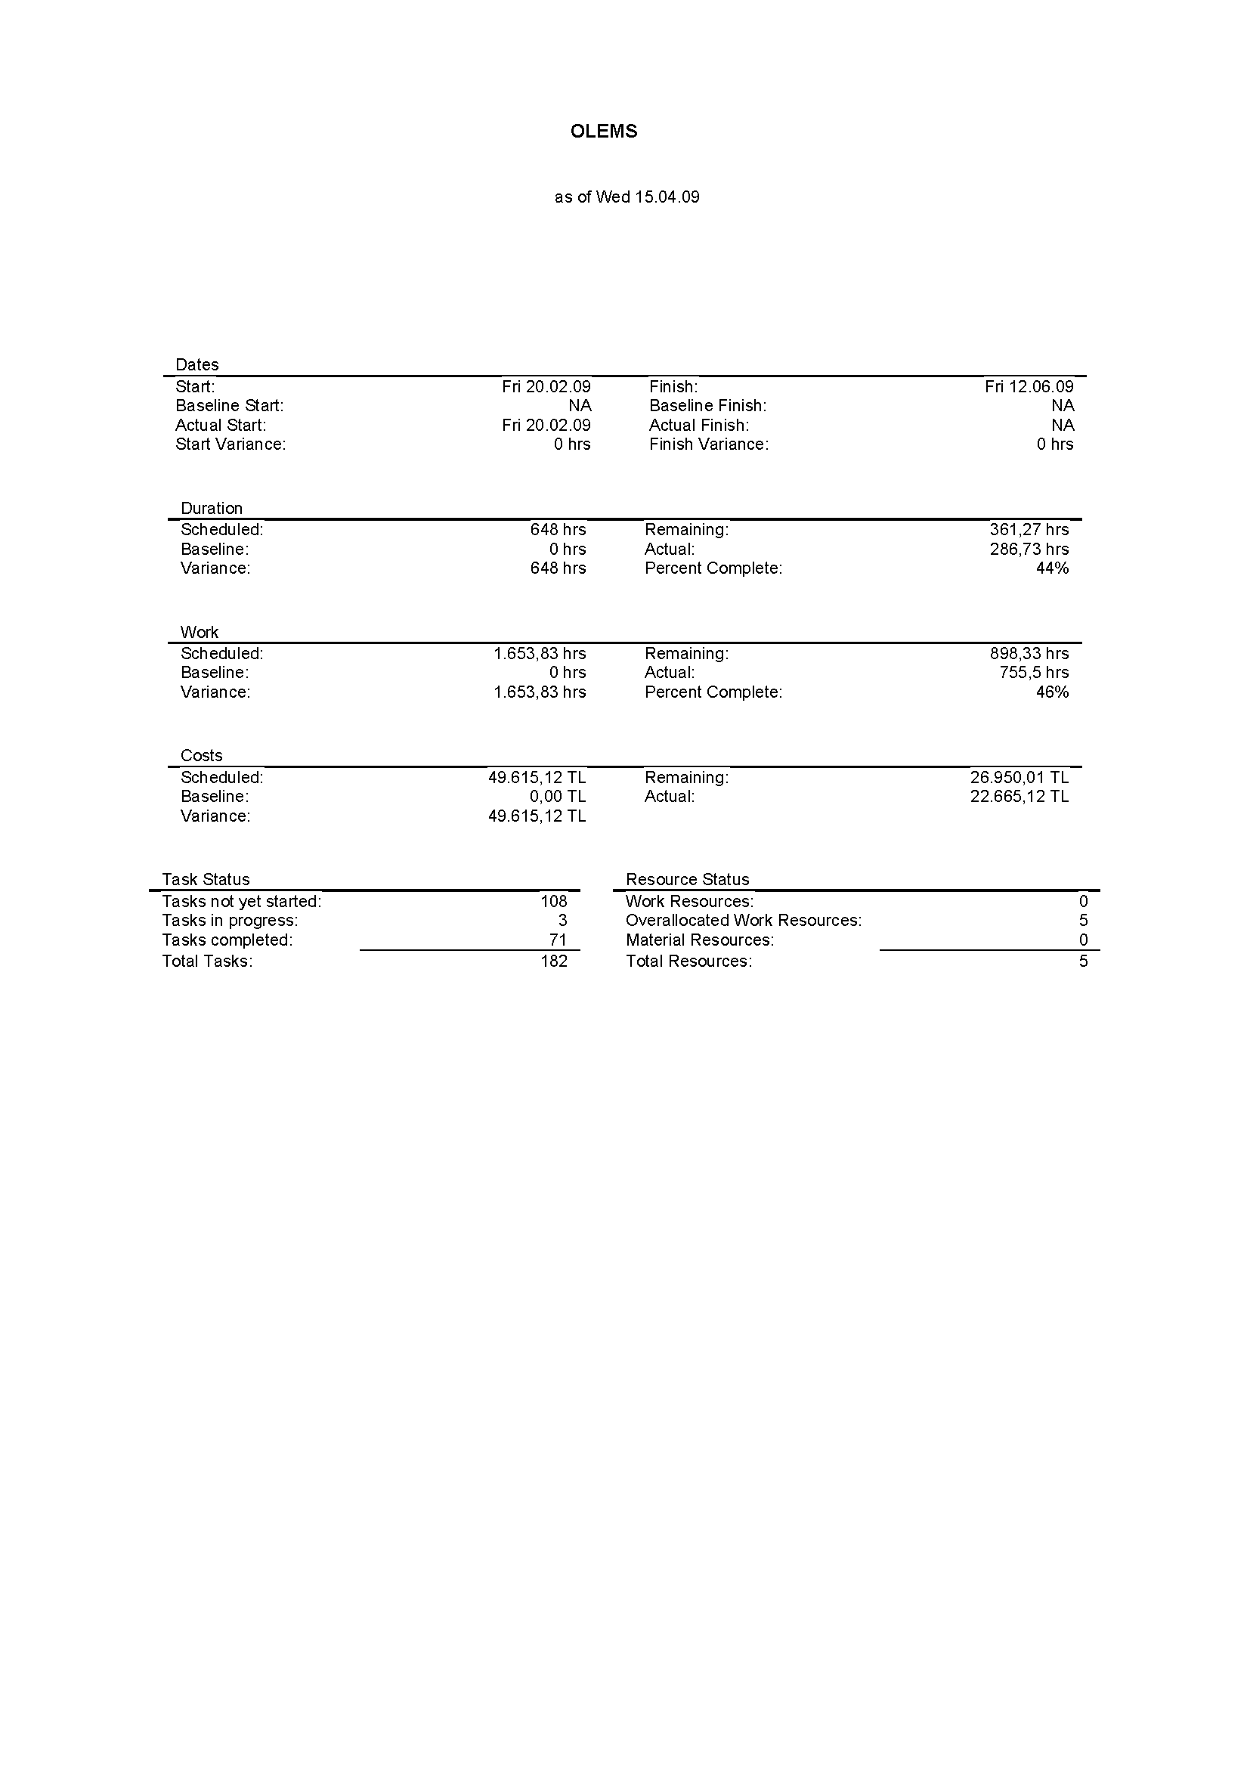

# Legend for Schedule



# Schedule Summary

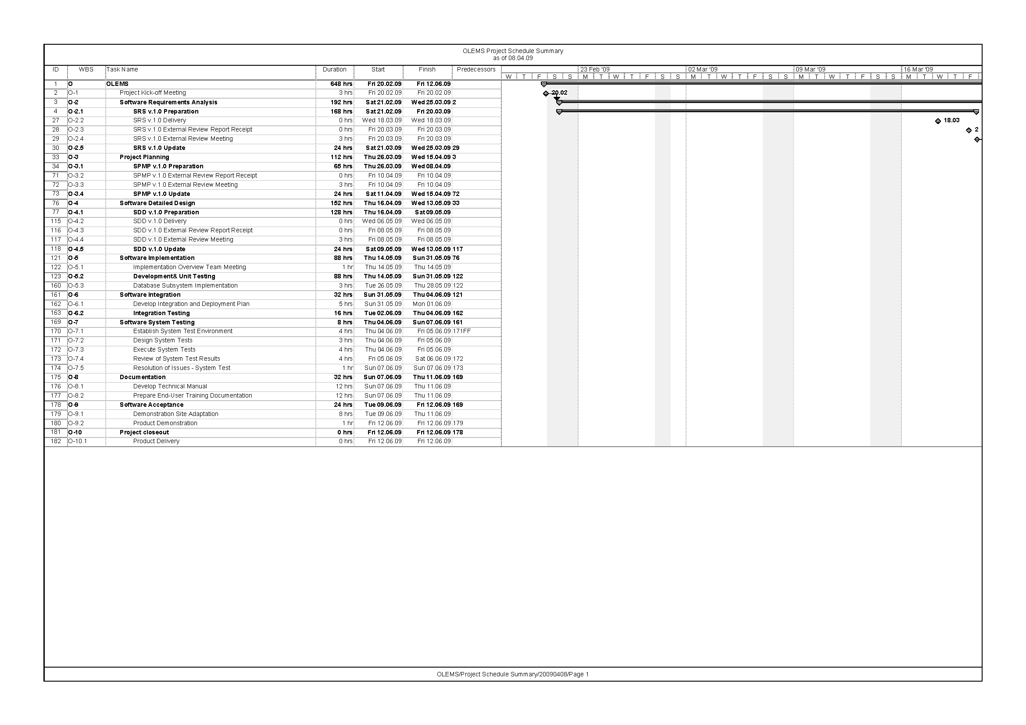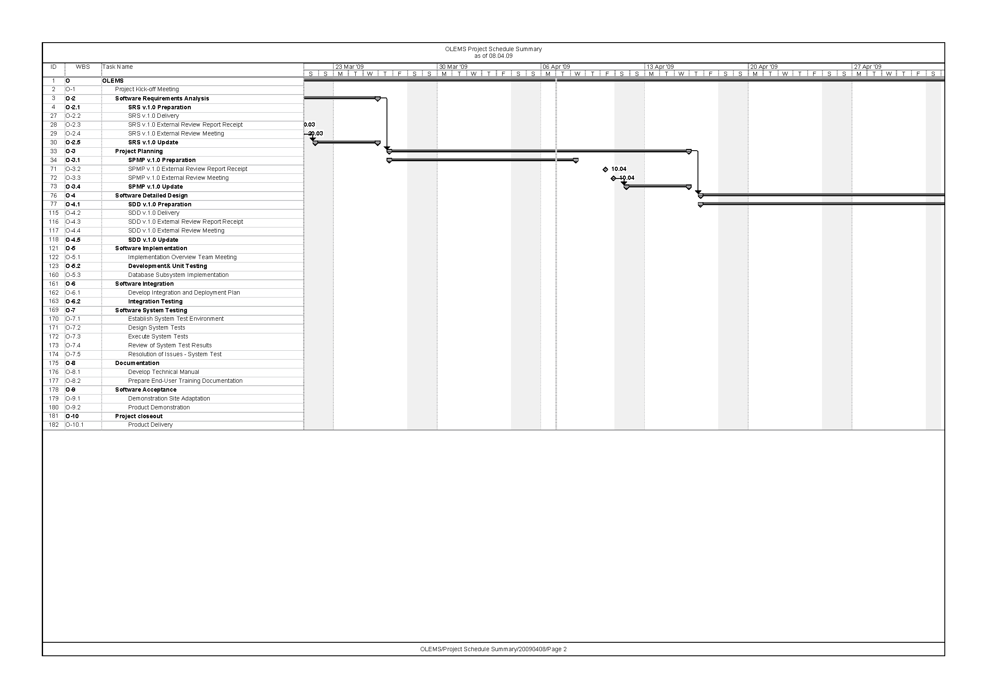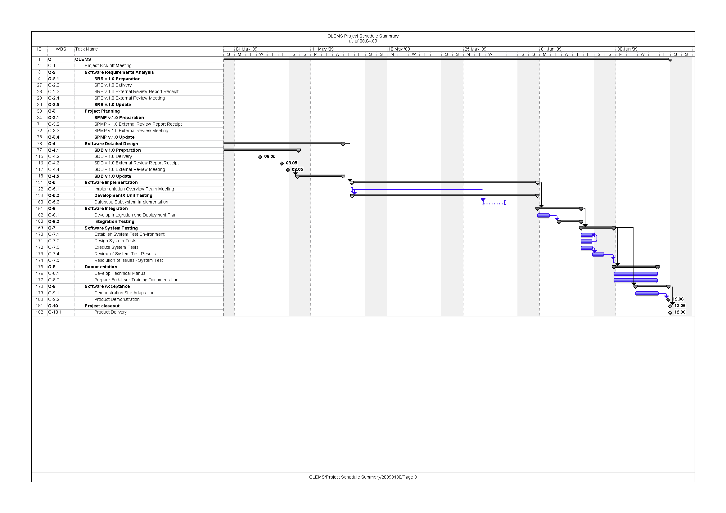

# Change Report





# Weekly Project Time Billing

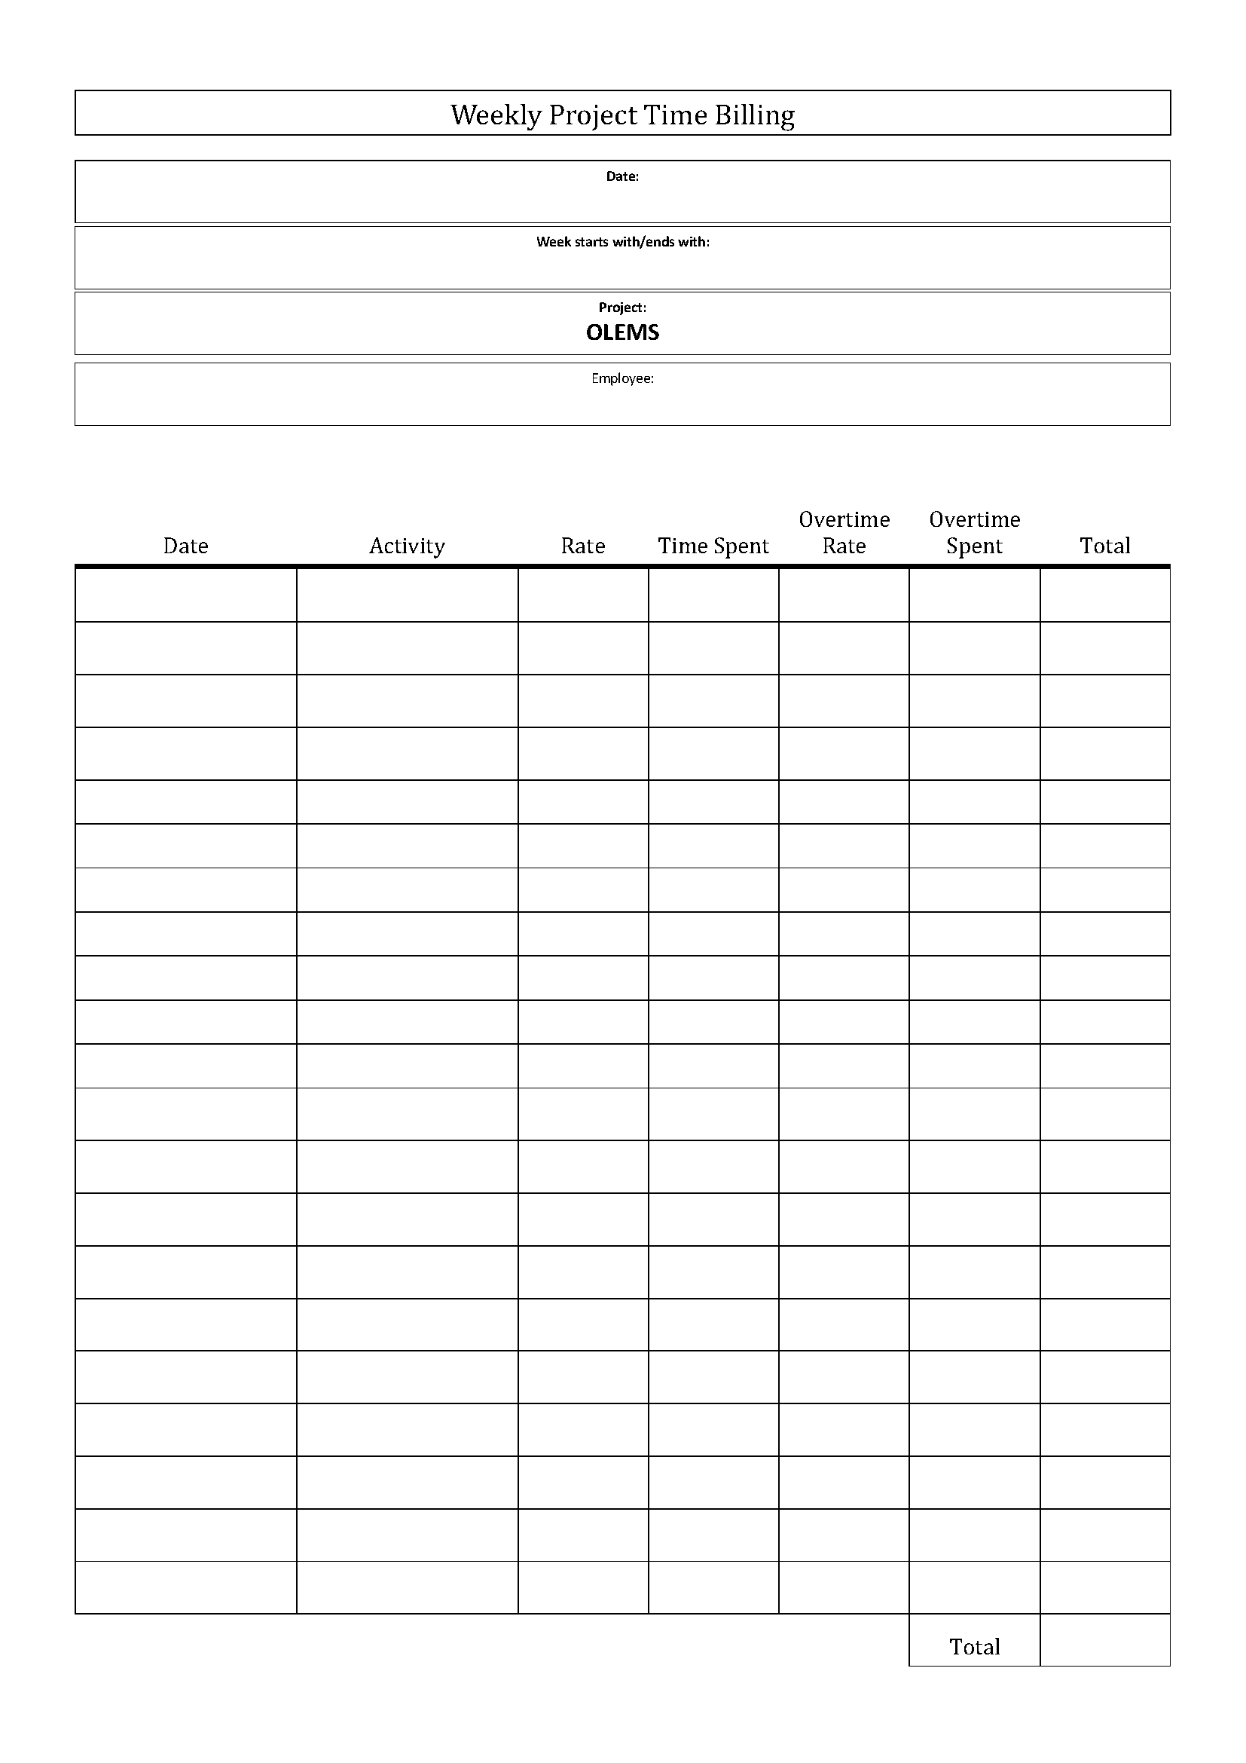

# WBS Dictionary

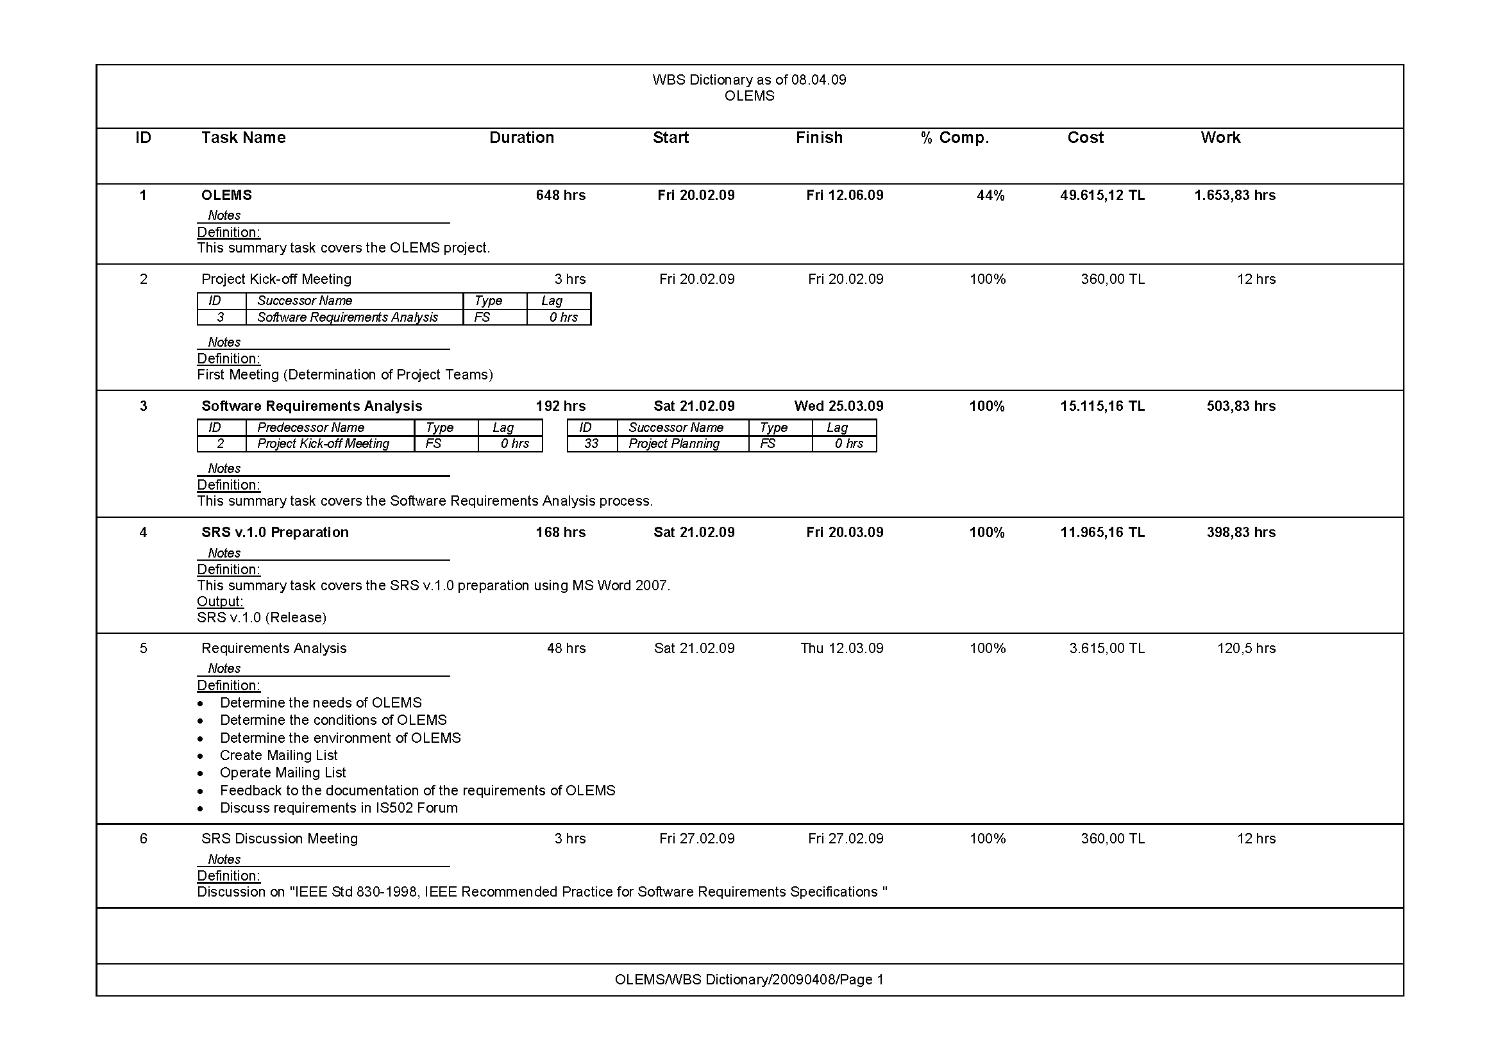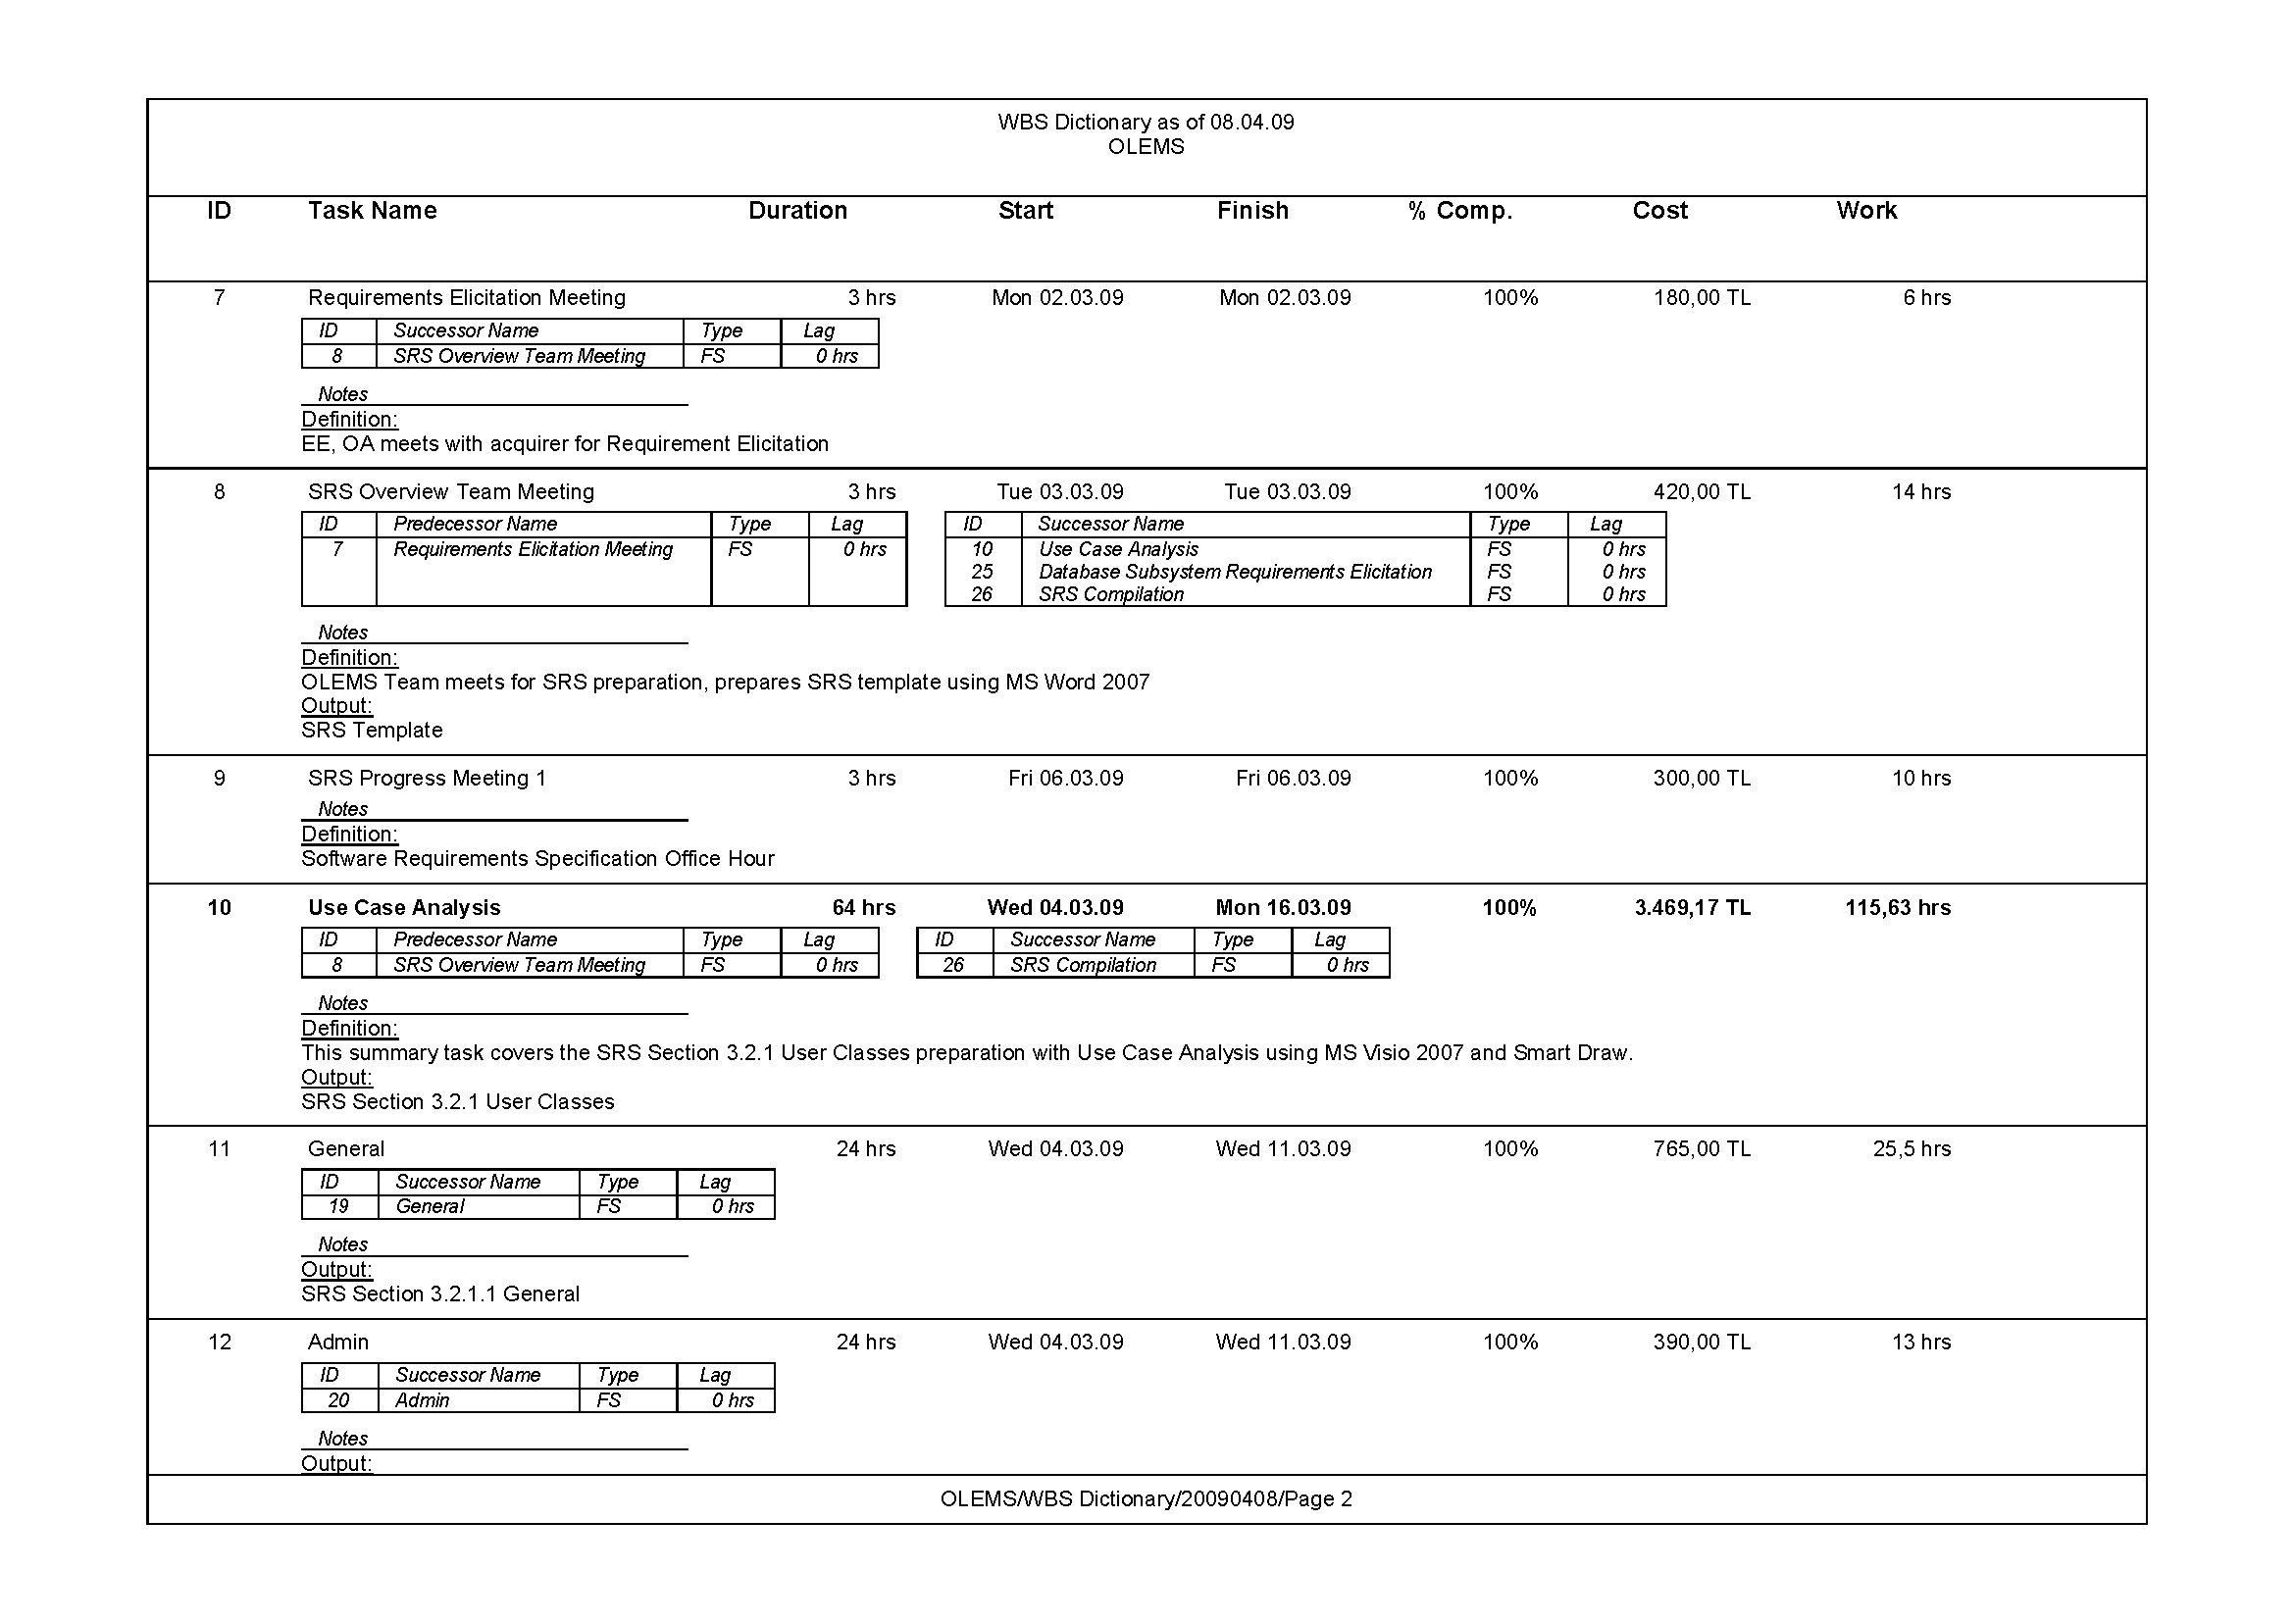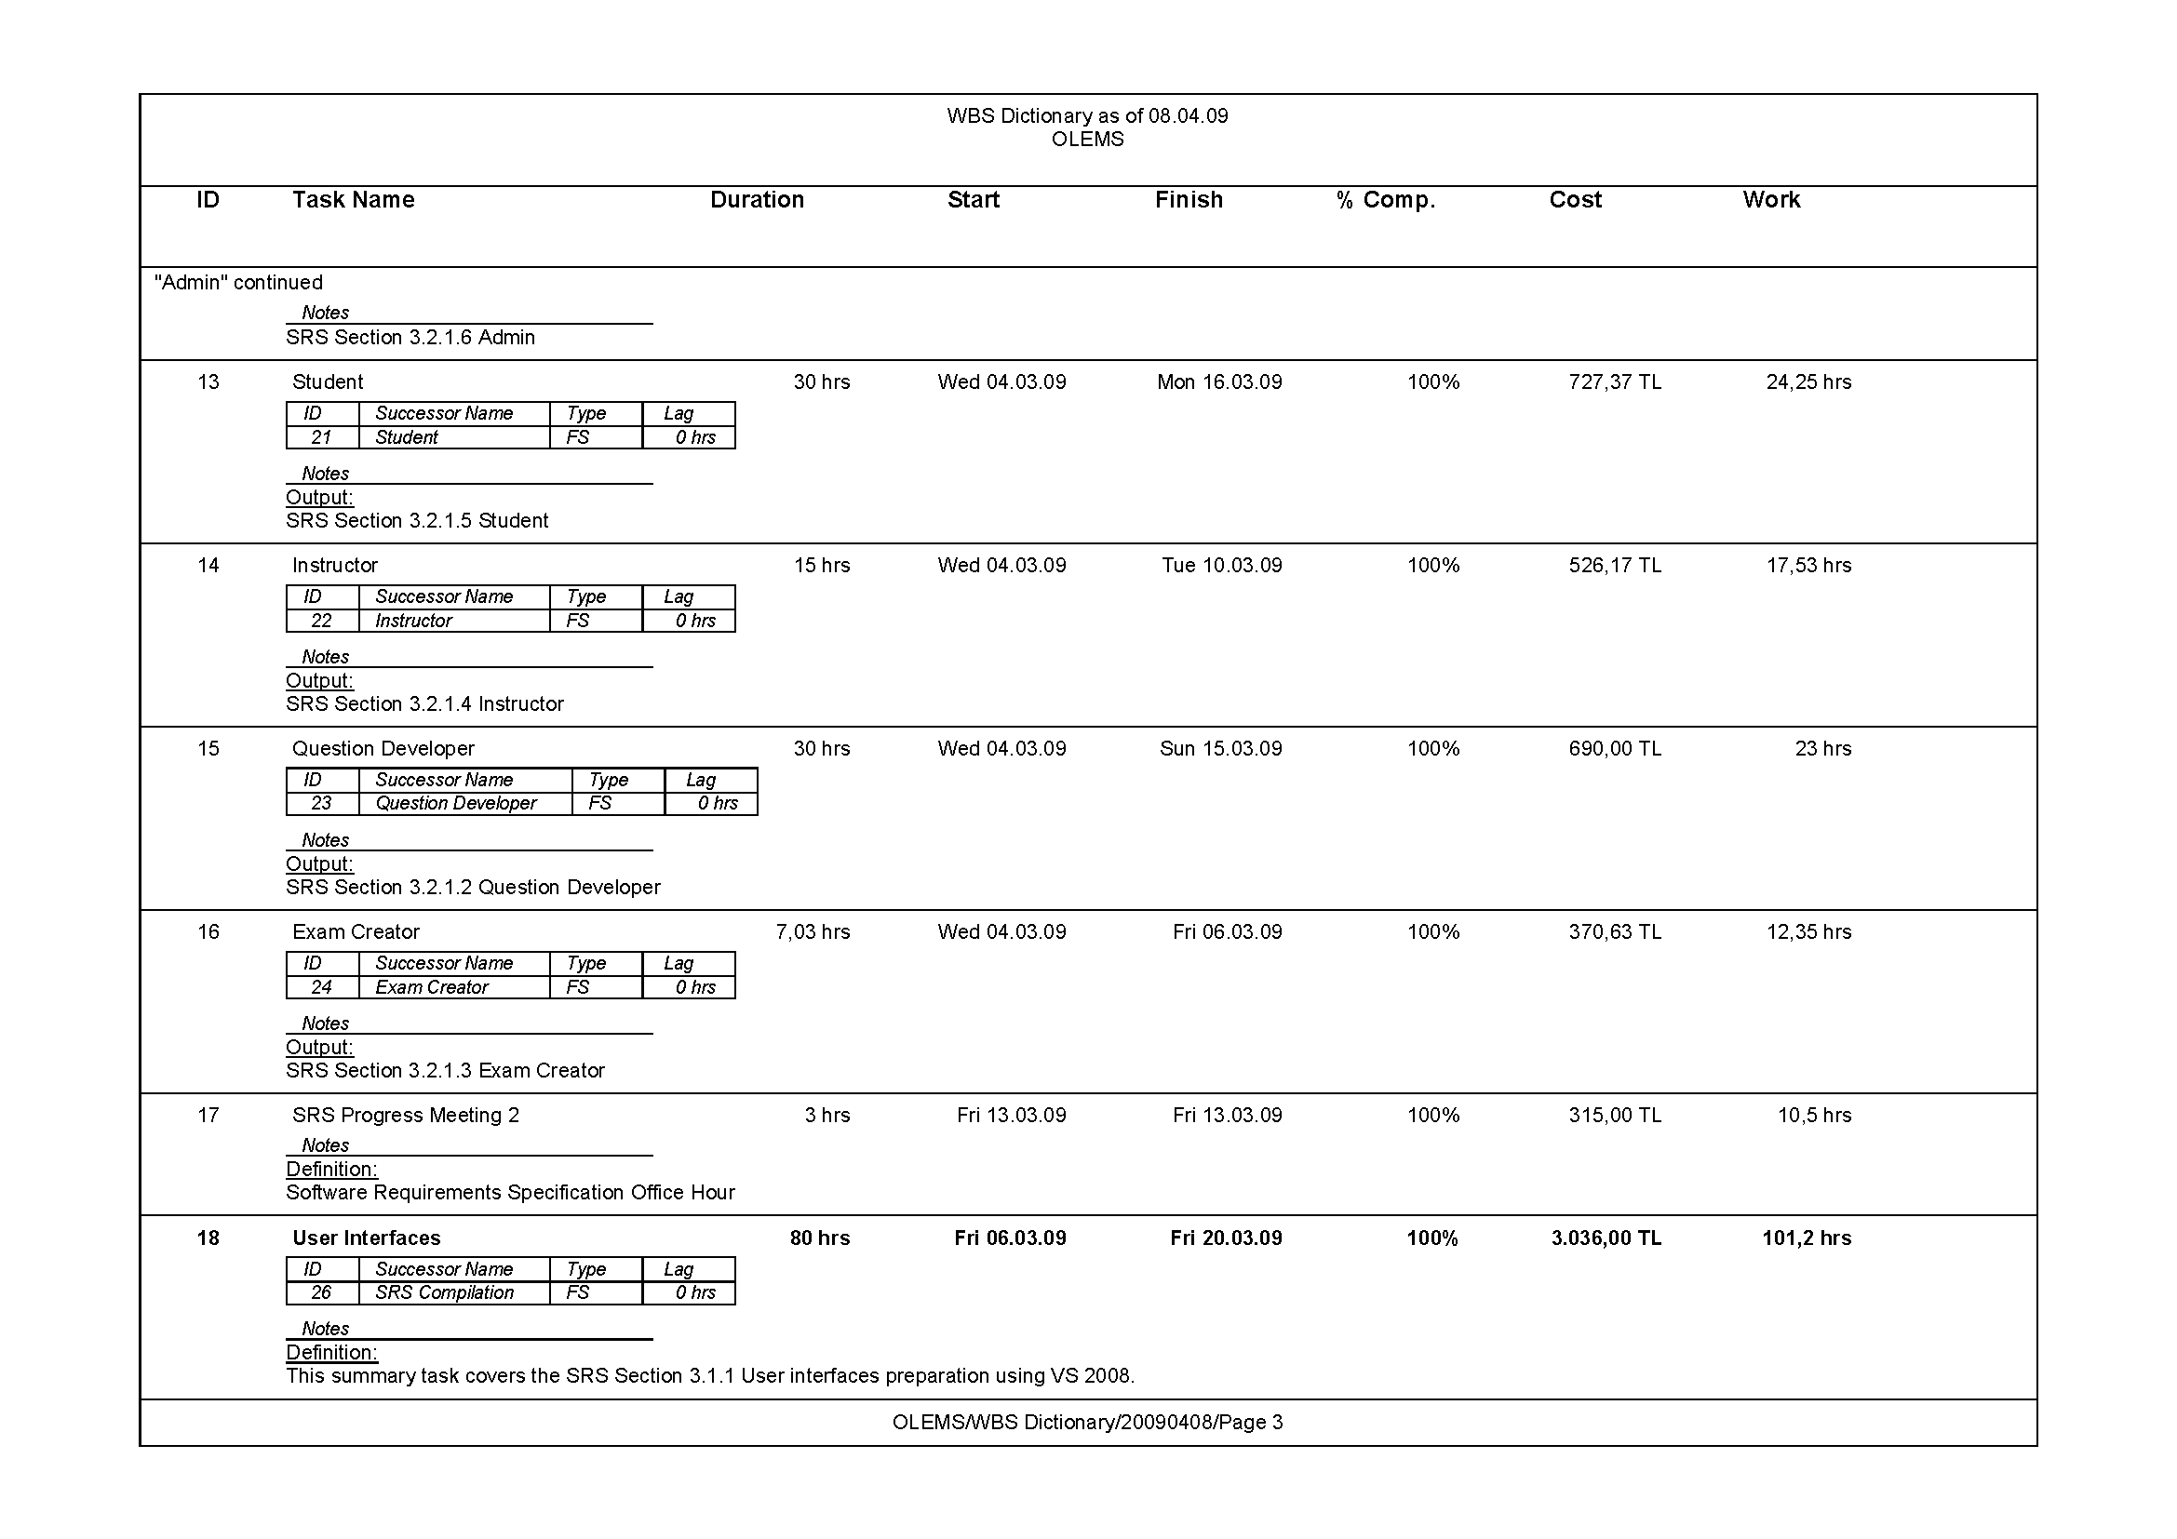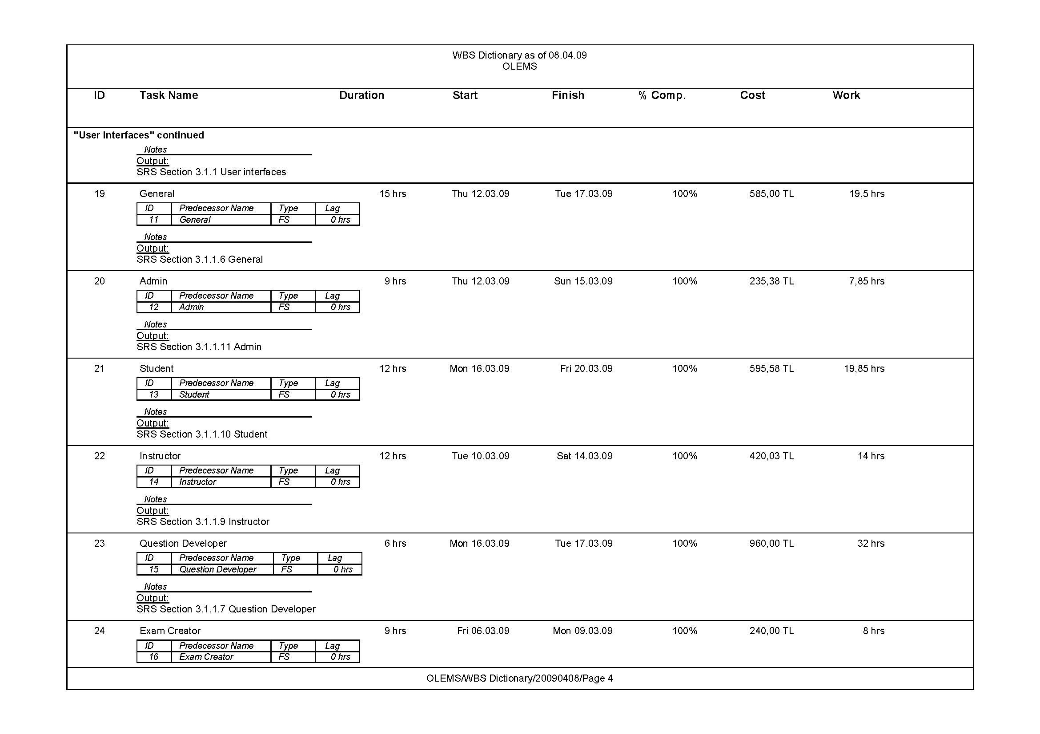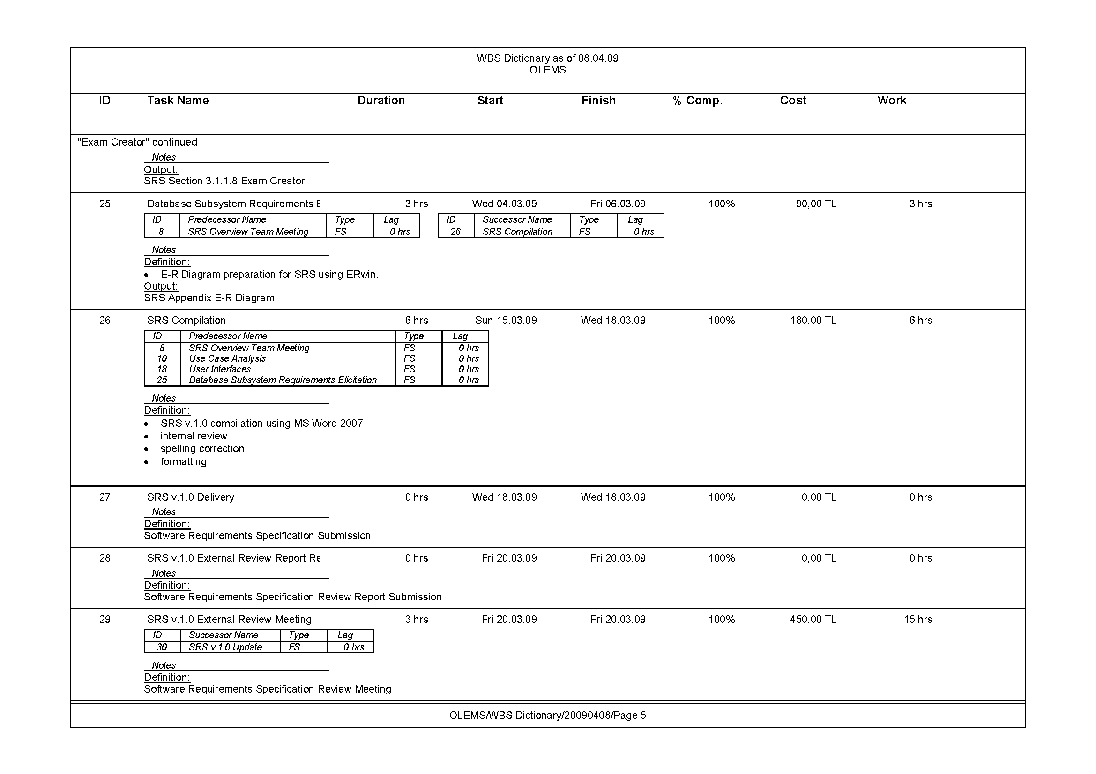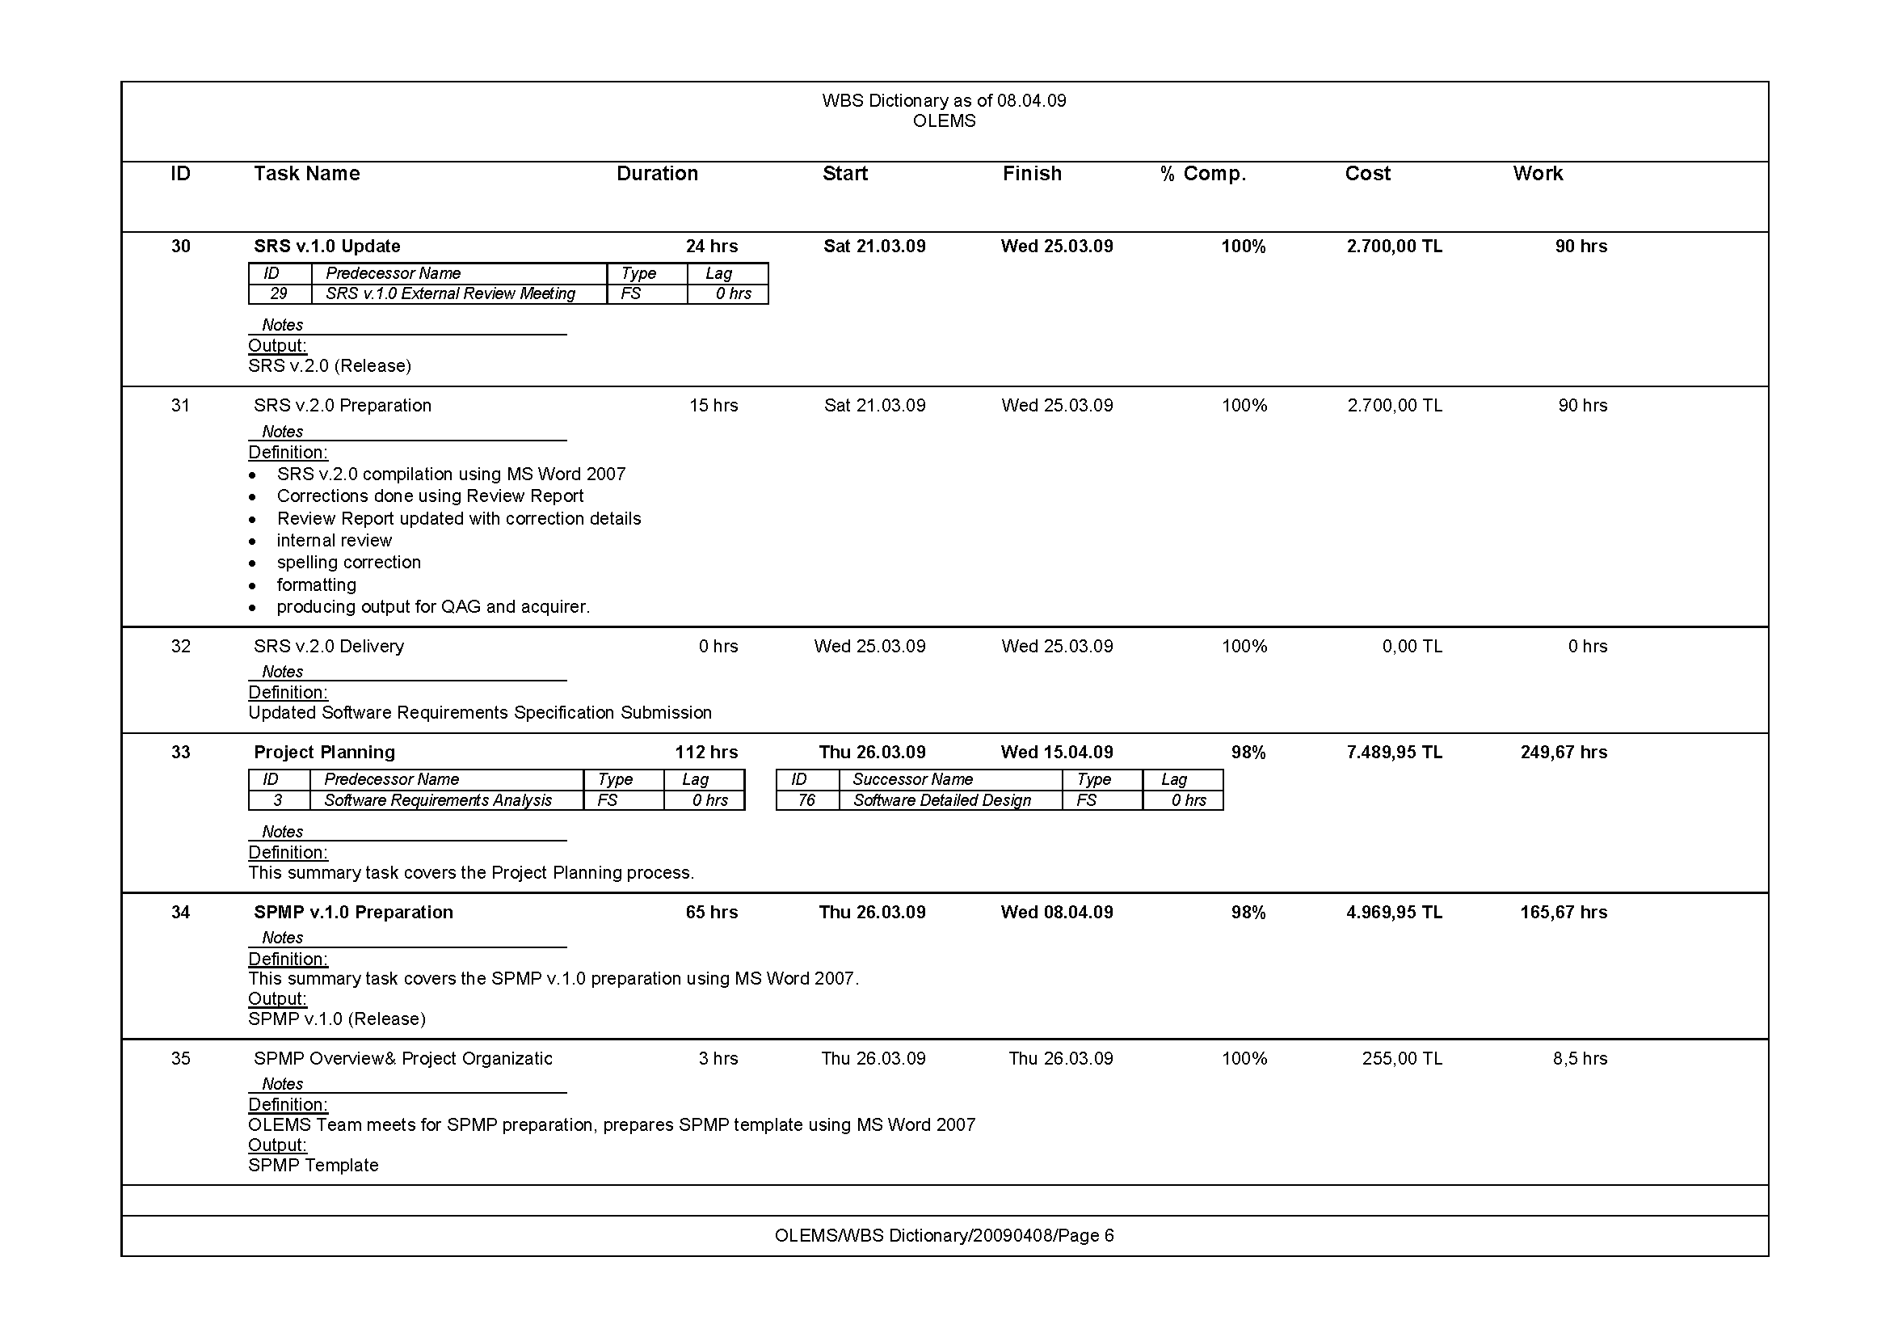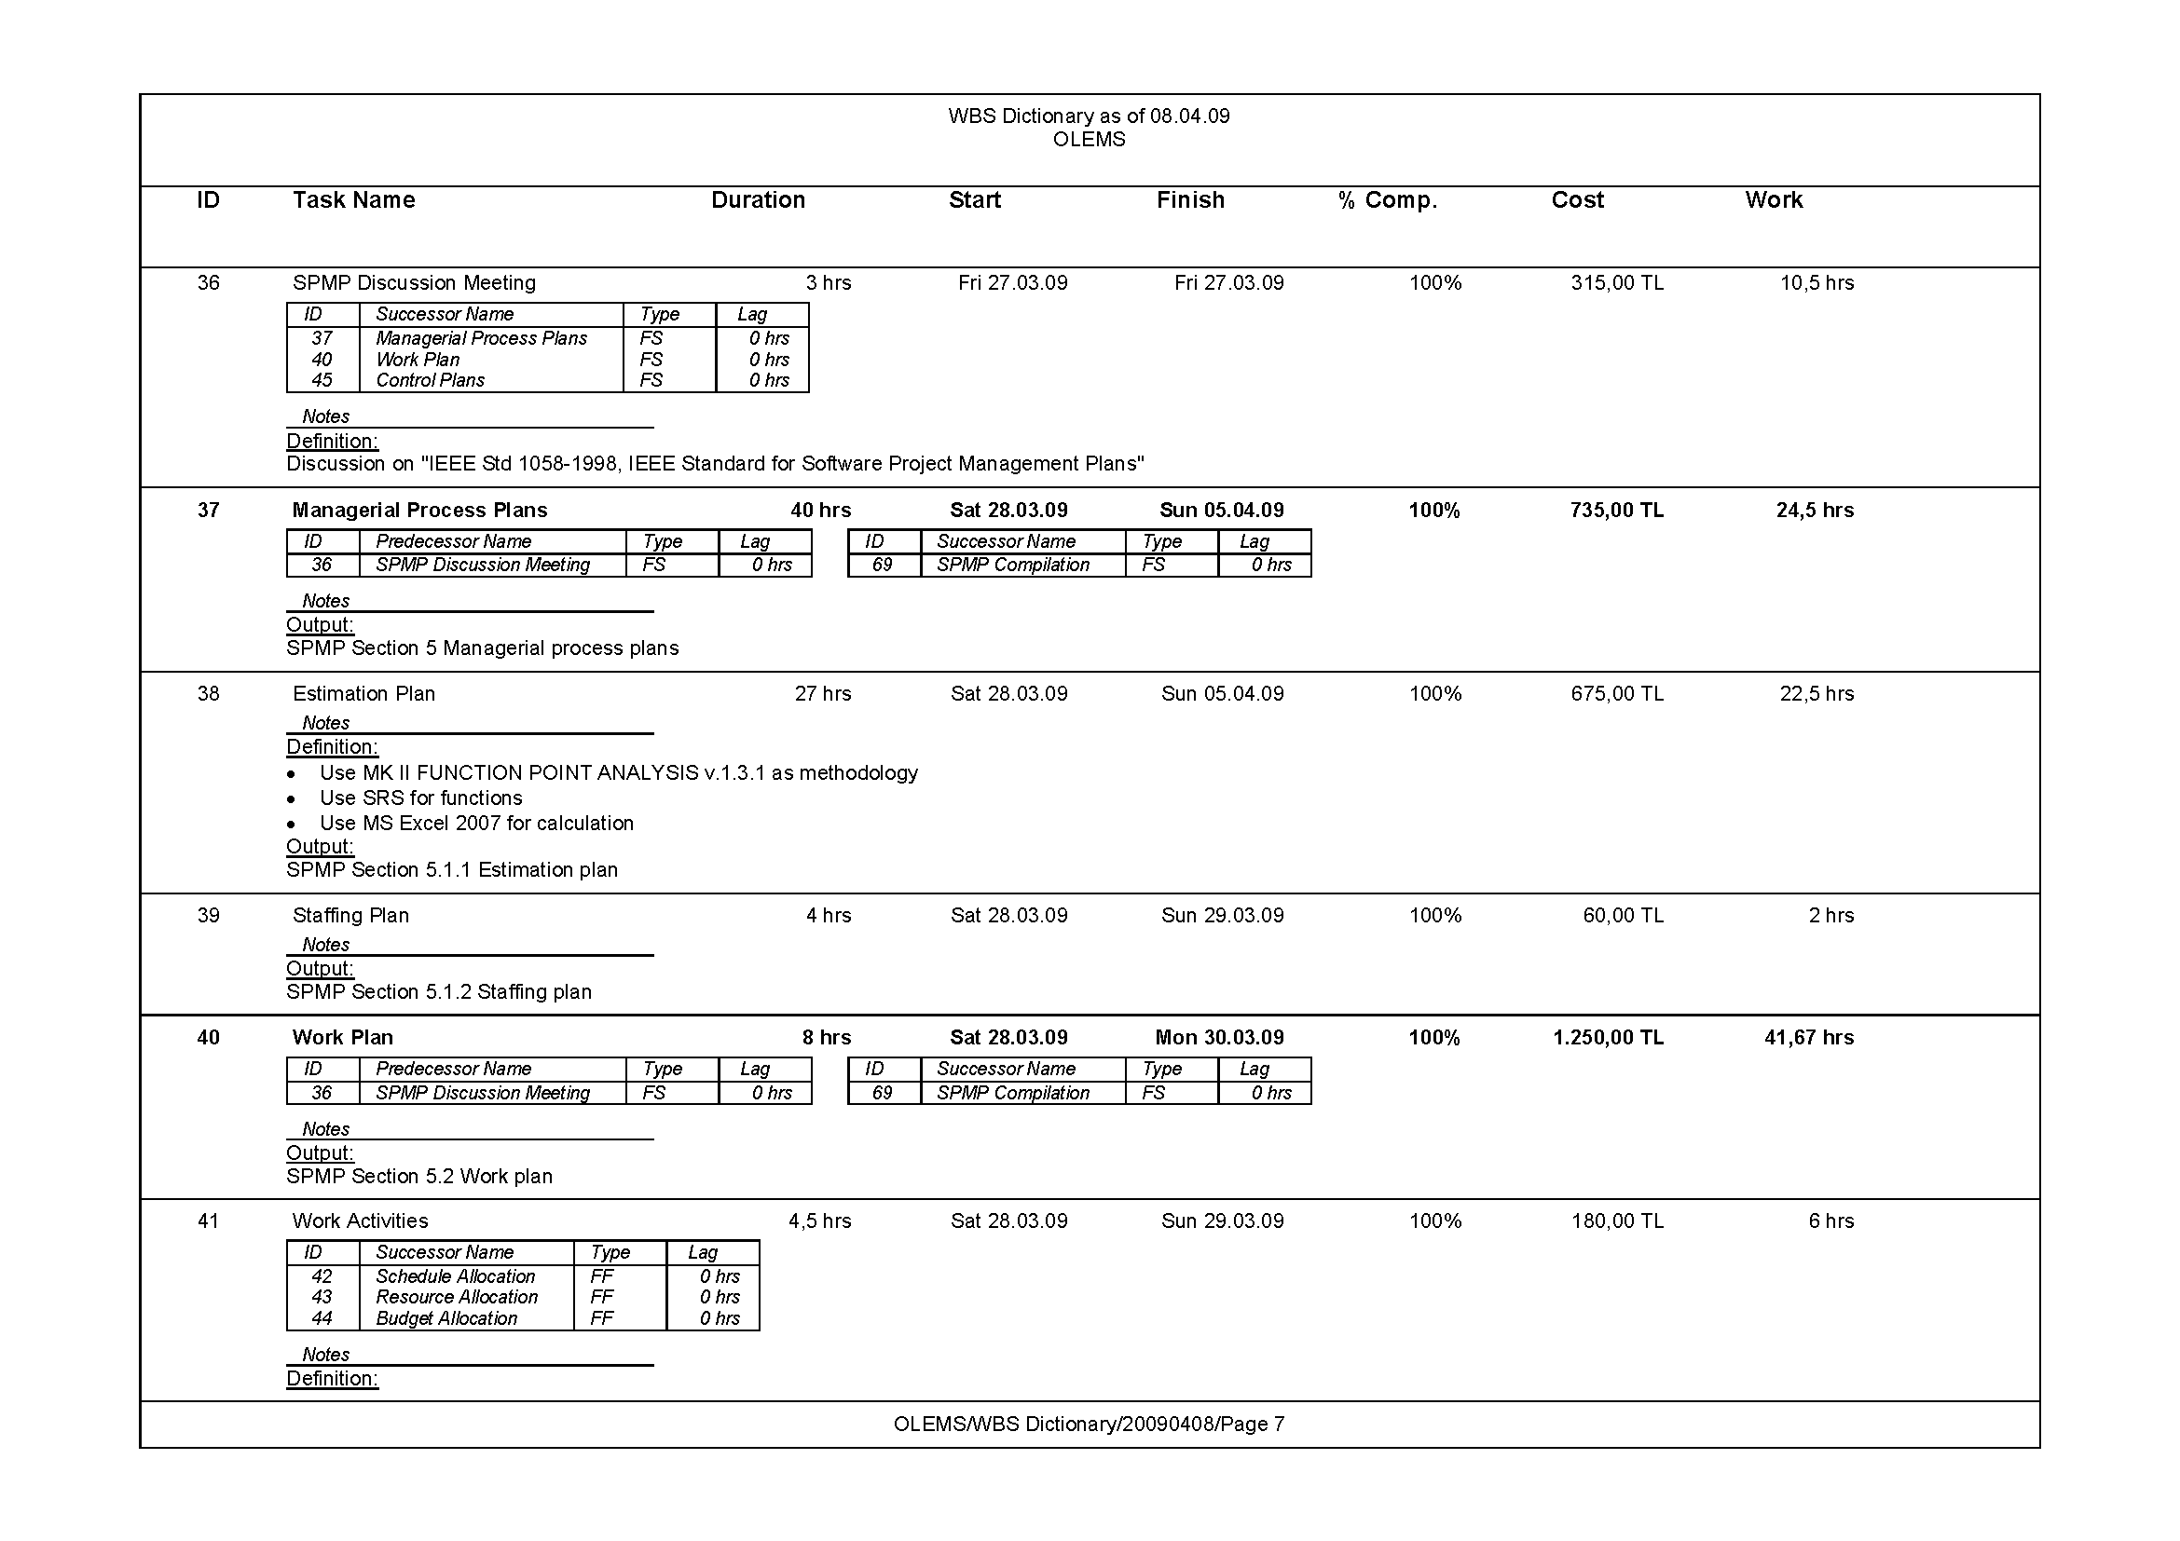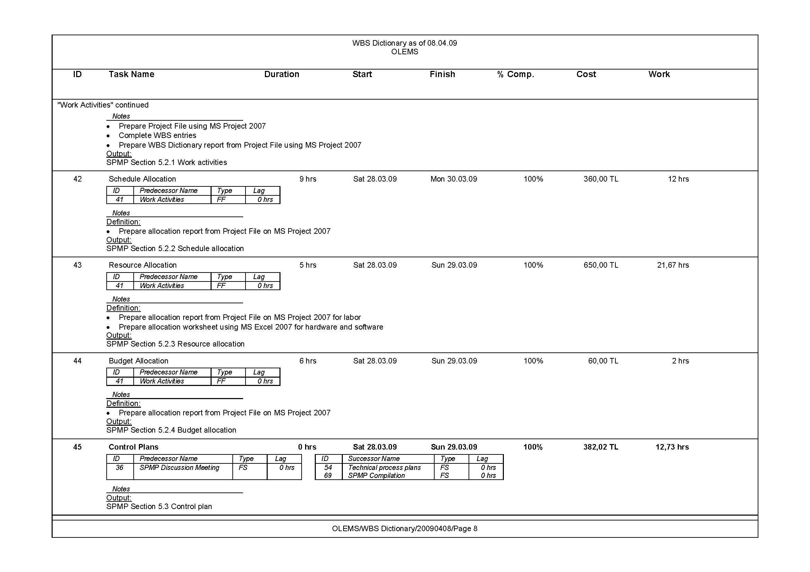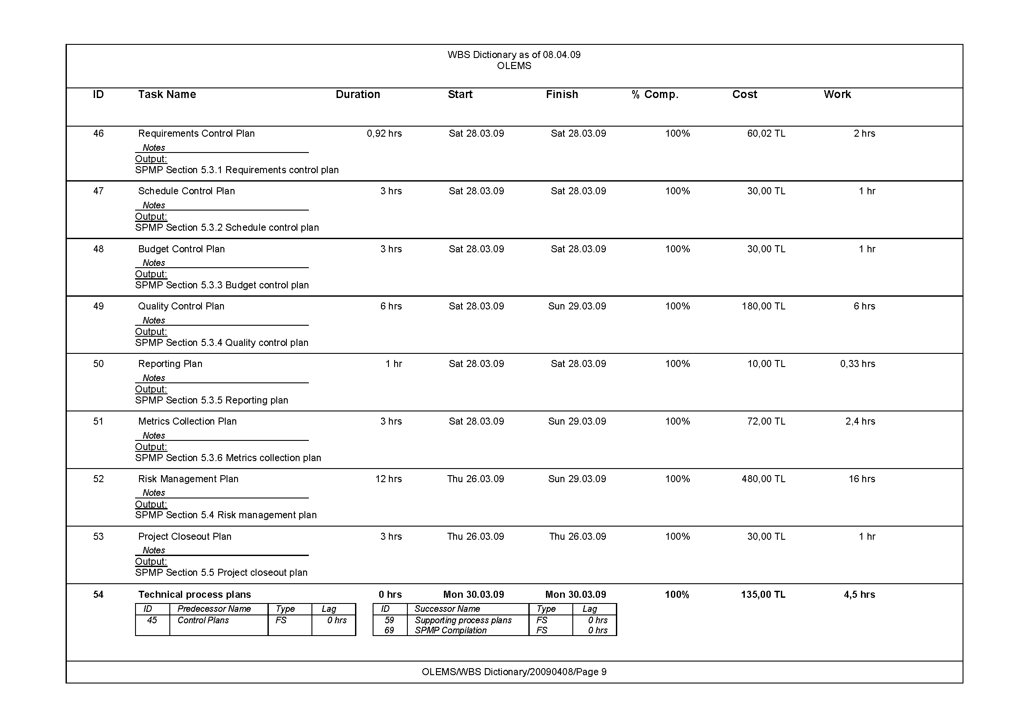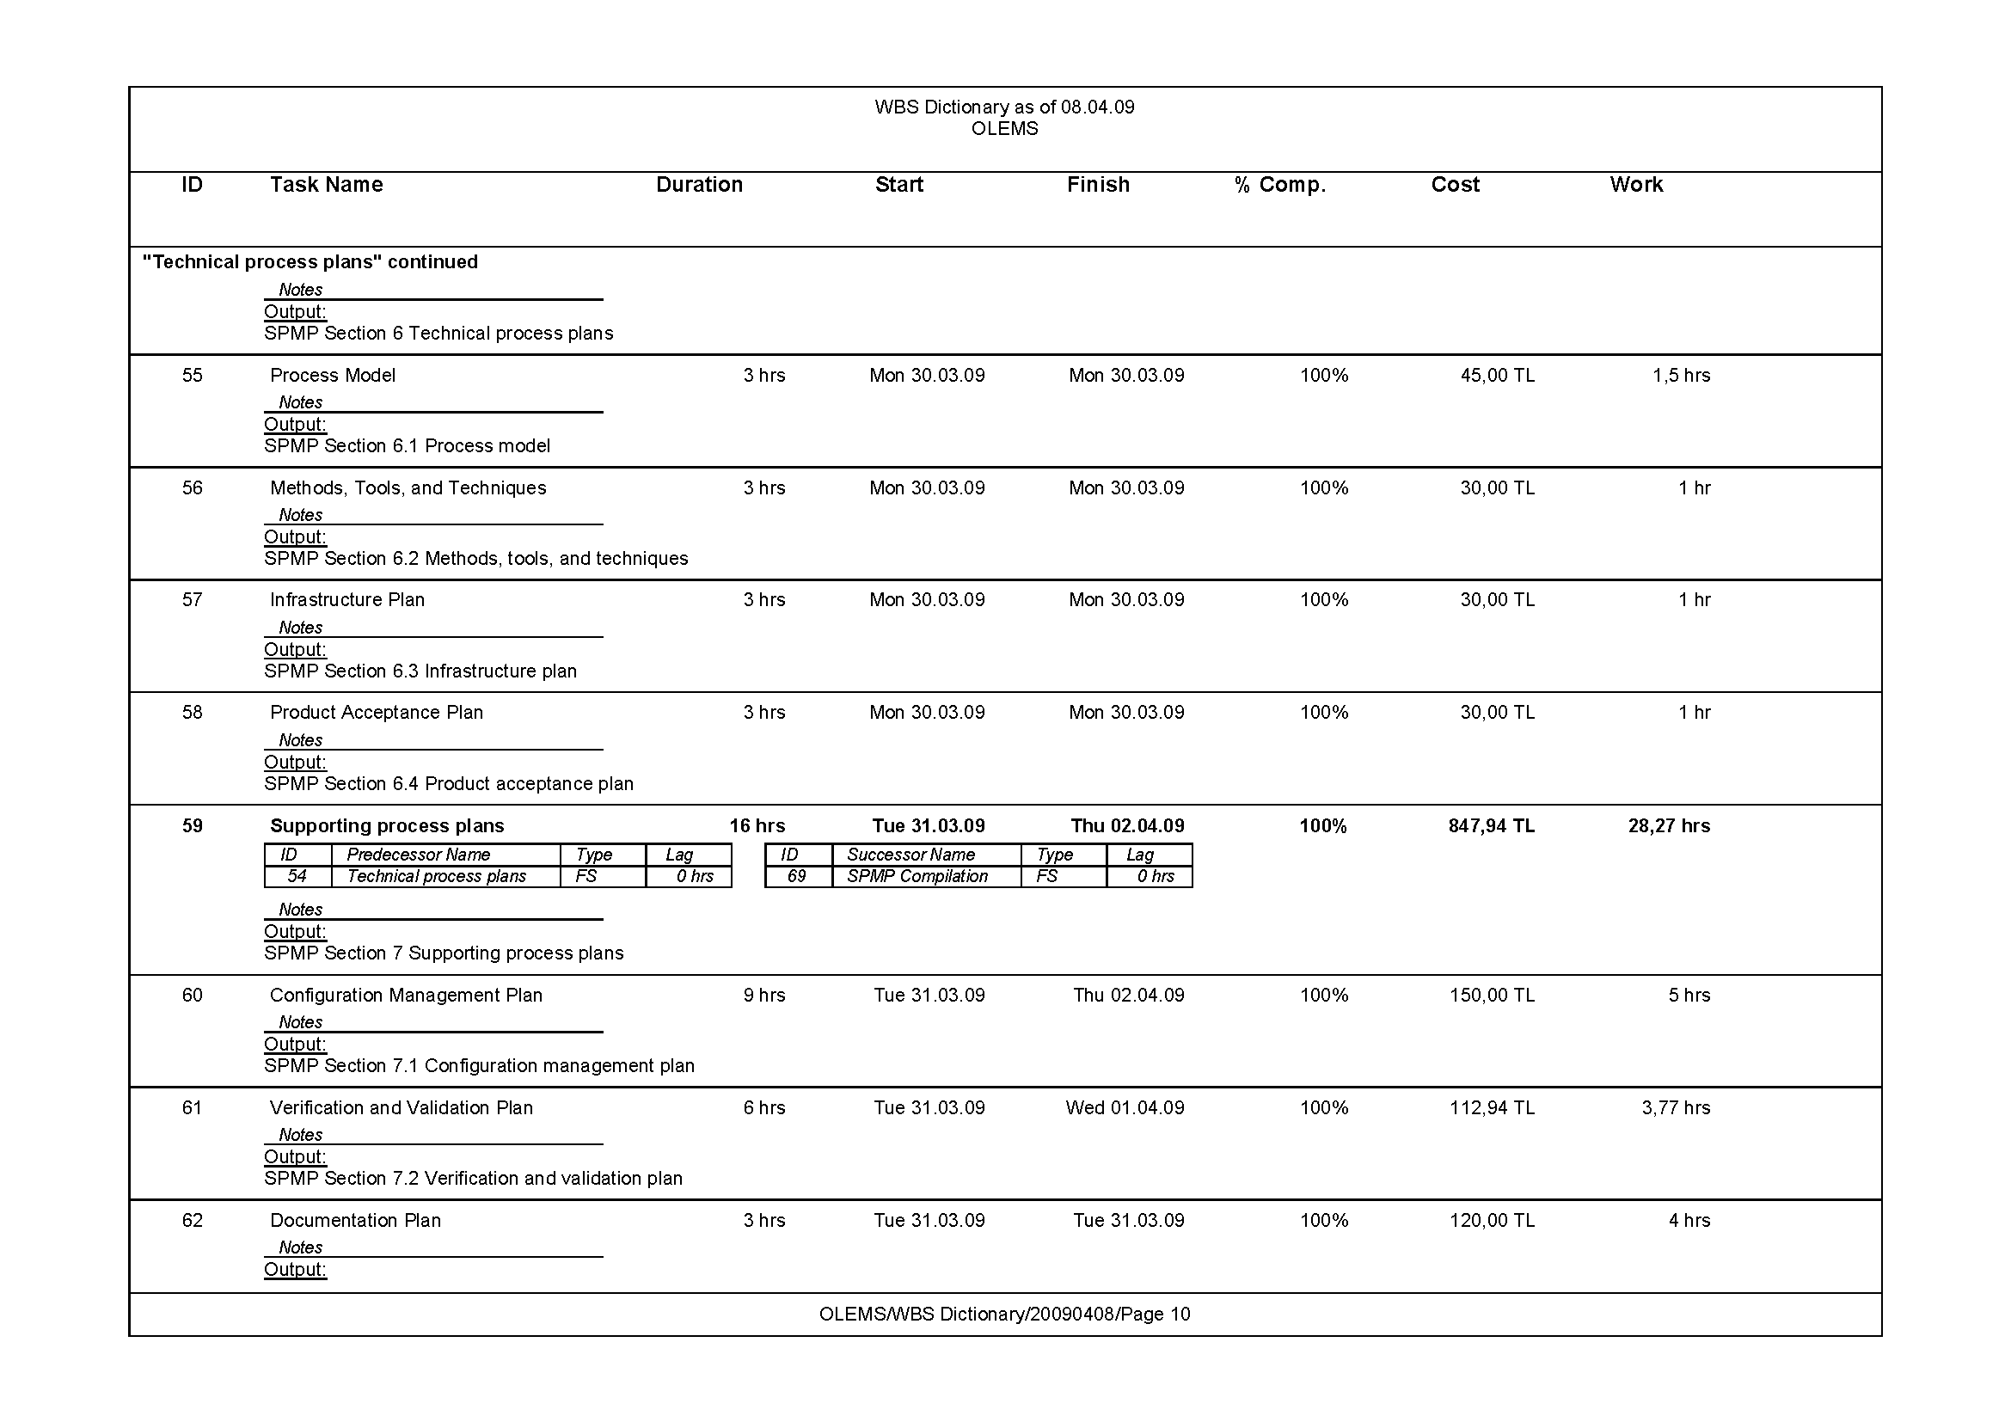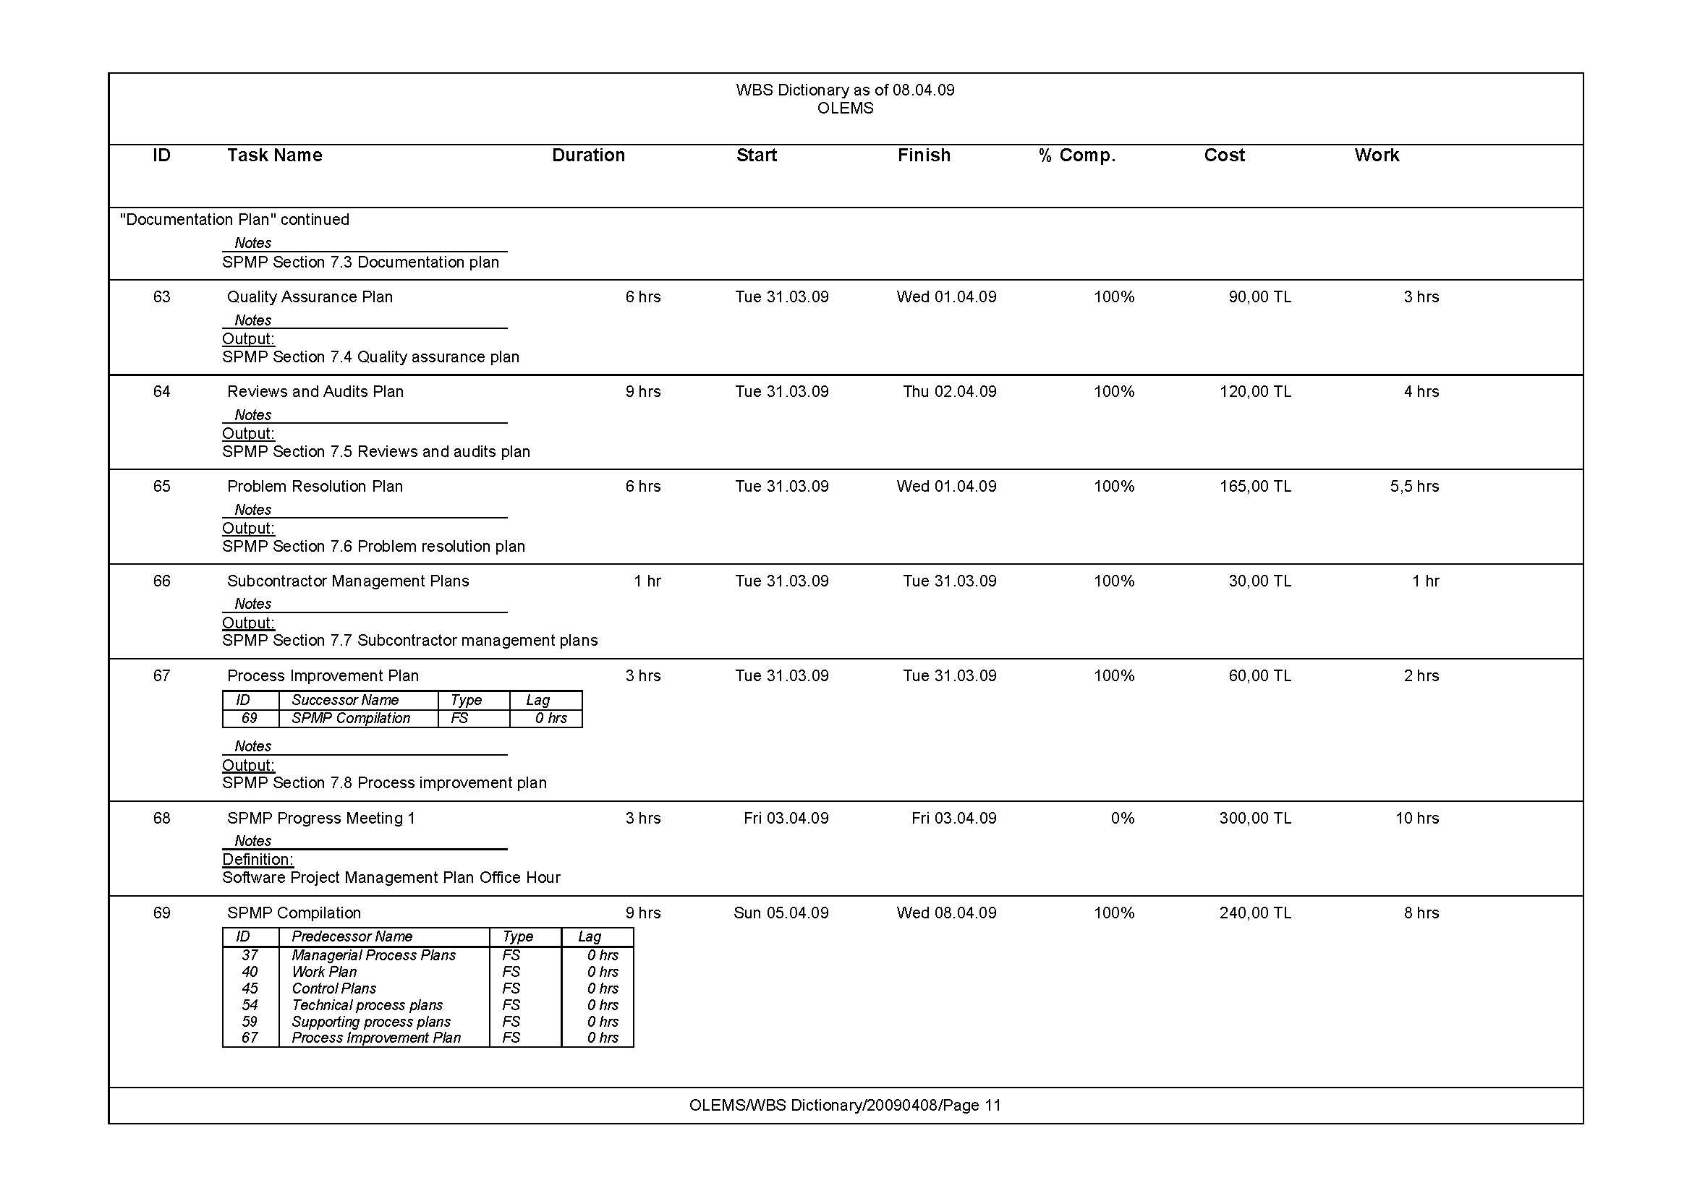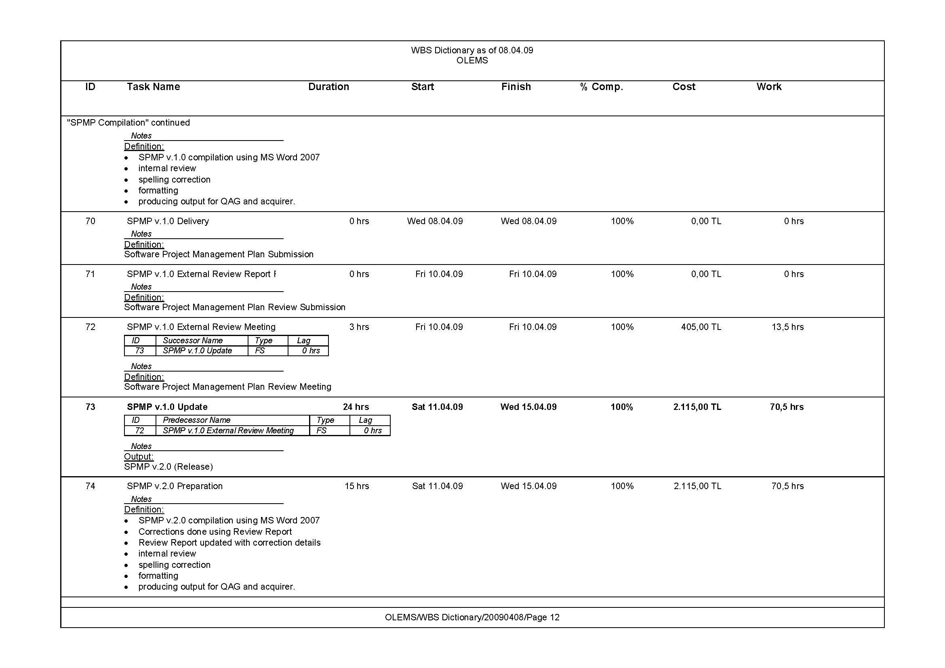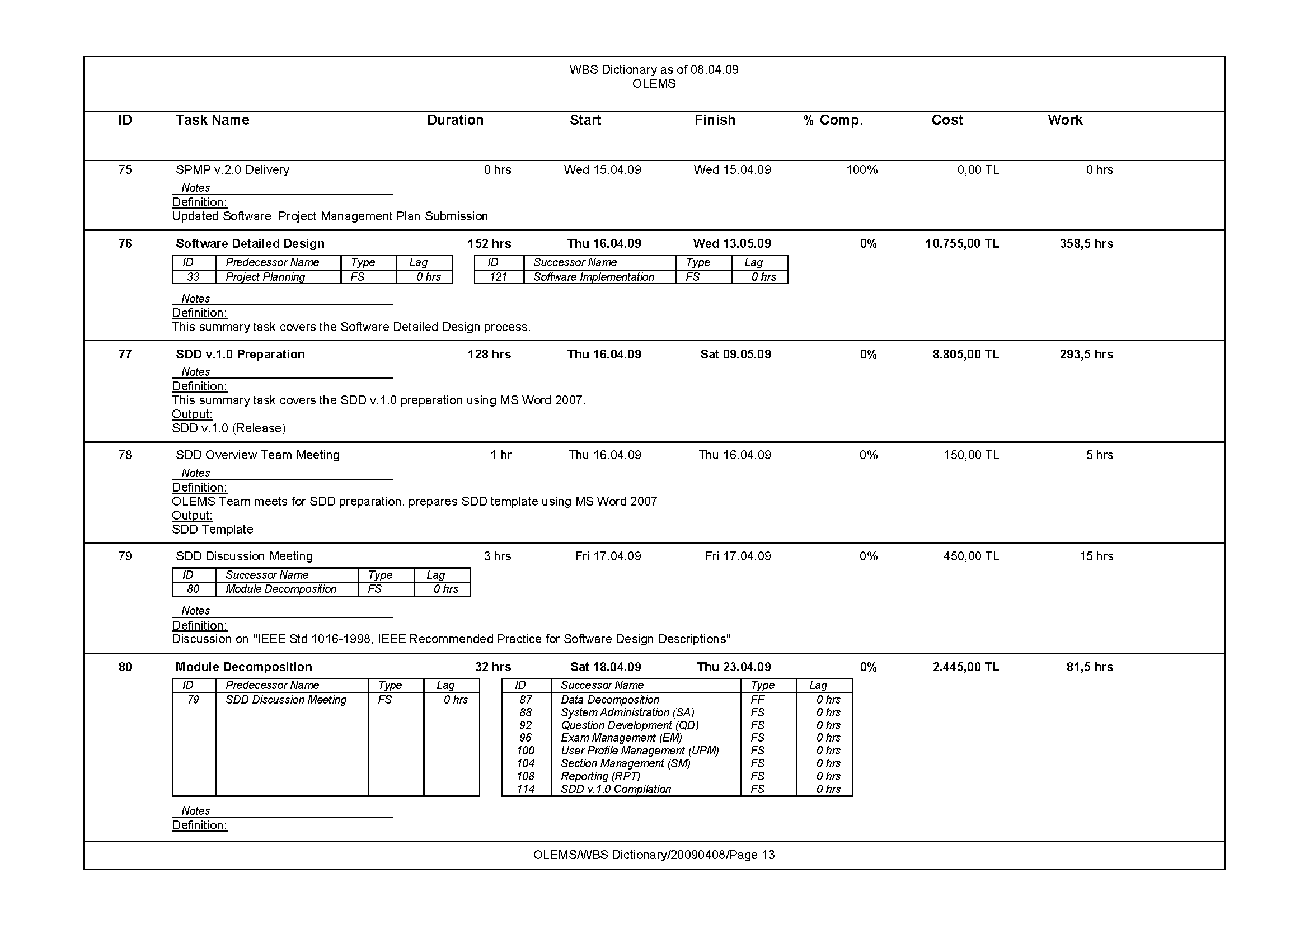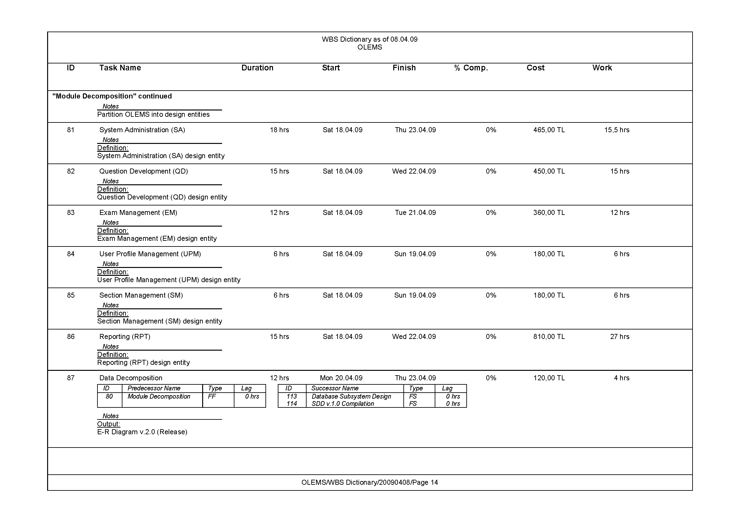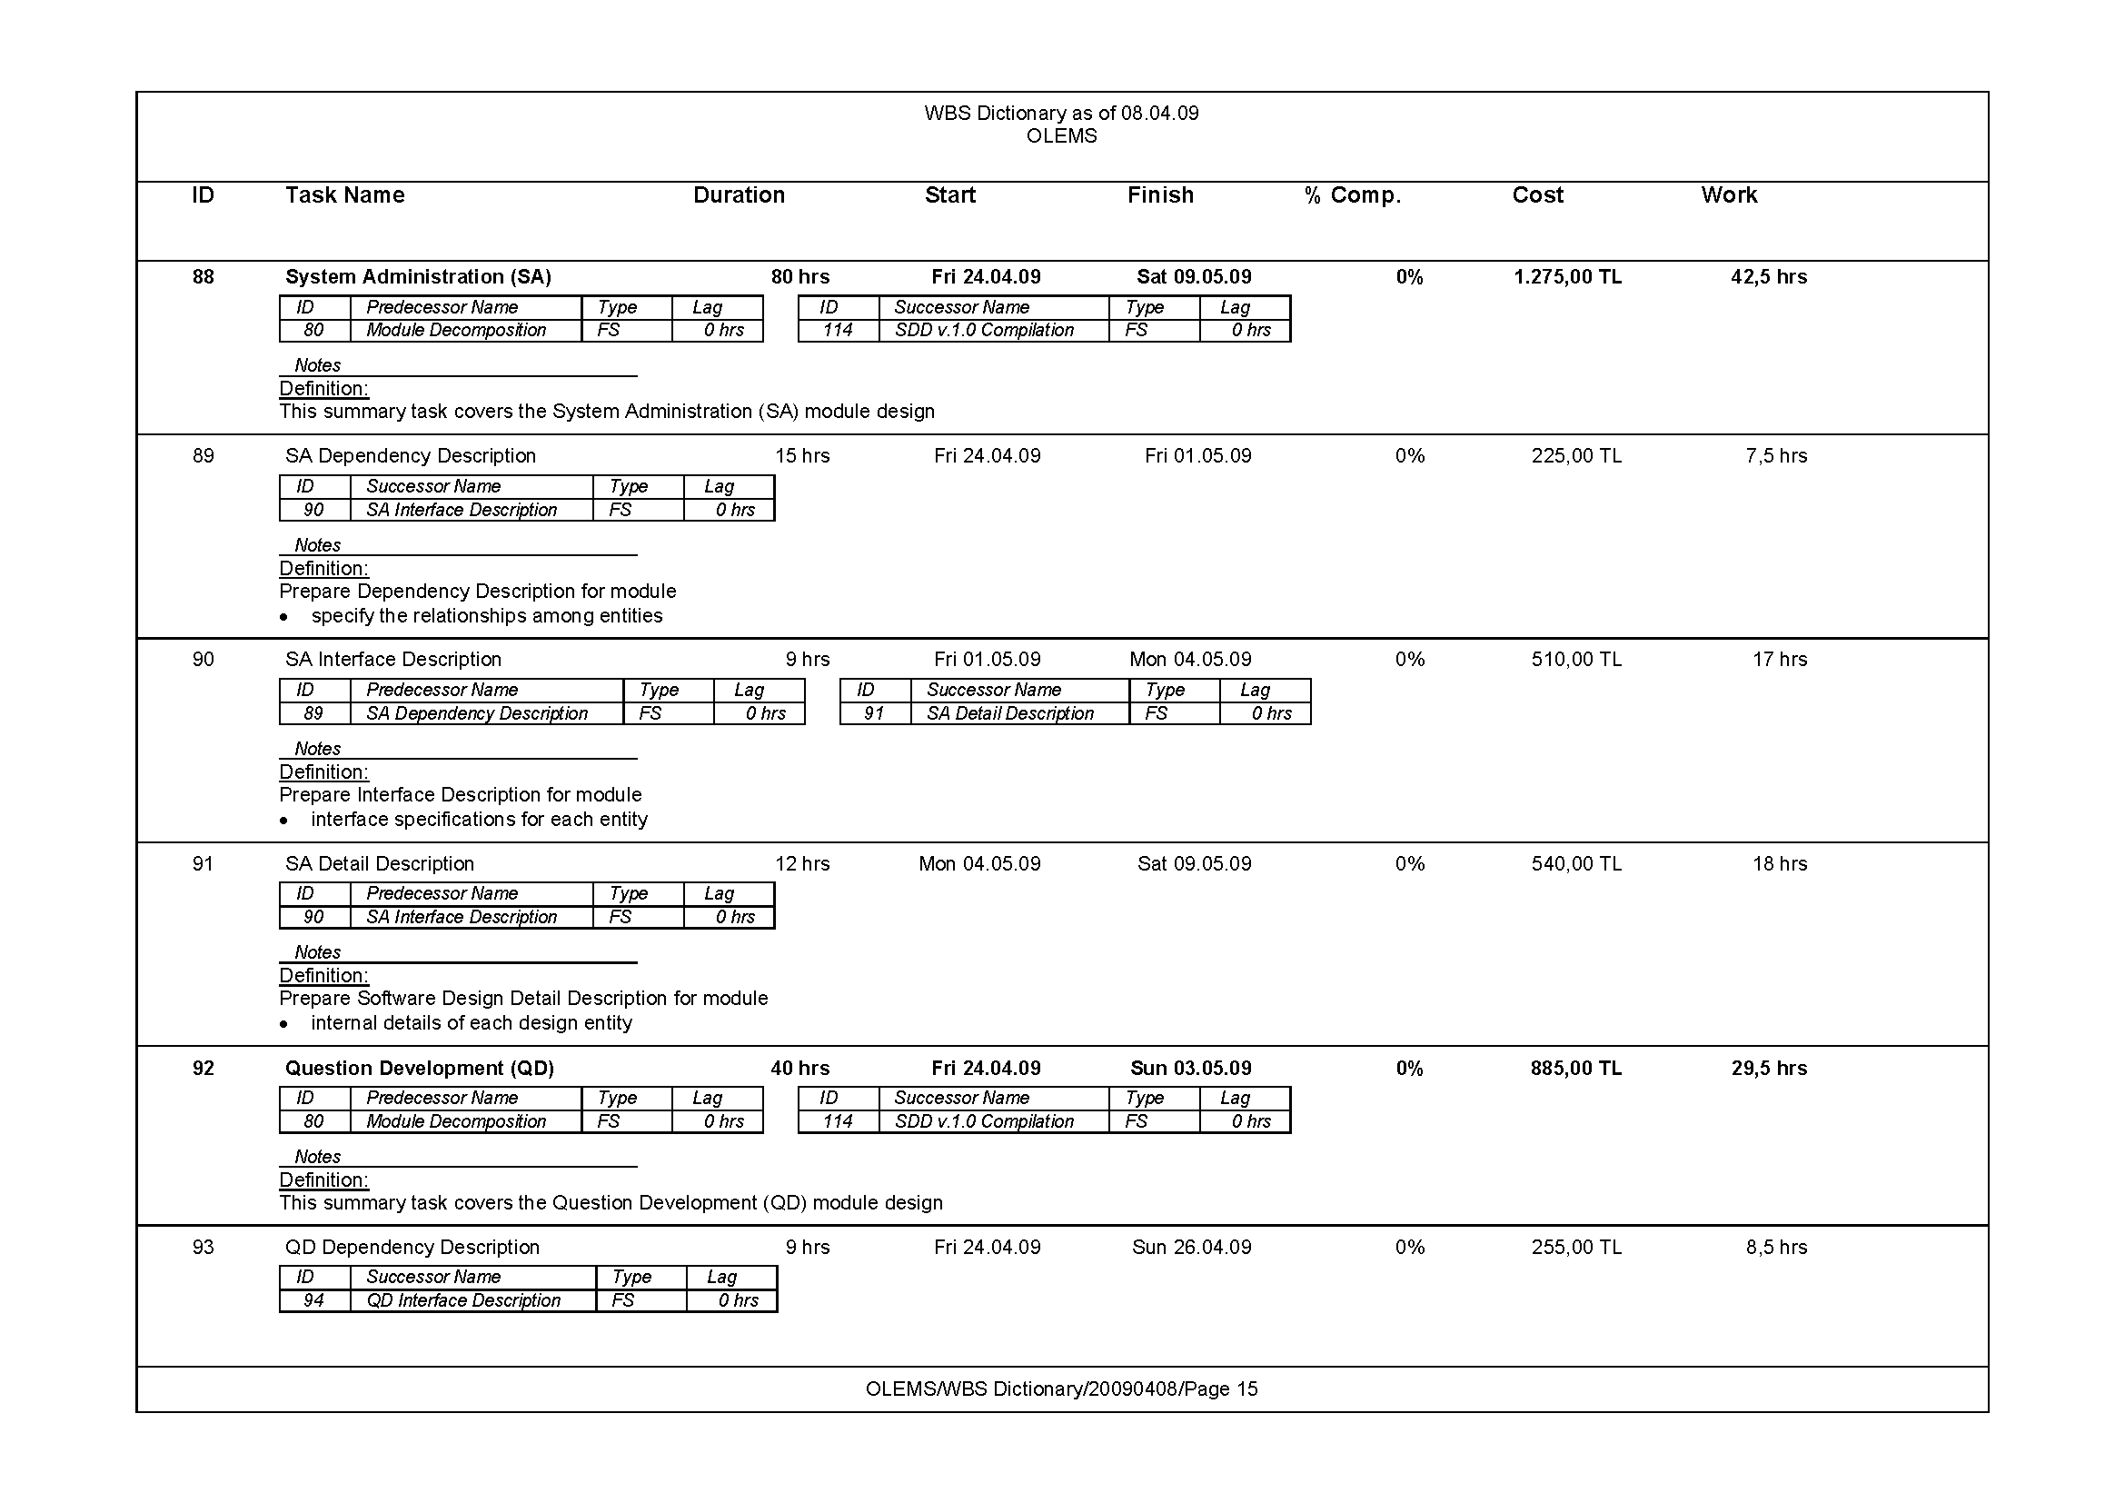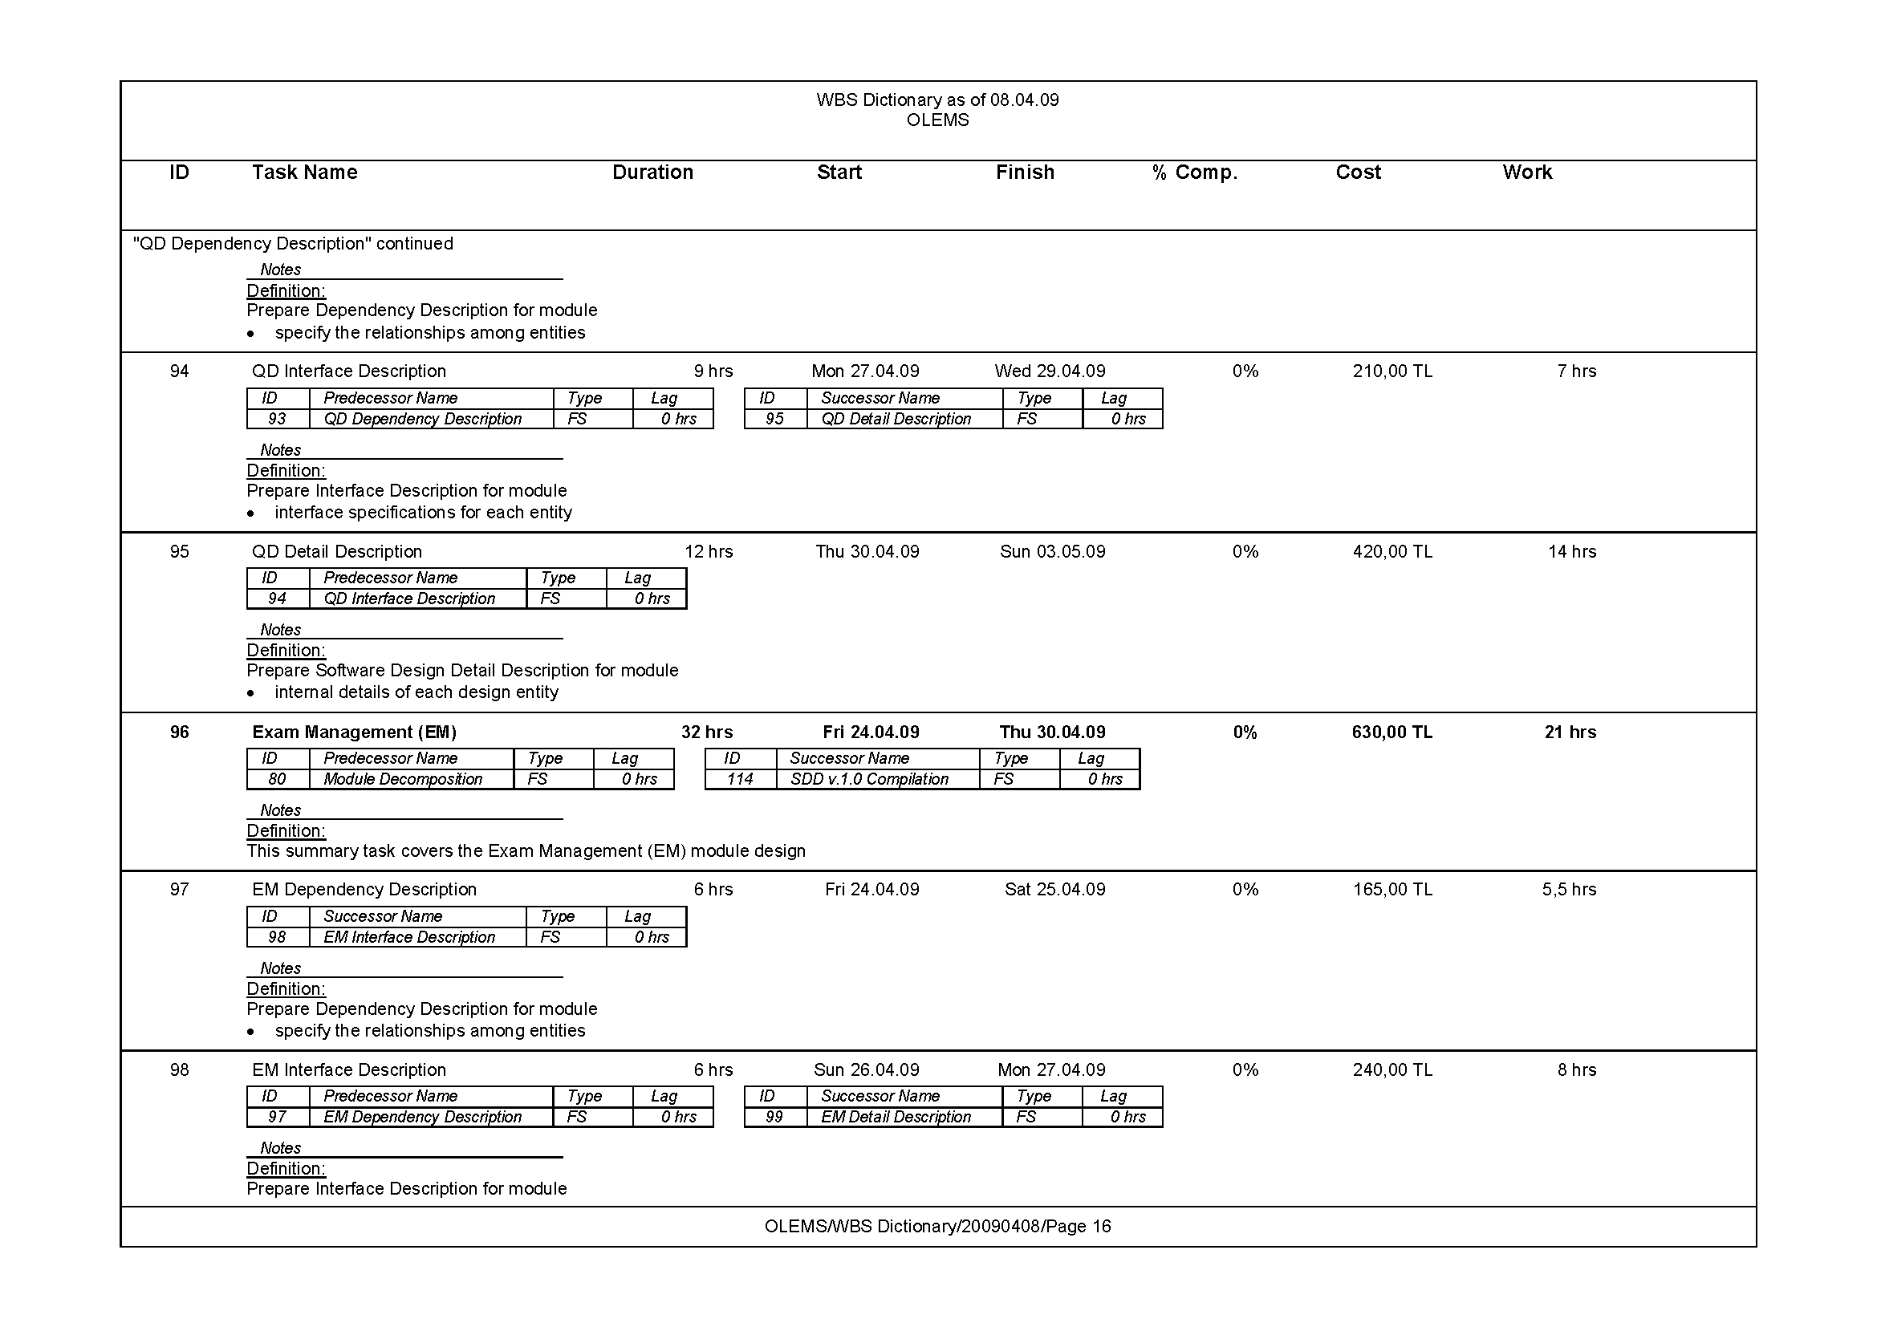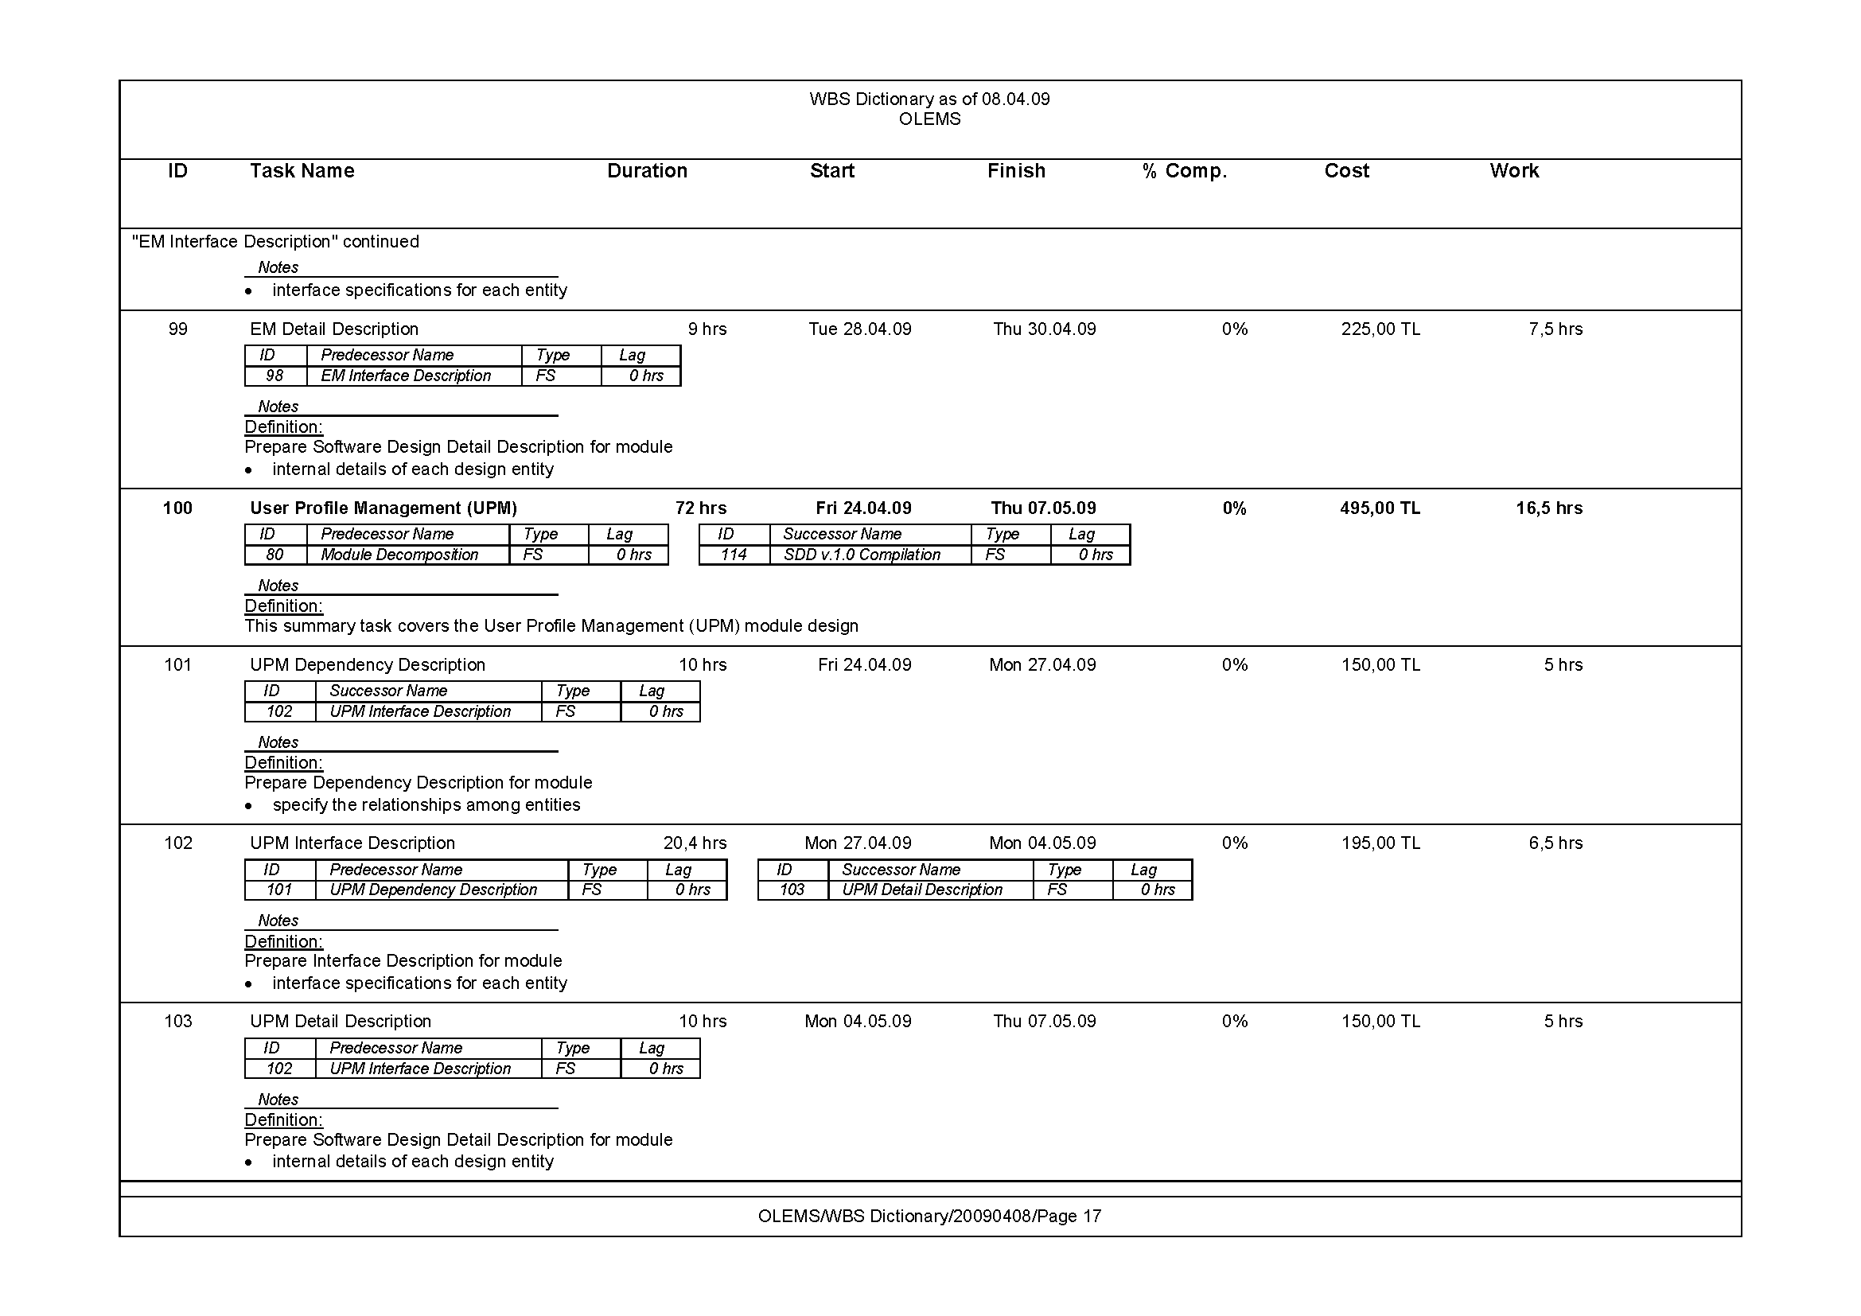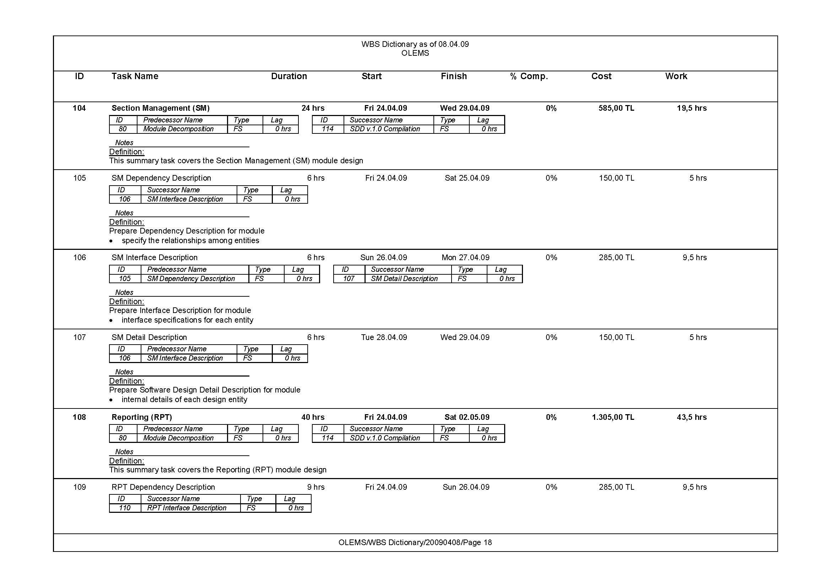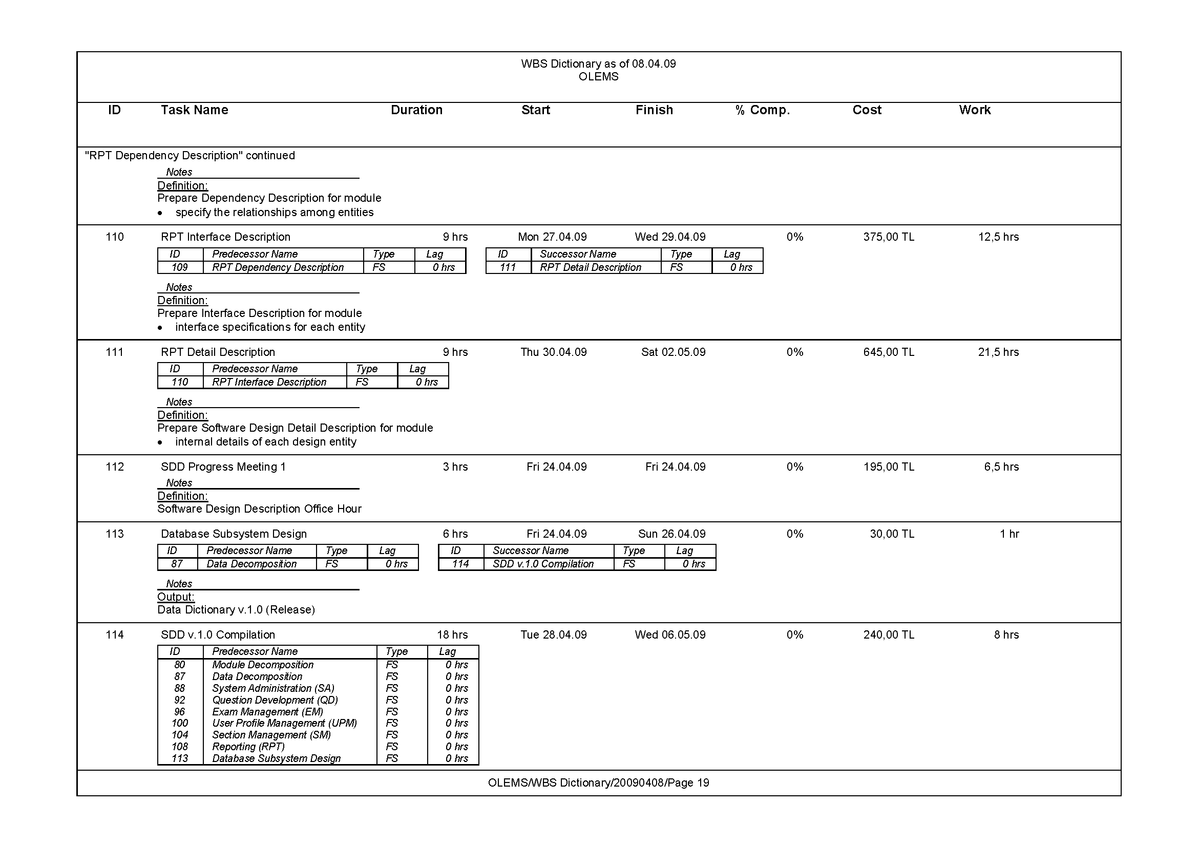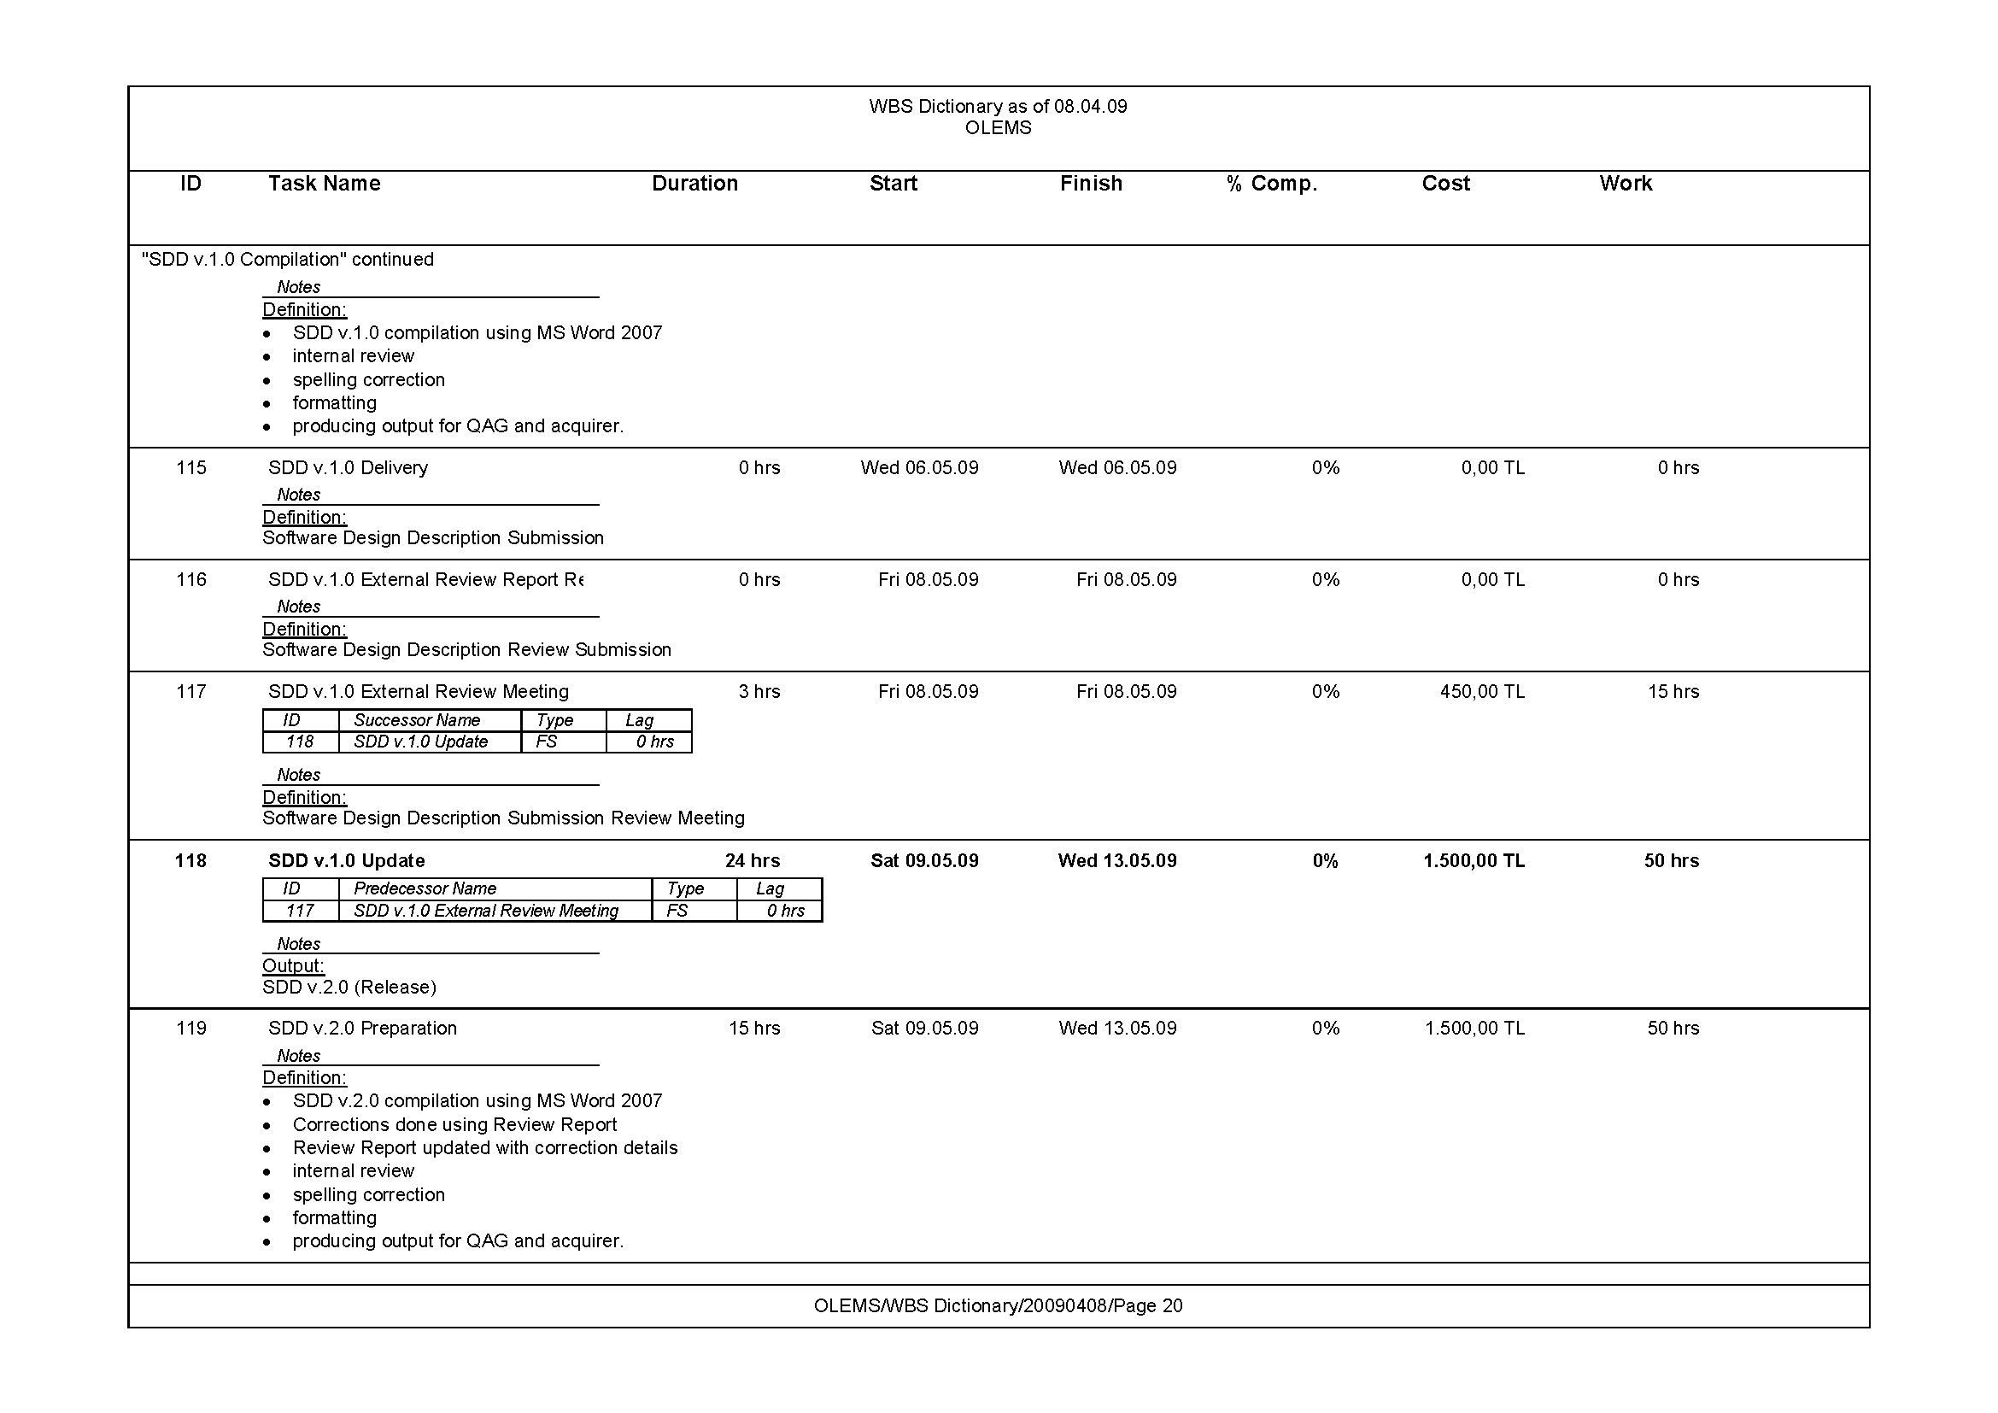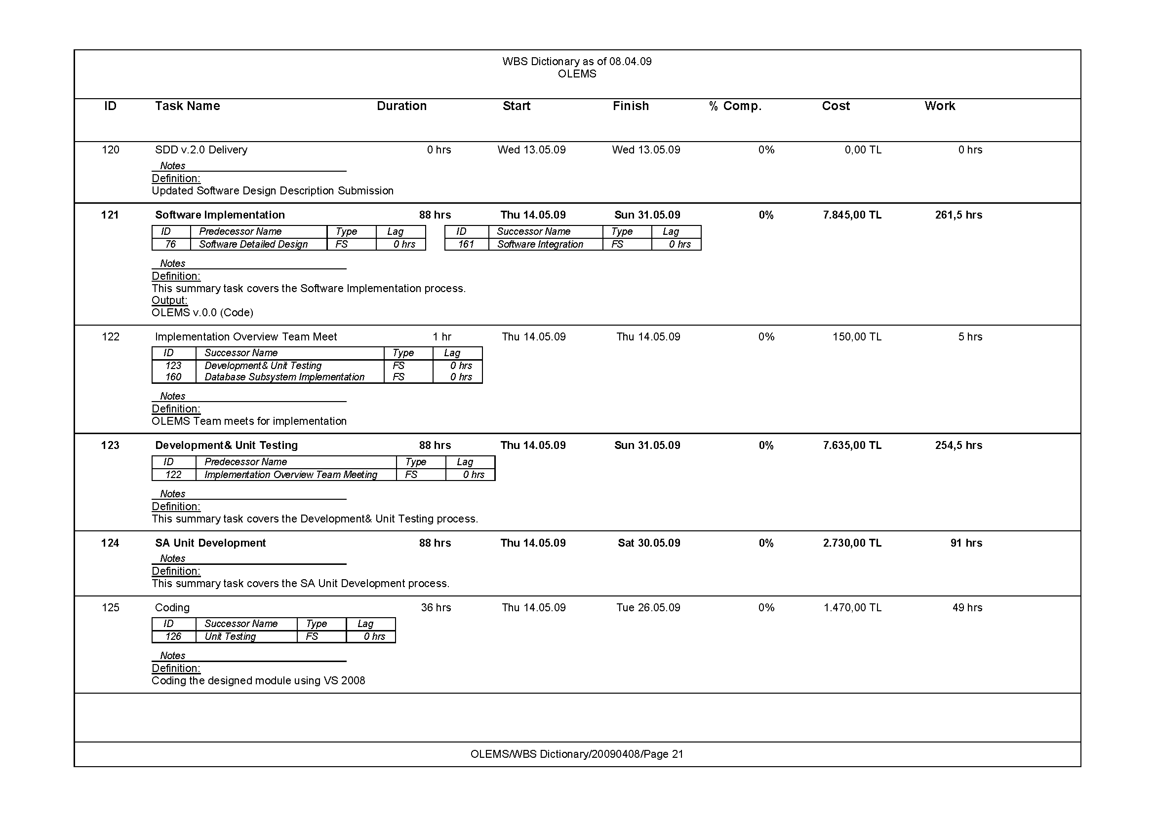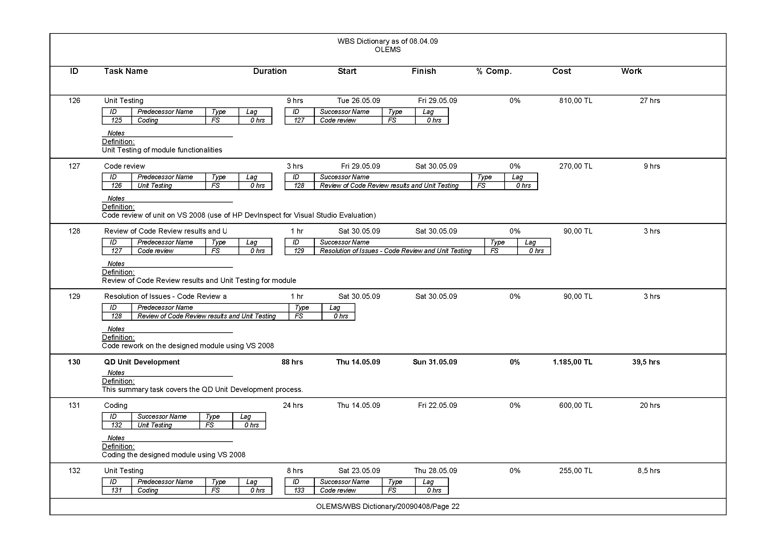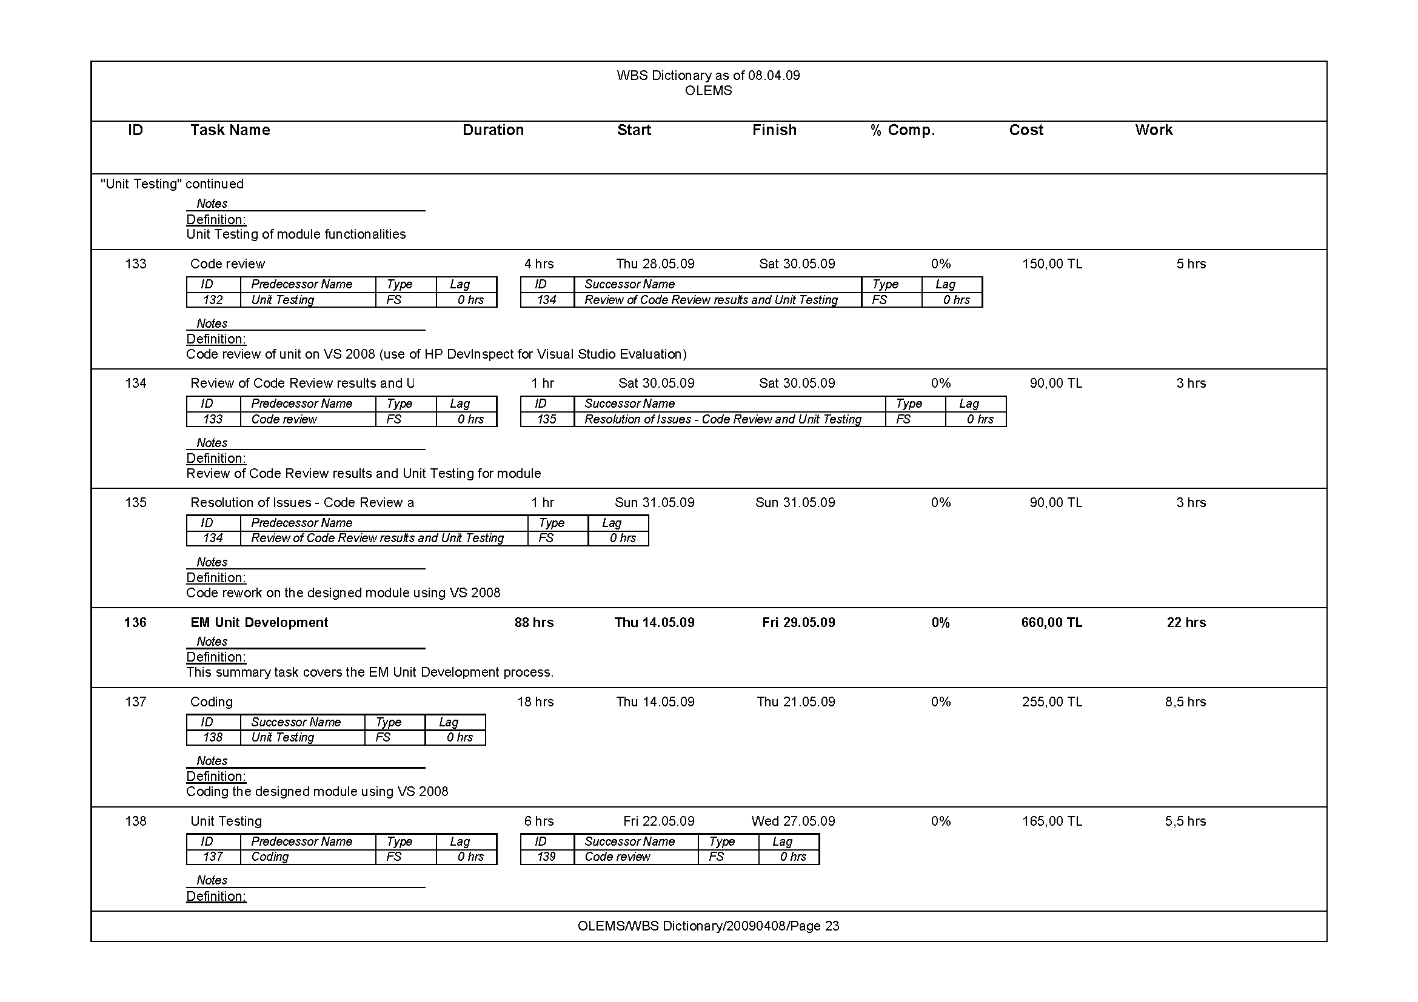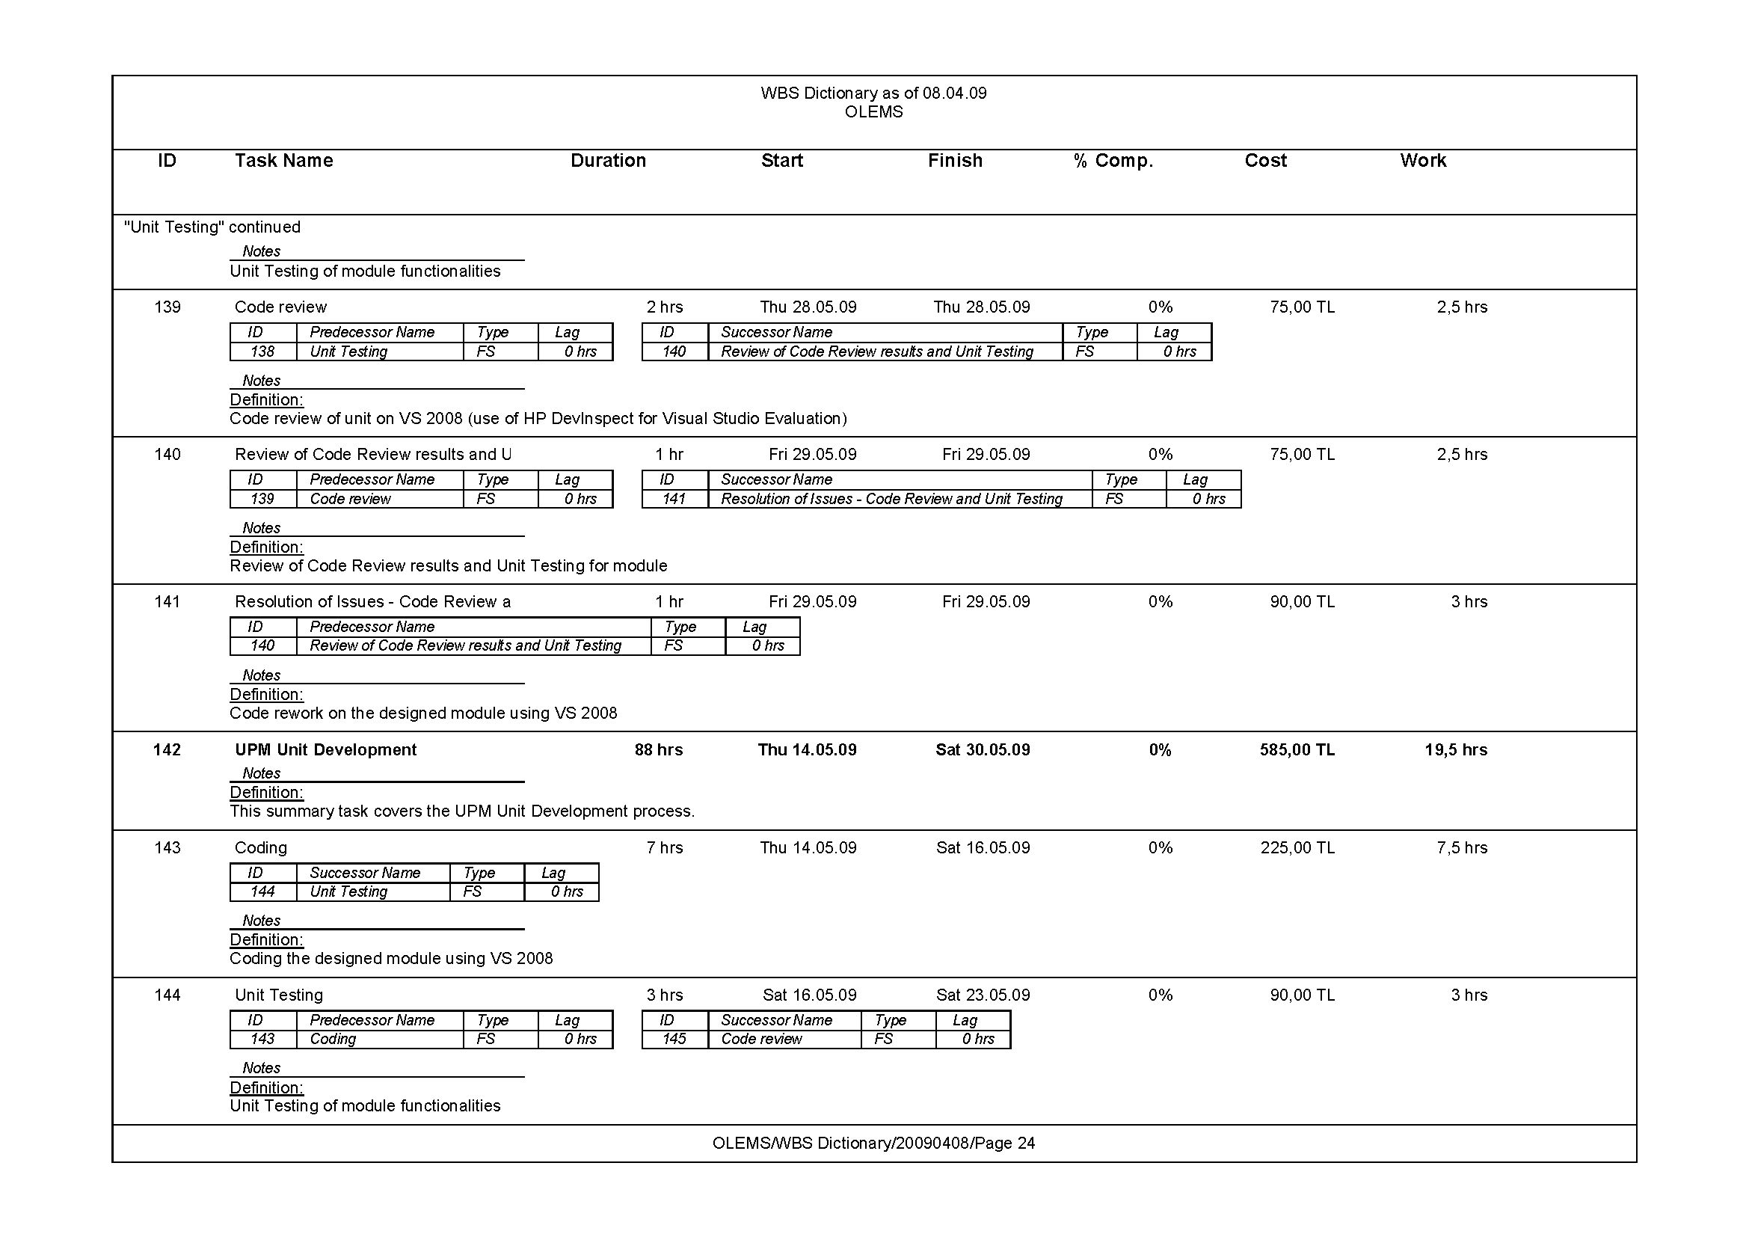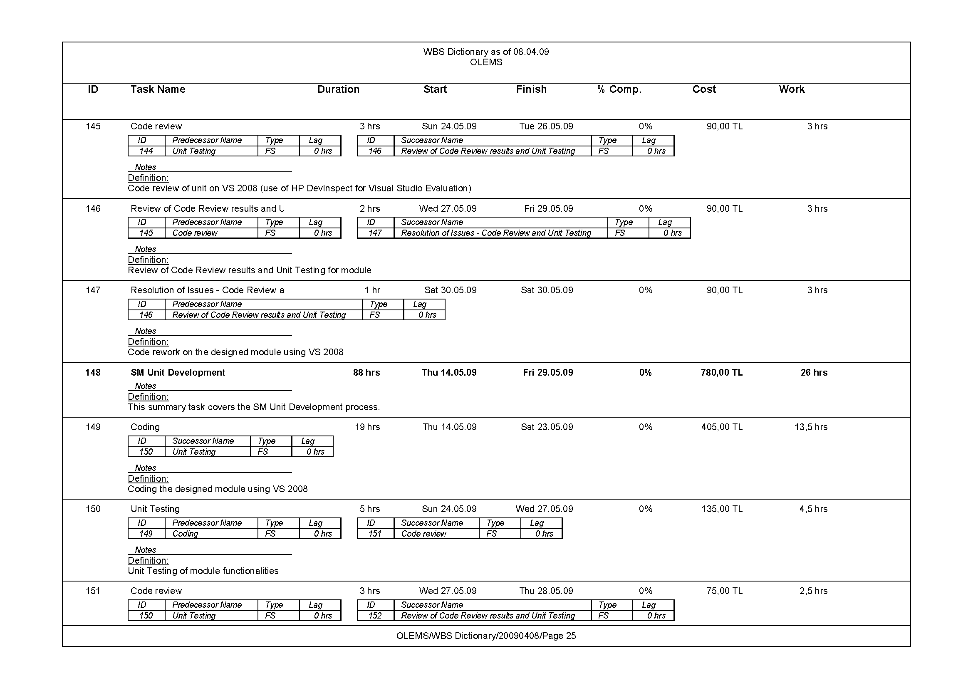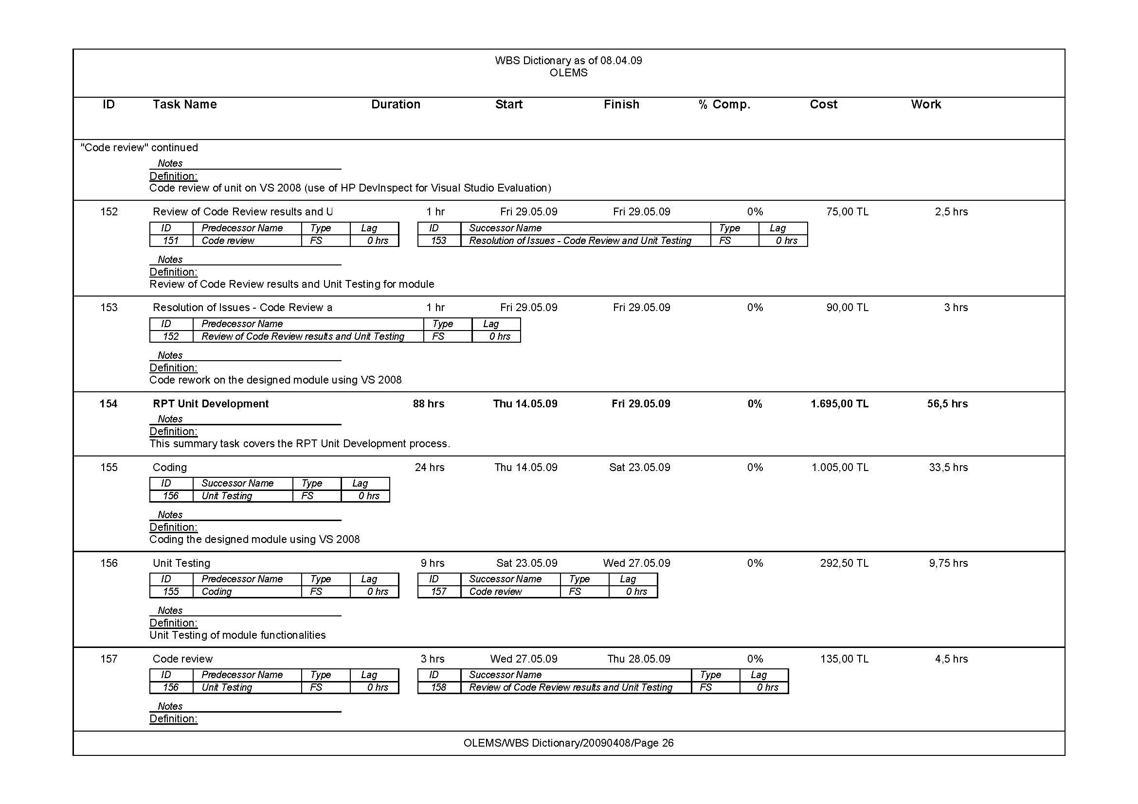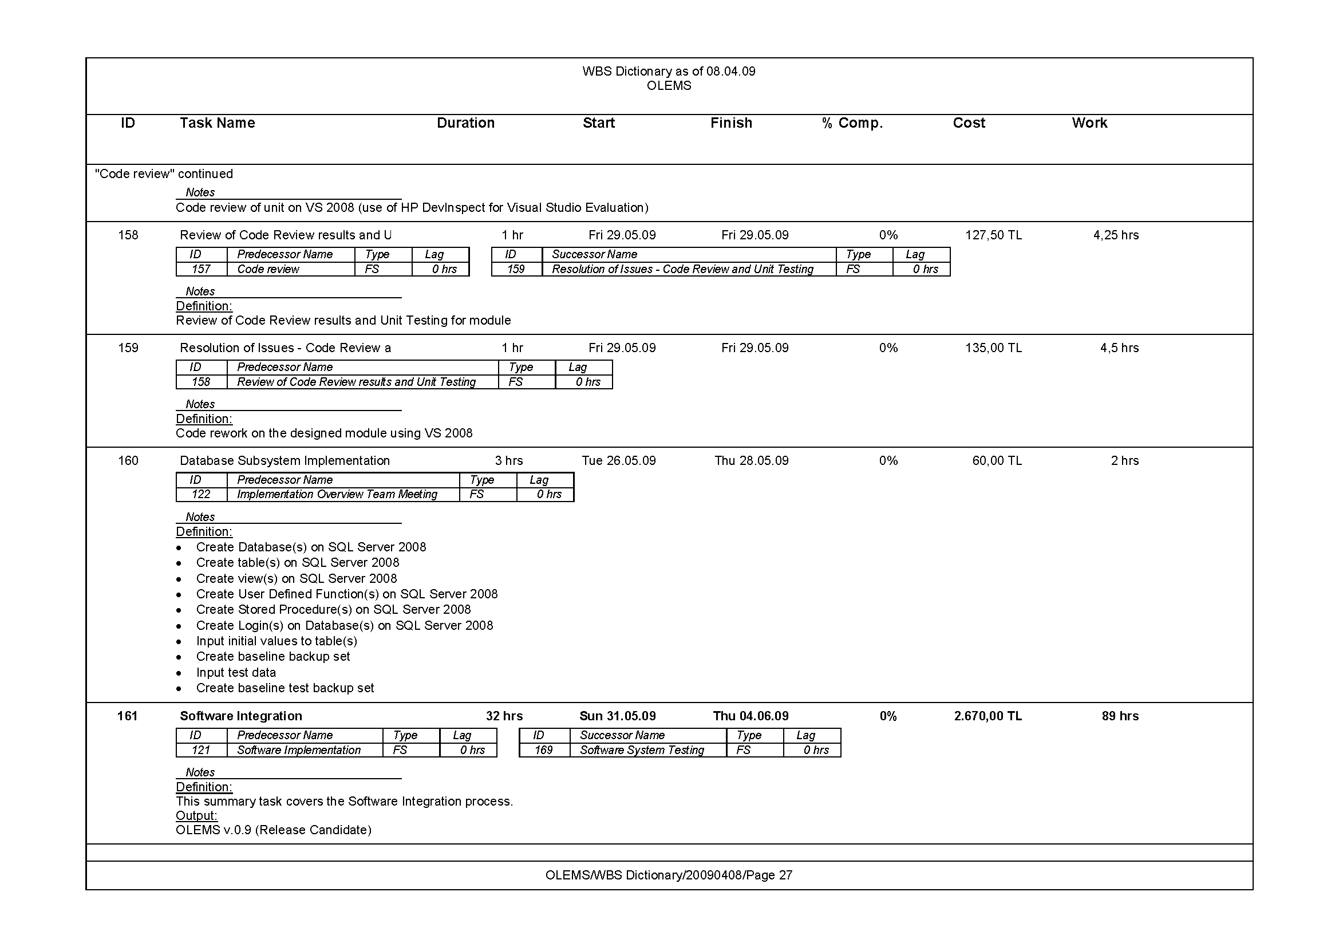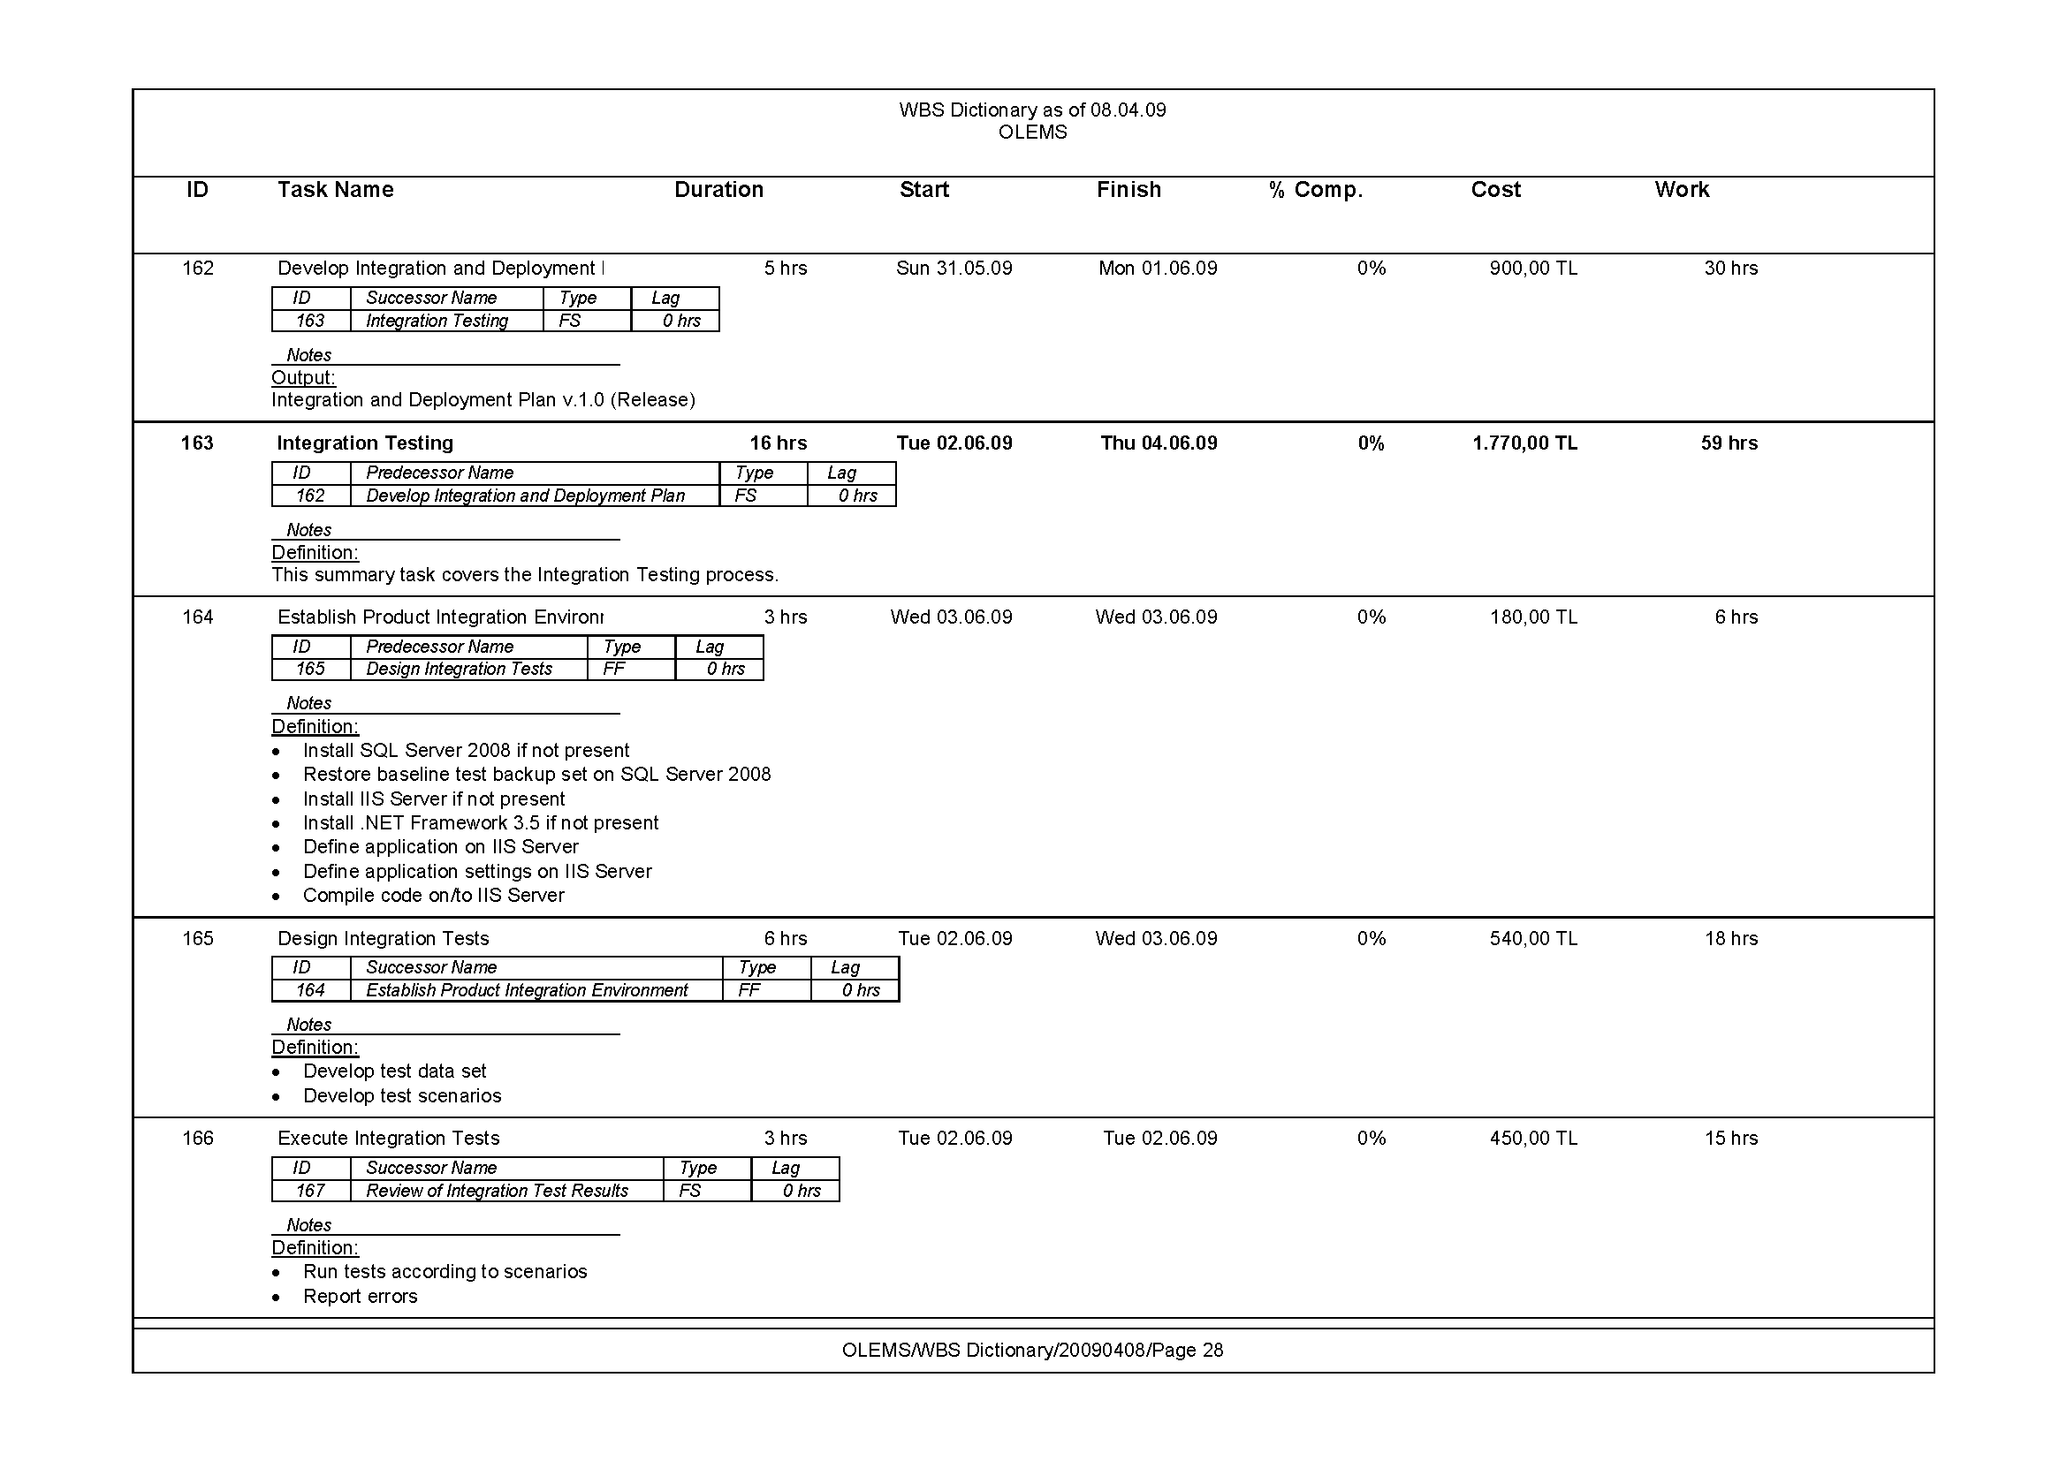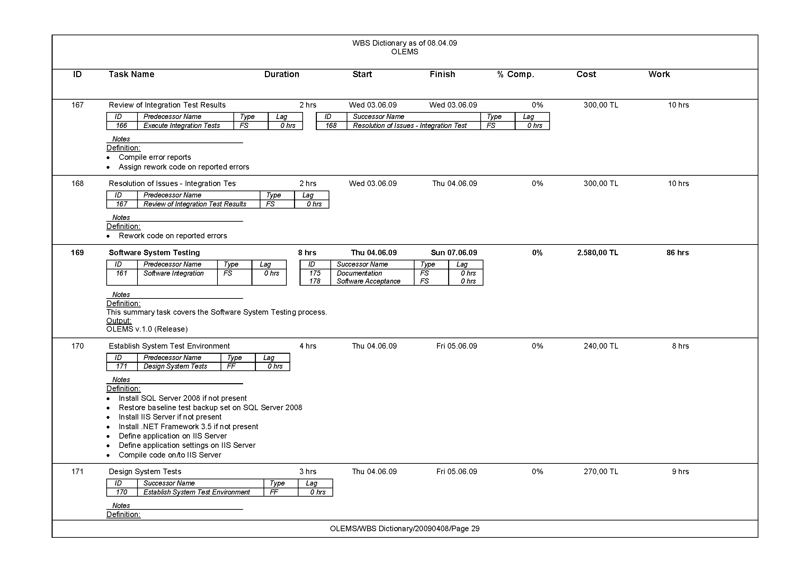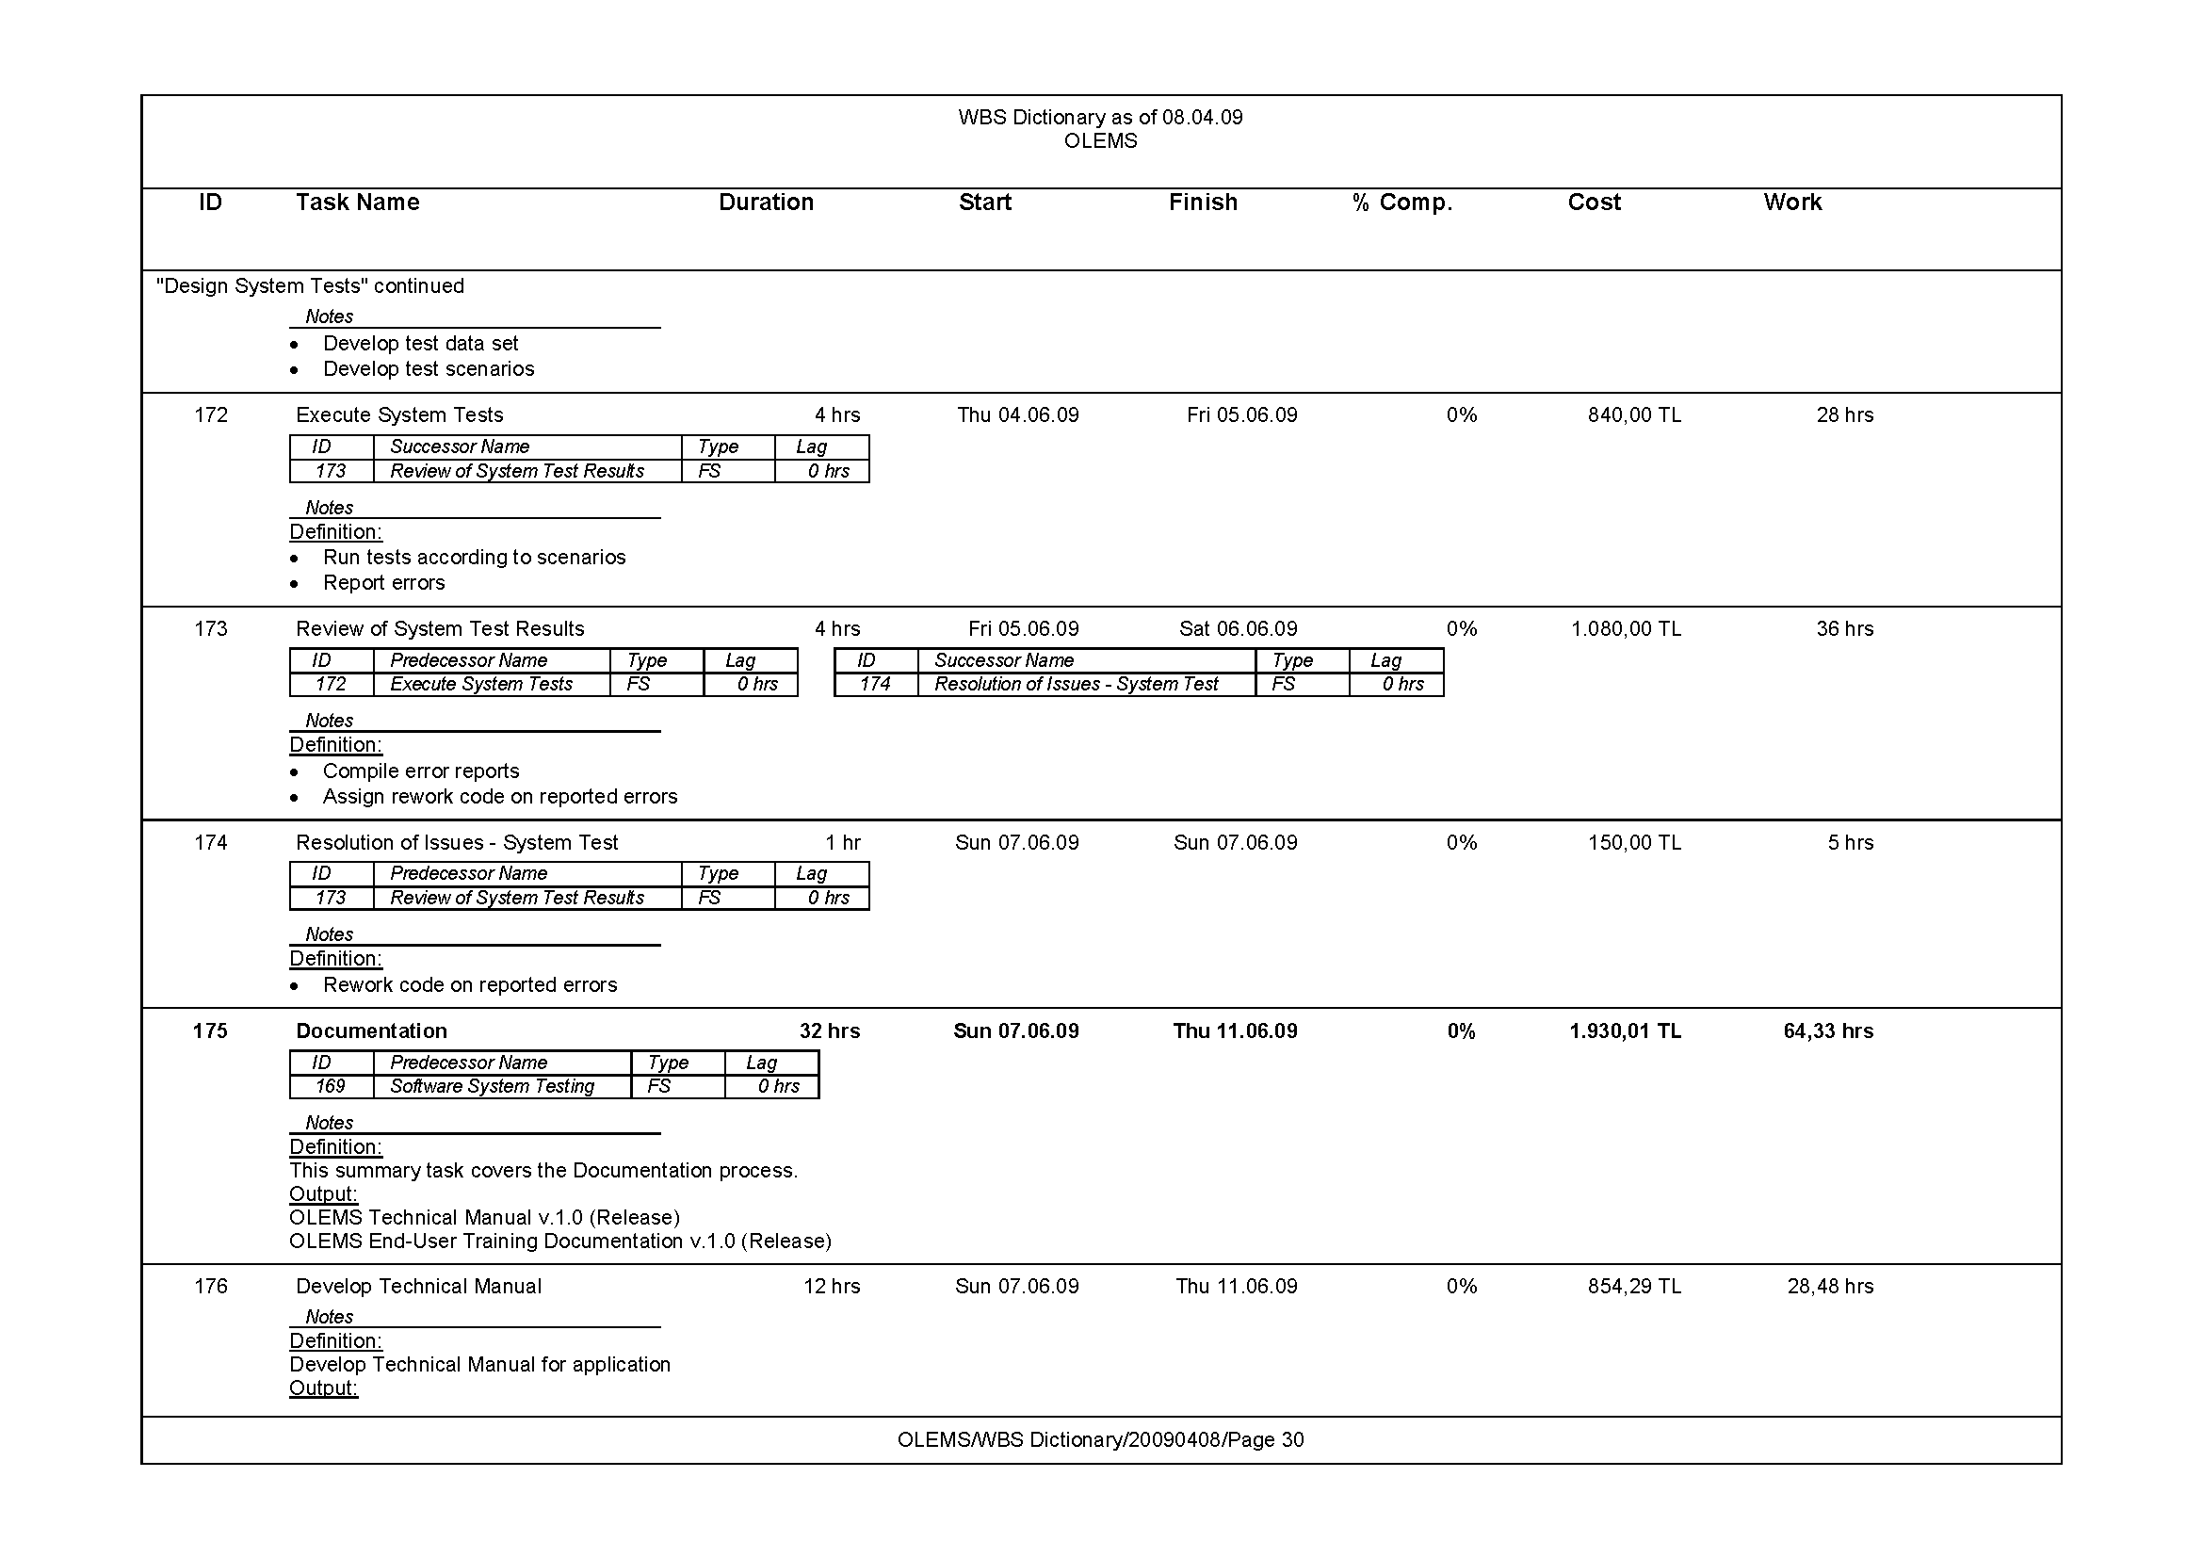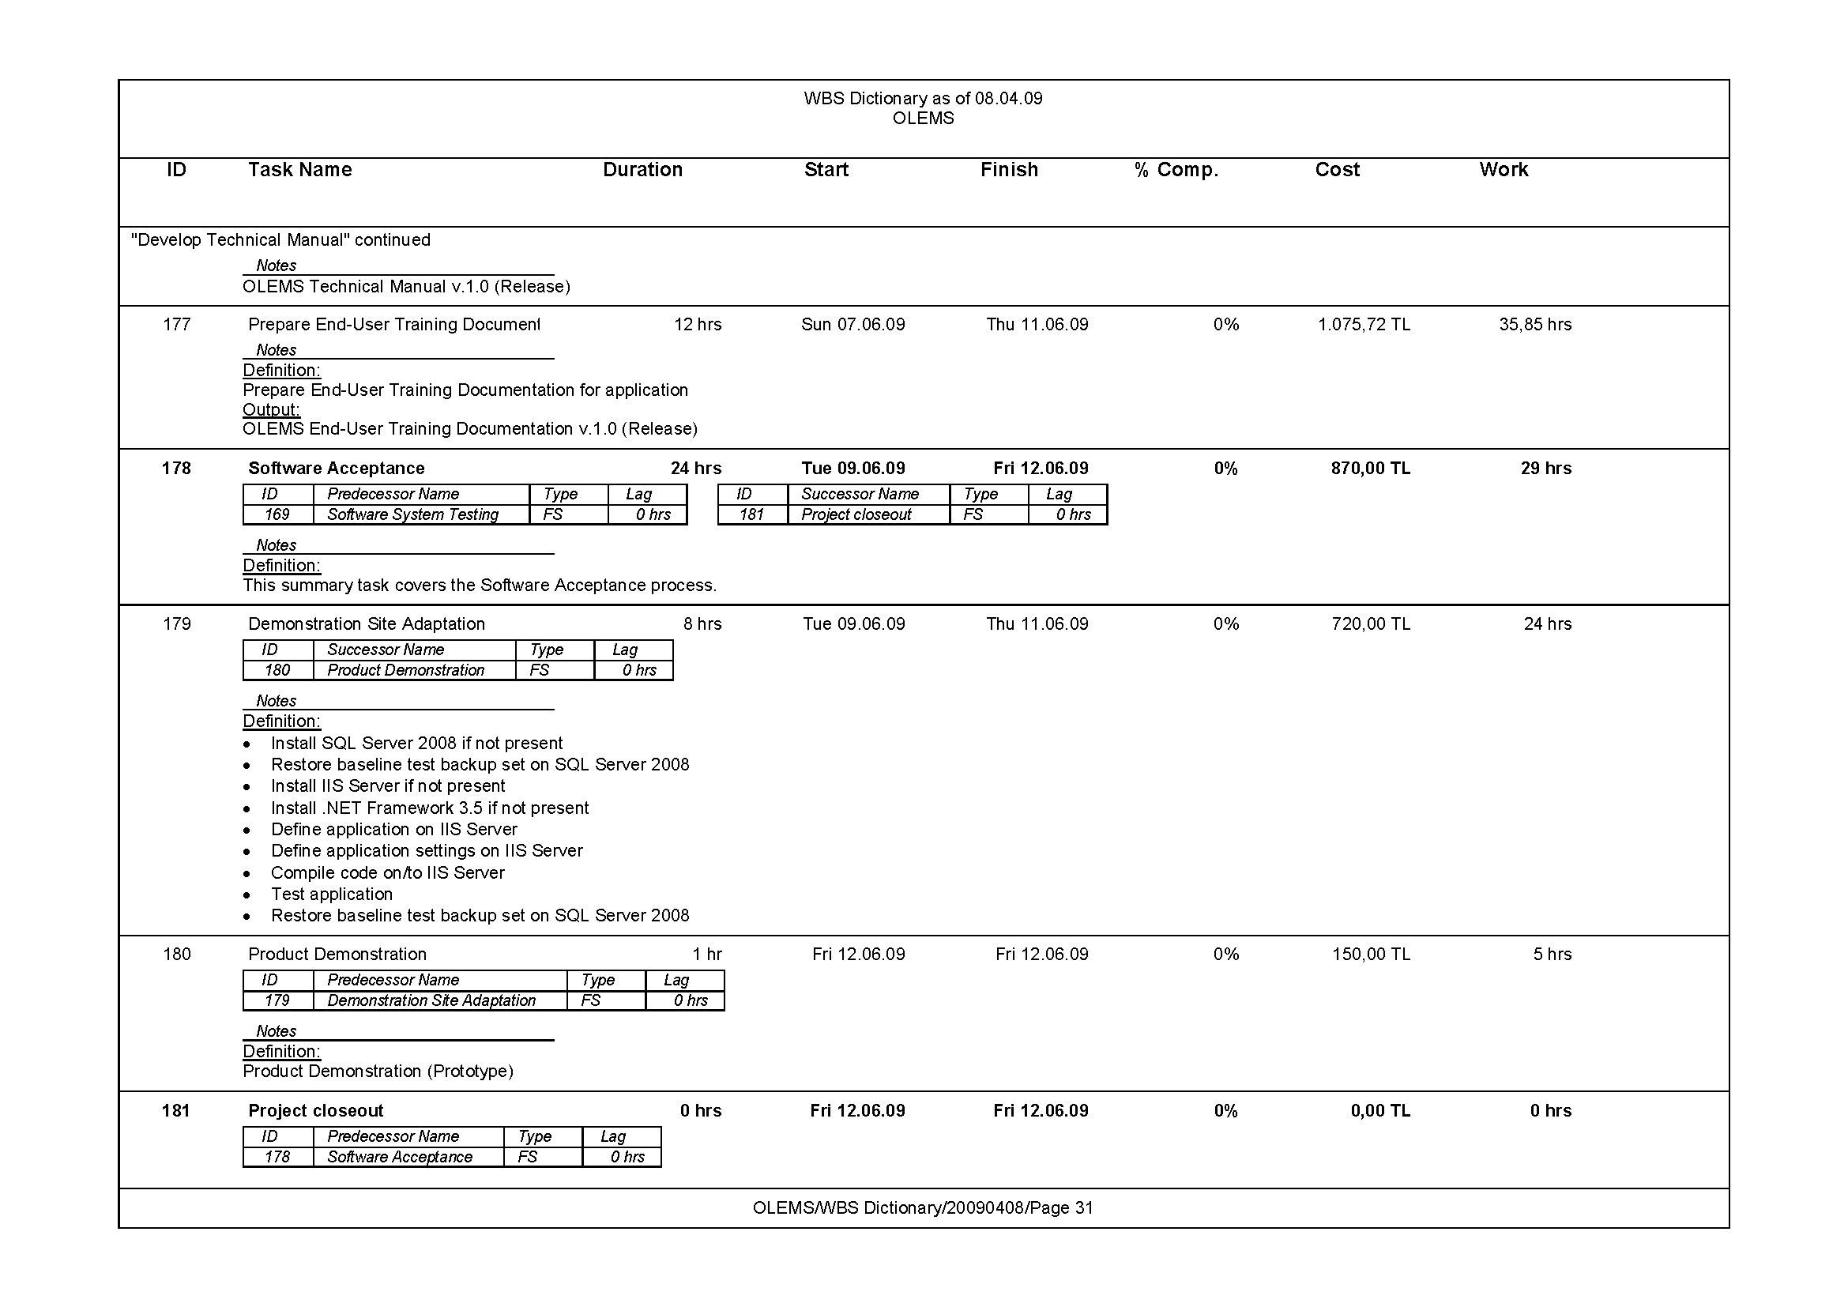

# Project Schedule

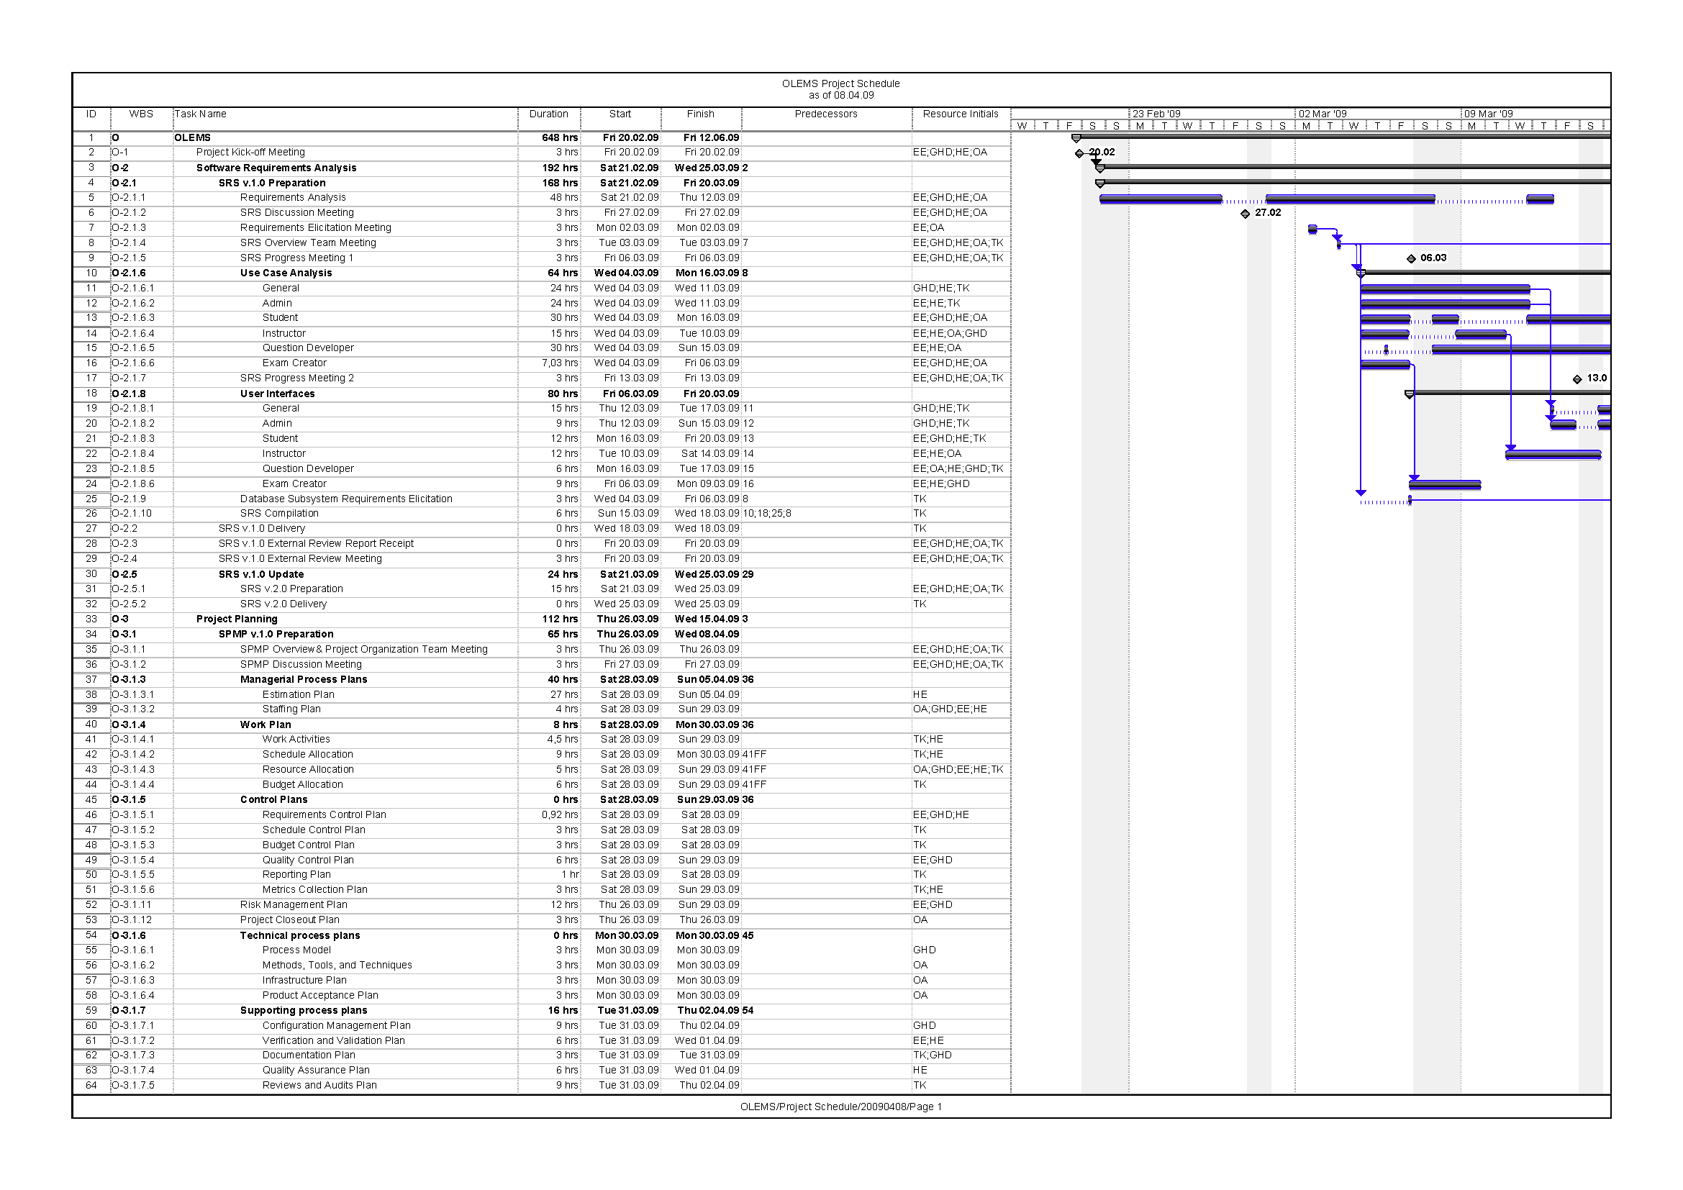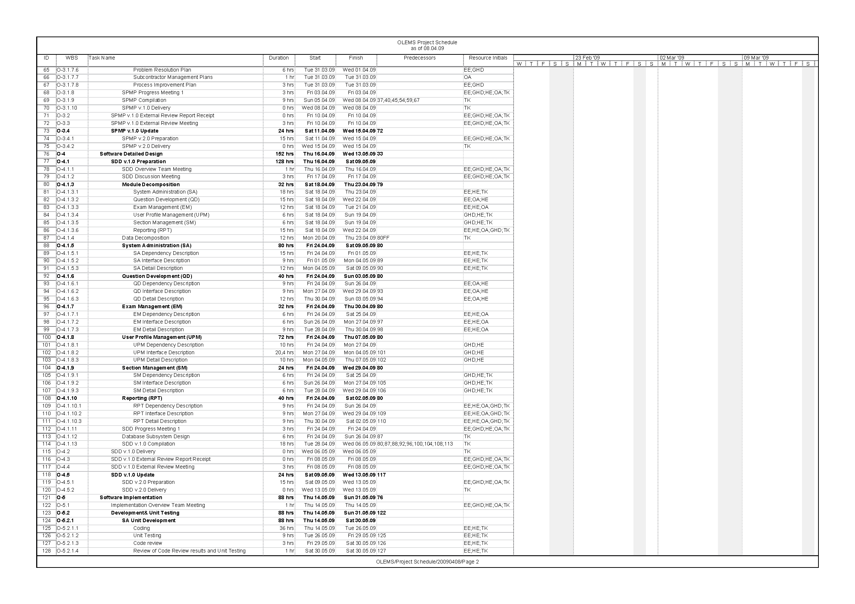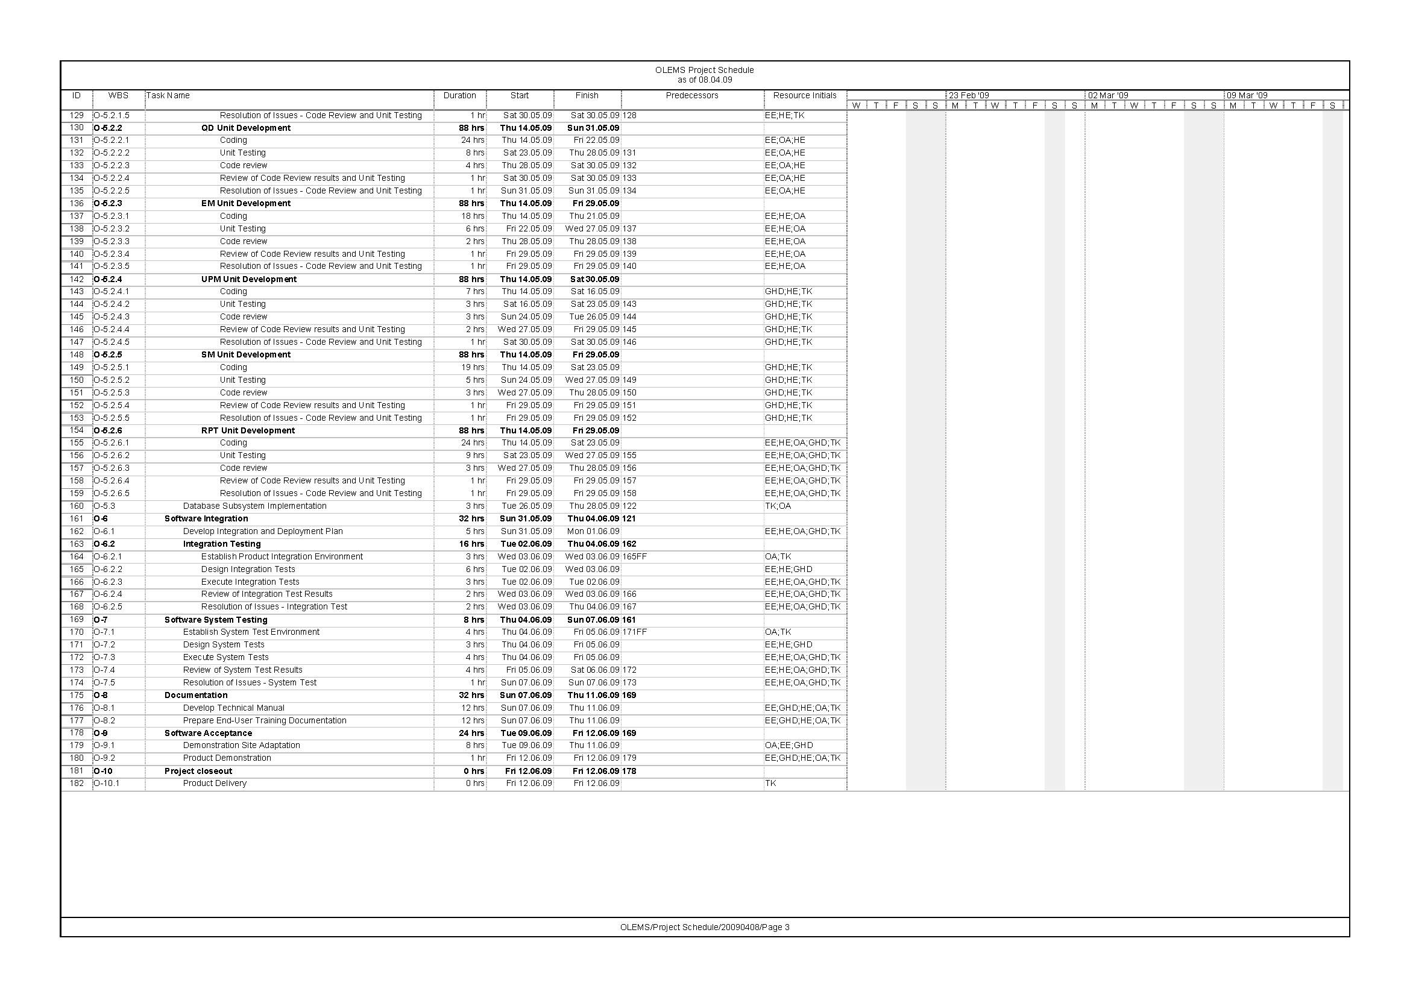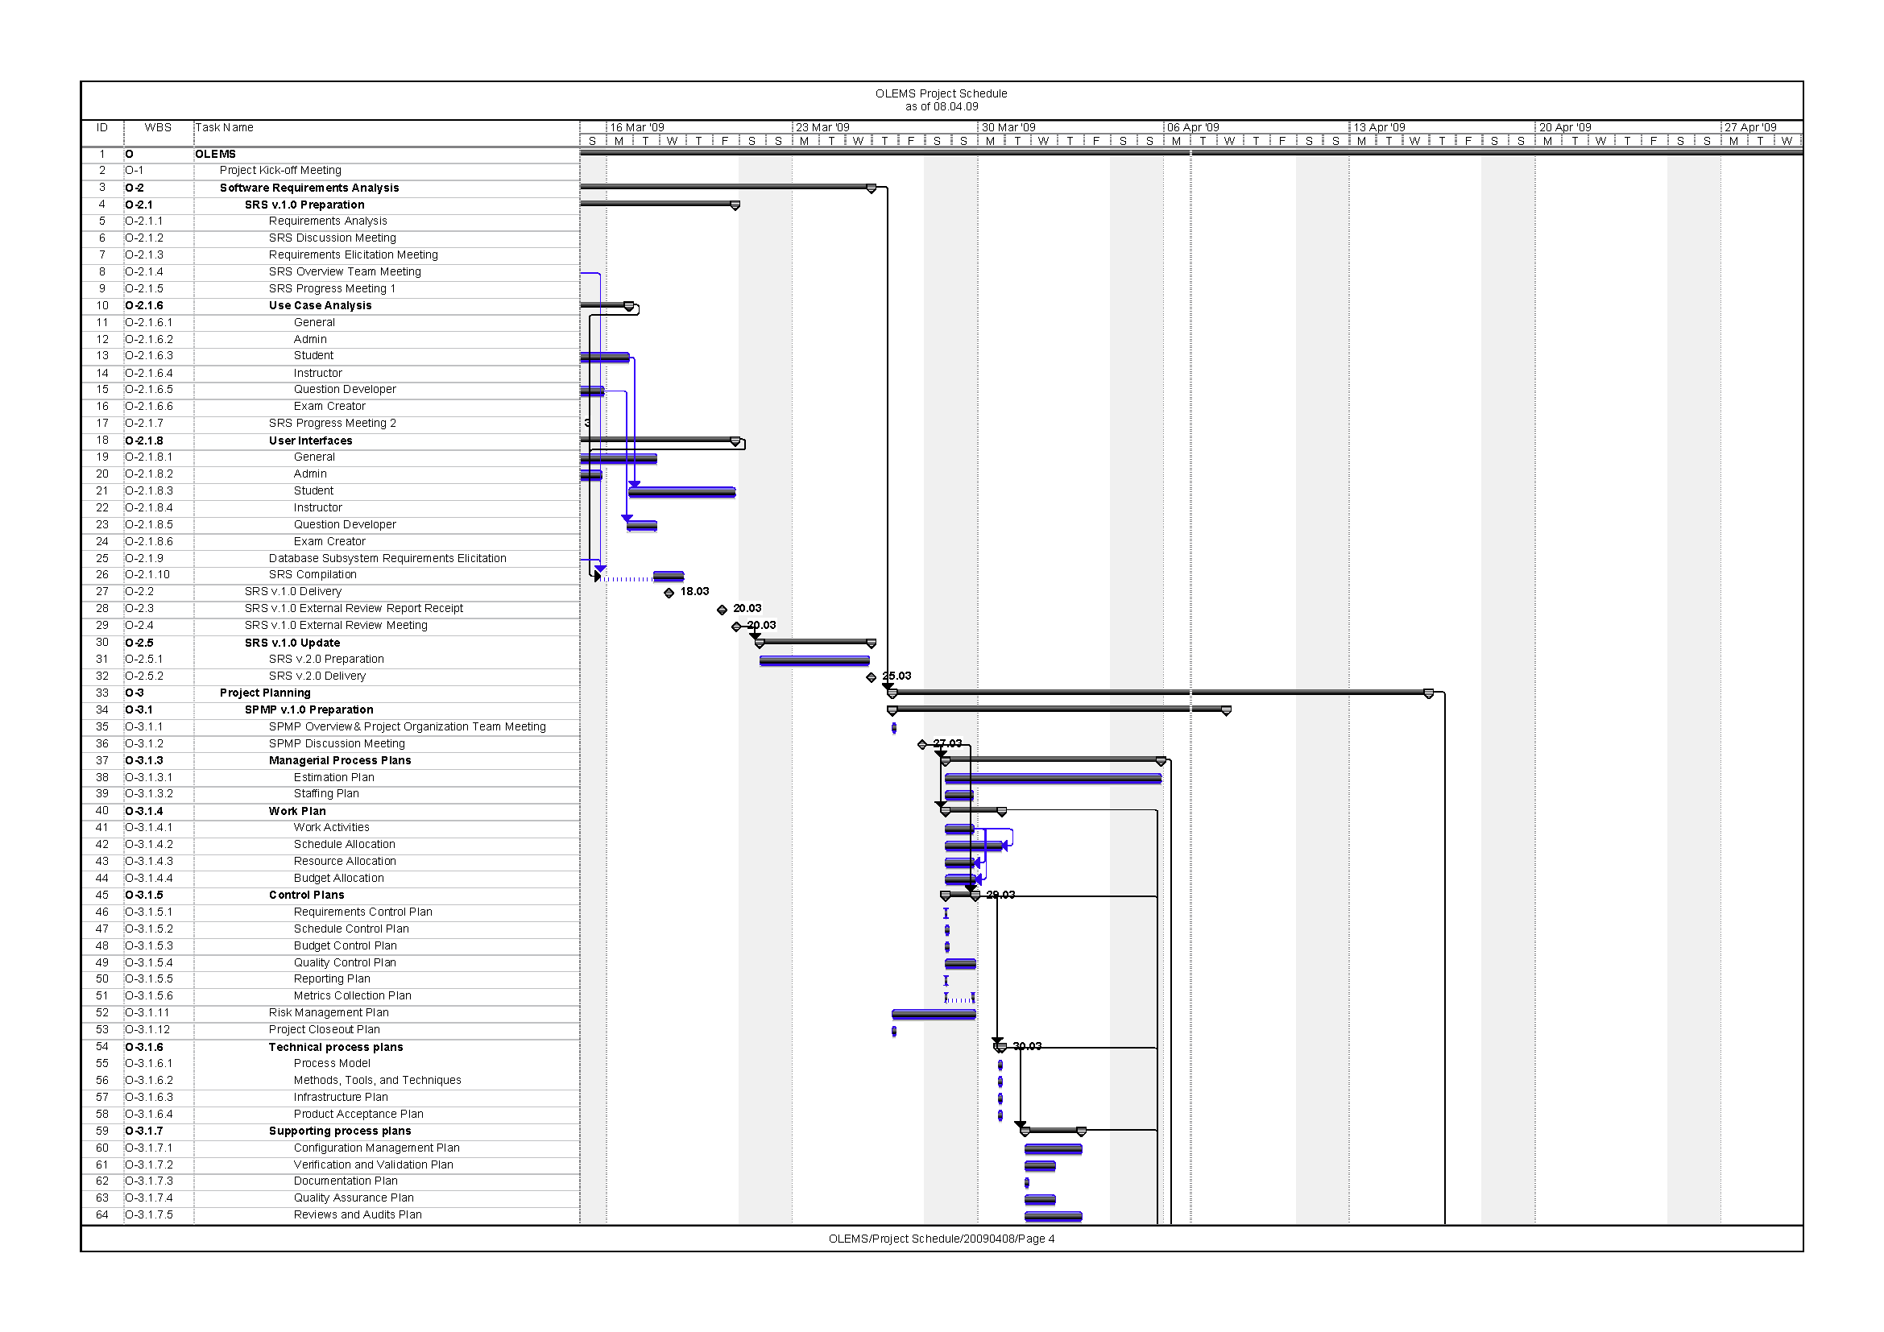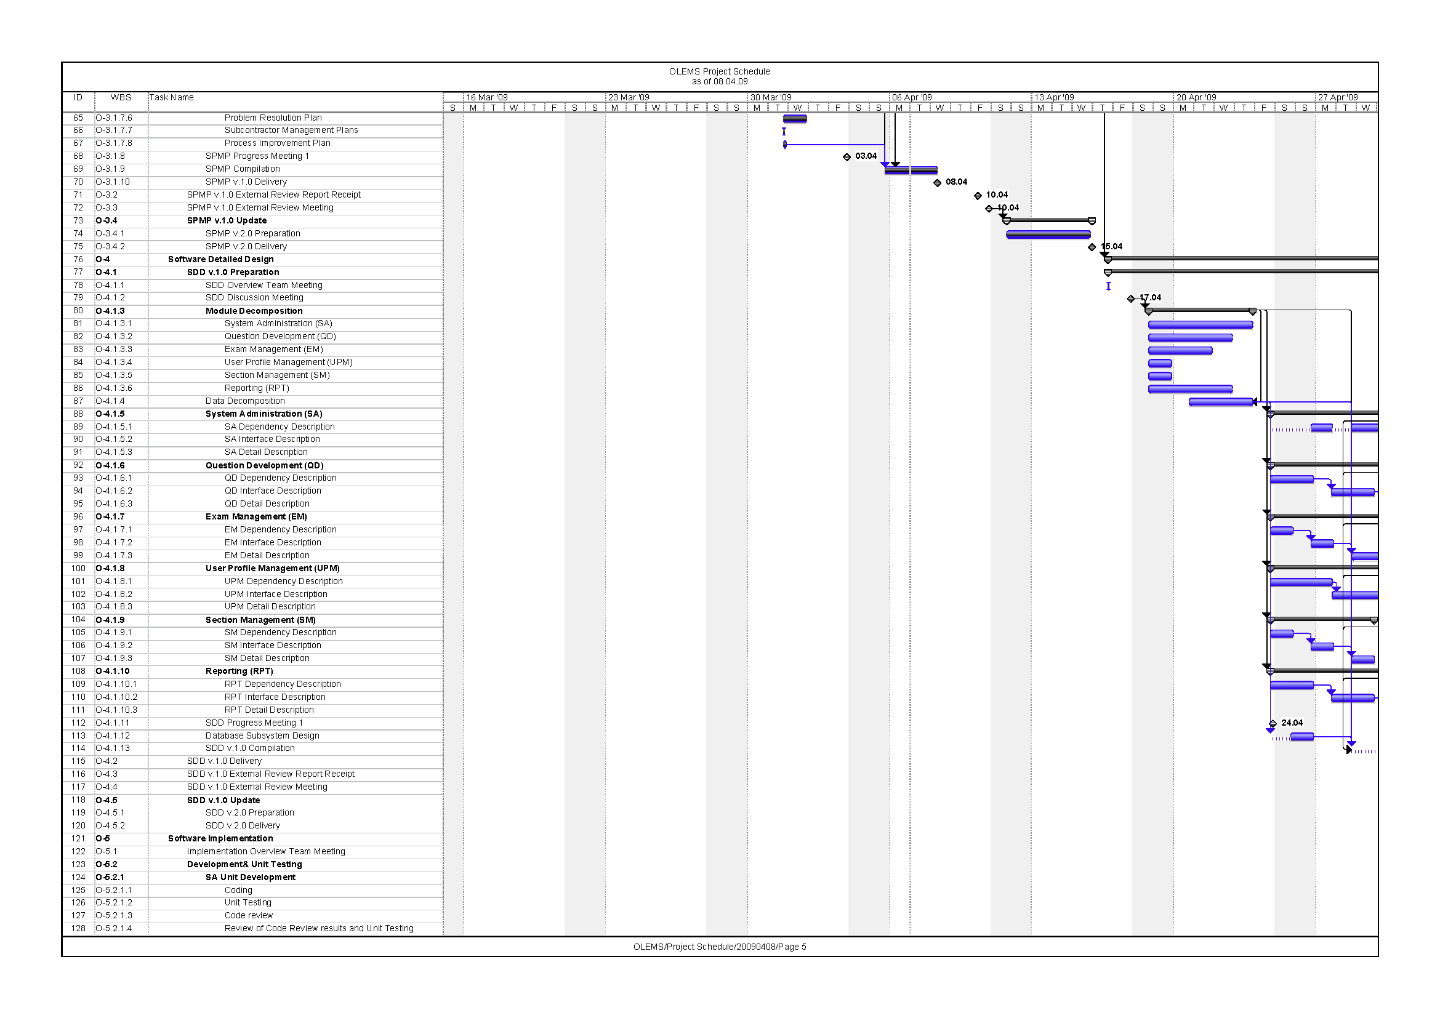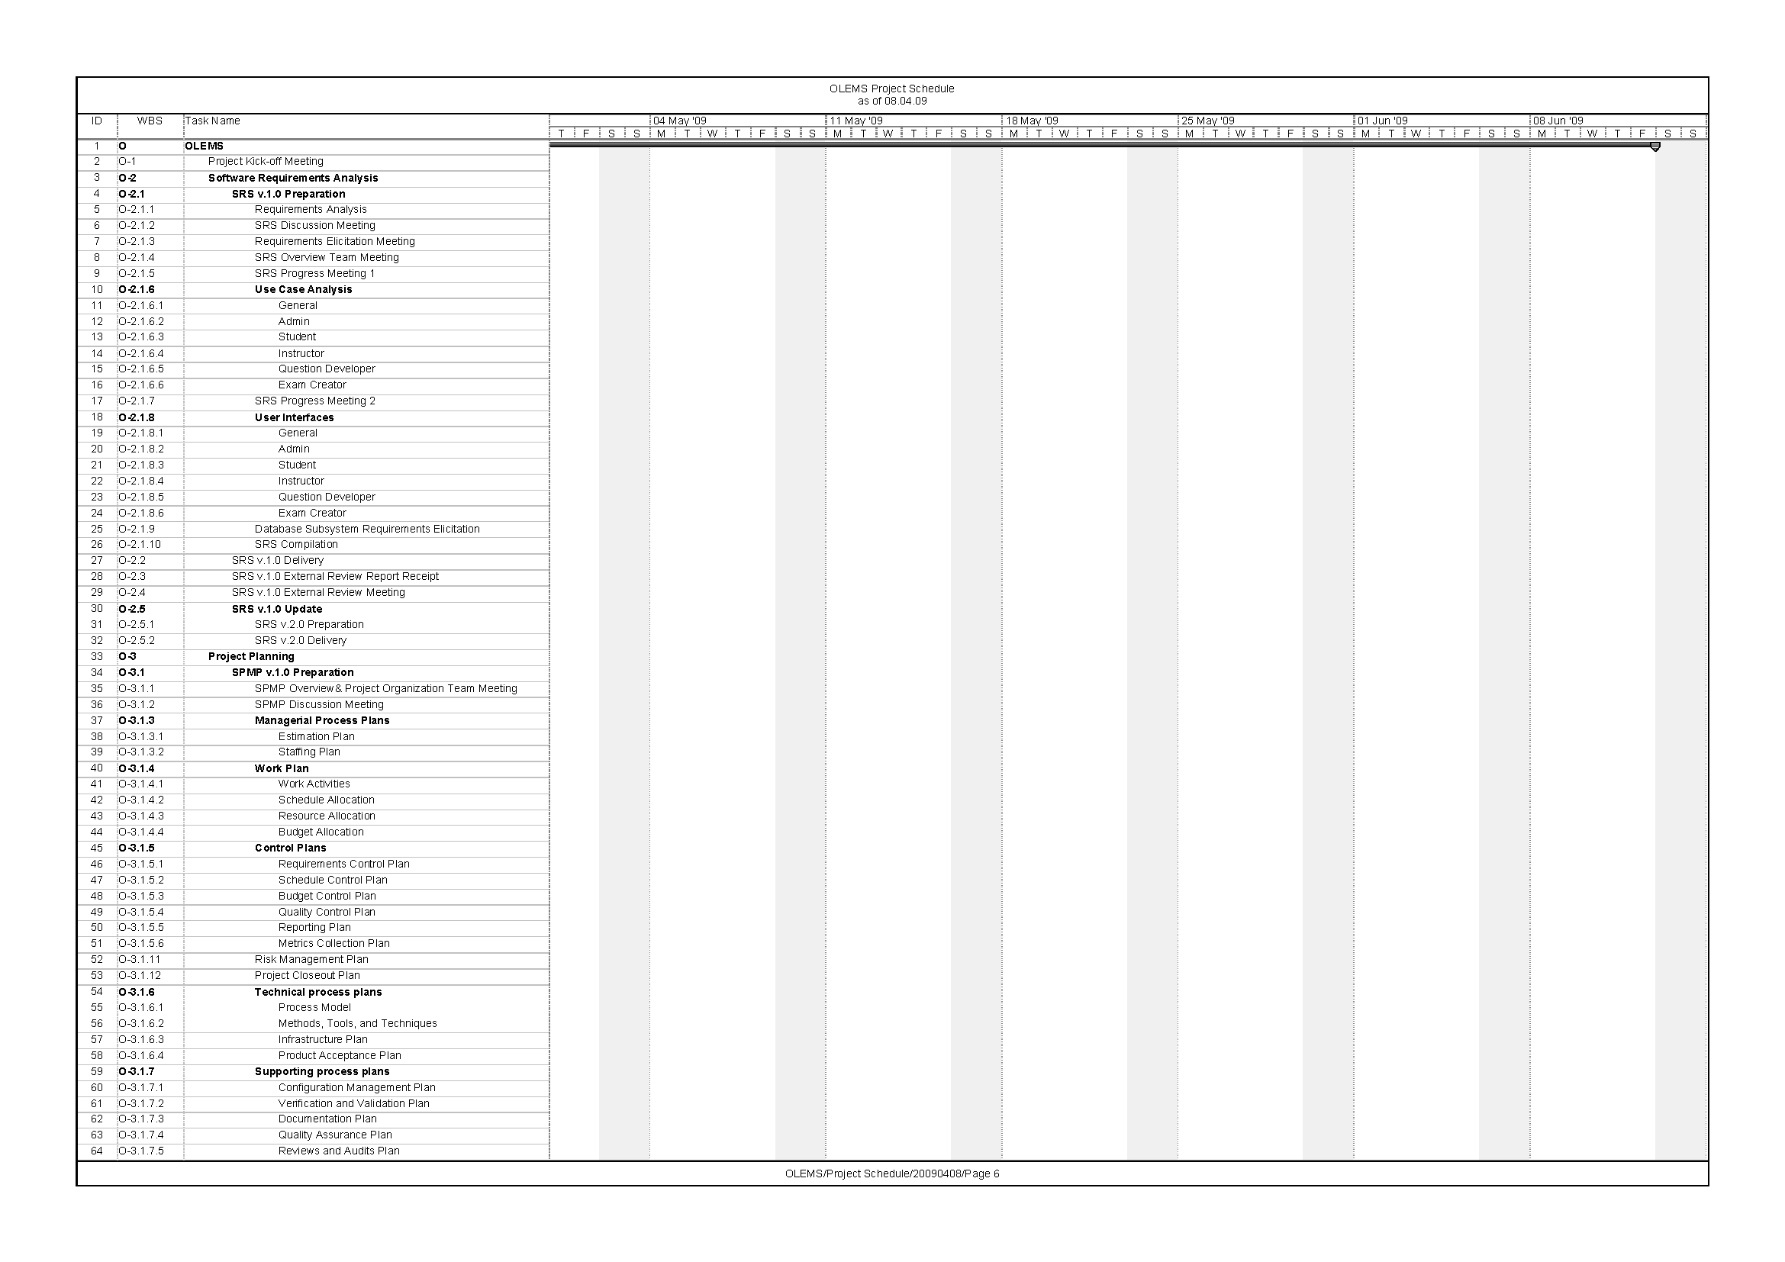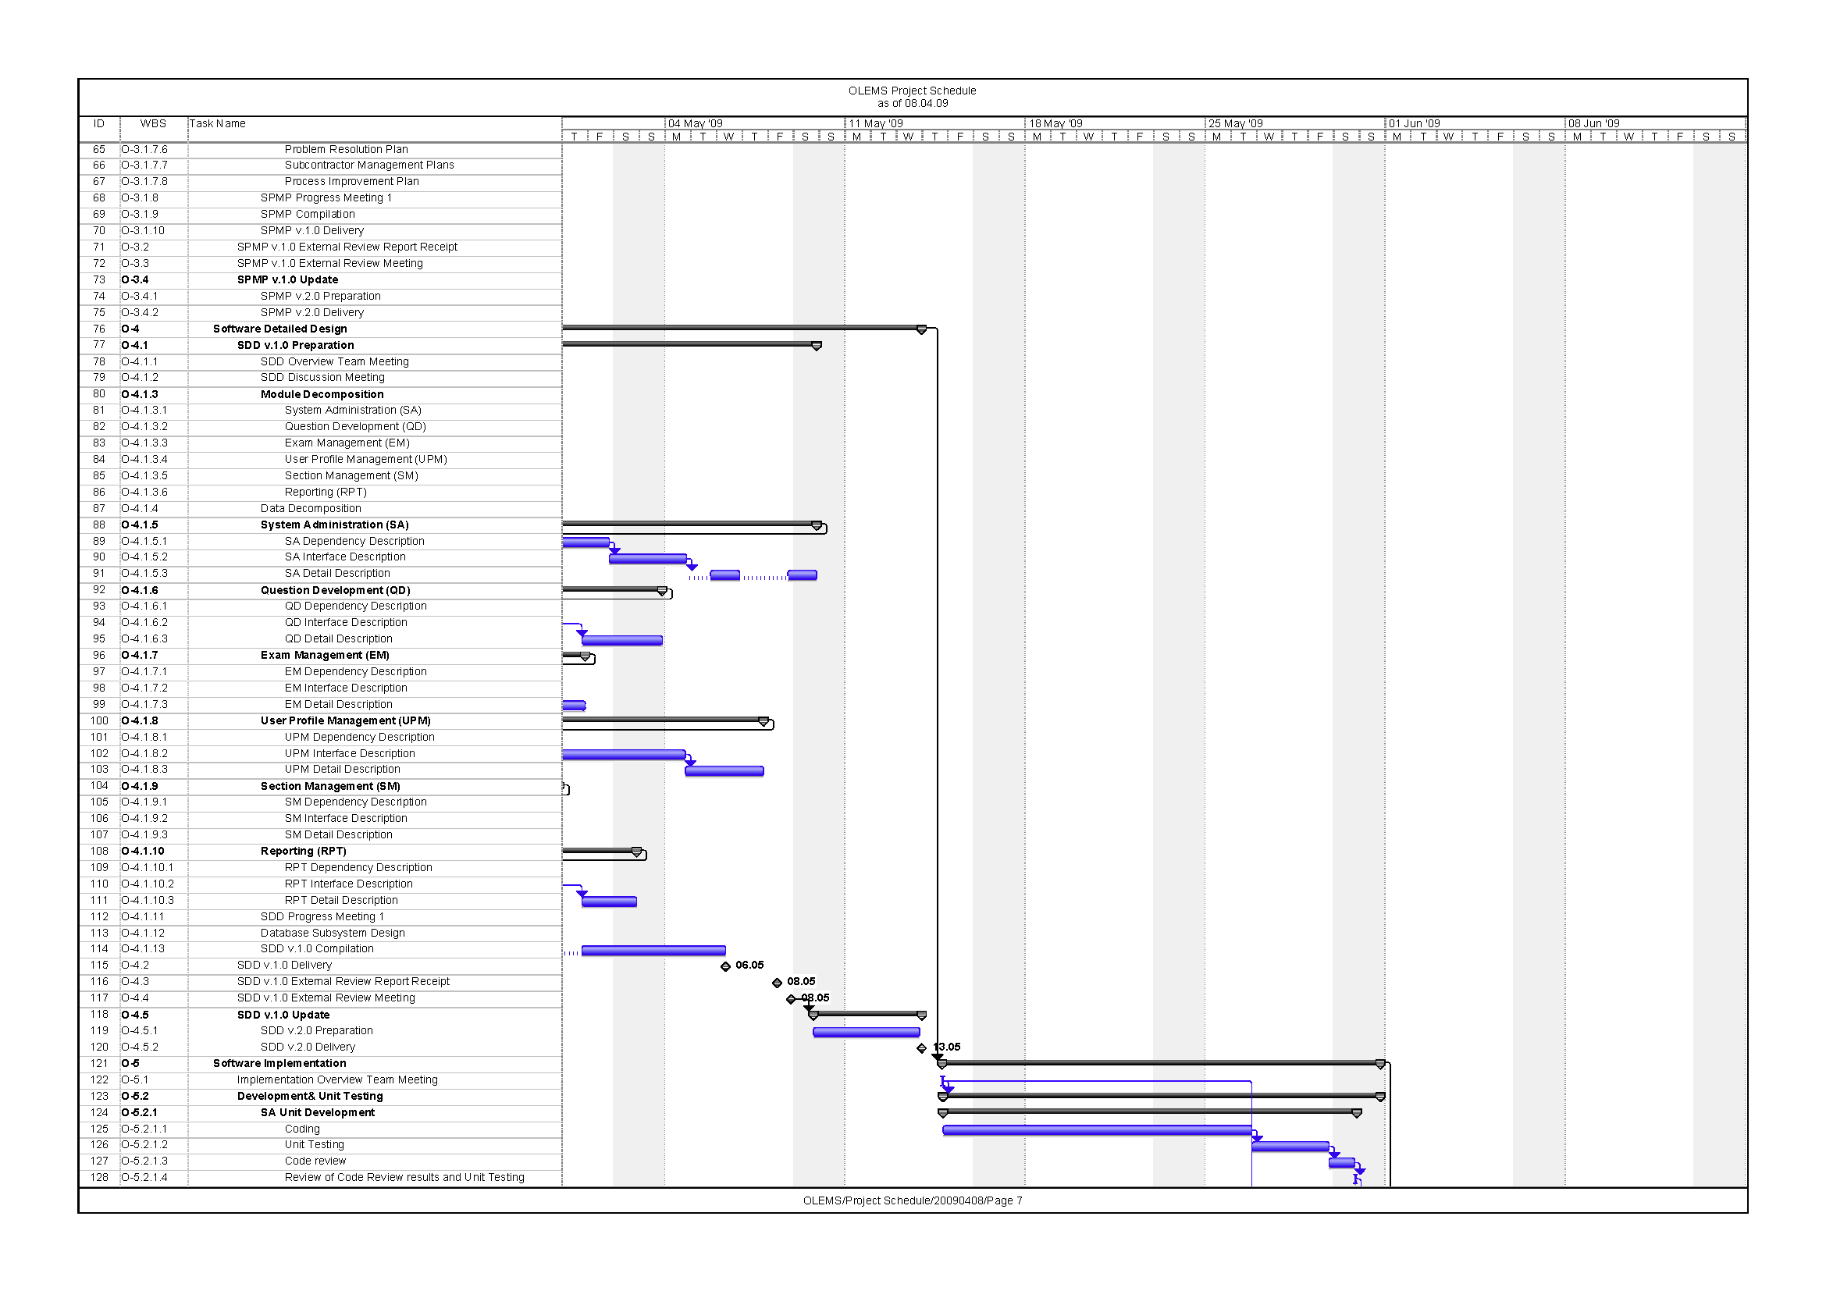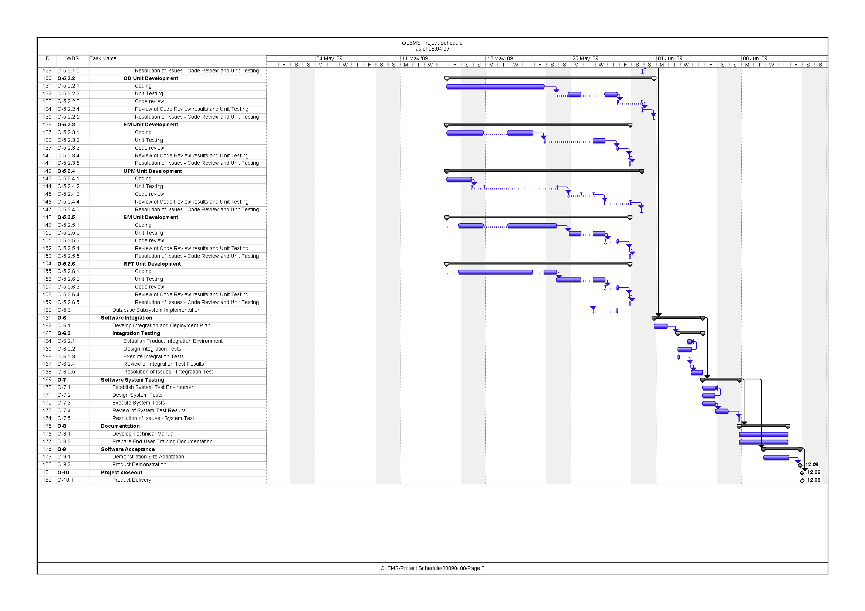

# Weekly Resource Usage

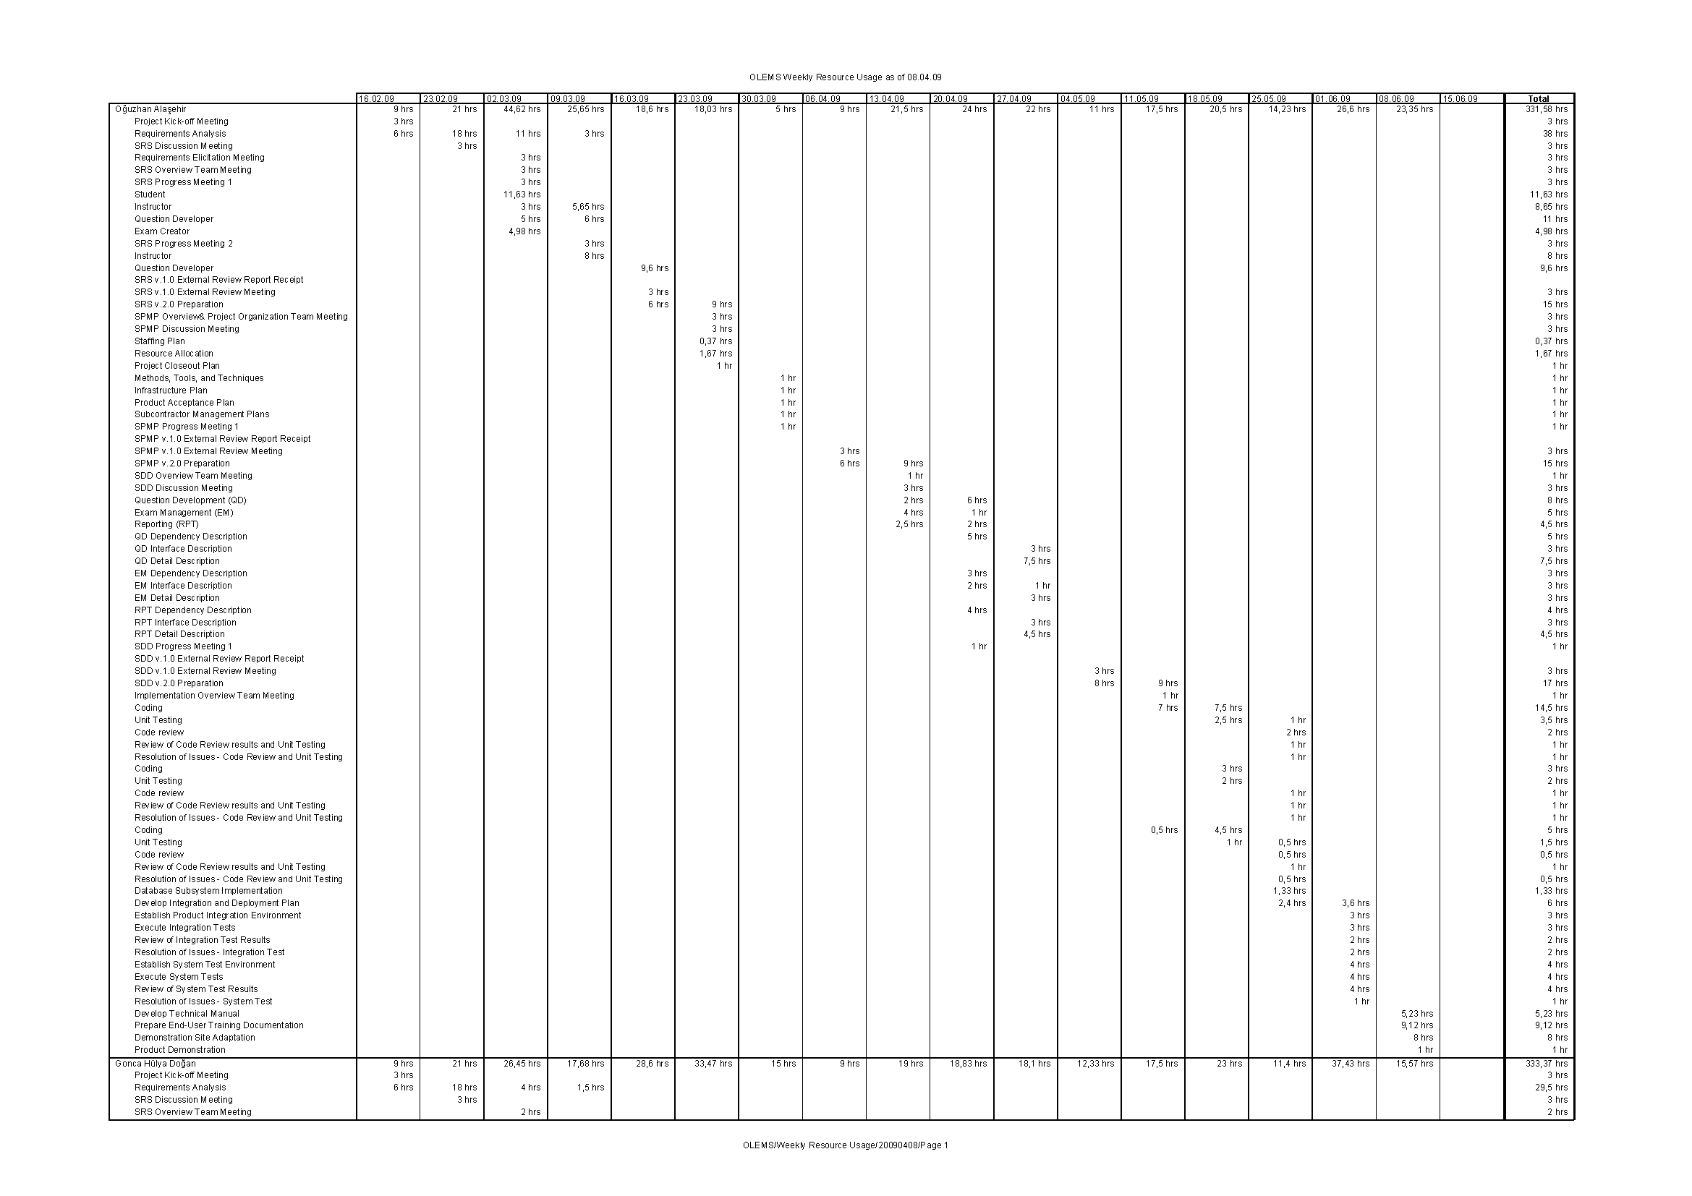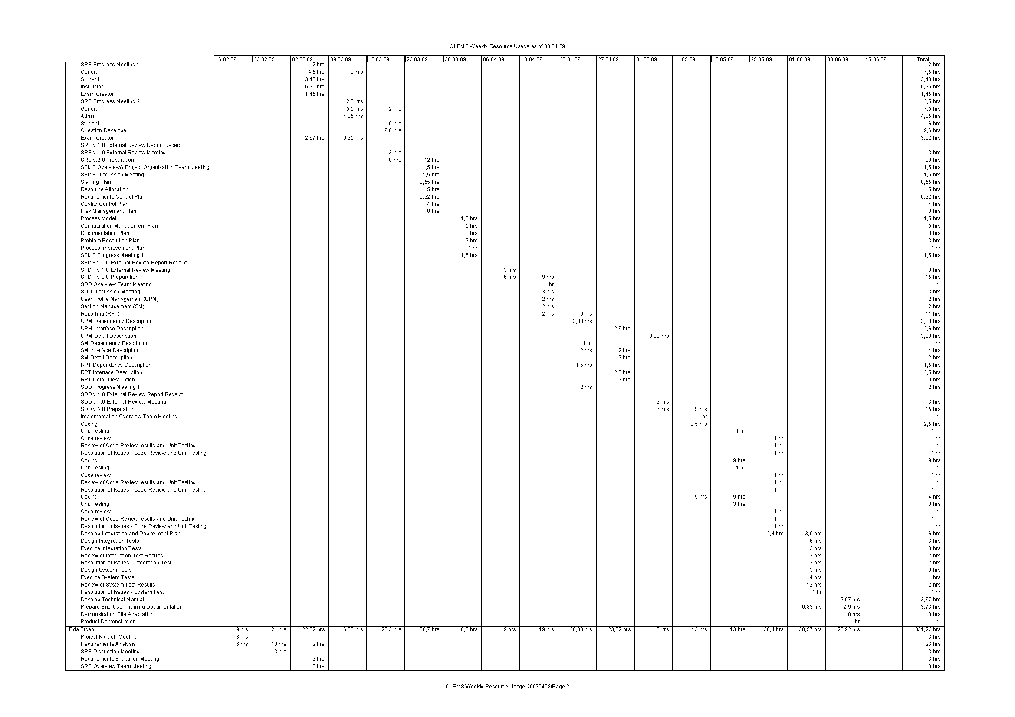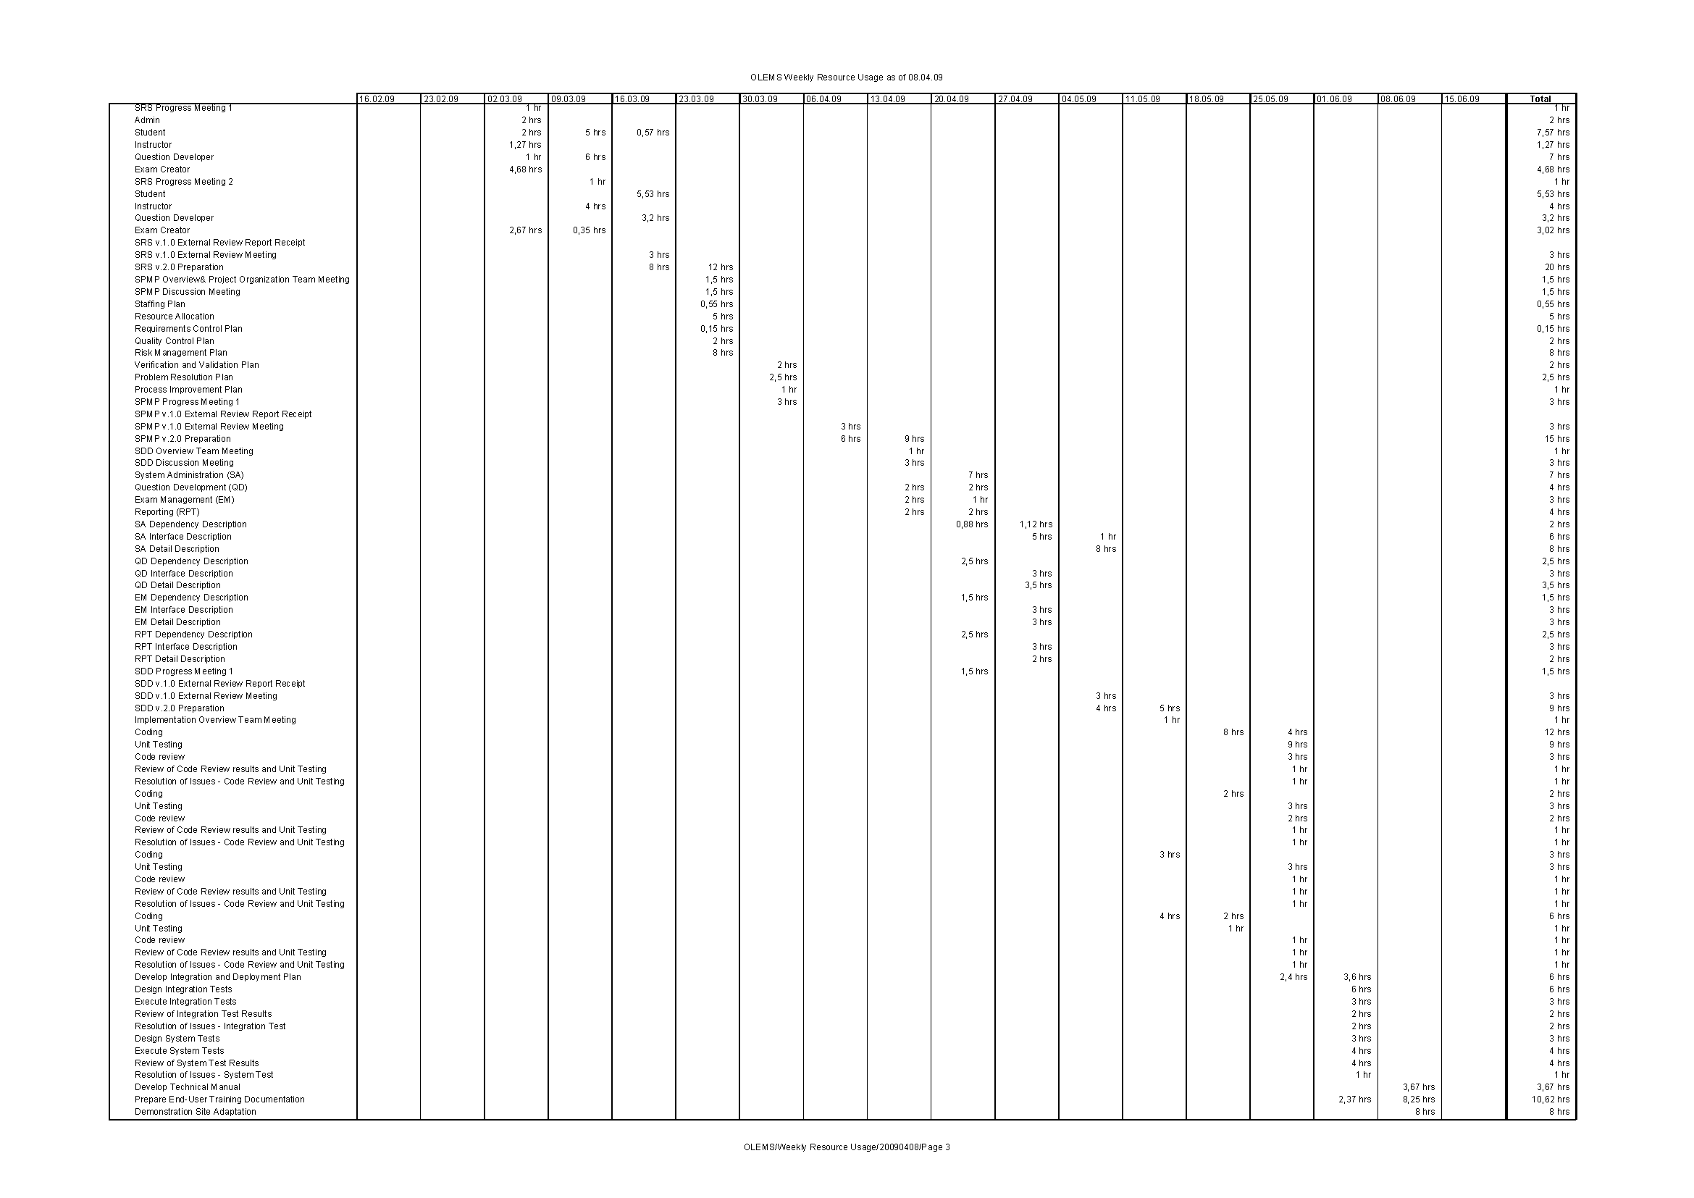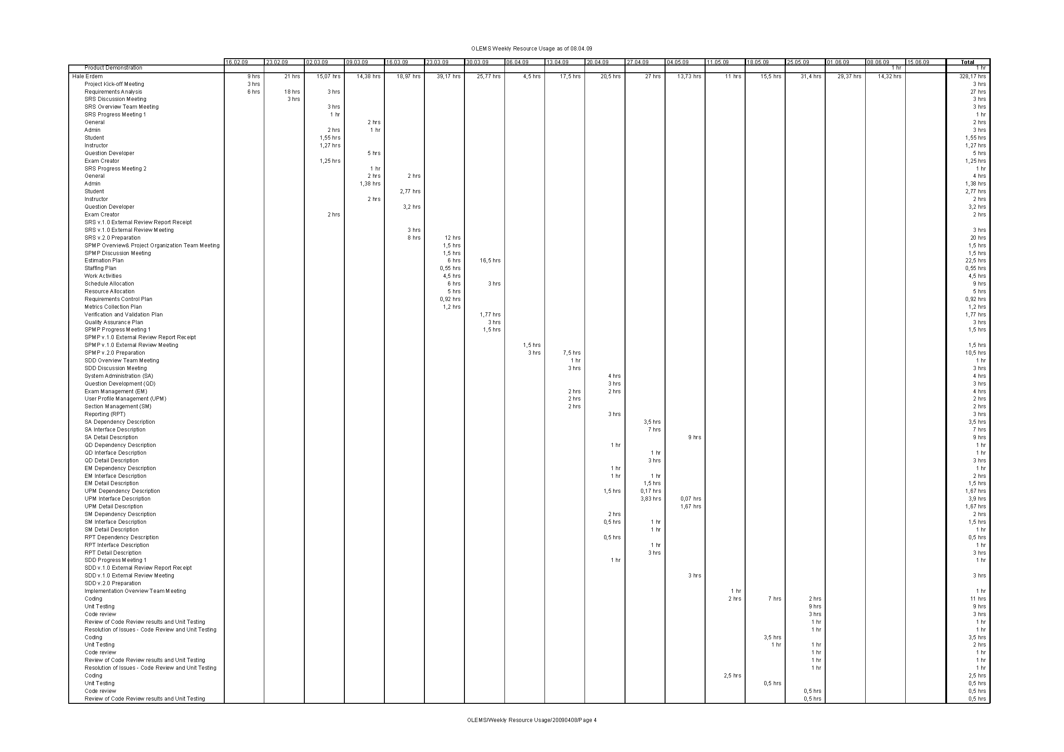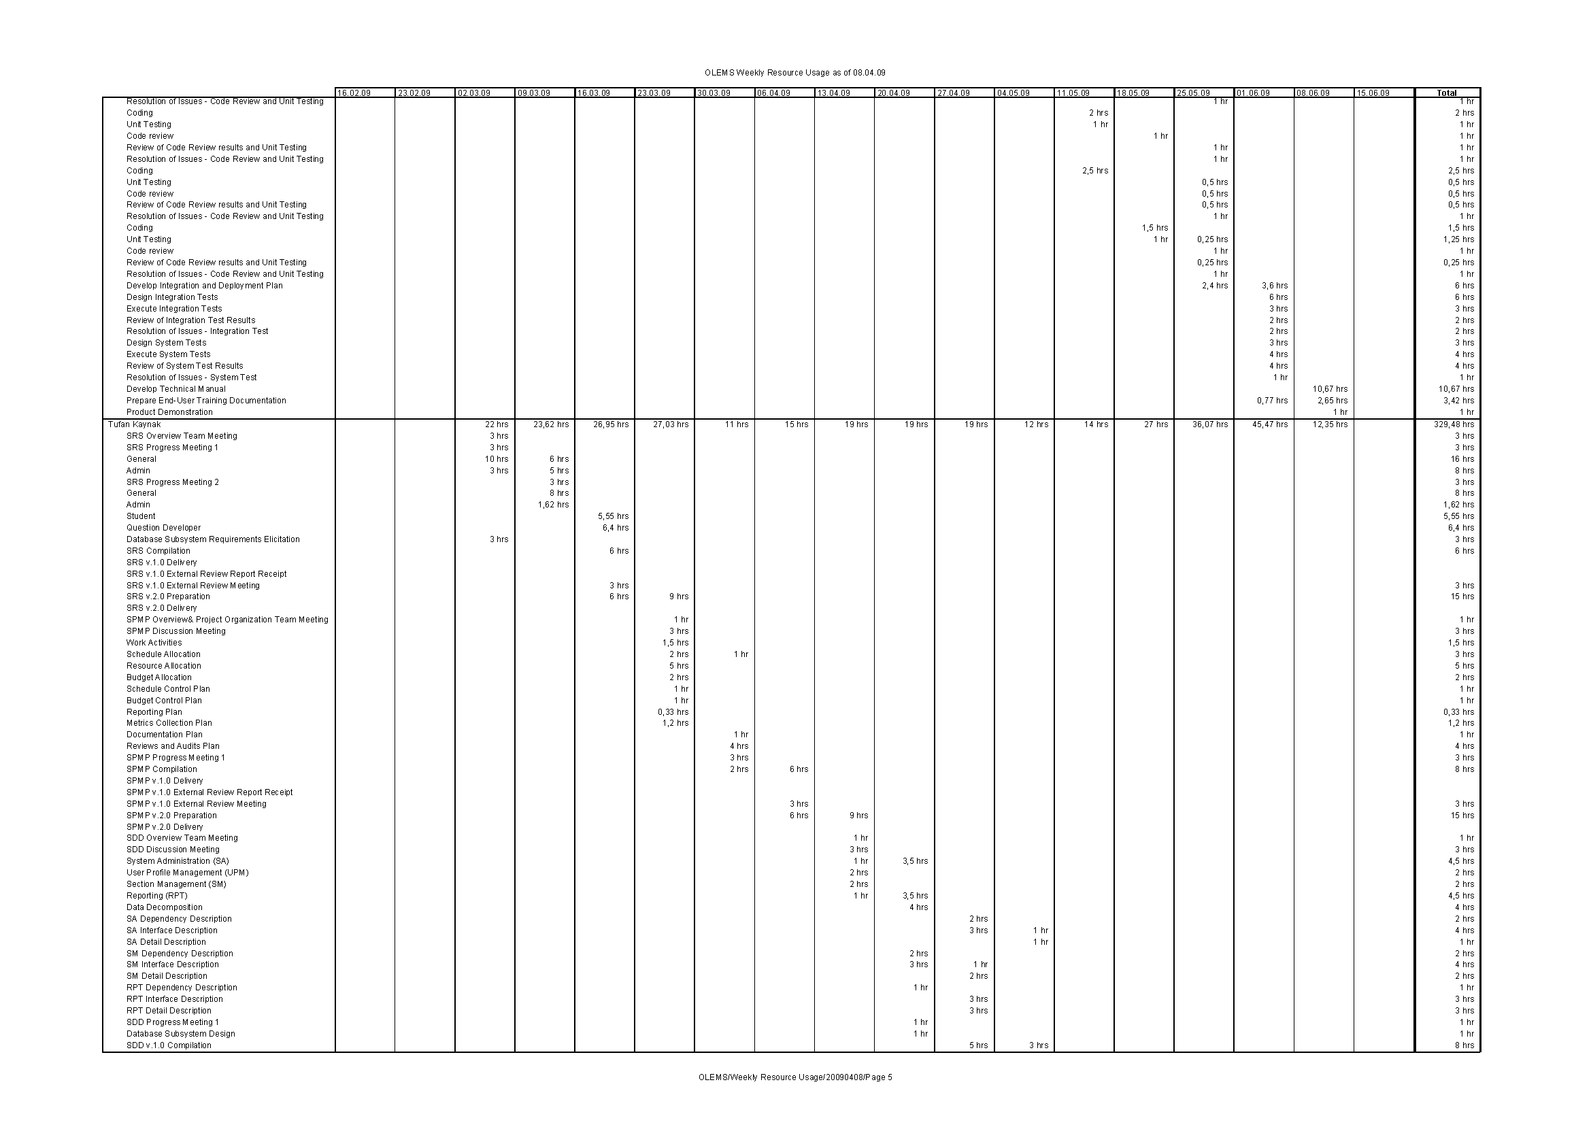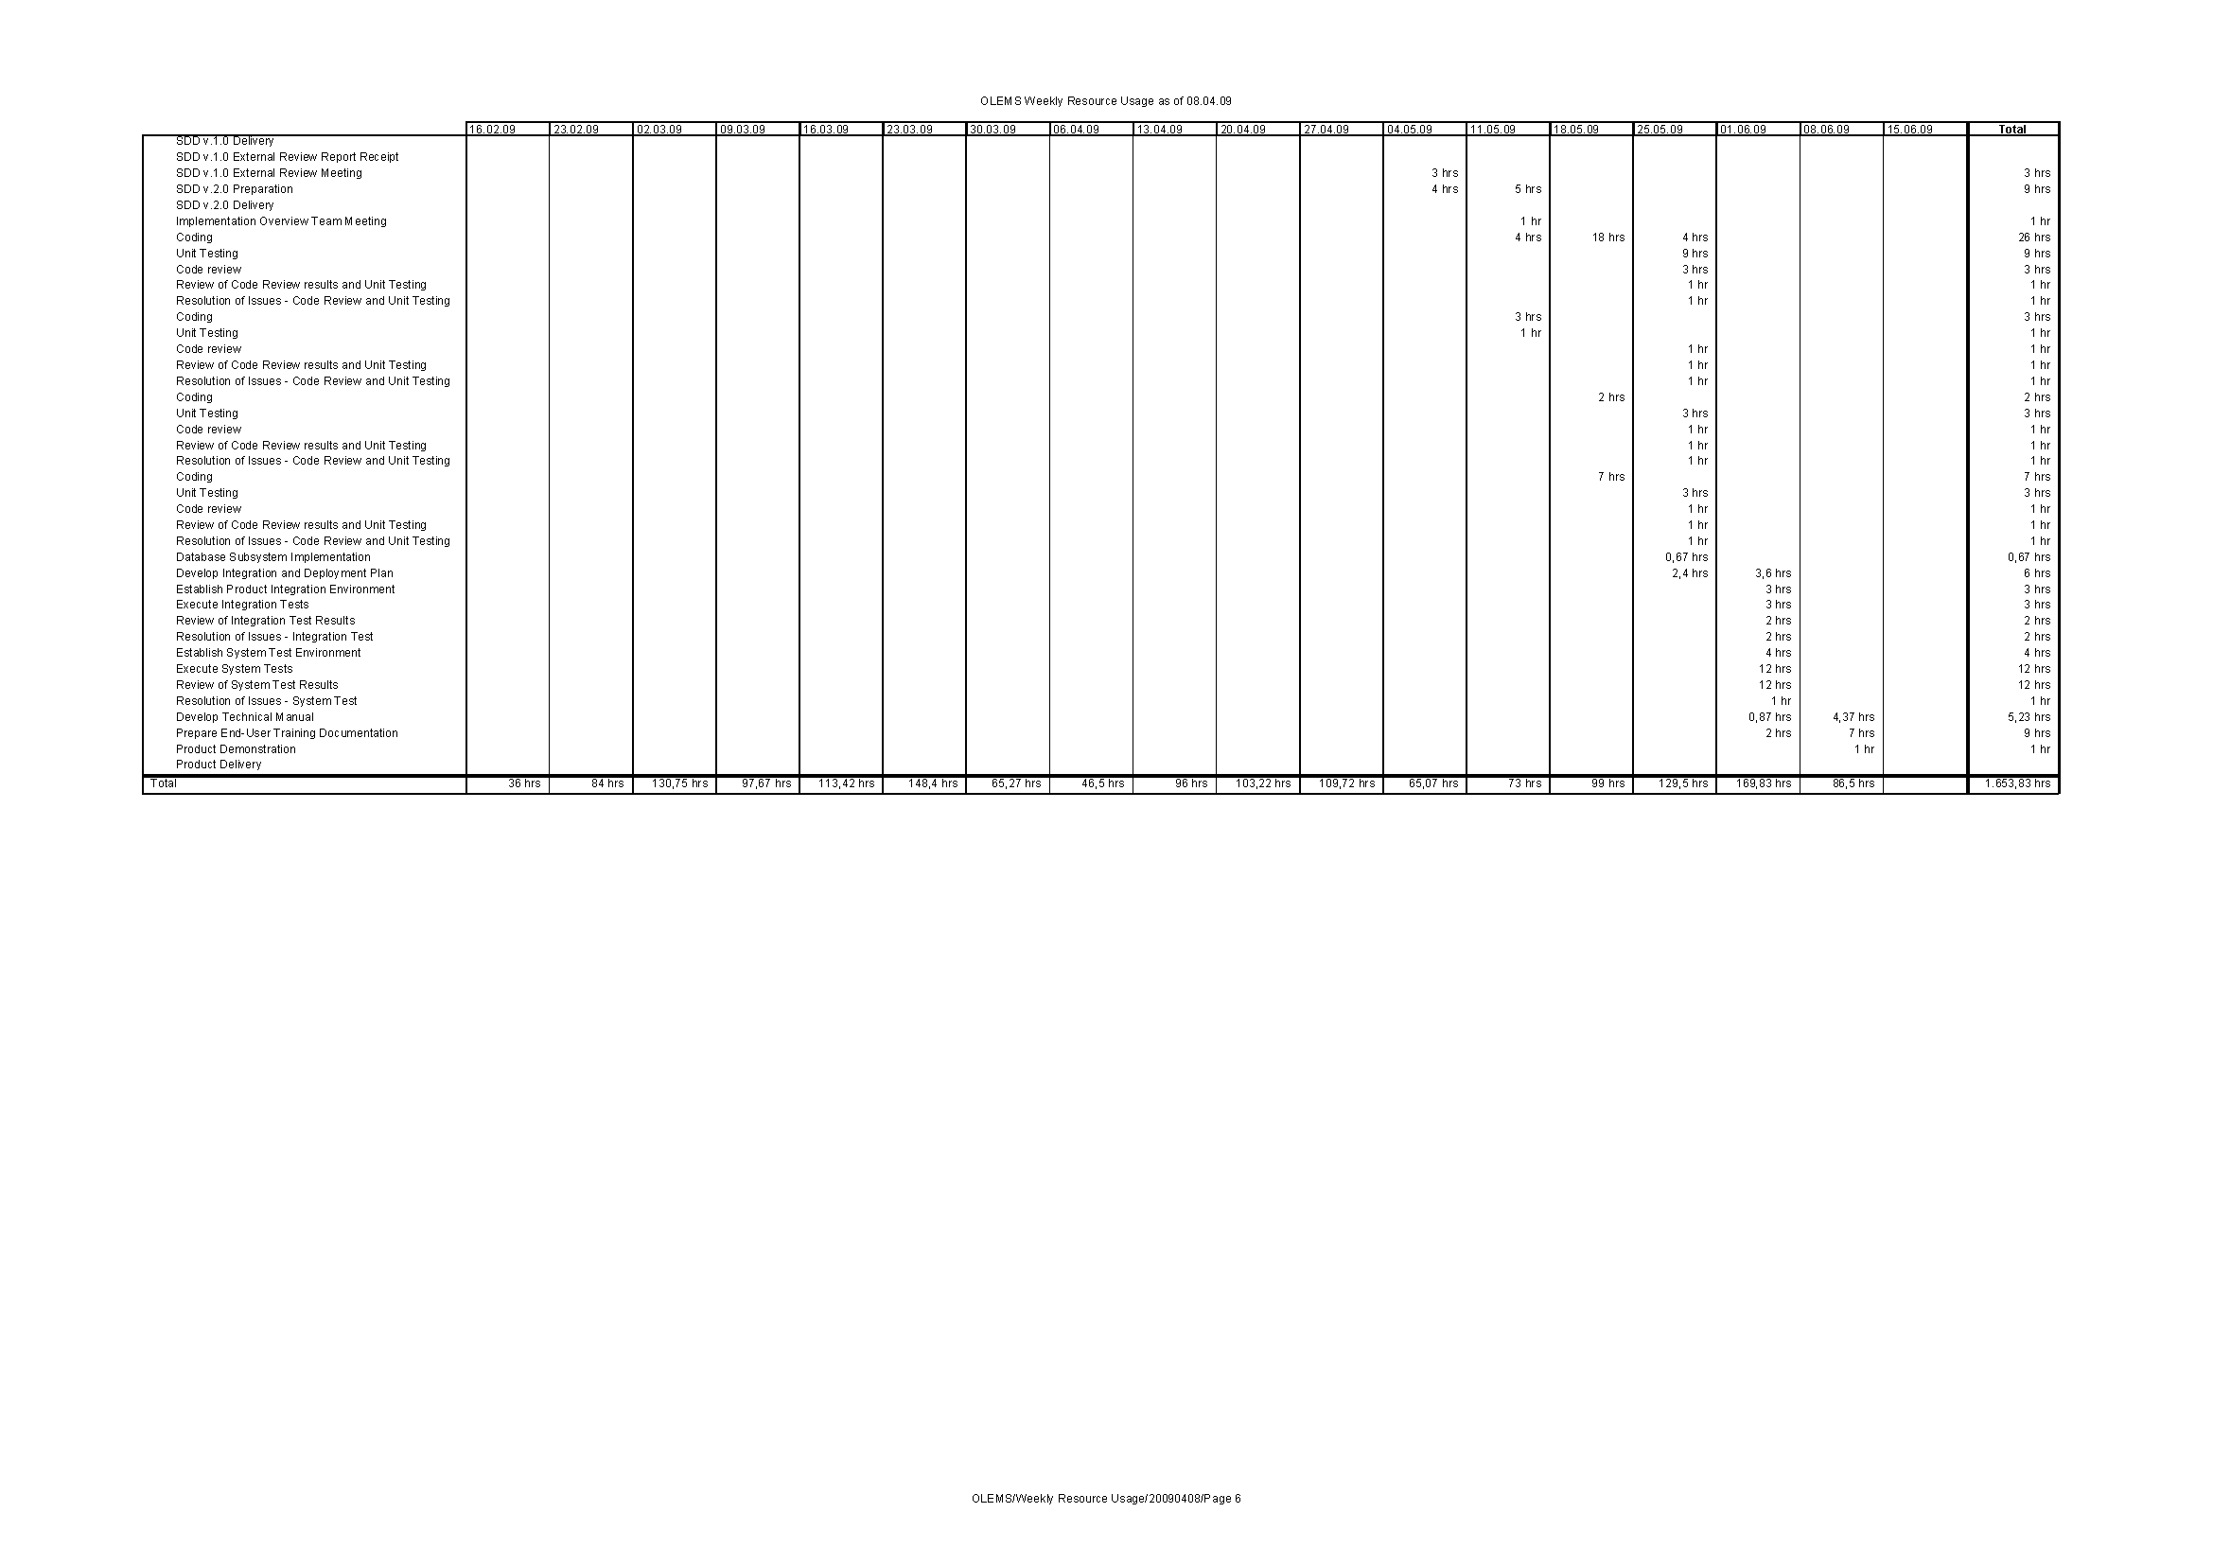

# Resource Allocation by Task

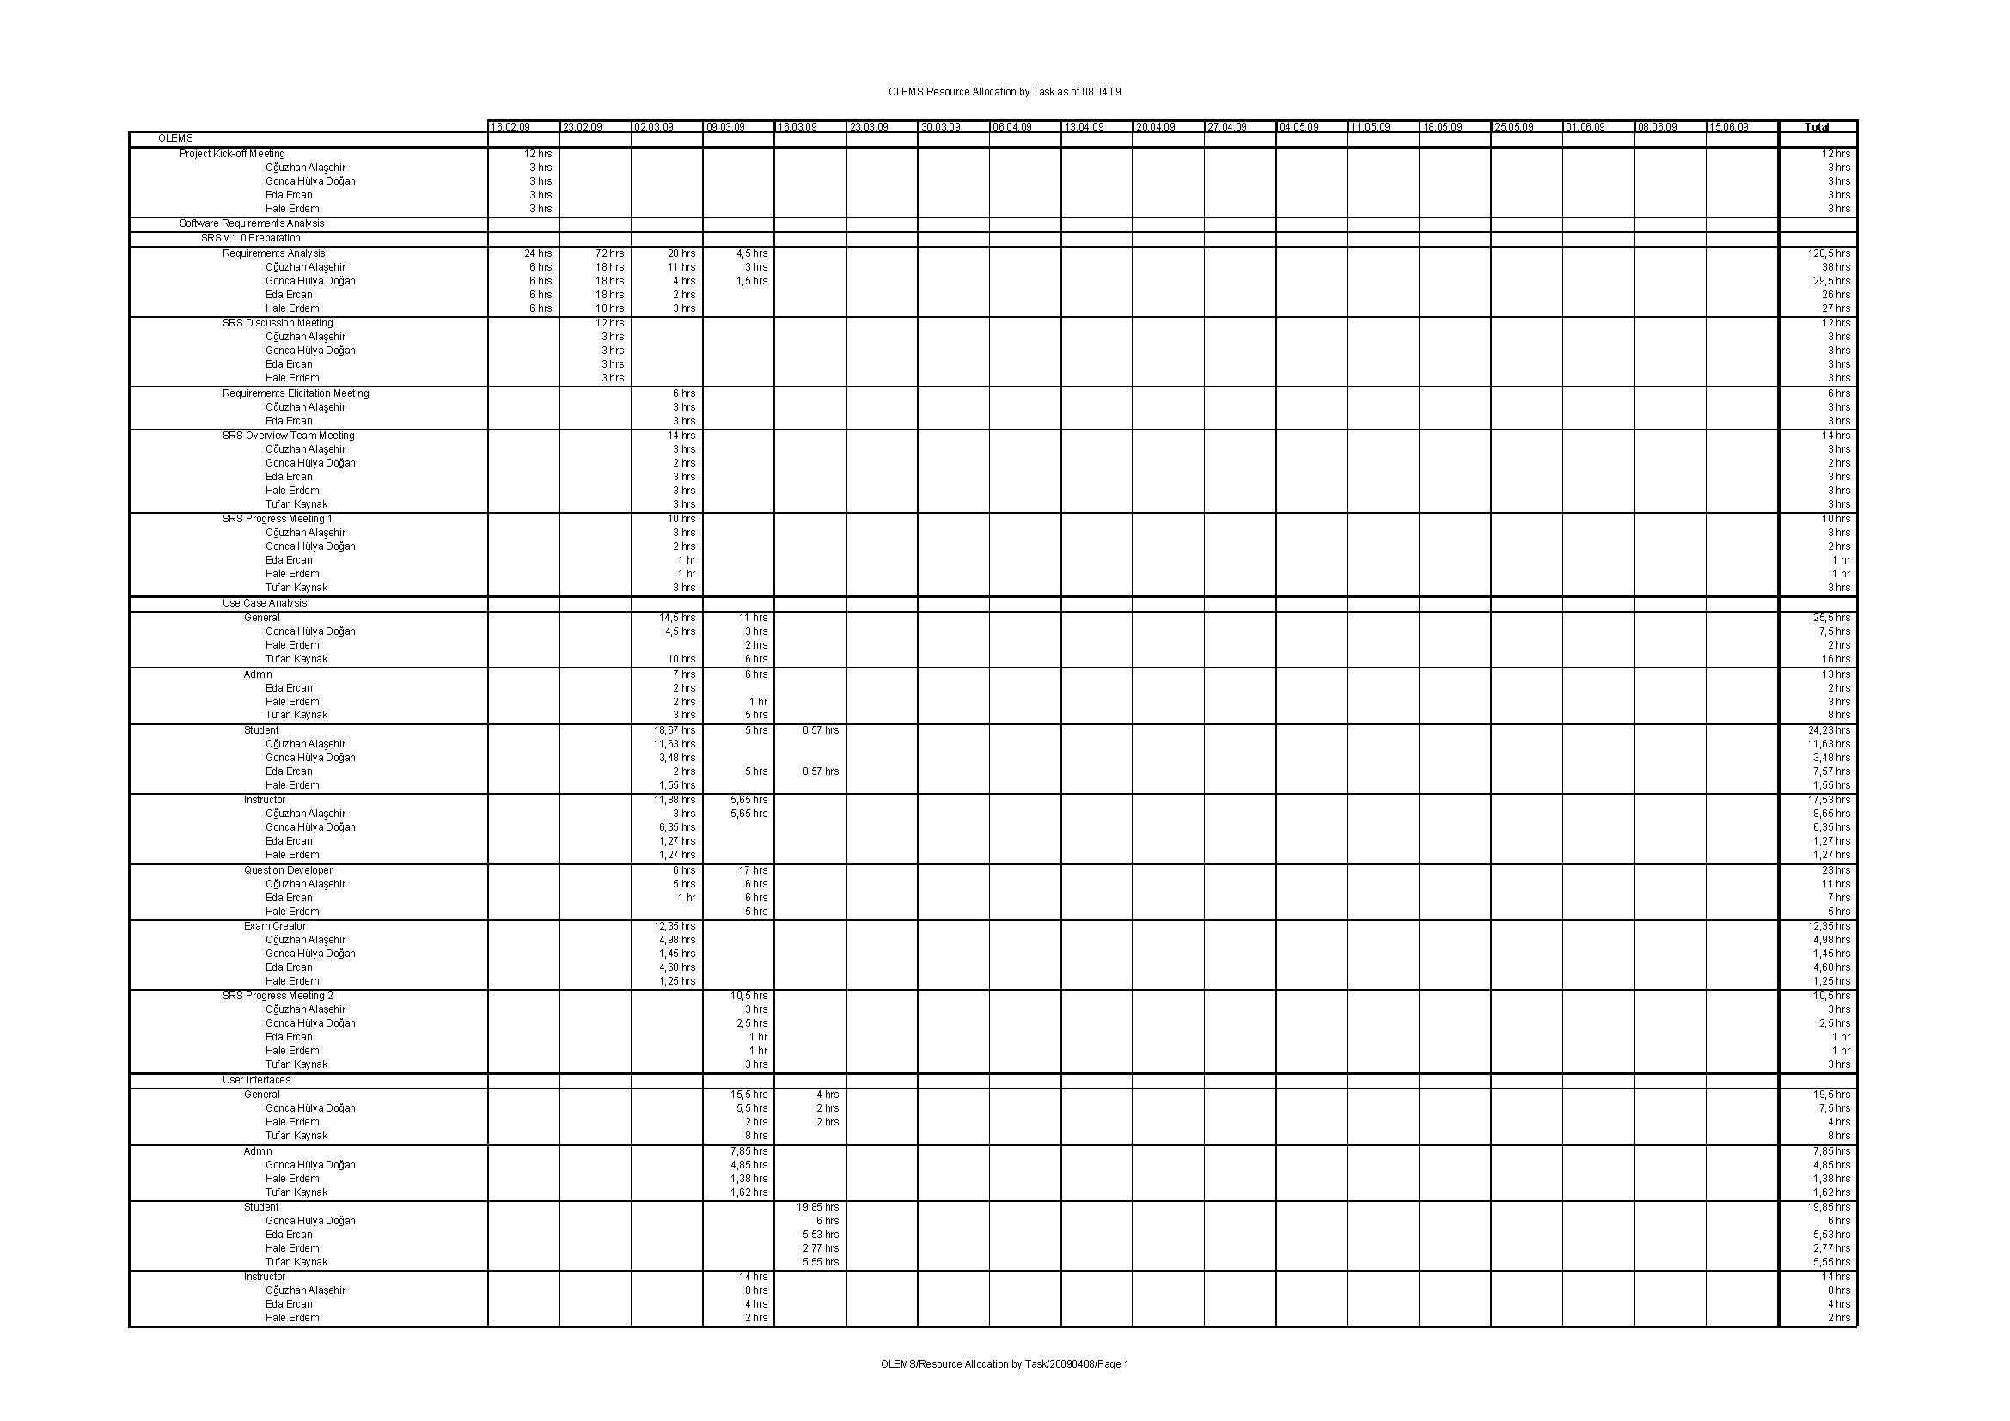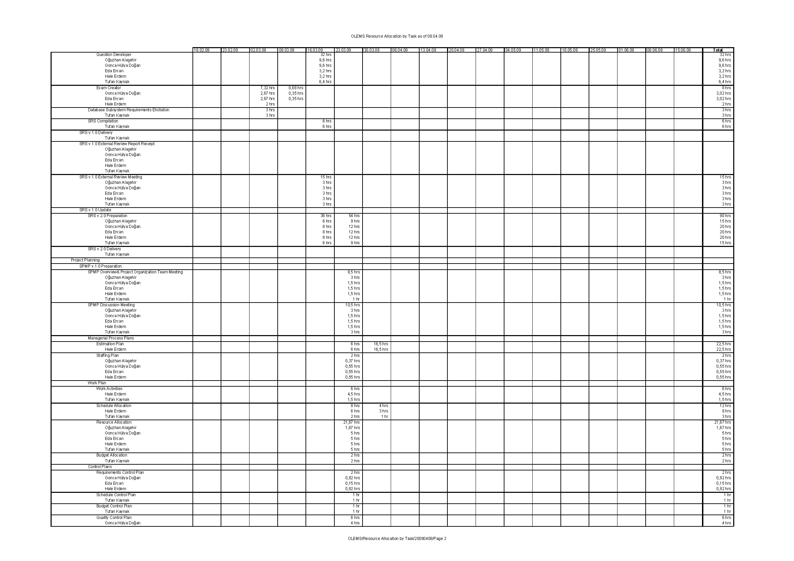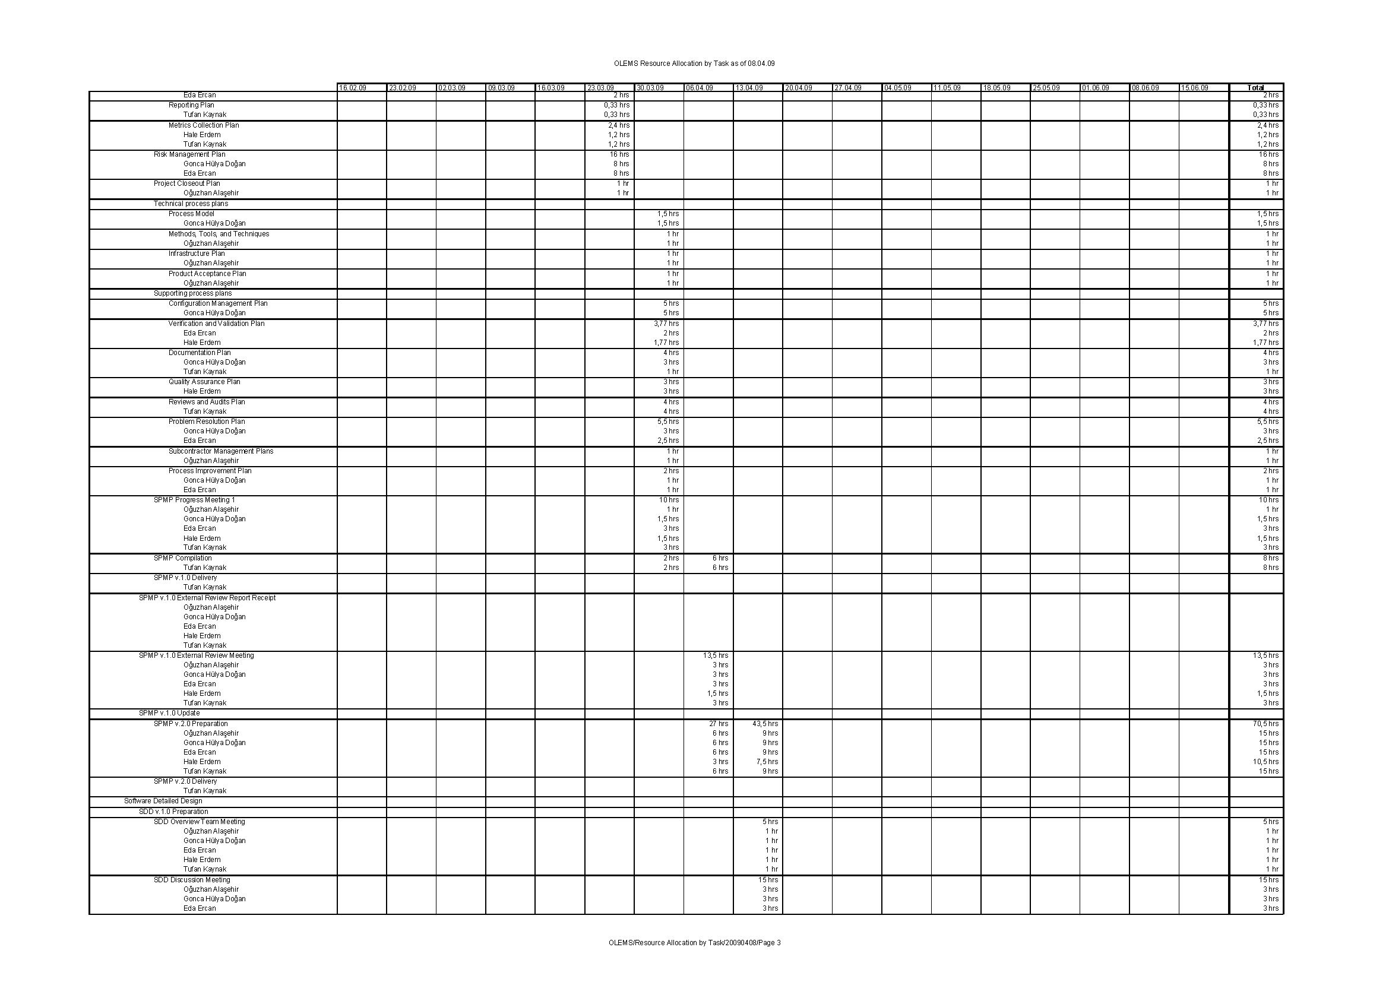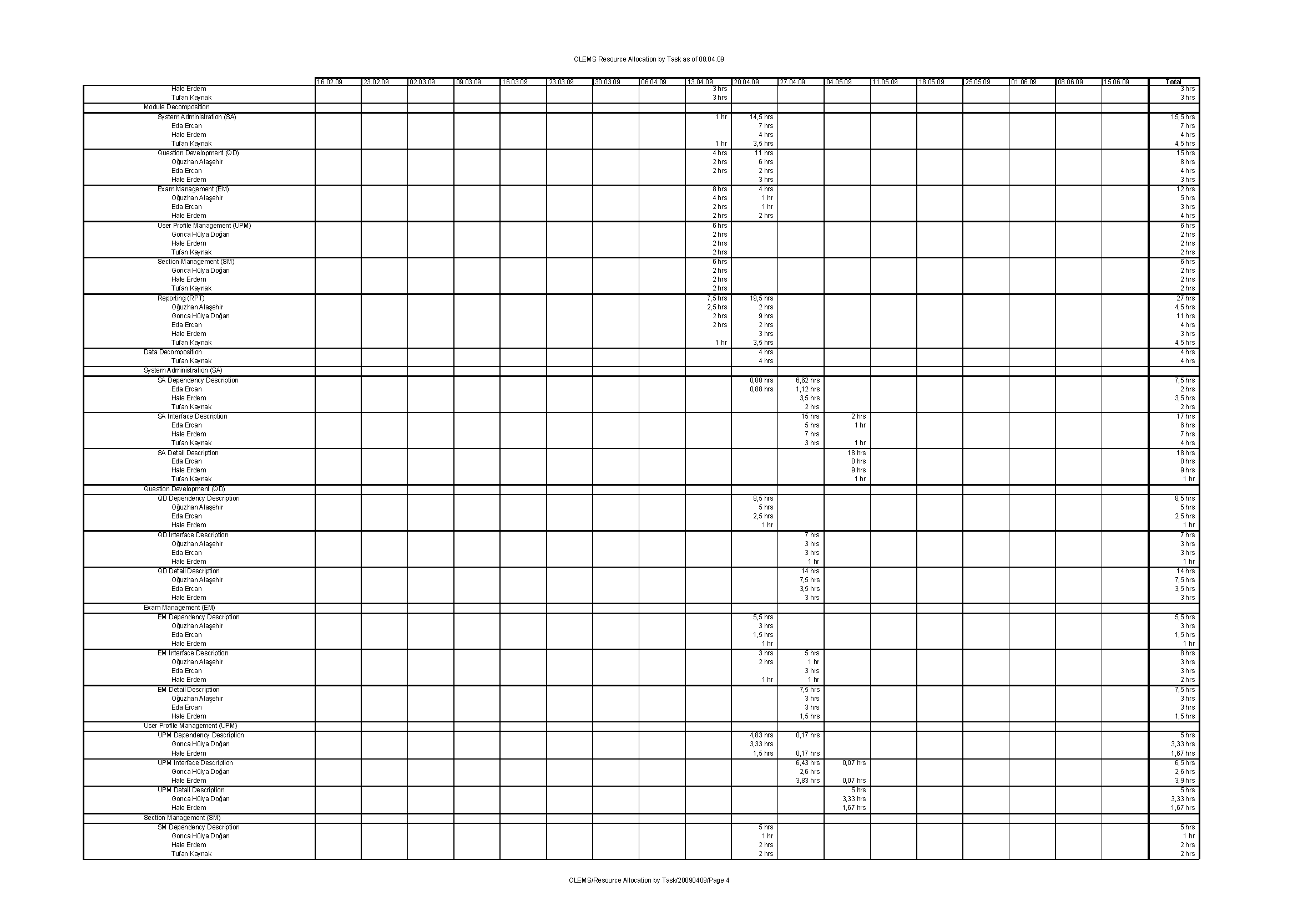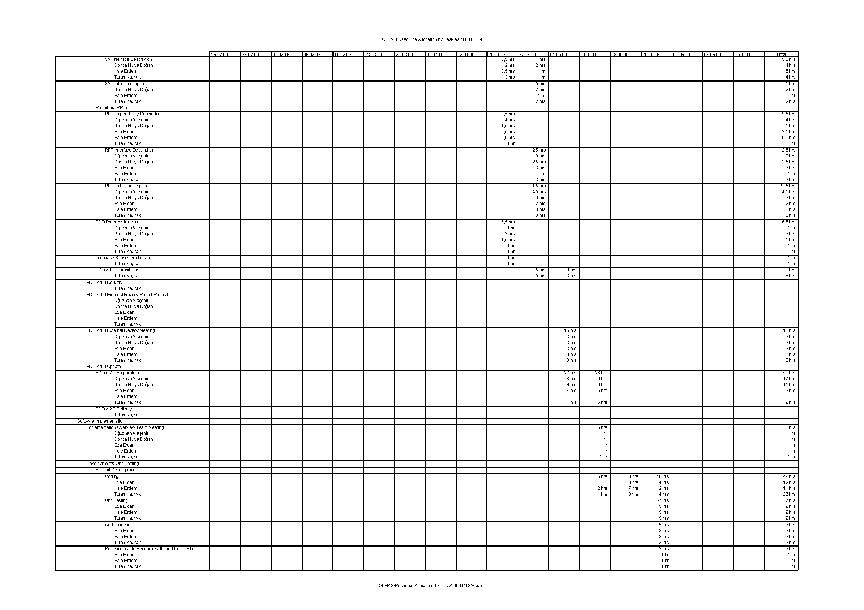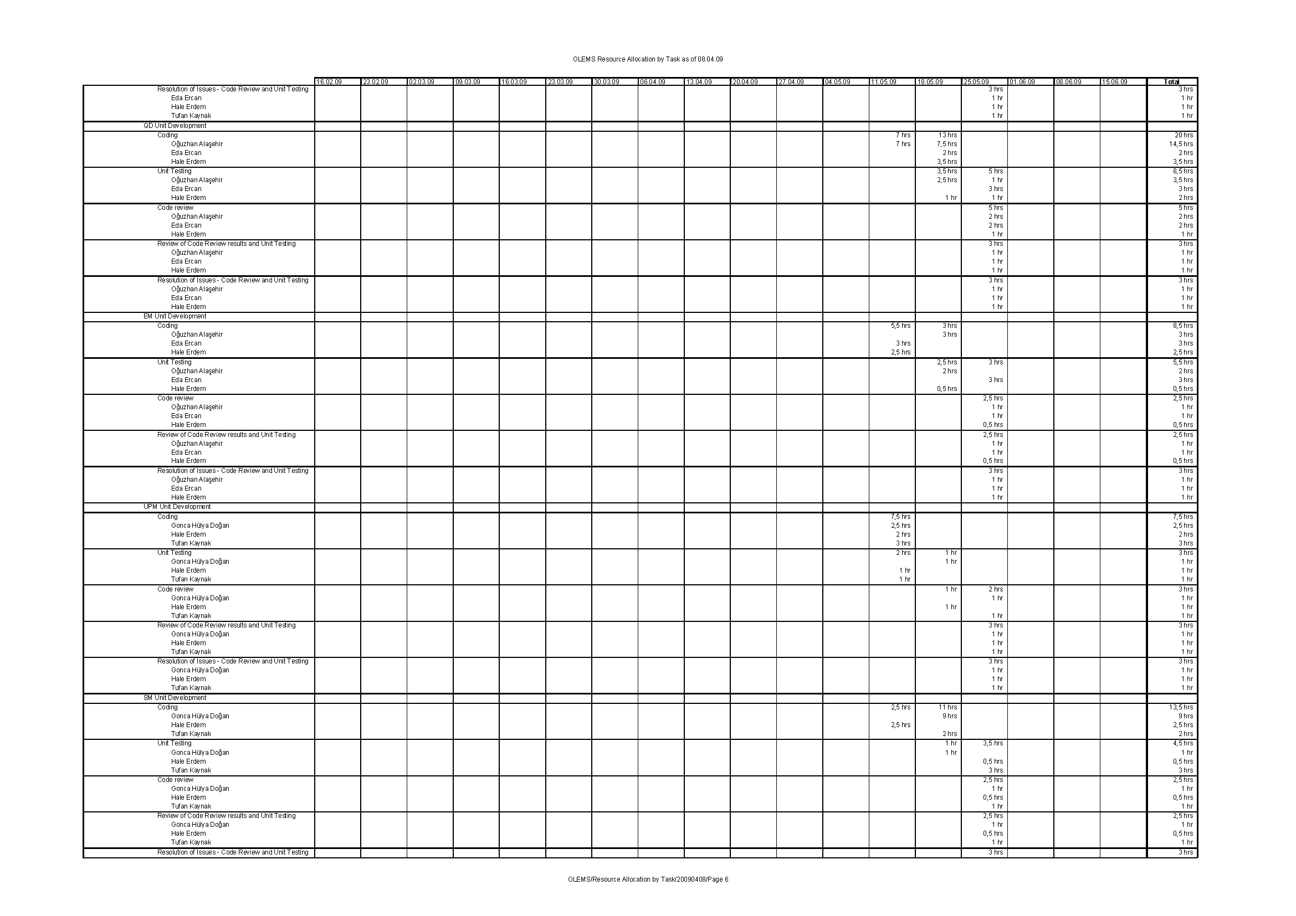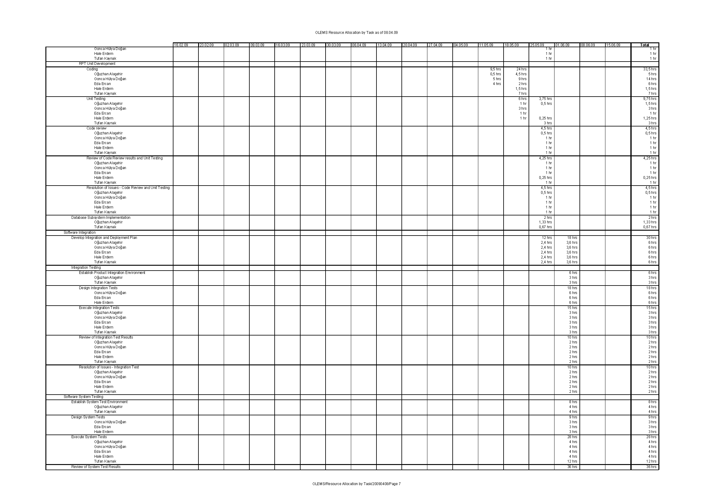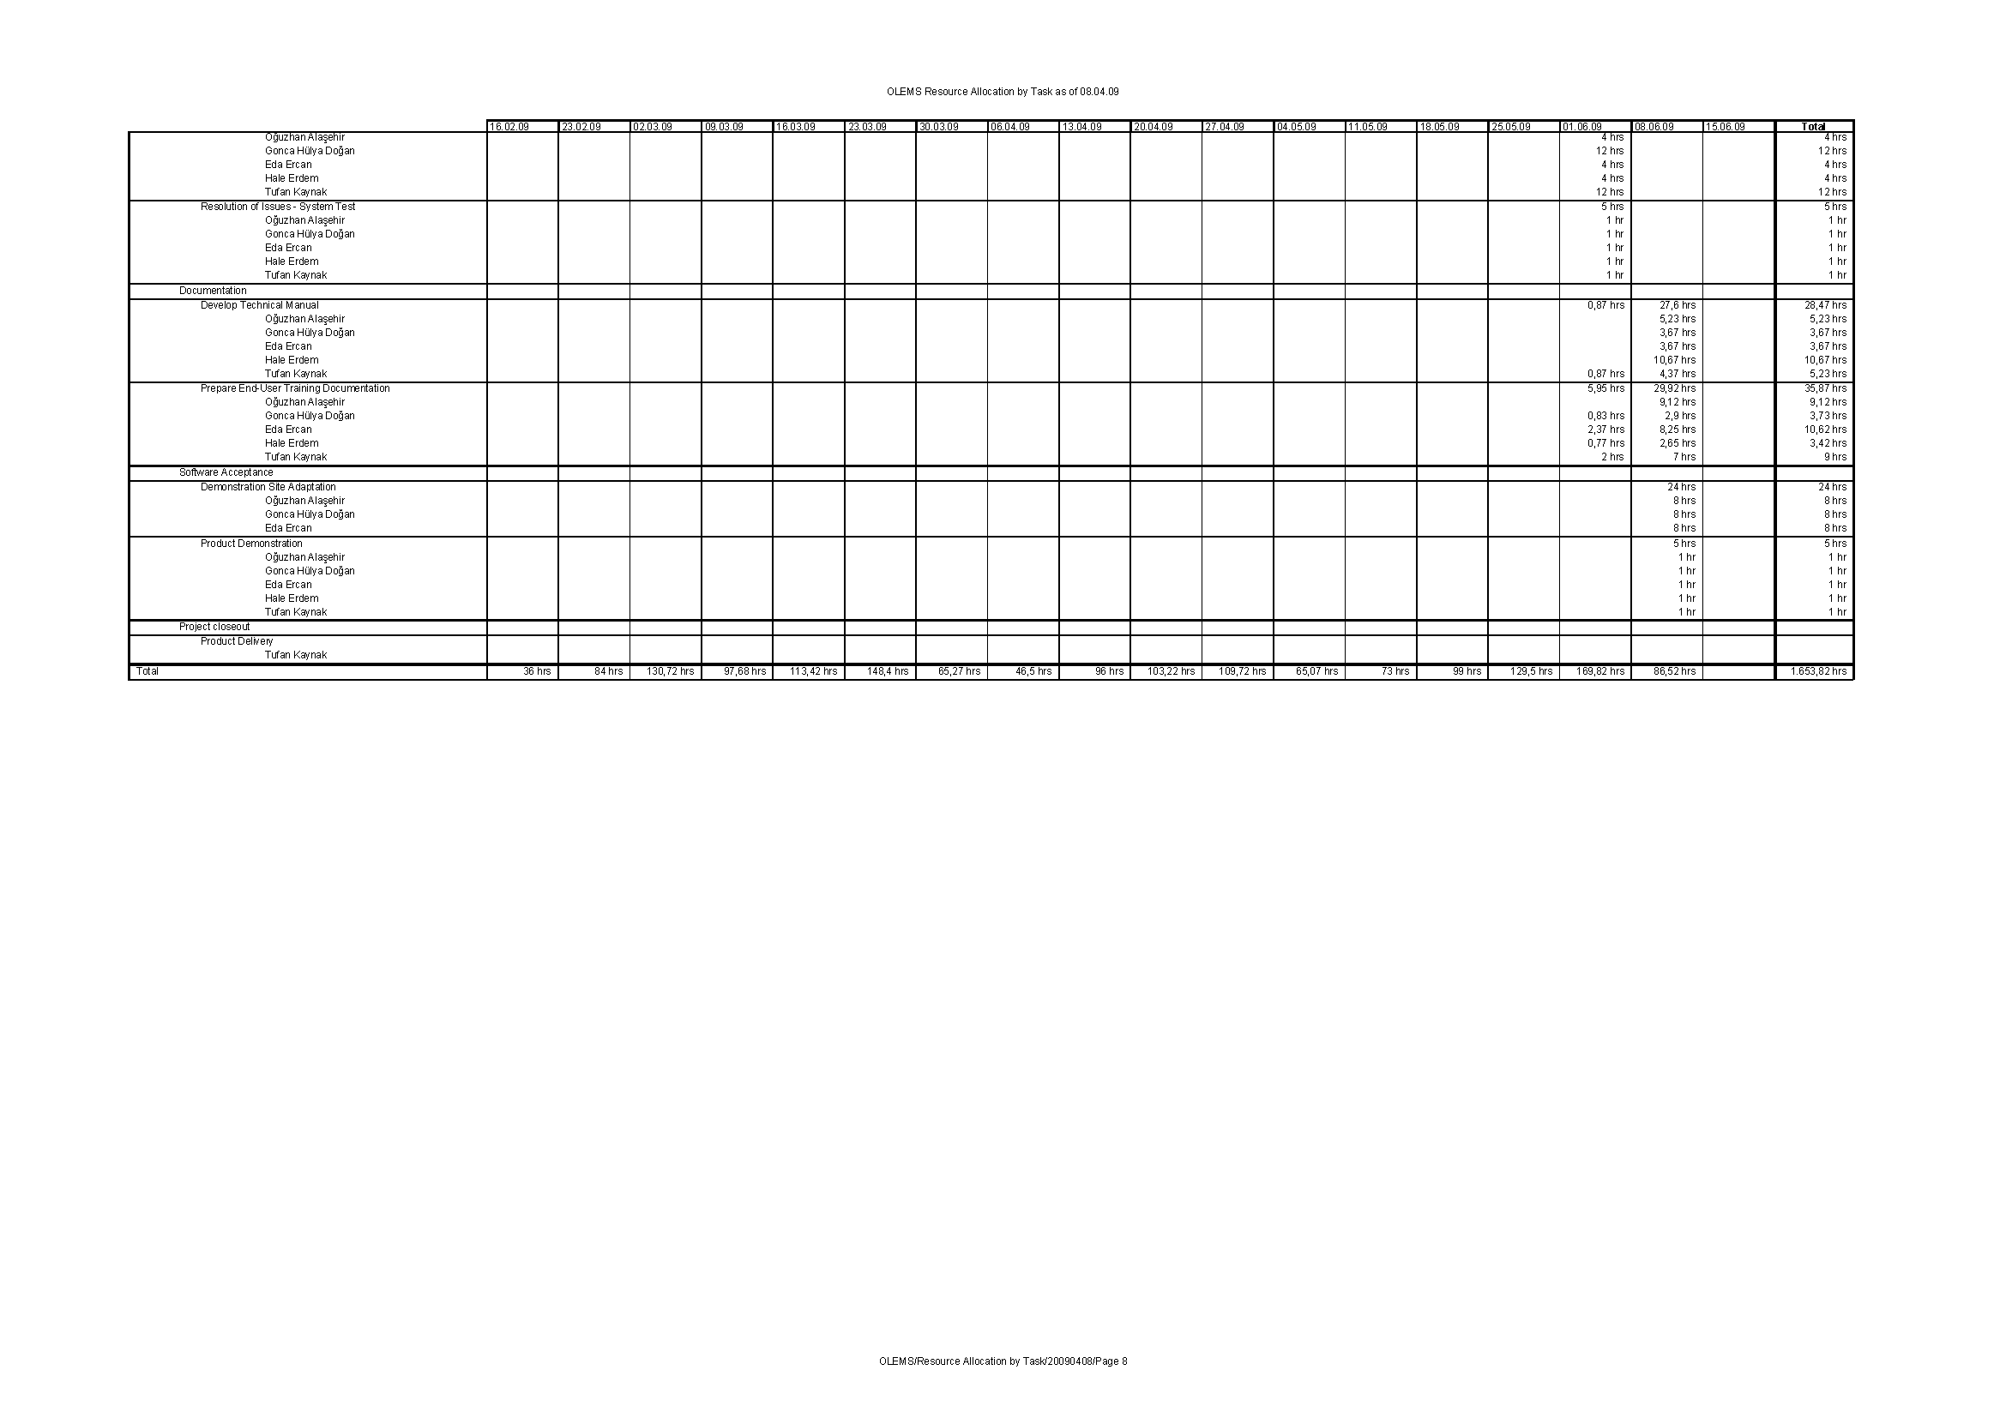

# Budget Report (by Cost)

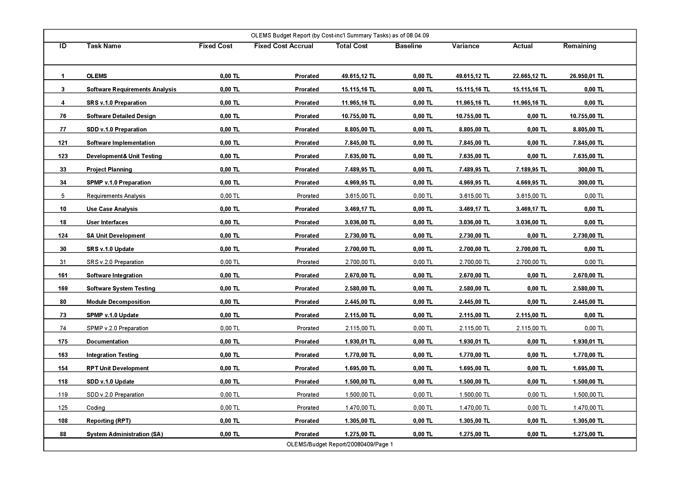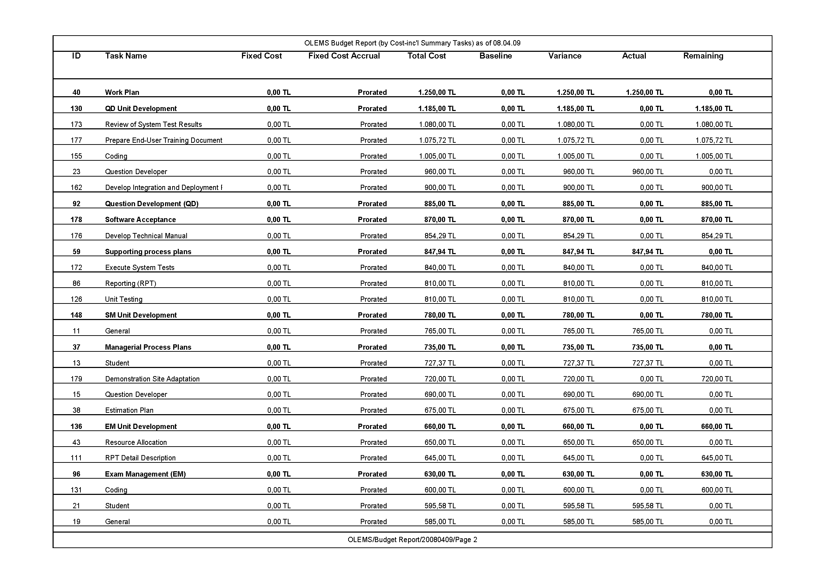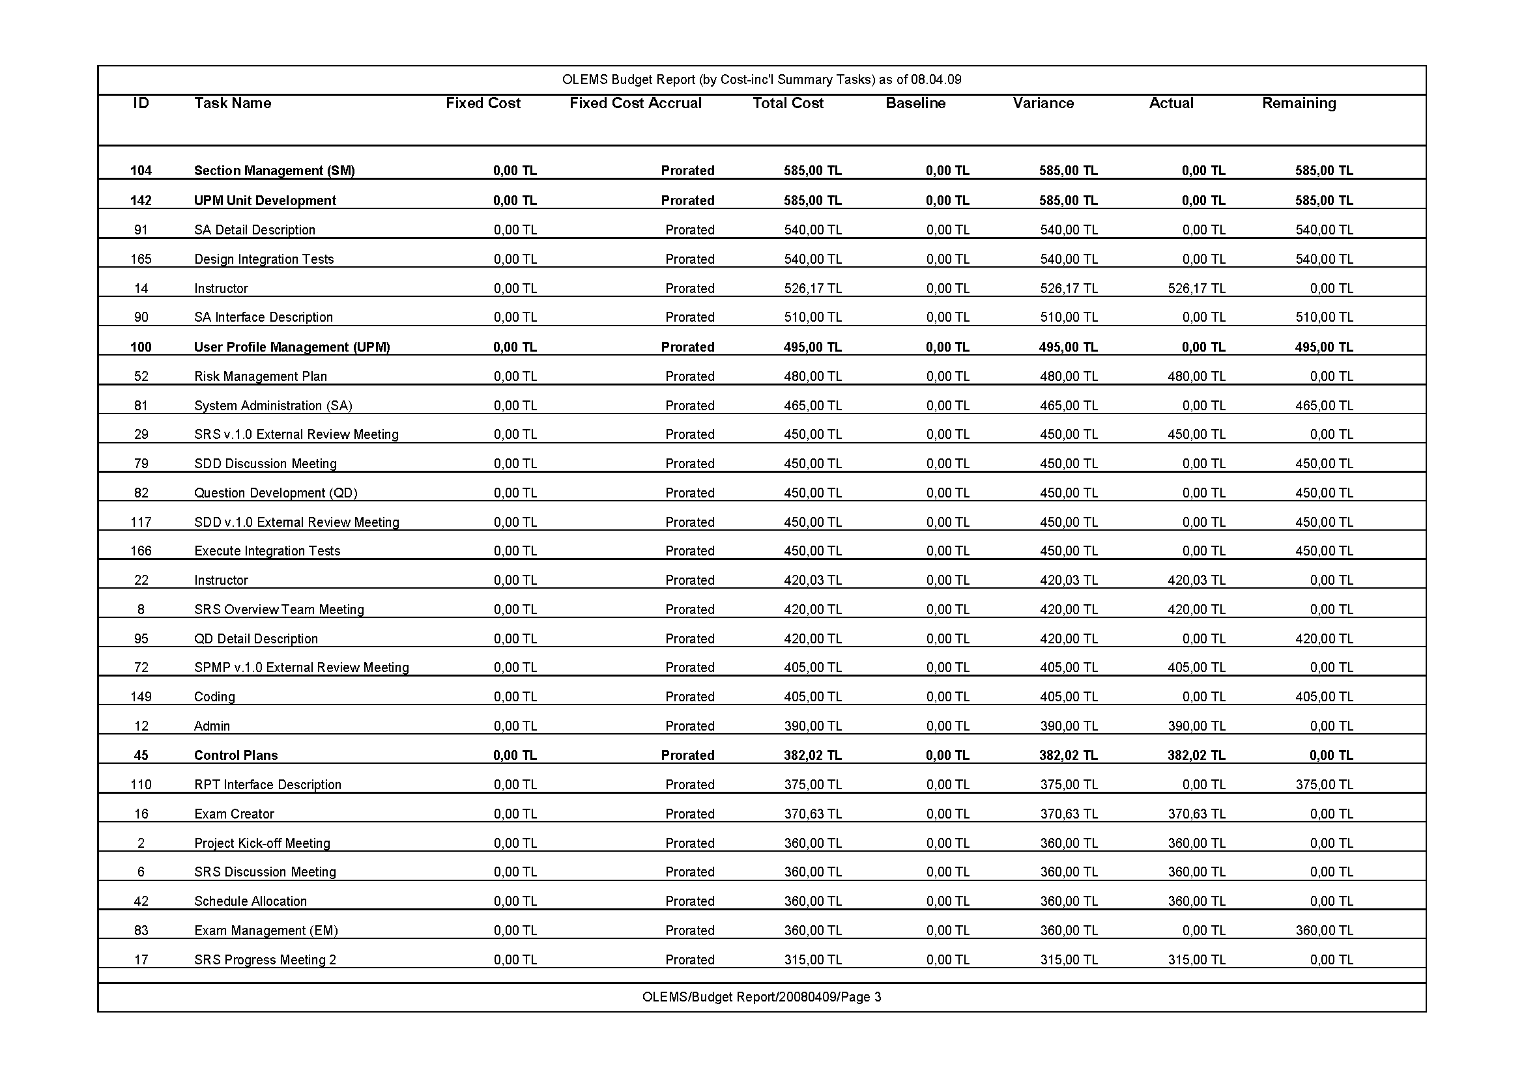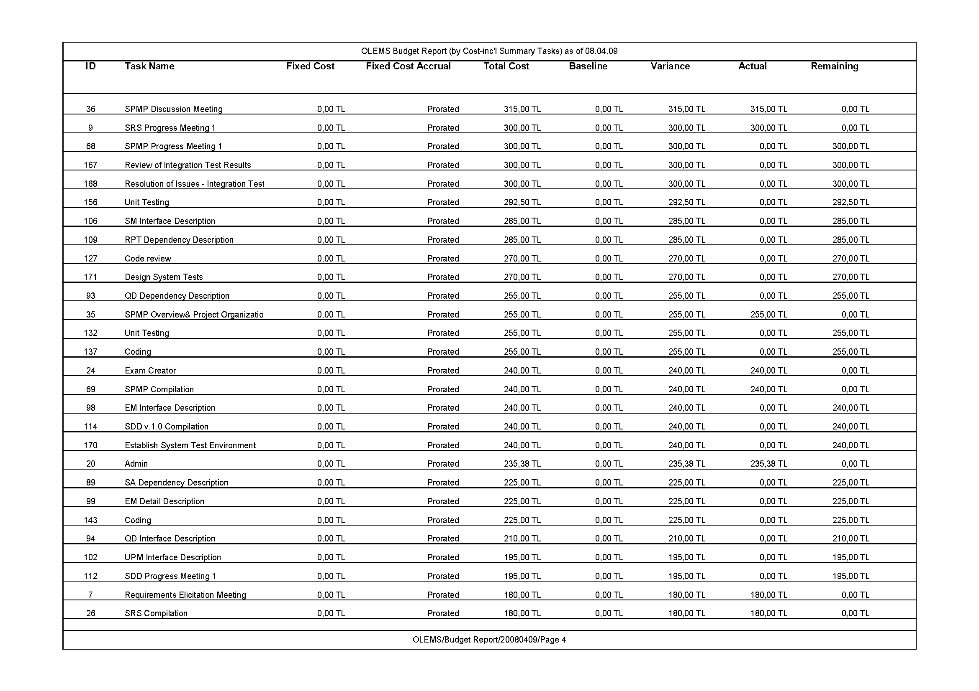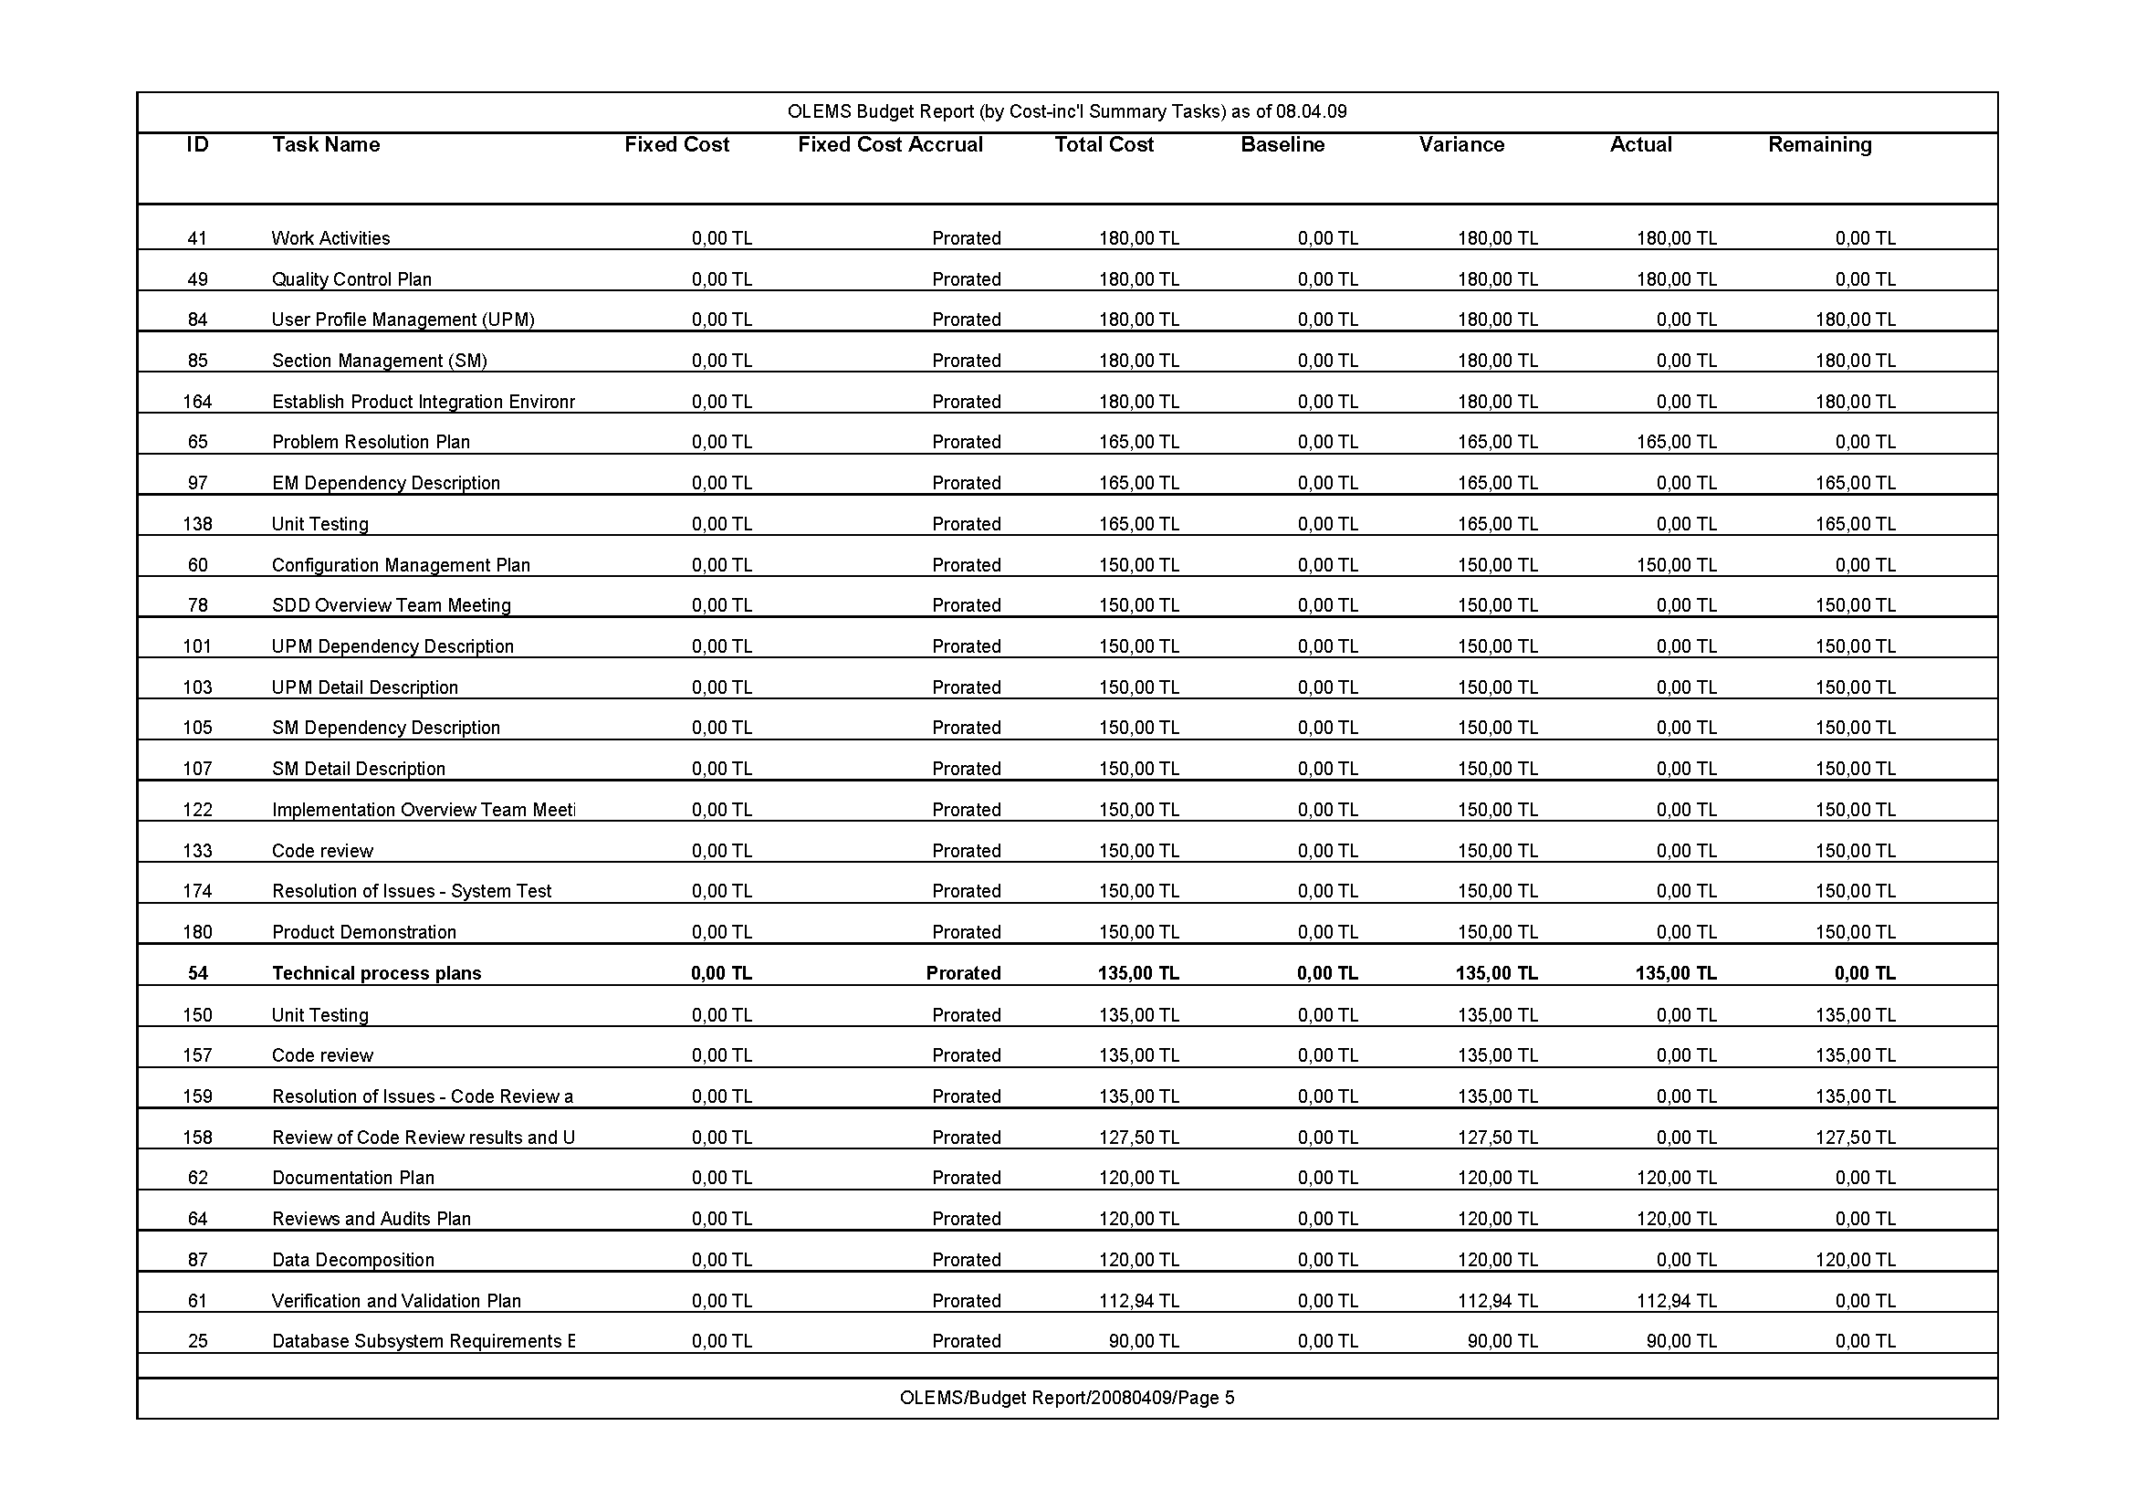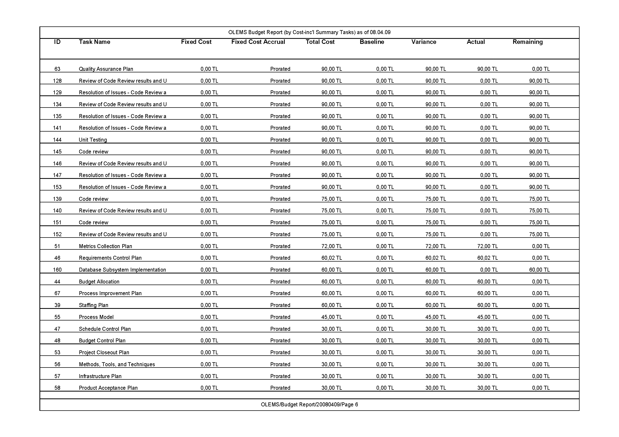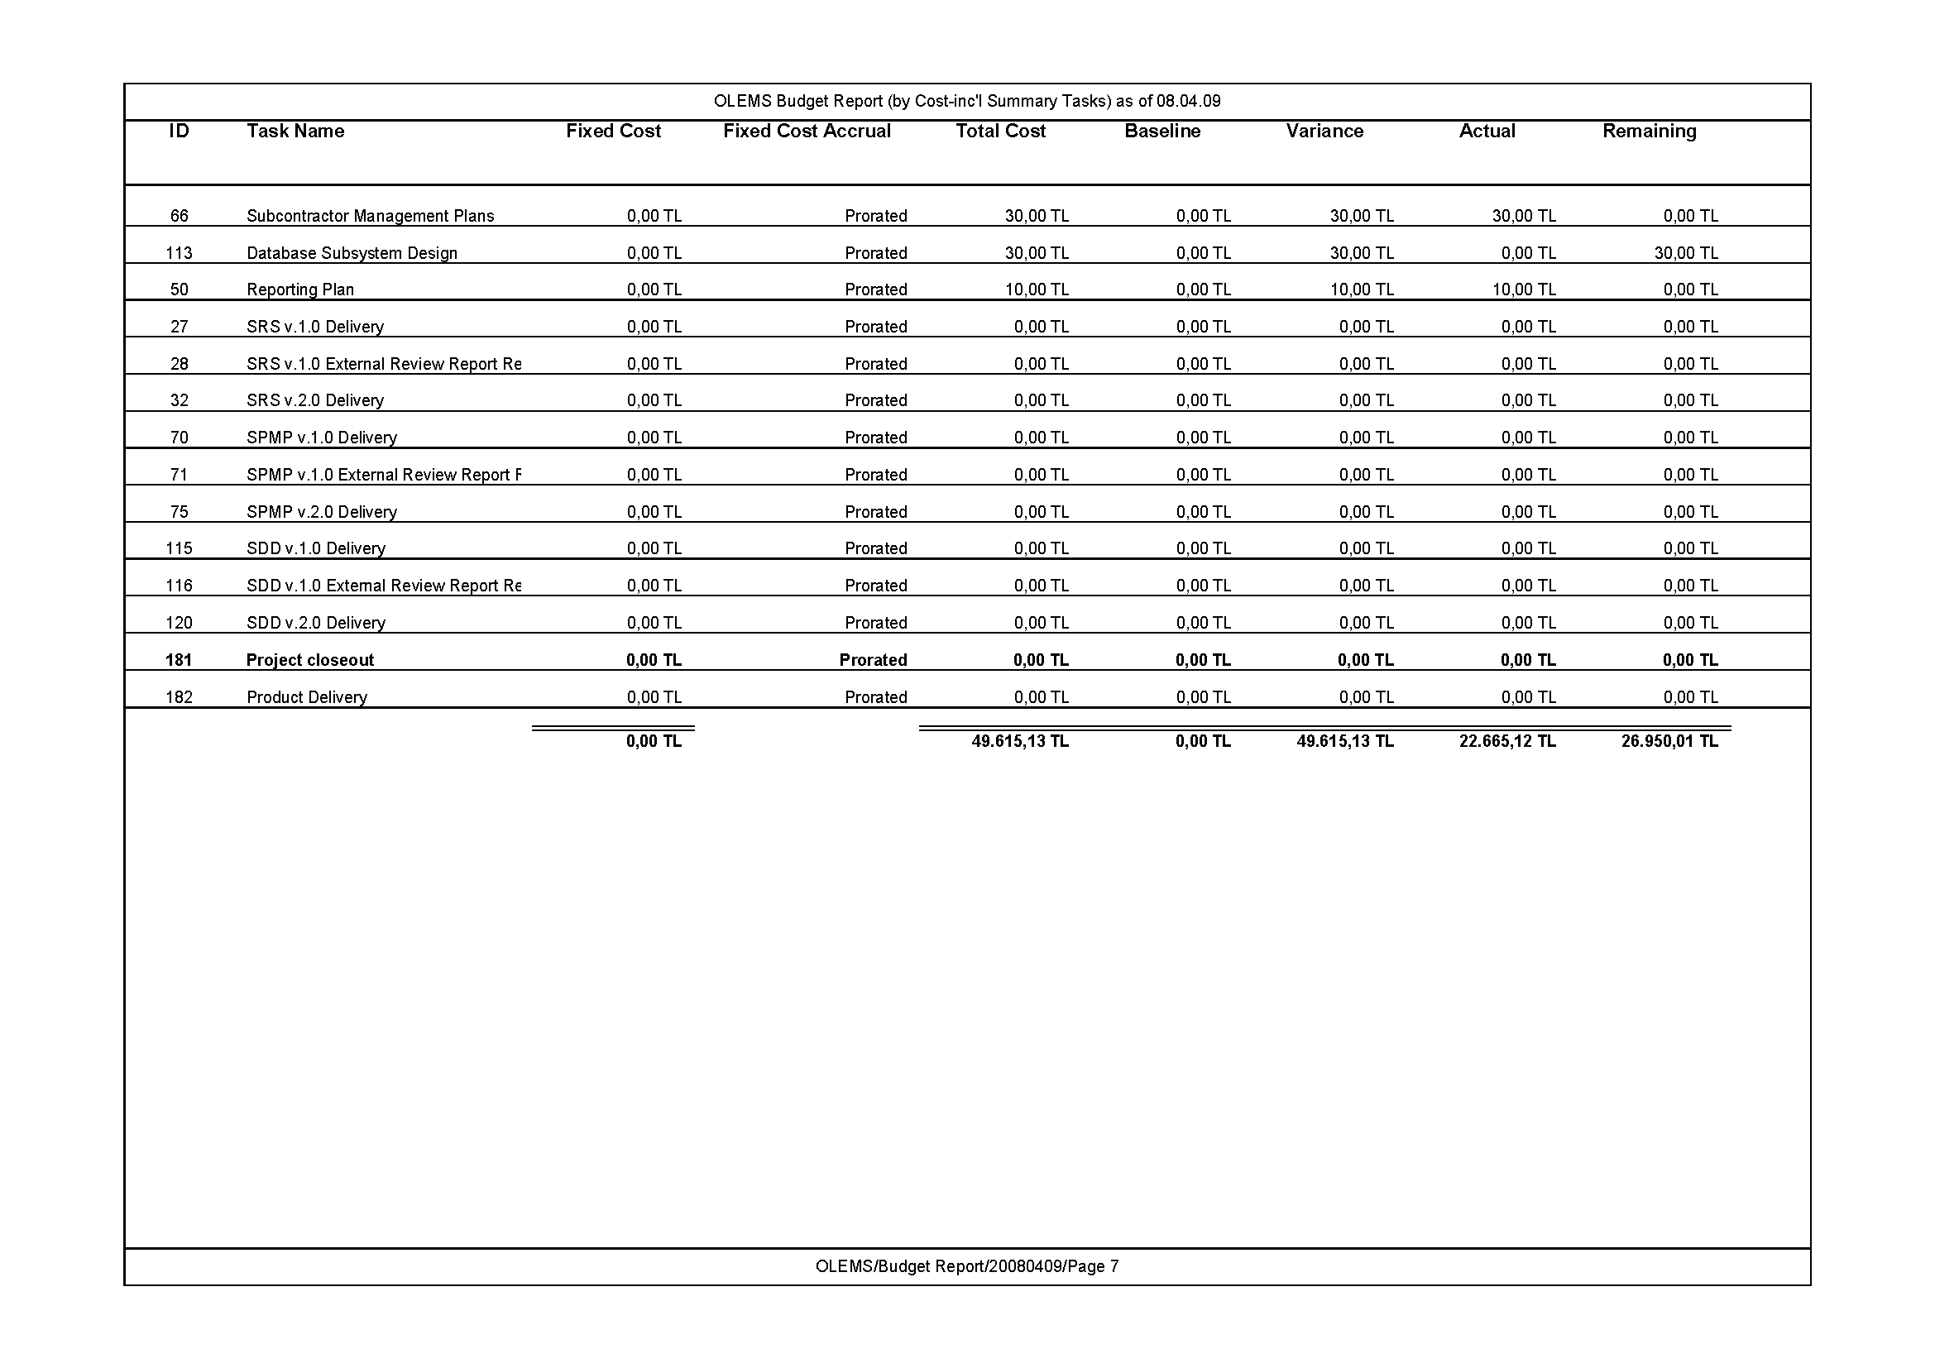

# Budget Report (by Task)

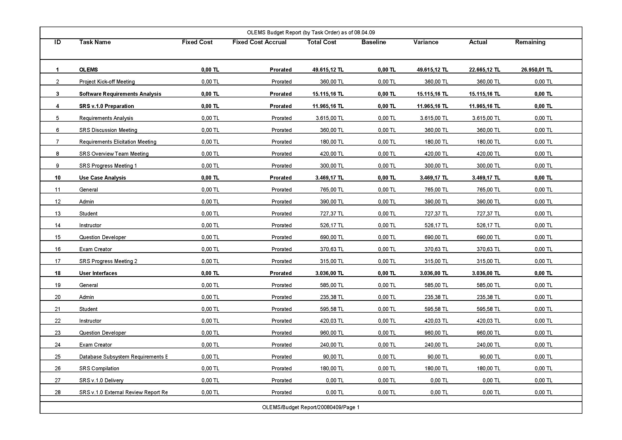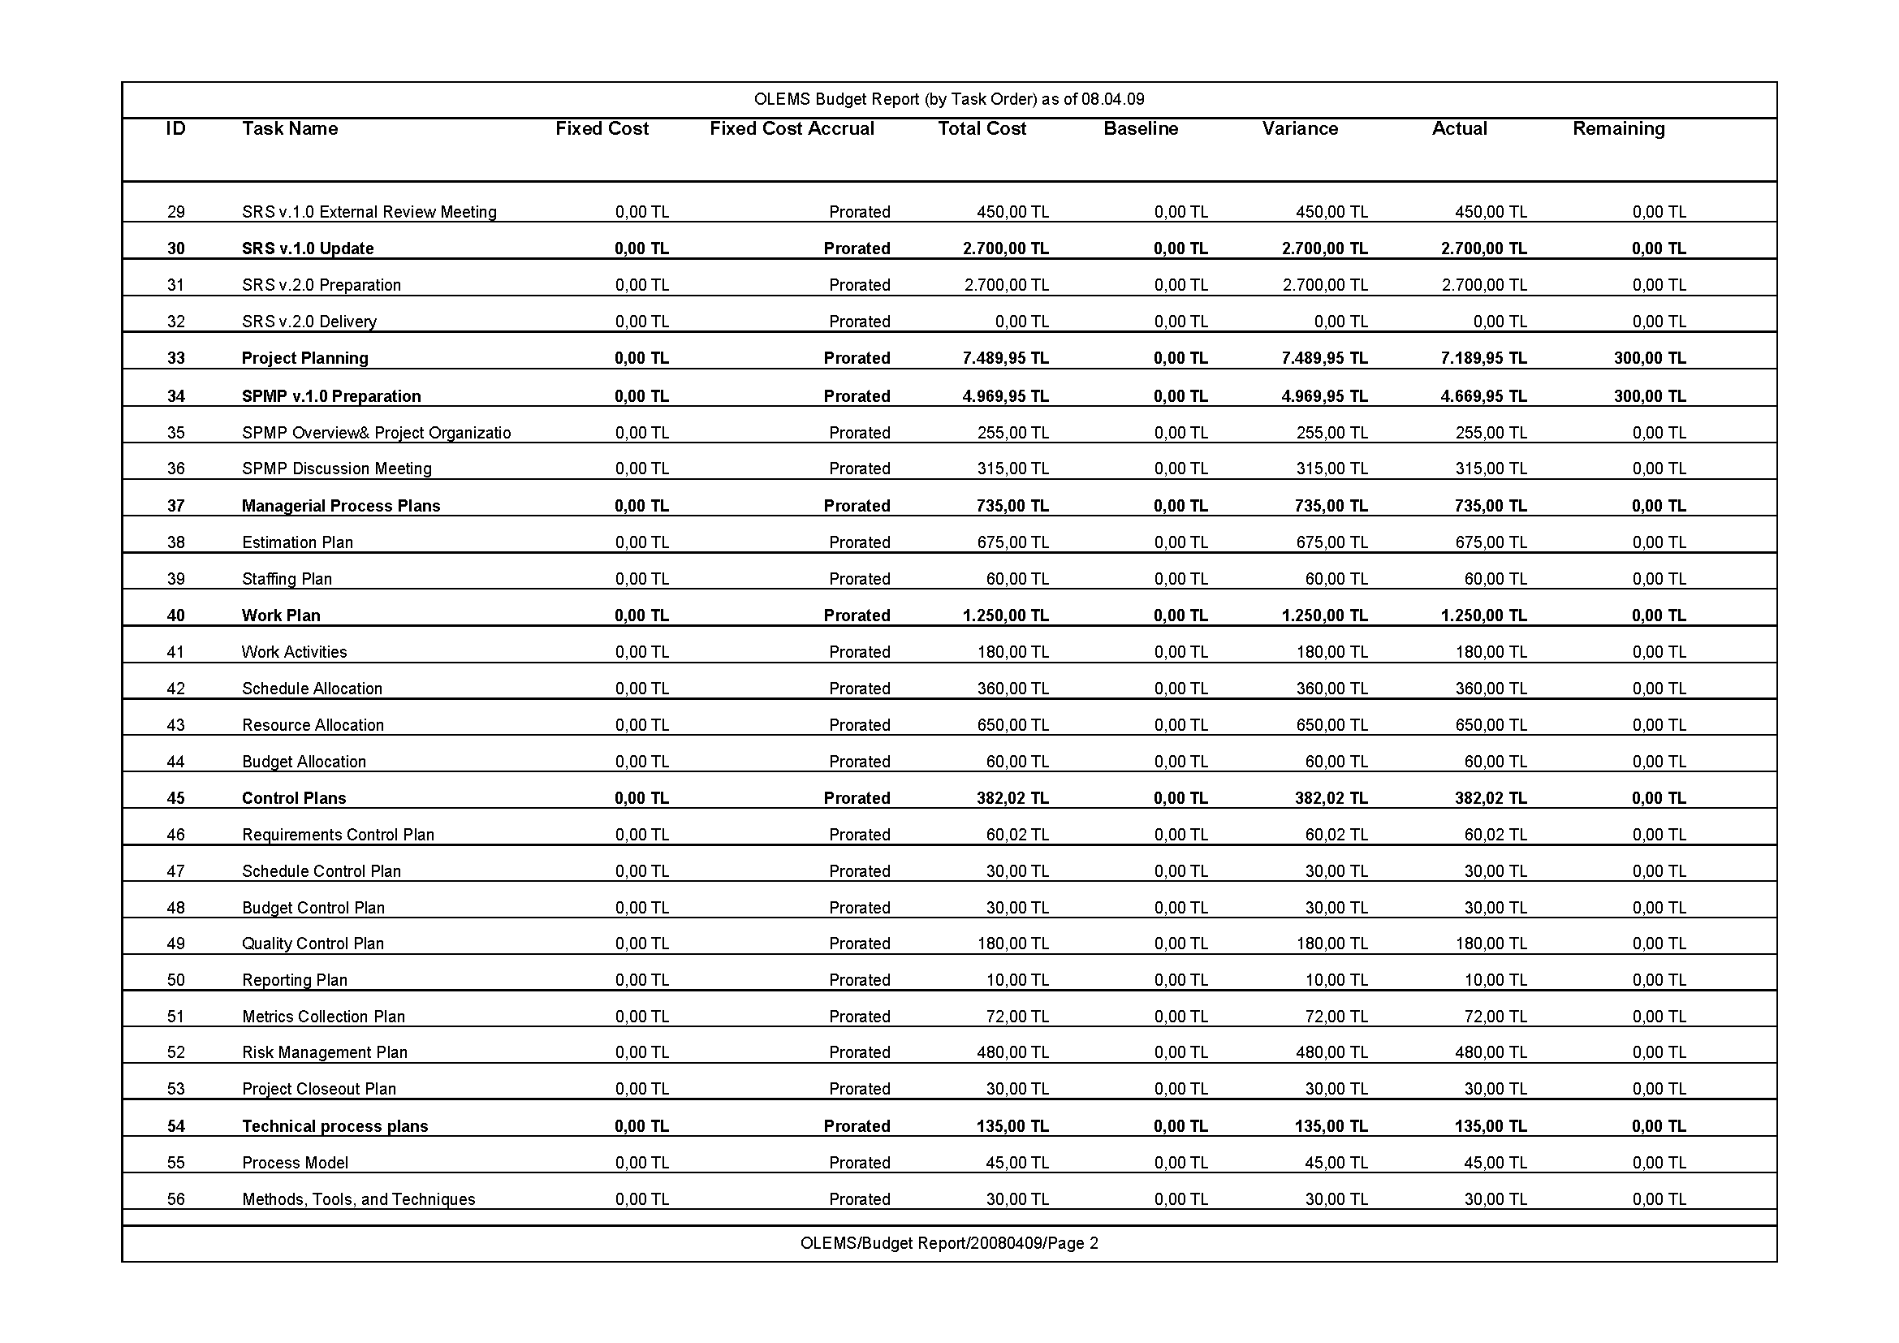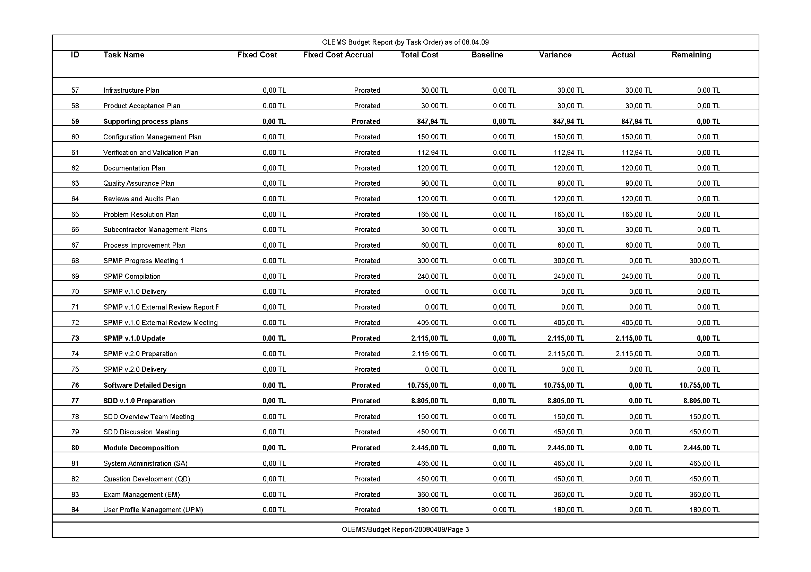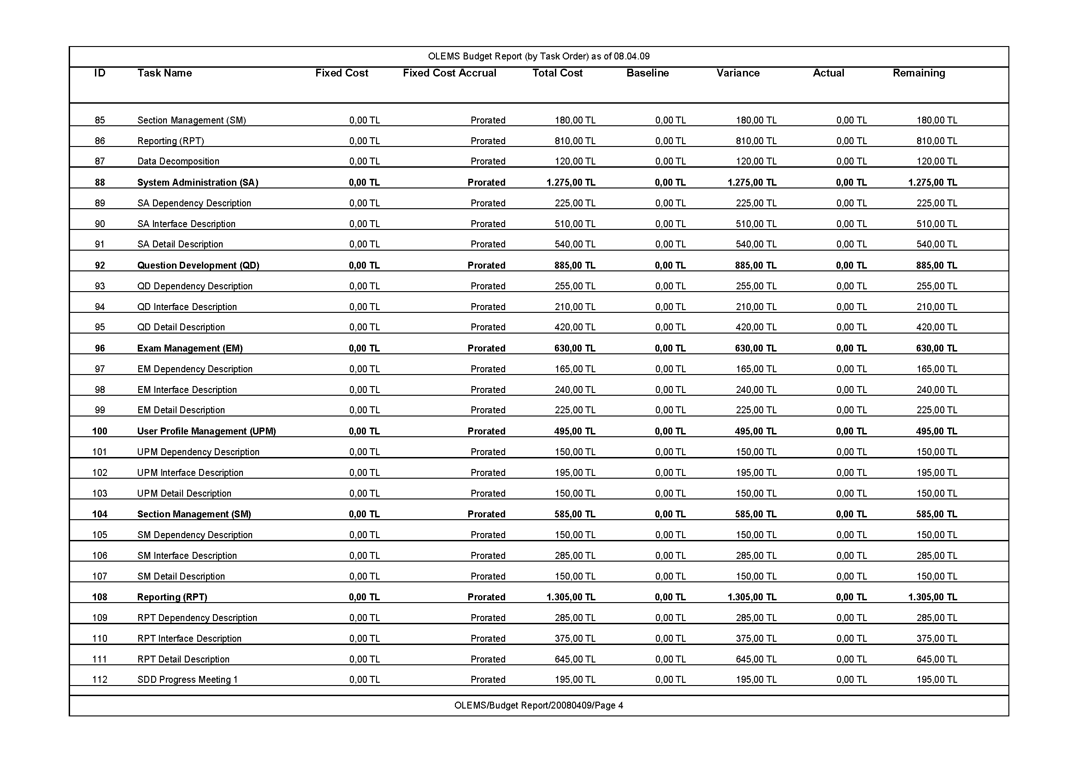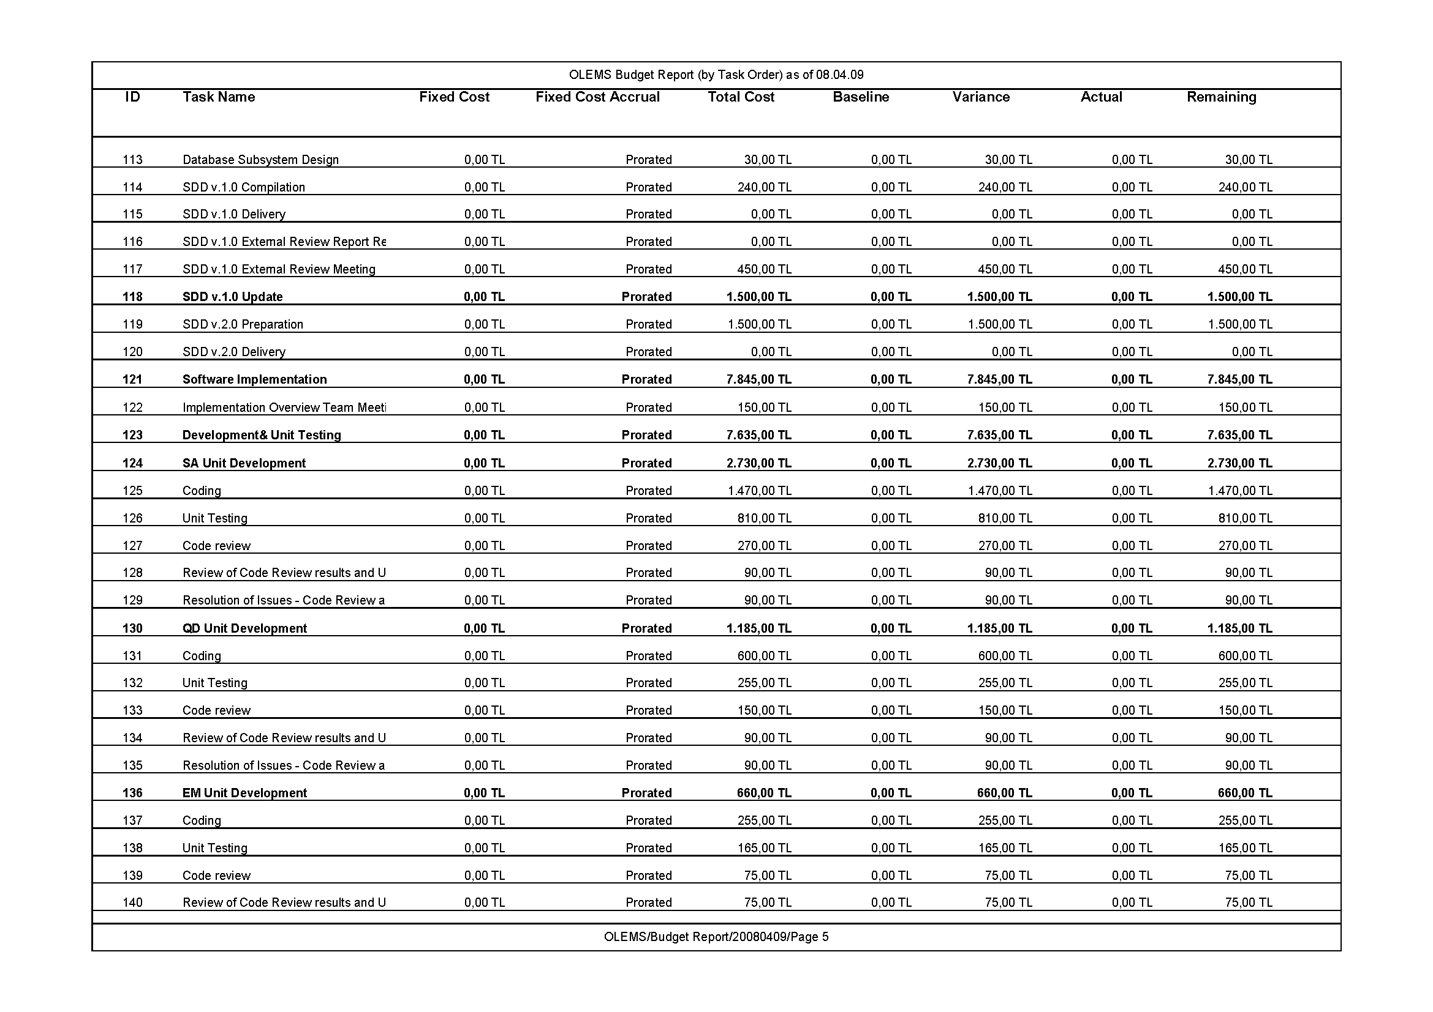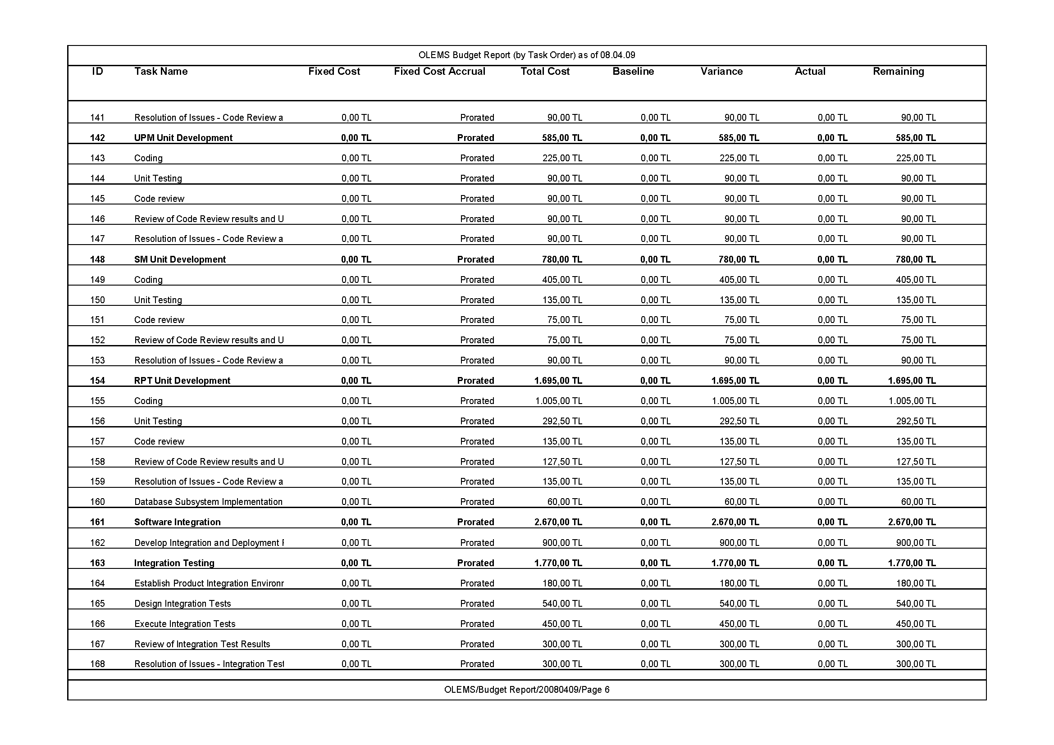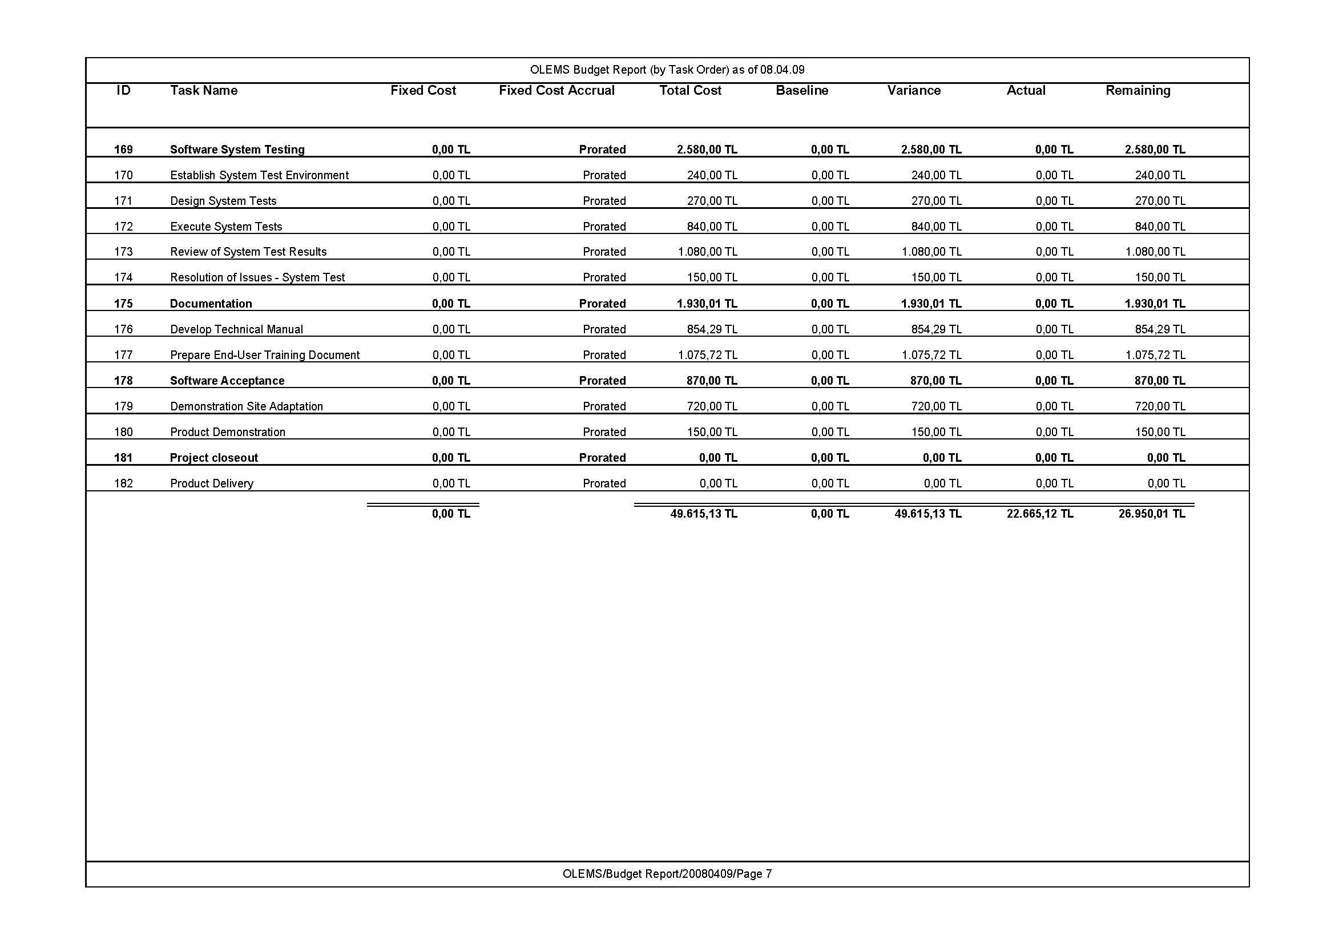

# Budget Report (by Cost, excluding Summary Tasks)

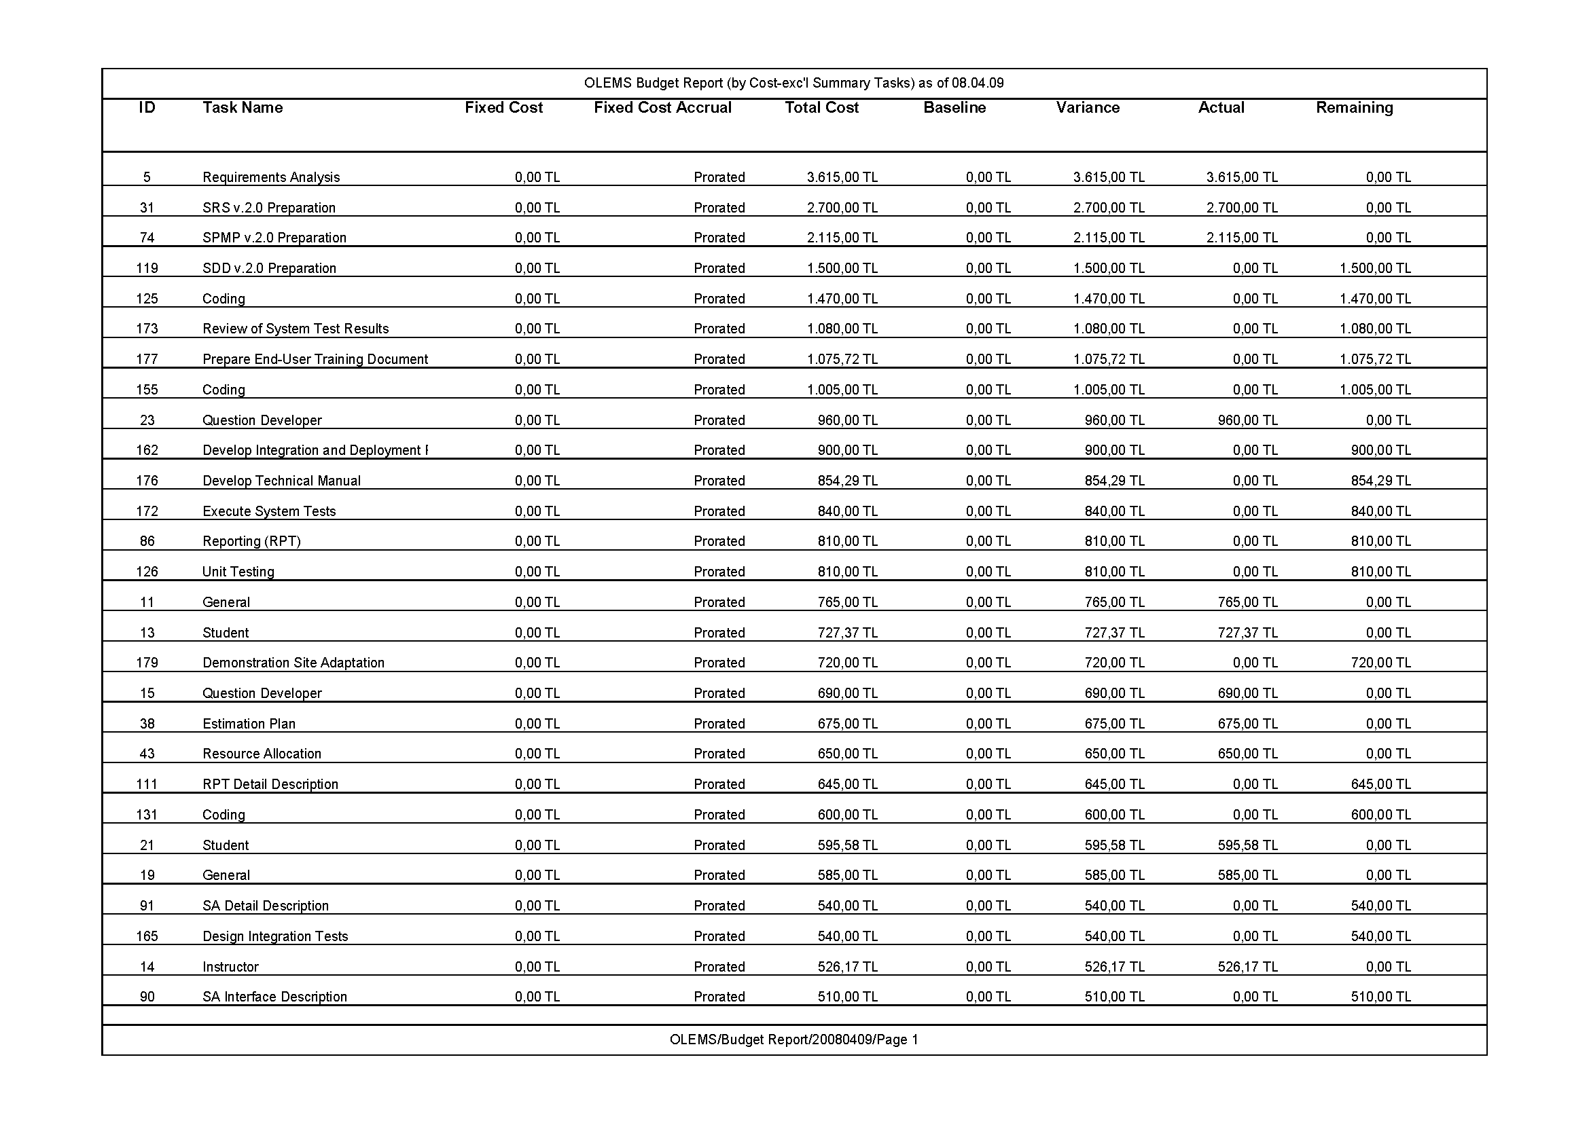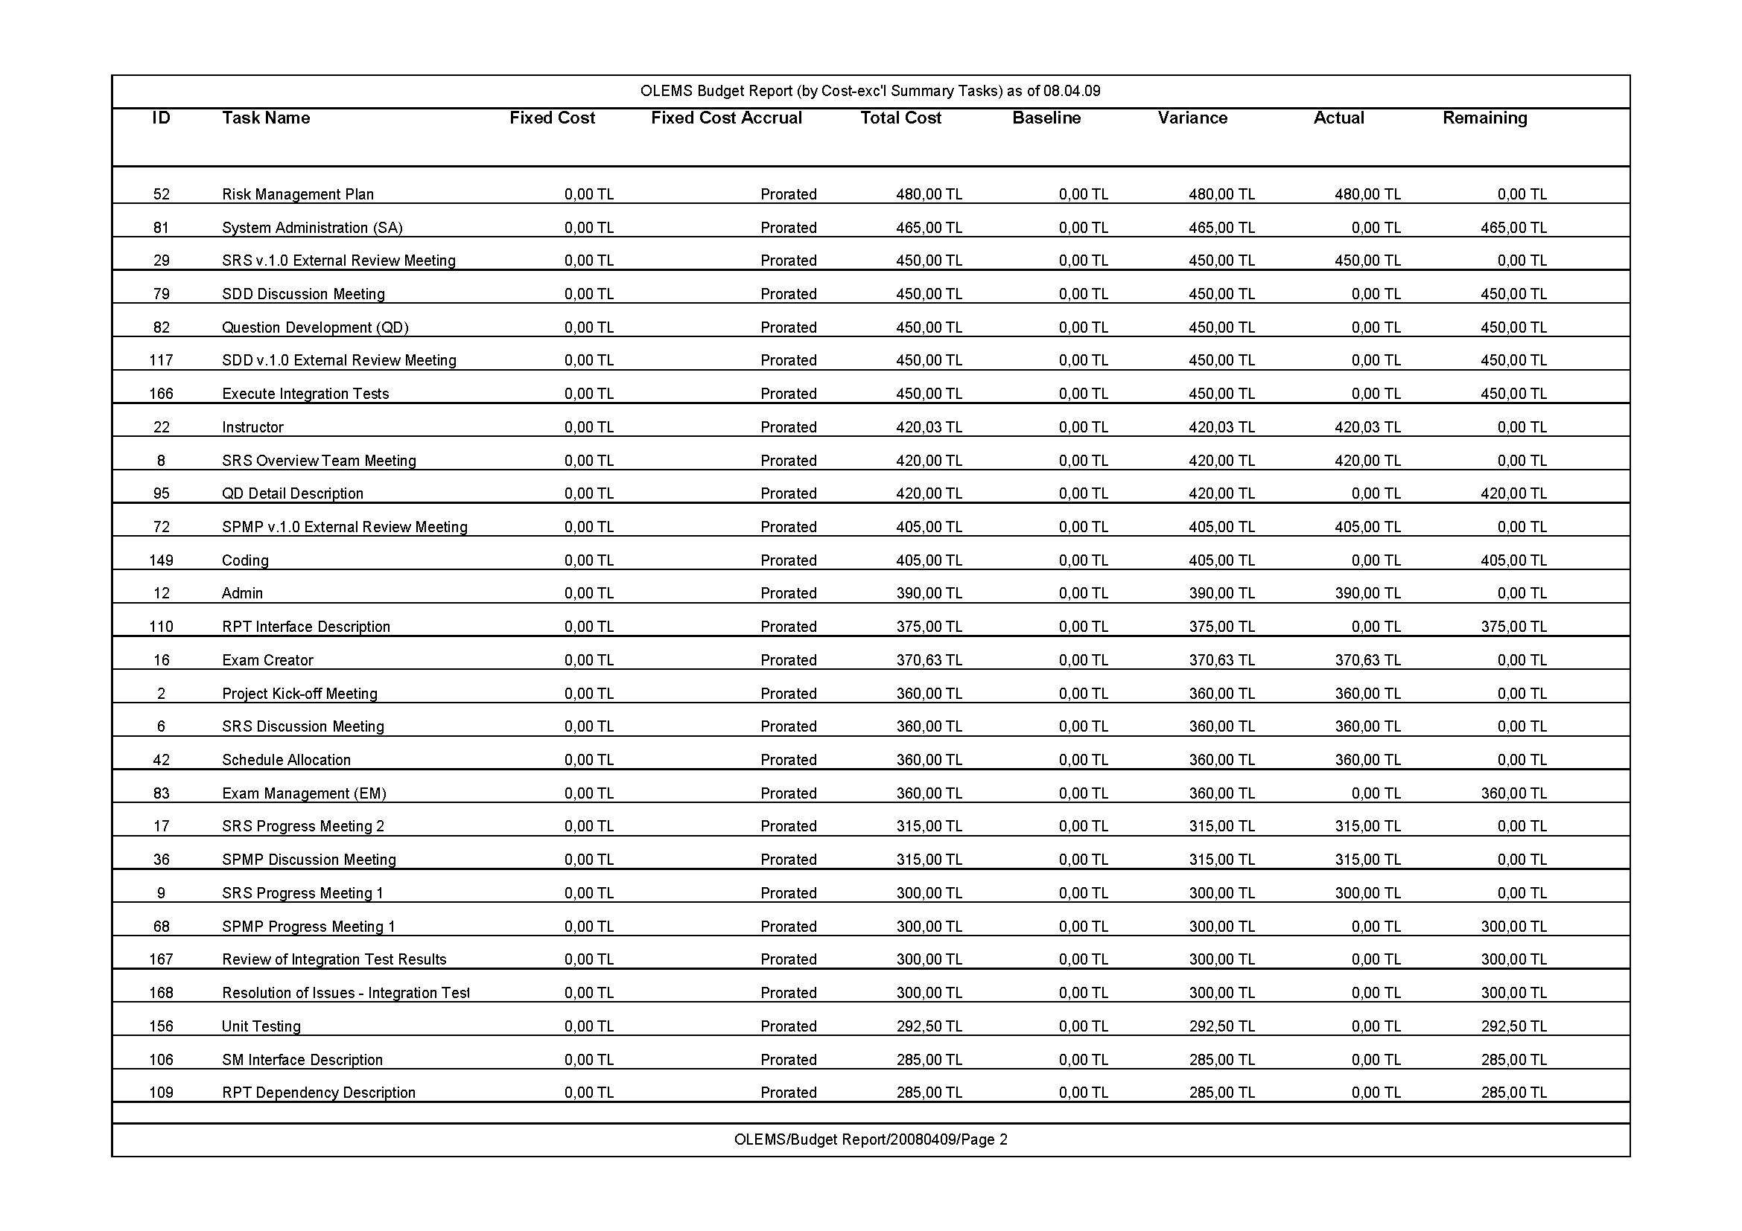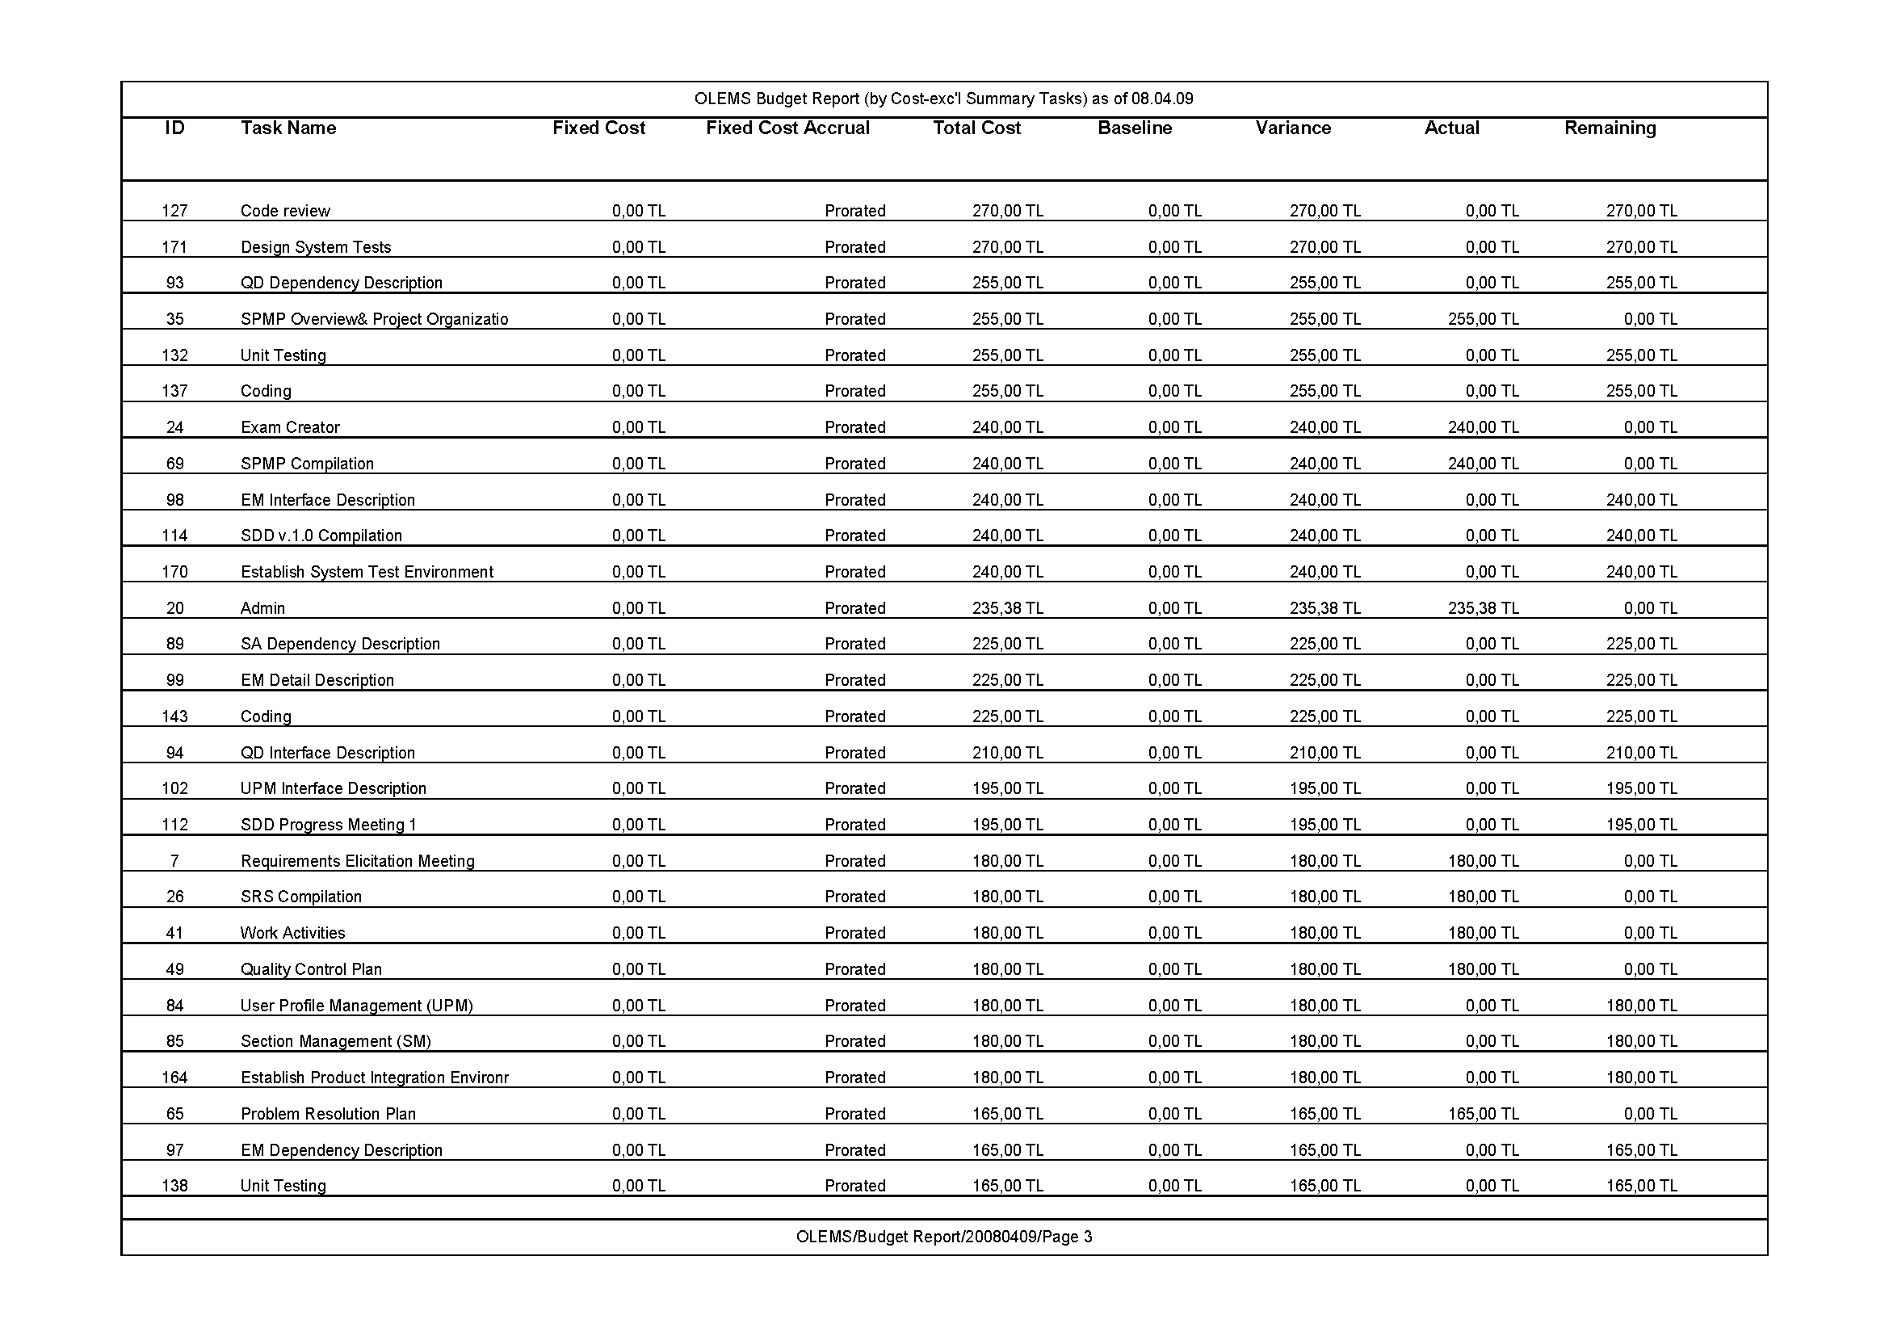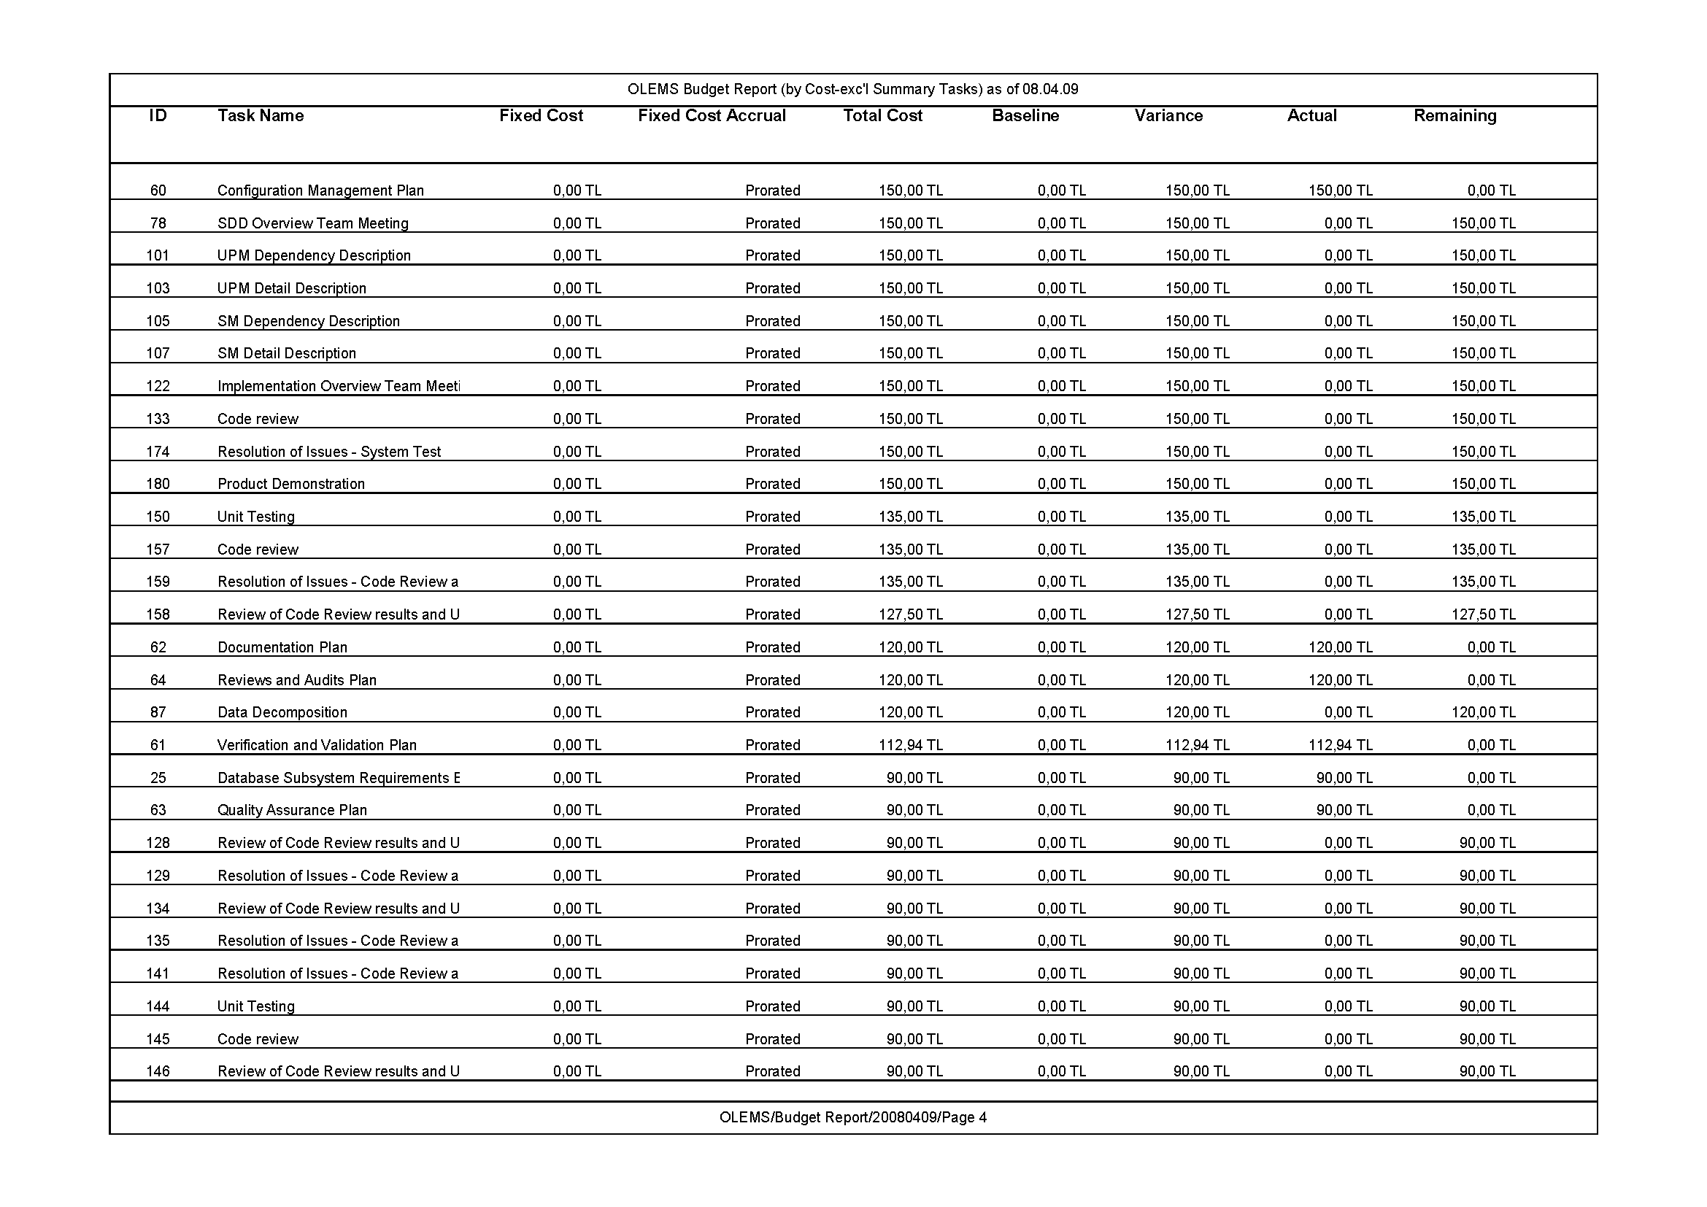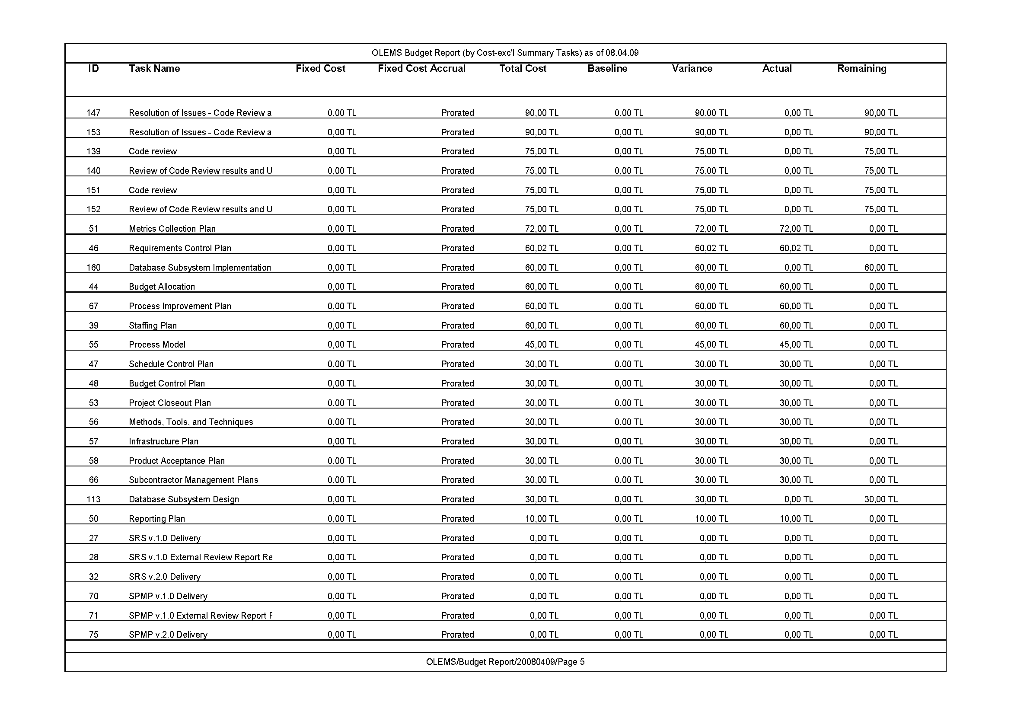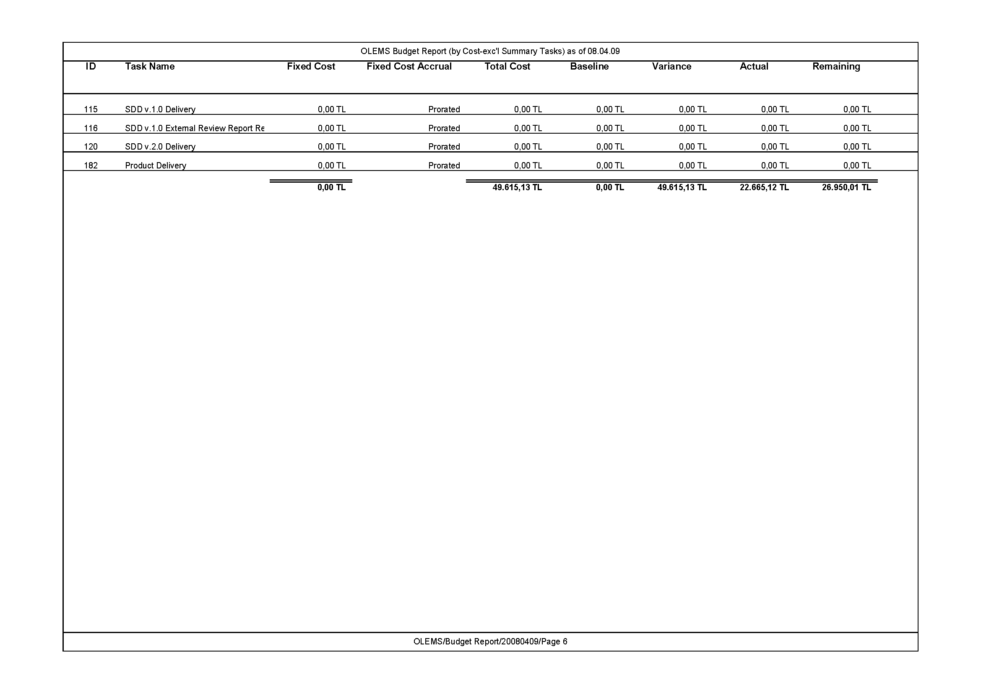

# Budget Report (by Task, excluding Summary Tasks)

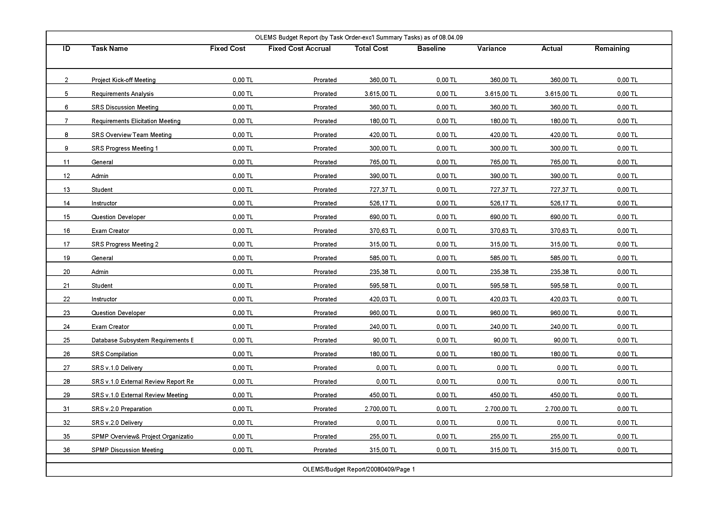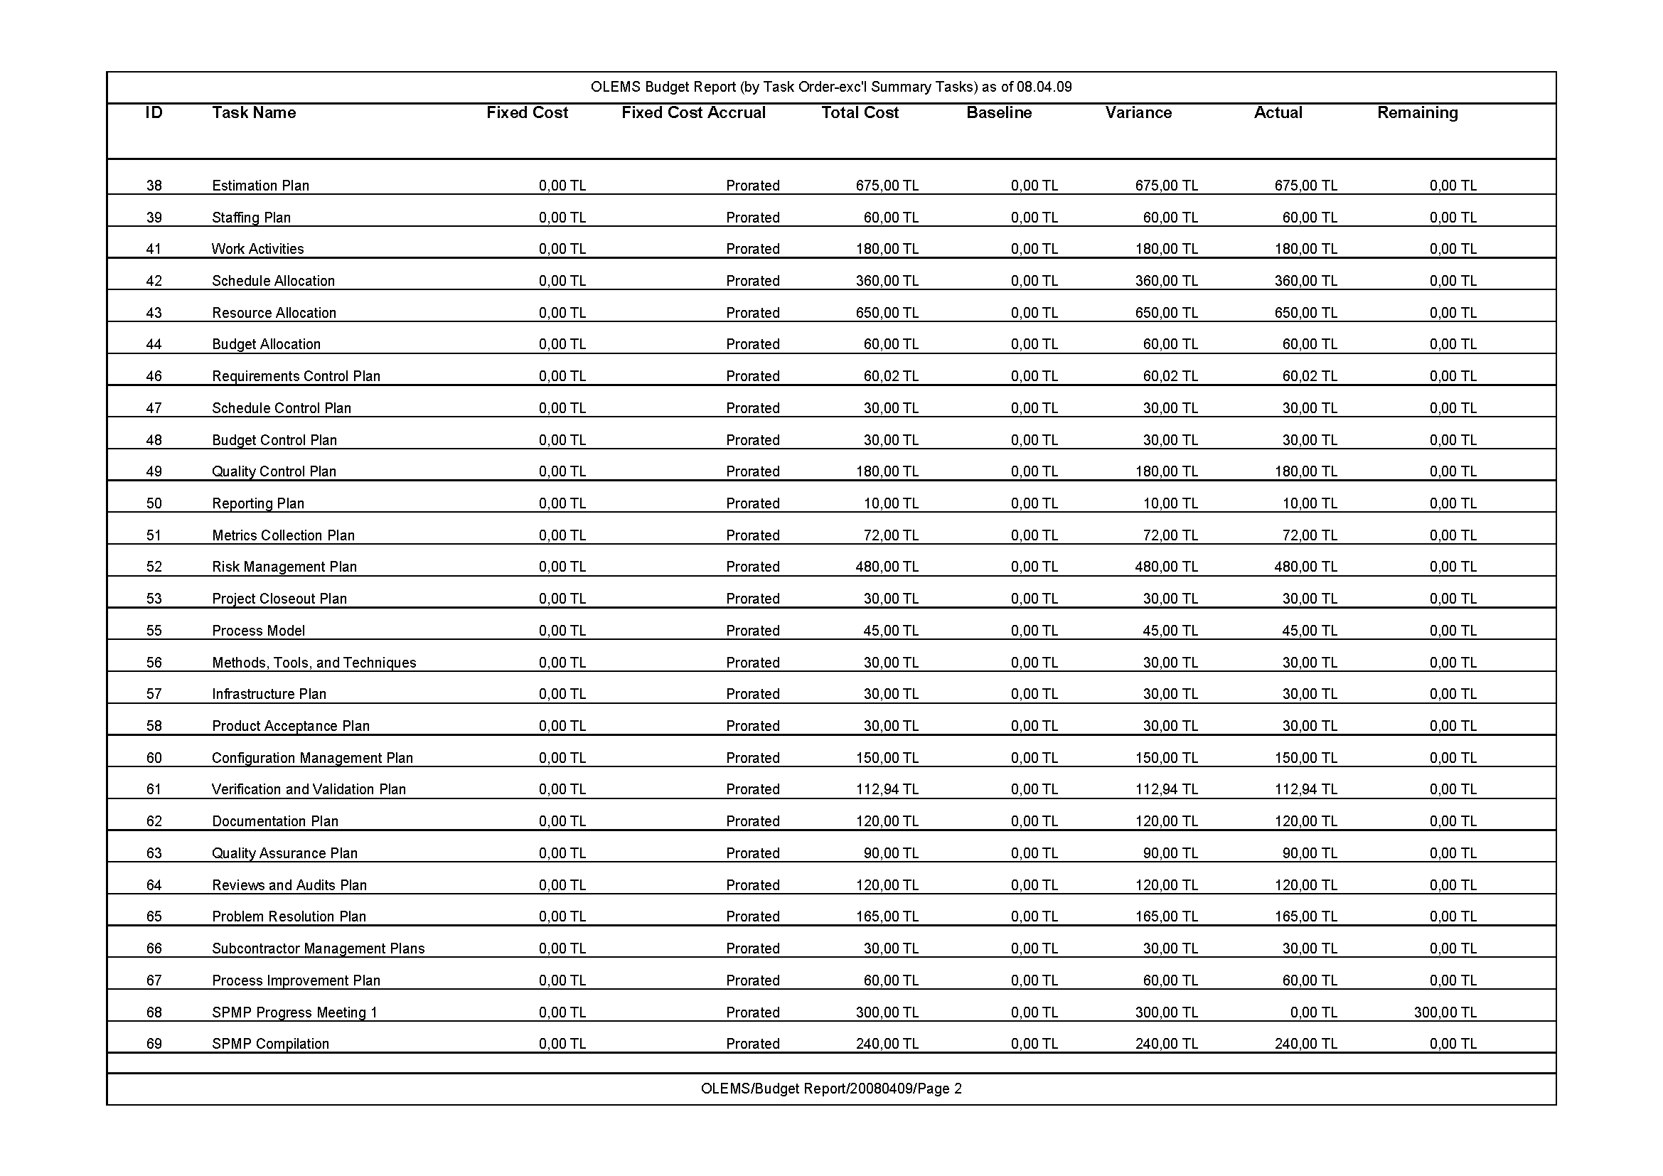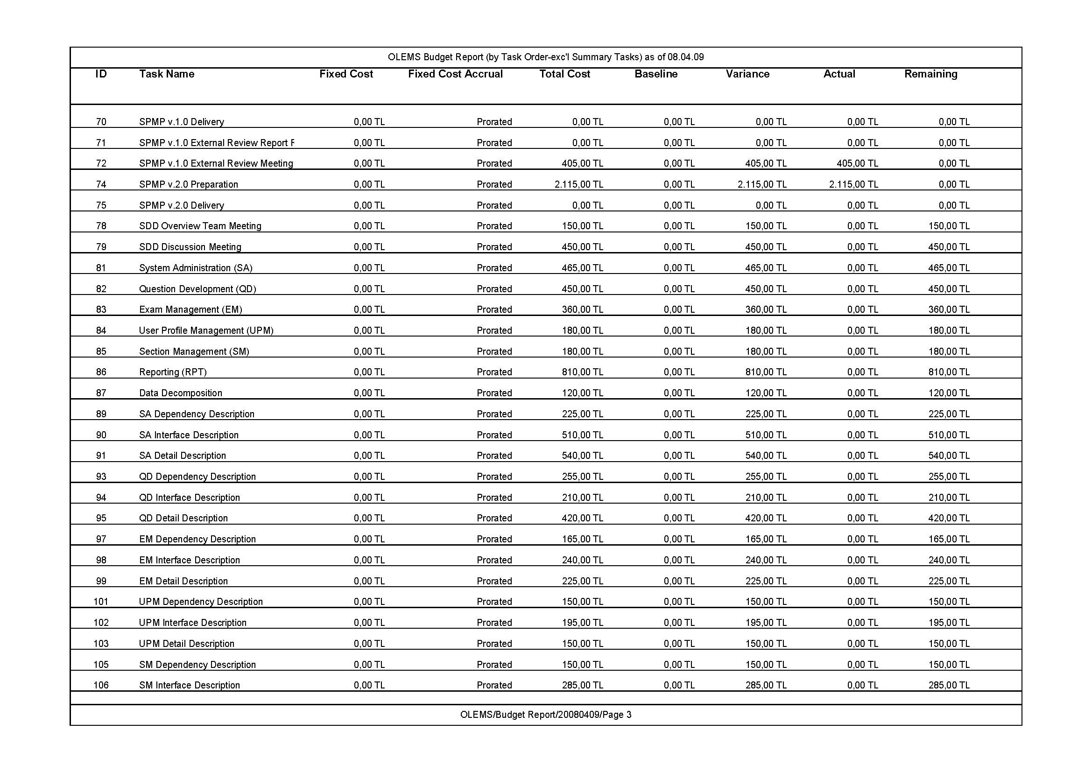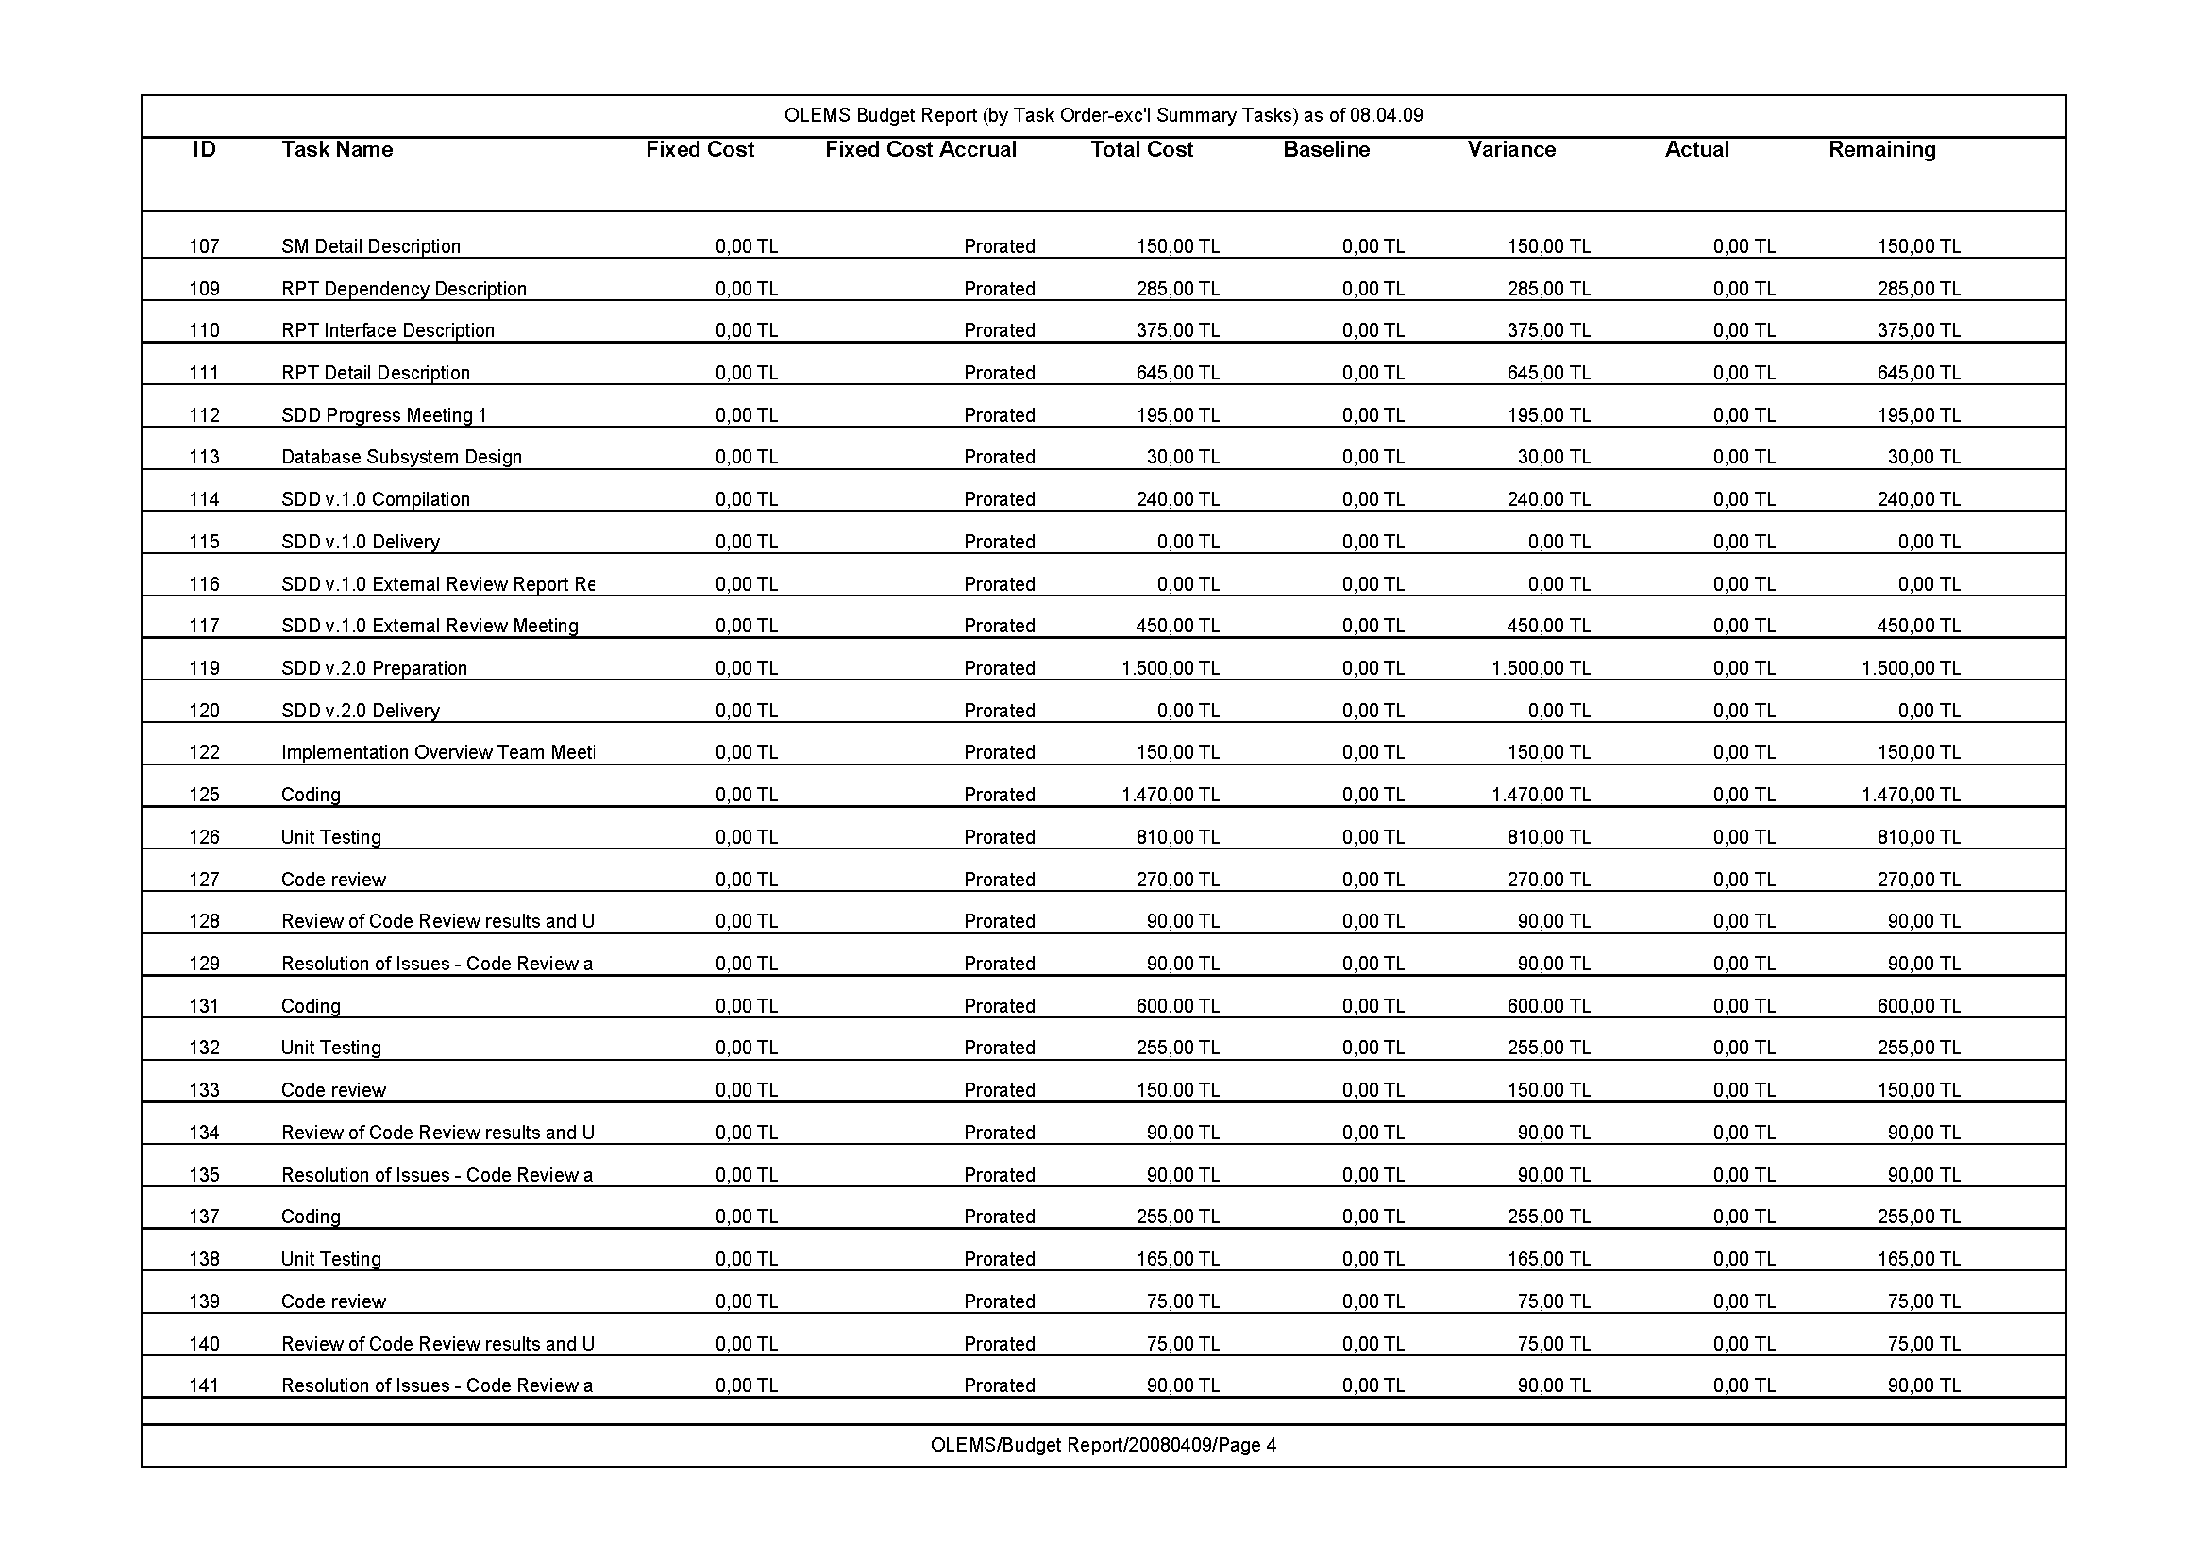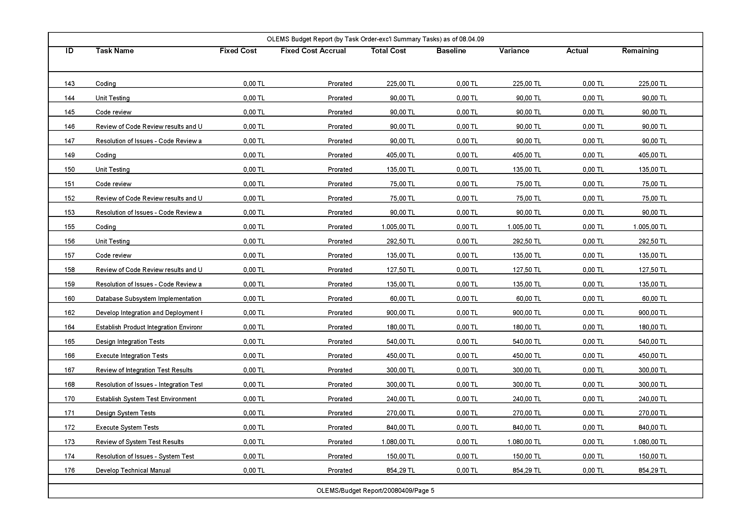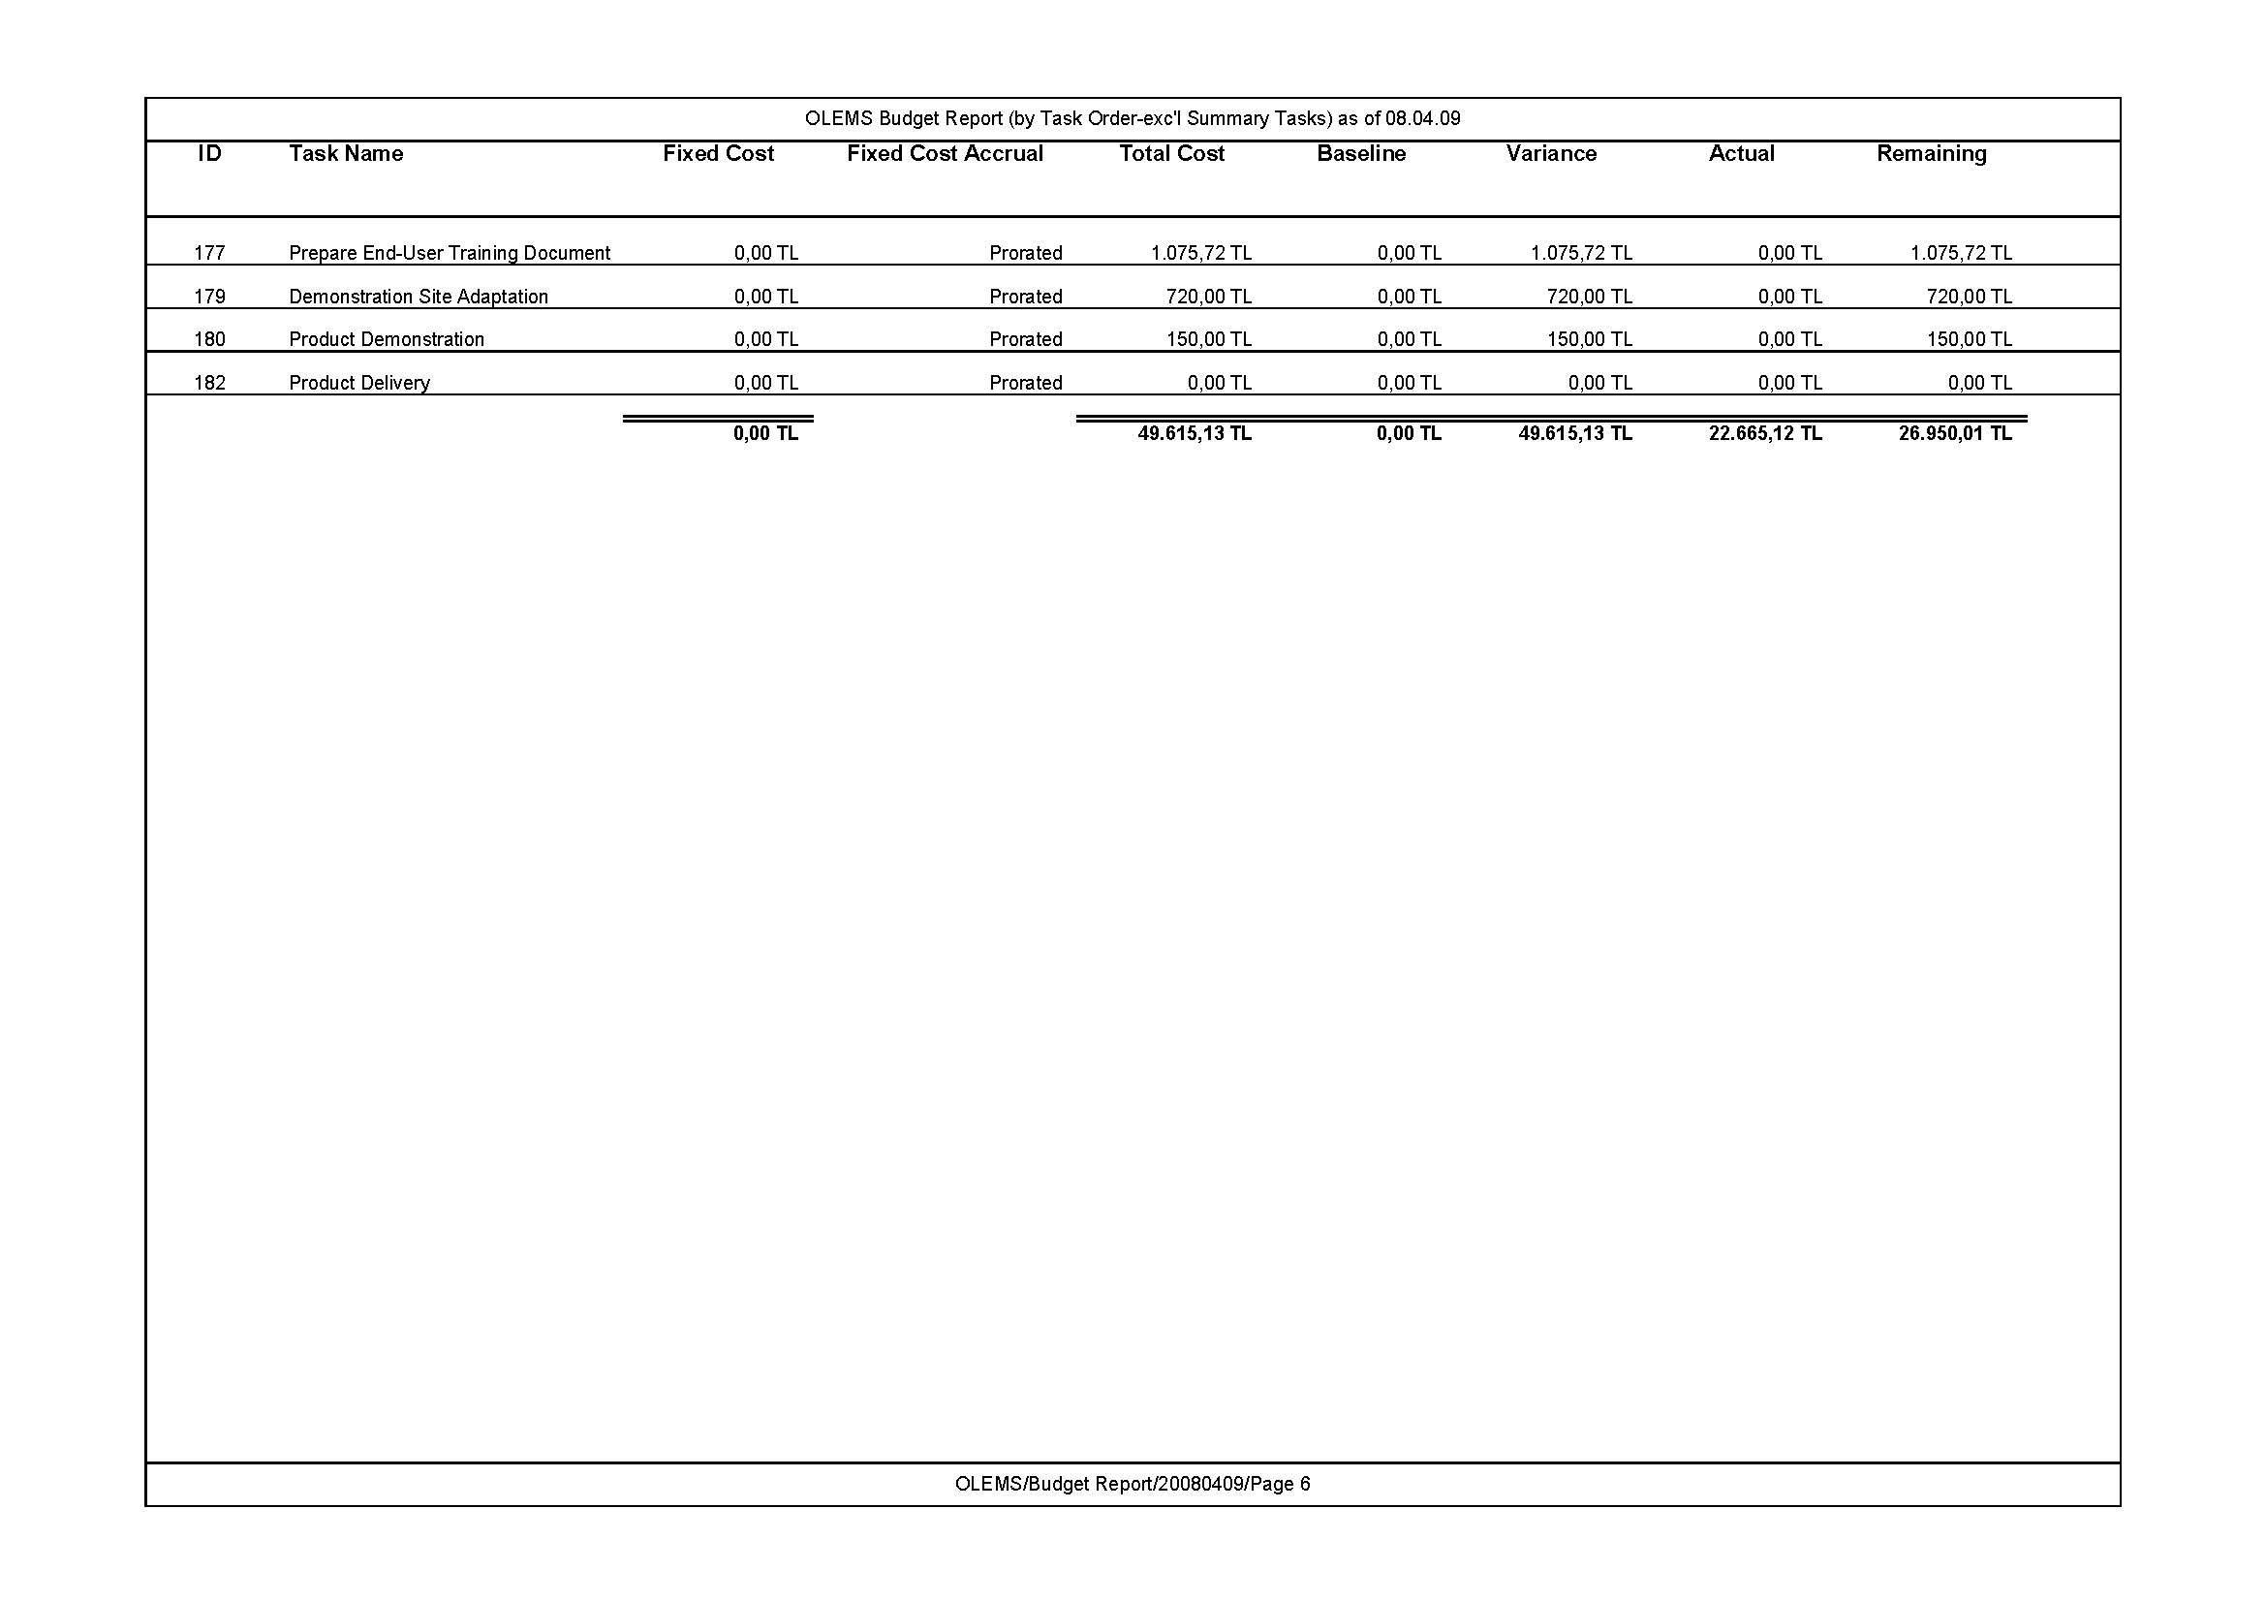

# Completed Tasks Report

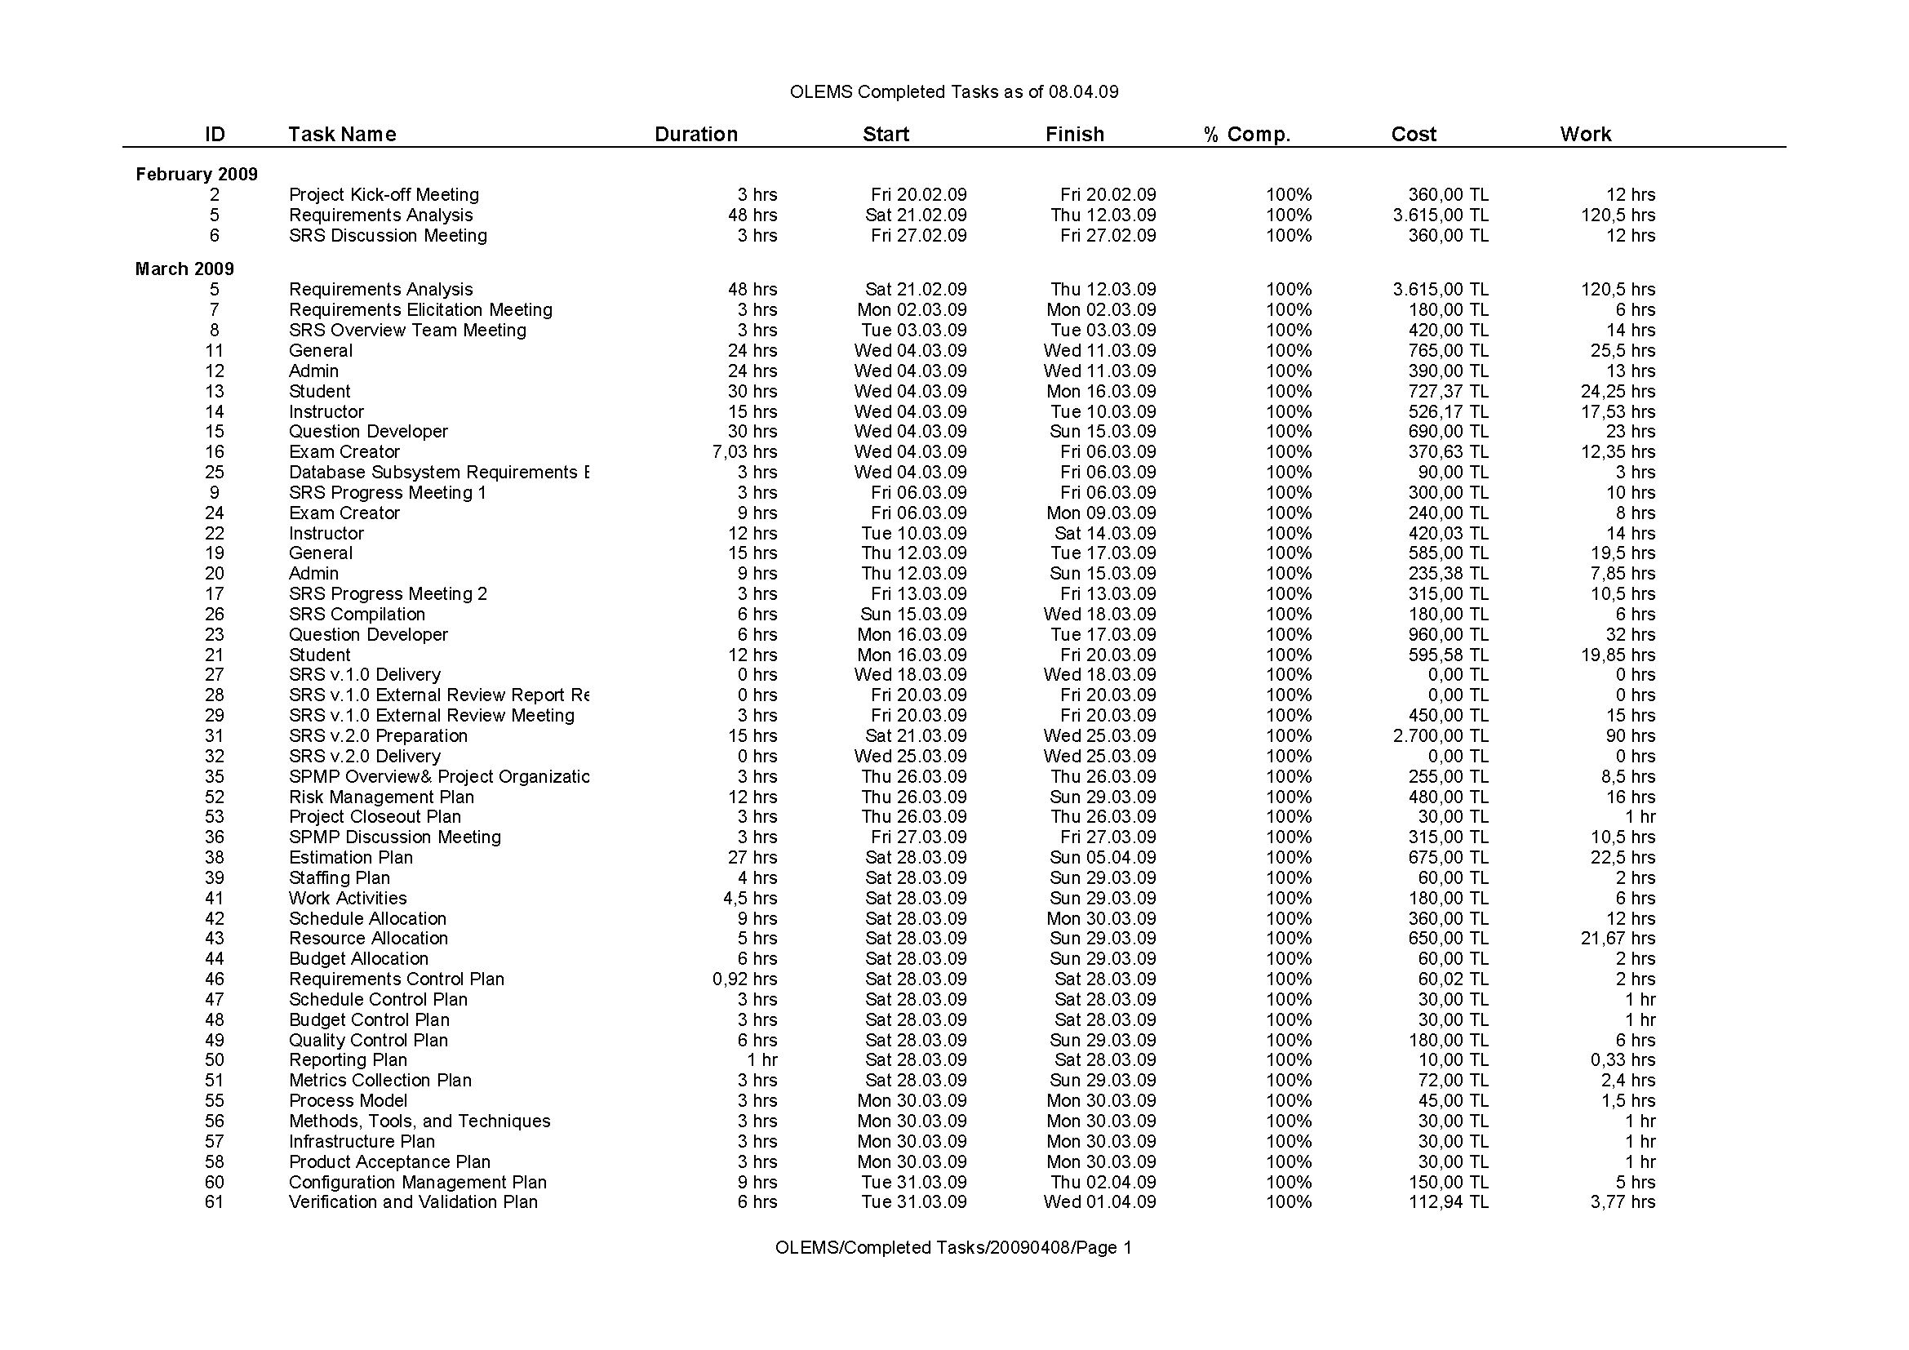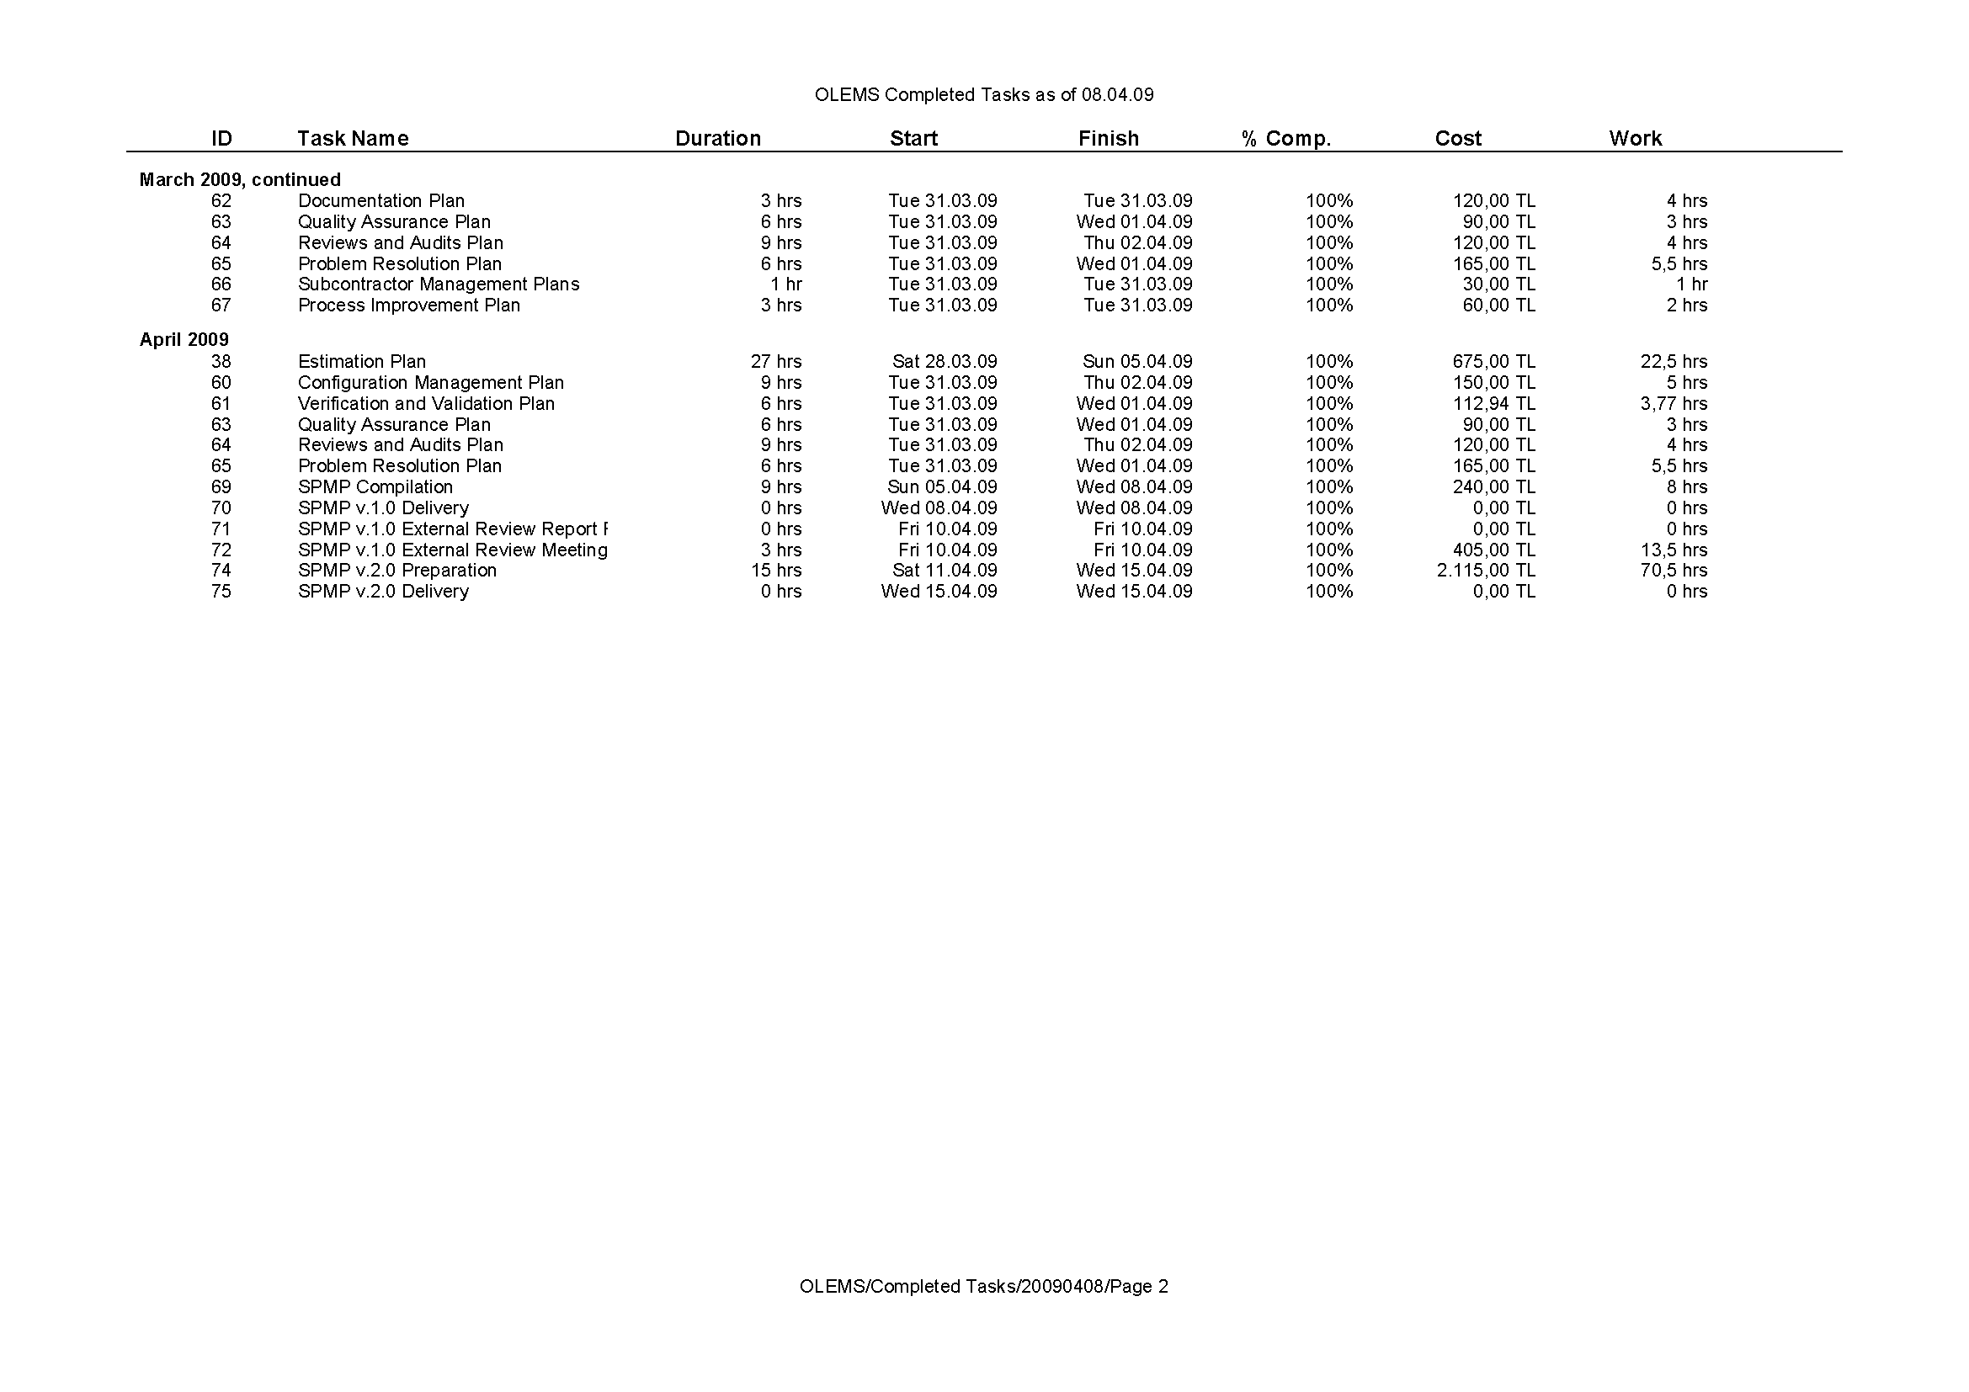

# MKII Function Point Calculation

| **#** | **Logical Transaction** | **Event or Query** | **Input DET** | **Description** | **Output DET** | **Description** | **# of Data Entities** | **Description** | **MK II FN** |
| --- | --- | --- | --- | --- | --- | --- | --- | --- | --- |
| **1** | All Users_Login | E | 2 | User Name, Password | 1 | Success/Error Msg. | 1 | User | **3.08** |
| **2** | All Users_Change Password | E | 3 | Old Password, New Password (twice) | 1 | Success/Error Msg. | 1 | User | **3.66** |
| **3** | All Users_Update Email (Manage Profile) | E | 1 | E-Mail | 1 | Success/Error Msg. | 1 | User | **2.5** |
| **4** | System_Fill All Lists on page load | E | 1 | Page Load | 2 | ID, Name | 1 | A single "System Entity" at each time | **2.76** |
| **5** | Question Developer_Create Question | E | 5 | Body, Point, Type, Topic, Attached file | 1 | Success/Error Msg. | 2 | Question, QuestionFile | **6.48** |
| **6** | Question Developer_Search Question | Q | 3 | Body, Topic, Status | 1 | Success/Error Msg. | 1 | Question | **3.66** |
| **7** | Question Developer_Display Question | Q | 1 | Question ID | 5 | All Question Info | 2 | Question, QuestionFile | **5.2** |
| **8** | Question Developer_Update Question | E | 5 | Body, Point, Type, Topic, Attached file | 1 | Success/Error Msg. | 2 | Question, QuestionFile | **6.48** |
| **9** | Question Developer_Delete Question | E | 1 | Question ID | 1 | Success/Error Msg. | 4 | Question, QuestionFile, AnswerSet, Choice | **7.48** |
| **10** | Question Developer_CreateAnswer Set of a Question | E | 1 | AnswerSet Name | 1 | Success/Error Msg. | 1 | AnswerSet | **2.5** |
| **11** | Question Developer_Display Answer Set of a Question | Q | 1 | AnswerSet ID | 1 | AnswerSet Name | 1 | AnswerSet | **2.5** |
| **12** | Question Developer_Update Answer Set of a Question | E | 1 | AnswerSet Name | 1 | Success/Error Msg. | 1 | AnswerSet | **2.5** |
| **13** | Question Developer_Delete Answer Set of a Question | E | 1 | AnswerSet ID | 1 | Success/Error Msg. | 2 | AnswerSet, Choice | **4.16** |
| **14** | Question Developer_Create Choices for an Answer Set | E | 2 | Choice, Truth Value | 1 | Success/Error Msg. | 1 | Choice | **3.08** |
| **15** | Question Developer_Display Choices for an Answer Set | Q | 1 | Choice ID | 2 | Choice, Truth Value | 1 | Choice | **2.76** |
| **16** | Question Developer_Update Choices for an Answer Set | E | 2 | Choice, Truth Value | 1 | Success/Error Msg. | 1 | Choice | **3.08** |
| **17** | Question Developer_Delete Choices for an Answer Set | E | 1 | Choice ID | 1 | Success/Error Msg. | 1 | Choice | **2.5** |
| **18** | Question Developer_Create Topic | E | 1 | Topic Name | 1 | Success/Error Msg. | 1 | Topic | **2.5** |
| **19** | Question Developer_Search Topic | Q | 1 | Topic Name | 1 | Success/Error Msg. | 1 | Topic | **2.5** |
| **20** | Question Developer_Display Topic | Q | 1 | Topic ID | 1 | Topic Name | 1 | Topic | **2.5** |
| **21** | Question Developer_Update Topic | E | 1 | Topic Name | 1 | Success/Error Msg. | 1 | Topic | **2.5** |
| **22** | Question Developer_Delete Topic | E | 1 | Topic ID | 1 | Success/Error Msg. | 1 | Topic | **2.5** |
| **23** | Exam Creator_Create Exam | E | 5 | Exam Name, Duration, Tolerance, Exam Type, Status | 1 | Success/Error Msg. | 1 | Exam | **4.82** |
| **24** | Exam Creator_Search Exam | Q | 4 | Exam Name, Exam Type, Status, Topic of the Included Questions | 1 | Success/Error Msg. | 2 | Exam, Exam_Questions | **5.9** |
| **25** | Exam Creator_Display Exam | Q | 1 | Exam ID | 5 | All Exam Info | 1 | Exam | **3.54** |
| **26** | Exam Creator_Update Exam | E | 5 | Exam Name, Duration, Tolerance, Exam Type, Status | 1 | Success/Error Msg. | 1 | Exam | **4.82** |
| **27** | Exam Creator_Delete Exam | E | 1 | Exam ID | 1 | Success/Error Msg. | 2 | Exam, Exam_Questions | **4.16** |
| **28** | Exam Creator_Assign Questions to an Exam | E | 6 | Exam Name, Topic, Number_of_TFQ, Number_of_FRQ, Number_of_MCQ, Number_of_MTCQ | 1 | Success/Error Msg. | 4 | Exam, Exam_Questions, Topic, Question | **10.38** |
| **29** | Exam Creator_Display Statistics | Q | 1 | ExamName | 9 | Duration, Number_of_TFQ_in_Exam, Number_of_FRQ_in_Exam, Number_of_MCQ_in_Exam, Number_of_MTCQ_in_Exam, Number_of_TFQ_in_QB, Number_of_FRQ_in_QB, Number_of_MCQ_in_QB, Number_of_MTCQ_in_QB | 2 | Exam, Exam_Questions | **6.24** |
| **30** | Instructor_Search Student | Q | 2 | SectionName, Exam Name | 5 | StudentName, StudentSurname, Exam_Start_Time, Student_Start_Time, Duration | 3 | Student, Examination, StudentExamination | **7.44** |
| **31** | Instructor_Start Active Exam | E | 1 | Start Active Exam Button click | 1 | Password | 1 | Examination | **2.5** |
| **32** | Instructor_Extend Exam Duration | E | 3 | Student ID, Exam ID, Duration | 1 | Success/Error Msg. | 2 | StudentExamination, StudentExaminationExtended | **5.32** |
| **33** | Instructor_Finalize Student Exam | E | 3 | Student ID, Exam ID, Reason | 1 | Success/Error Msg. | 1 | StudentExamination | **3.66** |
| **34** | Student_ Take Exam | E | 1 | Take Exam Button Click | 2 | Question Sequence Number, TimeLeft | 3 | StudentExamination, StudentExaminationQuestions, Question | **6.08** |
| **35** | Student_Display Question | Q | 1 | Question ID | 5 | Question Body, Question File, Question Type, AnswerSet Name, Choice | 4 | Question, QuestionFile, AnswerSet, Choice | **8.52** |
| **36** | Student_ Submit Answer | E | 1 | Response | 1 | Success/Error Msg. | 1 | StudentExaminationQuestionsResponse | **2.5** |
| **38** | Admin_Create Section | E | 1 | Section Name | 1 | Success/Error Msg. | 1 | Section | **2.5** |
| **39** | Admin_Search Section | Q | 1 | Section Name | 1 | Success/Error Msg. | 1 | Section | **2.5** |
| **40** | Admin_Display Section | Q | 1 | Section ID | 1 | Section Name | 1 | Section | **2.5** |
| **41** | Admin_Update Section | E | 1 | Section Name | 1 | Success/Error Msg. | 1 | Section | **2.5** |
| **42** | Admin_Delete Section | E | 1 | Section ID | 1 | Success/Error Msg. | 1 | Section | **2.5** |
| **43** | Admin_Create Location | E | 1 | Location Name | 1 | Success/Error Msg. | 1 | Location | **2.5** |
| **44** | Admin_Search Location | Q | 1 | Location Name | 1 | Success/Error Msg. | 1 | Location | **2.5** |
| **45** | Admin_Display Location | Q | 1 | Location ID | 1 | Location Name | 1 | Location | **2.5** |
| **46** | Admin_Update Location | E | 1 | Location Name | 1 | Success/Error Msg. | 1 | Location | **2.5** |
| **47** | Admin_Delete Location | E | 1 | Location ID | 1 | Success/Error Msg. | 1 | Location | **2.5** |
| **48** | Admin_Assign Instructor to Section (Define Section's Instructor) | E | 2 | Section Name, Instructor Name | 1 | Success/Error Msg. | 1 | SectionInstructor | **3.08** |
| **49** | Admin_Assign Students to Section (Define Student's Section) | E | 2 | Section Name, Student Name | 1 | Success/Error Msg. | 1 | SectionStudent | **3.08** |
| **50** | Admin_Schedule Exam for Section | E | 5 | Section Name, Exam Name, Location, Date, Time | 1 | Success/Error Msg. | 1 | SectionExam | **4.82** |
| **51** | Admin_Send Exam Notification | E | 1 | Section Name | 5 | Section Name, Exam Name, Location, Date, Time | 1 | SectionExam | **3.54** |
| **52** | Admin_Update Ownership Of Questions | E | 2 | Passive Question Developer Name, Active Question Developer Name | 1 | Success/Error Msg. | 1 | Question | **3.08** |
| **53** | Admin_Import Students | E | 1 | Student File | 1 | Success/Error Msg. | 1 | Student | **2.5** |
| **54** | Admin & Instructor_Generate Student List Report | Q | 2 | SectionName, Exam Name | 7 | SectionName, ExamName, Location, StudentName, StudentSurname, StudentNumber | 3 | Student, Exam, StudentExamination | **7.96** |
| **55** | Admin & Instructor & Student_Generate Exam Results Report | Q | 2 | SectionName, Exam Name | 7 | SectionName, ExamName, Location, StudentName, StudentSurname, StudentNumber, Score | 5 | Student, StudentExaminationQuestions, StudentExaminationQuestionsResponse, Question, Choice | **11.28** |
| **56** | Admin & Instructor_Display Statistics | Q | 3 | SectionName, Exam Name, Report Format | 3 | Question Name, Number_of_Answers, Success Rate | 4 | StudentExaminationQuestions, StudentExaminationQuestionsResponse, Question, Choice | **9.16** |
| **57** | Admin & Instructor_Export any report | E | 1 | Export Button click | 1 | An Excel file containing the report output | 1 | A single "System Entity" at each time | **2.5** |
|  |  |  |  |  |  |  |  | **TOTAL FPI** | **228.76** |

# Index

acquirer 2, 7, 16, 25, 27, 29, 30, 34, 35, 36, 39, 43

AFPI 5, 13

allocation 25, 26

budget 2, 8, 26, 27, 29

CM 5, 9, 10, 27, 28, 30

COCOMO 5, 14

cost 3, 8, 15, 27, 29, 36

CR 5, 27, 28, 29, 32

CRF 5

DBA 5, 9, 10

deliverables 2, 36, 38

DET 5, 12, 148

DV 5, 9, 10

Effort 13, 14

Estimation 11, 13, 14, 15, 34

exam 1, 2

Final Product 2

FPA 5, 11, 12, 13, 34

FPI 5, 11, 12, 13, 157

FRQ 5, 153

Hardware 25

IS i, 2, 5, 15, 27

IS100 1, 2

IS502 i, iii, 2, 5, 6, 7, 31, 32

KLOC *See* LOC

legend 2

Maintenance 1

MCQ 5, 153

meeting 27, 28, 37, 39

METU i, 2, 5, 15, 27, 28, 40, 45, 46

METU Online 2, 5, 27, 28

MK II 11, 12, 13, 34, 148

MSN 5, 40

MTCQ 5, 153

OLEMS i, iii, iv, 1, 2, 3, 5, 6, 7, 8, 9, 10, 11, 12, 14, 15, 16, 25, 26, 27, 28, 29, 30, 31, 32, 35, 36, 37, 38, 39, 40, 42, 46, 47

OnLine Exam Management System *See* OLEMS

organization iv, 7, 8

PM 6, 8, 9, 10, 29, 30, 32, 34, 37

project group 2, 28, 39, 43

project schedule 2, 25, 36

QA 6, 45

QAG 6, 7, 30, 31, 32, 42, 45

QB 6, 153

QC 6, 45

Quality assurance group *See* QAG

responsibilities 8

RM 6, 9, 10

role 1

SA 6, 9, 10

SCM 6

SD 6, 9, 10

SDD 2, 6, 7, 9, 30, 31, 32, 46

Size 11, 14

Skype 6, 40

Software i, iv, 1, 2, 6, 9, 11, 16, 26, 41, 42

Software Project Management Plans *See* SPMP

software requirements specification *See* SRS

SPMP i, iii, 1, 2, 3, 6, 7, 8, 16, 30, 31, 32, 45

SQAP 6, 9

SQAR 6, 9, 10, 45

SRS 1, 2, 6, 7, 30, 31, 32, 35, 36, 45

staff 1, 2, 13, 14, 15, 16, 38, 45

Staffing 15

TCA 6, 13

TDEV 6, 14, 15

TDI 6, 13

TFQ 6, 153

TS 6, 9, 10, 45

UKSMA 6, 11

WBS 6, 16, 58

Working days 1