Agria Media 2008 and ICI-8 Information Technology and Education Technology Conference and Exhibition
Eszterházy Károly College, Hungary
27-28 th October 2008.
----------------------------------------------------------------

LEARNERS’ ABILITY, EXPERIENCE AND PERCEPTION OF USE OF ICT IN LEARNING AND EDUCATION: A COMPARISON BETWEEN OPEN UNIVERSITY MALAYSIA (OUM) AND EUROPEAN UNIVERSITIES

Latifah Abdol Latif; Ramli Bahroom; Ng Man San;
Ahmad Izanee Awang and Nik Najib Nik Abdul Rahman

Abstract

Open and Distance Learning (ODL) institutions have long recognized the need of their learners to participate in education programmes through a flexible delivery of instructions. One of the key elements of a flexible delivery mode is the use of the Information and Communication Technologies (ICTs) in providing software applications and tools for e-learning. However, the potential of ICT will only be fully realized if learners have the ability and capacity to use them, and at the same time possess positive attitudes towards learning with ICT.

The study aims to determine learners’ perceptions of the use of ICT in learning at Open University Malaysia (OUM) by examining their abilities and experiences, with a view to identifying areas for enhancing the effectiveness of e-learning. Determining the competency of learners in their use of ICT applications is not an easy task; thus a survey methodology was employed, involving a random sample of 457 undergraduate learners. Respondents were asked to rate their own skills using four common software applications (word processing, presentation software, email and digital library). In general, the study found that between 39-56% of learners were able to use the four software applications on their own. In terms of experience, nearly three fourths of learners had used Online Forum several times, followed by Interactive Website and Email Support. With regards to learners’ perceptions on the value of ICT and its potential role in education, the respondents held a fairly positive view of the different advantages that ICT can bring to learning. However, they also showed a relatively strong preference for learning with traditional method, questioning the value of ICT. Finally, the study found that ability and experience in the use of ICT are correlated with positive perception towards learning with ICT. A regression analysis found that the significant predictors of positive perception towards learning with ICT, with an overall R-square of 20% include: ability to use email and the experience of using MyLMS, online discussion forums and email support. This implies that in order to encourage OUM learners to use ICT in learning, it is vital to upgrade their ICT skills and provide them with the means to gain experience in e-learning through myLMS. The results of this study are also compared with that of the European Universities (SPOT+, 2004).
Key words: Ability; experience; perception towards learning with ICT; regression analysis.

- Introduction
1.1 Background

As an integral part of higher education, Information and Communication Technology (ICT) has made positive inroads into learning and education. This is evident in a number of studies indicating that integration of ICT can have positive effects on learning outcomes (Diochon and Cameron 2001; The Pew Internet & American Life Project, 2002; SEUSISS Project, 2002; Saunders and Klemmif 2003; SPOT PLUS, 2004). These studies, however, focused mainly on young adult learners. Therefore, the study findings may not be useful enough as a basis to extrapolate to older working learners, part-time learners and other student groups. It follows that universities with intakes of diverse profiles would need to survey their own learners to better understand their abilities, experiences and perceptions of use of ICT in learning and education.

A study on ICT towards learning is even more necessary for the open and distance learning (ODL) institutions as their populations are more diverse than those of the traditional campus-based institutions. In addition, there is a lack of research knowledge of ICT usage among older learners. The Open University Malaysia (OUM), the first and largest open and distance learning (ODL) university in Malaysia is thus selected as the model for this case study.

1.2 Demands for ICT usage

OUM began operations in August 2001 with 753 learners enrolled in four academic programmes. Seven years later, (January 2008), the number of learners rose to more than 70,000 registered in 51 academic programmes. This large number of learners spread over a diverse range of academic programmes is an indicator of the challenging role that ICT is expected to play in impacting learning outcome in OUM.

Just as in other ODL institutions, working adult learners in OUM require a more flexible system of attending tutorials to balance family, social and work priorities and commitments. Under this challenging condition, working adult learners would require ICT to aid learning whenever they are not able to attend face-to-face tutorials. Moreover, these adult learners who are regularly exposed to increasing demands of society would also realize the need to equip themselves with ICT knowledge and skills. Finally, OUM also needs the ICT as a tool to reach out effectively to its distributed learners.
In response to the various demands for ICT usage, the Internet together with other forms of technology is adopted by OUM as one of the main instructional and learning means to accommodate the pedagogical shift from the teacher-dominated role to the learner-centred role. In particular, Internet is adopted to enhance time-tabling of courses, assessment results, tutor feedback to learners, and many others. ICT is also used to deliver the academic components of a course by making it more flexible. E-learning, which is one of the three components of OUM’s blended delivery mode, is made available 24 hours, seven days a week through the Learning Management System (or MyLMS). MyLMS which integrates e-mails, discussion forums, chats etc., provides seamless support for learners. It serves as an e-learning platform for interaction among the university community members, which include learners, tutors, subject matter experts, academic and non-academic staff.

- Objectives of study

Given the ICT facilities in OUM, it is pertinent to find out the extent to which learners are using them to improve their learning outcome. The present study was thus carried out to achieve the following objectives (a) to obtain a baseline assessment of learners’ abilities and experiences in using ICT, (b) to obtain learners’ views on the opportunities that can be enhanced by ICT, particularly its actual and potential role in learning and education, (c) to identify the significant predictor variables for predicting “positive perception of using ICT for learning and education”, and (d) to highlight the similarities and differences in ICT use in learning and education among Malaysian and European learners.

  - Significance of the study to OUM

This study is important to OUM in many respects. Firstly, getting learners inputs on the role of ICT in learning is an important component of the university’s strategic plan. Very often learners’ needs are not matched with the objectives of the university. Secondly, technologies change rapidly and the differential uptakes of the technologies may result in a mismatch between the university and the learners. Thirdly, when it involves a change in the university’s policy, such as increased use of e-learning, the acceptance level between learners and staff may differ. Finally, measuring change in learners’ ICT skills and attitude towards the use of ICT in learning and education will help the university in decision making.

- Methodology

  - The Sample and profile of respondents

The sample of the study consisted of 457 learners selected from three of the thirteen states in the country. The three selected states were Pahang, Kelantan and Sabah. The majority of the learners in the sample was females (71%), above 26 years old (62%) and married (87%). In terms of entry qualifications, slightly less than half of the learners (44%) had the equivalence of O-level while the rest had the equivalence of ‘A’-level or diploma certificates. The majority of the learners worked in the public sector while a small number worked in the private sector or were self-employed. This sample of respondents was from various programmes and it clearly showed that learners in OUM are of diverse socio-economic and demographic background.

  - Questionnaire and data collection

The research instrument used in this study was a set of questionnaires adapted from the SPOT-PLUS Project conducted in 2004 by the Directorate General for Education and Culture of the European Commission (ECEC) (http://www.spotplus.odl.org /questionnaire). The survey questionnaire has been designed for machine reading by using image-analysis scanning. The questionnaire is divided into five sections.

The first section contained questions concerning learners’ gender, race, programme of study, academic grades, source of finance, distance of learning centre from home, mode of transport, and means of communicating with the institution.

The second section measured learners’ ability in using four standard applications (Word Processor; Email; Presentation Manager; and Bibliographic Database) using a 3-point scale, that is, (1): I can do this by myself; (2): I would need some help to do this and (3): I have never done this type of task.

The third section measured learners’ experience in four different applications (Multimedia Learning Materials; Online Discussion Forum; Video Conferencing, myLMS and Academic Support and Advice) using a 4-point scale, that is, (1): Several times; (2): Once; (3): Never; (4): Never heard of this.

The fourth section contained 20 questions which were used to tease out learners’ attitudes towards the use of ICT in learning and education. The 20 questions were used to re-classify the responses into two factors, namely “positive perception of use of ICT in learning and education” and “positive perception of use of traditional method/negative perception of use of ICT in learning and education”. Learners were asked to provide answers to the 20 questions based on a 4-point scale, that is, (1): I totally agree; (2): I mostly agree; (3): I mostly disagree; and (4): I totally disagree. Another category was also provided, that is, (5): I do not know.

The final part of the questionnaire contained 17 questions concerning opportunities that might be enhanced by ICT use. The respondents were asked to indicate how important in their opinion each item was on a 4-point scale from 1 (no importance at all) to 4 (very important). An additional category (5: I do not know) was also provided. The responses to the 17 questions were re-classified into three factors in accordance with the SPOT-PLUS Project recommendation. The first factor was labeled ‘Facilitating contact and information exchange’, the second factor: ‘Promoting access to higher education’ and the third factor: ‘Changing the learning process and learning outcomes’

3.3 Data collection

The questionnaires were distributed to the learning centres, and administered to learners of different programmes and semesters of study after their tutorial sessions in May 2008. A total of 457 learners responded in the survey. The completed questionnaires were collected immediately after the tutorial session, and processed using SPSS and EXCEL.

- Analysis and results

4.1 Abilities of using ICT applications

In this study, the learners in the sample were asked to rate themselves in terms of their own ability to use four well-known software applications (word processing, presentation, e-mail and on-line bibliographic database) based on a 3-point scale. The study found that more learners in the sample could use word processing by themselves as compared with the other three applications (Figure 1). However, the proportion of learners who had this ability was not high. The proportion of learners who could use word processing was only 56%, while the proportions for the other three applications were lower, with 48% for emails, 44% for presentation and 39% for bibliographic database. Figure 1 also indicates that a fairly large proportion of the learners would need some help to use the ICT applications. Thus, some 50% and between 34% and 46% of them would need some help to use word processing, and the remaining three applications, respectively. Interestingly, the survey revealed that a small proportion between 10% and 13% of the learners had never used any one of the four ICT applications.

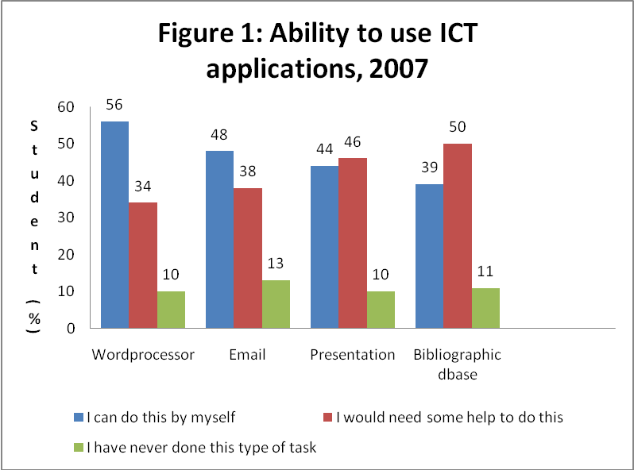

4.2 Experience of using ICT application

The learners were also asked about their experience in using five well-known e-learning tools (interactive website, online forum, video conferencing, MyLMS and academic support and advice). Four choices (several times, once, never used, and never heard) were provided for the learners to select the most appropriate answer. The survey found that 72% of the learners had used online forums, 50% interactive website, 59% MyLMS and 40% academic support and advice several times (Figure 2). However, less than half of the learners in the sample (41%) had used the video conferencing facility for one or more times. It is interesting to note at this point that the SPOT+ survey indicated that a lower percentage of 42% of European learners compared to 50% in OUM had several experiences with interactive website and 40% compared to only 12% in OUM had no experience at all in interactive website.

The survey also revealed that some learners had not used or never heard of the five e-learning tools, with the worst three situations reported for video conferencing (59%), academic support and advice (23%). and interactive websites (12%). Finally, the survey also found that a small number of learners (6% -14%) had never used or never heard of the MyLMS, interactive website and online forum.

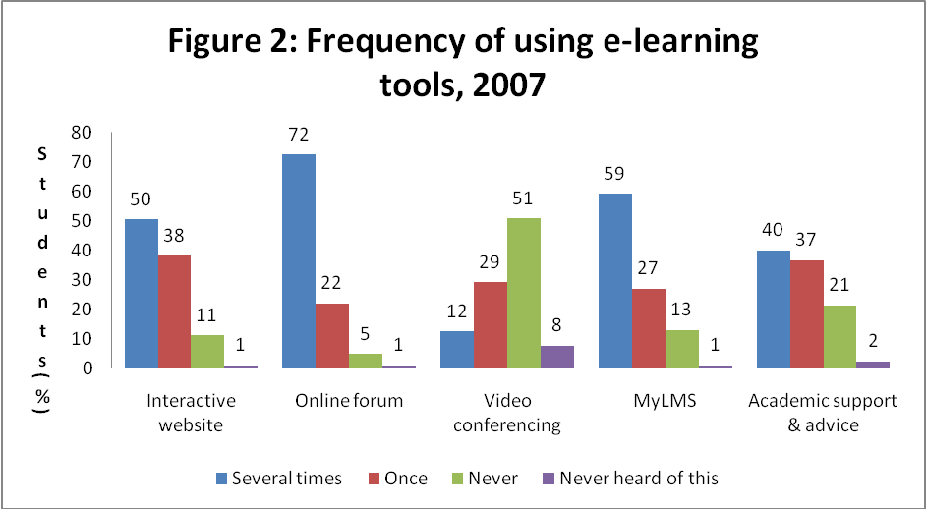

4.3 Positive perceptions of use of ICT and positive perceptions of use of traditional methods in learning and education

A total of 20 questions were used in this study to determine learners’ perceptions and attitudes towards learning with ICT versus that with traditional methods. The 20 questions, measured on a 4-point scale (4: I totally agree), (3: I mostly agree), (2: I mostly disagree) and (1: I totally disagree). In addition, a fifth category (5: I don’t know) was provided for those learners who lacked the information or experience needed to answer the question. Depending on the statements, a total of 2 to 29 (or 0.04% to 6.4%) out of 457 respondents responded to the fifth category “I don’t know”.

Figure 3 reveals that the learners scored an average of 3.2 out of 4 for “positive perception towards learning with ICT methods” as compared with a lower score of 2.9 points for “positive perception towards learning with traditional methods/negative perception towards learning with ICT methods.

A closer examination of the individual answers reveals that the learners were especially interested in using ICT for improving learning and sharing information and ideas with people having similar interest. Their positive perception towards traditional methods of learning was supported by (a) their belief that good access to a tutor requires face-to-face contacts; (b) their stronger preference for reading from a printed text; and (c) their indication that learning with ICT was time consuming.

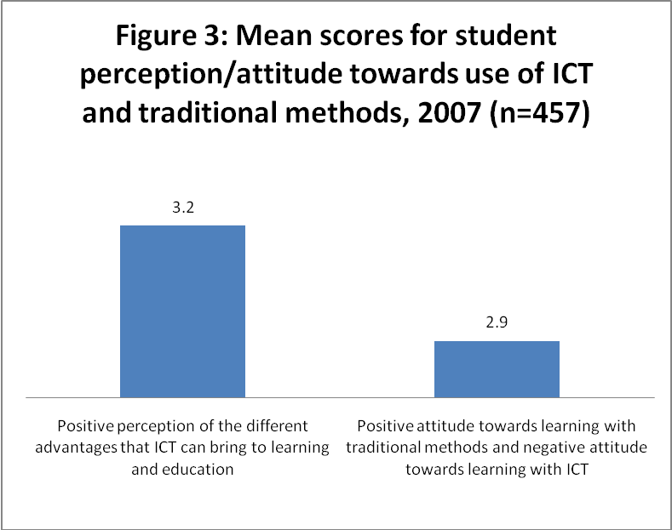

4.4 Opportunities offered by use of ICT
The learners were given a list of opportunities that might be enhanced by ICT and they were asked to rate the importance for each of these opportunities using a scale from 1 (no importance at all) to 4 (very important) together with a fifth category of “5: I don’t know”. The items of opportunities were grouped into three factors: (a) facilitating contact and information exchange (b) promoting access to higher education, and (c) changing the learning process and learning outcome, in accordance with the groupings provided for by the SPOT+ Survey. Depending on the items, a total of 4 to 14 (or 0.9% to 3.1%) out of 457 respondents responded to the fifth category “I don’t know”.

As shown in Figure 4, learners scored an average of 3.2 out of 4 points for ‘facilitating contact and information exchange’ and ‘changing the learning process and learning outcome’. An inspection of the detailed information reveals that learner contacts with lecturers/tutors for advice, was the highest rated item for facilitating contact and information exchange’ and the item development of employability skills such as teamwork, problem-solving, self-learning capability and presentation skills for the factor ‘changing the learning process and learning outcome’.

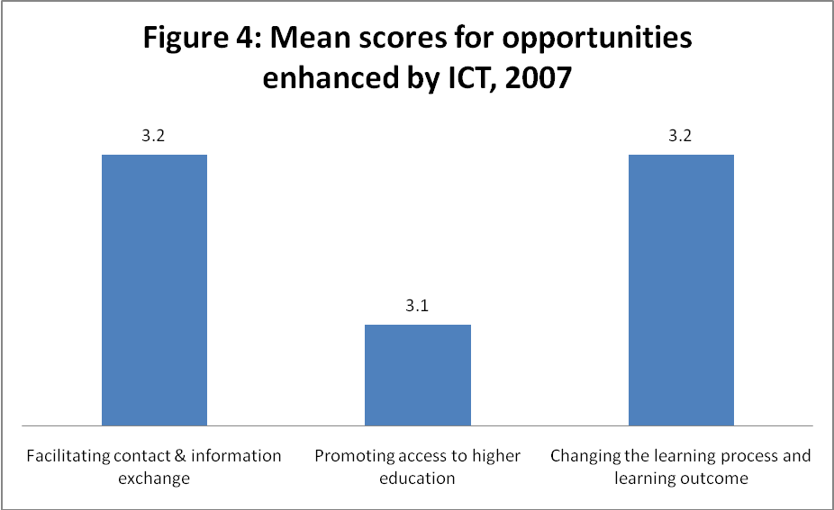

4.5 Correlation analysis
4.5.1 Relationship between opportunities enhanced by ICT usage and positive perception/attitude towards learning with ICT or traditional methods.

A correlation analysis was performed between the variable for “opportunities enhanced by ICT usage” and the variable for “positive perception towards ICT usage/traditional methods”. The results of the analysis indicate that there was a significant positive correlation between the two variables, with the correlation coefficients hovering around 0.5 to 0.6 (Table 1). This finding is consistent with the observation noted earlier in this paper. As expected, the correlation between “opportunities enhanced by ICT usage” and “positive perception towards learning with traditional methods/negative attitude towards learning with ICT” was weaker, with the correlation coefficient of only about 0.3.

Table 1: Correlation coefficients between factors of opportunities and perceptions/attitude towards learning

Factors of opportunities | Positive perception towards  learning with ICT | Positive perception towards learning  traditional methods/negative attitude towards learning with ICT
Facilitating contact & information exchange | .614** | .351**
Promoting access to higher education | .528** | .326**
Changing the learning process and learning outcome | .563** | .345**
** Correlation is significant at the 0.01 level (2-tailed).

4.5.2 Relationship between ability to use ICT applications and positive perception towards learning with ICT

Again the study found that there was a significant positive correlation between the ability to use ICT applications and positive perception towards learning with ICT. However, as shown in Table 2, the correlation was weak for each of the four ICT applications (word processing, email, presentation and bibliographic database applications).

Table 2: Correlation between ability to use ICT applications and perception/attitude towards learning with ICT/traditional methods

Ability to use ICT applications | Positive perception towards learning with ICT
Word processor application | 0.235**
Email application | 0.260**
Presentation application | 0.204**
Bibliographic database application | 0.201**
** Correlation is significant at the 0.01 level (2-tailed).

4.5.3 Relationship between frequency of using e-learning tools and positive perception towards learning with ICT

As shown in Table 3, there was a significant positive correlation between frequency of using e-learning tools and positive perception towards learning using ICT for only interactive website, online discussion forum, MyLMS and academic support and advice. However, the correlation for these four e-learning tools was very weak, that is the correlation coefficient has a value of about 0.3.

Table 3: Correlation between frequency of using e-learning tool and perception/attitude towards learning with ICT/traditional methods

Frequency of using e-learning tools (N-457) | Positive perception towards learning with ICT
Interactive website | 0.272**
Online discussion forum | 0.325**
Video conferencing | 0.076
MyLMS | 0.358**
Academic support and advice (n=457) | 0.284**
** Correlation is significant at the 0.01 level (2-tailed).

4.6 Regression analysis

4.6.1 Identifying significant factors influencing positive perception towards learning with ICT

A regression analysis was carried out to identify the significant factors influencing “positive perception towards learning with ICT”. From this analysis, it was found that the significant factors were ability to use email, frequency of using online discussion forum, frequency of using MyLMS and frequency of using academic support and advice. Collinearity among these four factors is within the tolerance limit of less than 10 for VIF, while the regression model selected for the study has a predictive power of 20% for the adjusted R-Square.

4.6.2 The prediction equation
Positive perception of use of ICT in learning
= 3.899 - 0.142 “frequency using myLMS” – 0.101 “ability using email” – 0.138 “frequency using online discussion forum” – 0.081 “frequency using academic support and advice”

5. 0 Discussion and Conclusions

In general, the study found that between 39-56% of OUM learners were able to use the four software applications on their own compared to 49-85% that shown by the European counterpart. This shows that OUM learners’ ability in using ICT was lower in all 4 applications. This is not unexpected since in general, the Europeans had been exposed to these applications much earlier than Malaysians. But, we are not too far behind.

In terms of experience, OUM learners’ used ICT more frequently compared to that of their European counterparts, except for online support and advice. The percentage of OUM learners using the applications several times ranged from 12 (for video conferencing) to 72 (for online forum) while that of Europe ranged from 8 (for video conferencing) to 49 (for online academic support). This is not unexpected since OUM learners are in an ODL institution with a blended mode of delivery, where online learning (using ICT) forms a major component. European learners are in the conventional universities and thus the need for ICT mode of learning is relatively less.

With regards to learners’ perceptions on the value of ICT and its potential role in education, the respondents held a fairly positive view of the different advantages that ICT can bring to learning. However, they also showed a relatively strong preference for learning with traditional method, questioning the value of ICT. Finally, the study found that ability and experience in using ICT are correlated with positive perception towards learning with ICT. However, this finding does not allow us to draw conclusions on the direction of the relationship. It is possible that a more positive perception leads learners to experiment more which leads to more experience, and better ability, rather than the other way around. Taking the extreme end, we can also conclude that in order to encourage OUM’s learners to use ICT in learning, it is vital to upgrade their ICT skills and to provide them with the means to gain more experience in e-learning through the e-learning platform.

While both OUM and European learners held a positive view of the use of ICT as well as the use of traditional methods in learning and education, the higher mean of positive attitude towards traditional methods appears to indicate that OUM learners have a higher preference for face-to-face and teacher-based learning compared to that of the European counterparts.

On the opportunities offered by use of ICT, learners attached highest importance to the two different groups of opportunities that is “facilitating contact and information exchange” and “changing the learning process and the learning outcomes”. Almost 50% of learners supported the opportunities of ICT in “enabling learners to contact lecturers/tutors/staffs for advice on academic questions and problems” and about 40% in “developing employability skills such as teamwork, problem-solving, self-learning capability, and presentation skills. Generally, OUM learners wanted ICT to be used more in teaching and learning as compared to that of the European university learners who wanted to use ICT more for information exchange. This difference is probably because OUM learners are largely working adults and they study on a part-time mode. Thus, they have to rely on the use of ICT for most part of their learning as compared to the full time European learners. One interesting observation was on the higher rating for “promoting access to higher education” given by OUM learners, which appears to imply that they acknowledge and support the institution’s motto “education for all”.

The regression result showed that: ability to use email, frequency of using online discussion forum, frequency of using myLMS and frequency of using academic support and advice are the determinants of the “positive perception of the use of ICT in learning”. Overall, the model has a predictive power of 20 percent. This implies that there are other variables that influence the positive perception of learners towards learning with ICT. This calls for an in depth study by incorporating other factors, so that specific improvements can be made to improve learners’ attitude towards the use of ICT which will in turn lead to greater usage of ICT.

This study looked into learners’ ability and experiences in using ICT in their learning and assessment of the value of ICT in helping them manage their studies. The results of this study are not unexpected, but they are relevant because they create a useful link between learners’ perceptions with the many initiatives undertaken by the institution, in employing ICT for teaching and learning.

6.0 References

Diochon, M.C. and A. F. Cameron (2001) Technology based interactive learning: designing and international student research project, 2, (2) 114-127.
Saunders, G. and Klemmif, F. (2003) Integrating technology into a traditional learning environment; Reasons for and risks of success. Active learning in higher education, 4(1), 74- 86.
SEUSISS Project (2002): http://www.intermedia.uib.no /seusiss/
SPOT PLUS (2004): http://www.spotplus.odl.org

