Báo cáo tuần 5 Thực hành lập trình hướng đối tượng

Tên sinh viên : Chu Việt Anh

MSSV : 20214983

Mục lục

1. Swing components 3

Source 3

Result 3

2. Class NumberGrid 4

Source 4

Result 5

3. Create a graphical user interface for AIMS with Swing 6

Source 6

4. JavaFX API 6

Source 6

Result 6

Function clear 7

5.Demo AimsProject 7

Source 7

Result 7

Menu-StoreScreen 8

FunctionAddToCart 8

Function options 9

Function AddBook 9

Function ViewDetail 12

FilterByCategory 13

FilterByCost 13

CartScreen 14

btnSortByTitle 14

btnSortByCost 14

btnOrder 15

Final Result 16

6.Diagrams 16

# 1. Swing components

## Source

## Result

# 2. Class NumberGrid

## Source

## Result

# 3. Create a graphical user interface for AIMS with Swing

## Source

# 4. JavaFX API

## Source

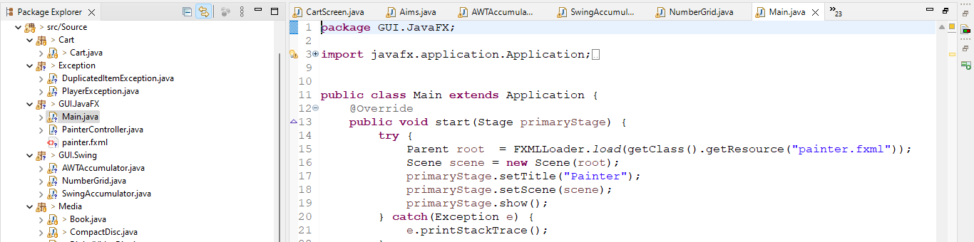

## Result

## Function clear

# 5.Demo AimsProject

## Source

## Result

### Menu-StoreScreen

### FunctionAddToCart

### Function options

### Function AddBook

Function AddCD

### Function ViewDetail

FilterBytTitle

### FilterByCategory

### FilterByCost

### CartScreen

### btnSortByTitle

### btnSortByCost

### btnOrder

### Final Result

# 6.Diagrams

