Báo cáo tuần 2 Thực hành lập trình hướng đối tượng

Tên sinh viên : Chu Việt Anh

MSSV : 20214983

Mục lục

1 Bài toán và yêu cầu đề bài 2

2 Use case diagram 4

3 Class diagram 5

4 Mã nguồn và kết quả chương trình 5

- Mã nguồn DigitalVideoDisc.java 5

- Mã nguồn Cart.java 6

- Mã nguồn Aims.java 8

- Kết quả chương trình 8

5 Q & A 9

# 1 Bài toán và yêu cầu đề bài

There might be a future that Tiki and Sendo be in talks over a potential merger to contend other e-commerce platforms and especially those who have foreign backers. The merger of these two firms would create a Ti-do company, where “Ti” is from Tiki, and “do” is from Sendo, which means a billion-dollar company in Vietnamese. That firm, Ti-do company, would like you to help them create a brand-new system for AIMS project (AIMS stands for An Internet Media Store). Currently, there is only one type of media: Digital Video Disc (DVD).

Customers can browse the list of DVDs available in the store, the display order is based on their added date, from latest to oldest. When a customer wants to search for DVDs to add to cart, he or she can choose one of three searching options. The software will display a list of all matches (latest DVDs first) with all their information. He or she can also choose to play a specific DVD. The software will play a DVD (a demo part). If a DVD has the length 0 or less, the system must notify the customer that the DVD cannot be played.

o When a customer searches for DVDs by title, he or she provides a string of keywords. If any DVD has the title containing any word in the string of keywords, it is counted as a match. Note that the comparison of words here is case-insensitive.

o When a customer searches for DVDs by category, he or she provides the category name. If any DVD has the matching category (case-insensitive), it is counted as a match.

o When a customer searches for DVDs by price, he or she provides either the minimum and maximum cost, or just the maximum cost.

Customers can view the detail information of a DVD from the list of DVDs. He/she can add a DVD to a cart from a list of DVDs or the detail screen.

When a customer wants to see the current cart, the system displays all the information of the DVDs, along with the total cost. Customers may listen to a DVD (a demo part) in the cart before confirming to place an order. Customers can sort all DVDs in the cart by title or by cost:

o Sort by title: the system displays all the DVDs in the alphabet sequence by title. In case they have the same title, the DVDs having the higher cost will be displayed first.

o Sort by cost: the system the system displays all the DVDs in decreasing cost order. In case they have the same cost, the DVDs will be ordered by increasing title.

Customers can update the quantity of a DVD in a cart or remove a DVD from a cart. To increase consumer demand for the product and grow sales, customers are allowed to have an item for free which is randomly picked out in the cart by the system. Customers can filter DVDs in the cart by providing either its ID or title. If the item is found, display information of the found item in the cart. Or else, notify the customer the item is not found in the current cart.

The customer can request to place order when they are seeing the current cart. For simplification, he/she does not need to log in to place an order. The application will prompt the customer to enter the delivery information and delivery instructions. The software will then calculate the delivery fee based on the total mass of the order & the delivery location. Then, it will display to the customer the invoice including the DVD list, total cost before VAT, total cost after VAT, and the delivery fee. The customer can then proceed to pay for the order. Currently, only one payment method – i.e. credit card – is allowed by connecting to a card association system for checking the validation of the card or performing the pay transaction. After the transaction, the AIMS software will display all the detailed information such as transaction ID, card owner, transaction amount, transaction message, balance, transaction date to the customer. The order will be in pending state and the information of the order & the transaction will be sent to the customer’s email.

The store manager needs to log in to the system to navigate to the management mode. He/she can see the list of pending orders, then can pick any order to see its detail to approve or reject the order. The store manager can add new DVDs to the store. He or she must provide all information of the new DVD, including its ID, title, category, director, length, and the cost. Additionally, the manager can also remove DVDs from the store.

# 2 Use case diagram

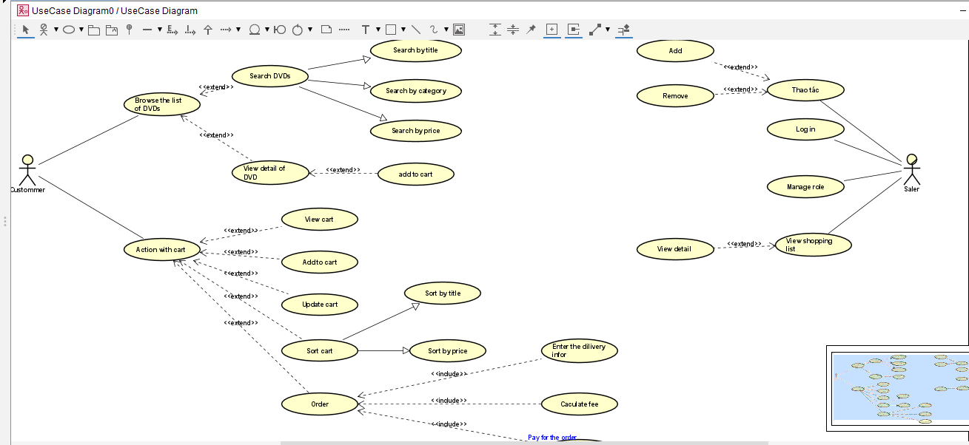

# 3 Class diagram

# 4 Mã nguồn và kết quả chương trình

* Mã nguồn DigitalVideoDisc.java

/**

* **@author** Chu Việt Anh

*/

**package** week2;

**public** **class** DigitalVideoDisc {

**private** String title;

**private** String category;

**private** String director;

**private** **int** length;

**private** **float** cost;

**public** String getTitle() {

**return** title;

}

**public** String getCategory() {

**return** category;

}

**public** String getDirector() {

**return** director;

}

**public** **int** getLength() {

**return** length;

}

**public** **float** getCost() {

**return** cost;

}

**public** DigitalVideoDisc(String title) {

**super**();

**this**.title = title;

}

**public** DigitalVideoDisc(String category, String title, **float** cost) {

**super**();

**this**.title = title;

**this**.category = category;

**this**.cost = cost;

}

**public** DigitalVideoDisc(String director, String category, String title, **float** cost){

**super**();

**this**.title = title;

**this**.director = director;

**this**.category = category;

**this**.cost = cost;

}

**public** DigitalVideoDisc (String title, String director, String category, **int** length, **float** cost) {

**super**();

**this**.director = director;

**this**.title = title;

**this**.category = category;

**this**.cost = cost;

**this**.length = length;

}

/***

* Phuong thuc so sanh hai doi tuong

*

* **@param** disc

* **@return**

*/

**public** **boolean** equals(DigitalVideoDisc disc) {

**return** **this**.getTitle() == disc.getTitle();

}

}

* Mã nguồn Cart.java

/**

* **@author** Chu Việt Anh

*/

**package** week2;

**public** **class** Cart {

**public** **static** **final** **int** ***MAX_NUMBER_ORDERED*** = 20;

**private** DigitalVideoDisc itemsOrdered[] = **new** DigitalVideoDisc[***MAX_NUMBER_ORDERED***];

**private** **int** numberOfItems;

// Phương thức trả về số lượng đĩa DVD trong giỏ hàng

**public** **int** numberOfItems() {

**return** numberOfItems;

}

// Phương thức thêm một đĩa DVD vào giỏ hàng

**public** **void** addDigitalVideoDisc(DigitalVideoDisc disc) {

**if** (**this**.numberOfItems == 0) {

**this**.itemsOrdered[0] = disc;

**this**.numberOfItems++;

System.***out***.println("Them thanh cong");

} **else** **if** (**this**.numberOfItems >= ***MAX_NUMBER_ORDERED***) {

System.***out***.println("Khong the them nua, gio hang da day!");

} **else** {

**for** (**int** i = 0; i < **this**.numberOfItems; i++) {

**if** (**this**.itemsOrdered[i].equals(disc)) {

System.***out***.println("Khong the them vi dia da co trong gio hang!");

**break**;

}

**if** (i == **this**.numberOfItems - 1) {

**this**.itemsOrdered[**this**.numberOfItems] = disc;

**this**.numberOfItems++;

System.***out***.println("Them thanh cong");

**break**;

}

}

}

}

// Phương thức xóa một đĩa DVD khỏi giỏ hàng

**public** **void** removeDigitalVideoDisc(DigitalVideoDisc disc) {

**if** (**this**.numberOfItems == 0) {

System.***out***.println("Gio hang trong!");

} **else** {

**for** (**int** i = 0; i < **this**.numberOfItems; i++) {

**if** (**this**.itemsOrdered[i].equals(disc)) {

**for** (**int** j = i; j < **this**.numberOfItems - 1; j++) {

**this**.itemsOrdered[j] = **this**.itemsOrdered[j + 1];

}

**this**.numberOfItems--;

System.***out***.println("Xoa thanh cong");

**return**; // Khi xoa xong, thoat khoi vong lap

}

}

System.***out***.println("Khong the xoa vi dia khong co trong gio hang");

}

}

// Phương thức tính tổng giá trị của giỏ hàng

**public** **float** totalCost() {

**float** totalCost = 0f;

**for** (**int** i = 0; i < **this**.numberOfItems; i++) {

totalCost += **this**.itemsOrdered[i].getCost();

}

**return** totalCost;

}

}

* Mã nguồn Aims.java

/**

* **@author** Chu Việt Anh

*/

**package** week2;

**public** **class** Aims {

**public** **static** **void** main(String[] args) {

// create a new cart

Cart anOrder = **new** Cart();

// create new dvd oj and add them to the cart

DigitalVideoDisc dvd1 = **new** DigitalVideoDisc("the lion king","animation","roger allers",87,19.95f);

anOrder.addDigitalVideoDisc(dvd1);

DigitalVideoDisc dvd2 = **new** DigitalVideoDisc("star wars", "science fiction","george lucas", 97, 24.95f);

anOrder.addDigitalVideoDisc(dvd2);

DigitalVideoDisc dvd3 = **new** DigitalVideoDisc("aladin", "animation", 18.99f);

anOrder.addDigitalVideoDisc(dvd3);

System.***out***.println("tong so tien phai thanh toan la: ");

System.***out***.println(anOrder.totalCost());

anOrder.removeDigitalVideoDisc(dvd3);

System.***out***.println("gia dvd3 la 18.99f");

System.***out***.println("tong so tien phai thanh toan la: ");

System.***out***.println(anOrder.totalCost());

}

}

* Kết quả chương trình

Chương trình thực hiện them dvd1, dvd2, dvd3 tính tổng lần 1 sau đó xoá dvd3 tính tổng lần 2

# 5 Q & A

- If you create a constructor method to build a DVD by title then create a constructor method to build a DVD by category. Does JAVA allow you to do this?

- Answer : Có, Java cho phép bạn tạo nhiều phương thức khởi tạo (constructor) cho một lớp, miễn là chúng có các danh sách tham số khác nhau. Điều này được gọi là constructor overloading. Nó cho phép bạn tạo các đối tượng của lớp theo nhiều cách khác nhau, tùy thuộc vào đối số được cung cấp khi bạn khởi tạo đối tượng.