Silicon Sampling Captures Country-Level Assumptions, Not Individual Attitudes:

Cross-National Evidence from the European Social Survey

Abstract
Silicon sampling uses large language models (LLMs) to simulate survey respondents. Whether it recovers cross-national variation, and why, is unresolved. This study evaluates it against European Social Survey Round 11 (30 countries, 42 items) with two major open-weight LLMs, two prompt framings, and a backstory-conditioning experiment. Aggregate recovery is moderate and uneven across items. Adding the country name to a three-variable demographic backstory raises the median country-level correlation from −0.03 to 0.52. No richer profile surpasses it. Swapping in a wrong country name leaves the respondents’ own country less well recovered than giving no country name at all. The model uses the country as a group-level prior and largely ignores respondent detail. Individual-level recovery is negligible everywhere and unrelated to aggregate recovery across countries. Naming the two endpoints of the response scale in words removes the item-level inversions and roughly triples individual recovery. A leave-one-out regional average, using no model at all, outperforms silicon sampling on both rank and level accuracy. Silicon sampling can support exploratory aggregate comparison after item-level validation. It does not support individual-level or distributional inference.
Keywords: silicon sampling, large language models, cross-national variation, survey methodology

1 Introduction
Cross-national surveys are indispensable to the social sciences. However, they are increasingly difficult to sustain, as costs rise and response rates decline (Curtin et al., 2005; Keeter et al., 2017). Against this backdrop, large language models (LLMs) have emerged as a potential source of synthetic survey data. Using silicon sampling, an LLM conditioned on a respondent’s demographic profile is intended to generate responses approximating those of a comparable human (Argyle et al., 2023). This offers a low-cost and real-time alternative to survey data collection. The same generative capabilities, however, also threaten survey integrity from the other direction: AI agents can now produce human-passing responses that evade standard quality checks (Westwood, 2025).
Previous evaluations suggest some promise. Argyle et al. (2023) report that GPT-3, when conditioned on sociodemographic backstories from the American National Election Studies, produces silicon samples whose correlational patterns mirror those of human respondents across multiple attitudinal domains. Dillion et al. (2023) likewise document close correspondence in the moral domain, reporting that model judgments of the wrongness of everyday actions closely correlate with human ratings. In experimental settings, Ashokkumar et al. (2026) show that GPT-4 can predict treatment effects in 70 nationally representative U.S. survey experiments.
The evidence of limitations concerns both response distributions and the representation of groups and countries. Bisbee et al. (2024) show that synthetic responses exhibit compressed variance, prompt sensitivity, and regression coefficients that diverge from human data. Dominguez-Olmedo et al. (2024) find strong ordering and labeling effects and near-uniform adjusted response distributions. Wang et al. (2025) document flattened within-group heterogeneity and misrepresentation of marginalized groups. Cross-nationally, model outputs remain closer to Western and English-speaking populations (Durmus et al., 2023; Tao et al., 2024).
Four gaps constrain the existing silicon-sampling literature. First, most evaluations remain centered on the United States. Available cross-national studies cover few countries or items. Second, many studies examine a narrow attitudinal domain, leaving item-level heterogeneity poorly characterized. Third, existing cross-national work shows that changing a country cue changes model responses (Qu & Wang, 2024). However, it does not compare otherwise identical sparse profiles with and without the country label. It also does not assess subsequent profile enrichment across a broad survey battery. Fourth, individual-level recovery is generally summarized across all respondents, leaving open whether it varies across countries and whether its geographic pattern aligns with aggregate recovery.
Together, the four gaps leave the central question open: why does aggregate recovery occur where it does? Two things are at issue: what supplies the cross-national signal, and what decides its direction. A cross-national design can separate two candidate sources of aggregate recovery that single-country studies cannot compare: a country label may activate country-level associations, while compositional differences across national samples may also generate cross-national variation, the mechanism demographic conditioning assumes (Argyle et al., 2023). Using European Social Survey (ESS) Round 11 data from 30 countries and 42 items, this paper evaluates aggregate and individual recovery and estimates the incremental contribution of the country label against the rest of the respondent profile.
To address these gaps, this study runs four tests in one design. The first characterizes aggregate recovery item by item across 30 countries and 42 items, which fixes the pattern to be explained. The second isolates the country label’s contribution from demographic composition and from profile enrichment in a backstory-conditioning experiment. The third crosses the country label with the response format in a 2 × 2, turning the interpretation of the item inversions into a test. The fourth estimates within-country individual recovery for each country and tests its geographic pattern against the aggregate one, which bounds what the pattern delivers. Throughout, recovery is judged against predictors that use no model at all.
Overall, the models treat the country name as a group-level prior. The label carries most of the aggregate signal. Enriching the profile beyond it adds no consistent gain. The response format decides whether the model ranks countries the right way round or backwards. None of it amounts to individual-level recovery. The study contributes on three fronts. The empirical contribution is a joint evaluation of item-level country rankings, within-country individual recovery, and the label’s incremental contribution on the same matched respondents. The methodological one is the experimental identification of that prior and of the format that decides which way the ordering runs. The practical one is a benchmark against model-free alternatives, the comparison a prospective user needs.

2 Related Literature and Research Questions

2.1 Cross-national evaluation of silicon sampling
Evaluating silicon sampling cross-nationally matters because comparative social science seeks to explain cross-national differences in public attitudes. For example, cross-national differences in political trust and system support are central to comparative accounts of civic culture and democratic legitimacy (Norris, 2011). Differences in political values underpin theories of modernization and cultural change (Inglehart & Welzel, 2005; Dalton & Welzel, 2014). Subjective well-being likewise varies systematically with national economic, institutional, and cultural conditions (Diener et al., 1995). All three domains appear in the 42-item battery evaluated below. An LLM-based substitute must recover country means and structured cross-national variation without introducing response-scale artifacts.
Existing cross-national evidence remains largely within one or a few countries. Qu and Wang (2024) compare one environmental item across six World Values Survey countries and a political item in the United States and find higher agreement in Western, English-speaking, and developed settings. Cao et al. (2025) use two global surveys and find that specialization improves distributional correspondence, although performance remains weaker on unseen questions and output diversity does not consistently track accuracy. Pataranutaporn et al. (2025) likewise find that individual well-being predictions are least accurate in underrepresented countries, but examine well-being only.
Broader cross-national benchmarks show the same unevenness. Durmus et al. (2023) find that default model responses are closer to some national distributions than others and that country prompting shifts responses without ensuring fidelity. Tao et al. (2024) compare five GPT models with values data from 107 countries and territories. Default outputs align most closely with English-speaking and Protestant European profiles, while cultural prompting improves correspondence for most countries but does not eliminate cross-country error. Together, these studies benchmark broad correspondence, but none jointly evaluates item-level country rankings, within-country individual recovery, and the incremental contribution of the country cue in a matched respondent-level design. The literature supports two expectations. Recovery should be uneven across items, and part of that unevenness should follow how the response scale is presented, because option format shifts model answers independently of content (Section 2.2). A pooled correlation that mixes items of different scale lengths should overstate recovery, because much of the covariance it captures falls between items and not between countries.
RQ1. How accurately does silicon sampling recover public attitudes at the aggregate level, and how far does that accuracy vary from item to item?

2.2 Cultural bias and the country cue in LLM responses
Before any country is named, model outputs already lean toward some populations. Cultural bias here means systematic differences in whose values and associations those default outputs reproduce. Internet-scale training data and model-development choices draw unevenly on languages and regions, making English-language and Western perspectives especially salient (Bender et al., 2021; Tao et al., 2024). A model can therefore answer fluently across languages while still defaulting to associations that are not representative of the target population. Naous et al. (2024), for example, find that multilingual and Arabic models favor Western over Arab cultural entities even in Arabic-language tasks. Uneven correspondence also appears within countries: Santurkar et al. (2023) find the closest correspondence to wealthier, educated, and politically liberal Americans. Model outputs are not a culturally neutral baseline.
Naming a country moves the output, though not necessarily toward the population named. In human judgment, national-character ratings can be consistent across raters yet fail to correspond to population mean traits (Terracciano et al., 2005). This illustrates that a country cue may activate a stereotype instead of recovering the distribution it names. Language models likewise attach systematic valence to national demonyms, with more negative sentiment for countries with fewer internet users and lower economic status (Narayanan Venkit et al., 2023). In public-opinion simulation, changing the simulated country shifts model responses (Qu & Wang, 2024). Yet the resulting correspondence is ambiguous: agreement with national averages may reflect calibrated country knowledge, stereotypic associations, or both.
A second, artifactual source of apparent cross-national difference is the response format, meaning how the answer scale is presented: numbers alone, or numbers whose endpoints are named in words. Reversed and negated items are a known source of misresponse in human surveys, where a minority of respondents answer them as though the direction had not changed (Weijters & Baumgartner, 2012). Language models show an analogous sensitivity to option format and position (Zheng et al., 2024), and the measured political position of a model can change substantially with the format in which the question is posed (Röttger et al., 2024). A numeric range without verbal endpoints leaves the scale direction to be inferred, and format effects can dominate synthetic distributions (Dominguez-Olmedo et al., 2024). Where numbers carry different meanings for human and model, the comparison fails the measurement-equivalence condition (King et al., 2004; Davidov et al., 2014). Cue and format can both generate cross-national structure. Crossing them separates the two.
Both the country label and the scale presentation are plausible sources of aggregate signal. This study therefore tests whether the country label adds recovery beyond demographic composition and whether richer profiles add further gains. The two readings of the label predict two different patterns. If the label activates calibrated knowledge that richer detail refines, recovery should rise with each level of enrichment. If it activates a group-level prior, the label should produce one large step and further detail should add little. A label account also has a falsification test: attaching the wrong country’s name should pull recovery toward the named country and away from the respondents’ real one. Format predicts something different. If the numeric scale is read in the wrong direction on reverse-coded items, the same country knowledge will rank countries backwards on those items and correctly elsewhere, and supplying verbal endpoints should remove the inversion without touching the model’s knowledge.
RQ2. Which part of the prompt produces the aggregate signal, and why does the model rank countries backwards on some items?

2.3 Individual-level simulation and its relation to aggregate recovery
Individual-level simulation sets a stricter standard than reproducing group means: model responses must preserve covariation between profile attributes and attitudes within populations. Recent work therefore evaluates aggregate, distributional, and individual recovery separately (Li et al., 2025; Miranda & Balbi, 2025). Although Argyle et al. (2023) report encouraging correlational structure in U.S. silicon samples, subsequent work identifies weak distributional and individual recovery. Bisbee et al. (2024) document compressed variance and unstable regression coefficients. Dominguez-Olmedo et al. (2024) show that response-format effects can dominate the resulting distributions. Wang et al. (2025) find that identity prompting flattens within-group heterogeneity and can reproduce out-group portrayals, not in-group responses. Even minimal identity cues such as dialect can shift model judgments (Hofmann et al., 2024). Persona responsiveness is not equivalent to accurate within-population differentiation.
Being the person and predicting the person are two different requests. Answering in persona speaks from the profile. Predicting how the person would answer reasons about it. If individual recovery depends on mapping attributes to attitudes, the two need not perform alike. The contrast also bears on the source question: a group-level prior gives the model nothing to gain from speaking as the person, so under that account the two framings should not differ. The design crosses model with first- and third-person framing, and the contrast is reported with the individual-level results.
Whether richer conditioning rescues individual recovery is debated. On one side, agents grounded in interview or survey self-reports reproduce respondents’ answers at 82–86% of two-week test-retest consistency and reduce racial and ideological accuracy gaps relative to demographics-only agents (Park et al., 2024). On the other, fine-tuned models improve mainly by learning annotator-specific patterns, not demographic ones (Orlikowski et al., 2025), and sociodemographic prompting alone does not reliably improve subjective judgment (Sun et al., 2025). Both sides agree that the gains require individual data far richer than scalable demographic profiles. Whether sparse demographic conditioning recovers within-country differentiation, and how this varies across countries, remains open.
The cultural-bias and individual-level literatures also imply competing cross-country expectations. If unequal country representation is the common constraint, countries with stronger aggregate recovery should also show stronger individual recovery (Durmus et al., 2023; Qu & Wang, 2024; Pataranutaporn et al., 2025). Conversely, aggregation itself predicts divergence: idiosyncratic errors cancel in country means, so aggregate recovery can rest on group-level regularities that individual prediction cannot use (Robinson, 1950). Structural inconsistencies across marginal, multivariate, and subgroup statistics point the same way (Li et al., 2025; Williams et al., 2026). The reviewed literature does not test whether aggregate and individual recovery covary across countries using matched respondents, items, and prompts. RQ3 asks both together, because the two levels have to be told apart before either can be used:
RQ3. How much individual-level recovery is there, and does it track aggregate recovery across countries?

3 Data and Method

3.1 Survey benchmark
The benchmark is the European Social Survey (ESS), a cross-national probability-based survey (European Social Survey European Research Infrastructure Consortium, 2026). This paper uses data from ESS Round 11, which covers 30 countries and roughly 50,000 respondents. The analysis includes 42 survey items spanning 12 domains: social trust, institutional trust, political attitudes, political efficacy, subjective well-being, immigration attitudes, social values, national attachment, health, religion, safety, and income. The full item list with question text, scales, and domain classification is reported in Appendix Table A1. Figure 1 below illustrates the simulation pipeline.
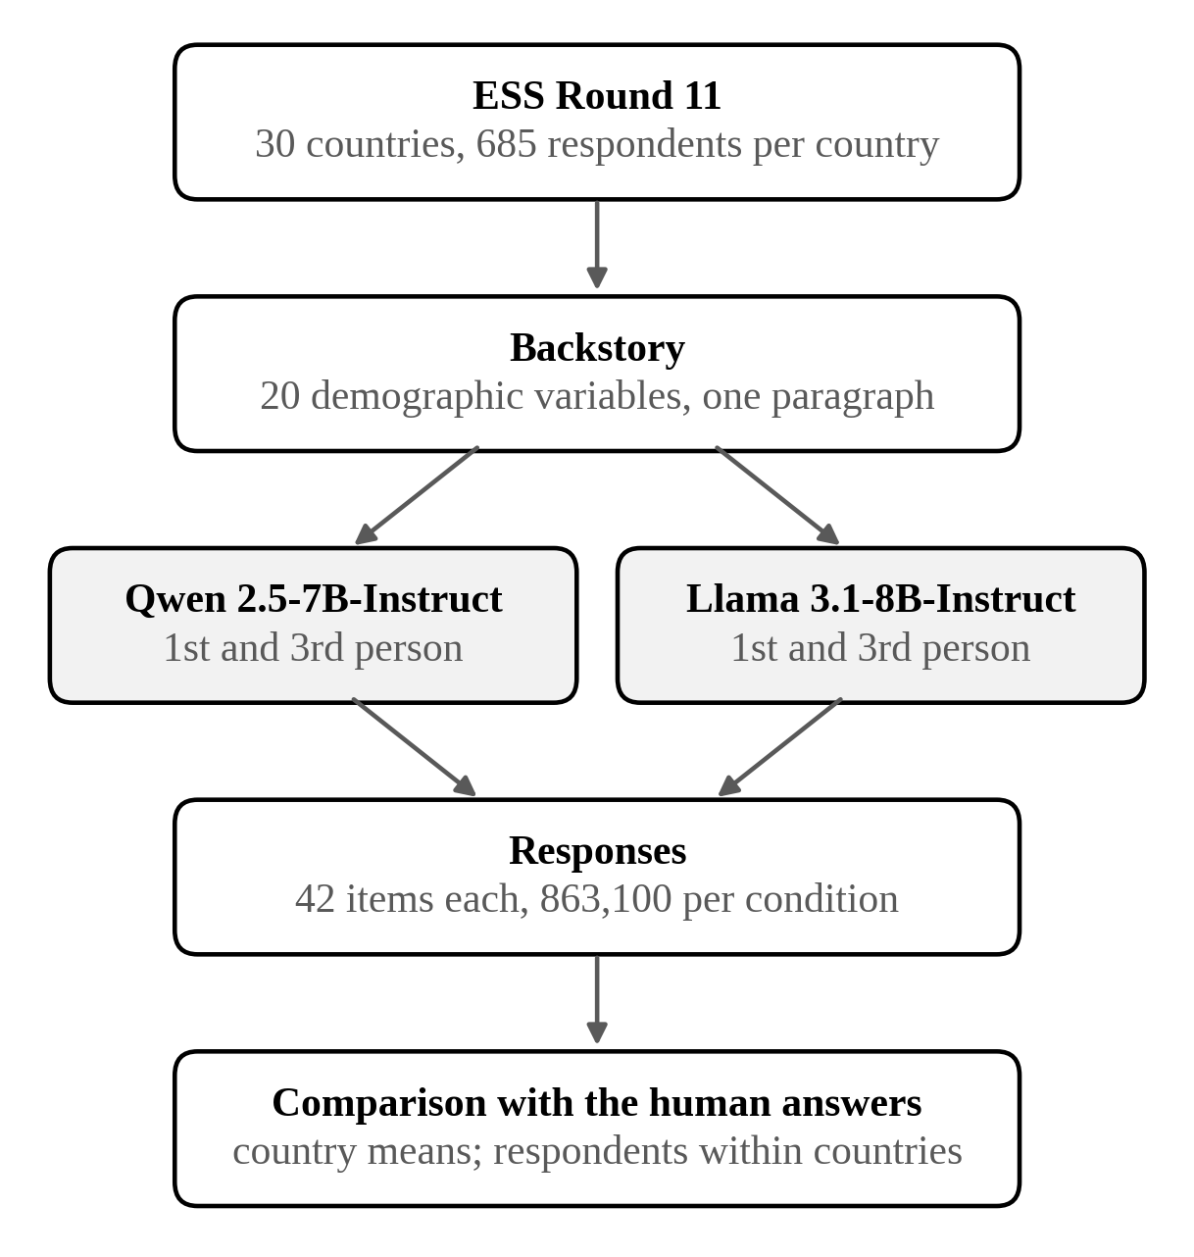
Figure 1. The simulation pipeline.
Note. ESS respondents are subsampled, assigned demographic backstories, and prompted through two models under two framing conditions. Model outputs are compared against human responses at the individual and country level.

3.2 Research design
The experiment is a 2 (model: Qwen, Llama) × 2 (prompt: first person, third person) crossing. Two open-weight instruction-tuned models are tested: Qwen 2.5-7B-Instruct (Alibaba) and Llama 3.1-8B-Instruct (Meta). Both are run locally on a university high-performance computing cluster (NVIDIA A100) using vLLM for batched inference. Temperature is set to 0.7, and respondent subsampling uses a fixed seed of 888.
Two prompt conditions are tested. In the first-person (1P) condition, the model is instructed to adopt the respondent’s persona and answer directly. In the third-person (3P) condition, the model is asked to predict how the described person would respond. Both prompts include the demographic backstory, the item text, the response scale, and a constraint to output a single number. The three social trust items, on whether most people can be trusted, try to be fair, and are helpful, carry the full ESS question wording, which embeds verbal endpoint descriptions. Every other item is presented with the abbreviated codebook wording reported in Table A1. Prompts specify the numeric scale range as digits (e.g., “Scale: 0-10”) and name no scale endpoints in words.
For each country, 685 respondents are randomly subsampled from the ESS, the number available in the smallest country sample. The subsample is drawn with no design weights. The human benchmark is weighted by the ESS post-stratification weight (pspwght) throughout, and the sensitivity of the results to that choice is reported in Section 4.4. The sample size is sufficient at both levels of analysis. Two random halves of the human sample agree at a median between-country correlation of 0.98, so the quantity being estimated is itself nearly noiseless. At n = 685 the median country-mean reliability is 0.99 on the human side and 0.94 on the silicon side, attenuating the between-country correlation by a median factor of 0.97. A single country-item cell has 80% power to detect a within-country correlation of 0.11, and pooling cells lowers it to 0.02, so the near-zero individual recovery in Section 4.3 is a measured near-zero.
Each respondent is prompted for all 42 items, yielding 28,770 prompts per country and 863,100 per model-prompt condition. Across the four model and prompt combinations the main experiment comprises 3,452,400 response attempts, and 33,743,100 across all 41 arms including the backstory, ablation, probe, and scale arms described below. The human-model valid intersection covered 97.74% of scheduled responses for Qwen 1P, 97.80% for Qwen 3P, 97.81% for Llama 1P, and 75.71% for Llama 3P. The Llama 3P shortfall is not uniform across items and is diagnosed in Section 4.4. The loss falls on the wide response scales, so that condition cannot identify a framing effect.
All four model-prompt conditions are reported for aggregate recovery and individual-level means (Figures 2 and 6). Detailed domain and model-prompt comparisons appear in the Appendix. The backstory, ablation, and scale experiments use Qwen 1P, because their purpose is source decomposition and not another model comparison. The country-label pair is also replicated under Llama (Section 4.2). Generation is unseeded, so one arm was run twice to establish a noise floor.

3.3 Backstory construction
Each respondent is described using a natural-language backstory generated from 20 ESS demographic variables: country, gender, age, birth year, marital status, domicile type, region, birth country, citizenship, education level, education years, main activity, household income decile, left-right political orientation, party affiliation, household size, children at home, trade union membership, discrimination group membership, and internet use frequency. These are core sociodemographic measures that any probability survey collects, so a backstory built from them is available wherever silicon sampling might be applied. The set was fixed for that scalability, and alternative variable sets were not explored. What each block of the fixed set contributes is measured in Section 3.4. The choice also gives the evaluation practical force: if conditioning on these standard variables fails, silicon sampling has little to offer the representative cross-national surveys it is meant to replace. An initial design used 27 backstory variables, seven of which overlapped with the 42 outcome items and created potential information leakage. Removing them left the 20 backstory variables above and reduced the inflated recovery (Appendix Table A2).
All backstories, prompts, and question texts are in English. Each backstory is constructed by mapping ESS codes to natural-language sentences with fixed value-label dictionaries (e.g., gender code 2 becomes “I am female”). Country codes from the International Organization for Standardization (ISO) are mapped to English country names (e.g., code DE becomes “I live in Germany”). Party affiliation is represented generically. No country-specific party is named. This generic coding omits a predictor of political attitudes and may reduce individual-level recovery. The sentences form one paragraph, using the same fixed mapping across countries.
An abbreviated example prompt is provided in the Appendix (Example Prompt). The 3P prompt replaces its first line with “Consider a person with the following background:” and rephrases the question as “how would this person respond?” Because prompting language affects cultural outputs (Lu et al., 2025; Tao et al., 2024), the English-only design may favor recovery of English-speaking opinion patterns. The replication materials provide the analysis-ready model summaries, the analysis and figure code, and the raw ESS benchmark.

3.4 Backstory conditioning experiment
The backstory conditioning experiment asks whether aggregate recovery comes from the country label or from compositional differences across national samples, using Qwen 1P throughout. The design is a set of paired contrasts on a common rich profile, each observed with and without one block on the same respondents and items. One pair differs only by the country sentence (both of its arms omit the region code, whose prefix would re-encode the country), one only by the region code, and one only by the political-identity variables.
The same with-and-without logic runs over the whole profile. The 20 backstory variables partition into ten named blocks: the base (gender, age, birth year), the country label, the region code, political identity, education with main activity and income, union membership with internet use, household composition, migration and citizenship, minority status, and domicile. The political block holds the same two variables the political ablation removes, so the chapter has one definition of it.
The unit is the block because single variables often repeat one another. The profile contains near-duplicate pairs: age and birth year, education level and education years, household size and children at home. Age and birth year encode the same fact, so dropping one leaves its twin in place and the contrast measures the repetition. Where a block holds no such pair, its variables are also tested one at a time.
Every block is observed at the two margins that bound its contribution. It is added alone to the sparse base plus the country label, and it is removed alone from the otherwise complete profile. These are the extreme positions a block can occupy in any order of additions, so the two margins bound it under every ordering. Three probes settle what they leave open. A country-only arm carries the label with no demographics at all. Two twin arms state the same age as a number of years and as a birth year. Union membership and internet use are added one variable at a time.
A falsification arm replaces every backstory’s country sentence with a wrong country, under a fixed derangement of the 30 countries, and leaves the rest of the profile intact. The logic is that of a placebo test (Eggers et al., 2024). If the label works as a group-level prior, recovery should follow the false label and abandon the respondents’ real countries. If aggregate recovery came from the composition of the profiles, mislabeling should not move it. The arm tests whether the model’s sensitivity to the country cue is specific to the country named. Nationality-assigned personas have been manipulated before (Kamruzzaman & Kim, 2024). Scoring swapped labels against the named country’s measured survey means has no direct precedent.
A 2 (country label: present, absent) × 2 (response scale: numbers only, numbers with verbal endpoints) experiment tests whether the format decides the direction of the label’s effect. Its four arms run on a 22-item batch: twelve of the thirteen reverse-coded items (vote is excluded, because its response options carry no scale direction), six forward-coded controls (items whose numeric scale runs in the intuitive direction), and four placebo items whose endpoints the question text already describes. The reverse-item set and the two exclusions were fixed in advance.

3.5 Evaluation metrics
Recovery denotes the correspondence between model-generated and human survey responses, at the level of aggregation a question concerns: country means for aggregate recovery, respondents within a country for individual recovery. It is assessed along three dimensions: rank-order correspondence, distributional spread, and mean-level bias. Pearson correlations are used for continuity with the silicon-sampling literature (Argyle et al., 2023; Bisbee et al., 2024).
The argument rests on two correlations. The primary aggregate measure, r_{bc}, is the per-item correlation across the 30 country means. The primary individual measure, r_{wc}, is the within-country correlation across respondents, computed per country-item cell. Three further quantities are diagnostic and appear only where a question requires them. Each country’s 42-item aggregate profile correlation, r_{prof}, carries the country-level comparison in Section 4.1. Two pooled quantities appear once each and carry no symbol. A pooled within-country correlation, taken across respondents from every country after centering within country, is used in Figure 6(b), where its statistical power suits the per-item display. A pooled correlation across all 1,260 country-item cells is reported as a labeled counterexample, because pooling lets scale differences between items read as cross-national signal. The countries are the full ESS set and the items a fixed battery, so these correlations estimate no wider parameter and carry no interval. Uncertainty is reported where it exists, in the sampling error inside each country mean and in the run-to-run variation of Section 4.4. Definitions appear in Appendix, Evaluation metrics.
Three reference points make these correlations interpretable. Two identical unseeded runs differ by a median absolute 0.060 in r_{bc} per item, which sets a noise floor. Regressing each human response on five demographic predictors with country fixed effects gives a median within-country multiple correlation of 0.210. That is the demographic ceiling: the most any demographic profile could recover at the individual level, whatever produces the answers. The third fixes what counts as adequate at the aggregate level: recovery is judged against predictors that use no model at all, built from regional neighbors and macro covariates and reported in Section 5.3. A model that does not beat them adds nothing a researcher could not already compute.
Distributional spread is evaluated by the ratio of model to human standard deviations for each country-item pair, and mean-level bias by the model-minus-human difference. Because a correlation is invariant to location and scale, Lin’s concordance coefficient is also reported. It factors into r_{bc} and an accuracy term, separating rank correspondence from calibration. Model and prompt contrasts use paired t-tests across the 42 items.

4 Results

4.1 Silicon sampling’s aggregate recovery is moderate and item-dependent
Addressing RQ1, aggregate recovery is moderate, uneven across items, and not captured by any single measure. Country-profile and mean-error statistics produce different country rankings, and the pooled correlation is a different quantity again. Figure 2(a) shows every item in every condition. The pooled correlation is drawn once, as a labeled counterexample. Under Qwen 1P it is 0.822 while the median item-level correlation is 0.443. The 0.379 gap carries no additional cross-national signal. Pooling places a 0-to-10 trust item near 5 and a 1-to-4 attitude item near 2 in one scatter, so most of the covariance it captures lies between items. Item means carry 96.5% of the pooled covariance, and removing each item’s mean leaves a pooled correlation of 0.515.
Qwen 1P performs best and is the reference for the focused analyses below. Against the pre-declared thresholds, 20 of 42 items exceed 0.5 and nine exceed 0.7. All four conditions appear in Figures 2 and 6, so this choice does not affect the main conclusions.
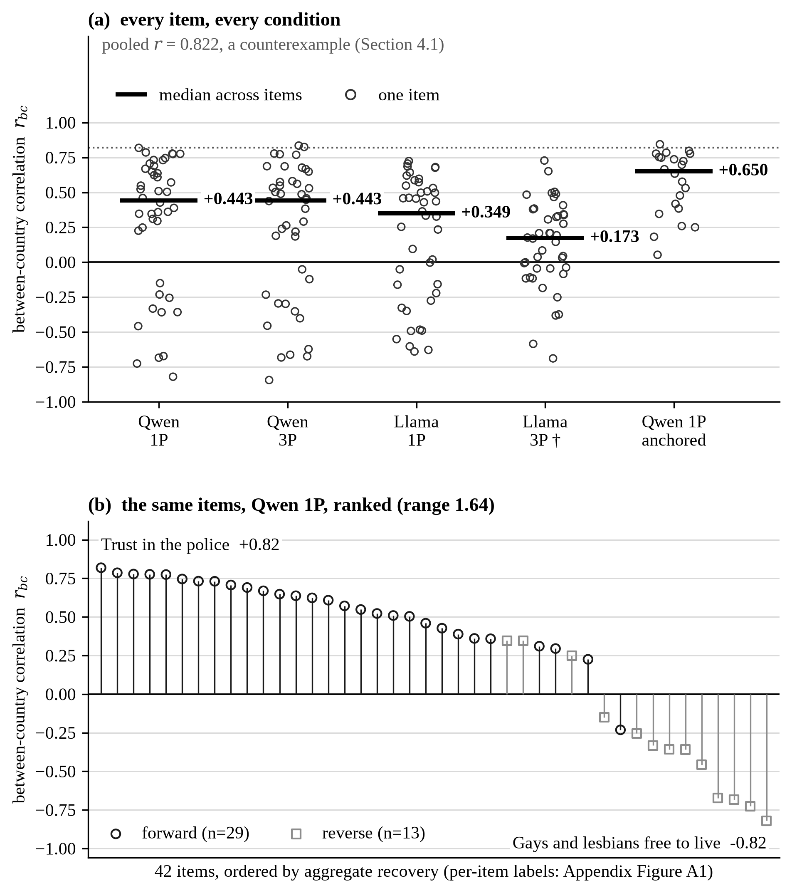
Figure 2. Aggregate recovery: by condition, and item by item.
Note. Panel (a): every item’s between-country correlation in each condition, with the median across items marked. The pooled correlation is drawn once, as a labeled counterexample (all pooled p < 0.001). The Llama 3P arm (†) loses 24% of its scheduled responses to a parse failure and is not read substantively (Section 4.4). The anchored arm repeats Qwen 1P with the two scale endpoints named in words, on the 22-item batch of Section 4.2. Panel (b): the same 42 items under Qwen 1P, ranked, with the highest and lowest named and reverse-coded items marked. Figure 6 is the individual-level counterpart, drawn on the scale of panel (b).
Figure 2(b) ranks the same items under Qwen 1P. The full labeled rankings appear in Appendix Figures A1 and A4. Figure 6(b) draws the individual level on the same scale, and the two together make the disparity visible: the aggregate series spans 1.64 correlation units, the individual series 0.30, a ratio of 5.5.
Panel (b) shows that institutional trust and subjective well-being recover best, whereas income, safety, and health invert. Trust items dominate the top (trust in the police 0.82, trust in parliament 0.79, trust in the legal system 0.78). Eleven items have negative r_{bc}, meaning the model reverses their cross-national ordering, and the two most severe are whether gay men and lesbians should be free to live as they wish (−0.82) and whether same-sex couples should have the right to adopt (−0.73). Ranks beyond the top two are not reported. They exchange places between independent runs of the same condition, as the noise floor of 0.060 per item implies.
Ten of the eleven inversions are reverse-coded items, and direction alone explains 66% of the variance in r_{bc} across the 42 items. One inversion is not explained by direction. Whether European unification should go further (−0.23) is forward-coded. It is a bipolar item whose numeric direction is a convention. In Figure 2(b) it is the one circle in the negative tail. Appendix Figure A2 puts a recovered item and an inverted one side by side. Section 4.2 tests the scale-direction account experimentally.
Recovery also varies across country profiles. For each country, r_{prof} is the correlation between the 42 human and model means. Figure 7 ranks all 30 of them. Under Qwen 1P, r_{prof} ranges from 0.69 in Bulgaria to 0.91 in Finland (mean 0.82, standard deviation 0.06). Finland, Switzerland, Ireland, Norway, and Austria rank highest (0.88–0.91), while Bulgaria, Serbia, Ukraine, Israel, and Latvia rank lowest (0.69–0.76). The band is narrow, so the measure does not discriminate well enough to select countries to trust.
The pattern depends on the error metric. After rescaling each item to the unit interval, mean absolute error averages 0.195 and ranges only from 0.16 to 0.22, and several Western European countries move into the higher-error group. Country ordering is nevertheless similar across Qwen and Llama (r = 0.76 for normalized error, 0.97 for r_{prof}), so the same countries are easier or harder for both models even though the regional gradient is weak.
Rank correspondence and calibration are close to independent. All 30 countries have positive mean bias under Qwen 1P, from 0.36 scale points in Finland to 1.40 in Bulgaria, consistent with a shift toward higher numeric responses. Mean standard-deviation ratios range from 0.54 in Estonia to 0.68 in Portugal with no clear geographic gradient. Lin’s concordance coefficient separates ranking from calibration and shows that 87% of the agreement attainable at the observed rank correspondence is lost to bias and compression (Appendix, Concordance). A reader who wants to rank countries gets moderate performance. A reader who wants to use the number as an estimate of a country’s value gets almost nothing.

4.2 The country label carries the signal, the response format its direction
Addressing RQ2, the falsification arm shows that the model reads the country name it is given. Scored against the respondents’ own country, the swapped arm reaches a forward-item median r_{bc} of 0.34, against 0.40 for the same profile with no country name at all. Per item the paired difference is −0.096, with a bootstrap interval over items of [−0.142, −0.003]. A wrong name costs the respondents’ own country more than no name does. A cue the model attends to should do that. A cue it ignores could not. The arm does not, however, hand recovery to the country it names. Scored against that country it reaches 0.40, well short of the 0.56 the true name reaches, and the paired difference between the two scorings is +0.012 [−0.068, +0.122]. The label is used without taking over, and the rest of the profile still carries country information of its own. The two scorings are not mechanically coupled: under the derangement the named and the true countries’ human means correlate at a median of −0.07. Figure 3 puts the conditions side by side.
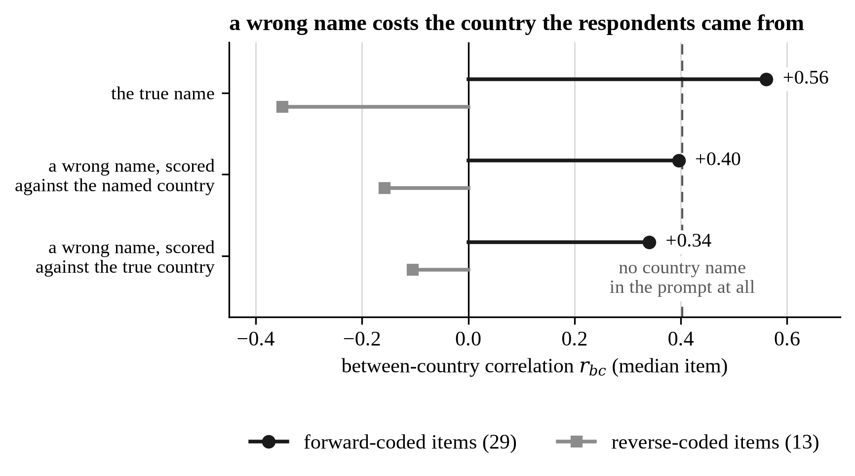
Figure 3. A wrong country name costs the country the respondents came from, Qwen 1P.
Note. Median r_{bc} over items, with forward- and reverse-coded items shown separately. The dashed line is the same profile with no country name in the prompt. The comparison that carries the argument is the third row against that line: a wrong name leaves the respondents’ own country worse recovered than no name does. The second row against the third is small and its interval includes zero, so the arm is not evidence that recovery transfers to the country named.
How much the name contributes is the next question, and one paired contrast answers it. The country sentence is removed from an otherwise identical rich profile, holding the same respondents and items. The paired item-level correlation rises by a median 0.135 on forward-coded items, where 27 of 29 improve (p < 0.001), and falls by 0.176 on reverse-coded items, where 1 of 13 improves. Of the three original removal contrasts, only the country label produces an effect that survives correction for multiplicity and exceeds the noise floor (Appendix, Block ablations).
Figure 4 gives every block’s effect at both margins, and Appendix Figure A3 gives the country-label contrast item by item. Adding the country name to a backstory that already specifies gender, age, and birth year raises median r_{bc} from −0.03 to 0.52 (Fisher z +0.73 on forward items, −0.44 on reverse items). No other block approaches either of the label’s margins. Union membership and internet use is the only other block beyond the noise floor on both (+0.09 added, +0.08 removed, forward items). Added one variable at a time, that gain comes from internet use (+0.13 against union’s +0.06), itself a strong country gradient.
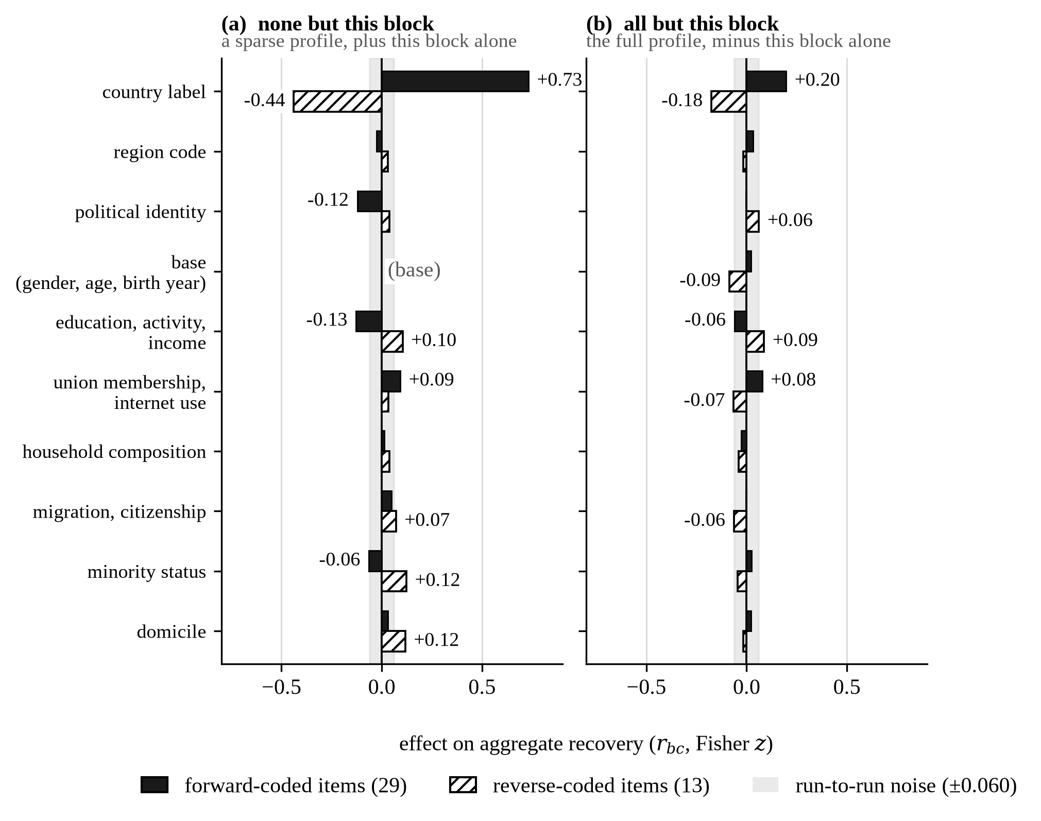
Figure 4. Each backstory block’s effect on aggregate recovery at the two margins that bound it, Qwen 1P.
Note. Each bar is a block’s median effect on r_{bc} (Fisher z) at one margin. Panel (a) adds the block alone to a sparse profile. Panel (b) removes it alone from the full profile. The two panels share one scale. The base has no add margin, because every other block is added to it. Reverse-coded items are the thirteen whose numeric scale runs against the direction of the question. They are drawn as separate bars because the effect reverses sign with wording, and one bar per block would average the forward gain against the reverse loss and read as no effect (later in this section). The shaded band is run-to-run noise, and effects inside it are left unlabeled: they are smaller than the difference between two identical runs. The same contrast item by item is in Appendix Figure A3. Per-block values ship with the figure data.
The blocks that describe the respondent subtract. Political identity lowers recovery when added to the sparse base (−0.12) and does nothing when removed from the full profile. The socioeconomic block lowers it at both margins (−0.13 added, −0.06 removed), and removing household income alone reproduces nearly the whole block effect (−0.055 of −0.061). The margins are also not additive: political identity and the socioeconomic block each subtract on their own, yet the full profile sits at 0.44. Block effects do not accumulate. The label’s effect is also larger when it is added than when it is removed (+0.73 against +0.20), because the full profile already carries some country information in the composition of its other variables, which Section 5.4 bounds.
The country label alone accounts for most of the aggregate recovery. The label with no demographics at all recovers 0.52, the same as with them, and the full profile recovers less than the label on its own (0.44). Stating the same age as a birth year leaves recovery unchanged, so the step does not depend on the surface form of the base. The gain is confined to the aggregate. Median within-country recovery remains near zero in every arm, so the manipulation that produces the cross-national correspondence yields no improvement in individual prediction.
The added information hurts even where it is directly relevant. Household income decile enters with the economic block, and income items recover worse with it than without. Dispersion sharpens the point: even in the best condition the model reproduces only a fraction of the true cross-national spread, and the between-country dispersion ratio is highest at the two richest profiles, where the correlation sits below the country-only level. Enrichment widens cross-national differentiation and misdirects it.
The country-label contrast replicates in the second model. Under Llama 1P the same removal moves forward items by +0.25 and reverse items by −0.20, with 25 of 29 forward items improving. Taken together the two margins and the falsification arm describe a group-level prior: the label places countries against one another, the rest of the profile does not refine that placement, and replacing the name degrades the placement it was carrying.
One explanation covers both the inversions of Section 4.1 and the negative label effect above, and the 2 × 2 experiment tests it (Figure 5). The model may be reading the numeric scale in the wrong direction while holding correct country associations. Under numeric scales the country label helps forward-coded items (mean Fisher-z effect +0.15) and harms reverse-coded ones (−0.24, 1 of 10 improving). Under anchored scales it helps both (+0.22 and +0.24, 10 of 10 and 8 of 10 improving). The triple difference is the change in the country effect on reverse items minus the change on forward items. It is +0.42, with a 95% bootstrap interval of [0.13, 0.79]. The forward-reverse gap closes from +0.39 to −0.03, which is within the noise floor of zero. Dropping the two largest movers leaves +0.16 [0.05, 0.27]. The result does not depend on them.
The country label therefore supplies cross-national signal, and the response format decides whether the countries come out in the right order or backwards. This is one interacting mechanism, not two parallel ones, and it means the item inversions are a property of the instrument, not of the model’s country knowledge.
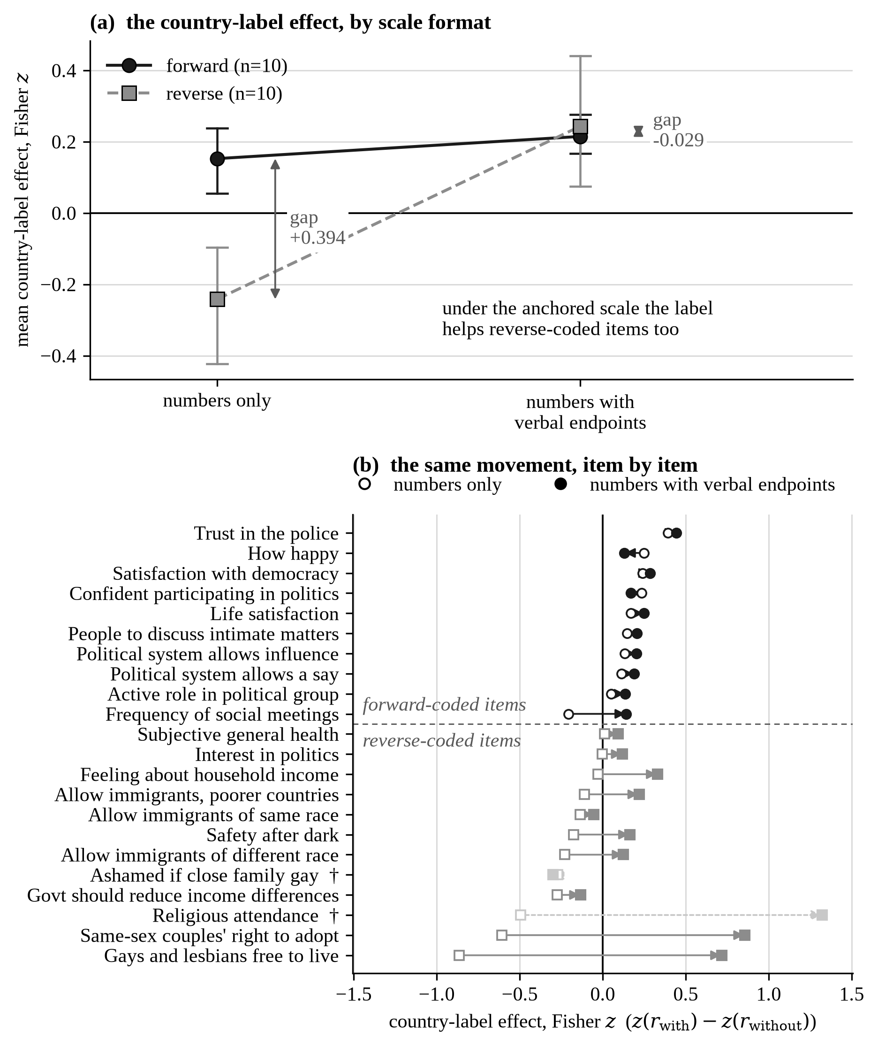
Figure 5. The country label by the response format, 22 items, Qwen 1P.
Note. A verbally anchored scale names the two endpoints of the response scale in words. The numeric arm gives the number range alone. Panel (a): the four cell means with bootstrap intervals over items. Verbal anchors flip the label’s effect on reverse-coded items from negative to positive. Panel (b): the same movement for every one of the 22 items in the batch, with the two pre-declared exclusions marked (†). The triple difference excludes zero under all three pre-specified reverse-item sets (Table A5).

4.3 Individual-level recovery is limited and unrelated to the aggregate
Addressing RQ3, recovery remains near zero across model-prompt conditions, and the models reproduce little of the demographic signal available in the human data. Median within-country recovery ranges from 0.006 (Llama 3P) to 0.028 (Qwen 1P), and even the largest implies less than 0.1% shared variance. First- and third-person framing do not differ in either model (Table A4). With 20,550 respondents per condition many of these correlations are statistically significant and substantively negligible. That weakness is not an absence of demographic signal in the human benchmark: the five-predictor ceiling is 0.210 against an achieved 0.028, so the model recovers 13.5% of what a demographic profile could in principle deliver. Figure 6 shows both cuts of the individual level: every condition against that ceiling, and the same 42 items on the scale of Figure 2(b).
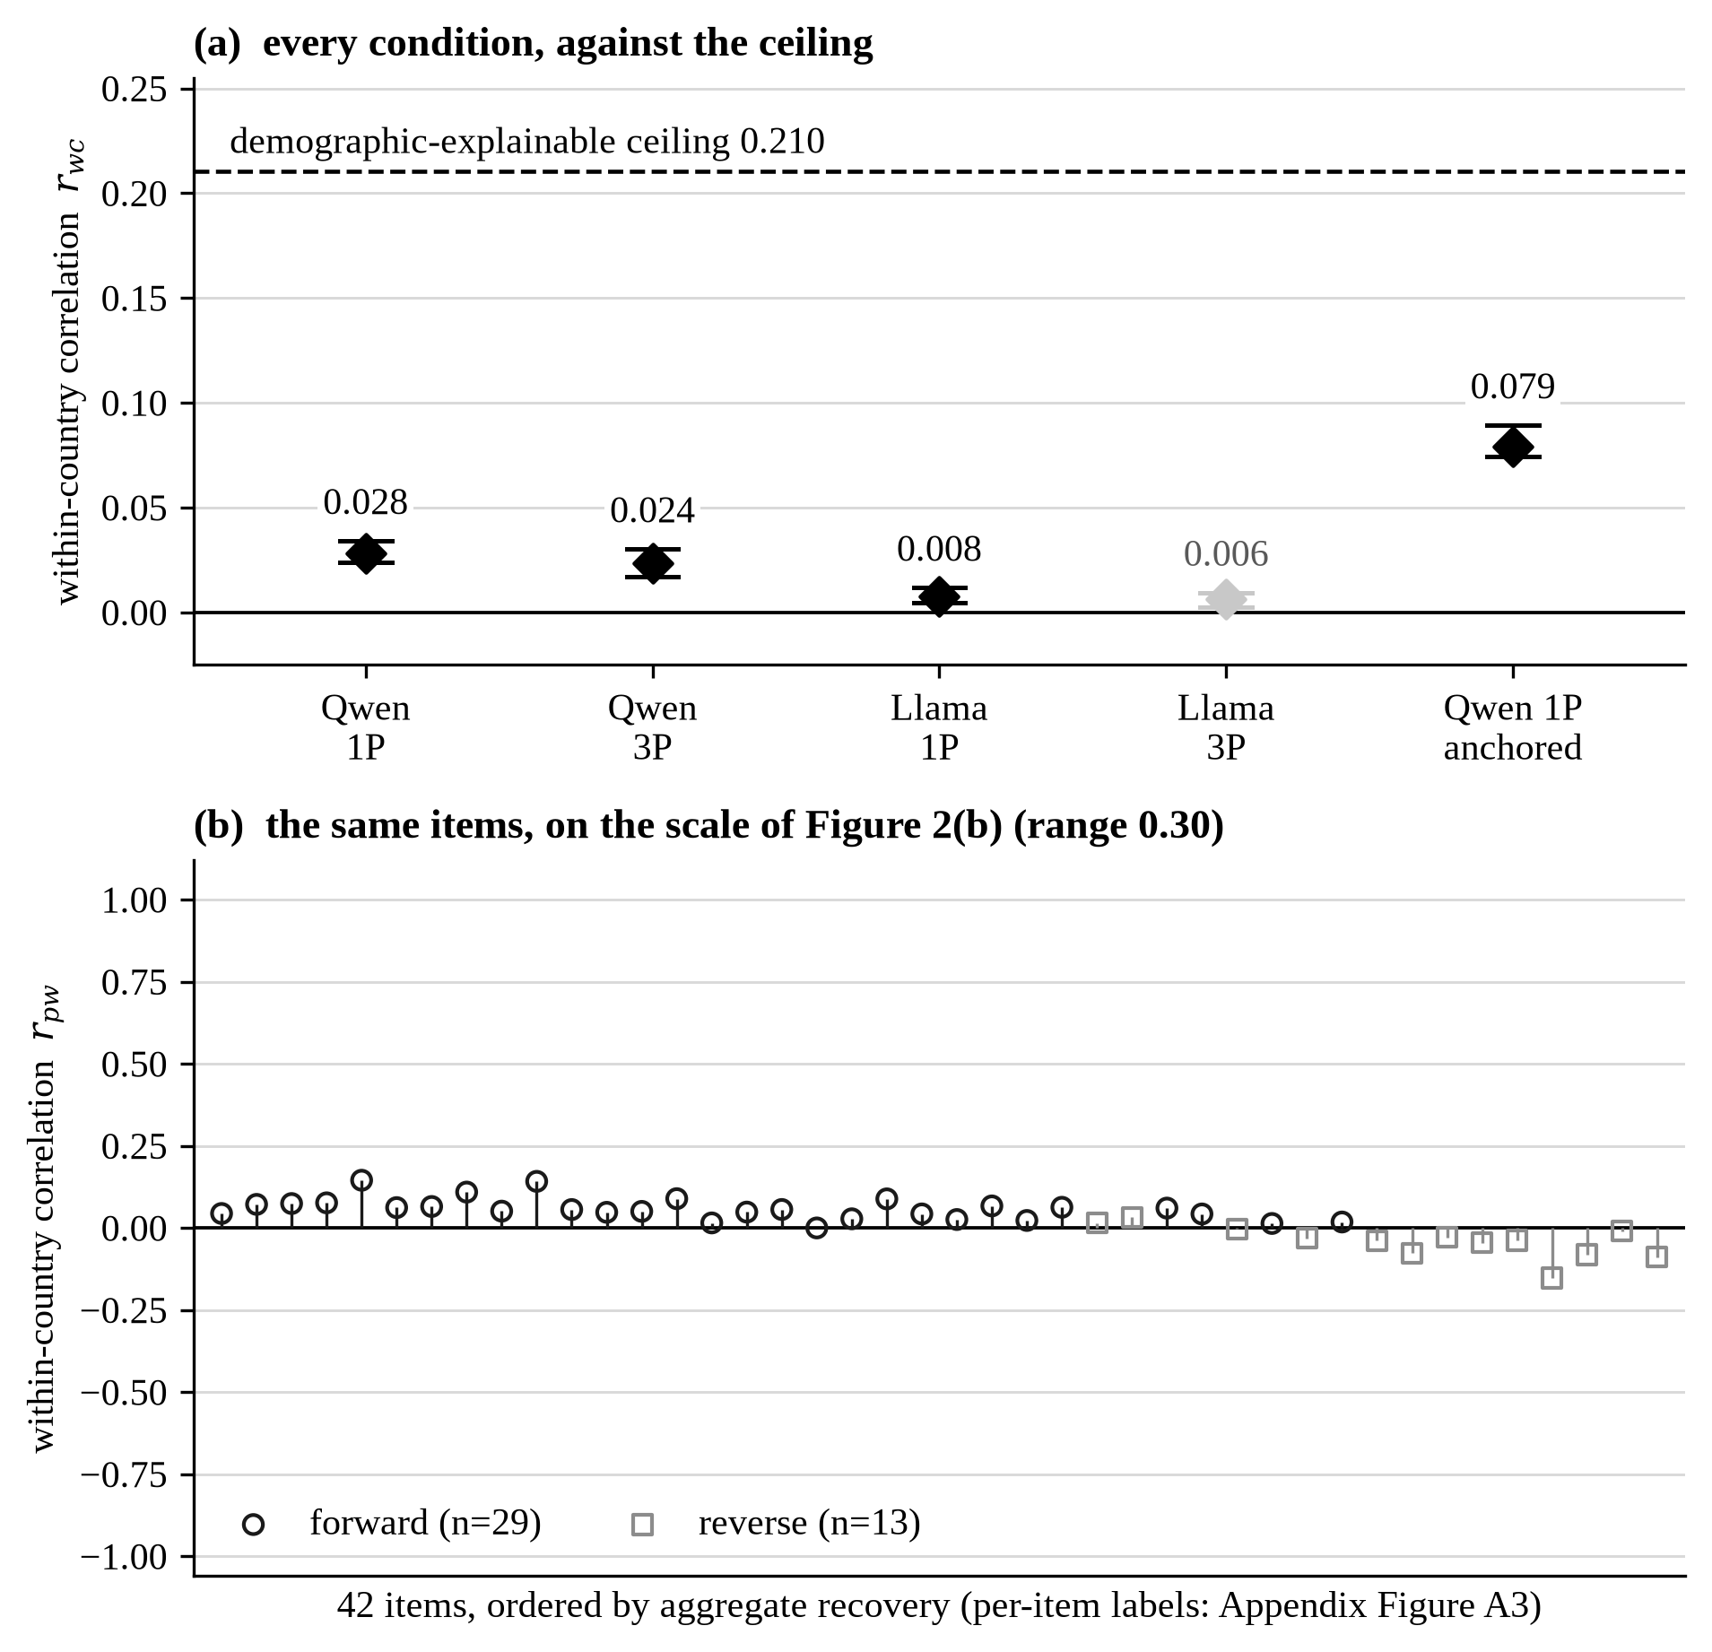
Figure 6. Individual-level recovery: by condition, and item by item.
Note. Panel (a): the median within-country correlation in each condition, with a bootstrap interval over country-item cells, against the demographic ceiling of 0.210. The conditions and the dagger are those of Figure 2(a), and the anchored arm is the 22-item batch of Section 4.2. Panel (b): the pooled within-country correlation for each of the 42 items, in the item order and on the scale of Figure 2(b), which is what makes the two series comparable.
The two levels sit far apart. The pooled correlation lies between 0.64 and 0.83 across conditions while within-country recovery is near zero (Figures 2 and 6). The aggregate-individual dissociation is established for single-country designs. What is new is that it survives across 30 countries and that scale anchoring moves both levels together.
Anchoring is the one manipulation that moves this level (Section 4.2). It raises median within-country recovery from 0.028 to 0.079, or from 13.5 to 31.9% of the demographic ceiling. Individual recovery is negligible under numeric scales and roughly triples when the scale direction is made explicit. It stays far below the ceiling in both cases.
Distributional recovery is also limited. Under Qwen 1P the mean ratio of model to human standard deviations is 0.61, using the mean of the per-cell ratios. The median is 0.57 and the ratio of means 0.59, and all three fail the pre-declared 0.9–1.1 band. Llama 3P instead expands variance (1.41), showing that dispersion can fail in either direction. Aggregate rank correspondence therefore does not imply distributional recovery.
Individual recovery is weak in every country. It is computed for each of the 1,260 country-item cells. Under Qwen 1P, mean r_{wc} is 0.027, with a standard deviation of 0.079. Of these, 826 are positive and 453 reach p < 0.05. Even Israel, the highest country mean at 0.077, has less than 1% of individual variance explained. No country reaches a level that supports substantive individual inference.
Recovery varies more by item than by country. Life satisfaction (0.146) and happiness (0.142) recover best, whereas feeling about household income (−0.148) and whether gay men and lesbians should be free to live as they wish (−0.085) are consistently negative. Eleven of the 42 items are negative at this level, the same count as at the aggregate level and largely the same items (Appendix Figure A4, and Table A3 by domain). That is the pattern a direction failure operating at both levels would produce. What is asked therefore matters more than which country is simulated.
The two levels do not share a geographic pattern either. Across 30 countries, r_{prof} and r_{wc} correlate at −0.21, with a 90% confidence interval of [−0.49, 0.10]. Using range-normalized error in place of r_{prof} gives +0.07. With 30 countries the data cannot distinguish a null from a moderate association, so the result is a bound. A scatter of the two quantities would draw that uncertainty as noise, so Figure 7 shows the decision-relevant object instead: the two country orderings side by side, joined per country.
The decision this bears on is pairwise, so counting is better than correlating: of the 435 country pairs, 232 are ordered one way by aggregate profile recovery and the other way by individual recovery. A researcher choosing between two countries on aggregate evidence would therefore be wrong slightly more often than right. Switzerland against Israel is the sharpest case: profile correlations of 0.91 and 0.75 but within-country correlations of 0.014 and 0.077. The aggregate-individual correlation is also non-positive under Qwen 3P (−0.52), Llama 1P (−0.21), and Llama 3P (−0.22). Aggregate performance cannot be used to select countries for individual-level work, and RQ3 finds no evidence that stronger aggregate recovery predicts stronger individual recovery.
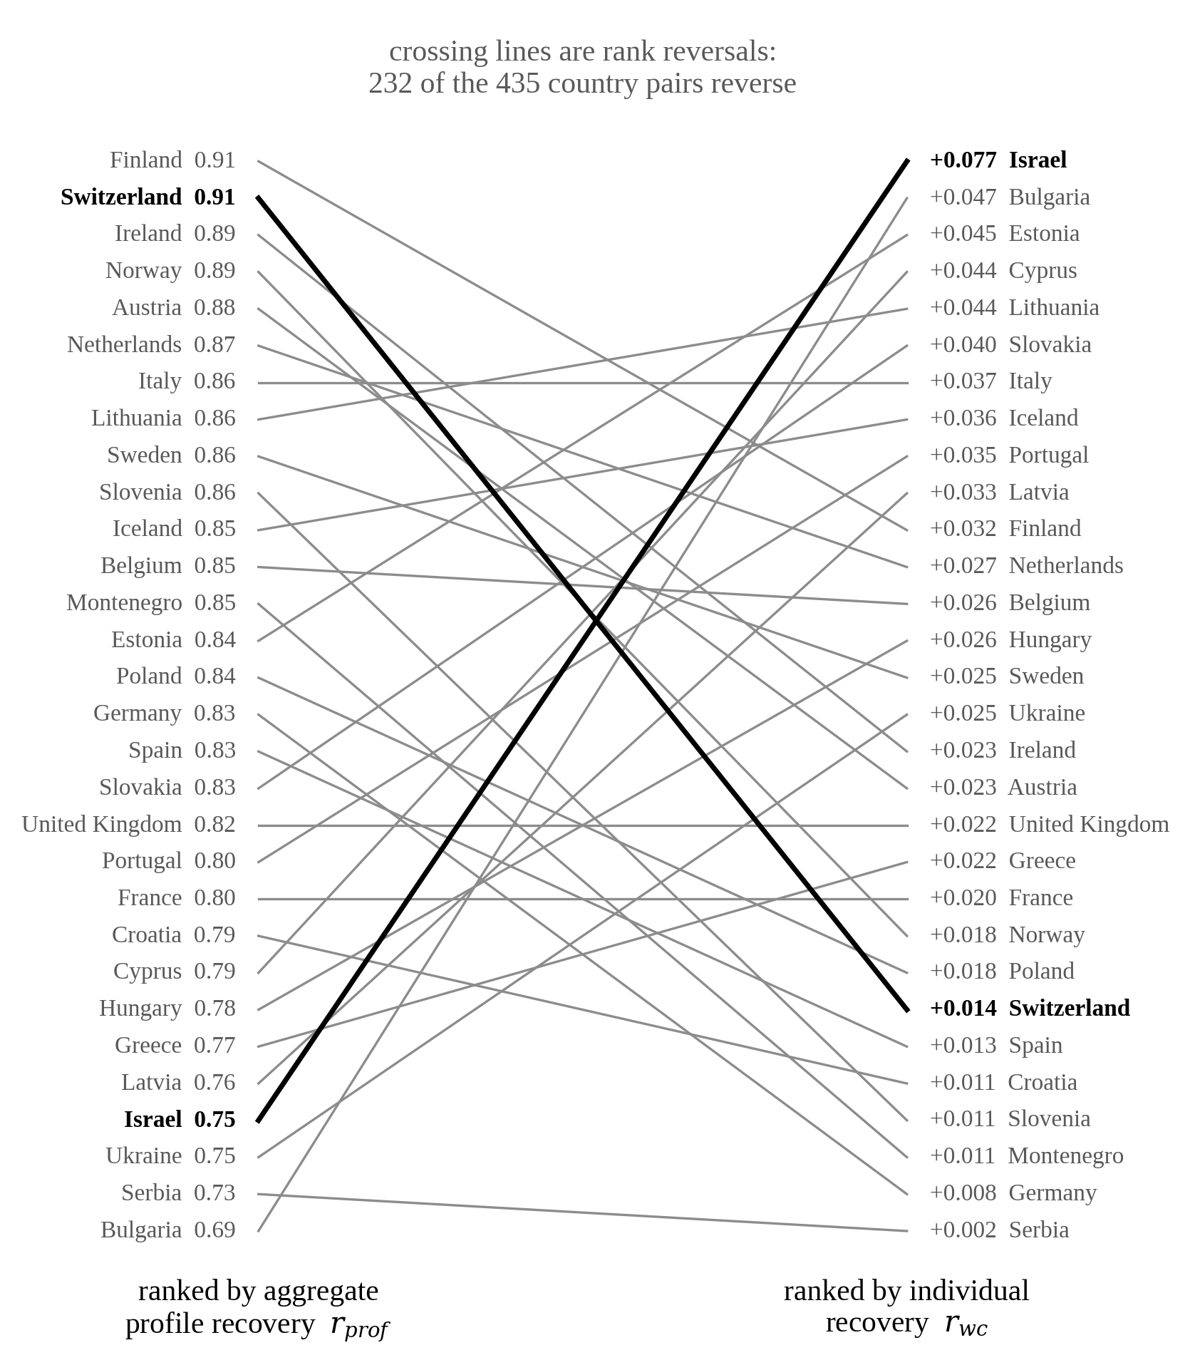
Figure 7. Aggregate against individual country rankings, Qwen 1P.
Note. Left: the 30 countries ranked by r_{prof}. Right: the same countries ranked by mean r_{wc}. Crossing lines are rank reversals, and 232 of the 435 country pairs reverse. Only Switzerland and Israel are drawn in black, because the text works through that pair. Every other country is drawn alike.

4.4 Robustness checks
Sixteen checks leave the conclusions where they stand, with one exception: parse coverage in the Llama third-person arm. Appendix Table A5 reports them all with the quantity each moves: the human benchmark (weighting, missingness, the country-mean frame), the investigator codings (item direction, item sets), estimator and aggregator choices, the comparator’s specification, parse coverage, and stability across runs and rounds. The exception is stated here, with the two checks that set the terms on which the others are read.
The direction coding survives the checks that could undo it. It was fixed from the ESS codebook before any result was seen, and the same pattern appears in a second, independently trained model, where the cross-variable agreement is r = 0.84.
Run-to-run stability sets the band an effect has to clear. The median absolute difference in r_{bc} between the two identical runs is 0.060 per item, with a maximum of 0.185. Every effect interpreted in this paper exceeds that band. A second replicate, run on the full battery under a different generation seed, gives a smaller median of 0.029 and a larger maximum of 0.242. The eight items beyond the band are led by the two the dispersion screen already declares uninterpretable. The band is kept at 0.060, which is the conservative choice.
Parse coverage in the Llama third-person arm is the exception. Restricting to items above 80% coverage moves the median r_{bc} from +0.17 to −0.00. The correlation falls as the threshold tightens, so the usable subset is biased and not cleaner: the poorly covered items are the wide response scales, on which recovery is otherwise strongest. Better parsing would not rescue the condition. Re-parsing every rejected response under four alternative extraction rules moves the median r_{bc} in that arm by at most 0.013, against a run-to-run noise floor of 0.060 (Appendix, Table A6). The framing null rests on Qwen alone.

5 Discussion and Conclusion
Read separately, the three findings look like three unrelated failures. The scale experiment shows they are not. Naming the two scale endpoints in words removes the item inversions, reverses the sign of the country-label effect on reverse-coded items, and triples individual-level recovery. One manipulation does all three. Two of the three main results therefore share a cause, and the cause lies in the measurement instrument. The third does not depend on it: the country label supplies most of the aggregate signal, richer profiles do not improve on it, and the two levels do not covary across countries.

5.1 The country label acts as a group-level prior
The country label carries the aggregate signal, and richer profiles do not improve on it (Section 4.2). A model that found respondent detail uninformative would show flat margins. The margins are negative, so the detail is used, and used badly.
Identifiability does not explain the label’s contribution. If it were the mechanism, recovery would track it. Recovery instead varies widely among profiles that identify the country equally well, and the sparsest profile containing the country beats every richer one (Appendix, Country identifiability). The model treats the country as a group-level prior and respondent detail as noise around it. Almost none of the variation it produces within a country is respondent-specific: in a replicate arm 95% of the within-country variance is generation noise. The label is also what steers: replacing it with a wrong name costs the country the respondents came from.
The model orders countries without calibrating the distances between them. Calibrated country knowledge would reproduce the spacing and the level of the country means, not only their order. The model does neither. It compresses cross-national spread, it shifts every country’s mean in the same direction, and most of the agreement available at the observed ranking is lost to that displacement (Section 4.1 and Appendix, Concordance).
Sensible cue use does not explain the pattern either. Country may be the most informative single cue available for these outcomes, so leaning on it could be cue use and not stereotype activation. Enrichment separates the two readings. A model weighing cues on their validity would not lose accuracy when given more valid ones, and the socioeconomic block widens cross-national differentiation while lowering the correlation (Section 4.2).
Country-conditioned differentiation is not equivalent to calibrated representation. Human national-character beliefs can be consensual yet unrelated to measured population traits (Terracciano et al., 2005), while LLM population simulations show uneven correspondence across countries (Durmus et al., 2023; Qu & Wang, 2024). Even models fine-tuned to reproduce survey response distributions capture group-level patterns, not individual attitudes (Cao et al., 2025). The observed correspondence cannot distinguish survey knowledge from online discourse, national stereotypes, or response-scale priors. The country label should therefore be read as a strong aggregate prior, not as evidence that the model reconstructs the population it names.
The result separates matching a group-level pattern from simulating a population’s internal structure. Cultural-alignment research asks which national profiles models resemble (Durmus et al., 2023; Tao et al., 2024). Survey-simulation research asks whether conditioned outputs reproduce the target population (Bail, 2024; Bisbee et al., 2024). These results show that the first capacity can be present while the second is absent.

5.2 Item-level failure is a property of the instrument
High pooled correlations mask negative item-level country correlations by combining well-recovered and inverted items. In these data, high pooled and profile correlations coexist with eleven of the 42 items whose cross-national ordering is reversed, so a screening rule based on either would pass the battery unchanged. Item-level diagnostics are therefore necessary before pooled or profile metrics are used.
The inversions are an instrument effect: the anchoring experiment of Section 4.2 removes them while holding the model, the respondents, and the items fixed. Prompt format is therefore part of the measurement instrument, and the instrument here was minimal by design, giving the model a bare numeric range where an ESS respondent hears the full question and sees a labeled show card. Röttger et al. (2024) reach the same conclusion for the measured political position of models under different question formats. What the numeric arm measures is a compound of the model’s country associations and its reading of the scale, and only the anchored arm separates the two. This is a measurement-equivalence problem of the kind cross-national survey research already recognizes between human populations (King et al., 2004; Davidov et al., 2014), arising here between human and model. A validation has to report the response format it used, because the same model and the same items rank countries the other way round under another one.
Direction accounts for two thirds of the variance in item-level recovery, and the remaining third has a pattern of its own. Institutional trust and subjective well-being recover best, while items about a respondent’s own circumstances (income, health, safety) invert. One reading, offered after the fact, is that the model recovers what is publicly said about a country and not what its residents report about themselves. Cross-national differences in institutional trust and in subjective well-being are the subject of a large descriptive literature and track visible national conditions (Norris, 2011; Diener et al., 1995), the same structure the model-free comparators exploit (Section 5.3). How safe a respondent feels walking home after dark has no comparable public ordering. The reading fits the group-level prior, and it predicts which items a country cue can carry: those already discussed at country level. Consistent with this, among forward-coded items recovery rises with the size of the true cross-national differences (r = 0.46, p = 0.012 across the 29 items).

5.3 Aggregate and individual recovery are different validity claims
The dissociation between the two levels is the ecological-inference problem in a new setting: relationships among group means need not reproduce relationships among individuals (Robinson, 1950; Firebaugh, 1978), and recovering individual relationships from aggregate data remains a distinct and difficult inferential problem (King, 1997). Silicon sampling reproduces that structure exactly. Evidence for aggregate recovery is therefore not weak evidence for individual recovery. It is evidence for a different claim. Recent evaluations point the same way. LLM-generated data can match marginal statistics while failing multivariate and subgroup structure (Boelaert et al., 2025; Li et al., 2025; Williams et al., 2026). LLM stand-ins reproduce group-level discourse while flattening the within-group variation on which individual recovery depends (Kozlowski & Evans, 2025).
What would close the gap is respondent information, and the amounts involved are large. Higher individual recovery appears only when models receive interview- or annotator-specific data far richer than demographic profiles (Park et al., 2024; Orlikowski et al., 2025), and sociodemographic prompting alone does not reliably improve subjective judgment (Sun et al., 2025; Gao et al., 2025). The profiles here are the scalable demographic minimum by design (Section 3.3), so the absence of improvement measures what that minimum buys. The framing null follows from the same prior account: a model that ignores the mapping from profile to attitude has no reason to answer differently when speaking as the person than when predicting the person. Presentation is the third constraint and the cheapest to change, and Section 5.2 shows it moves both levels at once.
A coverage account cannot absorb these results. If better-represented populations were easier to simulate, the countries recovered best at the aggregate level would also be recovered best at the individual level (Durmus et al., 2023; Pataranutaporn et al., 2025). They are not, and recovery varies more across items than across countries, which points to a weak mapping from profiles to attitudes, not to a coverage gradient.
Whether recovery is adequate depends on the alternative, and the alternatives are cheap. One predicts each country’s item mean by the leave-one-out average of its regional neighbors, using no model at all. It gives a median r_{bc} of 0.55 against the model’s 0.44, and a median normalized error of 0.056 against 0.180. The regional average wins on level accuracy for 41 of 42 items. Adding log GDP per capita to region dummies raises the comparator to 0.62 and 0.052. Both comparators require survey data from other countries. The question they pose is whether a researcher who already holds such data should use the model to extend it. On these items, at this sample size, the answer is no.
After item-level validation the model may still support exploratory cross-national rank comparison on topics it recovers well, where no survey data for the comparison countries exist. It does not support individual prediction, within-country heterogeneity estimation, or distributional analysis: matching country means can coexist with compressed variance, unstable coefficients, and incorrect dependence structure (Bisbee et al., 2024; Williams et al., 2026; Xie et al., 2026). Aggregate recovery is evidence about a specific estimand, not a certificate of representativeness. Validation should match the intended estimand and the design, since response coding, backstory wording, model choice, and sampling settings all change synthetic distributions (Bisbee et al., 2024; Dominguez-Olmedo et al., 2024; Röttger et al., 2024).

5.4 Contributions, limitations, and future directions
The three contributions are empirical, methodological, and practical. The empirical one is the evaluation itself: item-level country rankings, within-country individual recovery, and the country label’s incremental contribution, measured for the first time on the same matched respondents, items, and prompts. What it finds is a group-level prior: the label carries the aggregate signal, no richer profile improves on it, and none of it reaches the individual level. The methodological one is to make those readings testable. Each backstory block is observed at the two margins that bound its contribution, so no ordering of additions can be chosen after the fact. A falsification arm replaces the country name, to test whether the cue is specific to the country named. A 2 × 2 experiment crosses the country label with the response format, which turns the item inversions from an interpretation into a result. Recovery is reported item by item against a measured run-to-run floor. A pooled correlation would have hidden the inverted items. The practical one is a standard of adequacy. Recovery is judged against predictors that use no model at all and that a researcher who holds survey data already has, and on these items the regional average wins. A validation licenses only the estimand it tested: aggregate rank comparison after item-level validation, and no claim at the individual or distributional level.
Five limitations define the scope of these conclusions. First, English prompts and generic party coding omit country-specific language and party cues. Second, one European survey program and two open-weight 7–8B models limit generalization to non-European populations, other survey designs, and larger or proprietary models. Third, the no-country arm still carries country information in the composition of harmonized categories, where a classifier recovers the country 28.7% of the time against a 3.3% baseline, so its 0.34 median recovery bounds what composition achieves without a country name, and the arm is not a zero-information control. Fourth, the scale experiment uses Qwen 1P only, and no experiment here separates calibrated country knowledge from stereotype activation. Fifth, the Llama third-person arm lost 24% of scheduled responses to a format-compliance failure, which bounds what that arm can show (Appendix, Parse failures).
Each limitation names its next step. A factorial design can vary prompt language, country-specific party cues, verbal scale anchors, and profile content independently. The benchmark should extend to non-European surveys and to larger or proprietary models. Compositional country information should be measured and reported wherever a design cannot remove it. The anchoring experiment should be repeated in a second model, and unparsable outputs reported by item and country instead of as one coverage figure. Repeated runs of the same arm would separate item-level signal from generation noise directly. This design has one replicate pair. Beyond the limitations, the quantities a user needs are multivariate structure and subgroup calibration, each judged against the estimand-specific criteria above.

References
Argyle, L. P., Busby, E. C., Fulda, N., Gubler, J. R., Rytting, C., & Wingate, D. (2023). Out of one, many: Using language models to simulate human samples. Political Analysis, 31(3), 337-351. https://doi.org/10.1017/pan.2023.2
Ashokkumar, A., Hewitt, L., Ghezae, I., & Willer, R. (2026). Large language models can predict the results of social science experiments. Nature. https://doi.org/10.1038/s41586-026-10742-x
Bail, C. A. (2024). Can Generative AI improve social science? Proceedings of the National Academy of Sciences, 121(21), e2314021121. https://doi.org/10.1073/pnas.2314021121
Bender, E. M., Gebru, T., McMillan-Major, A., & Shmitchell, S. (2021). On the dangers of stochastic parrots: Can language models be too big? In Proceedings of the 2021 ACM Conference on Fairness, Accountability, and Transparency (FAccT ’21, pp. 610-623). ACM. https://doi.org/10.1145/3442188.3445922
Bisbee, J., Clinton, J. D., Dorff, C., Kenkel, B., & Larson, J. M. (2024). Synthetic replacements for human survey data? The perils of large language models. Political Analysis, 32(4), 401-416. https://doi.org/10.1017/pan.2024.5
Boelaert, J., Coavoux, S., Ollion, É., Petev, I., & Präg, P. (2025). Machine bias: How do generative language models answer opinion polls? Sociological Methods & Research, 54(3), 1156-1196. https://doi.org/10.1177/00491241251330582
Cao, Y., Liu, H., Arora, A., Augenstein, I., Röttger, P., & Hershcovich, D. (2025). Specializing large language models to simulate survey response distributions for global populations. In Proceedings of the 2025 Conference of the Nations of the Americas Chapter of the Association for Computational Linguistics: Human Language Technologies (pp. 3141-3154). Association for Computational Linguistics. https://doi.org/10.18653/v1/2025.naacl-long.162
Curtin, R., Presser, S., & Singer, E. (2005). Changes in telephone survey nonresponse over the past quarter century. Public Opinion Quarterly, 69(1), 87-98. https://doi.org/10.1093/poq/nfi002
Dalton, R. J., & Welzel, C. (Eds.). (2014). The civic culture transformed: From allegiant to assertive citizens. Cambridge University Press. https://doi.org/10.1017/CBO9781139600002
Davidov, E., Meuleman, B., Cieciuch, J., Schmidt, P., & Billiet, J. (2014). Measurement equivalence in cross-national research. Annual Review of Sociology, 40(1), 55–75. https://doi.org/10.1146/annurev-soc-071913-043137
Diener, E., Diener, M., & Diener, C. (1995). Factors predicting the subjective well-being of nations. Journal of Personality and Social Psychology, 69(5), 851–864. https://doi.org/10.1037/0022-3514.69.5.851
Dillion, D., Tandon, N., Gu, Y., & Gray, K. (2023). Can AI language models replace human participants? Trends in Cognitive Sciences, 27(7), 597–600. https://doi.org/10.1016/j.tics.2023.04.008
Dominguez-Olmedo, R., Hardt, M., & Mendler-Dünner, C. (2024). Questioning the survey responses of large language models. In Advances in Neural Information Processing Systems, 37 (NeurIPS 2024). https://doi.org/10.52202/079017-1458
Durmus, E., Nguyen, K., Liao, T. I., Schiefer, N., Askell, A., Bakhtin, A., Chen, C., Hatfield-Dodds, Z., Hernandez, D., Joseph, N., Lovitt, L., McCandlish, S., Sikder, O., Tamkin, A., Thamkul, J., Kaplan, J., Clark, J., & Ganguli, D. (2023). Towards measuring the representation of subjective global opinions in language models. arXiv preprint arXiv:2306.16388. https://doi.org/10.48550/arXiv.2306.16388
Eggers, A. C., Tuñón, G., & Dafoe, A. (2024). Placebo tests for causal inference. American Journal of Political Science, 68(3), 1106-1121. https://doi.org/10.1111/ajps.12818
European Social Survey European Research Infrastructure Consortium (ESS ERIC). (2026). ESS11 - integrated file, edition 4.1 [Data set]. Sikt - Norwegian Agency for Shared Services in Education and Research. https://doi.org/10.21338/ess11e04_1
Firebaugh, G. (1978). A rule for inferring individual-level relationships from aggregate data. American Sociological Review, 43(4), 557–572. https://doi.org/10.2307/2094779
Gao, Y., Lee, D., Burtch, G., & Fazelpour, S. (2025). Take caution in using LLMs as human surrogates. Proceedings of the National Academy of Sciences, 122(24), e2501660122. https://doi.org/10.1073/pnas.2501660122
Hofmann, V., Kalluri, P. R., Jurafsky, D., & King, S. (2024). AI generates covertly racist decisions about people based on their dialect. Nature, 633(8028), 147-154. https://doi.org/10.1038/s41586-024-07856-5
Inglehart, R., & Welzel, C. (2005). Modernization, cultural change, and democracy: The human development sequence. Cambridge University Press. https://doi.org/10.1017/CBO9780511790881
Kamruzzaman, M., & Kim, G. L. (2024). Exploring changes in nation perception with nationality-assigned personas in LLMs. arXiv preprint arXiv:2406.13993. https://doi.org/10.48550/arXiv.2406.13993
Keeter, S., Hatley, N., Kennedy, C., & Lau, A. (2017). What low response rates mean for telephone surveys. Pew Research Center. https://www.pewresearch.org/methods/2017/05/15/what-low-response-rates-mean-for-telephone-surveys/
King, G. (1997). A solution to the ecological inference problem: Reconstructing individual behavior from aggregate data. Princeton University Press. https://doi.org/10.1515/9781400849208
King, G., Murray, C. J. L., Salomon, J. A., & Tandon, A. (2004). Enhancing the validity and cross-cultural comparability of measurement in survey research. American Political Science Review, 98(1), 191-207. https://doi.org/10.1017/S000305540400108X
Kozlowski, A. C., & Evans, J. (2025). Simulating subjects: The promise and peril of artificial intelligence stand-ins for social agents and interactions. Sociological Methods & Research, 54(3), 1017–1073. https://doi.org/10.1177/00491241251337316
Li, D., Li, L., & Qiu, H. S. (2025). ChatGPT is not a man but Das Man: Representativeness and structural consistency of silicon samples generated by large language models. arXiv preprint arXiv:2507.02919. https://doi.org/10.48550/arXiv.2507.02919
Lu, J. G., Song, L. L., & Zhang, L. D. (2025). Cultural tendencies in generative AI. Nature Human Behaviour, 9, 2360-2369. https://doi.org/10.1038/s41562-025-02242-1
Miranda, F., & Balbi, P. P. (2025). Simulating public opinion: Comparing distributional and individual-level predictions from LLMs and random forests. Entropy, 27(9), 923. https://doi.org/10.3390/e27090923
Naous, T., Ryan, M. J., Ritter, A., & Xu, W. (2024). Having beer after prayer? Measuring cultural bias in large language models. In Proceedings of the 62nd Annual Meeting of the Association for Computational Linguistics (Vol. 1, pp. 16366–16393). Association for Computational Linguistics. https://doi.org/10.18653/v1/2024.acl-long.862
Narayanan Venkit, P., Gautam, S., Panchanadikar, R., Huang, T.-H. K., & Wilson, S. (2023). Nationality bias in text generation. In Proceedings of the 17th Conference of the European Chapter of the Association for Computational Linguistics (pp. 116–122). Association for Computational Linguistics. https://doi.org/10.18653/v1/2023.eacl-main.9
Norris, P. (2011). Democratic deficit: Critical citizens revisited. Cambridge University Press. https://doi.org/10.1017/CBO9780511973383
Orlikowski, M., Pei, J., Röttger, P., Cimiano, P., Jurgens, D., & Hovy, D. (2025). Beyond demographics: Fine-tuning large language models to predict individuals’ subjective text perceptions. In Proceedings of the 63rd Annual Meeting of the Association for Computational Linguistics (Vol. 1, pp. 2092–2111). ACL. https://doi.org/10.18653/v1/2025.acl-long.104
Park, J. S., Zou, C. Q., Kamphorst, J., Egan, N., Shaw, A., Hill, B. M., Cai, C., Morris, M. R., Liang, P., Willer, R., & Bernstein, M. S. (2024). LLM agents grounded in self-reports enable general-purpose simulation of individuals. arXiv preprint arXiv:2411.10109. https://doi.org/10.48550/arXiv.2411.10109
Pataranutaporn, P., Powdthavee, N., Archiwaranguprok, C., & Maes, P. (2025). Simulating human well-being with large language models: Systematic validation and misestimation across 64,000 individuals from 64 countries. Proceedings of the National Academy of Sciences, 122(48), e2519394122. https://doi.org/10.1073/pnas.2519394122
Qu, Y., & Wang, J. (2024). Performance and biases of large language models in public opinion simulation. Humanities and Social Sciences Communications, 11, 1095. https://doi.org/10.1057/s41599-024-03609-x
Robinson, W. S. (1950). Ecological correlations and the behavior of individuals. American Sociological Review, 15(3), 351–357. https://doi.org/10.2307/2087176
Röttger, P., Hofmann, V., Pyatkin, V., Hinck, M., Kirk, H. R., Schütze, H., & Hovy, D. (2024). Political compass or spinning arrow? Towards more meaningful evaluations for values and opinions in large language models. In Proceedings of the 62nd Annual Meeting of the Association for Computational Linguistics (Vol. 1, pp. 15295–15311). Association for Computational Linguistics. https://doi.org/10.18653/v1/2024.acl-long.816
Santurkar, S., Durmus, E., Ladhak, F., Lee, C., Liang, P., & Hashimoto, T. (2023). Whose opinions do language models reflect? In Proceedings of the 40th International Conference on Machine Learning (ICML) (pp. 29971-30004). PMLR. https://proceedings.mlr.press/v202/santurkar23a.html
Sun, H., Pei, J., Choi, M., & Jurgens, D. (2025). Sociodemographic prompting is not yet an effective approach for simulating subjective judgments with LLMs. In Proceedings of the 2025 Conference of the Nations of the Americas Chapter of the Association for Computational Linguistics: Human Language Technologies (Vol. 2, pp. 845-854). ACL. https://doi.org/10.18653/v1/2025.naacl-short.71
Tao, Y., Viberg, O., Baker, R. S., & Kizilcec, R. F. (2024). Cultural bias and cultural alignment of large language models. PNAS Nexus, 3(9), pgae346. https://doi.org/10.1093/pnasnexus/pgae346
Terracciano, A., Abdel-Khalek, A. M., Ádám, N., Adamovová, L., Ahn, C. K., Ahn, H. N., et al. (2005). National character does not reflect mean personality trait levels in 49 cultures. Science, 310(5745), 96–100. https://doi.org/10.1126/science.1117199
Wang, A., Morgenstern, J., & Dickerson, J. P. (2025). Large language models that replace human participants can harmfully misportray and flatten identity groups. Nature Machine Intelligence, 7(3), 400-411. https://doi.org/10.1038/s42256-025-00986-z
Weijters, B., & Baumgartner, H. (2012). Misresponse to reversed and negated items in surveys: A review. Journal of Marketing Research, 49(5), 737–747. https://doi.org/10.1509/jmr.11.0368
Westwood, S. J. (2025). The potential existential threat of large language models to online survey research. Proceedings of the National Academy of Sciences, 122(47), e2518075122. https://doi.org/10.1073/pnas.2518075122
Williams, T., Weeber, F., Padó, S., & Akbik, A. (2026). Beyond marginal distributions: A framework to evaluate the representativeness of demographic-aligned LLMs. In Findings of the Association for Computational Linguistics: ACL 2026 (pp. 4806–4826). Association for Computational Linguistics. https://doi.org/10.18653/v1/2026.findings-acl.236
Xie, Y., Liang, L., Li, S., Lu, Y., Xiao, Z., Shi, M., Huang, J., Wang, M., & Xie, Y. (2026). Evaluating the statistical realism of LLM-generated social science data. Proceedings of the National Academy of Sciences, 123(19), e2538145123. https://doi.org/10.1073/pnas.2538145123
Zheng, C., Zhou, H., Meng, F., Zhou, J., & Huang, M. (2024). Large language models are not robust multiple choice selectors. In The Twelfth International Conference on Learning Representations (ICLR 2024). https://openreview.net/forum?id=shr9PXz7T0

Appendix
The Appendix documents metric definitions, aggregate robustness checks, variable and prompt documentation, leakage checks, and domain-, item-, model-, and prompt-level diagnostics.
Table A1 documents the 42 ESS items, their abbreviated question wording, their numeric response scales, and the domain groupings used in the item- and domain-level analyses. These are the numeric scales supplied to the models. Verbal endpoints were omitted except where embedded in the three social-trust questions.
Table A1. The 42 ESS Round 11 survey items, with abbreviated question wording, response scale, and domain classification.
Variable | Question Text | Scale | Domain
health | Subjective general health | 1-5 | Health
imbgeco | Immigration bad or good for country’s economy | 0-10 | Immigration Attitudes
imdfetn | Allow many/few immigrants of different race/ethnic group from majority | 1-4 | Immigration Attitudes
impcntr | Allow many/few immigrants from poorer countries outside Europe | 1-4 | Immigration Attitudes
imsmetn | Allow many/few immigrants of same race/ethnic group as majority | 1-4 | Immigration Attitudes
imueclt | Country’s cultural life undermined or enriched by immigrants | 0-10 | Immigration Attitudes
imwbcnt | Immigrants make country worse or better place to live | 0-10 | Immigration Attitudes
hincfel | Feeling about household’s income nowadays | 1-4 | Income
trstep | Trust in the European Parliament | 0-10 | Institutional Trust
trstlgl | Trust in the legal system | 0-10 | Institutional Trust
trstplc | Trust in the police | 0-10 | Institutional Trust
trstplt | Trust in politicians | 0-10 | Institutional Trust
trstprl | Trust in country’s parliament | 0-10 | Institutional Trust
trstprt | Trust in political parties | 0-10 | Institutional Trust
trstun | Trust in the United Nations | 0-10 | Institutional Trust
atchctr | How emotionally attached to country | 0-10 | National Attachment
atcherp | How emotionally attached to Europe | 0-10 | National Attachment
polintr | How interested in politics | 1-4 | Political Attitudes
psppipla | Political system allows people to have influence on politics | 1-5 | Political Attitudes
psppsgva | Political system allows people to have a say in what government does | 1-5 | Political Attitudes
stfdem | How satisfied with the way democracy works in country | 0-10 | Political Attitudes
vote | Voted last national election | 1-3 | Political Attitudes
actrolga | Able to take active role in political group | 1-5 | Political Efficacy
cptppola | Confident in own ability to participate in politics | 1-5 | Political Efficacy
rlgatnd | How often attend religious services apart from special occasions | 1-7 | Religion
aesfdrk | Feeling of safety of walking alone in local area after dark | 1-4 | Safety
inprdsc | How many people with whom you can discuss intimate and personal matters | 0-6 | Social Trust
pplfair | Most people try to take advantage of you, or try to be fair | 0-10 | Social Trust
pplhlp | Most of the time people are helpful or mostly looking out for themselves | 0-10 | Social Trust
ppltrst | Most people can be trusted, or you can’t be too careful | 0-10 | Social Trust
sclmeet | How often socially meet with friends, relatives or colleagues | 1-7 | Social Trust
euftf | European unification go further or gone too far | 0-10 | Social Values
freehms | Gay men and lesbians free to live life as they wish | 1-5 | Social Values
gincdif | Government should reduce differences in income levels | 1-5 | Social Values
hmsacld | Gay male and lesbian couples should have right to adopt children | 1-5 | Social Values
hmsfmlsh | Ashamed if close family member is gay or lesbian | 1-5 | Social Values
happy | How happy are you | 0-10 | Subjective Well-being
stfeco | How satisfied with present state of economy in country | 0-10 | Subjective Well-being
stfedu | State of education in country nowadays | 0-10 | Subjective Well-being
stfgov | How satisfied with the national government | 0-10 | Subjective Well-being
stfhlth | State of health services in country nowadays | 0-10 | Subjective Well-being
stflife | How satisfied with life as a whole | 0-10 | Subjective Well-being
Note. Scale is the numeric range supplied to the model, with no verbal endpoints except in the three social trust questions. Domain is the grouping used in the domain-level analyses.

Example prompt (abbreviated)
The abbreviated example illustrates the first-person framing. It is reproduced as the model received it, including the scale line, which states the numeric range and names no endpoint. Only the respondent backstory is shortened for display.
Adopt the following persona and respond as if you were this person.
I live in Germany. I am female. I am 52 years old. I am married. I live in a big city. My highest level of education is upper secondary, with 12 years of full-time education. My main activity is paid work. My household income is in the 6th decile. [...]
Question: Using this card, generally speaking, would you say that most people can be trusted, or that you can’t be too careful in dealing with people? Please tell me on a score of 0 to 10, where 0 means you can’t be too careful and 10 means that most people can be trusted.

Scale: 0-10
Respond with ONLY a single number within the scale range. No explanation.
Table A2 shows how removing leaked outcome information changes the seven affected items. Its final column distinguishes direct echoes from attenuated inverse mappings.
Table A2. Backstory leakage for the seven overlapping variables, Qwen first-person.
Variable | pooled r (leaked) | pooled r (clean) | Difference | Interpretation
inprdsc | 0.854 | 0.038 | −0.817 | Echo removed
sclmeet | 0.291 | 0.035 | −0.256 | Echo removed
vote | 0.142 | −0.037 | −0.179 | Echo removed
hincfel | −0.184 | −0.164 | +0.020 | Attenuated
health | −0.327 | −0.093 | +0.234 | Attenuated
rlgatnd | −0.371 | 0.014 | +0.385 | Attenuated
polintr | −0.265 | −0.092 | +0.173 | Attenuated
Note. “Echo removed” indicates variables where the leaked backstory directly stated the answer. “Attenuated” indicates variables where leakage was associated with more negative correlations, consistent with inverse scale mapping. These correlations moved toward zero once the leaked variable was removed. Across all 42 items, the leaked backstory raised the mean pooled individual correlation from 0.044 (clean) to 0.070. The leaked column derives from the 27-variable-backstory run (Qwen, first-person, temperature 0.7, approximately 400 respondents per country) and the clean column from the earlier 20-variable run (approximately 500 respondents per country). Both predate the final 685-respondent round. The comparison is retained as the design rationale for removing the seven overlapping variables.

Evaluation metrics
(1) The primary aggregate metric correlates the 30 country means within each item. (2) The pooled metric combines all 1,260 country-item cells and is descriptive only. (3) Pooled individual-level recovery is summarized by a correlation across all respondents. Because pooling respondents combines within-country correspondence with between-country covariance, it is not a pure measure of individual-level prediction. (4) The per-country r_{wc} measure directly evaluates within-country differentiation, while (5) r_{prof} summarizes how well each country’s 42-item aggregate profile is recovered.
Figure A1 reports the full per-item country-level recovery that Figure 2(b) shows unlabeled.
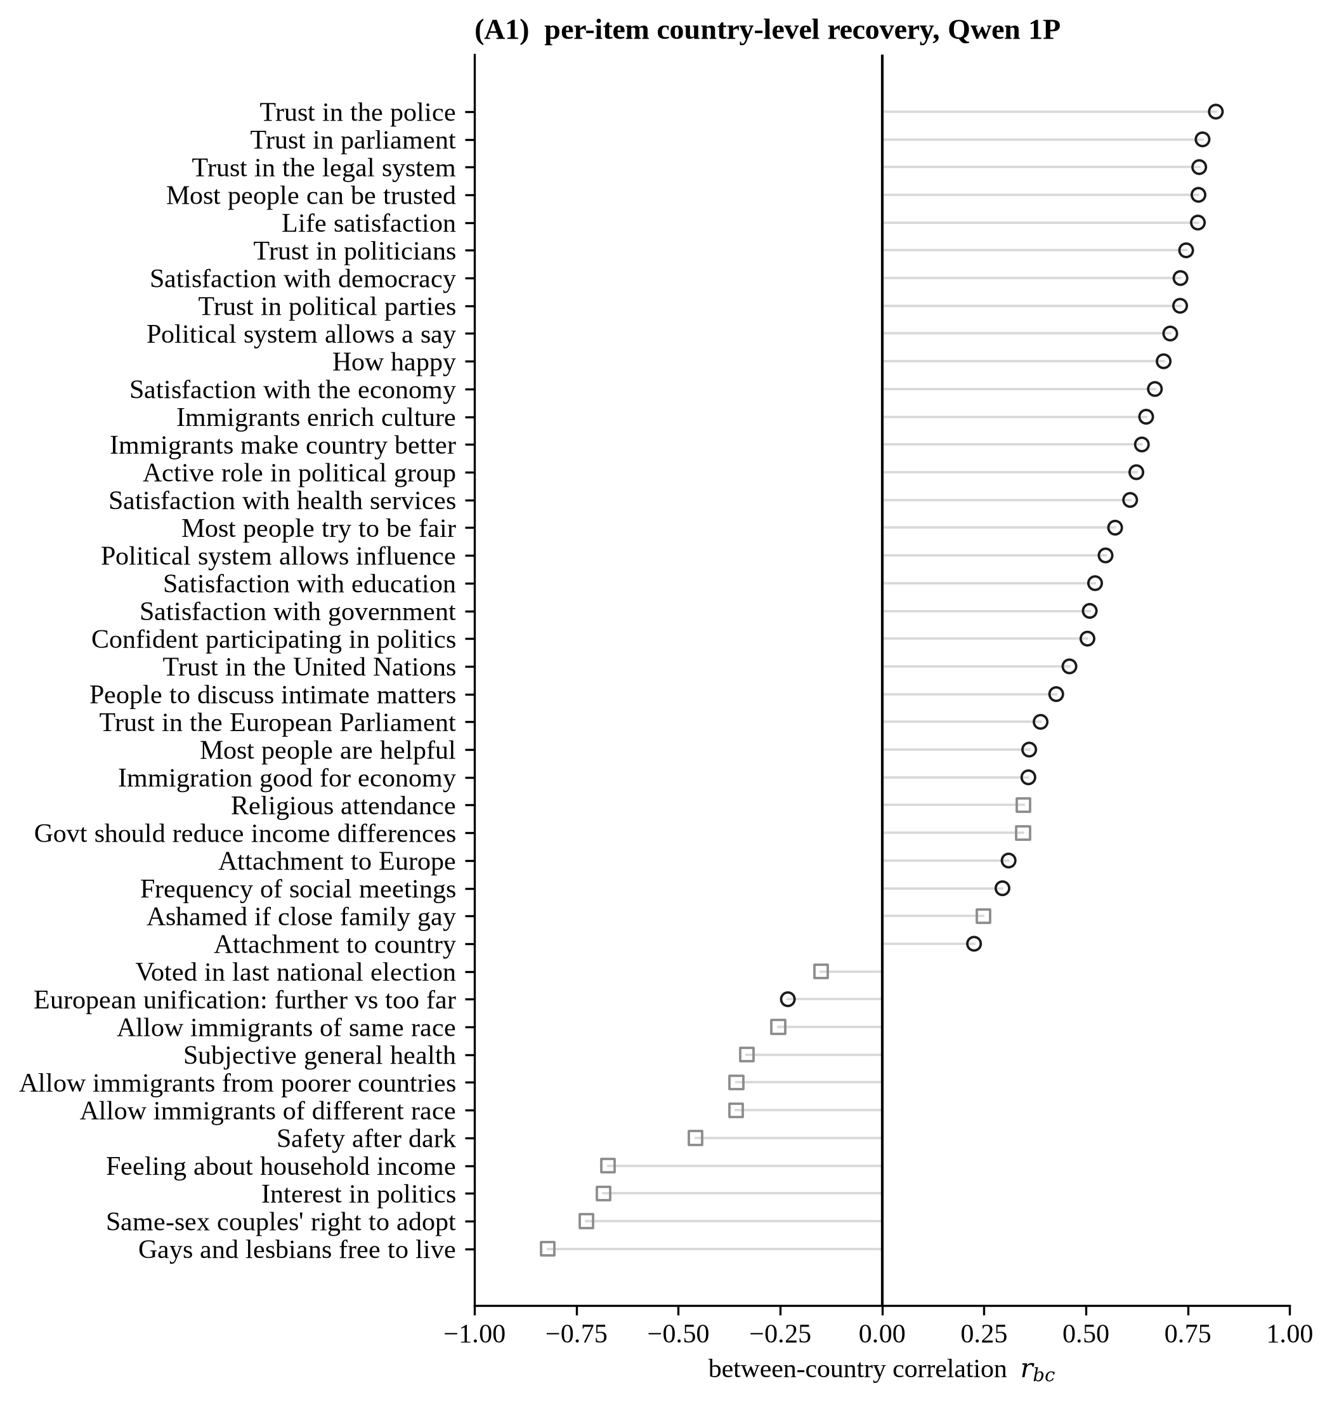
Figure A1. Per-item country-level recovery: r_{bc} for all 42 ESS items under Qwen 1P, ranked from most positive to most negative.
Note. Circles are forward-coded items and squares reverse-coded, as in Figure 2(b), which shows the same series without labels.
Item-level recovery can reflect either an accurate country ordering or a systematic inversion, while compressing cross-national differences in both cases. Figure A2 is the one place a reader sees both directly, and the compression it shows is what the concordance coefficient below puts a number on. For trust in police (trstplc, r_{bc} = 0.82), the model largely preserves the human country ranking. For attitudes toward homosexuality (freehms, r_{bc} = −0.82), it compresses scores into a narrow band and reverses the ordering.
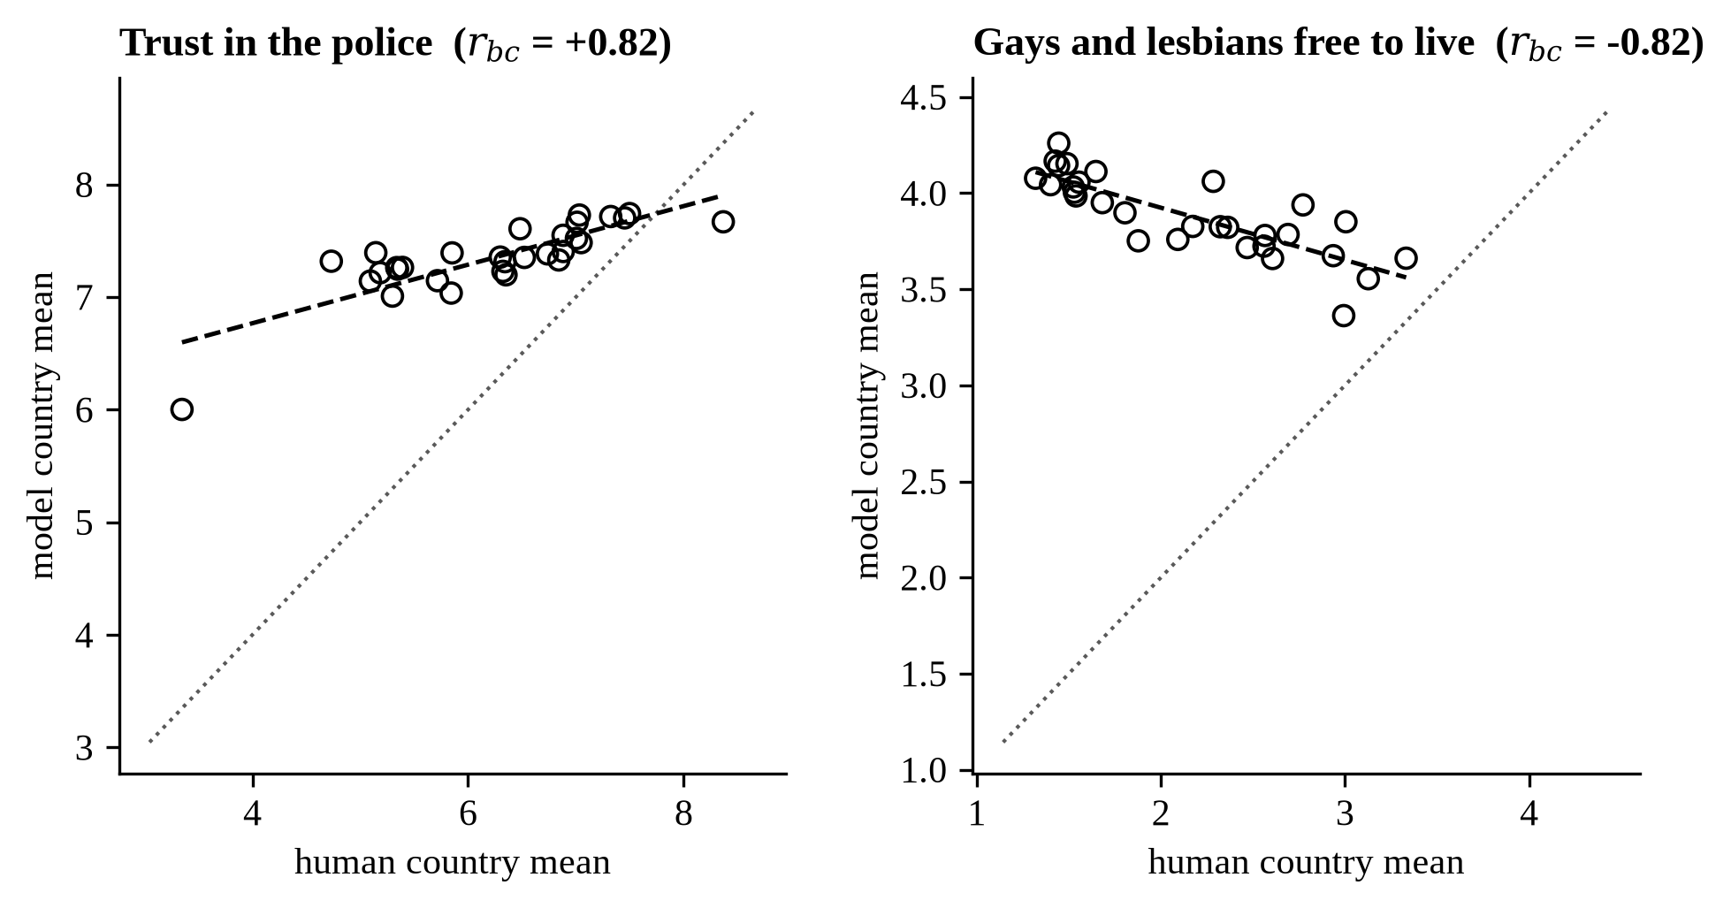
Figure A2. Country-level scatter for two contrasting items, Qwen 1P.
Note. Left: trust in police (r_{bc} = 0.82), with the country ordering largely recovered. Right: attitudes toward homosexuality (r_{bc} = −0.82), with the ordering inverted. Dashed lines show least-squares fits, and dotted lines show the 45-degree reference for perfect recovery.

Concordance
Pearson’s r is invariant to location and scale, so a model that ranks countries perfectly while compressing their spread and shifting their level still scores 1. Lin’s concordance coefficient rewards agreement with the 45-degree line and factors as r × C_{b}, where C_{b} is an accuracy term bounded by 1. Under Qwen 1P the median item has r = 0.443, C_{b} = 0.132 and concordance 0.036: 87% of the attainable agreement is lost to calibration, not to ranking. The median absolute bias is 1.13 scale points and the median between-country dispersion ratio 0.28. Eleven of 42 items have negative concordance, which is worse than no agreement at all.
Figure A3 reports the country-label contrast item by item, the per-item form of the block effect in Figure 4.
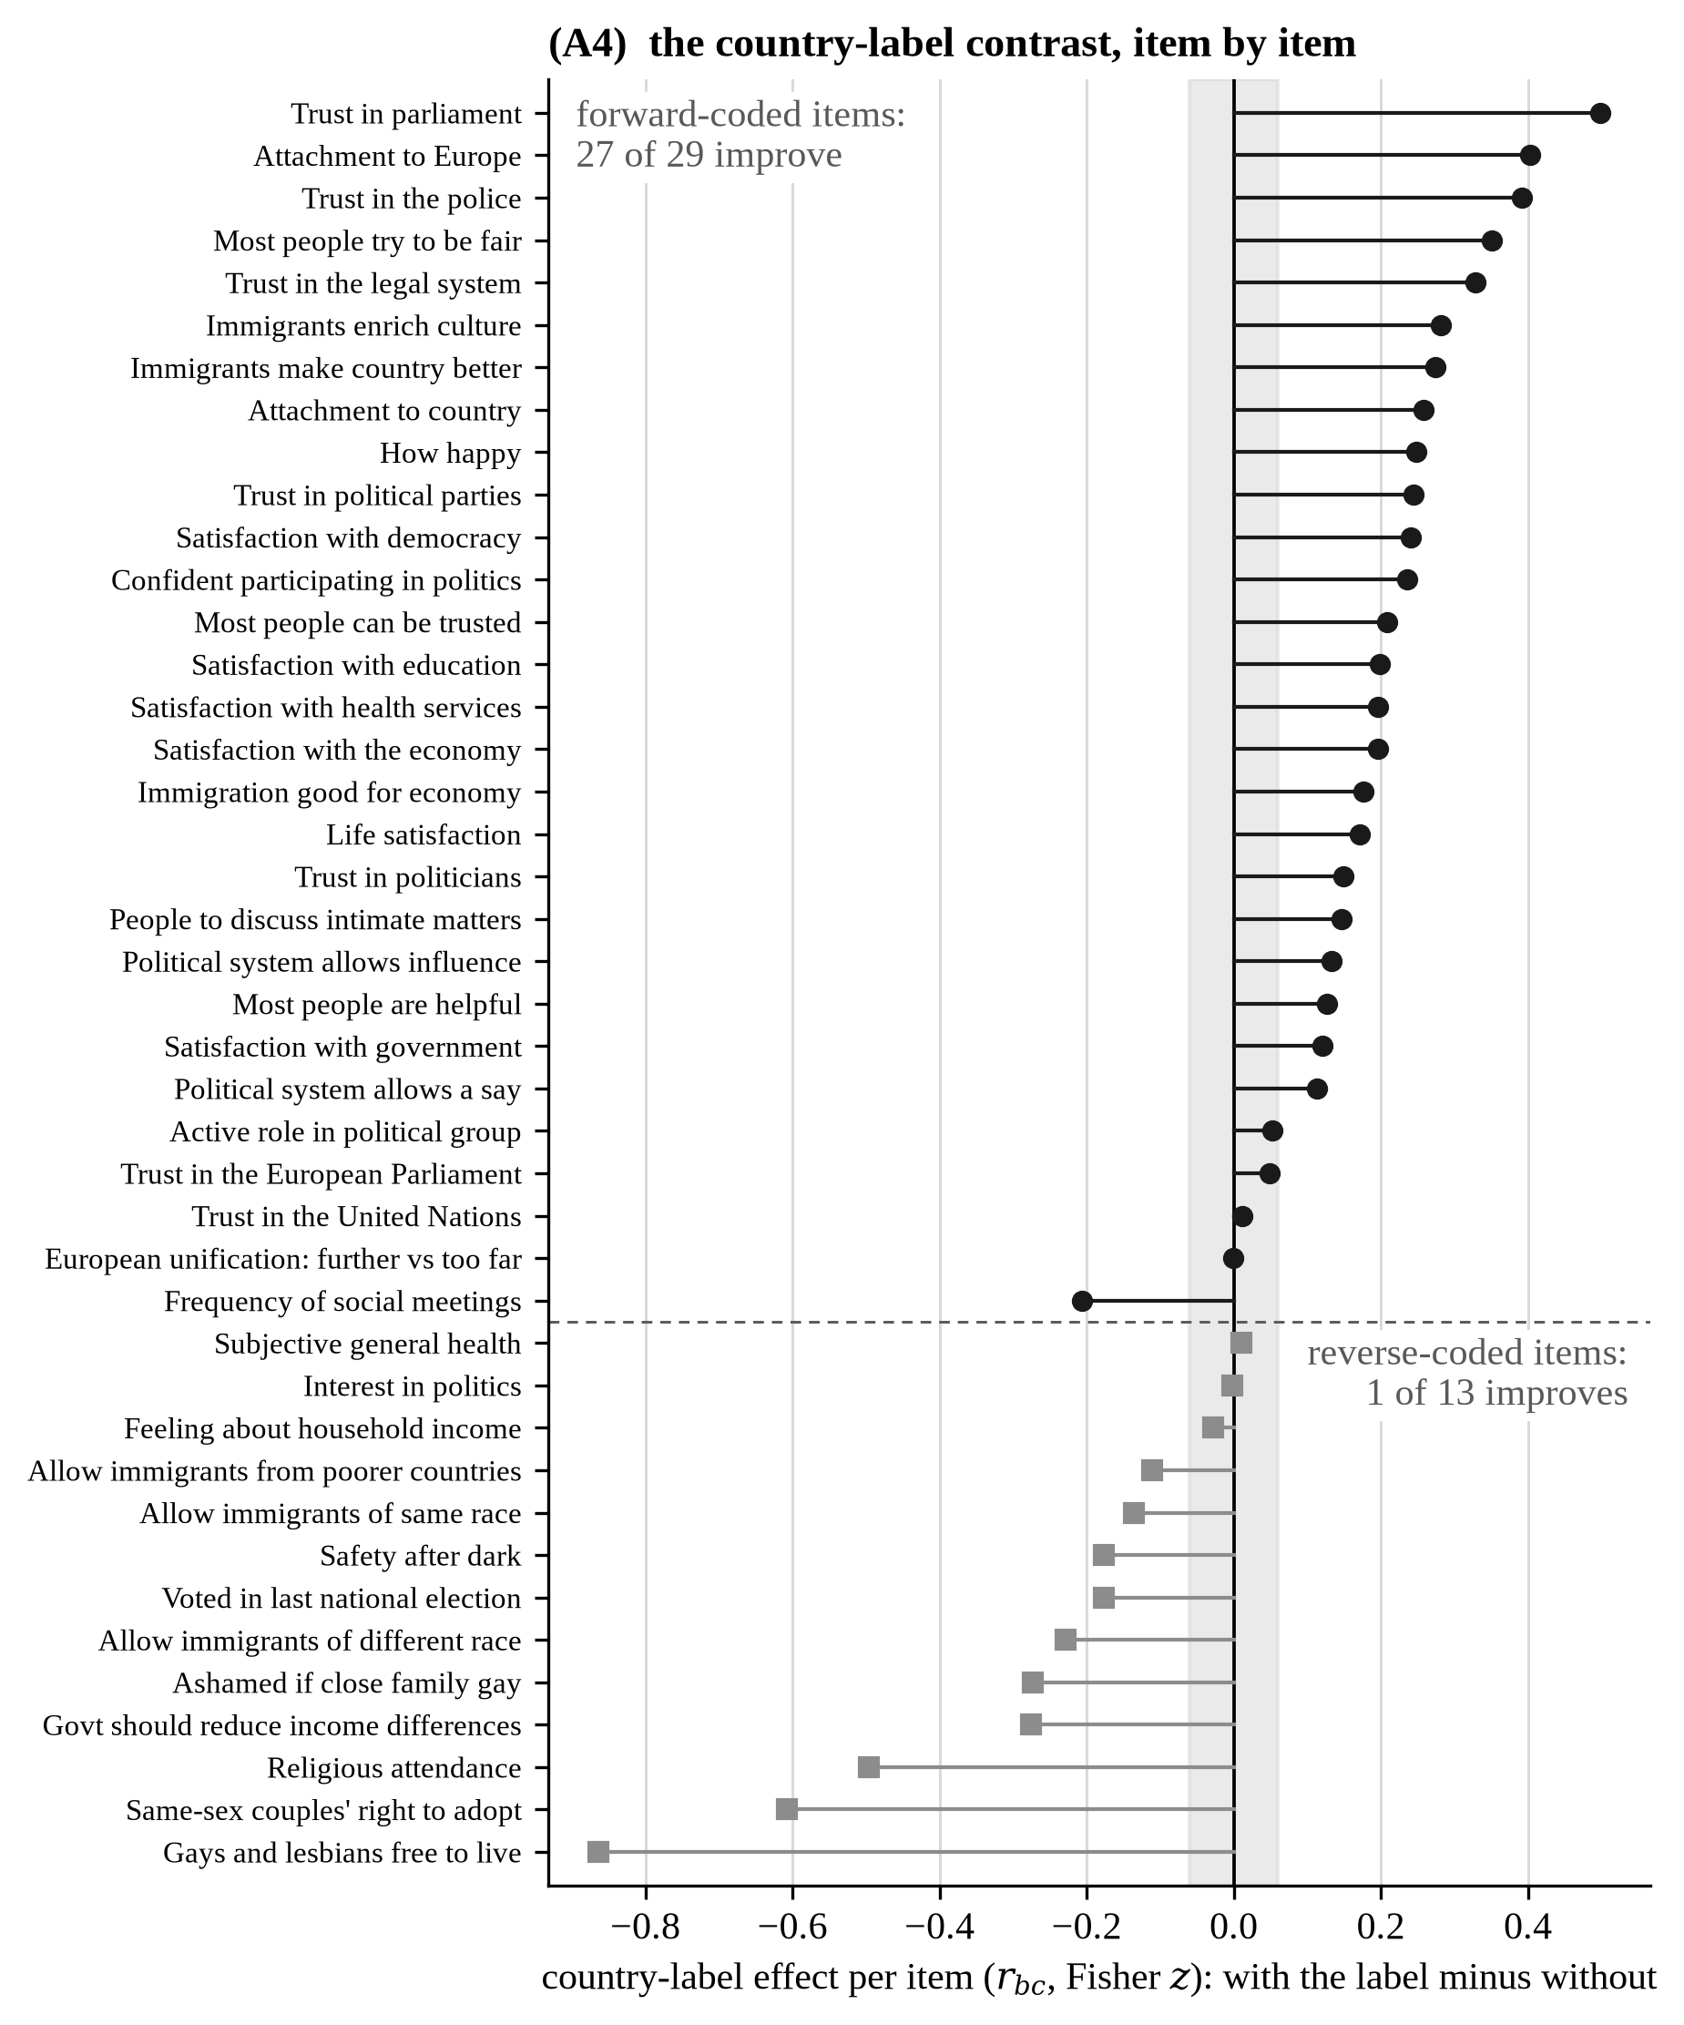
Figure A3. The country-label contrast, item by item, Qwen 1P.
Note. The change in r_{bc} (Fisher z) for each of the 42 items when the country sentence is present in an otherwise identical rich profile, the contrast Figure 4 summarizes as one bar. Items are ranked within wording direction. The shaded band is run-to-run noise.

Block ablations
Every block of the 20-variable partition is observed at two margins, added alone to the sparse base plus the label and removed alone from the full profile, on the same respondents throughout, so every comparison is paired at the item level. Among the three original removal contrasts, only the country label produces an effect that is both significant after Holm correction and larger than the 0.060 noise floor: +0.135 on forward items and −0.176 on reverse items. The region code (+0.020 forward) and the political variables (+0.042 reverse) point the same way but fall inside the noise floor, so they are reported as negligible. Across the remaining blocks the largest forward margin in either direction is +0.09, the union and internet block, and the single-variable arms attribute it to internet use. Per-block and per-item margins ship with the Figure 4 data.

Country identifiability
A multinomial classifier was trained to recover the country from the rendered backstory text of each of the ten variants, with a majority-class baseline of 3.33%. Eight of the ten reach exactly 100%, because each renders the country sentence, so identifiability is saturated and cannot produce a dose-response. At that identical level, median r_{bc} still ranges from 0.287 for the political variant to 0.523 for the four-variable minimal profile. The variant that omits the country sentence reaches 28.72%, replicated at 28.99% in an independent run. Its strongest n-grams are fragments of harmonized education, marital status, and main activity, and no rendered backstory names a country, so the residual identifiability is compositional.

Individual-level diagnostics
As a conservative human-data benchmark, human responses for each item are regressed on age, gender, education years, household-income decile, and left-right self-placement, with country fixed effects. The median within-country multiple correlation is 0.21 (interquartile range 0.15–0.26, maximum 0.47) and exceeds 0.20 for 23 of 42 items. Mean r_{wc} of 0.027 therefore recovers only a small fraction of the available demographic signal. The most predictable human items are among the model’s weakest: household income feeling (benchmark 0.47, model −0.148), subjective health (0.42, −0.078), and political interest (0.32, −0.079). The failure is not attributable to an absence of demographic signal in the human data.
Table A3 breaks individual-level recovery down by domain. Political efficacy, institutional trust, and subjective well-being recover best, while income, health, and safety are negative. The largest domain mean in any condition is 0.125, against the demographic ceiling of 0.210 in Section 3.5, so no domain reaches even two thirds of what a demographic profile could deliver. A table is the display because the object is 12 domains by four conditions.
Table A3. Mean r_{wc} by domain and model-prompt condition.
Domain | Qwen 1P | Qwen 3P | Llama 1P | Llama 3P
National Attachment | 0.036 | 0.103 | 0.021 | 0.006
Political Efficacy | 0.088 | 0.125 | 0.027 | 0.070
Health | -0.078 | -0.056 | -0.046 | -0.021
Immigration Attitudes | 0.008 | 0.000 | -0.005 | -0.007
Income | -0.148 | -0.133 | -0.052 | -0.022
Institutional Trust | 0.069 | 0.068 | 0.017 | 0.008
Political Attitudes | 0.013 | 0.009 | 0.008 | 0.014
Religion | 0.012 | -0.062 | -0.008 | 0.018
Safety | -0.037 | -0.050 | -0.002 | -0.002
Social Trust | 0.043 | 0.024 | 0.021 | 0.013
Social Values | -0.011 | -0.016 | -0.008 | -0.006
Subjective Well-being | 0.066 | 0.082 | 0.034 | 0.000
Note. Each cell is the mean within-country correlation over the items in that domain. The demographic ceiling for comparison is 0.210 (Section 3.5).
Eleven of 42 items show negative r_{wc} under Qwen 1P, meaning the model’s predictions are inversely related to human responses. These cases are concentrated in reverse-coded items, for which substantive inversion cannot be separated from scale-direction misinterpretation (Figure A4).
Figure A4 reports the full per-item individual-level recovery, the individual-level counterpart of Figure A1.
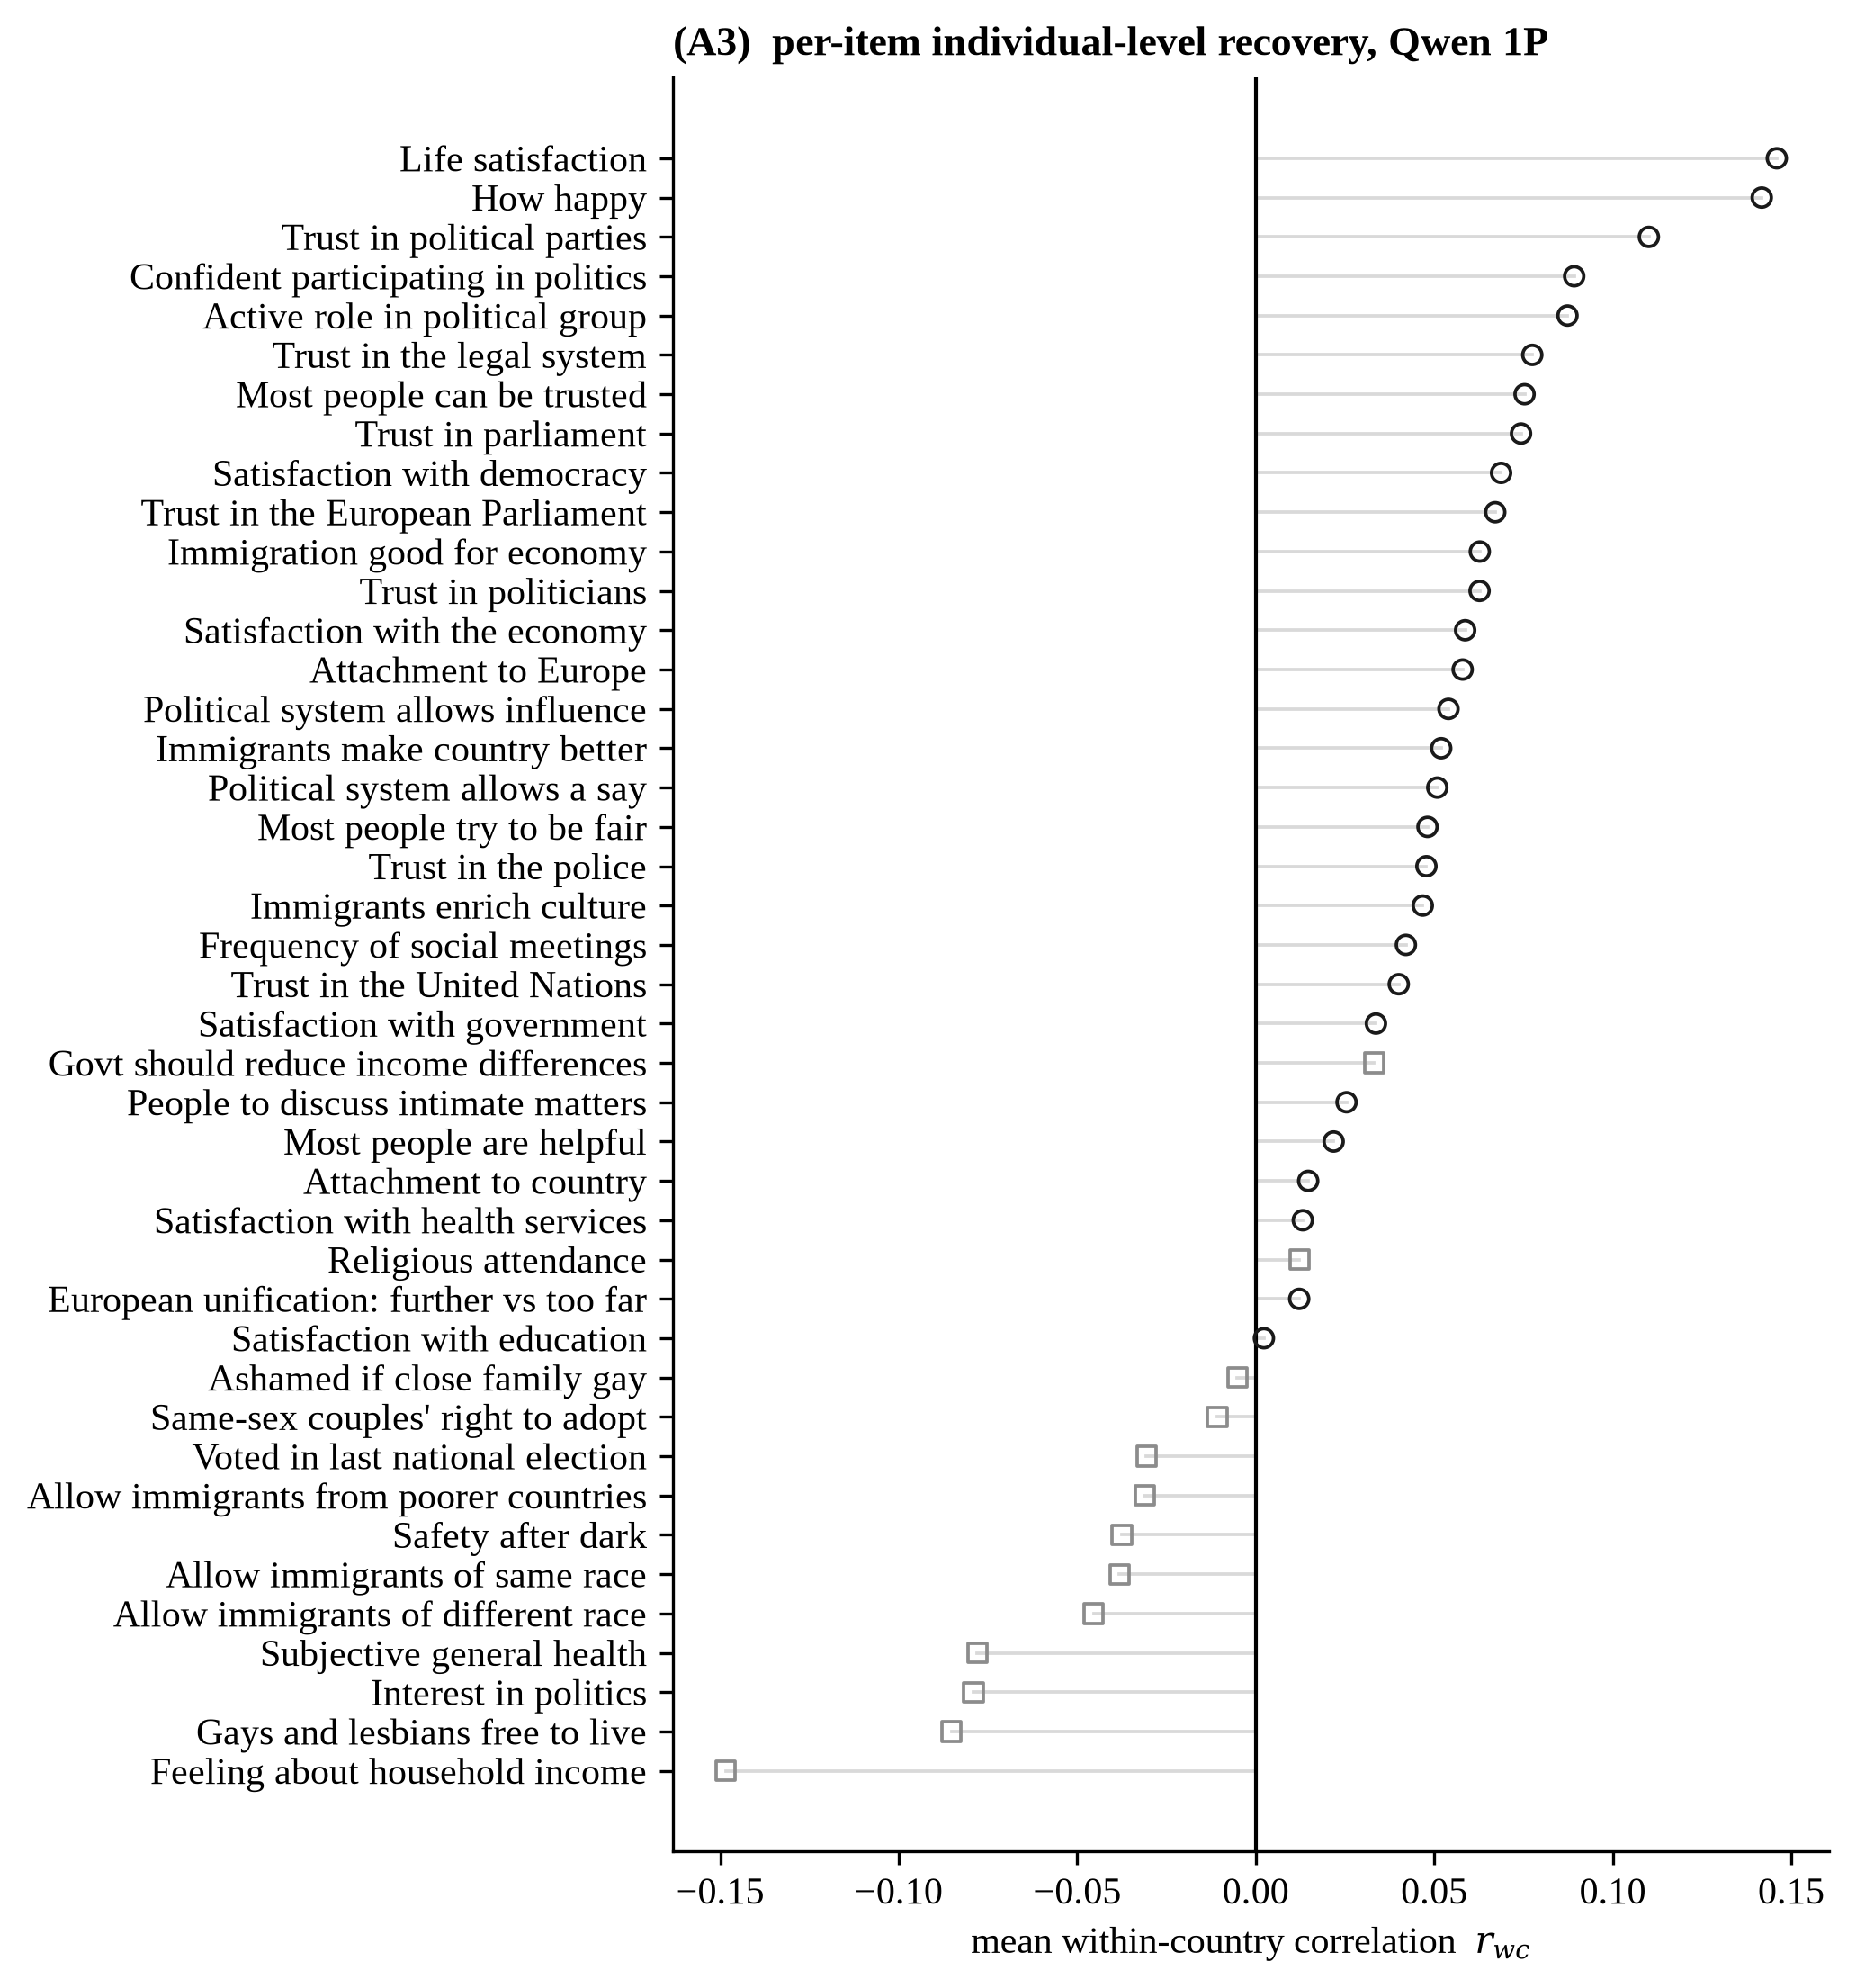
Figure A4. Per-item individual-level recovery: mean within-country r_{wc} for all 42 ESS items under Qwen 1P, ranked from most positive to most negative.
Note. The individual-level counterpart of Figure A1, ranked on its own values. Figure 6(b) shows the same quantity in the aggregate item order.
Table A4 reports the pre-specified model and prompt contrasts on the per-item mean r_{wc}. Prompt-framing differences are small and far from significance. The Qwen-Llama gap survives the four-test Bonferroni correction under first-person framing and falls short under third-person framing.
Table A4. Paired t-tests for model and prompt comparisons on the per-item mean r_{wc}, N = 42 items.
Comparison | rwc (A) | rwc (B) | Diff | Std. error | t | p
Qwen: 1P vs 3P | 0.027 | 0.029 | -0.002 | 0.006 | -0.28 | 0.785
Llama: 1P vs 3P | 0.009 | 0.006 | +0.004 | 0.004 | 0.99 | 0.326
1P: Qwen vs Llama | 0.027 | 0.009 | +0.018 | 0.006 | 2.81 | 0.007
3P: Qwen vs Llama | 0.029 | 0.006 | +0.023 | 0.010 | 2.28 | 0.028
Note. After Bonferroni correction for four tests (α = 0.0125), the first-person Qwen-Llama contrast reaches the adjusted threshold. The other three do not. Reported p values are unadjusted.

Aggregate robustness checks
Table A5 lists all 16 checks with the quantity each moves. One changes a conclusion, and Section 4.4 states it. Three others turn on the choice of estimator. The within-country dispersion ratio has three defensible aggregators (mean of ratios 0.61, median 0.57, ratio of means 0.59) and all three fail the pre-declared 0.9–1.1 band, so the choice is named wherever the quantity appears and no conclusion rests on it. Design weighting correlates the weighted and unweighted per-item coefficients at 0.999 while moving a single item by up to 0.103, so the item-level maximum is reported. The direction classification was frozen from the ESS codebook before any result was seen, and the direction R² rises from 0.658 to 0.746 when the three pre-declared unstable items are dropped, so the objection strengthens the result.
Table A5. The 16 robustness checks: what each varies, the result, and whether any conclusion changes.
Check | What it varies | Result | Any conclusion change?
Design weighting of the human benchmark | Human country means computed unweighted instead of with pspwght | The two coefficient vectors correlate at 0.9987; the largest item-level change is 0.103 (health) | No. The median and the direction decomposition are unaffected.
Direction classification of the 42 items | The frozen classification against the four disputed codings | R² = 0.6576 on all 42 items, 0.6531 excluding vote, 0.7455 further excluding the two screened items | No. The effect strengthens as the least interpretable items are removed.
Items whose silicon dispersion is near zero | A reliability screen on the silicon side | Two items fall below it: hmsfmlsh (reliability 0.25) and rlgatnd (0.44); inprdsc (0.615) is retained | No. Both are pre-declared uninterpretable and the primary anchored specification excludes them.
Item set for the anchoring experiment | Three pre-specified reverse-item sets | All 12 in batch: +0.4912 [+0.1515, +0.8809], 11 of 12 up; primary 10: +0.4230 [+0.1259, +0.7928], 10 of 10 up; strictest 8: +0.1636 [+0.0507, +0.2671], 8 of 8 up | No for the sign and the interval. Yes for the gap verdict: eliminated on the primary set, narrowed with a residual on the strictest.
Choice of forward control items | Ten leave-one-out control sets | The triple difference stays in [0.403, 0.455] against the primary 0.423; the largest shift is 0.032 | No.
Run-to-run stability of the generation | Two identical unseeded runs | Median absolute rbc difference 0.0602 per item, maximum 0.1854, no sign reversals | No, and it closes a stated limitation: every contrast is read against the 0.060 band.
Deflator for the macro-covariate comparator | Market dollars against purchasing parity | Median r 0.6177 under dollars, 0.6317 under parity; normalized error 0.0522 and 0.0527 | No for the comparison with the model. Yes for one claim, therefore not made: the covariate-alone ranking is deflator-dependent.
Israel as a bloc of one in the comparator | Israel handled as its own regional bloc | The comparator’s median r moves from 0.6177 to 0.6741; the gap to the model from 0.174 to 0.177 | No.
Influential countries in the comparator | Leave-one-out over the 30 countries | Excluding Ireland moves the reported value by 0.001; the high-leverage country is Ukraine (mean hat 0.495) | No.
Coverage in the Llama third-person arm | Restricting to items above 80% coverage | Median rbc falls from +0.1729 on all 42 items to −0.0009 on the 19 items above the threshold | Yes. The arm cannot identify a framing effect; the framing null rests on Qwen alone.
Aggregator for the dispersion ratios | Mean of ratios, median, and ratio of means | Within-country 0.6052, 0.5727, 0.5859; between-country 0.2821 median, 0.2952 mean | No. All three within-country estimators fail the pre-declared 0.9–1.1 band.
Estimator for the offset reduction | Four defensible estimators | Ratio of medians 64.2%, ratio of means 62.9%, median of per-item reductions 59.9%, mean of per-item reductions 53.7% | Yes for the number quoted: 59.9%, the median of the per-item reductions, named as such.
Specification for the cross-level agreement | As coded, forward items only, sign-aligned | Pearson 0.9368 as coded, 0.7745 forward-only, 0.8355 sign-aligned | No for the existence of the agreement. Yes for its description: about a third of the raw magnitude is the shared direction failure.
Frame for country-level quantities | Full frame against the human-model intersection | Median rbc moves from 0.4433 to 0.4425; single items move by up to 0.109 (health) | No for the median. The frame is fixed in one place and stated.
Stability across rounds | The March round against the final round | Median absolute item-level rbc change 0.0415, against a same-round replicate median of 0.060 | No.
Human-side missingness rule | Correcting the missing-code set for the coarse scales | Median rbc 0.418 to 0.431; items above 0.70 from eight to nine; inverted items from twelve to eleven; within-country dispersion ratio 0.553 to 0.605 | Yes for several reported figures, all corrected. No for any conclusion.
Note. Each row names what the check varies, what it moves, and whether any conclusion changes. The one Yes that changes a conclusion is parse coverage in the Llama third-person arm (Section 4.4).

Data-processing checks
Four data-processing checks leave the aggregate results unchanged. Weighted and unweighted per-item coefficients correlate at 0.9987, with a largest single-item change of 0.103 (Table A5). Computing each country mean on the human-model valid intersection moves per-item between-country correlations by at most about 0.1, for a few items. Two further checks ran on the earlier 500-respondent round: excluding the voting item’s ‘not eligible’ category, and replacing the human subsample with the full ESS sample. Both left the per-item correlations at r = 0.99 and preserved every negative correlation, and the cross-round stability check in Table A5 carries them to the final 685-respondent round.

Parse failures
Of the 863,100 responses scheduled in the Llama third-person arm, 77.28% parsed. Of the remainder, 5.75% fall outside the declared scale, 8.25% carry a value above 1,000, and 8.71% contain no digit. Four explanations were tested and rejected. Truncation: failed outputs have a median length of 61 characters against a maximum of 317, and none falls within 2% of that maximum. Overshoot: 93.5% of out-of-range values lie above the top of the scale, but the median excess is 39 scale points, 6.7 times the scale width. Scale confusion: the out-of-range values take 2,963 distinct values instead of clustering on values valid elsewhere in the battery. Backstory echo: 2.33% of rejected values match one of that respondent’s own backstory numbers, against 0.94% under a shuffled null. Reading the verbatim outputs shows what does occur: code blocks, enumeration of the scale in place of a choice within it, continuation of the prompt, and a junk number followed by a valid answer. The first-person control parsed 99.99% with 64 rejections, all fractional midpoints, so the difference is the framing, not the model.

Sensitivity to the extraction rule
Every correlation reported here is computed on responses that survived a rule that takes the first number in the response text. That rule discards answers the model gave correctly, such as a junk number followed by a valid one, so all 11.3 million raw responses were re-parsed and every rejected response in the 15 arms landed at the time of the check was re-scored under four alternative rules: the last number in the text, the number following an answer marker, the only in-range value where exactly one exists, and the first in-range value anywhere. The fourth is the loosest and is reported as an upper bound, in the same sense as the leakage bound on the no-country arm. In the Llama third-person arm 22.6% of rejections carry an in-range value somewhere in the text. In every other arm the share is below 38%. No rule moves a median between-country correlation by more than 0.013, and the primary Qwen first-person arm does not move at all under any rule (+0.4433 throughout). The largest movement in any single item anywhere is 0.092, in the demographics-only arm, whose median is near zero under every rule. The same pass recomputes each shipped country mean from the raw responses as a check on the accumulator. The worst disagreement is 1.8e-15. Table A6 reports all 15 arms.
Table A6. Sensitivity of the between-country correlation to the response-extraction rule.
Arm | Responses rejected | Of those, carry an in-range value | Median rbc, shipped rule | Range across the four rules | Largest shift in any single item
Qwen 1P | 619 (0.07%) | 0 (0.0%) | +0.4433 | +0.4433 to +0.4433 | 0.0000
Qwen 3P | 71 (0.01%) | 5 (7.0%) | +0.4426 | +0.4426 to +0.4426 | 0.0007
Llama 1P | 64 (0.01%) | 24 (37.5%) | +0.3486 | +0.3486 to +0.3486 | 0.0072
Llama 3P | 196,067 (22.72%) | 44,374 (22.6%) | +0.1729 | +0.1603 to +0.1798 | 0.0596
demographics only | 6,333 (0.73%) | 419 (6.6%) | -0.0286 | -0.0363 to -0.0286 | 0.0919
+ country | 10,729 (1.24%) | 165 (1.5%) | +0.5232 | +0.5232 to +0.5239 | 0.0067
+ socioeconomic | 1,716 (0.20%) | 6 (0.3%) | +0.3967 | +0.3967 to +0.3967 | 0.0005
+ political | 1,307 (0.15%) | 2 (0.2%) | +0.2870 | +0.2870 to +0.2870 | 0.0003
no country | 409 (0.05%) | 1 (0.2%) | +0.3441 | +0.3441 to +0.3441 | 0.0007
no region | 648 (0.08%) | 1 (0.2%) | +0.4157 | +0.4157 to +0.4157 | 0.0000
no political | 808 (0.09%) | 0 (0.0%) | +0.5231 | +0.5231 to +0.5231 | 0.0000
Qwen 1P anchored | 53 (0.01%) | 0 (0.0%) | +0.6501 | +0.6501 to +0.6501 | 0.0000
no country, anchored | 75 (0.02%) | 0 (0.0%) | +0.3891 | +0.3891 to +0.3891 | 0.0000
no region, anchored | 46 (0.01%) | 0 (0.0%) | +0.6369 | +0.6369 to +0.6369 | 0.0000
repeat run | 67 (0.01%) | 1 (1.5%) | +0.3249 | +0.3249 to +0.3249 | 0.0003
Note. The four alternative extraction rules are those described above. The shipped rule takes the first number in the response text.

