丽江文化旅游学院
信息学院
2022-2023 学年 第二 学期
专 业：计算机科学与技术
年 级：2020
课程名称：APP开发技术
任课教师：宋兴刚
实验名称：音乐播放器

一、实验目的
- 掌握Timer及TimerTask的使用
- 强化Handler的工作机制
- 强化RecyclerView控件的使用
- 掌握MediaPlayer类的使用
- 掌握SeekBar控件的使用
- 掌握VideoView控件的使用
- 掌握mediaController的使用
- 培养简单案例的设计开发能力

二、实验环境和设备
1.Android Studio 3.5.3
2.SDKversion 32.0.0
3.Android12 虚拟机

三、核心代码
MainActivity
package pdx.com.musicplayer;
import android.content.Intent;
import android.support.v7.app.AppCompatActivity;
import android.os.Bundle;
import android.view.View;
import android.widget.Button;
public class MainActivity extends AppCompatActivity {
Button button;
@Override
protected void onCreate(Bundle savedInstanceState) {
super.onCreate(savedInstanceState);
setContentView(R.layout.activity_main);
initView();
btnClick();
}
private void btnClick() {
button.setOnClickListener(new View.OnClickListener() {
@Override
public void onClick(View view) {
Intent intent = new Intent(MainActivity.this,MusicActivity.class);
startActivity(intent);
finish();
}
});
}
private void initView() {
button = findViewById(R.id.button1);
}
}

MusicActivity

package pdx.com.musicplayer;
import android.database.Cursor;
import android.provider.MediaStore;
import android.support.v7.app.AppCompatActivity;
import android.os.Bundle;
import android.support.v7.widget.RecyclerView;
import android.support.v7.widget.StaggeredGridLayoutManager;
import android.util.Log;
import java.util.ArrayList;
import java.util.List;
import pdx.com.MyAdapter.MusicAdapter;
import pdx.com.entity.Music;
public class MusicActivity extends AppCompatActivity {
RecyclerView recyclerView;
private static final String TAG = "MusicActivity";
@Override
protected void onCreate(Bundle savedInstanceState) {
super.onCreate(savedInstanceState);
setContentView(R.layout.activity_music);
initView();
initData();
}
private void initData() {
List<Music> musicList = new ArrayList<>();
Cursor cursor = getContentResolver()
.query(MediaStore.Audio.Media.EXTERNAL_CONTENT_URI,
null, null, null,
MediaStore.Audio.Media.DEFAULT_SORT_ORDER);
Log.d(TAG, "initData:我查询获取到的歌曲共:" + cursor.getCount() + "首");
while (cursor.moveToNext()){
String myMusicTitle = cursor.
getString(cursor.getColumnIndex(MediaStore.Audio.Media.TITLE));
String singerName = cursor.
getString(cursor.getColumnIndex(MediaStore.Audio.Media.ARTIST));
Music music = new Music(myMusicTitle,singerName);
musicList.add(music);
}
cursor.close();
MusicAdapter musicAdapter = new MusicAdapter(musicList);
StaggeredGridLayoutManager layoutManager =
new StaggeredGridLayoutManager(1,StaggeredGridLayoutManager.VERTICAL);
recyclerView.setLayoutManager(layoutManager);
recyclerView.setAdapter(musicAdapter);
}
private void initView() {
recyclerView = findViewById(R.id.recyclerview);
}
}
package pdx.com.musicplayer;
import android.database.Cursor;
import android.media.MediaPlayer;
import android.os.Handler;
import android.os.Message;
import android.provider.MediaStore;
import android.support.annotation.NonNull;
import android.support.v7.app.AppCompatActivity;
import android.os.Bundle;
import android.util.Log;
import android.widget.SeekBar;
import android.widget.TextView;
import java.io.IOException;
import java.util.Timer;
import java.util.TimerTask;
public class PlayerActivity extends AppCompatActivity {
private static final String TAG = "PlayerActivity";
private TextView title;
private TextView name;
private Cursor cursor;
private MediaPlayer mediaPlayer;
private SeekBar seekBar;
private TextView currentTime;
private TextView totalTime;
private Handler myHandler;
@Override
protected void onCreate(Bundle savedInstanceState) {
super.onCreate(savedInstanceState);
setContentView(R.layout.activity_player);
initView();
initData();
initPlay();
initSeek();
moveSeek();
initUpdate();
}
/**
* 按返回键停止播放
*/
@Override
protected void onDestroy() {
super.onDestroy();
mediaPlayer.stop();
}
/**
* 实时更新滑动条的当前时间
*/
private void initUpdate() {
Timer timer = new Timer();
TimerTask timerTask = new TimerTask() {
@Override
public void run() {
Message msg = new Message();
msg.what = 11;
myHandler.sendMessage(msg);
}
};
timer.schedule(timerTask,0,1000);
myHandler = new Handler(){
@Override
public void handleMessage(@NonNull Message msg) {
super.handleMessage(msg);
switch (msg.what){
case 11:
initSeek(); //重新执行进度条的初始化代码
break;
default:
break;
}
}
};
}
/**
* 拖动滑动条
*/
private void moveSeek() {
seekBar.setOnSeekBarChangeListener(new SeekBar.OnSeekBarChangeListener() {
@Override
public void onProgressChanged(SeekBar seekBar, int position, boolean b) {
if(b){
mediaPlayer.seekTo(position);
initSeek();
}
}
@Override
public void onStartTrackingTouch(SeekBar seekBar) {
}
@Override
public void onStopTrackingTouch(SeekBar seekBar) {
}
});
}
/**
* 初始化进度条
*/
private void initSeek() {
seekBar.setMax(mediaPlayer.getDuration()); //获取音频文件总时长
seekBar.setProgress(mediaPlayer.getCurrentPosition());
totalTime.setText(toTime(mediaPlayer.getDuration()));
currentTime.setText(toTime(mediaPlayer.getCurrentPosition()));
}
private String toTime(int duration) {
int time = duration / 1000;
int minute = time / 60;
int second = time % 60;
String mm = String.format("%01d:%02d",minute,second);
return mm;
}
/**
* 播放歌曲
*/
private void initPlay() {
mediaPlayer = new MediaPlayer();
String path = cursor.getString(cursor.getColumnIndex(MediaStore.Audio.Media.DATA));
mediaPlayer.reset(); //清空里面的其他歌曲
try {
mediaPlayer.setDataSource(path);
mediaPlayer.prepare(); //准备就绪
mediaPlayer.start(); //开始唱歌
} catch (IOException e) {
e.printStackTrace();
}
}
/**
* 获取并显示歌曲标题和歌手歌名
*/
private void initData() {
int position = getIntent().getIntExtra("my",0);
Log.d(TAG,"initData:" + position);
cursor = getContentResolver()
.query(MediaStore.Audio.Media.EXTERNAL_CONTENT_URI,
null,null,null,
MediaStore.Audio.Media.DEFAULT_SORT_ORDER);
cursor.moveToPosition(position);
String myTitle = cursor.getString(cursor.getColumnIndex(MediaStore.Audio.Media.TITLE));
String myName = cursor.getString(cursor.getColumnIndex(MediaStore.Audio.Media.ARTIST));
title.setText(myTitle);
name.setText(myName);
}
private void initView() {
title = findViewById(R.id.title);
name = findViewById(R.id.name);
seekBar = findViewById(R.id.seek_bar);
currentTime = findViewById(R.id.current_time);
totalTime = findViewById(R.id.total_time);
}
}
package pdx.com.musicplayer;
import android.content.Intent;
import android.content.SharedPreferences;
import android.os.Handler;
import android.os.Message;
import android.support.annotation.NonNull;
import android.support.v7.app.AppCompatActivity;
import android.os.Bundle;
import android.widget.TextView;
import java.util.Timer;
import java.util.TimerTask;
public class WelcomeActivity extends AppCompatActivity {
private static final String TAG = "MainActivity";
private TextView textView;
private Timer timer; //创建定时器
private TimerTask timerTask; //创建定时器任务
private int count = 5;
private Handler handler; //消息处理器，专门发送和接收消息
@Override
protected void onCreate(Bundle savedInstanceState) {
super.onCreate(savedInstanceState);
setContentView(R.layout.activity_welcome);
initView();
initDate();
initStatus();
}
/**
* 第一次登录App时显示欢迎界面倒计时，第二次登录App时直接进入
*/
private void initStatus() {
//读取保存的登录状态值
Boolean status = getSharedPreferences("mystatus",MODE_PRIVATE)
.getBoolean("firstlogin_status",false);
//将第一次登录的状态True保存起来，下次登录后的判断状态，如果为True直接跳转到主界面，否则倒计时
SharedPreferences.Editor editor = getSharedPreferences("mystatus",MODE_PRIVATE).edit();
editor.putBoolean("firstlogin_status",true);
editor.commit();
if(status){
Intent intent = new Intent(WelcomeActivity.this,MainActivity.class);
startActivity(intent);
finish();
timer.cancel();
timerTask.cancel();
}
}
/**
* 数据初始化
*/
private void initDate() {
//创建定时器
timer = new Timer();
//明确定时器要执行的任务
timerTask = new TimerTask() {
@Override
/**
* run里面指指示器要完成的任务，都是耗时的操作，耗时的都放在子线程中执行
*/
public void run() {
//让子线程给主线程发送消息信号，主线程接收到消息信号后就可以更新主界面中的数字显示信息
if (count != 0) {
Message msg = new Message();
msg.what = 1;
handler.sendMessage(msg);
} else {
Message msg = new Message();
msg.what = 0;
handler.sendMessage(msg);
}
}
};
//开启定时器，参数(定时器任务，延迟，变化周期)
timer.schedule(timerTask, 0, 1000);
//主线程接受到消息信号对主界面数字显示进行更新
handler = new Handler() {
@Override
public void handleMessage(@NonNull Message msg) {
super.handleMessage(msg);
//主线程根据接受的消息进行判断
switch (msg.what) {
case 1:
count--;
textView.setText(count + ""); //让变化的数字显示到主界面
break;
case 0:
Intent intent = new Intent(WelcomeActivity.this,
MainActivity.class); //倒计时结束，跳转到主界面
startActivity(intent);
finish();
timer.cancel();
timerTask.cancel();
break;
default:
break;
}
}
};
}
/**
* 控件初始化
*/
private void initView() {
textView = findViewById(R.id.text1);
}
}
package pdx.com.MyAdapter;
import android.content.Context;
import android.content.Intent;
import android.support.annotation.NonNull;
import android.support.v7.widget.RecyclerView;
import android.view.LayoutInflater;
import android.view.View;
import android.view.ViewGroup;
import android.widget.TextView;
import java.util.List;
import pdx.com.entity.Music;
import pdx.com.musicplayer.PlayerActivity;
import pdx.com.musicplayer.R;
public class MusicAdapter extends RecyclerView.Adapter<MusicAdapter.ViewHolder> {
Context myContext;
List<Music> musicList;
public MusicAdapter(List<Music> musicList) {
this.musicList = musicList;
}
/**
* 创建ViewHolder
* @param parent
* @param viewType
* @return
*/
@NonNull
@Override
public ViewHolder onCreateViewHolder(@NonNull ViewGroup parent, int viewType) {
View view = LayoutInflater
.from(parent.getContext())
.inflate(R.layout.music_item,parent,false);
final ViewHolder holder = new ViewHolder(view);
//单击任意歌曲跳转到播放界面
holder.musicView.setOnClickListener(new View.OnClickListener() {
@Override
public void onClick(View view) {
int position = holder.getAdapterPosition(); //返回数据在适配器的位置
Intent intent = new Intent(view.getContext(),PlayerActivity.class);
intent.putExtra("my",position);
view.getContext().startActivity(intent);
}
});
return holder;
}
/**
* 对RecycleView中子项的数据进行赋值
* @param viewHolder
* @param position
*/
@Override
public void onBindViewHolder(@NonNull ViewHolder viewHolder, int position) {
Music musicInfo = musicList.get(position);
viewHolder.musicTitle.setText(musicInfo.getMusicTitle());
viewHolder.singerName.setText(musicInfo.getSingerName());
}
/**
* 返回数据源长度
* @return
*/
@Override
public int getItemCount() {
return musicList.size();
}
public class ViewHolder extends RecyclerView.ViewHolder{
View musicView;
TextView musicTitle;
TextView singerName;
public ViewHolder(@NonNull View itemView) {
super(itemView);
musicView = itemView;
musicTitle = itemView.findViewById(R.id.music_title);
singerName = itemView.findViewById(R.id.singer_name);
}
}
}

package pdx.com.entity;
import lombok.AllArgsConstructor;
import lombok.Data;
@Data
@AllArgsConstructor
public class Music {
private String musicTitle;
private String singerName;
}

四、实验结果与总结

实验结果：

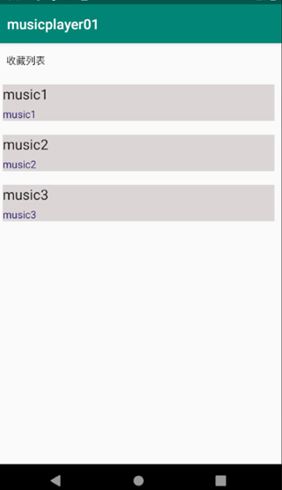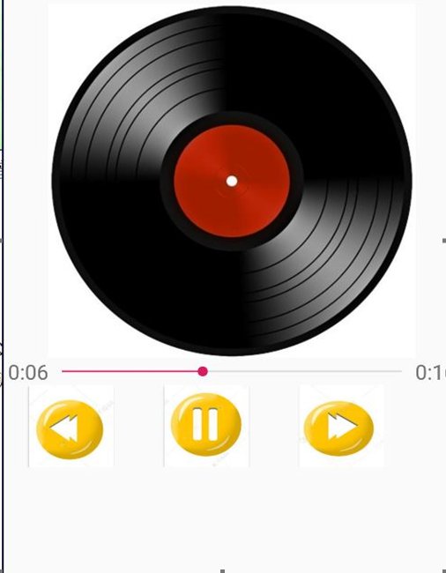

总结：
成功得出预期实验结果，完成实验目的要求，对各个知识点有所掌握，也进行了扩展

