3 Dataset
The dataset used in this project is the Titanic: Machine Learning from Disaster dataset from Kaggle.

Dataset URL: https://www.kaggle.com/competitions/titanic

This dataset contains information about passengers aboard the Titanic and is commonly used to predict whether a passenger survived the disaster. The task is a binary classification problem, where the goal is to predict passenger survival based on several features.

3.1 Dataset Size
The dataset consists of two main files:
Dataset | Number of Samples
Train Dataset | 891
Test Dataset | 418
The training dataset contains the target variable Survived, while the test dataset does not include labels and is used for prediction.

3.2 Feature Description
The dataset includes multiple passenger-related features:
Feature | Description
PassengerId | Unique passenger identifier
Pclass | Passenger class (1 = First, 2 = Second, 3 = Third)
Name | Passenger name
Sex | Gender
Age | Age
SibSp | Number of siblings/spouses aboard
Parch | Number of parents/children aboard
Ticket | Ticket number
Fare | Ticket fare
Cabin | Cabin number
Embarked | Port of embarkation

3.3 Target Variable
The target variable is Survived:
Value | Meaning
0 | Did not survive
1 | Survived
This variable indicates whether the passenger survived the Titanic disaster.

3.4 Data Issues
Initial inspection of the dataset reveals several missing values:
Feature | Missing Values
Age | 177
Cabin | 687
Embarked | 2
The Cabin feature contains a large number of missing values, which may require removal or transformation during the preprocessing stage.

4 Exploratory Data Analysis (EDA)
Exploratory Data Analysis (EDA) was conducted to understand the data distribution and the relationships between features and the survival outcome. Visualization techniques were used to identify patterns and potential predictive variables.

4.1 Survival Distribution

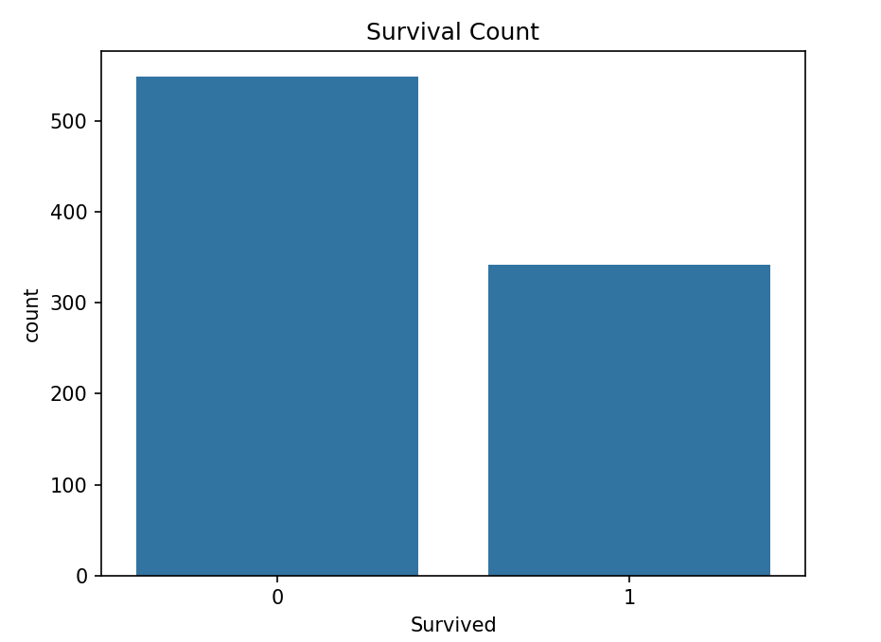
Figure 1 Survival Count
The distribution of survival outcomes shows that the majority of passengers did not survive the disaster, while a smaller proportion survived. This indicates a certain level of class imbalance in the dataset.

4.2 Survival Rate by Gender
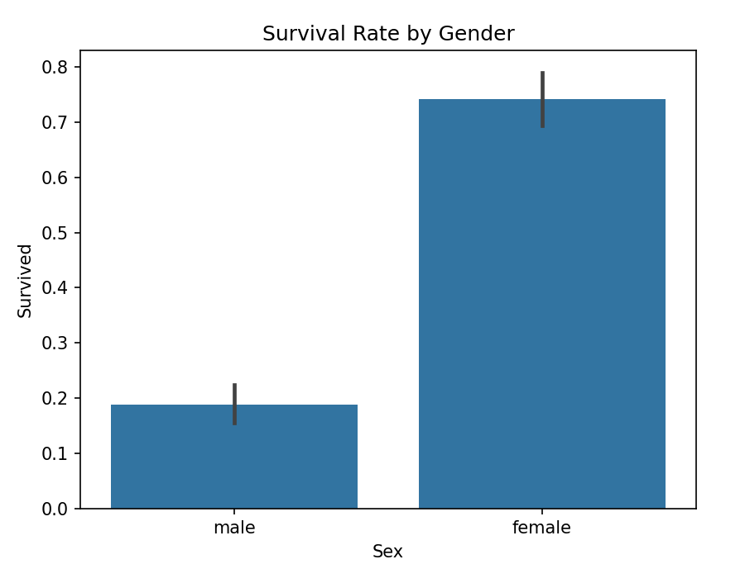
Figure 2 Survival Rate by Gender

The analysis shows that female passengers had a significantly higher survival rate compared to male passengers. This observation aligns with the historical evacuation policy of “women and children first,” suggesting that gender is an important predictive feature.

4.3 Survival Rate by Passenger Class
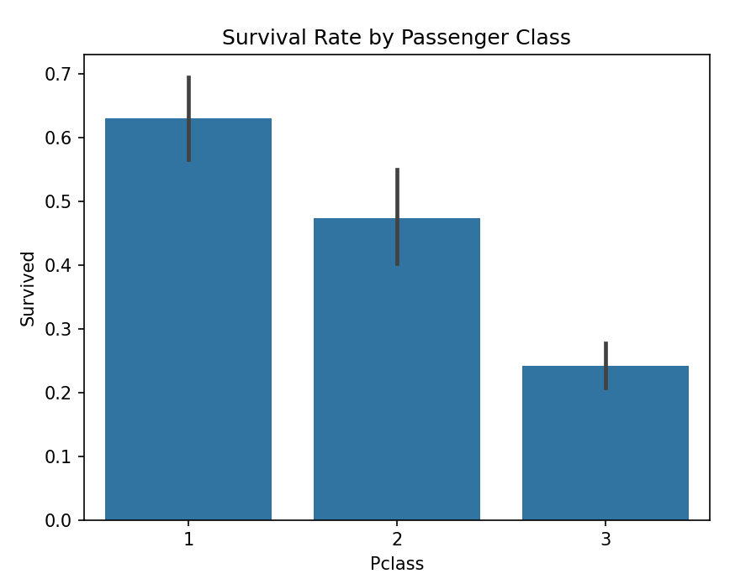
Figure 3 Survival Rate by Passenger Class

Passengers in the first class had the highest survival rate, while those in the third class had the lowest survival rate. This suggests that socioeconomic status may have influenced survival chances.

4.4 Age Distribution
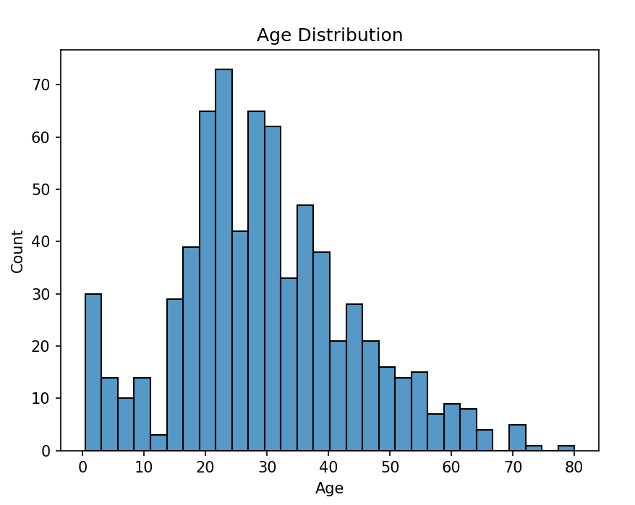
Figure 4 Age Distribution
The age distribution of passengers is shown in the figure above. Most passengers were between 20 and 40 years old, indicating that the majority of passengers were young or middle-aged adults.
The dataset also includes some younger passengers, suggesting that children were present on board. Age is useful for understanding the demographic structure of the passengers. However, based on the correlation analysis, age does not show a strong relationship with survival outcomes.

4.5 Correlation Heatmap
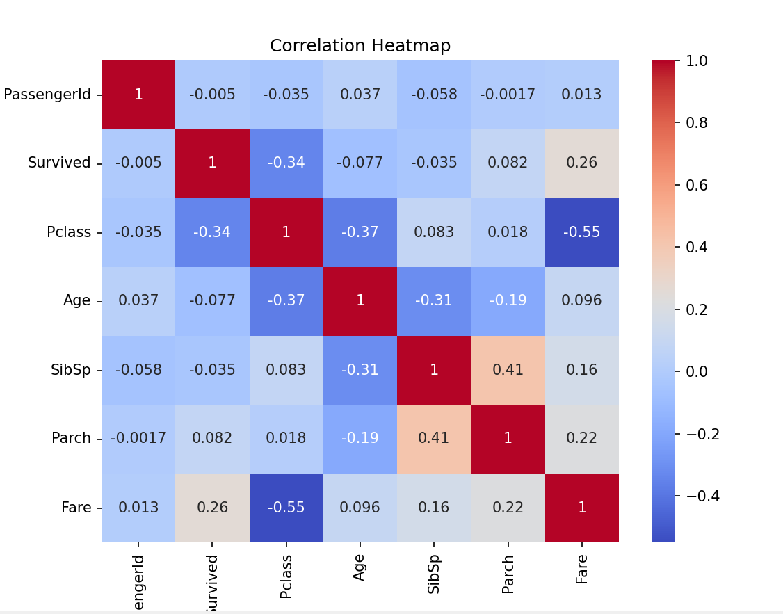
Figure 5 Correlation Heatmap
The correlation heatmap illustrates the relationships between numerical features.
The results indicate that:
- Pclass has a moderate negative correlation with Survived (-0.34), meaning passengers in higher classes were more likely to survive.
- Fare shows a positive correlation with Survived (0.26), indicating that passengers who paid higher fares had better survival chances.
- Pclass and Fare are strongly negatively correlated (-0.55), suggesting that ticket price is closely related to passenger class.
Overall, passenger class and ticket fare appear to be important factors influencing survival.

