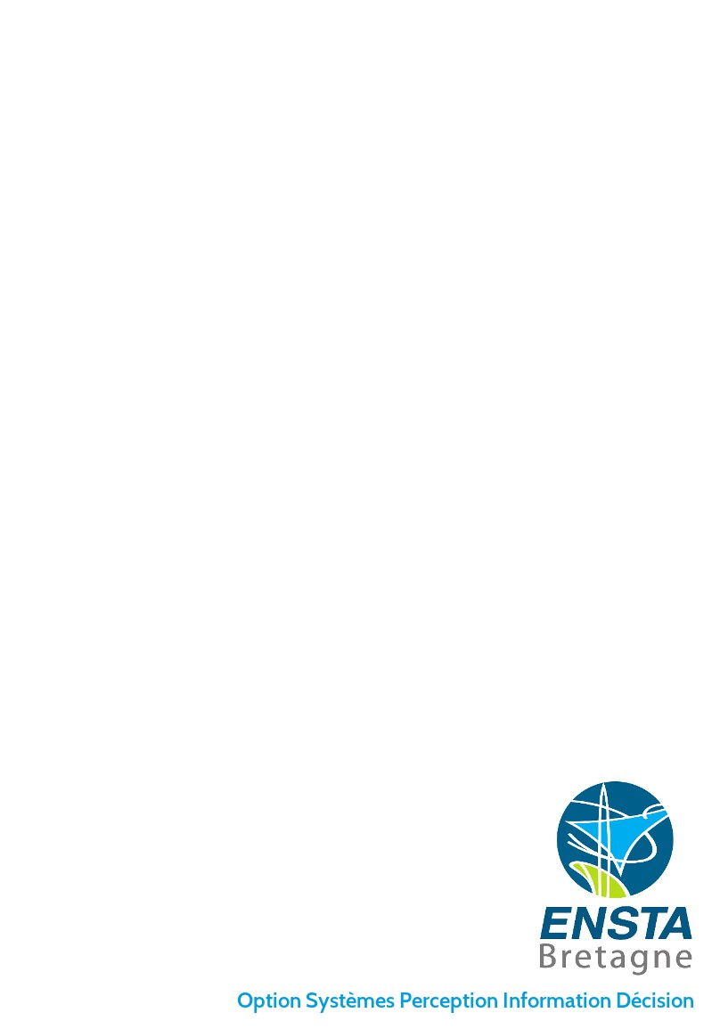

STAT U S RE PO RT

Time Frequency representation deformation

Written by:

Philippe Chuzel

Under the supervision of:

Jean-Christophe Cexus

Arnaud Coatanhay

Contents

1 Introduction 3

I Generation of the signal 5

2 Explication of the problem 6

2.1 Explication of the context . . . . . . . . . . . . . . . . . . . . . . . . . . . . . . . . 6

2.2 Equations . . . . . . . . . . . . . . . . . . . . . . . . . . . . . . . . . . . . . . . . 7

3 Expression of the wave resulting of this situation. 8

4 Examples of situation encountered. 9

II Time/frequency analysis 11

5 Spectrogram 12

6 Wigner-Ville 14

7 Pseudo Smooth Wigner-Ville 17

III Time frequency analysis 18

8 Seam carving algorithm 19

9 Application on our project 20

IV Appendix 21

Chapter 1

Introduction

The purpose of this project is to analyse the electromagnetic signature of object when its form changes during time. The electromagnetic signature analysis is a common subject for people who work in the filed of radar detection. However, the study of object signature which its form change through time is still full of many questions which have not been answered. The study of those object imply to do a very strict analyse of the electronic signature thanks to the time frequency analysis tools.

During this project [1], we have to look at the different tools which can help us to analyse the electronic signature of an object and to help us to understand the effects of change of shape of an object. The final deliverable expected is a set of program which can allow us to implement an entire loop of treatment. This loop has to help us to understand how an object deformed according to the modification of its electronic signature. All the code had to be done in python which imply that some function had to be implemented by ourself. A lot of documentation have been given by the supervisor but only have

The whole project code and result can be find here :

https : //github.com/chuzelph − EN ST A − Bretagne/ApplicationSystem54.git

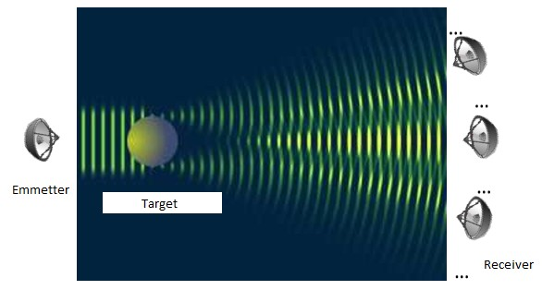

Figure 1.1: General situation of our subject.

The first part will try to explain which equations have to be understood in order to get the ana- lytic expression of the electromagnetic field coming from the object. The second part will expose

the different tools which have been create for the time frequency analysis that can be used for this project. During this part, some simple signals will be used in order to represent the results that can be obtain with those tools. The last part will present the tools which have been develop in order to extract information from the time/frequency representation in order to find correlation between the deformation of the object and the variation of the electromagnetic field.

Part I

Generation of the signal

Chapter 2

Explication of the problem

During this project, we will only study cylinder object. A lot of information given here come from this document [4]

2.1 Explication of the context

Let consider here a cylinder object which is excited by a plane wave. This problem is independent of the z-dimension so we can consider a two dimension problem. We will need to switch between a Cartesian landmark and a polar landmark.

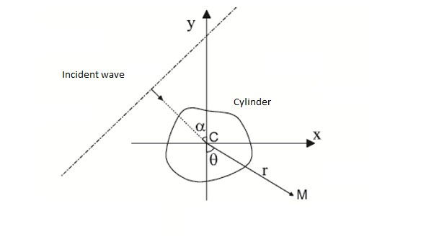

Figure 2.1: General situation of the problem.

Here, α is the incident angle of the wave and randθ are the polar position of the point M . Fur- thermore, the center of the cylinder is at the same place of the origin.

2.2 Equations

The wave equation can be written as follows:

(∇ + k2 ).p = 0 (2.1) In cylinder landmark, this result become :

1 ∂ r∂p

( ) +

1 ∂2p

+

∂2p

+ k2p = 0 (2.2)

r ∂r ∂r

r2 ∂θ2

∂z2

The problem is independent of the z-dimension so we obtain :

1 ∂ r∂p

( ) +

1 ∂2p

+ k2p = 0 (2.3)

r ∂r ∂r

r2 ∂θ2

This problem allows us to use the separation of variables (also known as the Fourier method) and allows to rewrite an equation so that each of two variables occurs on a different side of the equation. The set of solution p can be write as:

p(r, θ) = R(r).Θ(θ) (2.4) Thanks to the separation of variable, we know that we have a family of solution which is countable

so we can write:

pn (r, θ) = Rn (r).Θn (θ) (2.5) The function Θ is 2π periodic so it can be write as:

Θn (θ) = an .einθ + bn .e−inθ (2.6) Thanks to the Bessel and Hankel functions, we can express the solution:

Rn = cn .Jn (kr) + dn .Yn (kr) (2.7) Or:

Rn = cn .H (1) (kr) + dn .H (2) (kr) (2.8)

n n

The set of solution can be express by the functions:

Jn (kr)einθ Yn (kr)e−inθ n ∈ Z (2.9)

n (kr)e

H (1)

n

inθ

H (2) (kr)e

−inθ

n ∈ Z (2.10)

We will have two waves:

• An incident wave pinc .

• A diffused wave pdif resulted from the reaction of the incident wave and the object.

Chapter 3

Expression of the wave resulting of this situation.

Both the incident wave and the diffused wave have to be defined at (0,0) and mustn’t diverge for

r → +∞.

The consequences are that the incident wave can be written as :

pinc =

∞

X

n=−∞

an Jn (kr)einθ (3.1)

If we choose to use the Hankel functions in order to express the diffused wave, we get the result:

pdif =

∞

X

n=−∞

n (kr)e

bn H (1)

inθ

(3.2)

The limit condition which applies here is the SOMMERFELD condition. That means that:

pinc (r, θ) = pdif (r, θ) ∀(r, θ) ∈ {Border of the object} (3.3) Thanks to the fact each terms are independent, we have:

n (kr) = an Jn (kr) ∀n ∈ N ∀(r, θ) ∈ {Border of the object} (3.4)

bn .H (1)

So we have a relation between the coefficient an and bn . We still have to find an expression for an . The wave pinc is a plane wave which means that it can be write as:

pinc = eikinc x or pinc = eikinc r. cos(θ−α) (3.5) If we develop the term cos(θ − α) as a Fourier series, we get the equation:

pinc =

∞

X

n=−∞

in e−inα Jn (kr)einθ (3.6)

Which means an = in e−inα . With this, we can express the wave resulting to the diffraction of the incident wave on the object.

Chapter 4

Examples of situation encountered.

During this project, we will have only two situation.

We will in a first step consider a unique cylinder which its radius change through time and we will study the magnetic field at the point M:

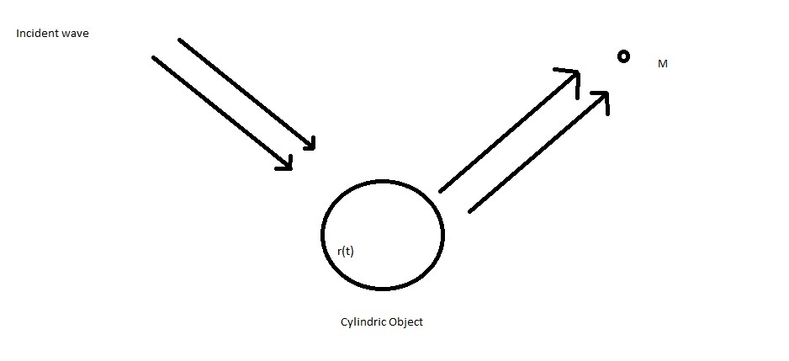

Figure 4.1: Study with a unique object.

In a second step, we will consider a lot of cylinders which can move through time and study the magnetic field at the point M:

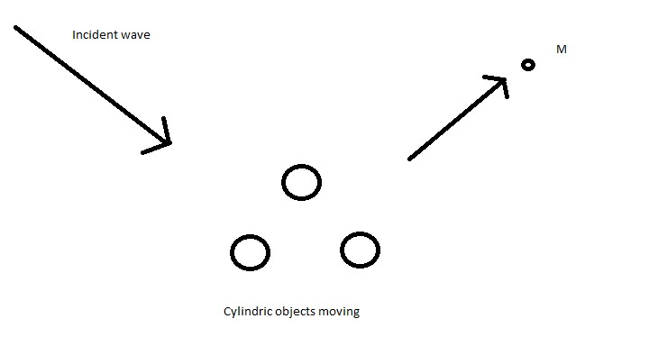

Figure 4.2: Study with a set of object.

For this situation, we have to estimate the phase shift between those objects and an origin. Thanks to some geometric theorems, this can be easily obtain.

Conclusion The code needed in order to generate those signals is already working and all we need is to simulate the movement and the deformation of one or two cylinders and see the effect of the movement and the form deformation on the electromagnetic signature.

Part II

Time/frequency analysis

Chapter 5

Spectrogram

The spectrogram is the most common tools used in order to do a time frequency representation. This representation use the short-time-Fourier transformation in order to apply an fast-Fourier transform- ation on a slippery window of the signal. In the end, we get an image which represent the frequency which compose the signal at an instant t given.

Let consider the signal chirp below which correspond to a signal which its frequency increases from 0 to 300Hz.

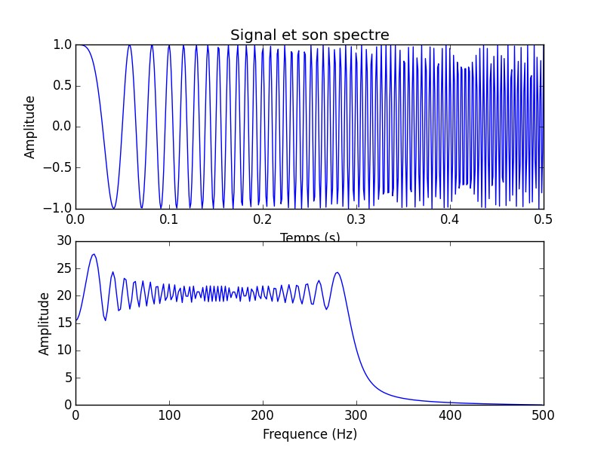

Figure 5.1: Time and frequency representation of a chirp signal. The figure below shows the results we can get:

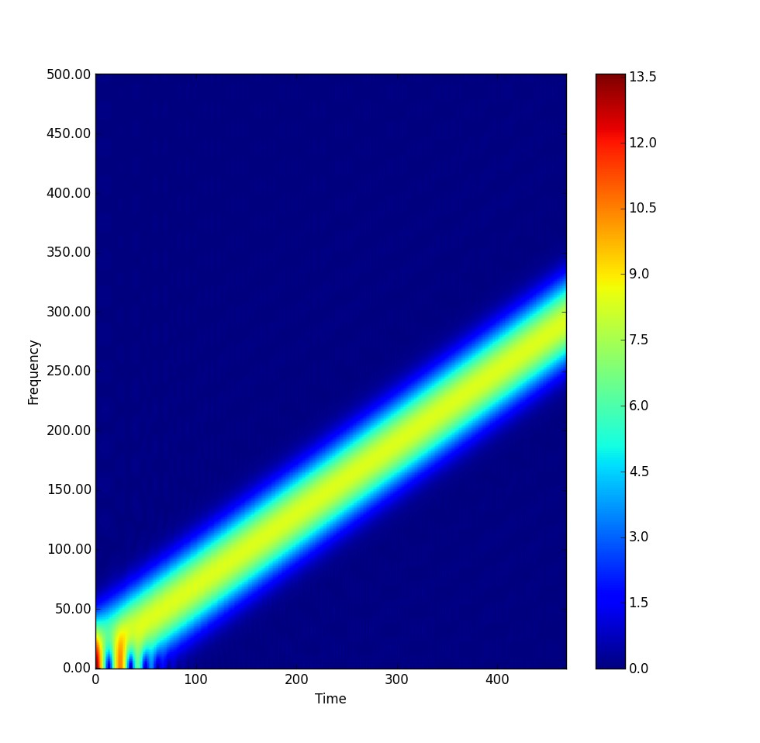

Figure 5.2: STFT/spectrogram of a chirp signal.

This figure shows clearly that the frequency of the signal increass through time but the result is a little blur and isn’t very accurate.

Chapter 6

Wigner-Ville

The Wigner-Ville distribution allows us to get a far more accurate time frequency representation. Nevertheless, this distribution create some interferences if the signal is a combination of different frequency laws.

The Wigner-Ville Distribution (WVD) of a signal y(t), denoted by Wz (t, f ), is defined as :

Wz (t, f ) =

Z ∞

n=−∞

z(t + τ /2)z∗(t − τ /2)e−j2πf τ dτ (6.1)

The following figure shows the result of the Wigner-Ville representation on the previous signal:

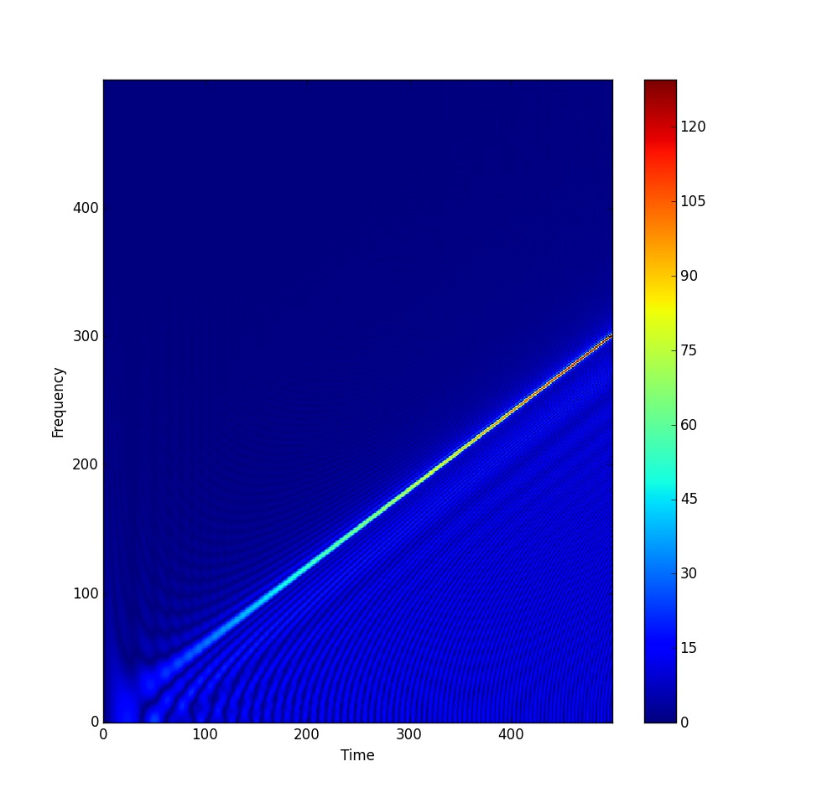

Figure 6.1: Wigner-Ville of a chirp signal.

Nevertheless, if we consider the following signal which contains two sinusoids, with different frequency and with one which last for only a portion of the signal. We get the result below:

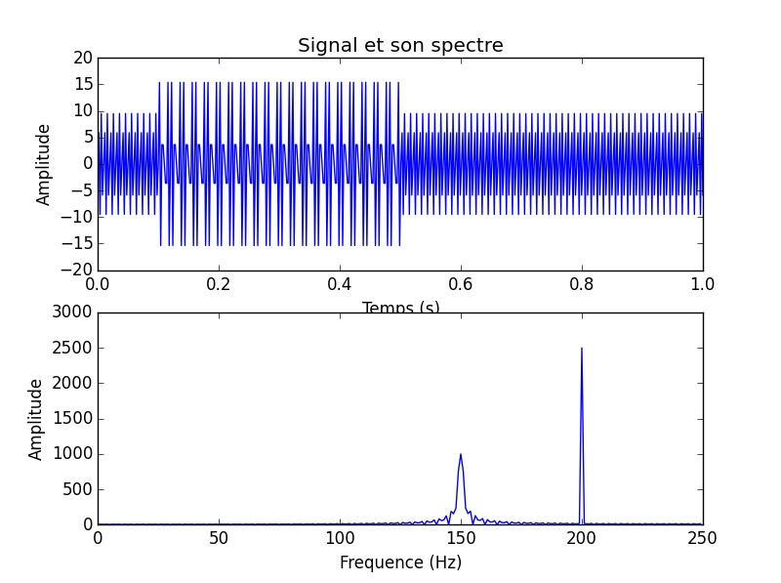

Figure 6.2: Time and frequency representation of the signal with two frequency laws.

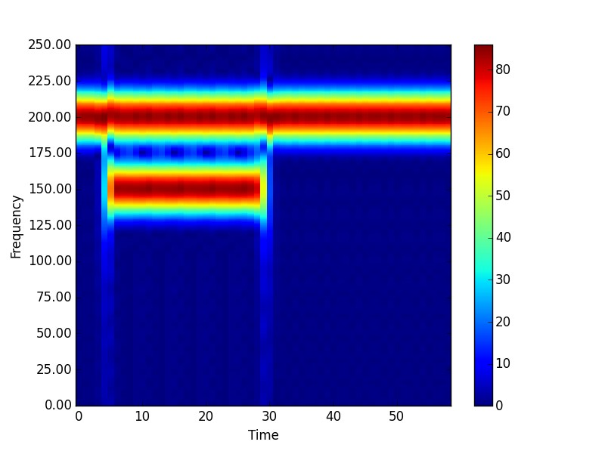

Figure 6.3: Spectrogram of the signal.

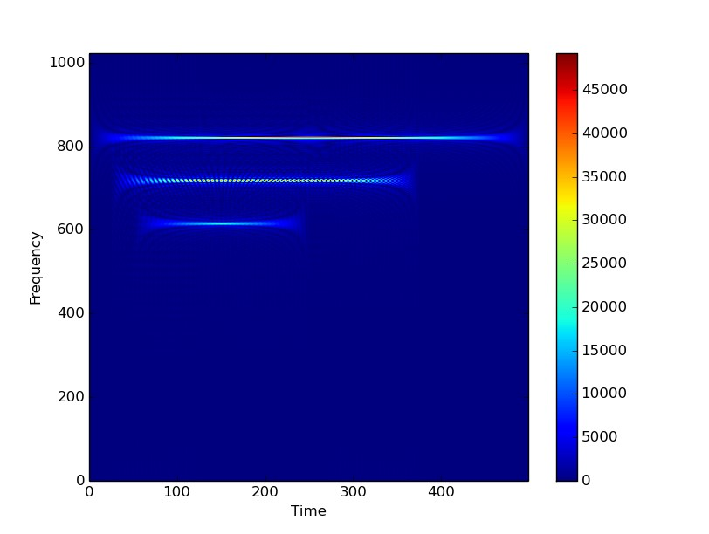

Figure 6.4: Wigner-Ville of the signal.

As you can see, there are an interference which imply to analyse this figure if we want to extract relevant information.

NB : The differences in the frequency scale is due to a problem in the implementation I realized. I will correct this as soon as I can.

Chapter 7

Pseudo Smooth Wigner-Ville

The Pseudo-Wigner-Ville Distribution is defined as:

Wz (t, f ) =

Z ∞

n=−∞

h(τ )z(t + τ /2)z∗(t − τ /2)e−j2πf τ dτ (7.1)

where h is a regular window. This windowing is equivalent to a frequency smoothing of the WVD

so It leads to the attenuation of the interference terms but it will damage the signal representation.

The result for the previous signal is below:

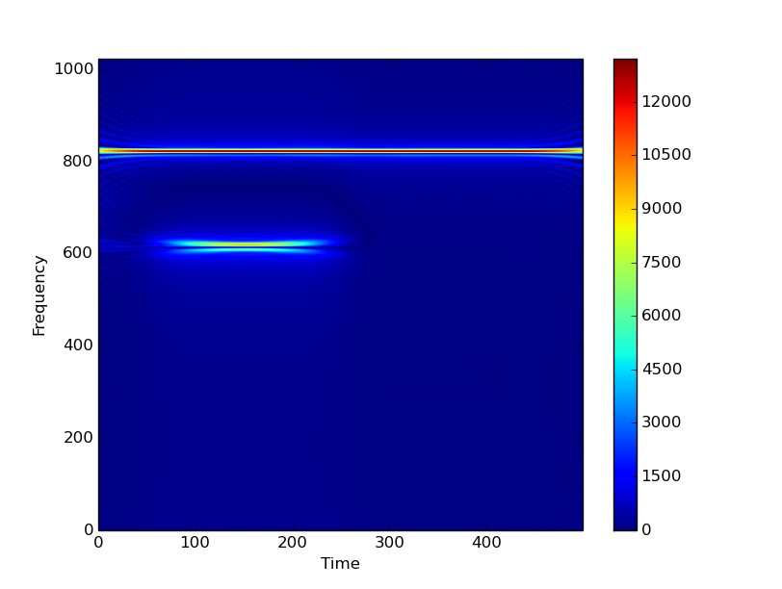

Figure 7.1: Pseudo Smooth Wigner-Ville of the signal.

Conclusion All those representation present some interests or disadvantages. Nevertheless, if we want to get as much information as we can, we will need to switch between a representation to another according to the kind of signal we have.

Part III

Time frequency analysis

Chapter 8

Seam carving algorithm

For this part, most of the tools come from those references [2] [5] [3]. For now, I’m still working on this part so I will complete this part as soon as I get result. The main purpose of this article is to present an algorithm which allow us to find the speed of an object thanks to the Doppler effect but it can be use here in order to find the frequency laws which compose the signal. With this, we have a way to find correlation between the electromagnetic signature and the kind of from changes of an object.

Chapter 9

Application on our project

We will now apply this algorithm to the time frequency representation coming from the part 2 and from the signal generate in the part 1. For now, I’m still working on this part so I will complete this part as soon as I get result.

Part IV

Appendix

Gaant diagram

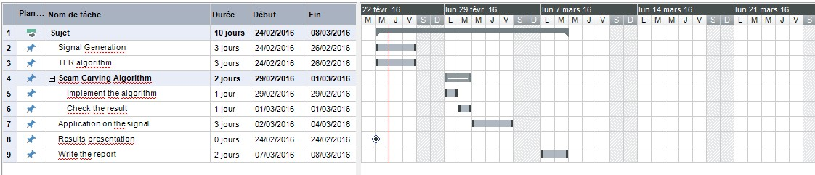

Figure 1: Gaant diagram.

This Gaant diagram has been realized at the middle of the week and show what remains to be done in order to implement a solution to the project. I let at least 3 days to test the seam carving algorithm on the signals in order to find if the results are relevant. They are some other algorithms that can be used but they will be implemented if this one doesn’t work.

The program which has been used in order to generate this diagram is MindView 6.0

Bibliography

[1] Alexandre Baussard Arnaud Coatanhay. Qualitative analysis of the time-frequency signature induced by a rflected l-band signal from time evolving sea surfaces. 2013.

[2] Shubhranshu Barnwal. Doppler based speed estimation of vehicles using passive sensor. 2015. [3] Volkan Cevher. Vehicle speed estimation using acoustic wave patterns. 2015.

[4] Arnaud Coatanhay. Equations aux derivees partielles et methode des elements finis. 2015.

[5] Christophe Couvreur. Doppler-based motion estimation for wide-band sources from single pass- ive sensor measurements. 2015.